Briefing Note on measuring Species Diversity

Carl James Schwarz

Department of Statistics and Actuarial Science

Simon Fraser University

[cschwarz@stat.sfu.ca](mailto:cschwarz@stat.sfu.ca)

2014-01-21

# 1. Introduction.

Changes in species diversity are often used as indicators of an environmental impact. However, there are many ways in which species diversity can be measured. Furthermore, most of these common measures do not account for the similarity among species. For example, the diversity of six dramatically different species of plants is considered to be no more diverse than six related species.

Leinster and Cobbold (2012) showed how different diversity measures all belong to a continuum (called a diversity profile) and how species similarity can be used to augment the standard diversity measures. The diversity profile also has a number of advantages over the traditional measures of diversity as noted by Chao and Jost (2013) and Jost (2013).

The key difficulty with traditional measures of diversity is that there is non-linear relationship between the diversity measure and biological implications. For this reason, it is often useful to think in terms of “effective number of species” (Jost, 2006; Jost 2013). Briefly, the effective number of species is the number of equally abundant species that give rise to a particular diversity index value.

Jost (2013) provides an example of the problems with traditional diversity measures:

“… suppose you are comparing the diversity of aquatic microorganisms before and after an oil spill. You wouldn't want to measure that diversity by species richness because even a massive toxic event is sure to leave a few vagrant individuals of each pre-spill species, and species richness doesn't distinguish between one individual of Species X or a million; the pre- and post-spill species counts might not be very different, even if the pre- and post-spill species frequencies are very different. So if you are a good traditional biologist you might use the popular Gini-Simpson diversity index, which is  [where  is a measure of relative abundance for species *i*]. Suppose that the pre-spill Gini-Simpson index is .99 and the post-spill index is .97. If you are a good traditional biologist you would figure out that this drop is statistically significant, but you would conclude that the magnitude of the drop is small. You might even say  (very wrongly) that the diversity has dropped by 2%, which sounds like a small drop, nothing to worry about.

The error which virtually all biologists make is that the Gini-Simpson index is not itself a diversity, and is highly nonlinear. The pre-spill community with a Gini-Simpson index of 0.99 has the same diversity as a community of 100 equally-common species. The post-spill community with a Gini-Simpson index of  0.97 has the same diversity as a community of 33 equally-common species. The difference between the pre-and post-spill diversities is in fact enormous. The drop in diversity is 66%, not 2%! This is not just a matter of different definitions of diversity, as some people would like to say. Rather, it is a matter of the indices being nonlinear with respect to our intuitive concept of diversity.”

Leinster and Cobbold (2012) defined the diversity profile as series of “effective numbers” dependent on an index *q* (which ranges from 0 to infinity) and a similarity matrix **Z** (whose (*i,j*) entry measures the similarity of species *i* and species *j* from 0 (not similar) to 1 (completely similar)). The diversity profile is computed as:

 (1)

where the vector **p**is the relative abundance of the species present (i.e. excluding species with 0 abundance), and **Z** is the similarity matrix among the vector of species. As shown by Leinster and Cobbold (2012), many of the common diversity indices are special cases of (1). For example, if *q* = 0*,* (1*)* reduces to species richness; if *q* = 1 and **Z=I**, then (1) is related to the Shannon Index; and if *q=2* and **Z=I**, then (1)is related to the Simpson Index of diversity.

The **Z** matrix (measure of similarity) resolves a number of problems with the common diversity measures. If two species are virtually identical (entries of **Z** close to 1), then the diversity measure (1) effectively treats them equivalently as a single species. The difficulty, is of course, defining this similarity matrix.

In the remainder of this document, we will illustrate the use of the diversity profile (1) based on vegetation data collected as part an baseline monitoring study summarized by Armada Environmental Inc (2012).

# 2. Study Protocol:

Briefly, permanent sample sites were established each at ******and ***** Lakes. The sites can be classified as being a string,, a flark, or a wooded fen of the wetland complex. [There are a small number of other types of sites which will be ignored.] From *** to *** surveys of the vegetation were done at the sites. At each site-year combination, 10 x 1 m2 plots were surveyed, and the percent cover of the vegetation species on the plot were recorded. In some cases, only the genus of the plant could be identified.

As a first illustration, the diversity profiles were computed for each site-year combination using the average of the percent cover from the 10 ground plots as a measure of relative abundance. The profiles are plotted in Figure 1.

The *q* index (along the bottom) controls the weight given to species abundance in computing the effective number of species. When *q = 0* each species is given equal weight regardless of abundance and corresponds to simple species richness. For example, in the wooded fen, all sites in all year seem to have about 40-80 distinct species. As *q* gets larger, rare species are given less weight, and the effective number of species essentially measures the number of ‘abundant’ species. Again for wooded fens, there appears to be two groups of sites – one where the number of abundant species is around 5-10 and another where the number of abundant species is around 2-4. Notice how the sites ‘diverge’ when abundance is taken into account. Again for wooded fens, all site-years appear to have comparable species richness with no clear distinction between the sites in the two complexes; but when abundance is taken in to account, there appears to be a further division of the two types of sites. The bottom panel of Figure 1 shows that the site-year diversity profiles in String habitats show no clear divisions.

These diversity profiles can be used to examine differences in species diversity similar to what was done in Table 7 of ********* as illustrated in Figures 2a and 2b. Here the diversity profiles for 2012 and 2013 (and pointwise 95% confidence intervals) were computed for the different vegetation grouping in the two habitat complexes. Consider the first column (the wooded fen sites). ******* found no evidence of a difference in the mean species richness (*q = 0*) for any vegetation group between the two wetland complexes. This can be seen by the substantial overlap in the confidence bounds at *q* = 0. However, the diversity profile for the *Graminoids* appears to diverge from approximately *q =* 1 onwards. So while the number of species appears to be comparable, the diversity of more common species appears to be different between the two complexes. Conversely, the species richness for *Bryophytes* appears to differ in string sites between the two complexes, but the diversity profiles soon overlap when rare species are given less weight.

All of the above analyzes assumed that all species are dissimilar from all other species. As noted by Leinster and Cobbold (2012) this is at odds with biological realism where very similar species that interchange in their abundance over time should not be treated in the same way as when two dissimilar species exchange abundances. The diversity profiles in Figures 3a and 3b illustrate the effect of assigning an (arbitrary) similarity measure of 0.5 for all species within the same major groups (G, F, L, and B) for **** and *****. When this similarity measure is applied, the diversity profile drops considerably. For example, at *q* = 0, the species richness in 2012 drops from around 50 to around 5 which essentially now just measures the number of vegetation groups! The value of 0.5 for the similarity was arbitrarily chosen to illustrate its impact – obviously a more refined similarity measure should be developed.

# 3. Summary.

Using a single measure of diversity, such as species richness, gives only one view of the diversity on the landscape. Rather than arguing about which measure of diversity is most relevant (e.g. should the same weight be given to rare species as to abundant species?), the diversity profile provides a `fingerprint’ of diversity.

The diversity profile also is less prone to errors of interpretation of changes in diversity over time caused by the (sometimes extreme) non-linear relationship between the diversity index value and the number of species. The diversity profile converts all diversity measures to a common currency – the effective number of species. This measures how many species of equal abundance would give the same diversity value as that observed on the site.

These diversity profiles can be computed with the same data as any single diversity index commonly used, so requires no additional data gathering.

Another problem with the standard diversity measures is that they treat all species as being equally dissimilar from each other. So two highly related species have the same influence on the diversity measure as two completely dissimilar species. The diversity profile can be modified to account for species similarity. There are many measures of species similarity – a discussion of how to assign these values is beyond this briefing note. Another advantage of using the similarity matrix is that uncertain identification is easily handled -- simply set the similarly of the unknown species against its identified similar species.

Diversity measures should not be the only tool to measure changes in species composition over time. The major shortcomings of diversity measures are that they do not account for species substitutions. So the diversity of one set of species could be identical to another completely different set of species if both sets had the same relative abundances within their respective sets.

Chao, A. and Jost, L. (2013). Diversity Analysis. Chapman and Hall.

Jost, L. (2013). Effective number of species. Available at <http://www.loujost.com/Statistics%20and%20Physics/Diversity%20and%20Similarity/EffectiveNumberOfSpecies.htm>. Downloaded 2013-12-10.

Leinster, T. and Cobbold, C. A. (2012). Measuring diversity: the importance of species similarity. Ecology, 93, 477-489.

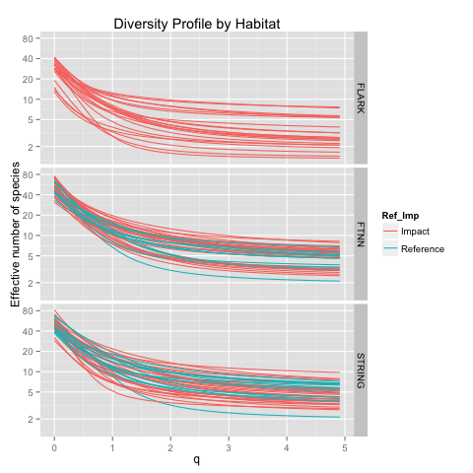

Figure 1. Diversity profile for each site-year combination divided by habitat (STRING=String, FTNN=Wooded Fen, FLARK=flark) of the site and if in the Impact or Reference complex. Note that the Y-axis is on a logarithmic scale.

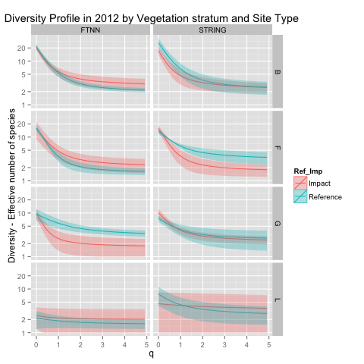

Figure 2a. Diversity profile (and approximate 95% pointwise confidence interval) for 2012 divided by vegetation grouping and by the habitat (STRING=String, FTNN=Wooded Fen) of the site and if in the Impact Reference complex. Note that the Y-axis is on a logarithmic scale.

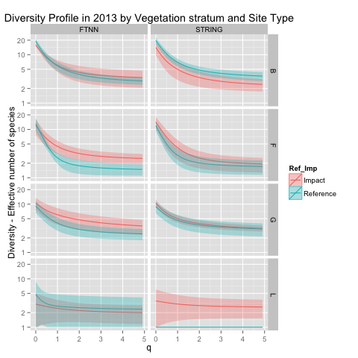

Figure 2b. Diversity profile (and approximate 95% pointwise confidence interval) for 2013 divided by vegetation grouping and by the habitat (STRING=String, FTNN=Wooded Fen) of the site and if in the Impact or Reference complex. Note that the Y-axis is on a logarithmic scale.

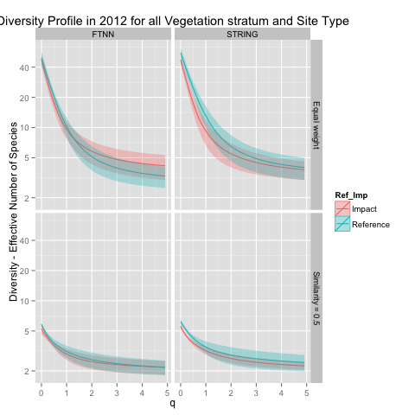

Figure 3a. Diversity profile (and approximate 95% pointwise confidence interval) for 2012 for all vegetation species divided by the habitat (STRING=String, FTNN=Wooded Fen) of the site and if in the Impact Reference complex. Note that the Y-axis is on a logarithmic scale. The top panels treat all species as non-similar. The bottom panels assigned an (arbitrary) similarity of 0.5 to all species with the same vegetation groups (G, F, L, B).

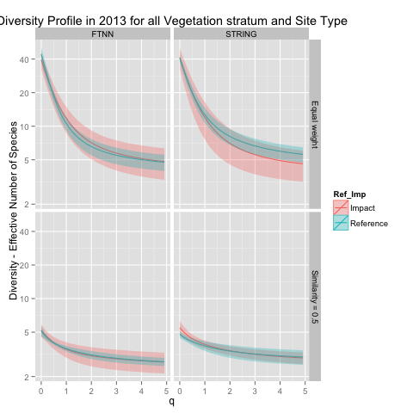

Figure 3b. Diversity profile (and approximate 95% pointwise confidence interval) for 2013 for all vegetation species divided by the habitat (STRING=String, FTNN=Wooded Fen) of the site and if in the Impact or Reference complex. Note that the Y-axis is on a logarithmic scale. The top panels treat all species as non-similar. The bottom panels assigned an (arbitrary) similarity of 0.5 to all species with the same vegetation groups (G, F, L, B).