
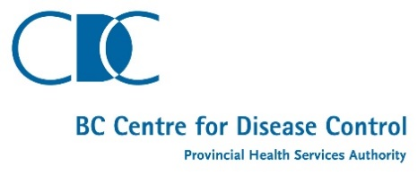

Provincial Health Services Authority
Revenue Services
1795 Willingdon Avenue
Burnaby, BC V5C 6E3

Account #: {{AccountNumber}} |  | Invoice #: {{RegulatoryTrxnFeeName}}
Facility Name: {{AccountName}} |  | Invoice Date: {{InvoiceCreatedDate}}
Attn: {{BillingContactName}}
{{AccountPhysicalAddressStreet}}
{{AccountPhysicalAddressCity}}, {{AccountPhysicalAddressStateCode}}
{{AccountPhysicalAddressCountryCode}} - {{AccountPhysicalAddressPostalCode}}

Date | Code | Description | Unit | Rate | Amount
{{RTFCreatedDate}} |  | {{RTFComments}} | {{RTFItemCount}} | ${{RTFItemFeeAmount}} | $ {{RTFTotalFeeAmount}}
 |  |  |  |  | $ {{RTFTotalFeeAmount}}

ACCOUNT COPY – PLEASE KEEP FOR YOUR RECORDS

TERMS & CONDITIONS
- All amounts are in Canadian Dollars.
- Amount due is payable in Canadian Dollars and due upon receipt.
- Interest will be charged 2% per month for late payment on account.
- Please note a $30.00 fee will be applied to your account for any bank returned cheques due to Non-Sufficient Funds.

PAYMENT OPTIONS
- IN PERSON: Cash, Cheque, Credit Card or Debit Card payments can be made in-person at Hospital Cashier sites
  - In-Person payments are NOT accepted at the 1795 Willingdon Location
- PHONE: 604-297-8512 Option 1
- MAIL: make cheques payable to Provincial Health Services Authority; Write the account number on the front of the cheque
  - Mail to Revenue Services, 1795 Willingdon Ave, Burnaby BC, V5C 6E3, Canada

FOR BILLING QUESTIONS
- Tel: 604-297-8512 OPTION 2
- Fax: 604-297-9306
- Email: npbphsa@phsa.ca

If you have recently paid this account, we thank you for your payment and we ask you to kindly disregard this notice

