Economics Report

Introduction

Commencing Investigation
This economics report has been produced pursuant to a Board investigation under section 27 of the Act (Policy Manual). The Board investigation was commenced on August 27, 2024, with respect to application #79999-24.
The Board’s letter of instruction to Senior Economist included the application details, outlined below, along with a request for economic analysis pertaining to the following relevant indicators:
Trip Volume: | ✓
Trip Revenue: | ✓
Number of Wheelchair Accessible Vehicles (WAVs): | ✓
Number of Active Vehicles per 1,000 Persons: | ✓
Fare per Kilometre: | ✓
Wait Time: | ✓
Concentration indices: | ✓
Revenue per Active Vehicle: | ✓
Taxi Fleet Utilization Rate: | ✓
Taxi Vehicle Occupancy Rate: | ✓
Peak-Hour Taxi Vehicle Occupancy Rate: | ✓

Application Details
This report was produced for the Board regarding a new application for a taxi licence.
The applicant is MS Taxi Ltd., which is doing business as MS Taxi. The application summary states the following:
There is a need for an additional taxi company servicing West Vancouver, North Vancouver, Vancouver, and YVR. It will positively affect transportation services. As MS Taxi, we will attract new taxi users that will increase the trip volume of all existing and new companies.
Additional details of the application include:
- Proposed operating area: West Vancouver, North Vancouver, Vancouver, YVR
- Proposed fleet size: 30 (25 Conventional; 5 WAV)

Area of Study
The proposed operating area for this taxi application is mainly within the City of Vancouver, District of West Vancouver, and District of North Vancouver. These municipalities are located in the Greater Vancouver Regional District.
For the purpose of statistical analysis, both taxi and TNS applications are associated with the same Region, as contemplated in the Board’s operating areas policy in the Policy Manual, even though taxi businesses do not generally operate at a regional level.
For taxi applicants, the Region is determined based on where the existing or proposed operating area is located. In this case, this taxi application is located in Region 1. The Regional District is also determined based on where the existing or proposed operating area is located.

Existing Licensees
The Board maintains a database of taxi and TNS licensees approved by the Board and key terms and conditions set by the Board, such as fleets, operating areas, and rates. On a regular basis, this is cross-correlated against a list of active licensees provided by the Registrar of Passenger Transportation (Registrar) at the Ministry of Transportation and Infrastructure (MoTI). The Board refers to this database as the “single source of licensee data” or SSOLD. Based on the SSOLD, last updated on September 30, 2024, the following relevant information can be observed about the existing licensees in the area:
- At the municipal level,
  - Number of taxi licensees operating: 8
  - Combined Board-approved maximum fleet size: 1,226
- At the Regional District level,
  - Number of taxi licensees operating: 29
  - Combined Board-approved maximum fleet size: 2,384
- At the Region level,
  - Number of taxi licensees operating: 49
  - Combined Board-approved maximum fleet size: 2,604

Background

Section 28 Criteria
Under section 28(1) of the Act, the Board must consider the following factors when determining applications:
- Whether the applicant is fit, proper, and capable of providing the service applied for (threshold test);
- Whether there is a public need for the service; and
- Whether the application would promote sound economic conditions in the B.C. passenger transportation business.
This economics report provides the Board with data analysis pertaining only to the “public need” (PN) and “sound economic conditions” (SEC) criteria. It does not speak to the fit, proper, and capable criteria.

PN and SEC Factors
The Board’s Policy Manual provides information on the factors the Board may consider when determining PN and SEC. This economics report will focus on the underlying PN and SEC factors for the Board’s consideration in determining whether PN and SEC exist. For clarity, this economics report does not determine whether PN and SEC exist.
Under the public need policy in the Policy Manual, PN is divided into the following factors:
- Demand
- Accessibility
- Affordability
- Safety
- Service Quality
Under the sound economic conditions policy in the Policy Manual, SEC is divided into the following factors:
- Sustainability
- Competition
- Innovation
- Variety
This economics report examines key indicators of the taxi and TNS sectors in B.C. Each indicator is identified with a primary PN or SEC factor, as indicated in the following chart:
Please note that this economics report does not provide an analysis of the “innovation” or “variety” factors under SEC.

Report Constraints
Under section 28(5) of the Act and the terms and conditions of licence, special authorization licences, including taxi and TNS, are required to submit trip data. The Board has established data requirements outlining the type of trip data that must be submitted. Trip data is submitted by licensees to the Registrar through the Vehicle Safety BC Portal (the Trip Database), also known as the “data warehouse”.
Since only the taxi and TNS sectors are required to report trip data under the data requirements, these are the only sectors eligible for an economics report at this time.
Due to data limitations, only two regions will be analyzed:
- Region 1 – Lower Mainland including Whistler; and,
- Region 2 – Capital Regional District (CRD).
Regional Districts within these Regions may be analyzed so long as there is adequate data reliability for those Regional Districts.
At this time, three other regions will not be included in this economics report due to insufficient data coverage, poor data quality, or unreliable trip data submissions: Region 3 (Vancouver Island excluding CRD); Region 4 (Interior); and, Region 5 (Northern B.C. and other).

Qualifications
This economics report was authored by the Board’s Senior Economist, Peter Tseng, who is ultimately responsible for the analysis contained in this report.
Peter Tseng has over a decade of experience in economic analytics, policy evaluation, and statistical reporting. He holds a Ph.D. in Economics from the University of Victoria and has held senior roles with the BC Public Service, including at the Ministry of Finance and Ministry of Health.

Factors and Their Indicators
All analyses in this report are based on data from the Trip Database unless otherwise specified. Technical details of each indicator can be found in Appendix 1.

Demand Factor (PN)

Trip Volume
Primary Factor: Demand
Description: Trip volume represents, in real terms, the observed quantities demanded for trip services, reflecting the equilibrium between passenger demand and industry supply.
Measurement: Trip volume is calculated as the number of completed trips reported to the Trip Database in an area over a month.
Interpretation: Increases in taxi trip volume or TNS trip volume indicate growth in the quantity demanded in the respective markets. Moreover, a shift in trip volume from the taxi sector to the TNS sector suggests evolving consumer preferences and competition between the two types of partially substitutable services.
It is helpful to note that while taxis and TNS are similar, they are not the same. This means that taxis and TNS, while partially interchangeable, ultimately serve distinct consumer needs and preferences, reflecting their roles as separate yet complementary services in the transportation market. Any higher combined volume of taxi and TNS trips can result from offering passengers greater choice, not the inherent superiority of one service over the other.*
The Board’s public need policy in the Policy Manual lists examples of the demand factor, which are set out below alongside their corresponding implications on trip volume: - There are people who require access to, or are seeking access to, or would likely access a new, expanded, or improved passenger transportation service. - When the proposed service fulfills previously unmet demand and brings new users into the market, it will result in an overall increase in trip volume. - The increase can only be evident after the proposed service is introduced. However, historical trends can provide valuable indications. For example, a steady increase in trip volume over time can signal a growing demand for the taxi or TNS services, suggesting potential usage for the proposed service.
There are people who would use the proposed service:
- If the proposed service attracts current users of taxis or TNS, it will result in a redistribution of market share measured by trip volume among existing providers.
- The redistribution can only be evident after the proposed service is introduced. However, historical trends can provide indications. For example, ongoing shifts in market share of sectors can indicate changes in customer preference.

Metro Vancouver Regional District Trip Volume Findings
Table 1: Metro Vancouver Regional District Trip Volume
Year | Jan | Feb | Mar | Apr | May | Jun | Jul | Aug | Sep | Oct | Nov | Dec
TAXI
2023 | 441,547 | 451,204 | 488,990 | 494,010 | 529,020 | 542,624 | 544,195 | 546,253 | 560,215 | 529,177 | 508,188 | 524,721
2024 | 492,159 | 451,466 | 493,271 | 488,513 | 502,672 | 528,812 | 494,332 | 471,542 | 466,280 | 464,842 | 466,840 | 500,580
2025 | 447,448 | 448,853 | 488,823
TNS
2023 | 1,501,486 | 1,442,653 | 1,632,532 | 1,782,845 | 1,803,991 | 1,903,989 | 2,062,898 | 2,019,125 | 2,042,966 | 2,200,489 | 2,081,708 | 2,309,909
2024 | 2,215,703 | 2,124,238 | 2,408,851 | 2,412,175 | 2,642,415 | 2,677,046 | 2,773,596 | 2,796,026 | 2,684,928 | 2,551,823 | 2,441,272 | 2,791,114
2025 | 2,475,193 | 2,417,966 | 2,619,607
Figure 1: Metro Vancouver Regional District Trip Volume
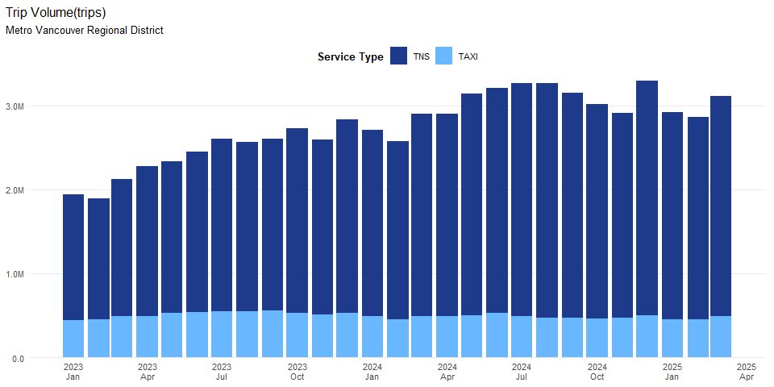
Analysis and Conclusions
In March 2025, Metro Vancouver Regional District saw a total of 488,823 taxi trips. On a year-over-year (YoY) basis, the total taxi trip volume was -0.90%, while on a year-to-date (YTD) basis it was -3.60%. relative to the same period in 2024. These results indicate strong momentum in demand for TAXI services in the region.
In March 2025, Metro Vancouver Regional District recorded 2,619,607 TNS trips. Compared with March 2024, TNS trip volume was +8.75% (YoY). Year-to-date through March 2025, TNS trip volume was +11.32% relative to the same period in 2024. These results indicate strong momentum in demand for TNS services in the region.
Limitations. Quantity demanded does not equate to demand. Quantity demanded refers to the actual number of trips observed, whereas demand includes all potential trips if there were no constraints. There can still be unmet demand due to limited vehicle availability preventing some customers from using the service. .

Trip Revenue
Description:
Trip revenue represents, in nominal terms, the observed quantities demanded for trip services, reflecting the equilibrium between passenger demand and industry supply.
Measurement:
Trip revenue is calculated as the total fare amount of all completed trips reported to the Trip Database in an area over a month.
Interpretations:
Increases in taxi trip revenue or TNS trip revenue indicate growth of quantity demanded in the respective markets. Moreover, a shift in trip revenue from the taxi sector to the TNS sector can signify a structural change in market dynamics, suggesting evolving consumer preferences or competition between the two types of partially substitutable services.
As stated previously, it is helpful to note that although taxis and TNS are similar, they are not the same. Taxis and TNS, while partially interchangeable, ultimately serve distinct consumer needs and preferences, reflecting their roles as separate yet complementary services in the transportation market. Any higher combined revenue of taxi and TNS trips can result from offering passengers greater choice, not the inherent superiority of one service over the other.

Policy Context: Public Need and Demand Factor
The Board’s Public Need Policy in the Policy Manual lists examples of the demand factor, which are set out below alongside their corresponding implications on trip revenue:
- There are people who would use the proposed service.
There are people who require access to, or are seeking access to, or would likely access a new, expanded, or improved passenger transportation service.
  - If the proposed service attracts current taxi or TNS users, it will result in a redistribution of market share as measured by trip revenue among existing providers.
  - The redistribution can only be observed after the proposed service is introduced. However, historical trends can provide valuable indications. For instance, ongoing shifts in market shares of sectors can indicate changes in customer preference.

Metro Vancouver Regional District Trip Revenue Findings
Table 1: Metro Vancouver Regional District Trip Revenue (thousands of dollars)
Year | Jan | Feb | Mar | Apr | May | Jun | Jul | Aug | Sep | Oct | Nov | Dec
TAXI
2023 | $8,577 | $8,785 | $9,623 | $9,750 | $10,803 | $11,301 | $11,269 | $11,352 | $11,683 | $11,344 | $10,686 | $10,971
2024 | $10,093 | $9,250 | $10,342 | $10,373 | $10,932 | $11,720 | $10,886 | $10,354 | $10,155 | $9,972 | $9,942 | $11,080
2025 | $9,713 | $9,652 | $10,437
TNS
2023 | $30,115 | $28,922 | $32,068 | $35,588 | $36,237 | $38,625 | $42,474 | $41,563 | $41,600 | $42,218 | $39,293 | $45,254
2024 | $41,551 | $36,697 | $41,997 | $42,567 | $47,183 | $47,730 | $50,908 | $50,543 | $48,632 | $44,534 | $42,725 | $50,759
2025 | $40,981 | $41,402 | $45,444
Figure 1: Metro Vancouver Regional District Trip Revenue
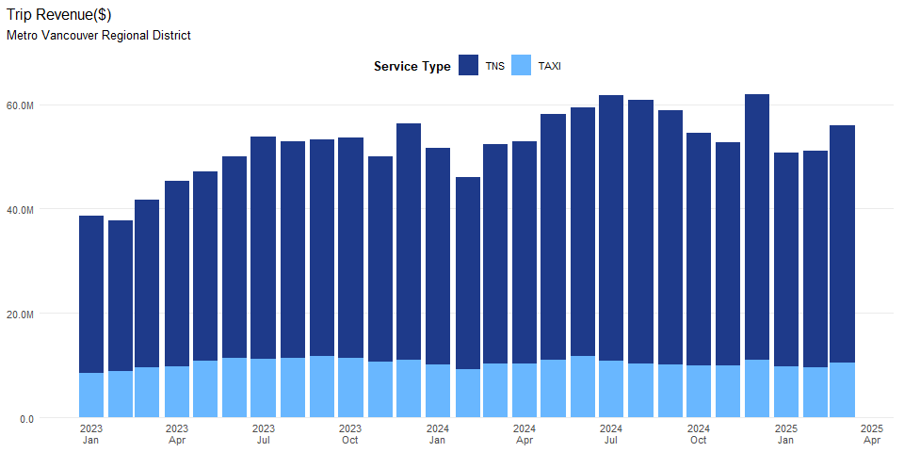
Analysis and Conclusions
In March 2025, Metro Vancouver Regional District saw a total of $10,437,417 taxi trips revenue. On a year-over-year (YoY) basis, the total taxi trip revenue was +0.92%, while on a year-to-date (YTD) basis it was +0.39%. relative to the same period in 2024. These results indicate strong momentum in demand for TAXI services in the region.
In March 2025, Metro Vancouver Regional District recorded $45,443,537 TNS trips. Compared with March 2024, TNS trip revenue was +8.21% (YoY). Year-to-date through March 2025, TNS trip revenue was +6.31% relative to the same period in 2024. These results indicate strong momentum in demand for TNS services in the region.
Limitations: Quantity demanded does not amount to demand. Quantity demanded refers to the actual trip revenue observed, whereas demand includes all potential trip revenue if there are no constraints. There can still be unmet demand due to limited vehicle availability preventing some customers from using the service.

Number of Active Vehicles per 1,000 Persons
Primary Factor: Accessibility
Description:
The number of active vehicles per 1,000 persons represents the total number of vehicles serving every 1,000 persons in an area over a month.
Measurement:
The number of active vehicles per 1,000 persons is calculated as the ratio of the total number of active vehicles (including both taxis and TNS) in an area relative to its population, normalized to a per 1,000 persons basis.
Interpretation:
A higher number of active vehicles per 1,000 persons indicates higher accessibility to services in the area, as more taxis and TNS vehicles are available to serve every 1,000 persons.
Policy Context: Public Need and Accessibility Factor
The Board’s Public Need Policy in the Policy Manual lists examples of the accessibility factor, which are set out below alongside their corresponding implications on the number of active vehicles per 1,000 persons:
-The proposed service enhances availability of passenger transportation services to everyone in the province, including in low-density areas, such as rural and remote communities. -A higher number of active vehicles per 1,000 persons directly and positively correlates with greater service availability. -The number of vehicles per 1,000 persons in low-density areas provides an area-specific assessment of overall service availability.

Metro Vancouver Regional District Active Vehicles per 1,000 Persons Findings
Table 1: Metro Vancouver Regional District Active Vehicles per 1,000 Persons
Year | Jan | Feb | Mar | Apr | May | Jun | Jul | Aug | Sep | Oct | Nov | Dec
TAXI
2023 | 0.42 | 0.46 | 0.47 | 0.49 | 0.51 | 0.54 | 0.53 | 0.54 | 0.57 | 0.55 | 0.57 | 0.56
2024 | 0.50 | 0.49 | 0.50 | 0.51 | 0.50 | 0.59 | 0.54 | 0.52 | 0.53 | 0.52 | 0.51 | 0.57
2025 | 0.57 | 0.54 | 0.55
TNS
2023 | 1.40 | 1.45 | 1.53 | 1.63 | 1.66 | 1.80 | 1.85 | 1.83 | 1.98 | 2.08 | 2.08 | 2.20
2024 | 2.03 | 2.07 | 2.18 | 2.27 | 2.39 | 2.45 | 2.46 | 2.51 | 2.63 | 2.65 | 2.66 | 2.77
2025 | 2.59 | 2.54 | 2.65
Figure 1: Metro Vancouver Regional District Active Vehicles per 1,000 Persons
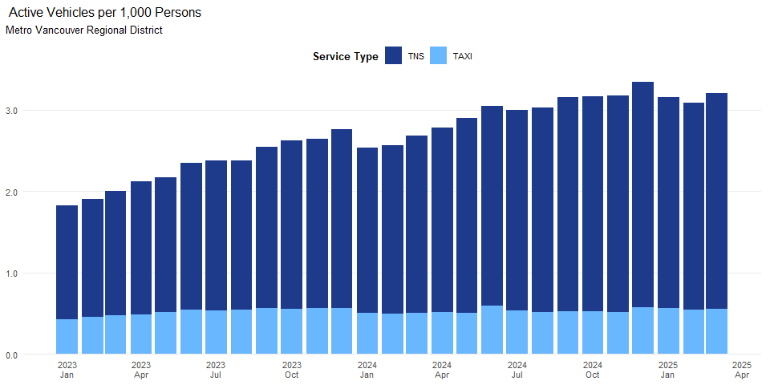
Analysis and Conclusions
In March 2025, Metro Vancouver Regional District had 0.55 active taxi vehicles per 1000 persons. On a year-over-year (YoY) basis, the active taxi vehicles per 1000 persons changed by +10.17%, while year-to-date (YTD), the figure was +10.72% compared to the same period in 2024.
In March 2025, Metro Vancouver Regional District had 2.65 active TNS vehicles per 1000 persons. Compared with March 2024, TNS active vehicles per 1000 persons changed by +21.56% (YoY). Year-to-date through March 2025, the active TNS vehicles per 1000 persons was +23.92% compared to the same period in 2024
Limitations: The number of active vehicles per 1,000 persons does not address the Board’s other examples of accessibility, including accessibility for people with other disabilities or underserved groups and communities. In addition, it does not reflect the reduction in the barriers to inclusion.

Affordability Factor (PN)

Fare for a 5-Kilometre Trip
Primary factor: Affordability
Description: Fare for a 5-kilometre trip reflects the trip revenue that service providers earn during a trip with a length of 5 kilometres.
Measurement: : Fare for a 5-kilometre trip is measured by the median (i.e., the 50th percentile) of the 5-kilometre trip fare distribution in an area over a month from the Trip Database. It is also measured by operating companies’ fares for a 5-kilometer trip in an area over the most recent month. Specifically, for taxi service in an area with a common rate, an operating company’s fare for a 5-kilometre trip is calculated as the common flag rate plus the product of 5 kilometres and the common distance rate. For taxi service in an area without a common rate, an operating company’s fare for a 5-kilometre trip is measured by the median of its 5-kilometre trip fare distribution. For TNS service in any area, an operating company’s fare for a 5-kilometre trip is measured by the median of its 5-kilometre trip fare distribution.
Interpretation: : For some areas, the average distance of trips approximates 5 kilometres in most months. For other areas, a majority of trips are shorter than 5 kilometres in most months. Hence, fare for a 5-kilometre trip can serve as indicators of the affordability of passenger transportation services. In general, a higher fare for a 5-kilometre trip indicates reduced affordability, as it suggests higher costs for passengers. Specifically, if the fare for a 5-kilometre trip increases more rapidly than B.C.’s average hourly wage rate, affordability would decrease as the rising costs outpace the passengers’ ability to pay.
The Board’s public need policy in the Policy Manual lists examples of the affordability factor, which are set out below alongside their corresponding implications on fare for a 5-kilometre trip:
-The proposed service provides more affordable options or services for consumers. -In general, a lower fare for a 5-kilometre trip leads to improved affordability of service. On the other hand, the ratio of fare for a 5-kilometre trip to personal hourly wage rate can more accurately reflect affordability, with a lower ratio indicating better affordability.

Metro Vancouver Regional District Fare for a 5-Kilometre Trip Findings
Table 1: Metro Vancouver Regional District Fare for a 5-Kilometre Trip
Year | Jan | Feb | Mar | Apr | May | Jun | Jul | Aug | Sep | Oct | Nov | Dec
TAXI
2023 | $15.27 | $15.42 | $15.38 | $15.33 | $15.59 | $15.64 | $15.53 | $15.53 | $15.64 | $16.73 | $16.77 | $16.68
2024 | $16.62 | $16.63 | $16.68 | $16.85 | $16.99 | $16.97 | $17.05 | $16.89 | $16.97 | $17.03 | $16.95 | $16.86
2025 | $16.86 | $16.83 | $16.90
TNS
2023 | $14.15 | $14.24 | $14.13 | $14.13 | $14.02 | $14.06 | $14.04 | $14.04 | $13.92 | $13.50 | $13.35 | $13.58
2024 | $13.03 | $11.98 | $12.33 | $12.24 | $12.04 | $11.96 | $12.00 | $12.06 | $12.27 | $12.12 | $12.29 | $11.76
2025 | $11.32 | $11.65 | $11.88
Figure 1: Metro Vancouver Regional District Fare for a 5-Kilometre Trip
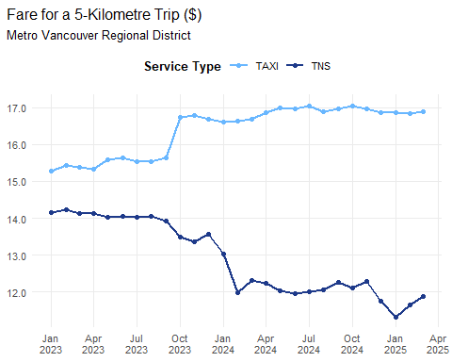
Analysis and Conclusions
In March 2025, Metro Vancouver Regional District recorded a total of $16.9 in fare per 5 km for taxi trips. On a year-over-year (YoY) basis, the fare per 5 km for taxi trips was +1.29%while on a year-to-date (YTD) basis it was +1.33% relative to the same period in 2024.
In March 2025, the Metro Vancouver Regional District recorded a total of $11.88 in fare per 5 km for TNS trips. Compared with March 2024, the fare per 5 km for TNS trips was -3.61% (YoY). Year-to-date through r end_label, the fare per 5 km for TNS trips was -6.64% relative to the same period in 2024.
Limitations: The number of Fare for a 5-Kilometre Trip does not address the Board’s other examples of accessibility, including accessibility for people with other disabilities or underserved groups and communities. In addition, it does not reflect the reduction in the barriers to inclusion.

Year-over-year (YoY) compares September 2024 with September 2023, while year-to-date (YTD) compares the cumulative data from January to September 2024 with the same period in 2023. YoY evaluates specific monthly changes, while YTD assesses trends over a recent period of time.
Statistics Canada. (2024). Table 14-10-0222-01 Employment, average hourly and weekly earnings (including overtime), and average weekly hours for the industrial aggregate excluding unclassified businesses, monthly.

