Economics Report
Table of contents

Introduction

Commencing Investigation
This economics report has been produced pursuant to a Board investigation under section 27 of the Act (Policy Manual). The Board investigation was commenced on August 27, 2024, with respect to application #79999-24.
The Board’s letter of instruction to Senior Economist included the application details, outlined below, along with a request for economic analysis pertaining to the following relevant indicators:
Trip Volume: | ✓
Trip Revenue: | ✓
Number of Wheelchair Accessible Vehicles (WAVs): | ✓
Number of Active Vehicles per 1,000 Persons: | ✓
Fare per Kilometre: | ✓
Wait Time: | ✓
Concentration indices: | ✓
Revenue per Active Vehicle: | ✓
Taxi Fleet Utilization Rate: | ✓
Taxi Vehicle Occupancy Rate: | ✓
Peak-Hour Taxi Vehicle Occupancy Rate: | ✓

Application Details
This report was produced for the Board regarding a new application for a taxi licence.
The applicant is MS Taxi Ltd., which is doing business as MS Taxi. The application summary states the following:
There is a need for an additional taxi company servicing West Vancouver, North Vancouver, Vancouver, and YVR. It will positively affect transportation services. As MS Taxi, we will attract new taxi users that will increase the trip volume of all existing and new companies.
Additional details of the application include:
- Proposed operating area: West Vancouver, North Vancouver, Vancouver, YVR
- Proposed fleet size: 30 (25 Conventional; 5 WAV)

Area of Study
The proposed operating area for this taxi application is mainly within the City of Vancouver, District of West Vancouver, and District of North Vancouver. These municipalities are located in the Greater Vancouver Regional District.
For the purpose of statistical analysis, both taxi and TNS applications are associated with the same Region, as contemplated in the Board’s operating areas policy in the Policy Manual, even though taxi businesses do not generally operate at a regional level.
For taxi applicants, the Region is determined based on where the existing or proposed operating area is located. In this case, this taxi application is located in Region 1. The Regional District is also determined based on where the existing or proposed operating area is located.

Existing Licensees
The Board maintains a database of taxi and TNS licensees approved by the Board and key terms and conditions set by the Board, such as fleets, operating areas, and rates. On a regular basis, this is cross-correlated against a list of active licensees provided by the Registrar of Passenger Transportation (Registrar) at the Ministry of Transportation and Infrastructure (MoTI). The Board refers to this database as the “single source of licensee data” or SSOLD. Based on the SSOLD, last updated on September 30, 2024, the following relevant information can be observed about the existing licensees in the area:
- At the municipal level,
  - Number of taxi licensees operating: 8
  - Combined Board-approved maximum fleet size: 1,226
- At the Regional District level,
  - Number of taxi licensees operating: 29
  - Combined Board-approved maximum fleet size: 2,420
- At the Region level,
  - Number of taxi licensees operating: 44
  - Combined Board-approved maximum fleet size: 2,646

Background

Section 28 Criteria
Under section 28(1) of the Act, the Board must consider the following factors when determining applications:
-Whether the applicant is fit, proper, and capable of providing the service applied for (threshold test); -Whether there is a public need for the service; and -Whether the application would promote sound economic conditions in the B.C. passenger transportation business.
This economics report provides the Board with data analysis pertaining only to the “public need” (PN) and “sound economic conditions” (SEC) criteria. It does not speak to the fit, proper, and capable criteria.

PN and SEC Factors
The Board’s Policy Manual provides information on the factors the Board may consider when determining PN and SEC. This economics report will focus on the underlying PN and SEC factors for the Board’s consideration in determining whether PN and SEC exist. For clarity, this economics report does not determine whether PN and SEC exist.
Under the public need policy in the Policy Manual, PN is divided into the following factors:
- Demand
- Accessibility
- Affordability
- Safety
- Service Quality
Under the sound economic conditions policy in the Policy Manual, SEC is divided into the following factors:
- Sustainability
- Competition
- Innovation
- Variety
This economics report examines key indicators of the taxi and TNS sectors in B.C. Each indicator is identified with a primary PN or SEC factor, as indicated in the following chart:
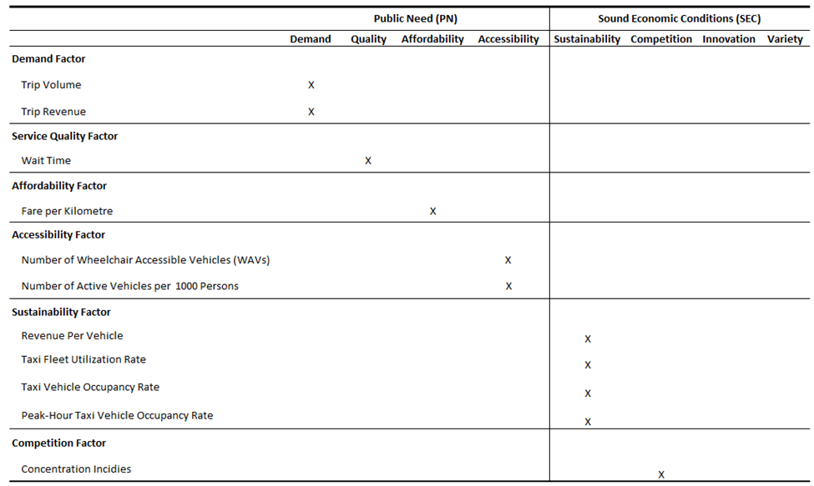
Please note that this economics report does not provide an analysis of the “innovation” or “variety” factors under SEC.

Report Constraints
Under section 28(5) of the Act and the terms and conditions of licence, special authorization licences, including taxi and TNS, are required to submit trip data. The Board has established data requirements outlining the type of trip data that must be submitted. Trip data is submitted by licensees to the Registrar through the Vehicle Safety BC Portal (the Trip Database), also known as the “data warehouse”.
Since only the taxi and TNS sectors are required to report trip data under the data requirements, these are the only sectors eligible for an economics report at this time.
Due to data limitations, only two regions will be analyzed:
- Region 1 – Lower Mainland including Whistler; and,
- Region 2 – Capital Regional District (CRD).
Regional Districts within these Regions may be analyzed so long as there is adequate data reliability for those Regional Districts.
At this time, three other regions will not be included in this economics report due to insufficient data coverage, poor data quality, or unreliable trip data submissions: Region 3 (Vancouver Island excluding CRD); Region 4 (Interior); and, Region 5 (Northern B.C. and other).

Qualifications
This economics report was authored by the Board’s Senior Economist, Peter Tseng, who is ultimately responsible for the analysis contained in this report.
Peter Tseng has over a decade of experience in economic analytics, policy evaluation, and statistical reporting. He holds a Ph.D. in Economics from the University of Victoria and has held senior roles with the BC Public Service, including at the Ministry of Finance and Ministry of Health.

Factors and Their Indicators
All analyses in this report are based on data from the Trip Database unless otherwise specified. Technical details of each indicator can be found in Appendix 1.

Demand Factor (PN)

Trip Volume
Primary Factor: Demand
Description: Trip volume represents, in real terms, the observed quantities demanded for trip services, reflecting the equilibrium between passenger demand and industry supply.
Measurement: Trip volume is calculated as the number of completed trips reported to the Trip Database in an area over a month.
Interpretation: Increases in taxi trip volume or TNS trip volume indicate growth in the quantity demanded in the respective markets. Moreover, a shift in trip volume from the taxi sector to the TNS sector suggests evolving consumer preferences and competition between the two types of partially substitutable services.
It is helpful to note that while taxis and TNS are similar, they are not the same. This means that taxis and TNS, while partially interchangeable, ultimately serve distinct consumer needs and preferences, reflecting their roles as separate yet complementary services in the transportation market. Any higher combined volume of taxi and TNS trips can result from offering passengers greater choice, not the inherent superiority of one service over the other.
The Board’s public need policy in the Policy Manual lists examples of the demand factor, which are set out below alongside their corresponding implications on trip volume: - There are people who require access to, or are seeking access to, or would likely access a new, expanded, or improved passenger transportation service. - When the proposed service fulfills previously unmet demand and brings new users into the market, it will result in an overall increase in trip volume. - The increase can only be evident after the proposed service is introduced. However, historical trends can provide valuable indications. For example, a steady increase in trip volume over time can signal a growing demand for the taxi or TNS services, suggesting potential usage for the proposed service.
There are people who would use the proposed service:
- If the proposed service attracts current users of taxis or TNS, it will result in a redistribution of market share measured by trip volume among existing providers.
- The redistribution can only be evident after the proposed service is introduced. However, historical trends can provide indications. For example, ongoing shifts in market share of sectors can indicate changes in customer preference.

Metro Vancouver Regional District Trip Volume Findings
Table 1: Metro Vancouver Regional District Trip Volume
Year | Jan | Feb | Mar | Apr | May | Jun | Jul | Aug | Sep | Oct | Nov | Dec
TAXI
2023 | 441,482 | 450,939 | 488,784 | 493,952 | 528,744 | 542,318 | 543,881 | 545,957 | 559,961 | 528,953 | 507,762 | 524,518
2024 | 492,046 | 451,361 | 493,157 | 488,383 | 502,567 | 528,430 | 494,078 | 471,421 | 466,124 | 464,431 | 465,795 | 498,143
2025 | 444,985 | 447,222 | 487,384 | 476,773 | 507,063 | 480,583 | 486,849 | 476,078 | 463,459 | 467,403 | 289,516
TNS
2023 | 1,501,486 | 1,442,653 | 1,632,531 | 1,782,845 | 1,803,991 | 1,903,989 | 2,062,898 | 2,019,125 | 2,042,966 | 2,200,489 | 2,081,708 | 2,309,909
2024 | 2,215,703 | 2,124,238 | 2,408,851 | 2,412,175 | 2,642,415 | 2,677,046 | 2,773,596 | 2,796,026 | 2,684,928 | 2,551,823 | 2,441,272 | 2,791,114
2025 | 2,475,193 | 2,417,966 | 2,619,607 | 2,755,574 | 3,061,178 | 3,027,388 | 3,231,939 | 3,092,951 | 2,628,551 | 3,120,650 | 2,335,582
Figure 1: Metro Vancouver Regional District Trip Volume
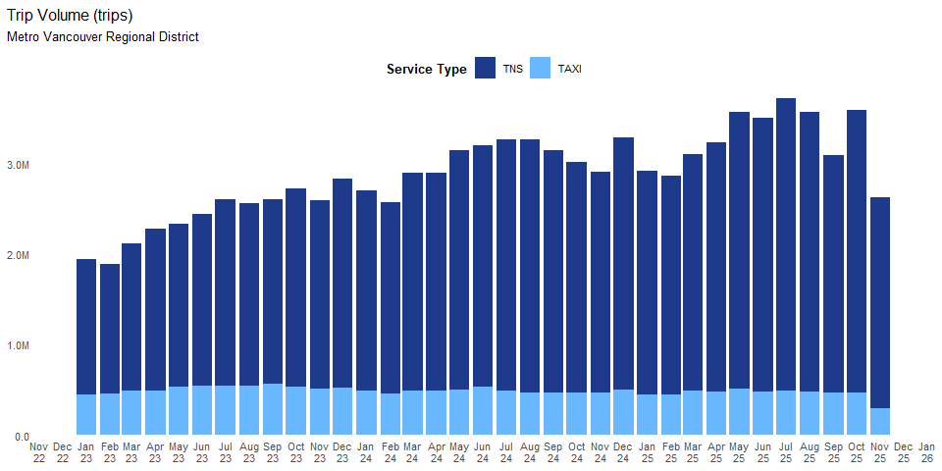
Analysis and Conclusions
In November 2025, Metro Vancouver Regional District saw a total of 289,516 taxi trips. On a year-over-year (YoY) basis, the total taxi trip volume was -37.84%, while on a year-to-date (YTD) basis it was -5.46%. relative to the same period in 2024. These results indicate strong momentum in demand for TAXI services in the region. On a month-over-month (MoM) basis, taxi trip volume was-38.06%. Looking over the past two years, statistical analysis of the long-term trend suggests that there is no meaningful change in direction. Statistical analysis of the short-term trend suggests that there is downward shift in market direction.
In November 2025, Metro Vancouver Regional District recorded 2,335,582 TNS trips. Compared with November 2024, TNS trip volume was -4.33% (YoY). Year-to-date through November 2025, TNS trip volume was +10.96% relative to the same period in 2024. These results indicate strong momentum in demand for TNS services in the region. On a month-over-month (MoM) basis, TNS trip volume was -25.16%. Looking over the past two years, statistical analysis of the long-term trend suggests that a upward trajectory is evident. Statistical analysis of the short-term trend suggests that there is downward shift in market direction.
Limitations. Quantity demanded does not equate to demand. Quantity demanded refers to the actual number of trips observed, whereas demand includes all potential trips if there were no constraints. There can still be unmet demand due to limited vehicle availability preventing some customers from using the service.

Trip Revenue
Primary Factor: Demand
Description:Trip revenue represents, in nominal terms, the observed quantities demanded for trip services, reflecting the equilibrium between passenger demand and industry supply.
Measurement:Trip revenue is calculated as the total fare amount of all completed trips reported to the Trip Database in an area over a month.
Interpretations:Increases in taxi trip revenue or TNS trip revenue indicate growth of quantity demanded in the respective markets. Moreover, a shift in trip revenue from the taxi sector to the TNS sector can signify a structural change in market dynamics, suggesting evolving consumer preferences or competition between the two types of partially substitutable services.
As stated previously, it is helpful to note that although taxis and TNS are similar, they are not the same. Taxis and TNS, while partially interchangeable, ultimately serve distinct consumer needs and preferences, reflecting their roles as separate yet complementary services in the transportation market. Any higher combined revenue of taxi and TNS trips can result from offering passengers greater choice, not the inherent superiority of one service over the other.
Policy Context: Public Need and Demand Factor
The Board’s Public Need Policy in the Policy Manual lists examples of the demand factor, which are set out below alongside their corresponding implications on trip revenue:
- There are people who would use the proposed service.
There are people who require access to, or are seeking access to, or would likely access a new, expanded, or improved passenger transportation service.
  - If the proposed service attracts current taxi or TNS users, it will result in a redistribution of market share as measured by trip revenue among existing providers.
  - The redistribution can only be observed after the proposed service is introduced. However, historical trends can provide valuable indications. For instance, ongoing shifts in market shares of sectors can indicate changes in customer preference.

Metro Vancouver Regional District Trip Revenue Findings
Table 2: Metro Vancouver Regional District Trip Revenue(thousands of dollars)
Year | Jan | Feb | Mar | Apr | May | Jun | Jul | Aug | Sep | Oct | Nov | Dec
TAXI
2023 | 441,482 | 450,939 | 488,784 | 493,952 | 528,744 | 542,318 | 543,881 | 545,957 | 559,961 | 528,953 | 507,762 | 524,518
2024 | 492,046 | 451,361 | 493,157 | 488,383 | 502,567 | 528,430 | 494,078 | 471,421 | 466,124 | 464,431 | 465,795 | 498,143
2025 | 444,985 | 447,222 | 487,384 | 476,773 | 507,063 | 480,583 | 486,849 | 476,078 | 463,459 | 467,403 | 289,516
TNS
2023 | 1,501,486 | 1,442,653 | 1,632,531 | 1,782,845 | 1,803,991 | 1,903,989 | 2,062,898 | 2,019,125 | 2,042,966 | 2,200,489 | 2,081,708 | 2,309,909
2024 | 2,215,703 | 2,124,238 | 2,408,851 | 2,412,175 | 2,642,415 | 2,677,046 | 2,773,596 | 2,796,026 | 2,684,928 | 2,551,823 | 2,441,272 | 2,791,114
2025 | 2,475,193 | 2,417,966 | 2,619,607 | 2,755,574 | 3,061,178 | 3,027,388 | 3,231,939 | 3,092,951 | 2,628,551 | 3,120,650 | 2,335,582
Figure 2: Metro Vancouver Regional District Trip Revenue
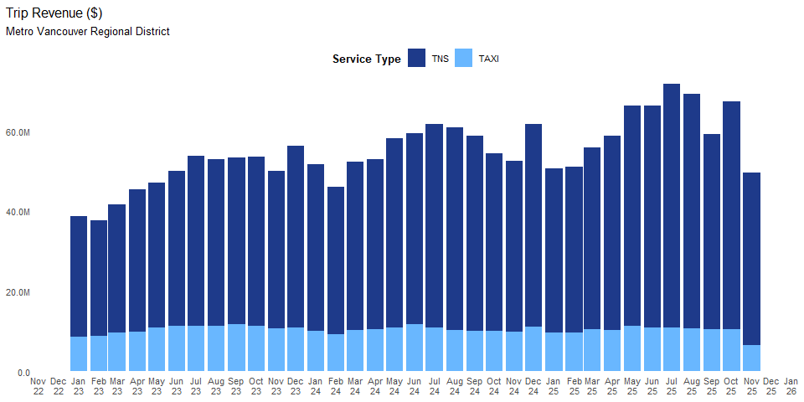
Analysis and Conclusions
In November 2025, Metro Vancouver Regional District saw a total of $6,558,869 taxi trips revenue. On a year-over-year (YoY) basis, the total taxi trip revenue was -33.90%, while on a year-to-date (YTD) basis it was -2.36%. relative to the same period in 2024. These results indicate strong momentum in demand for TAXI services in the region. On a month-over-month (MoM) basis, taxi trip revenue was -37.08%. Looking over the past two years, statistical analysis of the long-term trend suggests that there is no meaningful change in direction. Statistical analysis of the short-term trend suggests that there is downward shift in market direction.
In November 2025, Metro Vancouver Regional District recorded $42,985,969 TNS trips. Compared with November 2024, TNS trip revenue was +0.61% (YoY). Year-to-date through November 2025, TNS trip revenue was +12.03% relative to the same period in 2024. These results indicate strong momentum in demand for TNS services in the region. On a month-over-month (MoM) basis, TNS trip revenue was -24.44%. Looking over the past two years, statistical analysis of the long-term trend suggests that a upward trajectory is evident. Statistical analysis of the short-term trend suggests that there is downward shift in market direction.
Limitations: Quantity demanded does not amount to demand. Quantity demanded refers to the actual trip revenue observed, whereas demand includes all potential trip revenue if there are no constraints. There can still be unmet demand due to limited vehicle availability preventing some customers from using the service.

Accessibility Factor (PN)

Number of Wheelchair Accessible Vehicles
Primary Factor: Accessibility
Description:The number of wheelchair accessible vehicles can be further divided into two sub-metrics: (1) the number of active wheelchair accessible vehicles and (2) the number of active wheelchair accessible vehicles providing at least one accessible trip. The number of active wheelchair accessible vehicles (WAVs) refers to the total number of vehicles equipped to accommodate passengers who use wheelchairs and that have been in operation in an area over a month. On the other hand, the number of active wheelchair accessible vehicles (WAVs) providing at least one accessible trip refers to the number of active WAVs that have recorded at least one accessible trip in the Trip Database.
Measurement: The number of active WAVs is determined by cross-referencing the list of WAVs reported to the Registrar’s Office during licence renewal with the list of active vehicles (which may not necessarily have provided accessible trips) reported to the Trip Database. Then, the number of active wheelchair accessible vehicles providing at least one accessible trip is determined by limiting the list of active WAVs to those reported as having provided accessible trips. Both metrics can be further normalized per 1,000 persons to indicate their growth relative to the population.
Interpretations: The number of active WAVs indicates the accessibility and inclusiveness of passenger transportation services for individuals who use wheelchairs. Generally, a higher number of active WAVs, especially compared to growth in overall demand (proxied by the number of WAVs per 1,000 persons), indicates a greater level of availability for these individuals. A lack of growth in the number of WAVs (both sub-metrics) would indicate suppliers’ unwillingness to match the demand, potentially due to the high costs associated with WAVs.
The Board’s public need policy in the Policy Manual lists examples of the accessibility factor, which are set out below alongside their corresponding implications on the number of active wheelchair vehicles:
- The proposed service provides more or improved service to persons with mobility disabilities, including WAVs.
-There are people who require access to, or are seeking access to, or would likely access a new, expanded, or improved passenger transportation service.
  - The number of WAVs on the road directly and positively correlates with the extent and quality of service provided to individuals with mobility disabilities.

Metro Vancouver Regional District Number of Wheelchair Accessible Vehicles Findings
Table 3: Metro Vancouver Regional District Number of Active Wheelchair Accessible Vehicles
Year | Jan | Feb | Mar | Apr | May | Jun | Jul | Aug | Sep | Oct | Nov | Dec
TAXI
2023 | 218 | 230 | 244 | 245 | 257 | 273 | 271 | 290 | 303 | 312 | 310 | 306
2024 | 304 | 303 | 302 | 315 | 313 | 324 | 325 | 326 | 327 | 321 | 317 | 321
2025 | 324 | 310 | 308 | 313 | 318 | 312 | 321 | 308 | 312 | 317 | 272
Table 4: Metro Vancouver Regional District Number of Active Wheelchair Accessible Vehicles Providing at Least One Accessible Trip
Year | Jan | Feb | Mar | Apr | May | Jun | Jul | Aug | Sep | Oct | Nov | Dec
TAXI
2023 | 181 | 190 | 212 | 209 | 222 | 234 | 235 | 237 | 230 | 235 | 239 | 247
2024 | 251 | 239 | 248 | 255 | 266 | 275 | 286 | 278 | 282 | 275 | 265 | 277
2025 | 269 | 269 | 265 | 275 | 279 | 272 | 281 | 272 | 278 | 281 | 240
Figure 3: Metro Vancouver Regional District Trip Volume
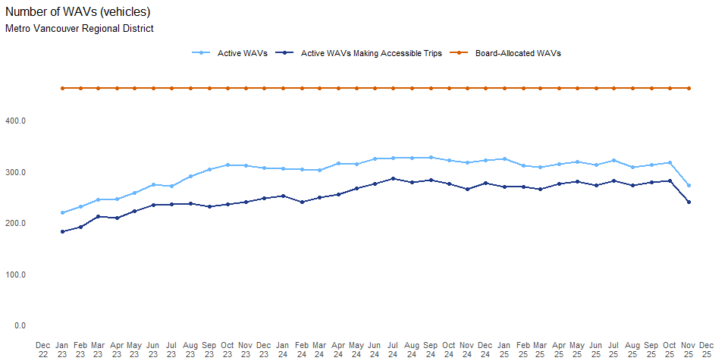
Analysis and Conclusions
In November 2025, Metro Vancouver Regional District recorded a total of active WAVs. On a year-over-year (YoY) basis, the number of active WAVs in the taxi fleet was while on a year-to-date (YTD) basis it was relative to the same period in 2024. On a month-over-month (MoM) basis, the number of active WAVs in the taxi fleet changed by . However, the number of active WAVs remained below the Board’s approved WAVs (462 vehicles in November 2025), indicating that the full potential utilization of approved WAVs in this area had yet to be realized. NA NA
In November 2025, Metro Vancouver Regional District recorded a total of 240 active WAVs providing accessible trips. On a year-over-year (YoY) basis, the number of active WAVs providing accessible trips was -9.43%, while on a year-to-date (YTD) basis it was +2.09% relative to the same period in 2024. On a month-over-month (MoM) basis, the number of active WAVs providing accessible trips changed by -14.59%. Looking over the past two years, statistical analysis of the long-term trend suggests that a upward trajectory is evident. Statistical analysis of the short-term trend suggests that there is downward shift in market direction.
Limitations: The number of active WAVs does not capture the Board’s other aspects of accessibility, including accessibility for persons with other disabilities, overall availability of services, essential service levels, service to underserved groups or communities, and inclusion.

Number of Active Vehicles per 1,000 Persons
Primary Factor: Accessibility
Description: The number of active vehicles per 1,000 persons represents the total number of vehicles serving every 1,000 persons in an area over a month.
Measurement: The number of active vehicles per 1,000 persons is calculated as the ratio of the total number of active vehicles (including both taxis and TNS) in an area relative to its population, normalized to a per 1,000 persons basis.
Interpretation: A higher number of active vehicles per 1,000 persons indicates higher accessibility to services in the area, as more taxis and TNS vehicles are available to serve every 1,000 persons.
Policy Context: Public Need and Accessibility Factor
The Board’s Public Need Policy in the Policy Manual lists examples of the accessibility factor, which are set out below alongside their corresponding implications on the number of active vehicles per 1,000 persons:
-The proposed service enhances availability of passenger transportation services to everyone in the province, including in low-density areas, such as rural and remote communities. -A higher number of active vehicles per 1,000 persons directly and positively correlates with greater service availability. -The number of vehicles per 1,000 persons in low-density areas provides an area-specific assessment of overall service availability.

Metro Vancouver Regional District Active Vehicles per 1,000 Persons Findings
Table 7: Metro Vancouver Regional District Active Vehicles per 1,000 Persons
Year | Jan | Feb | Mar | Apr | May | Jun | Jul | Aug | Sep | Oct | Nov | Dec
TAXI
2023 | 0.42 | 0.46 | 0.47 | 0.49 | 0.51 | 0.54 | 0.53 | 0.54 | 0.57 | 0.55 | 0.57 | 0.56
2024 | 0.50 | 0.49 | 0.50 | 0.51 | 0.50 | 0.59 | 0.54 | 0.52 | 0.53 | 0.52 | 0.51 | 0.57
2025 | 0.57 | 0.54 | 0.55 | 0.58 | 0.59 | 0.58 | 0.58 | 0.57 | 0.58 | 0.57 | 0.42
TNS
2023 | 1.40 | 1.45 | 1.53 | 1.63 | 1.66 | 1.80 | 1.85 | 1.83 | 1.98 | 2.08 | 2.08 | 2.20
2024 | 2.03 | 2.07 | 2.18 | 2.27 | 2.39 | 2.45 | 2.46 | 2.51 | 2.63 | 2.65 | 2.66 | 2.77
2025 | 2.59 | 2.54 | 2.65 | 2.78 | 2.88 | 2.92 | 2.97 | 2.99 | 3.07 | 3.15 | 2.90
Note: The above table reports the number of active vehicles per 1,000 persons up to the most recent year for which annual population data is available from Statistics Canada. As of October 2024, the most recent data available is up to 2023.[^4] [^4]: Statistics Canada. (2024). Table 17-10-0152-01 Population estimates, July 1, by census division, 2021 boundaries.https://www150.statcan.gc.ca/t1/tbl1/en/tv.action?pid=1710015201
Figure 4: Metro Vancouver Regional District Active Vehicles per 1,000 Persons
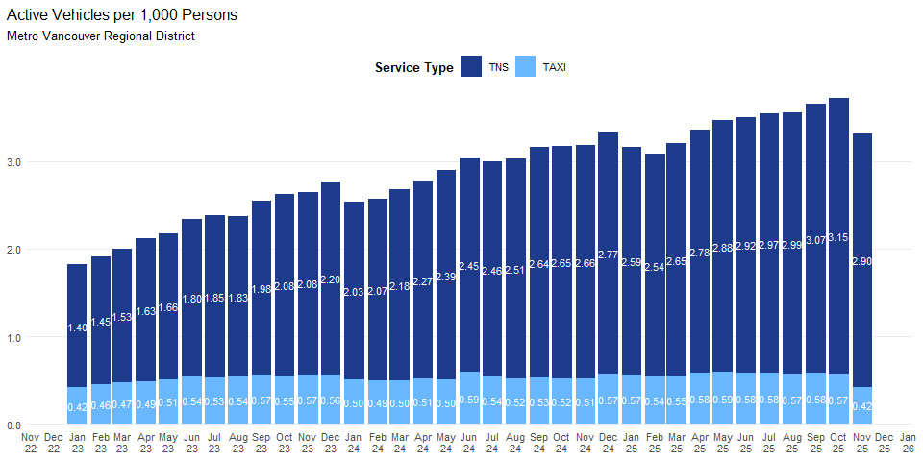
Analysis and Conclusions
In November 2025, Metro Vancouver Regional District had 0.42 active taxi vehicles per 1000 persons. On a year-over-year (YoY) basis, the active taxi vehicles per 1000 persons changed by -17.93%, while year-to-date (YTD), the figure was +7.23% compared to the same period in 2024. On a month-over-month (MoM) basis, the active taxi vehicles per 1000 persons changed by -26.31%. Looking over the past two years, statistical analysis of the long-term trend suggests that a upward trajectory is evident. Statistical analysis of the short-term trend suggests that there is downward shift in market direction.
In November 2025, Metro Vancouver Regional District had 2.9 active TNS vehicles per 1000 persons. Compared with November 2024, TNS active vehicles per 1000 persons changed by +8.73% (YoY). Year-to-date through November 2025, the active TNS vehicles per 1000 persons was +19.42% compared to the same period in 2024. On a month-over-month (MoM) basis, the active TNS vehicles per 1000 persons changed by -7.94%. Looking over the past two years, statistical analysis of the long-term trend suggests that a upward trajectory is evident. Statistical analysis of the short-term trend suggests that there is downward shift in market direction.
Limitations: The number of active vehicles per 1,000 persons does not address the Board’s other examples of accessibility, including accessibility for people with other disabilities or underserved groups and communities. In addition, it does not reflect the reduction in the barriers to inclusion.

Affordability Factor (PN)

Fare for a 5-Kilometre Trip
Primary factor: Affordability
Description: Fare for a 5-kilometre trip reflects the trip revenue that service providers earn during a trip with a length of 5 kilometres.
Measurement: : Fare for a 5-kilometre trip is measured by the median (i.e., the 50th percentile) of the 5-kilometre trip fare distribution in an area over a month from the Trip Database. It is also measured by operating companies’ fares for a 5-kilometer trip in an area over the most recent month. Specifically, for taxi service in an area with a common rate, an operating company’s fare for a 5-kilometre trip is calculated as the common flag rate plus the product of 5 kilometres and the common distance rate. For taxi service in an area without a common rate, an operating company’s fare for a 5-kilometre trip is measured by the median of its 5-kilometre trip fare distribution. For TNS service in any area, an operating company’s fare for a 5-kilometre trip is measured by the median of its 5-kilometre trip fare distribution.
Interpretation: : For some areas, the average distance of trips approximates 5 kilometres in most months. For other areas, a majority of trips are shorter than 5 kilometres in most months. Hence, fare for a 5-kilometre trip can serve as indicators of the affordability of passenger transportation services. In general, a higher fare for a 5-kilometre trip indicates reduced affordability, as it suggests higher costs for passengers. Specifically, if the fare for a 5-kilometre trip increases more rapidly than B.C.’s average hourly wage rate, affordability would decrease as the rising costs outpace the passengers’ ability to pay.
The Board’s public need policy in the Policy Manual lists examples of the affordability factor, which are set out below alongside their corresponding implications on fare for a 5-kilometre trip:
- The proposed service provides more affordable options or services for consumers.
  - In general, a lower fare for a 5-kilometre trip leads to improved affordability of service. On the other hand, the ratio of fare for a 5-kilometre trip to personal hourly wage rate can more accurately reflect affordability, with a lower ratio indicating better affordability.

Metro Vancouver Regional District Fare for a 5-Kilometre Trip Findings
Table 8: Metro Vancouver Regional District Fare for a 5-Kilometre Trip
Year | Jan | Feb | Mar | Apr | May | Jun | Jul | Aug | Sep | Oct | Nov | Dec
TAXI
2023 | $15.27 | $15.42 | $15.38 | $15.33 | $15.59 | $15.64 | $15.53 | $15.53 | $15.64 | $16.73 | $16.77 | $16.68
2024 | $16.61 | $16.63 | $16.68 | $16.85 | $16.99 | $16.97 | $17.05 | $16.89 | $16.97 | $17.05 | $16.95 | $16.86
2025 | $16.88 | $16.83 | $16.90 | $17.09 | $17.15 | $17.30 | $17.29 | $17.20 | $17.30 | $17.34 | $17.17
TNS
2023 | $14.15 | $14.24 | $14.13 | $14.13 | $14.02 | $14.06 | $14.04 | $14.04 | $13.92 | $13.50 | $13.35 | $13.58
2024 | $13.03 | $11.98 | $12.33 | $12.24 | $12.04 | $11.96 | $12.00 | $12.06 | $12.27 | $12.12 | $12.29 | $11.76
2025 | $11.32 | $11.65 | $11.88 | $11.89 | $12.09 | $12.16 | $12.28 | $12.40 | $12.43 | $12.49 | $12.67
Figure 5: Metro Vancouver Regional District Fare for a 5-Kilometre Trips
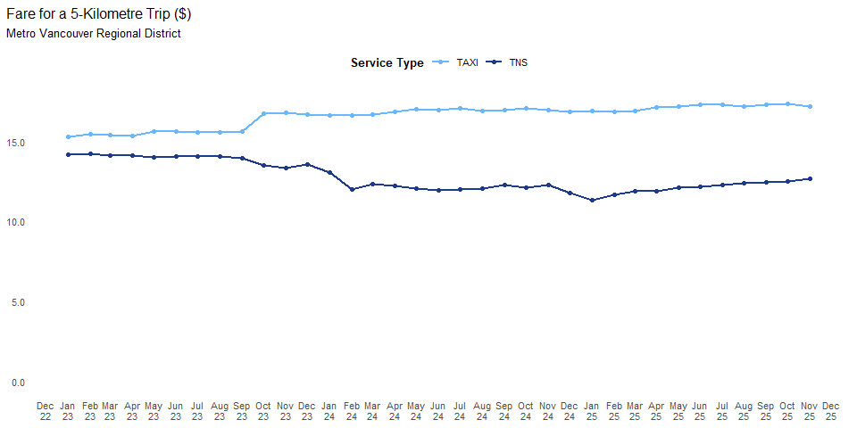
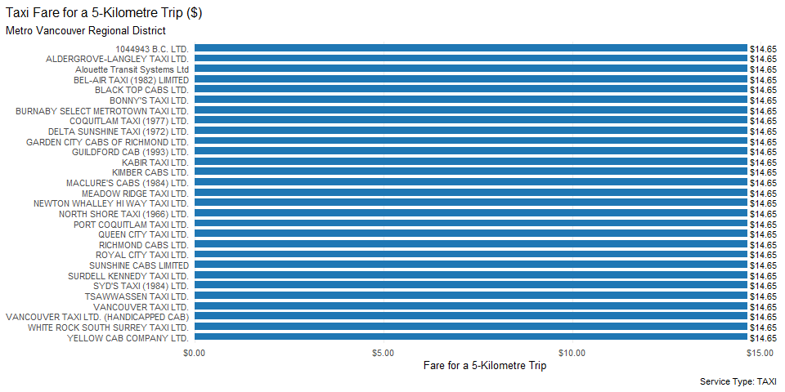
Analysis and Conclusions
In November 2025, Metro Vancouver Regional District recorded a total of $17.17 in fare per 5 km for taxi trips. On a year-over-year (YoY) basis, the fare per 5 km for taxi trips was +1.25%while on a year-to-date (YTD) basis it was +1.51% relative to the same period in 2024.On a month-over-month (MoM) basis, the fare per 5 km for taxi trips changed by -1.02%. Looking over the past two years, statistical analysis of the long-term trend suggests that there is no meaningful change in direction. Statistical analysis of the short-term trend suggests that there is no active shift in market direction.
In November 2025, the Metro Vancouver Regional District recorded a total of $12.67 in fare per 5 km for TNS trips. Compared with November 2024, the fare per 5 km for TNS trips was +3.07% (YoY). Year-to-date through r end_label, the fare per 5 km for TNS trips was -0.77% relative to the same period in 2024. On a month-over-month (MoM) basis, the fare per 5 km for TNS trips changed by +1.41%. Looking over the past two years, statistical analysis of the long-term trend suggests that there is no meaningful change in direction. Statistical analysis of the short-term trend suggests that there is no active shift in market direction.
Limitations: The number of Fare for a 5-Kilometre Trip does not address the Board’s other examples of accessibility, including accessibility for people with other disabilities or underserved groups and communities. In addition, it does not reflect the reduction in the barriers to inclusion.

Safety Factor (PN)
There is no analysis related to this factor.

Service Quality Factor (PN)

Wait Time
Primary Factor: Service Quality
Description: Wait time reflects the duration passengers wait for vehicles to arrive for pick up.
Measurement: Wait time for each trip is calculated as the difference between the pick-up arrival time and the hail time. Wait time is measured by the median (i.e., the 50th percentile) of the monthly wait time distribution in an area, and different percentiles of the monthly wait time distribution are also calculated.
Interpretation: Wait time serves as an indicator of the quality of passenger transportation services. It acts as a market-clearing variable, influenced by factors such as demand, supply, and the efficiency of the technology used to match passengers with vehicles. A longer wait time indicates reduced service quality, as it suggests longer delays for passengers and higher operating costs for licensees.
Policy Context: Public Need and Accessibility Factor
The Board’s Public Need Policy in the Policy Manual lists examples of the service quality factor, which are set out below alongside their corresponding implications on wait times:
- The proposed service provides more or improved service where there is currently inadequate service.
  - A long wait time suggests an inadequate level of service supplied.
- The proposed service provides more reliable service.
  - Consistent short wait times suggest that the service is reliable.
  - Significant changes in wait times can suggest that the service is not reliable.
  - Consistently long wait times suggest that the service is not reliable.
- The proposed service encourages more efficient service to the public, including trip speed.
  - A long wait time suggests an inadequate level of service supplied.
- The proposed service provides a service that is comfortable and convenient.
  - A short wait time contributes to a more comfortable and convenient service.
  - The proposed service supports better customer service and customer satisfaction. A short wait time contributes to better customer service and customer satisfaction.

Metro Vancouver Regional District Wait Time Findings
Table 9: Metro Vancouver Regional District Wait Time (minutes)
Year | Jan | Feb | Mar | Apr | May | Jun | Jul | Aug | Sep | Oct | Nov | Dec
TAXI
2023 | 4.63 | 4.77 | 4.67 | 4.88 | 4.90 | 5.07 | 4.93 | 4.98 | 5.23 | 4.98 | 4.93 | 4.92
2024 | 4.93 | 4.70 | 4.73 | 4.83 | 4.88 | 5.00 | 4.88 | 4.77 | 4.85 | 4.82 | 4.77 | 5.07
2025 | 4.97 | 4.95 | 4.83 | 4.97 | 5.00 | 5.05 | 5.03 | 5.03 | 5.07 | 5.08 | 4.90
TNS
2023 | 4.87 | 4.77 | 4.32 | 5.08 | 5.20 | 4.88 | 5.17 | 5.03 | 4.90 | 4.15 | 4.62 | 4.78
2024 | 4.90 | 4.48 | 4.43 | 4.73 | 4.73 | 4.78 | 5.13 | 4.78 | 4.62 | 4.47 | 4.78 | 5.23
2025 | 4.27 | 5.07 | 4.25 | 4.23 | 4.27 | 4.48 | 4.77 | 4.55 | 4.03 | 4.05 | 3.77
Figure 6: Metro Vancouver Regional District Wait Time (minutes)
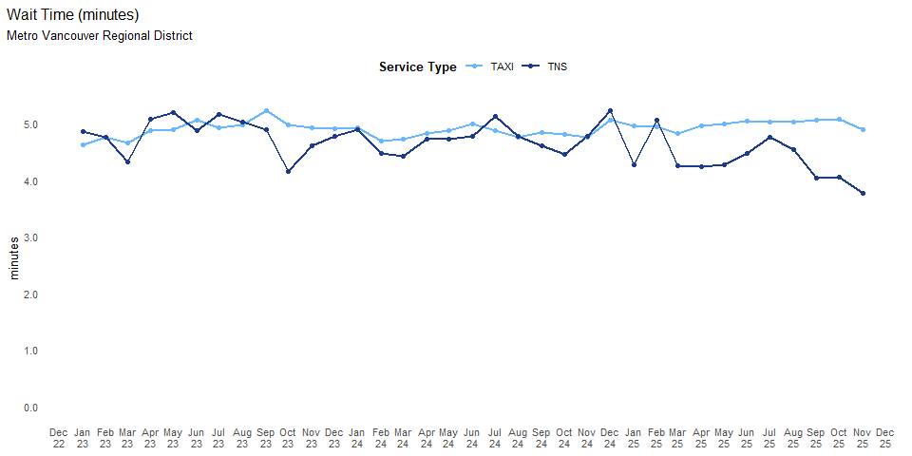
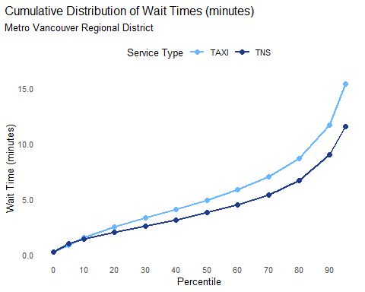
Analysis and Conclusions
In November 2025, Metro Vancouver Regional District recorded a total of 4.9 min in wait time for taxi trips. On a year-over-year (YoY) basis, the wait time for taxi trips was +2.80%while on a year-to-date (YTD) basis it was +3.23% relative to the same period in 2024.On a month-over-month (MoM) basis, taxi wait time changed by -3.61%. Looking over the past two years, statistical analysis of the long-term trend suggests that there is no meaningful change in direction. Statistical analysis of the short-term trend suggests that there is no active shift in market direction.
In November 2025, the Metro Vancouver Regional District recorded a total of 3.8 min in wait time for TNS trips. Compared with November 2024, the wait time for TNS trips was -21.25% (YoY). Year-to-date through r end_label, the wait time for TNS trips was -7.94% relative to the same period in 2024. On a month-over-month (MoM) basis, TNS wait time changed by -7.00%. Looking over the past two years, statistical analysis of the long-term trend suggests that a downward trajectory is evident. Statistical analysis of the short-term trend suggests that there is no active shift in market direction.
Limitations: In calculating the median wait time, trips with unreasonably long wait times due to data errors were not included. Extreme outlier wait times are not reported in the figure on cumulative distribution as they are unusually long, which may be due to data errors.

Innovation Factor (SEC)
There is no analysis related to this factor.

Sustainability Factor (SEC)

Revenue per Active Vehicle
Primary Factor: Sustainability
Description: Revenue per active vehicle measures the amount of revenue generated by each vehicle that was in operation in a given area during the reporting period.
Measurement: Revenue per active vehicle is calculated as the median (50th percentile) of the revenue-per-active-vehicle distribution in an area over a month.
Interpretation: Higher revenue per active vehicle supports the industry’s sustainability by ensuring each vehicle generates more gross income.
Policy Context: Public Need and Accessibility Factor
The Board’s sound economic conditions policy in the Policy Manual lists examples of the sustainability factor, which are set out below alongside their corresponding implications on revenue per active vehicle:
- The proposed service promotes long-term stability for the passenger transportation industry. -Assuming fixed costs, high and stable revenue per active vehicle implies high and stable profits, thus promoting long-term stability for the industry.
- The proposed service encourages resiliency in the passenger transportation industry. -Assuming fixed costs, high and stable revenue per active vehicle implies high and stable profits, thus encouraging industry resilience.
- The proposed service minimizes significant market disruption. -Assuming fixed costs, stable or gradually increasing revenue per active vehicle in the taxi sector indicates a lack of rapid disruption.
- The proposed service promotes overall profitability and economic sustainability of the industry. -Assuming fixed costs, stable or gradually increasing revenue per active vehicle in the taxi sector indicates overall profitability and economic sustainability for the industry.

Metro Vancouver Regional District Revenue per Active Vehicle Findings
Table 10: Metro Vancouver Regional District Revenue per Active Vehicle
Year | Jan | Feb | Mar | Apr | May | Jun | Jul | Aug | Sep | Oct | Nov | Dec
TAXI
2023 | $4,583.97 | $4,666.92 | $4,936.14 | $4,931.91 | $4,484.03 | $5,226.88 | $5,197.57 | $5,129.72 | $5,225.30 | $5,054.11 | $4,747.51 | $4,901.19
2024 | $4,524.58 | $4,122.23 | $4,569.47 | $4,475.29 | $4,679.93 | $4,952.96 | $4,591.38 | $4,421.76 | $4,303.19 | $4,319.88 | $4,260.96 | $4,609.21
2025 | $4,038.47 | $4,105.83 | $4,446.65 | $4,364.69 | $4,695.14 | $4,619.54 | $4,640.45 | $4,579.21 | $4,400.98 | $4,333.02 | $3,257.15
TNS
2023 | $3,311.18 | $3,343.23 | $3,419.51 | $3,706.26 | $3,660.65 | $3,687.38 | $3,937.15 | $3,850.20 | $3,656.84 | $3,555.19 | $3,281.52 | $3,537.65
2024 | $3,152.10 | $2,961.79 | $3,231.31 | $3,212.14 | $3,408.21 | $3,400.55 | $3,555.79 | $3,435.75 | $3,200.10 | $2,925.27 | $2,788.10 | $3,179.80
2025 | $2,623.94 | $2,808.85 | $2,992.46 | $3,101.70 | $3,398.58 | $3,399.85 | $3,665.71 | $3,496.25 | $2,858.02 | $3,286.80 | $2,548.30
Figure 7: Metro Vancouver Regional District Revenue per Active Vehicle
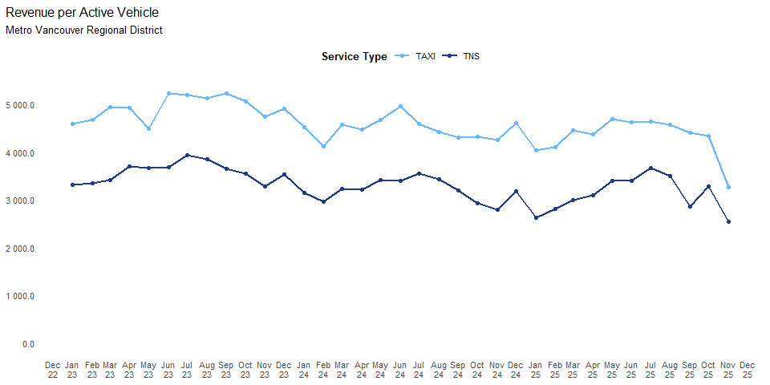
Analysis and Conclusions
In November 2025, Metro Vancouver Regional District recorded a total of $3,257 in revenue per active vehicle for taxi trips. On a year-over-year (YoY) basis, the revenue per active vehicle for taxi trips was -23.56%while on a year-to-date (YTD) basis it was -3.54% relative to the same period in 2024. On a month-over-month (MoM) basis, revenue per active taxi vehicle changed by -24.83%. Looking over the past two years, statistical analysis of the long-term trend suggests that there is no meaningful change in direction. Statistical analysis of the short-term trend suggests that there is downward shift in market direction.
In November 2025, the Metro Vancouver Regional District recorded a total of $2,548 in revenue per active vehicle for TNS trips. Compared with November 2024, the revenue per active vehicle for TNS trips was -8.60% (YoY). Year-to-date through r end_label, the revenue per active vehicle for TNS trips was -3.09% relative to the same period in 2024. On a month-over-month (MoM) basis, revenue per active TNS vehicle changed by -22.47%. Looking over the past two years, statistical analysis of the long-term trend suggests that there is no meaningful change in direction. Statistical analysis of the short-term trend suggests that there is downward shift in market direction.
Limitations: The median (i.e., the 50th percentile) revenue per active vehicle cannot fully represent the sustainability of all active vehicles in a region in a month. Moreover, revenue per active vehicle does not address the Board’s other sustainability examples, including balance across different sectors, promotion of driver incomes and contribution to a stable supply of drivers in the taxi sector, environmental sustainability, reduction of greenhouse gas emissions, other pollutions, congestion, or reduction of harm to or enhancement of Public Transportation.

Taxi Fleet Utilization Rate
Primary factor: Sustainability
Description: Taxi fleet utilization rate represents the proportion of licensed vehicles that are active in an area over a month.
Measurement: The taxi fleet utilization rate is determined by dividing the number of active vehicles by the total number of licensed vehicles in a given area during the reporting period. The number of active vehicles is determined by data reported to the Trip Database, while the maximum fleet size is based on the
Interpretation: A relatively stable taxi fleet utilization rate over time can indicate long-term stability for the taxi and TNS industry . On the other hand, a decline in utilization rates, other things being equal, suggests unsustainable economic conditions as licensees choose to operate fewer vehicles in their fleet.
The Board’s sound economic conditions policy in the Policy Manual lists examples of the sustainability factor, which are set out below alongside their corresponding implications on taxi fleet utilization rate:
- The proposed service promotes long-term stability for the passenger transportation industry.
  - Stability in taxi fleet utilization rate can indicate the long-term stability of the industry.
- A higher taxi fleet utilization rate indicates greater resiliency in the passenger transportation industry.
  - A consistently close-to-full fleet utilization rate indicates the industry is at its supply capacity, and unable to meet further demand growth. A consistently low fleet utilization can indicate a lack of growth of the industry.
- The proposed service minimizes significant market disruption.
  - A low taxi fleet utilization rate increases the risk of market oversupply.
- The proposed service protects the taxi sector from rapid disruption to ensure its long-term stability as an essential service.
  - A low taxi fleet utilization rate increases the risk of rapid disruption in the taxi sector.
- The proposed service promotes overall profitability and economic sustainability of the industry.
  - A low taxi fleet utilization rate suggests lower profitability or economic unsustainability in the market.

Metro Vancouver Regional District Taxi Fleet Utilization Rate Findings
Table 11: Metro Vancouver Regional District taxi fleet utilization rate
Year | Jan | Feb | Mar | Apr | May | Jun | Jul | Aug | Sep | Oct | Nov | Dec
TAXI
2023 | 0.52 | 0.56 | 0.58 | 0.60 | 0.63 | 0.67 | 0.66 | 0.67 | 0.70 | 0.68 | 0.70 | 0.69
2024 | 0.65 | 0.63 | 0.64 | 0.66 | 0.65 | 0.76 | 0.69 | 0.66 | 0.67 | 0.67 | 0.66 | 0.73
2025 | 0.74 | 0.70 | 0.72 | 0.75 | 0.77 | 0.76 | 0.75 | 0.74 | 0.75 | 0.75 | 0.55
Figure 8: Metro Vancouver Regional District taxi fleet utilization rate
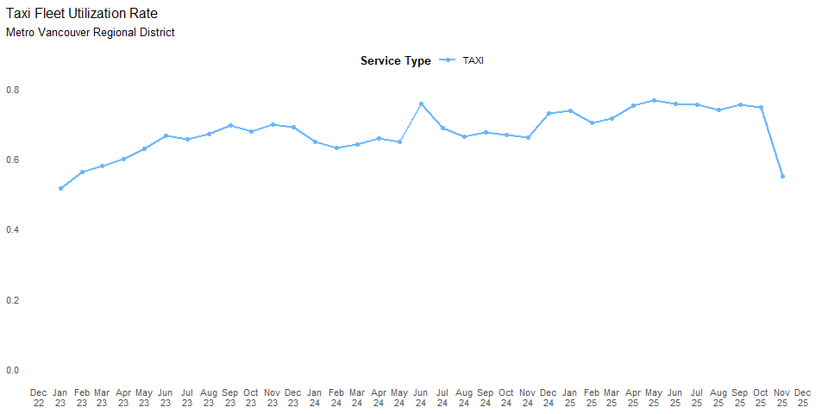
Analysis and Conclusions
In November 2025, Metro Vancouver Regional District recorded a total of in taxi fleet utilization rate trips. On a year-over-year (YoY) basis, the taxi fleet utilization rate trips was while on a year-to-date (YTD) basis it was relative to the same period in 2024. On a month-over-month (MoM) basis, taxi fleet utilization changed by . NA NA
In November 2025, the Metro Vancouver Regional District recorded a total of in fleet utilization rate for TNS trips. Compared with November 2024, the taxi fleet utilization rate for TNS trips was (YoY). Year-to-date through r end_label, the taxi fleet utilization rate for TNS trips was relative to the same period in 2024. On a month-over-month (MoM) basis, TNS fleet utilization changed by . NA NA
Limitations: The taxi fleet utilization rate does not provide insight into the equitability of opportunities in the industry, the impact on Public Transportation, the industry’s sustainable profitability levels, or driver incomes, nor does it address the environmental aspects of sustainability.

Vehicle Occupancy Rate
Primary Factor: Sustainability
Description: The vehicle occupancy rate represents the proportion of working time during which a taxi or TNS vehicle carries passengers over the total working time over a month in an area.
Measurement: The vehicle occupancy rate is calculated as the median (50th percentile) of the ratio of the total duration of all trips to the total working hours of all taxi vehicles in an area over a month.
Interpretation: A high vehicle occupancy rate indicates frequent passenger occupancy and low wasted time waiting for new trip requests. In contrast, a low taxi vehicle occupancy rate suggests that vehicles are driving longer times to pick up passengers or the wait time to receive new trips is long. A low vehicle occupancy rate is unfavourable as it negatively impacts sustainable profitability. Additionally, significant changes in the vehicle occupancy rate can signal shifts in market stability and potential sustainability challenges.
Policy Context: Public Need and Accessibility Factor
The Board’s sound economic conditions policy in the Policy Manual lists examples of the sustainability factor, which are set out below alongside their corresponding implications on the taxi vehicle occupancy rate:
- The proposed service promotes long-term stability for the passenger transportation industry. -Stability in the vehicle occupancy rate can reflect long-term stability in the industry.
- The proposed service encourages resiliency in the passenger transportation industry. -Higher vehicle occupancy rates can reflect higher resiliency levels in the passenger transportation industry.
- The proposed service minimizes significant market disruption -Large shifts in the vehicle occupancy rate can indicate a significant market disruption.
- The proposed service protects the passenger transportation sector from rapid disruption to ensure its long-term stability as an essential service. -Large shifts in the vehicle occupancy rate can indicate a rapid disruption, leading to challenges for long-term stability as an essential service.
- The proposed service promotes the overall profitability and economic sustainability of the industry. -A low vehicle occupancy rate indicates unsustainable profitability and economic instability in the industry.
- The proposed service promotes adequate driver incomes to contribute to a stable supply of drivers. -A low vehicle occupancy rate can signal inadequate driver incomes. To assess whether a vehicle occupancy rate is high or low, we define the range of possible values it can take, referred to as the Vehicle Occupancy Rate Possible Range (VORPR).
If no trips occur during the working period, the vehicle occupancy rate is zero, representing the lower end of the range. Conversely, if there is no idle time between trips, the vehicle occupancy rate reaches its upper limit. Based on 2024 data for taxi and TNS vehicles in the Metro Vancouver Regional District (MVRD), the upper limit of the vehicle occupancy rate is approximately 0.7 for TNS vehicles and 0.8 for taxis. These values define the upper end of the VORPR.
Existing studies provide baseline VOR levels for taxis and rideshare platforms. Cramer and Krueger (2016) found that Uber consistently achieved higher VOR than taxis across major U.S. cities. Their analysis showed that Uber’s VOR ranged from 55% to 68%, while taxi VOR remained lower, between 47% and 53%. The largest gap was observed in New York City, where Uber’s VOR (68%) exceeded taxi VOR (53%) by 15 percentage points. This trend suggests that rideshare platforms operate more efficiently than traditional taxi services (see Table 19 in Appendix 2 for detailed comparisons).
Additionally, data from the NYC Taxi & Limousine Commission (TLC) Factbook indicate that between April 2023 and September 2024, Uber’s VOR fluctuated between 54.2% and 60.4%, while Lyft’s VOR ranged from 43.9% to 52.5%. The overall industry average varied between 48.7% and 57.5%, with NYC regulations requiring a minimum VOR of 53% (see Figure 22 in Appendix 2 for NYC-specific data).

Metro Vancouver Regional District Taxi and TNS Vehicle Occupancy Rate Findings
Table 12: Metro Vancouver Regional District Taxi and TNS Vehicle Occupancy Rate Findings
Year | Jan | Feb | Mar | Apr | May | Jun | Jul | Aug | Sep | Oct | Nov | Dec
TAXI
2023 | 0.42 | 0.42 | 0.41 | 0.42 | 0.43 | 0.43 | 0.43 | 0.42 | 0.43 | 0.41 | 0.40 | 0.40
2024 | 0.40 | 0.39 | 0.39 | 0.40 | 0.41 | 0.41 | 0.41 | 0.41 | 0.41 | 0.40 | 0.40 | 0.41
2025 | 0.39 | 0.39 | 0.39 | 0.39 | 0.40 | 0.41 | 0.41 | 0.41 | 0.41 | 0.40 | 0.41
TNS
2023 | 0.55 | 0.56 | 0.55 | 0.58 | 0.59 | 0.59 | 0.60 | 0.60 | 0.58 | 0.57 | 0.57 | 0.57
2024 | 0.57 | 0.57 | 0.57 | 0.58 | 0.58 | 0.59 | 0.60 | 0.59 | 0.58 | 0.56 | 0.56 | 0.56
2025 | 0.54 | 0.55 | 0.54 | 0.55 | 0.56 | 0.56 | 0.57 | 0.57 | 0.55 | 0.55 | 0.54
Figure 9: Metro Vancouver Regional District Taxi and TNS Vehicle Occupancy Rate Findings
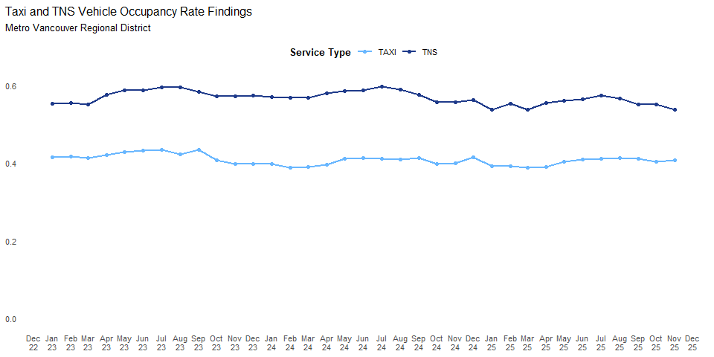
Analysis and Conclusions
In November 2025, Metro Vancouver Regional District recorded a total of 40.7% in Vehicle Occupancy Rate Findings for taxi trips. On a year-over-year (YoY) basis, the Vehicle Occupancy Rate Findings for taxi trips was +1.88%while on a year-to-date (YTD) basis it was -0.08% relative to the same period in 2024. On a month-over-month (MoM) basis, vehicle occupancy for taxi trips changed by +0.89%. NA NA
In November 2025, the Metro Vancouver Regional District recorded a total of 53.8% in Vehicle Occupancy Rate Findings for TNS trips. Compared with November 2024, the Vehicle Occupancy Rate Findings for TNS trips was -3.39% (YoY). Year-to-date through r end_label, the Vehicle Occupancy Rate Findings for TNS trips was -3.90% relative to the same period in 2024. On a month-over-month (MoM) basis, vehicle occupancy for TNS trips changed by -2.34%. NA NA
Limitations: The vehicle occupancy rate illustrates the interaction between demand and supply and offers limited insight into the industry’s sustainability. However, this indicator does not provide information about the Board’s other sustainability examples, including environmental impact and equity within the industry.

Driver hourly revenue
Primary Factor: Sustainability
Description: Driver Hourly Revenue reflects whether the passenger transportation sector is producing a sustainable level of revenue for drivers to promote retention of their workforce. It is important to note that hourly revenue does not reflect take-home pay, which depends on factors such as business-level labour payment arrangements, employment classification (e.g., employee vs. independent contractor), operating costs, and hours worked. However, revenue per hour remains a useful indicator of market stability and service sustainability from a labour supply perspective.
Measurement: This indicator captures the median[1] of the total fare[2] collected by taxi and TNS drivers per working hour in a defined geographical area for over a month. It reflects whether the passenger transportation sector is producing a sustainable level of revenue for drivers to promote retention of their workforce.
Interpretation: Higher hourly revenue indicates stronger revenue generation for the sector, supporting its long-term operational sustainability. This indicator measures median hourly revenue at the sector level and does not reflect individual driver take-home earnings, which can vary based on a variety of factors. The focus is on the sector’s overall financial health and its ability to maintain service levels over time.
Policy Context: Public Need and Accessibility Factor

Metro Vancouver Regional District Taxi and TNS Driver hourly revenue Findings
Table 13: Metro Vancouver Regional District Taxi and TNS Driver hourly revenue Findings
Year | Jan | Feb | Mar | Apr | May | Jun | Jul | Aug | Sep | Oct | Nov | Dec
TAXI
2023 | $35.79 | $36.18 | $35.90 | $36.41 | $35.81 | $36.44 | $36.94 | $35.87 | $36.39 | $36.95 | $36.34 | $36.90
2024 | $36.34 | $36.06 | $36.23 | $36.09 | $36.79 | $36.52 | $36.98 | $36.91 | $36.78 | $35.88 | $36.28 | $37.57
2025 | $35.81 | $35.76 | $35.48 | $34.76 | $35.08 | $35.89 | $36.04 | $36.20 | $35.67 | $34.89 | $35.28
TNS
2023 | $43.63 | $44.68 | $43.28 | $45.25 | $43.95 | $43.87 | $44.79 | $44.86 | $43.53 | $41.10 | $40.60 | $42.00
2024 | $41.08 | $38.09 | $38.07 | $38.21 | $38.14 | $37.98 | $39.20 | $38.74 | $38.00 | $36.53 | $37.03 | $38.52
2025 | $35.35 | $38.08 | $37.42 | $37.81 | $38.38 | $38.88 | $39.75 | $39.88 | $38.26 | $38.21 | $39.07
Figure 10: Metro Vancouver Regional District Taxi and TNS Driver hourly revenue Findings
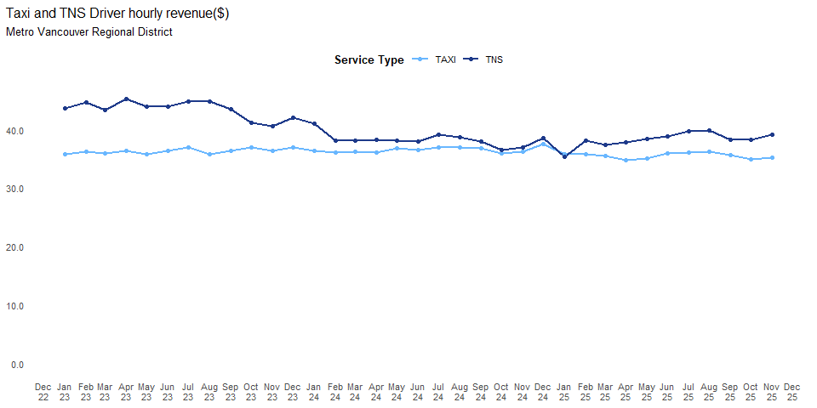
In November 2025, Metro Vancouver Regional District recorded a total of $35 in driver earnings for taxi services. On a year-over-year (YoY) basis, average driver earnings for taxi services were -2.74%while on a year-to-date (YTD) basis it was -2.50% relative to the same period in 2024. On a month-over-month (MoM) basis, driver earnings for taxi trips changed by +1.13%. Looking over the past two years, statistical analysis of the long-term trend suggests that there is no meaningful change in direction. Statistical analysis of the short-term trend suggests that there is no active shift in market direction.
In November 2025, the Metro Vancouver Regional District recorded a total of $39 in driver earnings for TNS services. Compared with November 2024, average driver earnings for TNS services were +5.53% (YoY). Year-to-date through November 2025, earnings for TNS services were +0.01% relative to the same period in 2024. On a month-over-month (MoM) basis, driver earnings for TNS trips changed by +2.25%. Looking over the past two years, statistical analysis of the long-term trend suggests that there is no meaningful change in direction. Statistical analysis of the short-term trend suggests that there is no active shift in market direction.
Limitations:

Variety Factor (SEC)
There is no analysis related to this factor.

Appendix 1: Technical Methodology
A set of completed trips in a given area j during the period t is denoted by $T_{j,t}$, and each completed trip is denoted by i in $T_{j,t}$ is associated with a unique trip ID (one-to-one) and a unique vehicle ID denoted by $v_{i}$ (many to one). Indicators discussed in this report are calculated as follows. Unless otherwise mentioned, the underlying data is retrieved from the Trip Database.

Demand Factor

Trip Volume
Trip volume is the total count of trip IDs of completed trips.
$$TV_{j,t}=|T_{j,t}| \left(1\right)$$
where |∙| counts the number of elements in the set.

Trip Revenue
Total trip revenue is:
TRj,t=i∈Tj,t​ri 2
where $TR_{j,t}$ is trip revenue and $r_{i}$ is the fare amount of the trip $i$.

Accessibility Factor

Number of Wheelchair Accessible Vehicles (WAVs)
Number of WAVs has two sub-metrics: (1) the number of active wheelchair accessible and (2) the number of active wheelchair accessible providing accessible trips. The number of active wheelchair accessible vehicles is determined by identifying a set of unique vehicle IDs denoted by $V_{j,t}$ from completed trips in the Trip Database and cross-referencing them with a set of the registry of accessible vehicles denoted by R.
$$WAV_{j,t}^{1}=\left|R_{j,t}∩V_{j,t}\right| \left(3\right)$$
where |∙| counts the number of elements in the set, and $V_{j,t}∩R_{j,t}$ represents the set of active vehicles that are also registered as accessible.
The number of active wheelchair accessible vehicles providing acceptable trips is determined by limiting the list of active WAVs to those reported as having provided accessible trips.
$$WAV_{j,t}^{2}=\left|R_{j,t}∩V_{j,t}∩A_{j,t}\right| \left(4\right)$$
where |∙| counts the number of elements in the set, and $R_{j,t}∩V_{j,t}∩A_{j,t}$ represents the set of active WAVs that are also providing accessible trips.
The number of active wheelchair accessible vehicles per 1,000 person is the ratio of $WAV_{j,t}^{1}$ to the area’s population denoted by P_(j,t), multiplied by 1,000.
$$WAV_{j,t}^{\text{per1}}=\frac{WAV_{j,t}^{1}}{P_{j,t}}×1000 \left(5\right)$$
The number of active wheelchair accessible vehicles providing accessible trips per 1,000 person is the ratio of $WAV_{j,t}^{2}$ to the area’s population denoted by $P_{j,t}$, multiplied by 1,000.
$$WAV_{j,t}^{\text{per2}}=\frac{WAV_{j,t}^{2}}{P_{j,t}}×1000 \left(6\right)$$

Active Vehicles per 1,000 Persons
The number of active vehicles per 1,000 persons is calculated as the ratio of total number of taxi and TNS active vehicles $V_{j,t}\left(V_{j,t}=v_{i}|i∈T_{j,t}\right)$ to the area’s population $\left(P_{j,t}\right)$, multiplied by 1,000.
$$NumberofActiveVehiclesPer1000Persons_{j,t}=\frac{|V_{j,t}|}{P_{j,t}}×1000 \left(7\right)$$

Affordability Factor

Fare per Kilometre
For each trip i, the fare per kilometre denoted by $f_{i}$ is calculated as the ratio of its fare denoted by $r_{i}$ to its trip length in kilometres denoted by $d_{i}$.
$$f_{i}=\frac{r_{i}}{d_{i}} \left(8\right)$$
The 10th, 50th, and the 90th percentiles of the fare per kilometre distribution are reported. Only trips recorded with a fare of at least $2.50 were included, in line with the minimum flag rate of $2.50.

Safety Factor
There is no analysis related to this factor.

Service Quality Factor

Wait Time
For each trip, wait time, denoted by $w_{i}$, is defined as the difference between the pickup arrival time, denoted by $t_{i}^{p}$ and the hail time, denoted by $t_{i}^{h}$, measured in minutes.
$$w_{i}=t_{i}^{p}−t_{i}^{h} \left(9\right)$$
The median of the wait time distribution is reported. The median, when compared to the average, is less affected by outliers or extreme values, providing a more accurate representation of the central tendency (i.e., typical wait times). Pre-booked and street hail trips were excluded, as they were not the focus of what the wait time indicator is intended to capture.

Competition Factor

Concentration Indices
Herfindahl-Hirschman Index (HHI) and Theil Index are both measures of market concentration. The HHI index is calculated by summing the squares of each firm’s market share, with lower values indicating more competition and higher values suggesting greater concentration. Specifically, the corresponding HHI Index for a given region is constructed as follows:
$$HHI_{j,t}=\sum_{i=1}^{n}{s_{i,j,t}^{2}} \left(10\right)$$
where $s_{i,j,t}$is the market share of firm i in area j during period t, and n is the total number of companies The Theil Index is based on the concept of entropy from information theory. It measures the deviation of a distribution (like market shares) from a perfectly equal distribution. Specifically, the corresponding Theil Index for a given region is constructed as follows:
$$T=\sum_{i=1}^{n}{\left(\frac{x_{i}}{μ}ln​\left(\frac{x_{i}}{μ}\right)\right)} \left(11\right)$$
where n is the total number of companies, and $x_{i}$ represents the revenue share of the $i^{th}$ entity and μ is the average share. The Theil decomposition is conducted as follows:
$$T=\sum_{j=1}^{k}{\left(\frac{n_{j}}{n}\frac{y_{j}}{y}ln​\left(\frac{y_{j}}{y}\right)\right)}+\sum_{j=1}^{k}{\left(\frac{y_{j}}{y}\sum_{i=1}^{n_{j}}{\frac{y_{ij}}{y_{j}}}ln​\left(\frac{y_{ij}}{y_{j}}\right)\right)}=B+W \left(12\right)$$
where n_j refers to the population size of the $j^{th}$ region, $y_{j}$ is the mean income of the $j^{th}$ region, and $y_{i,j}$ corresponds to the income of the $i^{th}$ entity in the $j^{th}$ region.

Innovation Factor
There is no analysis related to this factor.

Sustainability Factor

Revenue per Active Vehicle
Trip revenue per active vehicle is calculated by dividing the sum of the total fare amount by the total number of active vehicles:
$$RevPerVehicle_{j,t}=\frac{TR_{j,t}}{|V_{j,t}|} \left(13\right)$$
where $TR_{j,t}$ is total trip revenue, and $\left|V_{j,t}\right|$ is the number of active vehicles.

Taxi Fleet Utilization
Taxi fleet utilization is calculated as the ratio of the total number of active taxi vehicles denoted by $AV_{i,t}$ to the total number of approved taxi vehicles denoted by $Capicity_{i,t}$, multiplied by 100 to express it as a percentage.
$$FleetUtilization_{i,t}=\frac{AV_{i,t}}{Capacity_{i,t}} \left(14\right)$$

Taxi Vehicle Occupancy Rate
Taxi Vehicle Occupancy Rate (VOR) is calculated as the ratio of the sum of all trip durations denoted by $D_{i,t}$to the sum of all shift lengths denoted by $L_{i,t}$.
$$VOR_{i,t}=\frac{D_{i,t}}{L_{i,t}} \left(15\right)$$
The shift length is determined by the difference between the shift end time and the shift start time. TNS trips are not included, as the start time for TNS shifts recorded in the Trip Database corresponds to the driver’s first ride request rather than the actual beginning of their work shift.

New Vehicle Occupancy Rate
A shift is defined as a series of trips performed by a driver, where the start time of each trip occurs within 60 minutes of the previous trip’s end. After defining the group of trips that are included in one shift, the following attributes are calculated:

Shift Start Time
(Denoted as $t_{\text{start}}^{\text{shift}}$) This is the earliest vehicle assignment DateTime ($t_{\text{assign},i}^{\text{vehicle}}$) in the shift.
$$t_{\text{start}}^{\text{shift}}=\min_{i}\left(t_{\text{assign},i}^{\text{vehicle}}\right) \left(16\right)$$

Shift End Time
Denoted as ( $t_{\text{end}}^{\text{shift}}$).
This is the latest drop-off arrival DateTime ( $t_{\text{arrive},i}^{\text{dropoff}}$ ):
$$t_{\text{end}}^{\text{shift}}=\max_{i}\left(t_{\text{arrive},i}^{\text{dropoff}}\right) \left(17\right)$$

Shift Length
Denoted as ( $L^{\text{shift}}$ ):
$$L^{\text{shift}}=t_{\text{end}}^{\text{shift}}−t_{\text{start}}^{\text{shift}} \left(18\right)$$

Shift Occupancy
Denoted as ($D^{\text{shift}}$).
This is the total sum of all trip durations ($D_{i}$) within the shift:
$$D^{\text{shift}}=\sum_{i=1}^{n}{D_{i}} \left(19\right)$$
The Average Vehicle Occupancy Rate (VOR) is calculated as the ratio of the sum of all trip durations denoted by $D_{i,t}$ to the sum of all shift lengths denoted by $L_{i,t}$.
$$VOR=\frac{D_{i,t}}{L_{i,t}} \left(20\right)$$
This formula ensures that the VOR represents the proportion of time within a shift that a vehicle is actively engaged in service.
The Vehicle Occupancy Rate Possible Range (VORPR) is calculated as the ratio of the sum of all trip durations denoted by $D_{i,t}$ to the sum of all Operating Time denoted by $O_{i,t}$.
$$VORPR=\frac{D_{i,t}}{O_{i,t}} \left(21\right)$$
The Operating time includes the time between vehicle assignment time and drop-off time.
$$O_{i}=t_{\text{arrive},i}^{\text{dropoff}}−t_{\text{assign},i}^{\text{vehicle}} \left(22\right)$$

Drivers’ Gross Hourly Earnings
Drivers’ Gross Hourly Earnings are calculated as:
GHEj,t=Mediani∈Tj,t​rii∈Tj,t​hi 23
where: - $GHE_{\left(j,t\right)}$ represents the drivers’ gross hourly earnings in area j during period t. - $r_{i}$ is the fare revenue for trip i. - $h_{i}$ is the total working hours of the driver associated with trip i. - $T_{j,t}$ is the set of completed trips in area j during period t.

Number of Active Drivers
The number of active drivers is determined by identifying a set of unique driver IDs, denoted by $DR_{j,t}$ , from completed trips in the Trip Database.
$$DR_{j,t}=\left|\{dr_{i}∣i∈T_{j,t}\}\right| \left(24\right)$$
here: $DR_{j,t}$ represents the number of active drivers in area j during period t. $dr_{i}$ is the unique driver associated with trip i. $T_{j,t}$ is the set of completed trips in area j during period t.

Peak-Hour Taxi Vehicle Occupancy Rate
Peak Hour Taxi Vehicle Occupancy Rate is calculated by identifying the peak hours, which are determined by examining the trip volume for each hour throughout the day. The hour with the highest trip volume, relative to other hours, is designated as the peak hour. An example is shown below. Figure 11: Metro Vancouver Identification of Peak Hours
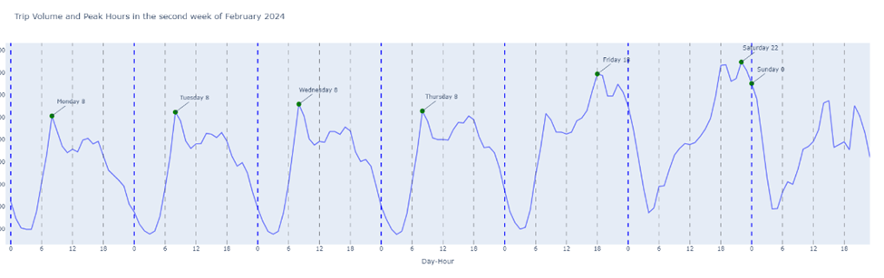
Once the peak hours are identified, the Peak-Hour Taxi Vehicle Occupancy Rate is then calculated by dividing the total trip duration during peak hours, denoted by $D_{i,t}^{peak}$, by the total working hours of all vehicles during the peak hours, denoted by $L_{i,t}^{peak}$.
$$PeakVOR_{i,t}=\frac{D_{i,t}^{\text{peak}}}{L_{i,t}^{\text{peak}}} \left(25\right)$$

Variety Factor
No analysis conducted.

Appendix 2: Technical Methodology

New Vehicle Occupancy Rate
Figure 12: Metro Vancouver New York City VOR (2023 and 2024)
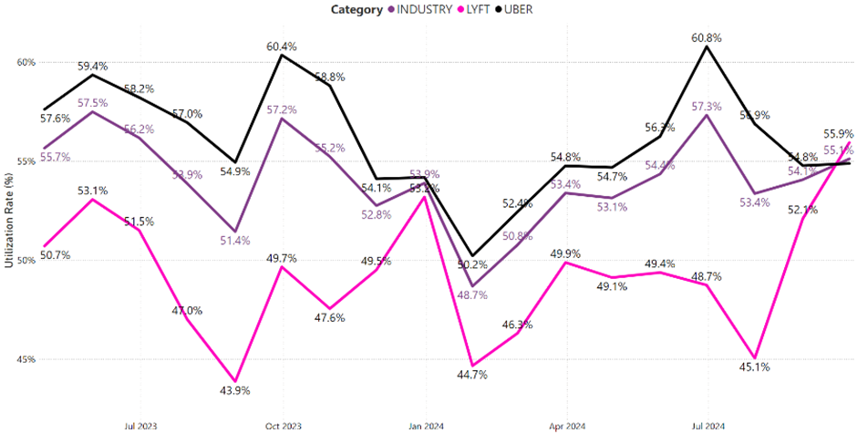

Year-over-year (YoY) compares September 2024 with September 2023, while year-to-date (YTD) compares the cumulative data from January to September 2024 with the same period in 2023. YoY evaluates specific monthly changes, while YTD assesses trends over a recent period of time.
Statistics Canada. (2024). Table 14-10-0222-01 Employment, average hourly and weekly earnings (including overtime), and average weekly hours for the industrial aggregate excluding unclassified businesses, monthly,seasonally adjusted [Data table]. https://www150.statcan.gc.ca/t1/tbl1/en/tv.action?pid=1410022201&pickMembers%5B0%5D=1.11&cubeTimeFrame.startMonth=01&cubeTimeFrame.startYear=2022&cubeTimeFrame.endMonth=07&cubeTimeFrame.endYear=2024&referencePeriods=20220101%2C20240701
There are a few trips whose distances are exactly 5 kilometres from the Trip Database. As such, all trips with distances not longer than 5.5 kilometres and not shorter than 4.5 kilometres were pooled together to calculate the fare distribution for a 5-kilometre trip. Fares for pooled trips were divided by their respective lengths, which is fare per kilometre, and then were multiplied by 5, yielding the fare distribution for a 5-kilometre trip.
The method of calculating The Vehicle Occupancy Rate Possible Range has been included in the Appendix.
Data from Cramer, J., & Krueger, A. B. (2016). Disruptive Change in the Taxi Business: The Case of Uber. American Economic Review, 106(5), 177–182. https://www.aeaweb.org/articles?id=10.1257/aer.p20161002.
Data from NYC Taxi & Limousine Commission (TLC). (2024). TLC Factbook: Data Dashboard for Industry Trends. Available at https://app.powerbigov.us/view?r=eyJrIjoiY2FlNjI3YWQtMDkzOS00MjliLTk0MTQtODc2NzU4OTYwNjFiIiwidCI6IjMyZjU2ZmM3LTVmODEtNGUyMi1hOTViLTE1ZGE2NjUxM2JlZiJ9&pageName=ReportSection28c004ce23fc37acd783.
Novotný, J. (2007). On the measurement of regional inequality: Does spatial dimension of income inequality matter? Annals of Regional Science, 41(3), 563-580. https://web.natur.cuni.cz/~pepino/NOVOTNY2007AnnalsofRegionalScience.pdf

