

Telephone: 1 877 526-1526

SECURED/REGISTERING PARTY CODES APPLICATION AND CHANGES

*PERSONAL PROPERTY SECURITY ACT*

Mailing Address: PO Box 9431 Stn Prov Govt Courier Address: 200 – 940 Blanshard Street

[**www.bcreg.ca**](http://www.bcreg.ca/)Victoria BC V8W 9V3 Victoria BC V8W 3E6

## INSTRUCTIONS:

* There is no filing fee to issue a new code.

***Freedom of Information and Protection of Privacy Act (FOIPPA):*** Personal information provided on this form is collected, used and disclosed under the authority of the *FOIPPA* and the *Personal Property Security Act* for the purposes of assessment. Questions regarding the collection, use and disclosure of personal information can be directed to the Manager of Registries Operations at 1 877 526-1526, PO Box 9431 Stn Prov Govt, Victoria BC V8W 9V3.

* A filing fee of $100.00 applies to a change request. A change request is filed to change a name and/or address and to update any prior registrations where the code was used.

## Send this completed form to:

By Mail: Personal Property Registry

PO Box 9431 Stn Prov Govt, Victoria BC V8W 9V3 By Fax: 250 387-3055

**1. Application Request**

Receivables Management Office – Antoinette Shinaba

CITY PROVINCE POSTAL CODE

3350 Douglas Street

Authorization to debit your BC OnLine account for future Personal Property Registry services:

# Victoria BC V8W 9V8

BC ONLINE DEPOSIT ACCOUNT NUMBER

# 458150

SECURED/REGISTERING PARTY CODE NAME OF CODE HOLDER

**2. Change Request**

## Check ( ✔ ) all applicable boxes

* Check box **one** to change your code, due to a name and/or address change. Current registrations **will not** be updated. A new code will be assigned. No fee will be charged.
* Check box **two** if you wish to have your name and/or address changed. Current registrations **will** be updated. Fee $100.00.
* Check box **three** if you wish to have your BC OnLine account added to the **new code**.  Please change our code and advise us of the new code assigned.

 Please change the name/address of the secured/registering party code holder and update any prior registrations in which the code was used.

 Authorization to link your BC OnLine Deposit Account number with the secured/registering party code to facilitate Personal Property Registry billings.

|  |  |  |  |  |
| --- | --- | --- | --- | --- |
| **Previous Name/Address**  NAME |  | | | |
| ADDRESS | CITY |  | PROVINCE | POSTAL CODE |
| **New Name/Address**  NAME |  |  |  |  |
| ADDRESS | CITY |  | PROVINCE | POSTAL CODE |
| **3. Authorization** |  |  |  |  |
| NAME (*please type or print*) |  | OFFICIAL POSITION |  |  |
| Client Analyst - Nick Preston | | Business Security and Support Analyst | | |

2025-05-16

*Note: If forwarding form to Personal Property Registry by fax, please provide the Registry with your return fax number.* Fax number: ( )

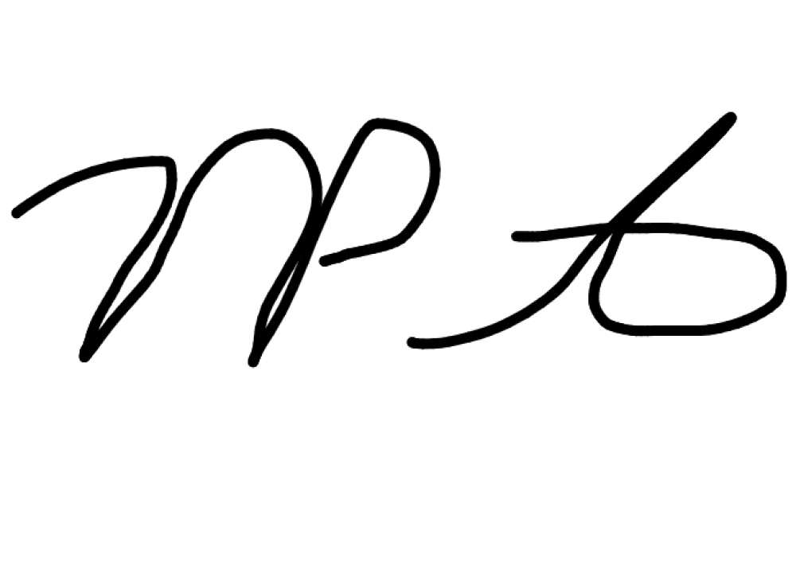

SIGNATURE

**X**

DATE SIGNED

YYYY / MM / DD

FORM 03 PPR (AUG 2017)