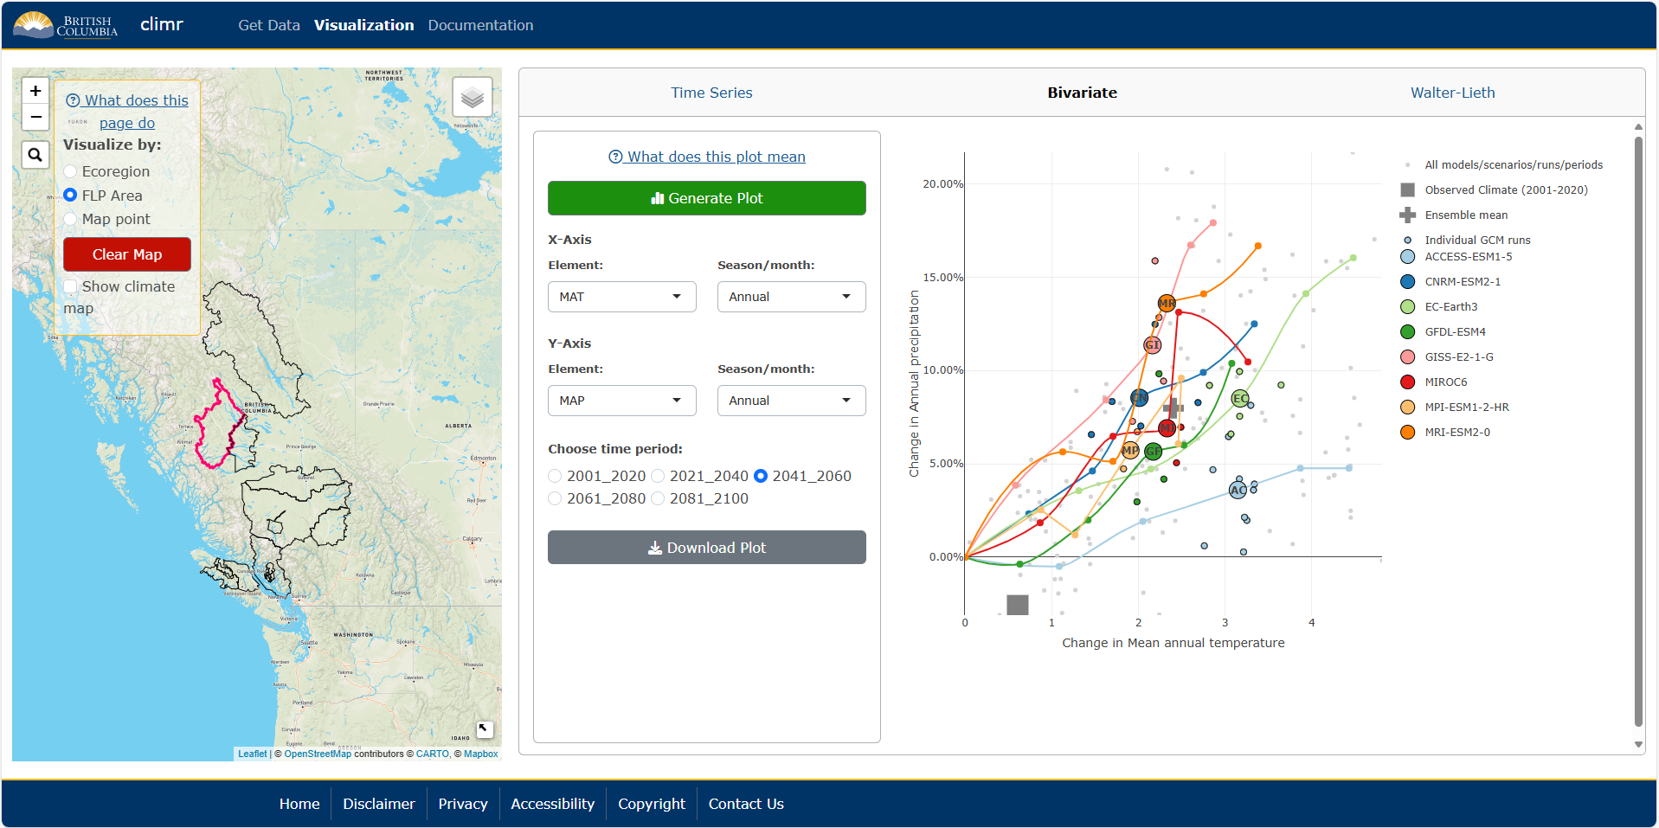
6
5
4
3
2
1
How to use (Ecoregion/FLP Area):
1. Select Ecoregion or FLP Area in the Visualize by panel. When selected, the plot panel will appear.
2. Click on an Ecoregion/FLP Area (areas contained by boundary lines).
3. Select which plot to view from the navigation bar.
4. Select the variable(s) to include.
5. Click Generate Plot. These plots are not interactive – if variables are changed, the Generate Plot button must be clicked again.
6. (Optional) Click Download Plot.
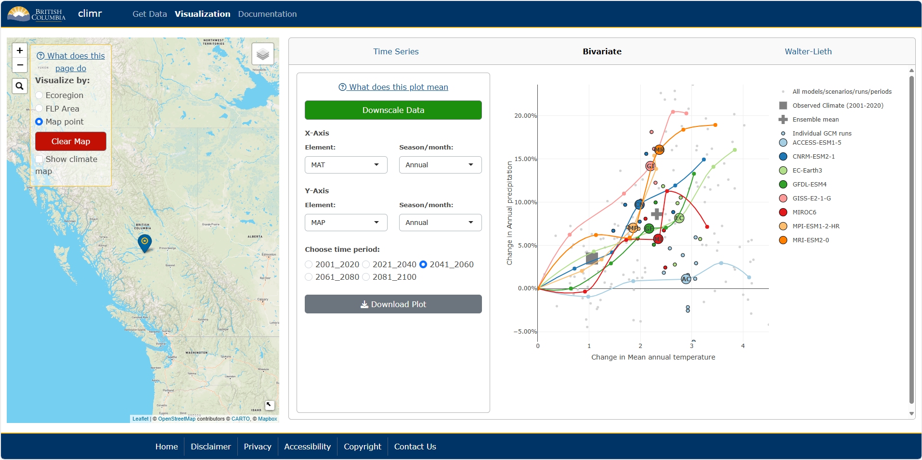
6
5
4
3
2
1
How to use (Map point):
1. Select Map point in the Visualize by panel. When selected, the plot panel will appear.
2. Click on the map to add a point.
3. Select which plot to view from the navigation bar.
4. Click Downscale Data. This will take about 10 seconds (the Time Series data can take up to about 20 seconds).
5. Select the variable(s) to view. These plots are interactive – when a variable is changed, the plot will automatically update.
6. (Optional) Click Download Plot.
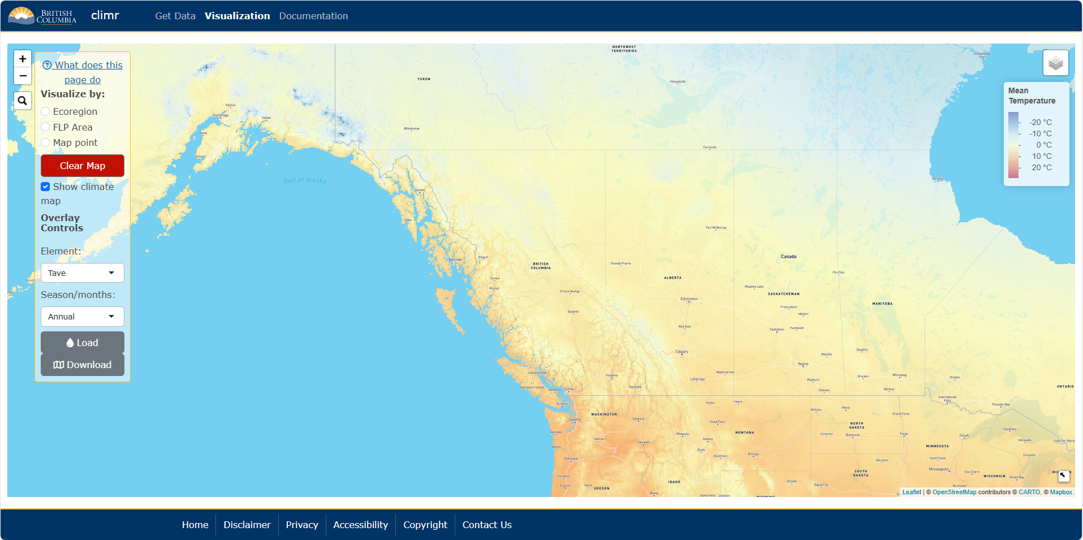
3
4
2
1
How to use (Climate map overlay):
1. Click on the Show climate map checkbox in the Visualize by panel.
2. Select the variable to view.
3. Click Load. It will take 5-10 seconds for the map to render.
4. (Optional) Click Download.
Note: Climate map overlays can be used during Ecoregion/FLP Area/map point selection and plotting.

