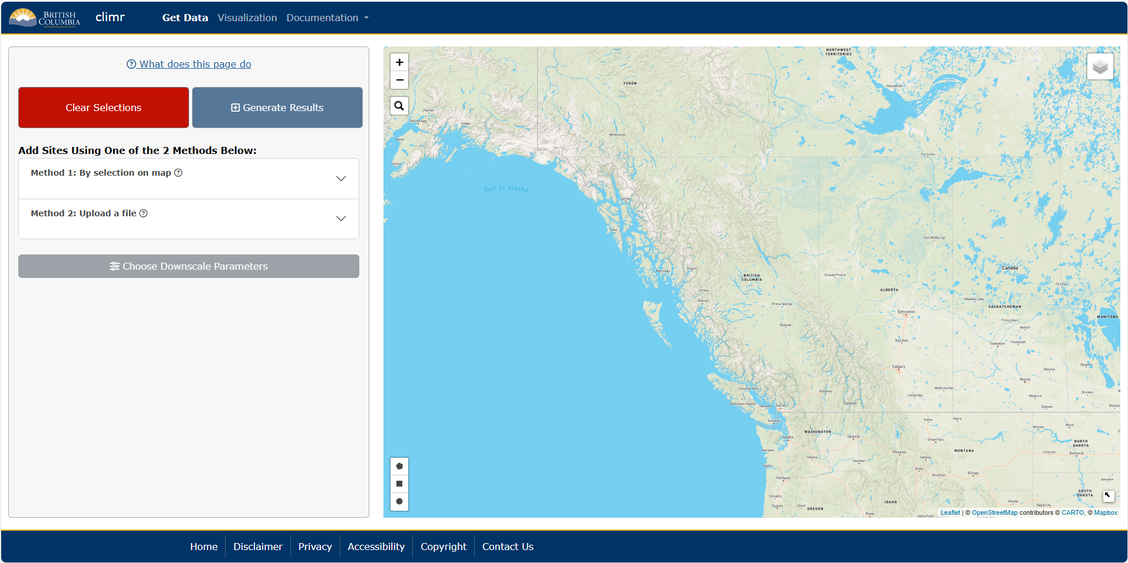
5
3
2
1
How to use:
1. Add area of interest by clicking/drawing on the map or uploading a file
2. Click on Choose Downscale Parameters, select wanted parameters and click Apply
3. Click on Generate Results, choose output format/resolution and click on Launch Downscale Process
4. For csv output, click on Download Downscaled Data underneath the preview in the popup window. For GeoTIFF output, click on Download Downscaled Data under the raster preview options in the main side panel (pictured below)
5. To start again, click on Clear Selections

Step 4: CSV Output
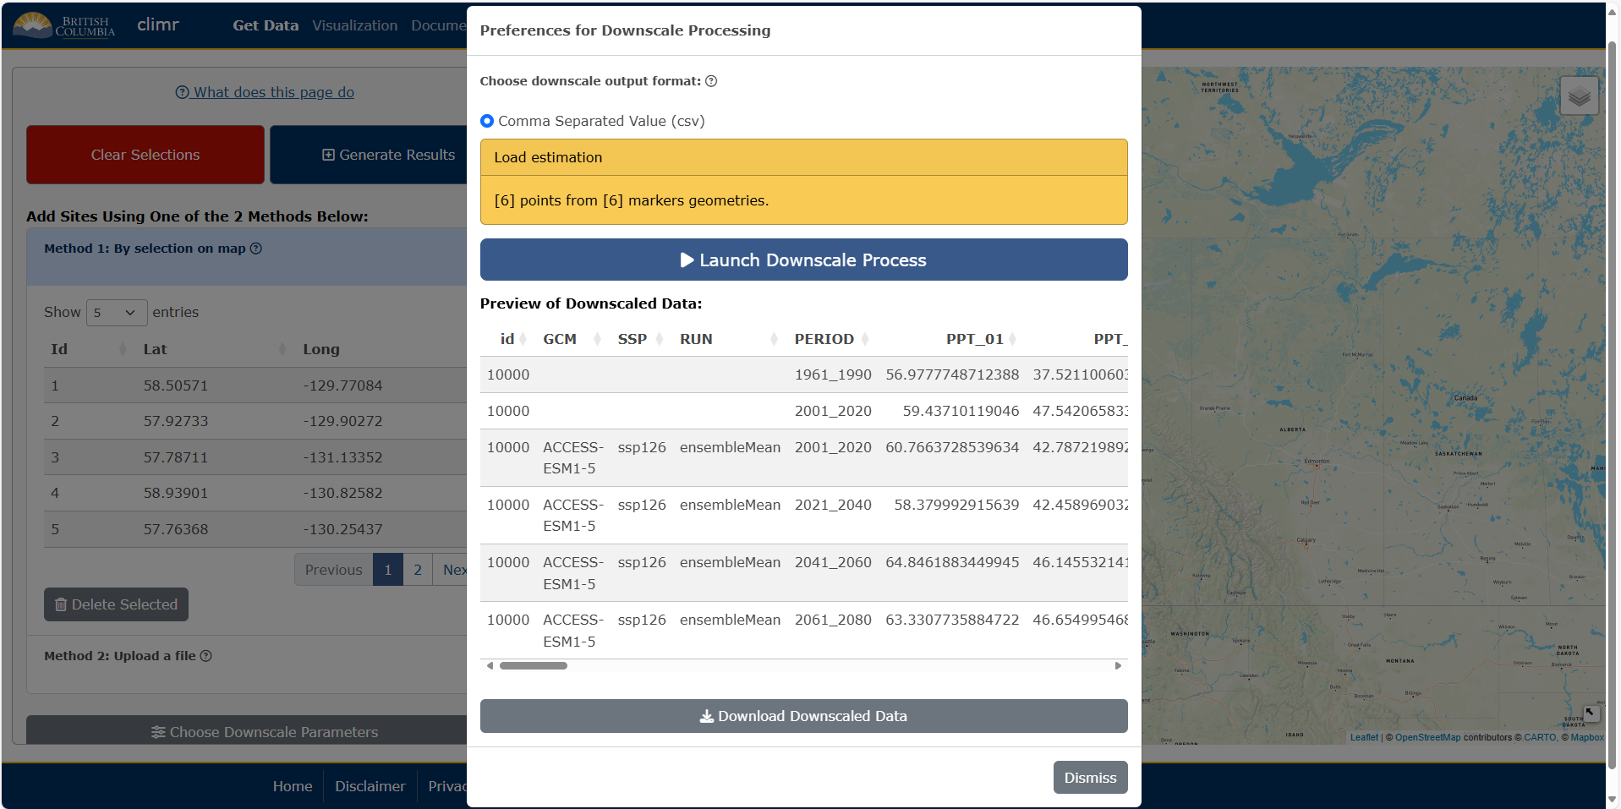
4

Step 4: GeoTIFF Output
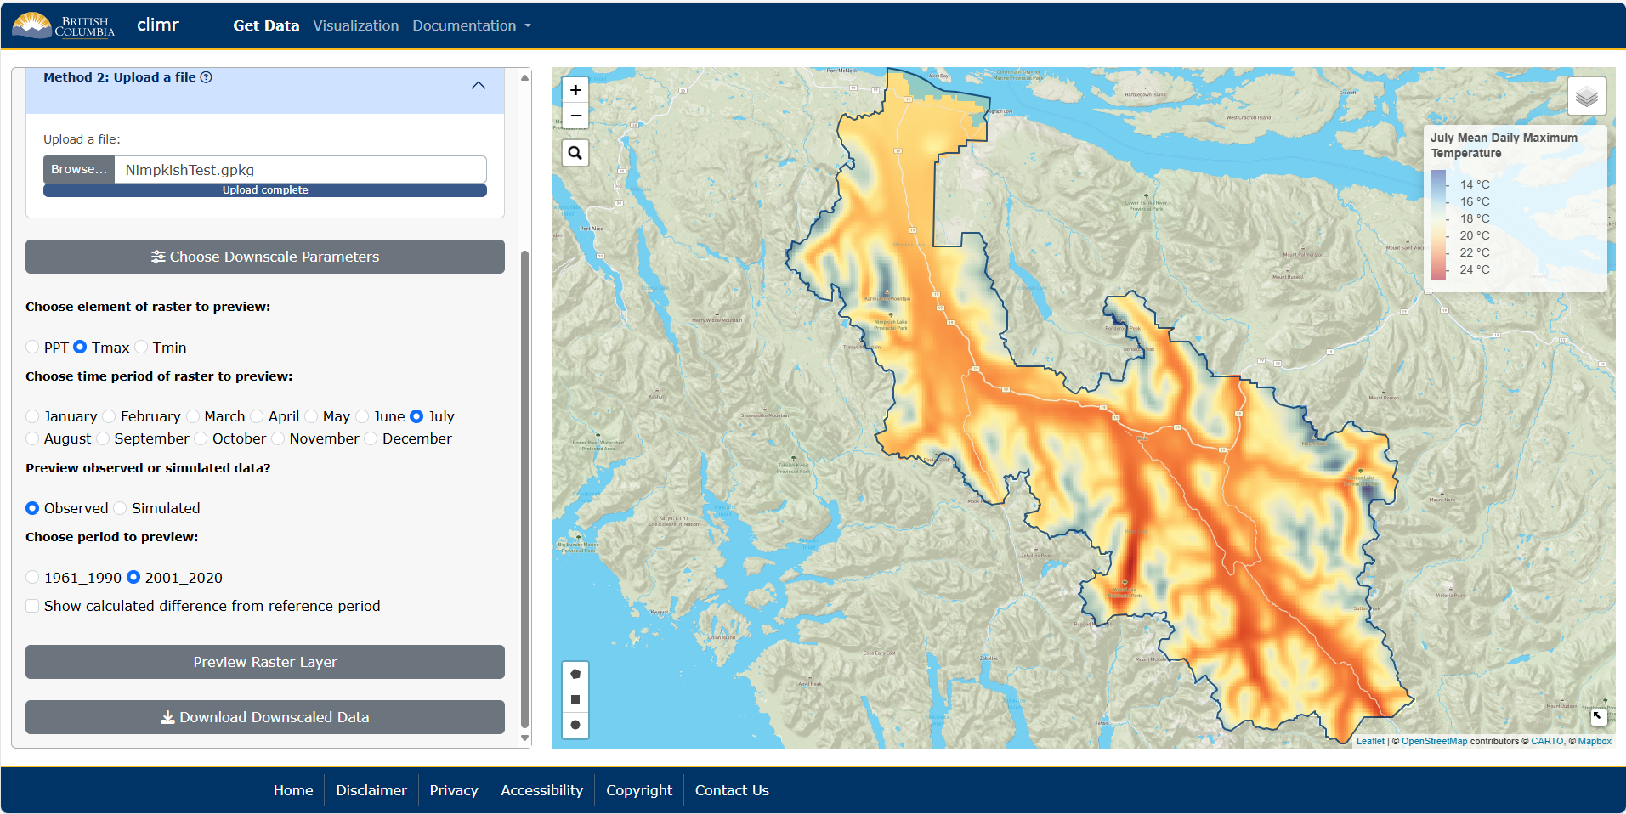
4a
4
4a. (Optional) Select the raster layer to preview from the options given and click on Preview Raster Layer

