IAO Adobe Redax Guidelines

FOR ALL GENERAL FOI REQUESTS - these severing guidelines should be used wherever possible.

|  |  |
| --- | --- |
| WHAT YOU DO IN ADOBE REDAX | |
| SEVER INFORMATION  (REDLINING THE DOCUMENT) | Sever information by electronically “red lining” then redacting that information from the document(s).  Redacted information must appear as “blanked out” space on the applicants final release package.  Ensure that your exemption stamps (e.g. s.15) appear in the centre of the “blanked out” spaces.  See: *Setting Redax Preferences* for information. |
| APPLY EXCEPTION STAMP | When red lining information in a document, apply only the relevant section of the Act (e.g. s.15) rather than identifying the subsections that were used (e.g. s.15 (1) (l)). Further explanation of the relevant subsection(s) may be detailed in the applicant release letter. See Applying Exception Stamps for more information. |
| SEVERING MULTIPLE CONSECUTIVE PAGES | If you sever multiple consecutive pages, do not release a series of blank pages. Withhold or remove multiple consecutive pages using the “Full Page Range” feature in Redax. See: *Redacting whole pages and ranges of pages* for more information. |
| PAGINATE RECORDS  (Add a Footer to Redline)  PAGINATE RECORDS  (Add a Footer to large files)  PAGINATE RECORDS  (Add a Footer to Phased Releases) | When preparing your *sign-off* package, add a document footer that will indicate the FOI request file number and page numbers to your Redline.  IAO Standards recommend that the footer should appear at the bottom right hand corner of each page (if space permits, if not place on page where space permits).  Underneath the “Page #”, insert the FOI request file number. For example:  Page 527  TRA-2011-00524  Paginate **large files** - when the Redline (and subsequent Response Package) is so large that it cannot be sent to the applicant in one package and/or may consist of more than one pdf file, two options to add a footer:   1. Paginate the entire records so that the page numbers are continuous and then split the pdf into two or more documents as needed. For example:   Part 1 of 2 Page 1  TRA-2011-00524  Part 2 of 2 Page 243  TRA-2011-00524   1. Paginate each pdf file separately and add an additional identifier (e.g. “Part 1 of 3”) to the footer of each pdf file to distinguish one pdf from the other. For example:   Part 1 of 3 Page 1  TRA-2011-00524  Part 2 of 3 Page 1  TRA-2011-00524  Part 3 of 3 Page 1  TRA-2011-00524  Paginate **Phased** **Releases** Redline using the following format:  Phase 1 Page 1  TRA-2011-00524    Phase 2 Page 1  TRA-2011-00524  See: Pagination for more information. |

**Remember**:

* To update your pagination whenever you create a Redline or Response copy of your records.
* If you need to rotate a page within your document, the pagination will appear where the original scanned document would have been. The pagination feature will not adjust the position of the footer to reflect the new orientation of your page. You will need to re-paginate your document. **This makes it essential that you review your records before sending them to scanning and placing them exactly as you would like them to appear in the finished scanned version.**

Procedures for Adobe Redax Standards

## Setting Redax Preferences

Information Access Operations has determined that there are standard settings in Redax which should be applied throughout our organization. The standard appearance of redacted records should carry the section number in red print located in the middle of the redaction box. The red frame of the box should be removed in the redacted process. To apply these settings to your Redax program, open Adobe, choose Redax + Redax Preferences from the Menu Bar:

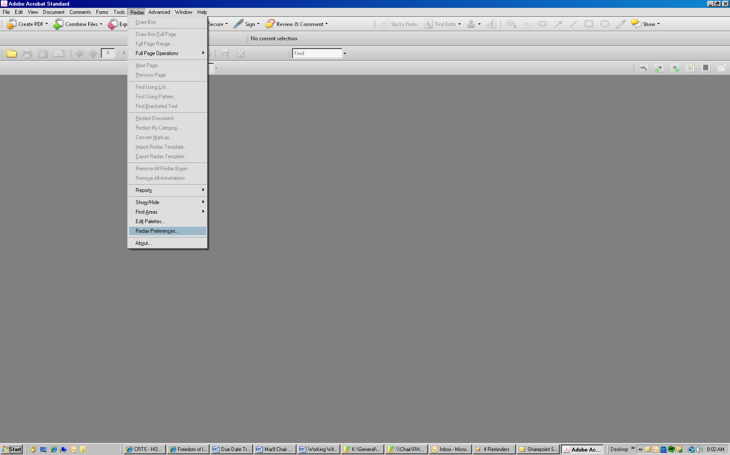

The Redax Preferences dialogue box has 3 tabs to work with. Copy the settings from each of the examples below to apply the standard settings:

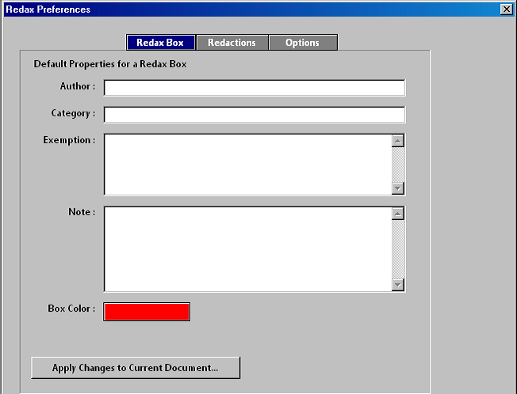

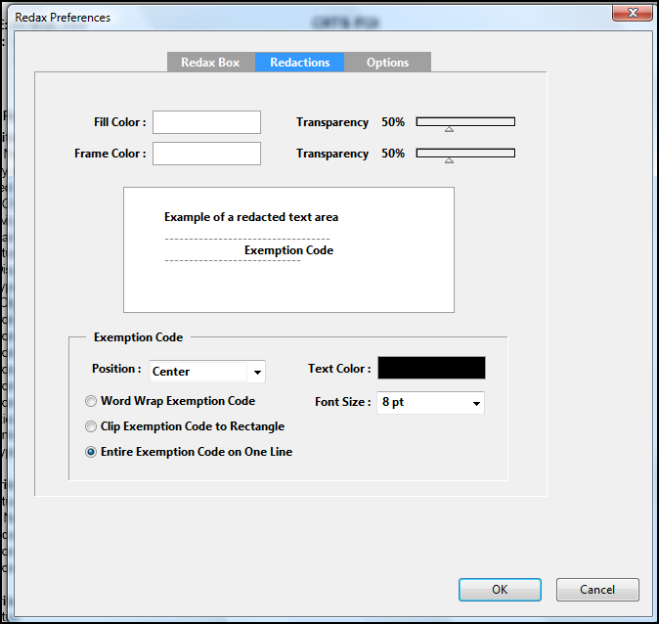

Once you have made your preference updates, remember to shut down Adobe and restart your computer to apply the settings.

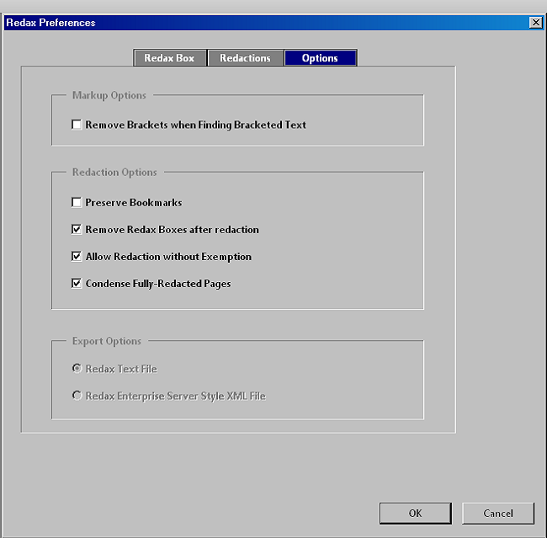

When you red line a document, this is how the box settings will appear:

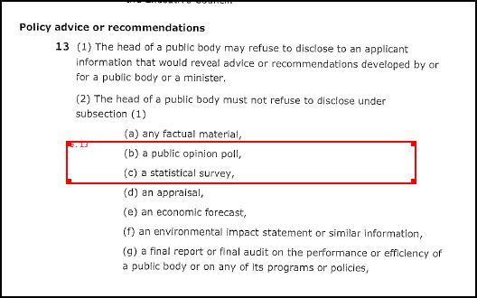

When redacted, this is how the standard settings will appear:

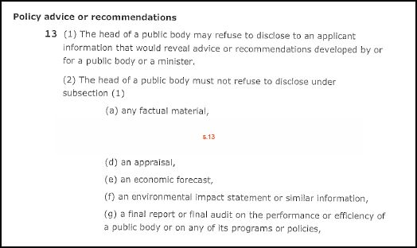

## Applying Exception Stamps

When red lining information in a document, apply only the relevant section of the Act (e.g. s.15)

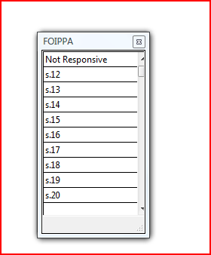

## 

## Redacting Whole Pages and Ranges of Pages

**To Sever/Remove Several Pages, Select the Following:**

**Redax + Full Page Range**

You will now see the Page Range dialogue box pictured below. As in our previous example, the palette is disabled when your dialogue box is open. Key in your section number in the Exemption Code area and select the page range in the areas given. If you need several sections, separate them with a comma and one space. The Redact Page icon will appear in the upper left hand corner of the pages selected without any visible references to the sections used. The program will only display them in the Redax Box Properties dialogue box, or in the redacted version of the document

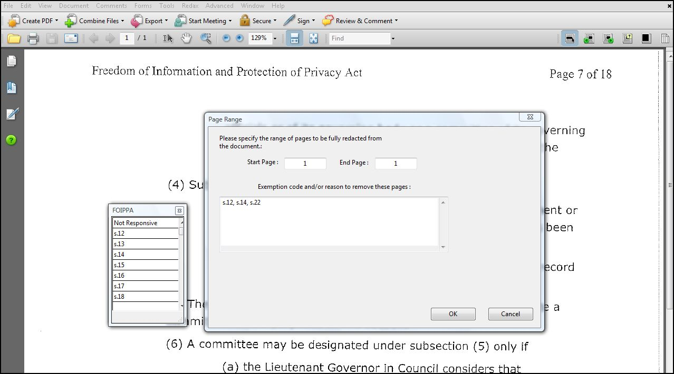

The redacted version of the document will resemble the following, and in this case pages 10 to 16 will not be included in the release package.

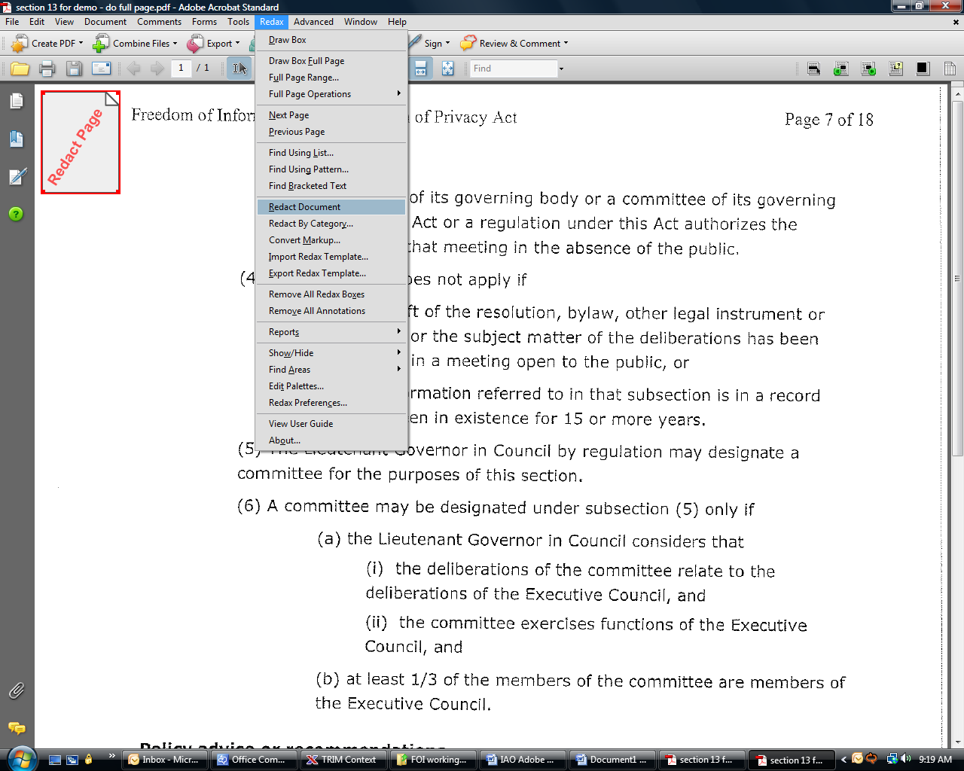

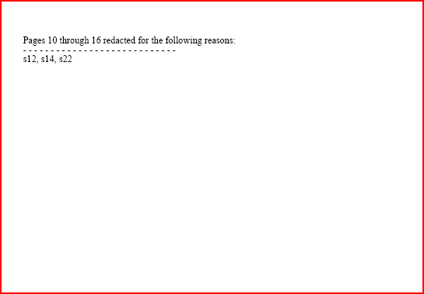

## 

## Pagination:

At the menu bar, choose **Document + Header & Footer + Add**

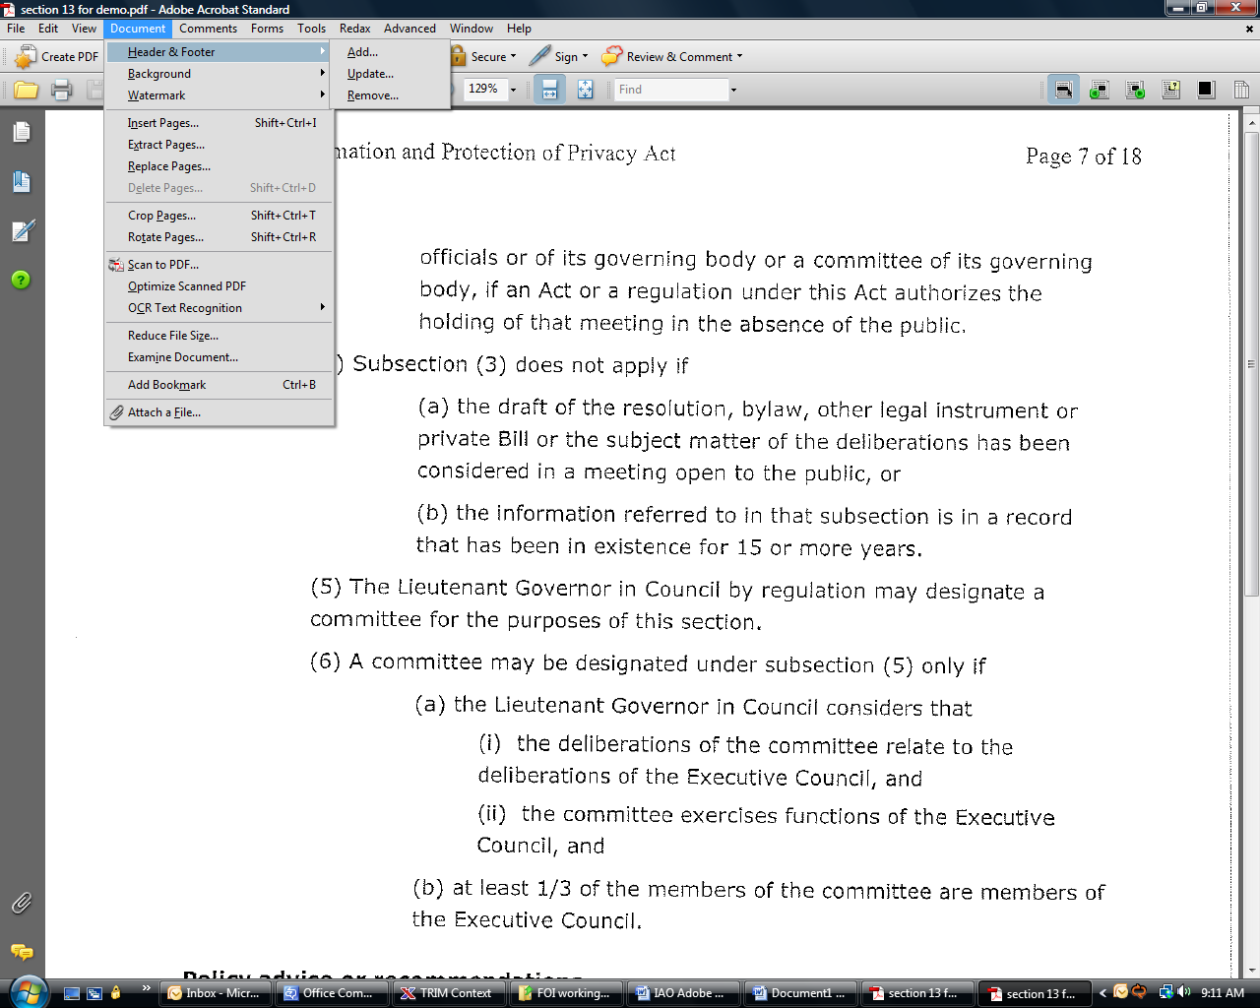

In the Add Header and Footer dialogue box, select the Right Footer Text option. Type in the footer information as you would like it to appear. To insert the page number, type “Page” followed by a space, then click Insert Page Number. Adobe will now automatically paginate your document.

Underneath the word “Page”, insert the FOI request number and select Ok. The pagination with the FOI request number will appear at the **bottom right hand corner of the each page**. For example:

Page 1

TRA-2011-00524

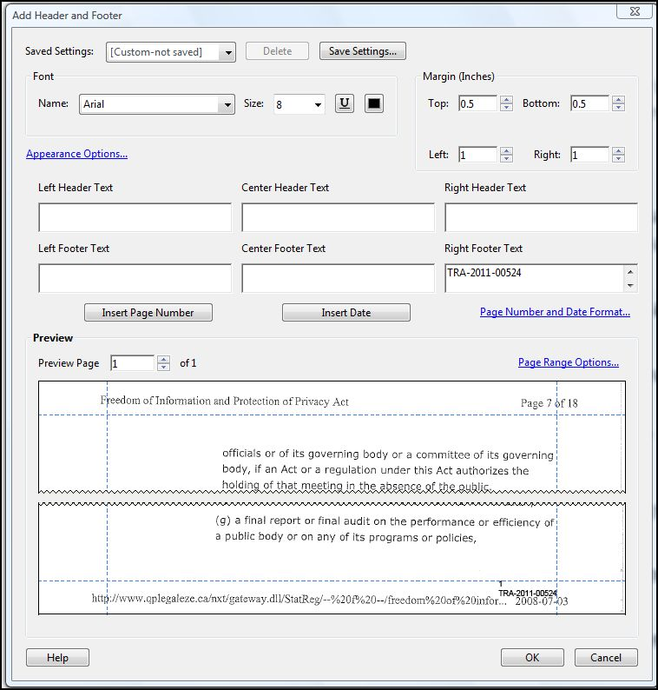

**Remember**:

* To update your pagination whenever you create a Redline or Redacted copy of your records.
* If you need to rotate a page within your document, the pagination will appear where the original scanned document would have been. The pagination feature will not adjust the position of the footer to reflect the new orientation of your page. You will need to re-paginate your document. **This makes it essential that you review your records before sending them to scanning and placing them exactly as you would like them to appear in the finished scanned version.**
* If you see the footer information wrapping on to a second line in the dialogue box, do not worry. The version that appears at the bottom of your page should be on one line only.