Creating Publication-Quality Graphics with ggplot2

This section will provide more detail on creating graphics with ggplot2. This lesson is part of a detailed intro to cr course put together by the BC government. You can find more details [here](https://github.com/bcgov/ds-cop-intro-to-r). This example required the dataset from [gapminder.org](https://www.gapminder.org) containing population information for many countries through time. Firstly you will need to download and save

Plotting our data is one of the best ways to quickly explore it and the various relationships between variables.

There are three main plotting systems in R, the [base plotting system](http://www.statmethods.net/graphs/index.html), the [lattice](http://www.statmethods.net/advgraphs/trellis.html) package, and the [ggplot2](http://www.statmethods.net/advgraphs/ggplot2.html) package.

Today we’ll be learning about the ggplot2 package, because it is the most effective for creating publication quality graphics.

ggplot2 is built on the grammar of graphics, the idea that any plot can be expressed from the same set of components: a **data** set, a **coordinate system**, and a set of geometric objects or **geoms**–the visual representation of data points.

The key to understanding ggplot2 is thinking about a figure in layers. This idea may be familiar to you if you have used image editing programs like Photoshop, Illustrator, or Inkscape.

Let’s start off by loading our gapminder data:

library(gapminder)

## Warning: package 'gapminder' was built under R version 3.6.2

gapminder

## # A tibble: 1,704 x 6  
## country continent year lifeExp pop gdpPercap  
## <fct> <fct> <int> <dbl> <int> <dbl>  
## 1 Afghanistan Asia 1952 28.8 8425333 779.  
## 2 Afghanistan Asia 1957 30.3 9240934 821.  
## 3 Afghanistan Asia 1962 32.0 10267083 853.  
## 4 Afghanistan Asia 1967 34.0 11537966 836.  
## 5 Afghanistan Asia 1972 36.1 13079460 740.  
## 6 Afghanistan Asia 1977 38.4 14880372 786.  
## 7 Afghanistan Asia 1982 39.9 12881816 978.  
## 8 Afghanistan Asia 1987 40.8 13867957 852.  
## 9 Afghanistan Asia 1992 41.7 16317921 649.  
## 10 Afghanistan Asia 1997 41.8 22227415 635.  
## # ... with 1,694 more rows

And jump right into in me making an example ggplot2 plot:

# install.packages("ggplot2")  
library("ggplot2")  
ggplot(data = gapminder, mapping = aes(x = gdpPercap, y = lifeExp)) +  
 geom_point()

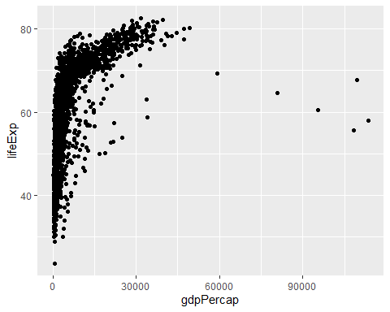

So the first thing we do is call the ggplot function. This function lets R know that we’re creating a new plot, and any of the arguments we give the ggplot function are the *global* options for the plot: they apply to all layers on the plot.

We’ve passed in two arguments to ggplot. First, we tell ggplot what data we want to show on our figure, in this example the gapminder data we read in earlier. For the second argument, we passed in the aes function, which tells ggplot how variables in the **data** map to *aesthetic* properties of the figure, in this case the **x** and **y** locations. Here we told ggplot we want to plot the “gdpPercap” column of the gapminder data frame on the x-axis, and the “lifeExp” column on the y-axis. Notice that we didn’t need to explicitly pass aes these columns (e.g. x = gapminder[, "gdpPercap"]), this is because ggplot is smart enough to know to look in the **data** for that column!

By itself, the call to ggplot isn’t enough to draw a figure:

ggplot(data = gapminder, mapping = aes(x = gdpPercap, y = lifeExp))

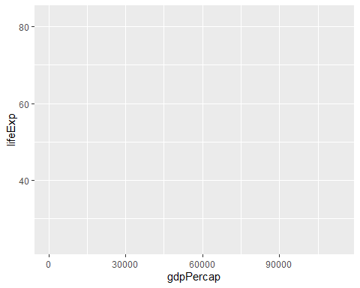

We need to tell ggplot how we want to visually represent the data, which we do by adding a new **geom** layer. In our example, we used geom_point, which tells ggplot we want to visually represent the relationship between **x** and **y** as a scatterplot of points:

ggplot(data = gapminder, mapping = aes(x = gdpPercap, y = lifeExp)) +  
 geom_point()



*Recap*: Every ggplot2 plot has three key components: (1) data, (2) set of aesthetic mappings between variables in the data and visual properties on the plot, and (3) at least one layer, created with a geom function.

## Challenge 1

Modify the example so that the figure shows how life expectancy has changed over time:

ggplot(data = gapminder, mapping = aes(x = gdpPercap, y = lifeExp)) + geom_point()

Hint: the gapminder dataset has a column called “year”, which should appear on the x-axis.

## Challenge 2

In the previous examples and challenge we’ve used the aes function to tell the scatterplot **geom** about the **x** and **y** locations of each point. Another *aesthetic* property we can modify is the point *colour*. Modify the code from the previous challenge to **colour** the points by the “continent” column. What trends do you see in the data? Are they what you expected?

## Layers

Using a scatterplot probably isn’t the best for visualizing change over time. Instead, let’s tell ggplot to visualize the data as a line plot:

ggplot(data = gapminder, mapping = aes(x = year, y = lifeExp, colour = continent)) +  
 geom_line()

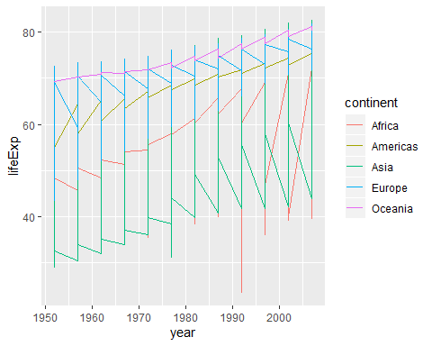

Instead of adding a geom_point layer, we’ve added a geom_line layer, however it looks like the lines are connecting the wrong points? We need to add the **group** *aesthetic*, which tells ggplot to draw a line for each country.

ggplot(data = gapminder, mapping = aes(x = year, y = lifeExp, colour = continent, group = country)) +  
 geom_line()

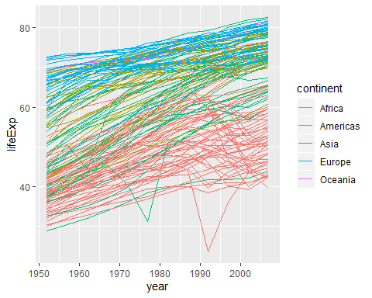

What if we want to visualize both lines and points on the plot? We can simply add another layer to the plot:

ggplot(data = gapminder, mapping = aes(x = year, y = lifeExp, colour = continent, group = country)) +  
 geom_line() + geom_point()

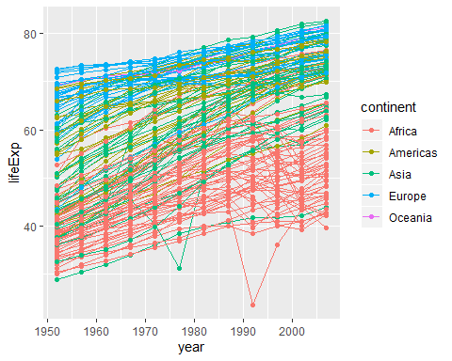

It’s important to note that each layer is drawn on top of the previous layer. In this example, the points have been drawn *on top of* the lines. Here’s a demonstration:

ggplot(data = gapminder, mapping = aes(x = year, y = lifeExp, group = country)) +  
 geom_line(mapping = aes(colour = continent)) + geom_point()

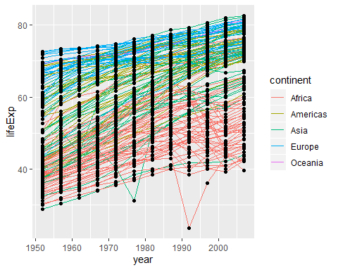

In this example, the *aesthetic* mapping of **colour** has been moved from the global plot options in ggplot to the geom_line layer so it no longer applies to the points. Now we can clearly see that the points are drawn on top of the lines.

## Tip: Setting an aesthetic to a value instead of a mapping

So far, we’ve seen how to use an aesthetic (such as **colour**) as a *mapping* to a variable in the data. For example, when we use geom_line(mapping = aes(colour = continent)), ggplot will give a different colour to each continent. But what if we want to change the colour of all lines to blue? You may think that geom_line(mapping = aes(colour = "blue")) should work, but it doesn’t. Since we don’t want to create a mapping to a specific variable, we simply move the colour specification outside of the aes() function, like this: geom_line(colour = "blue").

ggplot(data = gapminder, mapping = aes(x = year, y = lifeExp, group = country)) +  
 geom_line(colour = "blue") + geom_point()

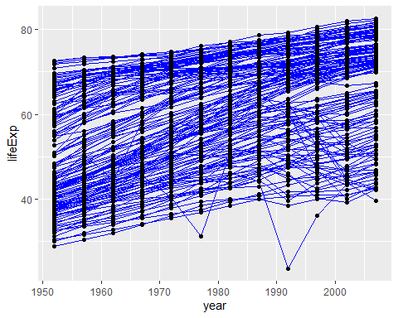

## Challenge 3

Switch the order of the point and line layers from the previous example. What happened?

## Transformations and statistics

ggplot2 also makes it easy to overlay statistical models over the data. To demonstrate we’ll go back to our first example:

ggplot(data = gapminder, mapping = aes(x = gdpPercap, y = lifeExp)) +  
 geom_point()



Currently it’s hard to see the relationship between the points due to some strong outliers in GDP per capita. We can change the scale of units on the x axis using the *scale* functions. These control the mapping between the data values and visual values of an aesthetic. We can also modify the transparency of the points, using the *alpha* function, which is especially helpful when you have a large amount of data which is very clustered.

ggplot(data = gapminder, mapping = aes(x = gdpPercap, y = lifeExp)) +  
 geom_point(alpha = 0.5) + scale_x_log10()

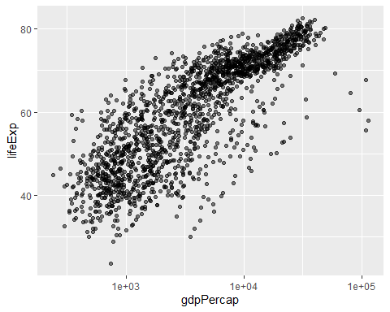

The log10 function applied a transformation to the values of the gdpPercap column before rendering them on the plot, so that each multiple of 10 now only corresponds to an increase in 1 on the transformed scale, e.g. a GDP per capita of 1,000 is now 3 on the y axis, a value of 10,000 corresponds to 4 on the y axis and so on. This makes it easier to visualize the spread of data on the x-axis.

## Tip Reminder: Setting an aesthetic to a value instead of a mapping

Notice that we used geom_point(alpha = 0.5). As the previous tip mentioned, using a setting outside of the aes() function will cause this value to be used for all points, which is what we want in this case. But just like any other aesthetic setting, *alpha* can also be mapped to a variable in the data. For example, we can give a different transparency to each continent with geom_point(mapping = aes(alpha = continent)). We can fit a simple relationship to the data by adding another layer, geom_smooth:

ggplot(data = gapminder, mapping = aes(x = gdpPercap, y = lifeExp)) +  
 geom_point() + scale_x_log10() + geom_smooth(method = "lm")

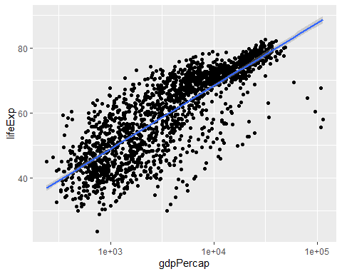

We can make the line thicker by *setting* the **size** aesthetic in the geom_smooth layer:

ggplot(data = gapminder, mapping = aes(x = gdpPercap, y = lifeExp)) +  
 geom_point() + scale_x_log10() + geom_smooth(method = "lm", size = 1.5)

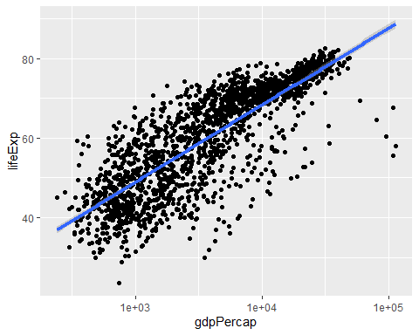

There are two ways an *aesthetic* can be specified. Here we *set* the **size** aesthetic by passing it as an argument to geom_smooth. Previously in the lesson we’ve used the aes function to define a *mapping* between data variables and their visual representation.

## Challenge 4a

Modify the colour and size of the points on the point layer in the previous example.

Hint: do not use the aes function.

## Challenge 4b

Modify your solution to Challenge 4a so that the points are now a different shape and are coloured by continent with new trendlines. Hint: The colour argument can be used inside the aesthetic.

## Multi-panel figures

Earlier we visualized the change in life expectancy over time across all countries in one plot. Alternatively, we can split this out over multiple panels by adding a layer of **facet** panels.

## Tip

We start by making a subset of data including only countries located in the Americas.

asia_oceania <- gapminder[gapminder$continent == c("Asia", "Oceania"),]  
# library(dplyr)  
# asia_oceania <- filter(gapminder, continent %in% c("Asia", "Oceania"))  
ggplot(data = asia_oceania, mapping = aes(x = year, y = lifeExp)) +  
 geom_line() +   
 facet_wrap( ~ country)

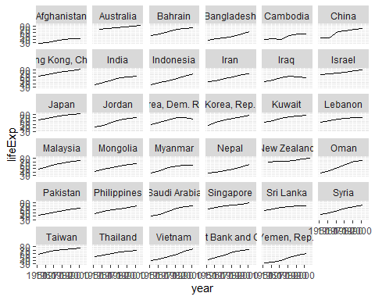

The facet_wrap layer took a “formula” as its argument, denoted by the tilde (~). This tells R to draw a panel for each unique value in the country column of the gapminder dataset.

## Modifying text

To clean this figure up for a publication we need to change some of the text elements. The x-axis is too cluttered, and the y axis should read “Life expectancy”, rather than the column name in the data frame.

We can do this by adding a couple of different layers. The **theme** layer controls the axis text, and overall text size. Labels for the axes, plot title and any legend can be set using the labs function. Legend titles are set using the same names we used in the aes specification. Thus below the colour legend title is set using colour = "Continent", while the title of a fill legend would be set using fill = "MyTitle".

ggplot(data = asia_oceania, mapping = aes(x = year, y = lifeExp, colour = continent)) +  
 geom_line() + facet_wrap( ~ country) +  
 labs(  
 x = "Year", # x axis title  
 y = "Life expectancy", # y axis title  
 title = "Figure 1", # main title of figure  
 colour = "Continent" # title of legend  
 ) +  
 theme(axis.text.x = element_text(angle = 90, hjust = 1),  
 plot.title = element_text(face = "bold"))

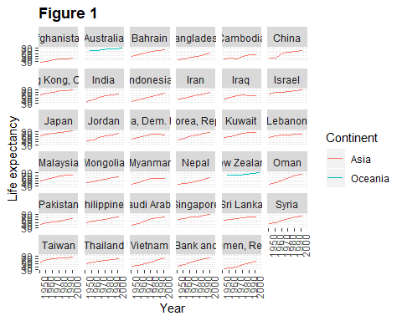

## Tip

Note that we apply a “theme” definition to rotate the x-axis labels to maintain readability. Nearly everything in ggplot2 is customizable.

## Exporting the plot

The ggsave() function allows you to export a plot created with ggplot. You can specify the dimension and resolution of your plot by adjusting the appropriate arguments (width, height and dpi) to create high quality graphics for publication. In order to save the plot from above, we first assign it to a variable lifeExp_plot, then tell ggsave to save that plot in png format to a directory called results. (Make sure you have a results/ folder in your working directory.)

lifeExp_plot <- ggplot(data = asia_oceania, mapping = aes(x = year, y = lifeExp, colour = continent)) +  
 geom_line() + facet_wrap( ~ country) +  
 labs(  
 x = "Year", # x axis title  
 y = "Life expectancy", # y axis title  
 title = "Figure 1", # main title of figure  
 colour = "Continent" # title of legend  
 ) +  
 theme(axis.text.x = element_text(angle = 90, hjust = 1),  
 plot.title = element_text(face = "bold"))  
ggsave(filename = "results/lifeExp.png", plot = lifeExp_plot, width = 18, height = 16, units = "cm")  
ggsave(filename = "results/lifeExp_widetv.png", plot = lifeExp_plot, width = 13.33, height = 7.5)

There are two nice things about ggsave. First, it defaults to the last plot, so if you omit the plot argument it will automatically save the last plot you created with ggplot. Secondly, it tries to determine the format you want to save your plot in from the file extension you provide for the filename (for example .png or .pdf). If you need to, you can specify the format explicitly in the device argument.

This is a taste of what you can do with ggplot2. RStudio provides a really useful [cheat sheet](http://www.rstudio.com/wp-content/uploads/2015/03/ggplot2-cheatsheet.pdf) of the different layers available, and more extensive documentation is available on the [ggplot2 website](http://docs.ggplot2.org/current/). Finally, if you have no idea how to change something, a quick Google search will usually send you to a relevant question and answer on Stack Overflow with reusable code to modify!

## Solution to challenge 1

Here is one possible solution:

ggplot(data = gapminder, mapping = aes(x = year, y = lifeExp)) + geom_point()

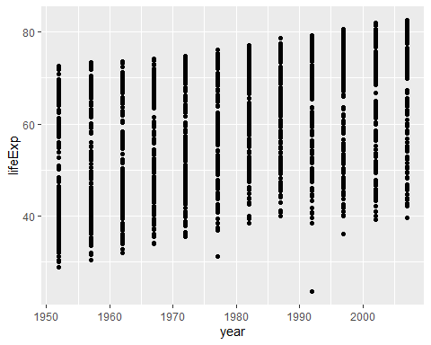

## Solution to challenge 2

In the previous examples and challenge we’ve used the aes function to tell the scatterplot **geom** about the **x** and **y** locations of each point. Another *aesthetic* property we can modify is the point *colour*. Modify the code from the previous challenge to **colour** the points by the “continent” column. What trends do you see in the data? Are they what you expected?

ggplot(data = gapminder, mapping = aes(x = year, y = lifeExp, colour = continent)) +  
 geom_point()

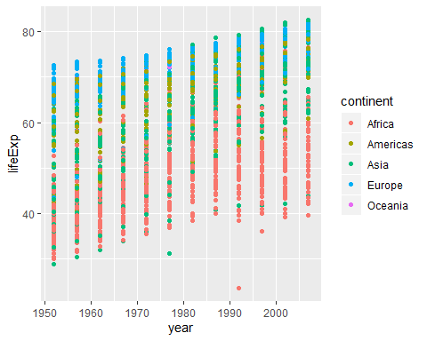

## Solution to challenge 3

Switch the order of the point and line layers from the previous example. What happened?

ggplot(data = gapminder, mapping = aes(x = year, y = lifeExp, group = country)) +  
 geom_point() + geom_line(mapping = aes(colour = continent))

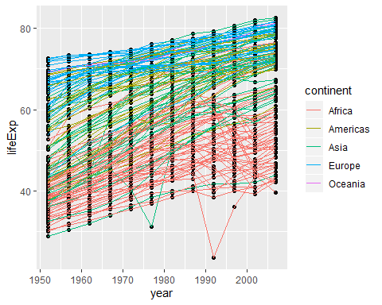

The lines now get drawn over the points!

## Solution to challenge 4a

Modify the colour and size of the points on the point layer in the previous example.

Hint: do not use the aes function.

ggplot(data = gapminder, mapping = aes(x = gdpPercap, y = lifeExp)) +  
 geom_point(size = 3, colour = "orange") + scale_x_log10() +  
 geom_smooth(method = "lm", size = 1.5)

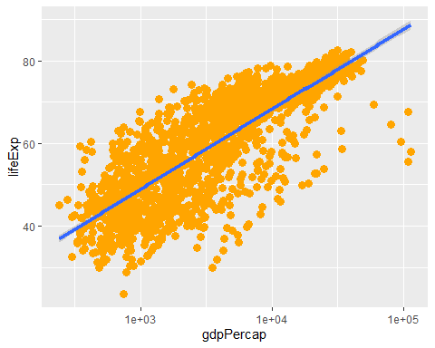

## Solution to challenge 4b

Modify Challenge 4 so that the points are now a different shape and are coloured by continent with new trendlines.

Hint: The colour argument can be used inside the aesthetic.

ggplot(data = gapminder, mapping = aes(x = gdpPercap, y = lifeExp, colour = continent)) +  
geom_point(size = 3, shape = 17) + scale_x_log10() +  
geom_smooth(method = "lm", size = 1.5)

