Animal Health Act (SBC 2014) c.16

**{d.LicenceHolderName}**

{d.MailingAddress}

{d.MailingCity}, {d.MailingProv}

{d.PostCode}

# Is issued a

## LIVESTOCK DEALER AGENT LICENCE

|  |  |  |  |  |  |
| --- | --- | --- | --- | --- | --- |
| **Licence Number:** | {d.LicenceNumber} | **Issued:** | {d.IssueDate} | **Expires:** | March 31, 2022 |

Agent For: {d.AgentFor}

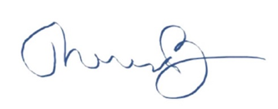

_______________________________­­­­­___

Dr. Theresa Burns, Chief Veterinarian