{d.ActsAndRegs}

**{d.LicenceHolderCompany}**

{d.LicenceHolderName}

{d.MailingAddress}

{d.MailingCity} {d.MailingProv}

{d.PostCode}

# Is issued a

## MEDICATED FEED LICENCE

|  |  |  |  |  |  |
| --- | --- | --- | --- | --- | --- |
| **Licence Number:** | {d.LicenceNumber} | **Issued:** | {d.IssueDate} | **Expires:** | {d.ExpireDate} |

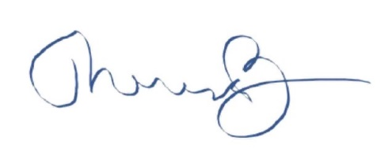

_______________________________­­­­­___

Dr. Theresa Burns, Chief Veterinarian