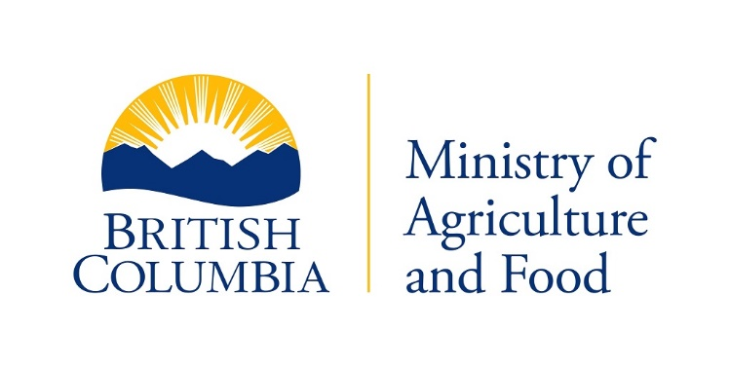

Livestock Health Management and Regulation

# PURCHASE LIVE POULTRY

# LICENCE RENEWAL 2022 – 2023

Under the authority of the *Animal Health Act* your licence to Purchase Live Poultry will expire on March 31st.

# PLEASE VERIFY THAT THE INFORMATION IS CORRECT AND NOTE CHANGES WHERE APPLICABLE

{d.LicenceHolderName}

{d.MailingAddress}

{d.MailingCity}, {d.MailingProv}

{d.PostCode}

Licence Number: {d.LicenceNumber}

Purchase Live Poultry Licence Fee...{d.LicenceFee}

The total value of live poultry purchased by the applicant from producers in the province of British Columbia during the two calendar years immediately previous to the date of this application:

Year ________ $ _____________; Year ________ $ ____________

The security for payment of money payable to a producer for poultry purchased by or through the applicant, in accordance with the security Bonding Act is as follows:

Bond No. {d.BondNumber} in the sum of {d.BondValue} Company Issuing Bond: {d.BondCarrier}

Date of bond in effect from _______________ to __________________.

A continuation copy of the bond or surety certificate must be faxed to this office when renewed each year.

An applicant for a licence to purchase live poultry shall furnish, and a holder of licence to purchase live poultry shall maintain, security in the form of a bond of a surety licensed under the Insurance Act, for the payment of money payable to a producer for live poultry purchased by or through the holder of a licence, in the following amounts:

1. For an annual purchase of $50,000. a bond of $5,000.00;
2. For an annual purchase of $50,000.00 to $1, 000, 000.00, a bond of $20,000.00;
3. For an annual purchase of more than $1, 000,000.00, a bond of $50,000.00

Signature: ___________________________ Date: ____________________

**Please make cheque or money order payable to the *Minister of Finance* and return this application/renewal notice to:**

### Ministry of Agriculture and Food

**Livestock Health Management and Regulation**

**1767 Angus Campbell Road Toll: 1 877-877-2474**

**Abbotsford, B.C. V3G 2M3 Tel: (778) 666-0560 Fax: (604) 556-3015**