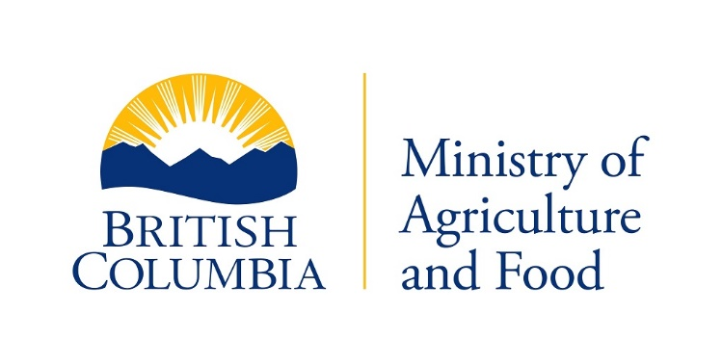

**VETERINARY DRUG DISPENSER**

**LICENCE RENEWAL NOTICE**

Name:  {d.LastFirstName}

Address:  {d.MailingAddress}

{d.MailingCity}, {d.MailingProv}

Postal Code:  {d.PostCode}

Phone:  {d.PhoneNumber}

Licence Number:  {d.LicenceNumber}

Associated Licencee: {d.AssocLic[0].CompanyName}

Our records indicate your Veterinary Drug Dispensing Licence expires on March 31st. To renew your licence you must re-write the Veterinary Drug Dispenser exam.

The exam is open book and 1.5 hours in duration. If you wish to take the bee products exam, an additional half hour will be allotted. You can contact our office by calling toll free 1-877-877-2474 or 778-666-0560 to schedule an exam.

The Veterinary Drug Dispenser License fee is $12.00 and is issued to eligible applicants over 18 years of age who have successfully passed an examination.

A copy of the study guide can be downloaded at:

<https://www2.gov.bc.ca/assets/gov/farming-natural-resources-and-industry/agriculture-and-seafood/animal-and-crops/agricultural-licenses-and-forms/rua_-_vddl_handbook.pdf>

**Ministry of Agriculture and Food**

**Livestock Health Management and Regulation**

**1767 Angus Campbell Road**

**Abbotsford, B.C. V3G 2M3**

**Toll: 1-877-877-2474**

**Tel: 778-666-0560**