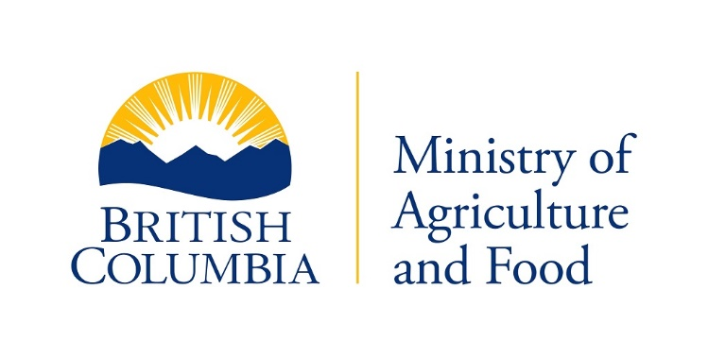

**Plant and Animal Health Branch**

Livestock Health Management and Regulation

{d.CurrentDate}

{d.IRMA_Num}

REGISTERED

{d.LicenceHolderCompany}

{d.MailingAddress}

{d.MailingCity}, {d.MailingProv}, {d.PostCode}

Recent milk quality testing for extraneous water, as required by the Milk Industry Standards Regulation, indicated that two or more test results exceeded the maximum allowable level of water (3.7%) in {d.DairyTestDataLoadDate}.

The average of the test results exceeding 3.7%, determined with a Milkoscann 6000 (FOSS) instrument resulted in a freezing point equivalent to {d.DairyTestCryoPercent}.

Subsequent infractions over the tolerance level of 3.7% within a 12 month period will result in a cash penalty being applied.

Sincerely,

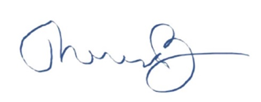

Dr. Theresa Burns

Chief Veterinarian

Ministry of Agriculture and Food Telephone: (778) 666-0560

1767 Angus Campbell Road Fax: (604) 556-3015

Abbotsford, B.C. V3G 2M3 Toll Free: 1-877-877-2474