Under the authority of the *Animal Health Act* and s.9(2) of the Poultry Health and Buying Regulation

**{d.LicenceHolderName}**

{d.MailingAddress}

{d.MailingCity} {d.MailingProv}

{d.PostCode}

# Is issued a

## {d.LicenceName} LICENCE

|  |  |  |  |  |  |
| --- | --- | --- | --- | --- | --- |
| **Licence Number:** | {d.LicenceNumber} | **Issued:** | {d.IssueDate} | **Expires:** | {d.ExpiryDate} |

## Details

|  |  |  |  |  |  |
| --- | --- | --- | --- | --- | --- |
| **Bond Number:** | {d.BondNumber} | **Bond Value:** | {d.BondValue} | **Bond Carrier:** | {d.BondCarrier} |

Business Address {d.BusinessAddressLocation}

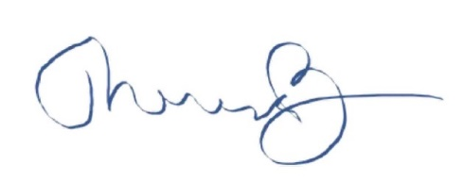

_______________________________­­­­­___

Dr. Theresa Burns, Chief Veterinarian