

**Plant and Animal Health Branch**

### Livestock Health Management and Regulation

## SUSPENSION OF DAIRY FARM LICENCE

MILK INDUSTRY ACT

{d.CurrentDate}

{d.IRMA_Num}

REGISTERED

{d.LicenceHolderCompany}

{d.MailingAddress}

{d.MailingCity}, {d.MailingProv}, {d.PostCode}

You are hereby advised that your dairy farm premises at {d.SiteDetails}, under the authority of the regulations under the Milk Industry Act, chapter 289, and the amendments thereto, your dairy farm license, dated {d.IssueDate} is hereby suspended until the defect(s) listed below are corrected:

* **Milk Industry Act, Standards Regulation, excessive Water Dilution, minimum 4-day suspension from ____________________ to ____________________ inclusive, or until bulk tank is <3.7% water dilution**.

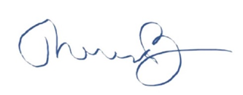

____________________________

Dr. Theresa Burns

Chief Veterinarian

Copy: Producer File

Milk Board

________________________________________________________________________________________

Ministry of Agriculture and Food Tel: (778) 666-0560

1767 Angus Campbell Road Toll Free: 1-877-877-2474

Abbotsford, B.C. V3G 2M3 Fax: (604) 556-3015