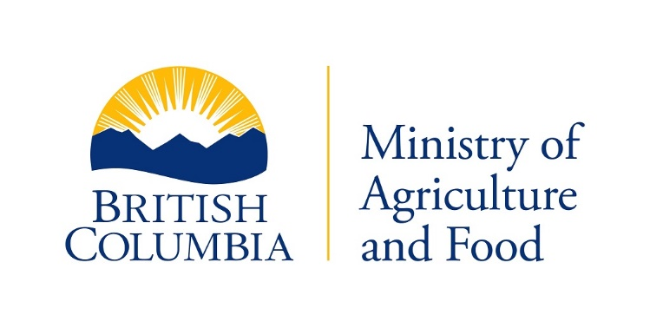

Plant and Animal Health Branch

Livestock Health Management and Regulation

{d.CurrentDate}

{d.IRMA_Num}

{d.LicenceHolderCompany}

{d.MailingAddress}

{d.MailingCity}, {d.MailingProv}, {d.PostCode}

# Warning - Excessive Individual Bacteria Content

Results of testing of samples taken from your milk shipments, reported on {d.ReportedOnDate} and graded for total individual bacterial content (IBC) in accordance with the regulations under the *Milk Industry Act*, OIC 156, indicated an average IBC of {d.DairyTestIBC} per millilitre.

A second bacterial infraction within a 12 month period will result in a cash penalty of 2% of the gross value for all milk shipped by you during the month. A third bacterial infraction in a 12 month period will result in a cash penalty of 4% of the gross value for all milk shipped during the month. The continued shipment of substandard milk will result in a suspension.

Regards,

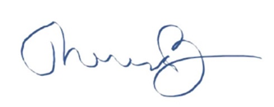

Dr. Theresa Burns

Chief Veterinarian

Ministry of Agriculture and Food Telephone: (778) 666-0560

1767 Angus Campbell Road Fax: (604) 556-3015

Abbotsford, B.C. V3G 2M3 Toll Free: 1-877-877-2474