Animal Health Act (SBC 2014) c.16

{d.LicenceHolderName}

{d.MailingAddress}
{d.MailingCity}, {d.MailingProv}
{d.PostCode}

Is issued a

LIVESTOCK DEALER AGENT LICENCE
Licence Number: | {d.LicenceNumber} | Issued: | {d.IssueDate} | Expires: | {d.ExpiryDate}
Agent For: {d.AgentFor}

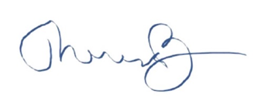
__________________________________
Dr. Theresa Burns, Chief Veterinarian

