{d.ActsAndRegs}

{d.LicenceHolderName}

{d.MailingAddress}
{d.MailingCity} {d.MailingProv}
{d.PostCode}

Is issued a

{d.LicenceName} LICENCE
Licence Number: | {d.LicenceNumber} | Issued: | {d.IssueDate} | Expires: | {d.ExpiryDate}

Details
SPECIES: {d.Species}

Site Information
Legal Description: {d.LegalDescription}
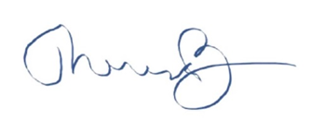
__________________________________
Dr. Theresa Burns, Chief Veterinarian

