{d.ActsAndRegs}

{d. LicenceHolderCompany}

{d.MailingAddress}
{d.MailingCity} {d.MailingProv}
{d.PostCode}

Is issued a

{d.LicenceName} LICENCE
Licence Number: | {d.LicenceNumber} | Issued: | {d.IssueDate} | Expires: | {d.ExpiryDate}

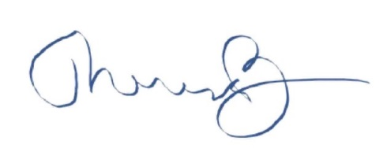
__________________________________
Dr. Theresa Burns, Chief Veterinarian

