{d.ActsAndRegs}

{d.LicenceHolderCompany}
{d.LicenceHolderName}, {d.LicenceHolderTitle}
{d.MailingAddress}
{d.MailingCity} {d.MailingProv}
{d.PostCode}

Is issued a

{d.LicenceName} LICENCE
Licence Number: | {d.LicenceNumber} | Issued: | {d.IssueDate} | Re-Issued | {d.ReIssueDate}

Details
{d.SiteDetails}

Site Information
Tank: {d.SiteInformation[i].DairyTankCompany} Serial No. {d.SiteInformation[i].DairyTankSN} Model: {d.SiteInformation[i].DairyTankModel} Capacity: {d.SiteInformation[i].DairyTankCapacity} Calibration date: {d.SiteInformation[i].DairyTankCalibrationDate}

Tank: {d.SiteInformation[i+1].DairyTankCompany} Serial No. {d.SiteInformation[i+1].DairyTankSN} Model: {d.SiteInformation[i+1].DairyTankModel} Capacity: {d.SiteInformation[i+1].DairyTankCapacity} Calibration date: {d.SiteInformation[i+1].DairyTankCalibrationDate}

{d.IRMA_Num}
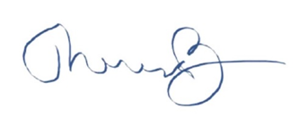
__________________________________
Dr. Theresa Burns, Chief Veterinarian

