{d.ActsAndRegs}

**{d.LicenceHolderName}**

{d.MailingAddress}

{d.MailingCity} {d.MailingProv}

{d.PostCode}

# Is issued a

## {d.LicenceName} LICENCE

|  |  |  |  |  |  |
| --- | --- | --- | --- | --- | --- |
| **Licence Number:** | {d.LicenceNumber} | **Issued:** | {d.IssueDate} | **Expires:** | {d.ExpiryDate} |

## Details

SPECIES: {d.Species}

## Site Information

Site Details: {d.SiteDetails}

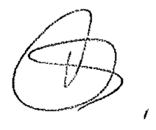

_______________________________­­­­­___

Dr. Rayna Gunvaldsen, Chief Veterinarian