***A picture containing text

***

**Plant and Animal Health Branch**

Livestock Health Management and Regulation

{d.CurrentDate}

{d.IRMA_Num}

REGISTERED

{d.LicenceHolderCompany}

{d.MailingAddress}

{d.MailingCity} {d.MailingProv} {d.PostCode}

A recent test for extraneous water, as required by the Milk Industry Standards Regulation, indicated there may be added water in your milk supply reported on {d.DairyTestDataLoadDate}.

Your milk had a freezing point equivalent to {d.DairyTestCryoPercent} added water, which was determined with a Milkoscann 6000 (FOSS) instrument.

Subsequent infractions over the tolerance level of 3.7% within a 12 month period will result in a cash penalty being applied.

Sincerely,

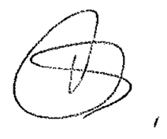

Dr. Rayna Gunvaldsen

Chief Veterinarian

Ministry of Agriculture, Food and Fisheries Telephone: (778) 666-0560

1767 Angus Campbell Road Fax: (604) 556-3015

Abbotsford, B.C. V3G 2M3 Toll Free: 1-877-877-2474