Skeena Caribou Population Mortality Count

Aubertin-Young, Macgregor WLRS:EX

September 21, 2023

Species Inventory Management System Data Citation:

Project ID 2, Survey ID 2

# Introduction

## Background

## Objectives

# Methods

## Study Area

Insert description here

## Warning: attribute variables are assumed to be spatially constant throughout all geometries

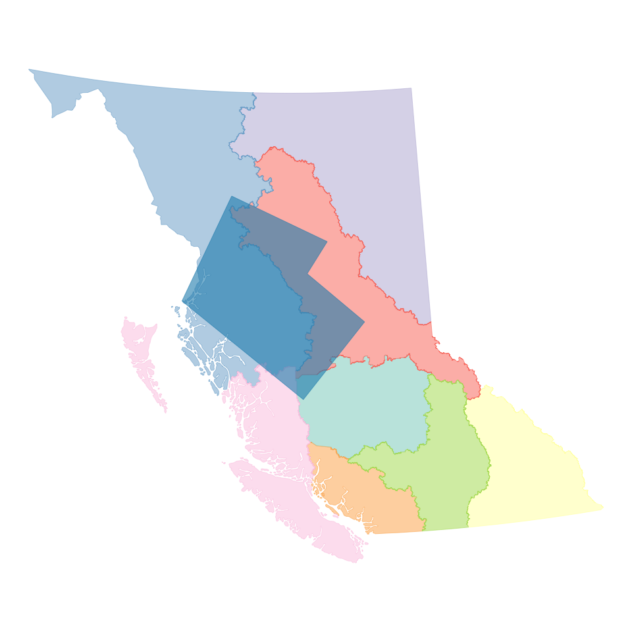

sa_bbox <- study_area_proj |> st_bbox()  
  
study_area <- study_area_bc +  
 coord_sf(xlim = c(sa_bbox[1], sa_bbox[3]),  
 ylim = c(sa_bbox[2], sa_bbox[4]))  
  
study_area

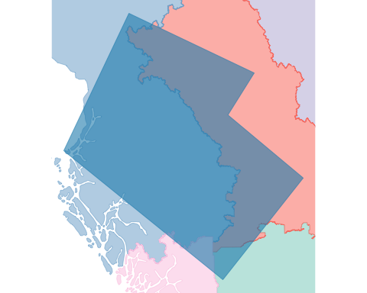

## Survey Design

## Analysis

# Results

# Discussion

# Conclusion