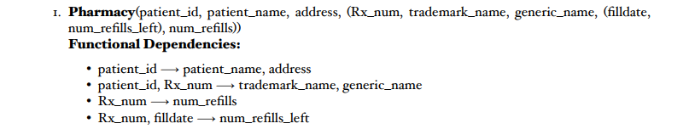

1. Is this relation in 1NF? If not, write an explanation of why it isn’t, then make the necessary change to fix it.

**No, this relation is not in 1NF. There are multiple non atomic attributes. One patient has multiple *Rx_num*, and one *Rx_num* has multiple *filldate.***

Schema(First Normal Form):

**Pharmacy** (Patient_id, patient_name, address, Rx_num, trademark_name, generic_name, Filldate, num_refills)

1. Is this relation in 2NF? If not, write an explanation of why it isn’t, then make the necessary change to fix it.

**Not quite, for the relation to be in 2NF all the non-prime attributes of the relation have to fully depend upon the entire primary key which there not.**

Schema(Second Normal Form):

**Patient** (Patient_id, patient_name, address)

**Recipe** (Patient_id, Rx_num, trademark_name, generic_name)

**Refill** (Rx_num, num_refills)

**RefDate** (Rx_num, filldate, num_refills)

1. Is this relation in 3NF? If not, write an explanation of why it isn’t, then make the necessary change to fix it.

**Doing the 2NF was enough, as there is no transitive dependency**

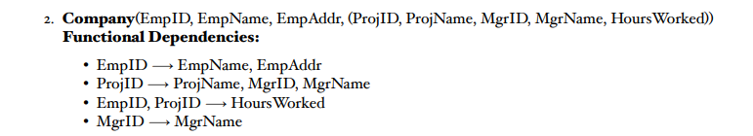

1. Is this relation in 1NF? If not, write an explanation of why it isn’t, then make the necessary change to fix it.

**No, this relation is not in 1NF. There are multiple non atomic attributes. One employee can have multiple projects and have different managers for different projects.**

Schema (First Normal Form):

**Company** (EmpID, EmpName, EmpAddr, ProjID, ProjName, MgrID, MgrName, HoursWorked)

1. Is this relation in 2NF? If not, write an explanation of why it isn’t, then make the necessary change to fix it.

**No, to make this relation to be in 2NF all the non-prime attributes must fully depend upon the entire primary key, which in our relation they do not.**

Schema (Second Normal Form):

**Employee** (EmpID, EmpName, EmpAddr, ProjID)

**Projects** (ProjID, ProjName, MgrName, MgrID)

**Time** (EmpID, ProjID, HoursWorked)

**Supervisor** (MgrID, MgrName)

1. Is this relation in 3NF? If not, write an explanation of why it isn’t, then make the necessary change to fix it.

**Doing the 2NF was enough, as there is no transitive dependency**

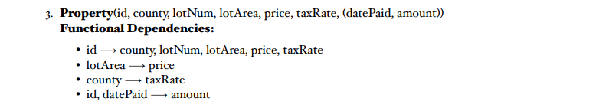

1. Is this relation in 1NF? If not, write an explanation of why it isn’t, then make the necessary change to fix it.

**No, in order to be in 1NF we need remove any repeating cell. We have many different datePaid for one property, which is a violation of 1NF. We need to find an appropriate primary key that will functionally determine all the other attributes.**

Schema (First Normal Form):

**Property** (ID, country, lotNum, lotArea, price, taxRate, datePaid, amount)

1. Is this relation in 2NF? If not, write an explanation of why it isn’t, then make the necessary change to fix it.

**No, not yet. We need to create the attribute to depend upon the entire primary key ID not only a part. We can fix that by doing decomposition.**

Schema (Second Normal Form):

**Location**(ID, country, lotNum, lotArea, price, taxRate)

**Payment** (ID, datePaid, amount,)

1. Is this relation in 3NF? If not, write an explanation of why it isn’t, then make the necessary change to fix it.

**No, this relation is not in 3NF due to having non-prime (lotArea, country) attribute that are functionally dependent upon the primary key. To fix this, I looked at the functional dependencies and looked on the LHS for the attributes that are non-prime in the context of the correct relation. In this attribute -> lotArea, country**

Schema (Third Normal Form):

**Location** (ID, country, lotNum, lotArea)

**Payment** (ID, datePaid, amount)

**AreaPrice** (lotArea, price)

**TaxRate** (country taxRate)

1. Is this relation in 1NF? If not, write an explanation of why it isn’t, then make the necessary change to fix it.

**Yes, the table looks right without multiple values in a single cell. One stock exchange per company. But, there isn’t any keys available yet.**

**StockExchange** (Company, Symbol, HQ, Date, ClosePrice)

1. Is this relation in 2NF? If not, write an explanation of why it isn’t, then make the necessary change to fix it. But WITHOUT keys

**No, the attributes need to depend upon the entire primary key not just part of the primary key. Need to identify keys!**

Schema (Second Normal Form):

**StockExchange** (Company, Symbol, HQ, Date, ClosePrice)

1. Is this relation in 3NF? If not, write an explanation of why it isn’t, then make the necessary change to fix it.

**No, the relation is not in 3NF due to existing transitive dependencies. We need to use composition in order to address this violation.**

Schema (Third Normal Form):

**Info** (Symbol, Date, Company, HQ, ClosePrice)

**Logo** (Company, HQ)

**MainOffices** (Symbol, HQ