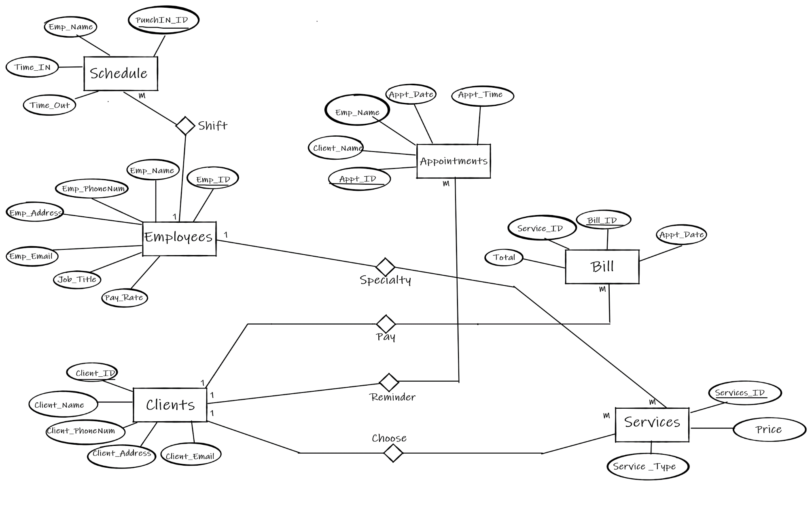**Serenity Springs Day Spa ER Diagram**

**Entities**

Clients

Employees

Schedule

Appointments

Bill

Services

**Attributes**

Entity -> Clients

**Attributes**: Client_ID, Client_Name, Client_PhoneNum, Client_Address, Client_Email

Entity -> Employees

**Attributes**: Emp_ID, Emp_Name, Emp_PhoneNum, Emp_Address, Emp_Email, Job_Title, Pay_Rate

Entity -> Appointments

**Attributes**: Appt_ID, Client_Name, Emp_Name, Appt_Date, Appt_Time

Entity -> Schedule

**Attributes**: PunchIn_ID, Emp_Name, Time_In, Time_out

Entity -> Bill

**Attributes**: Bill_ID, Service_ID, Total, Appt_Date

Entity -> Services

**Attributes**: Services_ID, Price, Service_Type

**Relationships**

Clients and Services => One – to – Many (Choose)

Clients and Appointments => One – to – Many (Visit)

Clients and Bill => One – to – Many (Pay)

Employees and Services => One – to – Many (Specialty)

Employees and Schedule => One – to – Many (Shift)

**Relational Schema**

1a. **Entities** -> Clients, Employees, Schedule, Appointments, Bill, Services

**Clients** (Client_ID, Client_Name, Client_PhoneNum, Client_Address, Client_Email)

**Employees** (Emp_ID, Emp_Name, Emp_PhoneNum, Emp_Address, Emp_Email, Job_Title, Pay_Rate)

**Appointments** (Appt_ID, Client_Name, Emp_Name, Appt_Date, Appt_Time)

**Schedule** (PunchIn_ID, Emp_Name, Time_In, Time_out)

**Bill** (Bill_ID, Service_ID, Total, Client_ID, Appt_Date)

**Service** (Service_ID, Price, Service_Type)

1b. **Strong Entities that are Subtypes**

1c. **No weak entities**

2a. One – to – One relationships -> **None**

2b. One – to – Many relationships -> **Services, Appointments, Bill, Schedule**

**Services** (Services_ID, Price, Service_Type, *Client_ID†*)

**Appointments** (Appt_ID, Client_Name, Emp_Name, Appt_Date, Appt_Time, *Client_ID†*)

**Bill** (Bill_ID, Service_ID, Total, Client_ID, Appt_Date, *Client_ID†*)

**Schedule** (PunchIn_ID, Emp_Name, Time_In, Time_out, Emp_ID*†*)

2c. Many – to – many relationships **None**

**Final Schema**

**Clients** (Client_ID, Client_Name, Client_PhoneNum, Client_Address, Client_Email)

**Employees** (Emp_ID, Emp_Name, Emp_PhoneNum, Emp_Address, Emp_Email, Job_Title, Pay_Rate)

**Services** (Services_ID, Price, Service_Type, *Client_ID†*)

**Appointments** (Appt_ID, Client_Name, Emp_Name, Appt_Date, Appt_Time, *Client_ID†*)

**Bill** (Bill_ID, Service_ID, Total, Appt_Date, *Client_ID†*)

**Schedule** (PunchIn_ID, Emp_Name, Time_In, Time_out, Emp_ID*†*)

**Keys and Foreign Keys**

Underline = Primary Key

*Italics†*  = Foreign Key