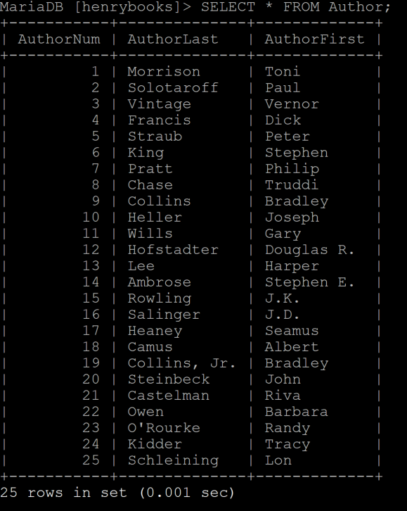**Author Table**

**Books Table** 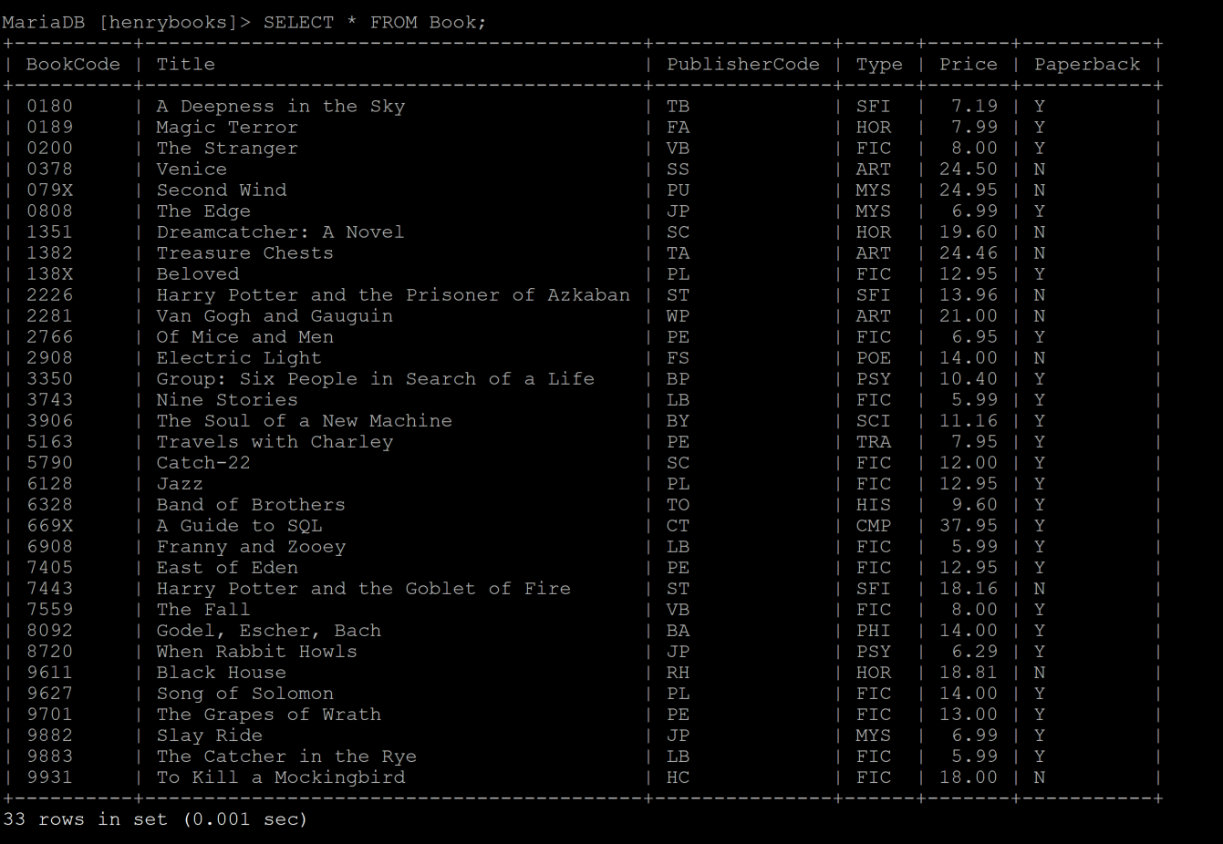

**• The user will search through a list of workouts to find the one closest to the one they’re going to do, in order to track the activity**

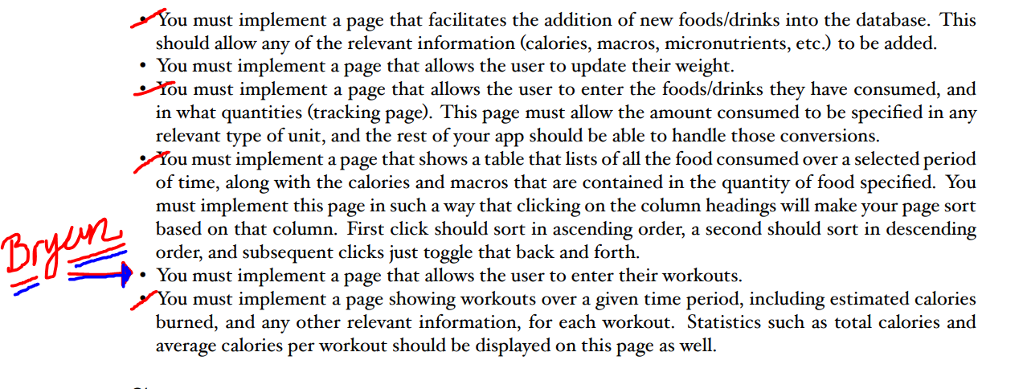

**• The user will search through a list of workouts to find the one closest to the one they’re going to do, in order to track the activity**

**Drop down -> cardio and strength**

**SELECT**

        echo "<datalist id=\"timingList\">";

            echo "<option value=\"15:00\>";

            echo "<option value=\"25:00\>";

            echo "<option value=\"35:00\>";

            echo "<option value=\"45:00\>";

            echo "<option value=\"55:00\>";

            echo "<option value=\"23:59:59.999\>";

        echo "</datalist>";

list=\"timingList\"