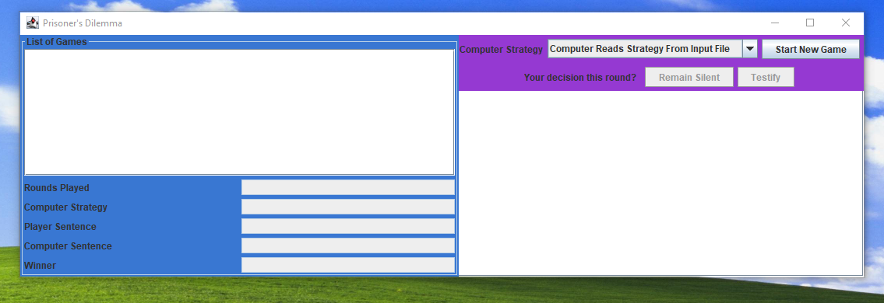**No data entered yet, just run program**



**User press button “Start New Game,” Computer Strategy “Computer Reads Strategy From Input File.” User press buttons “Remain Silent” and “Testify.”**

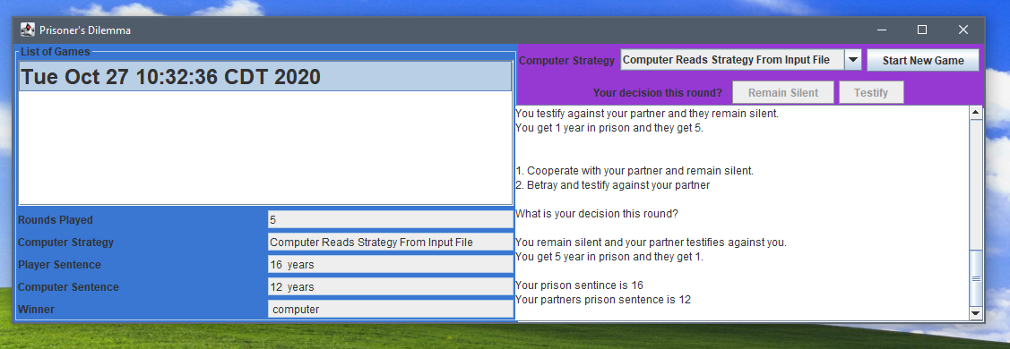



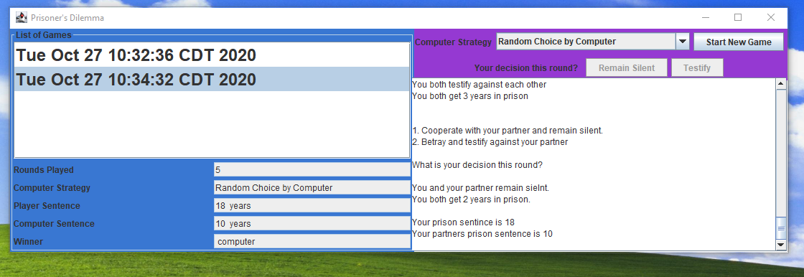**User pressed “Start New Game” and will start another game. The list of the games will be displayed and the top left. The Computer Strategy has been changed to “Random Choice by Computer”**



**Lets play one more game, Computer Strategy is “Tit-For-Tat.”**

