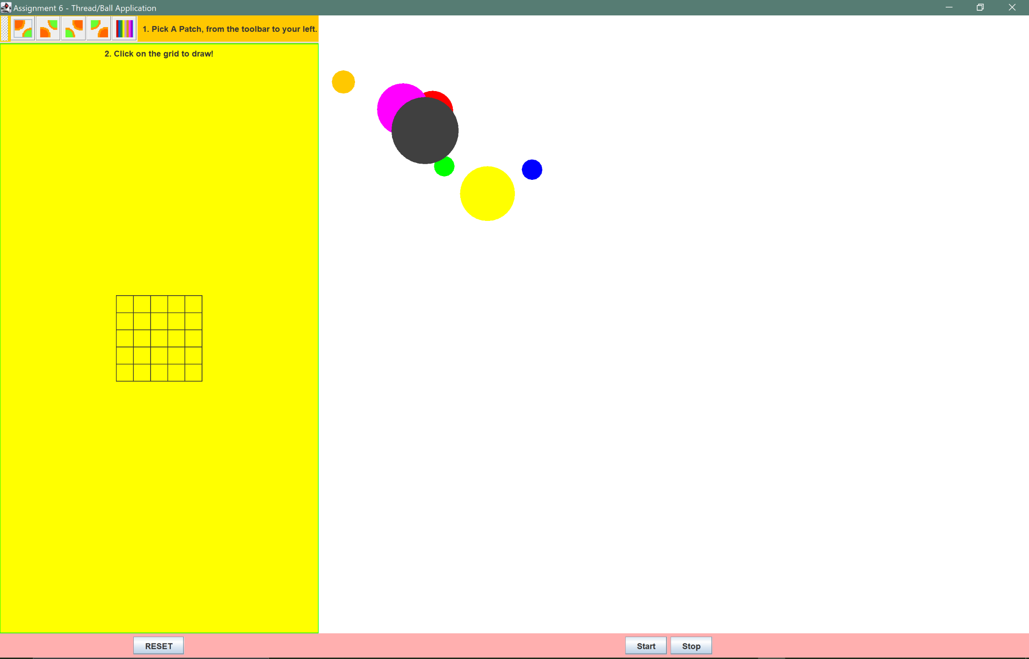**Assignment06 Output**

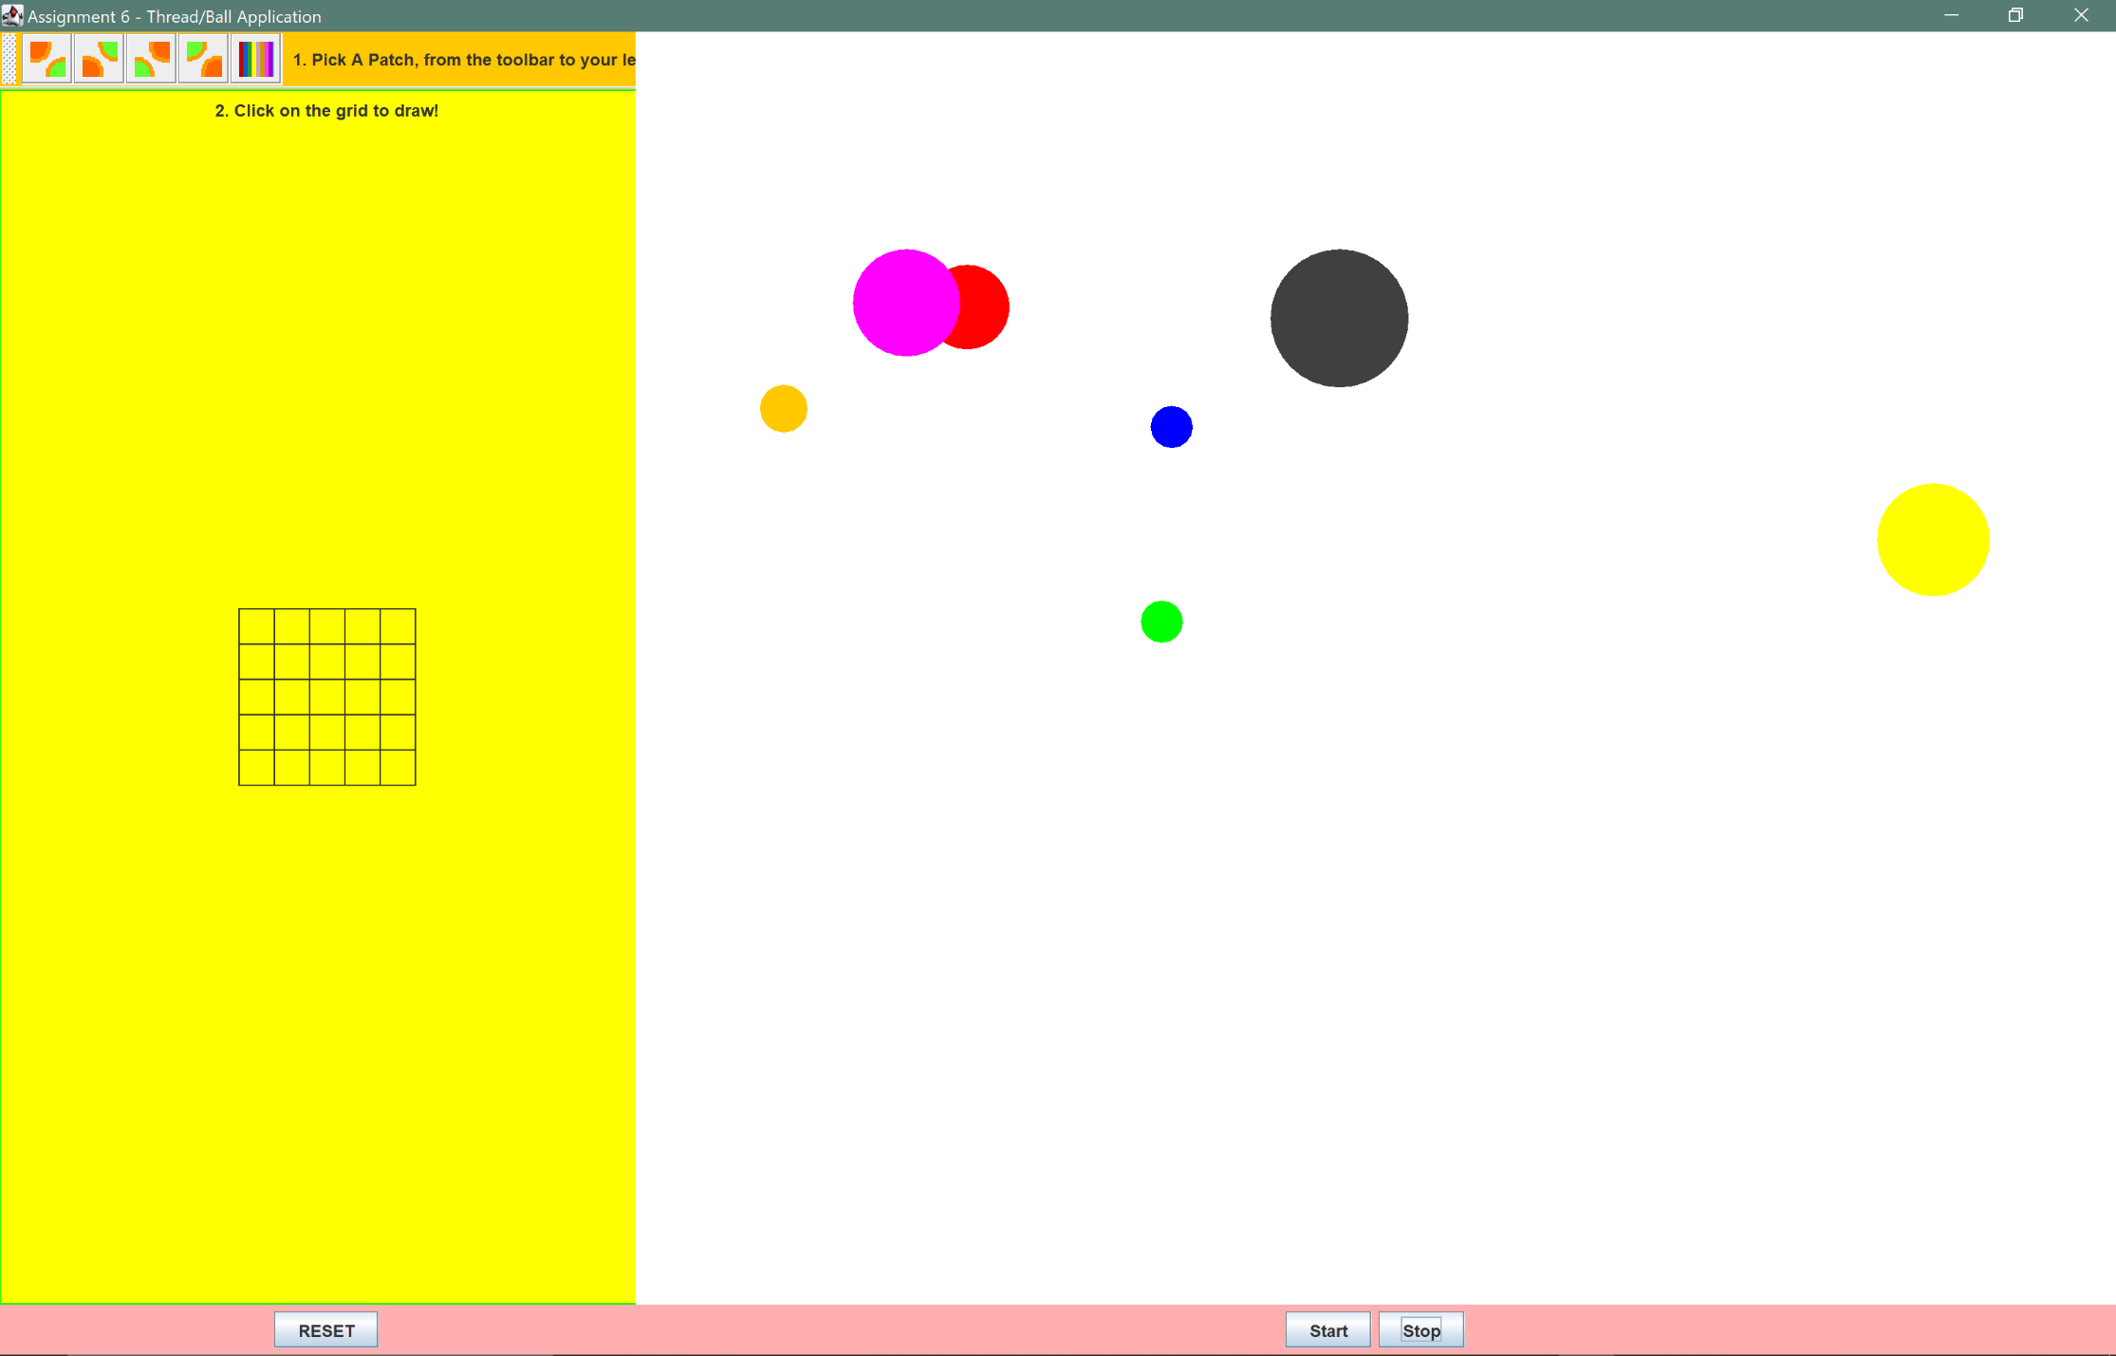**the “start” button has been press, the possition of the balls have moved.**

**The button “stop” has been press. The position of the balls stop while we can draw on the left-hand side**

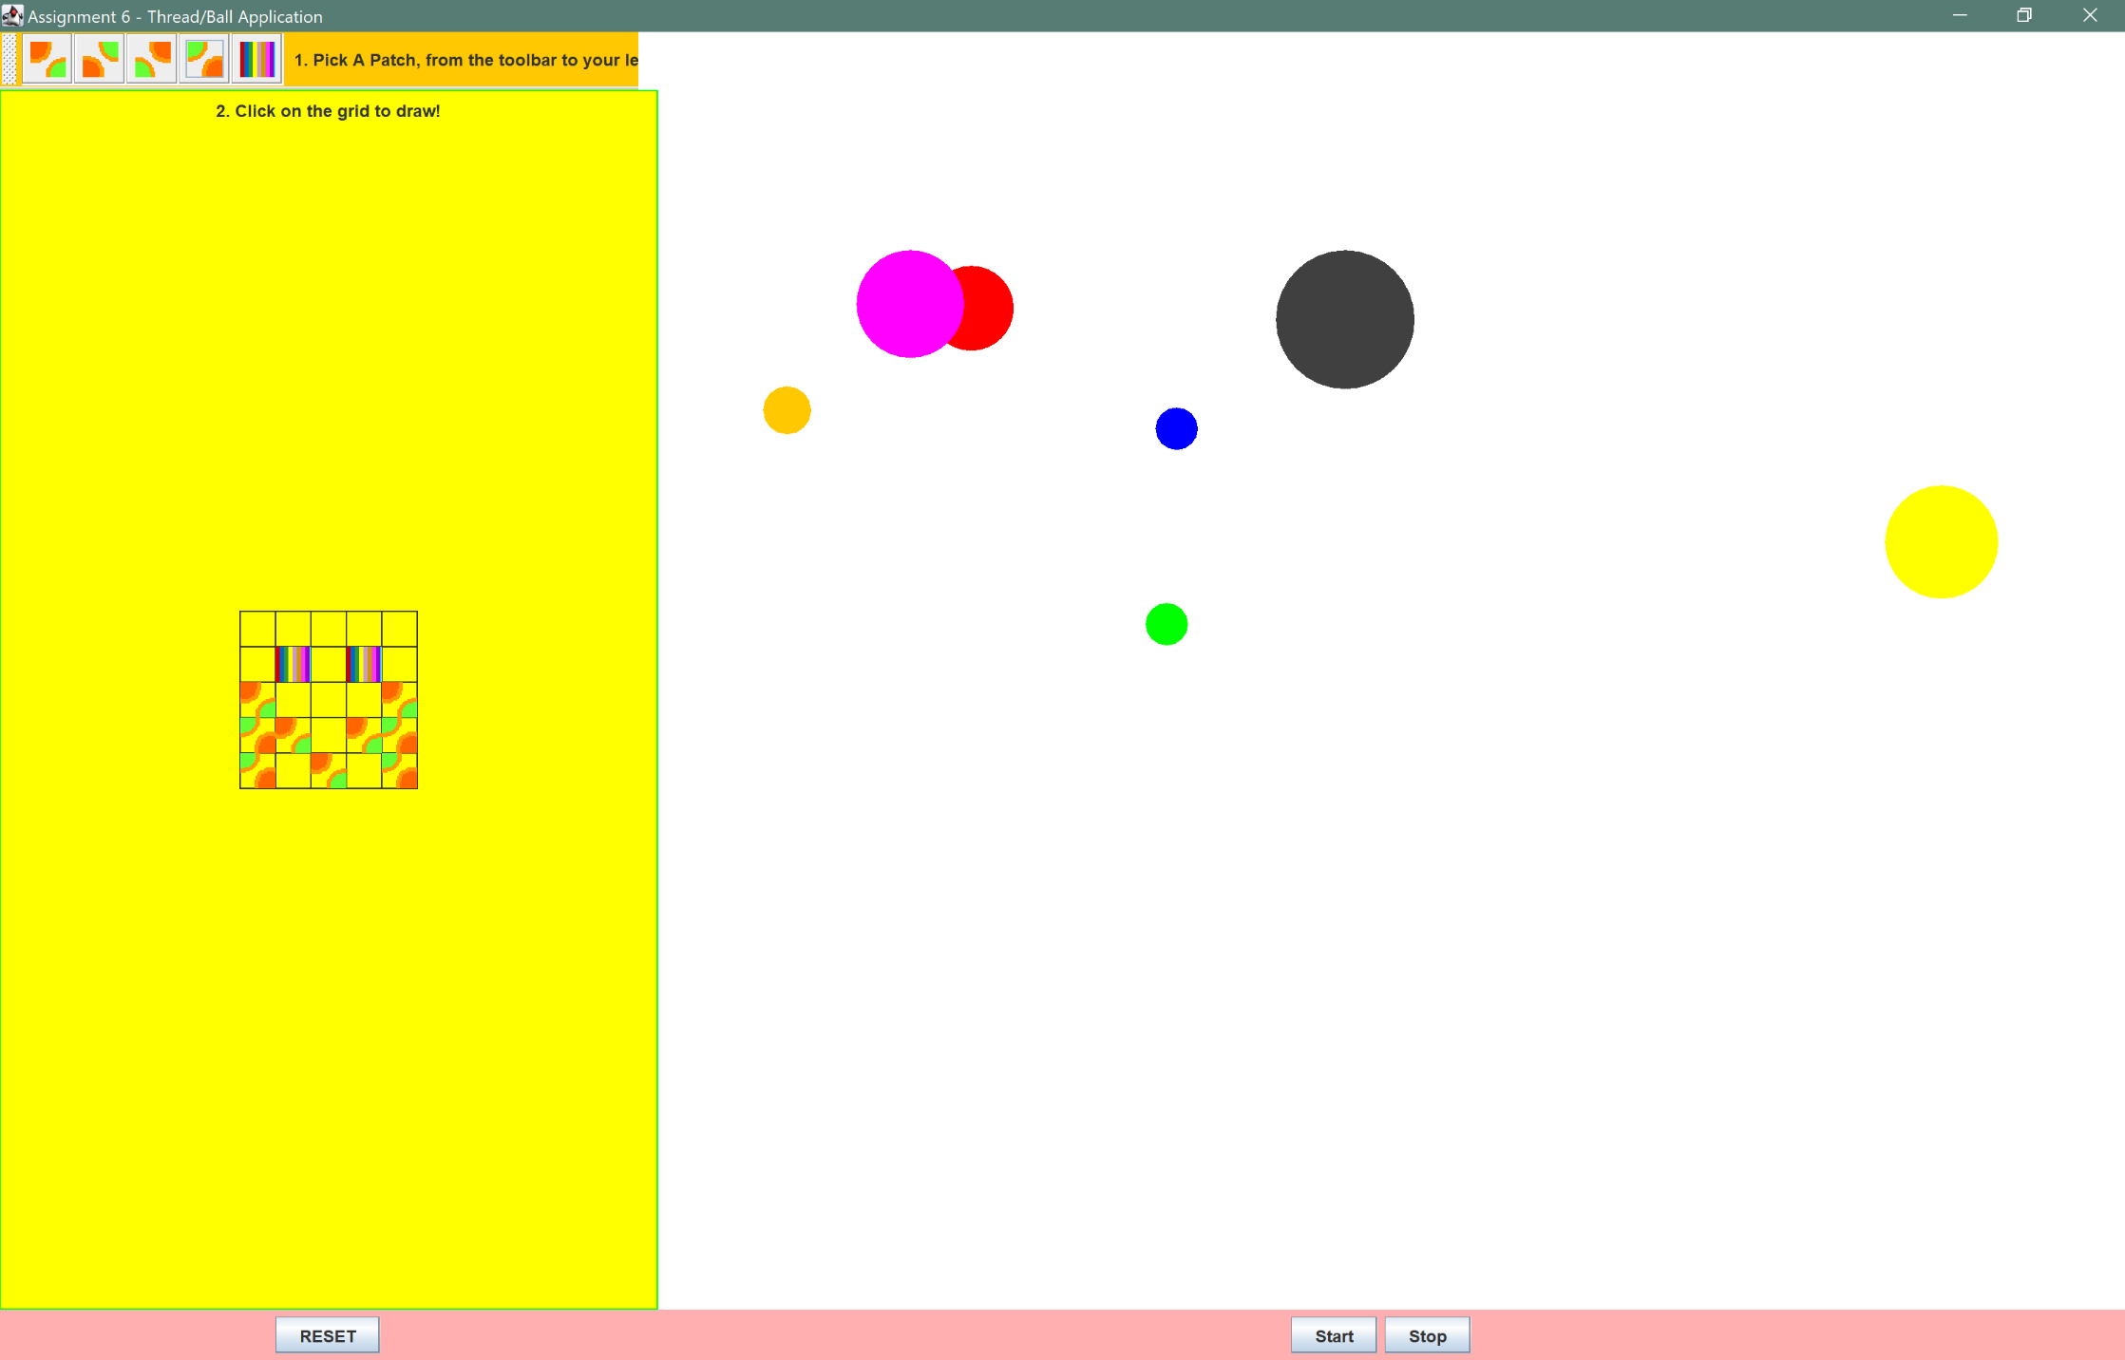

**The “start” has been pressed once again with a painting on the left-hand side**

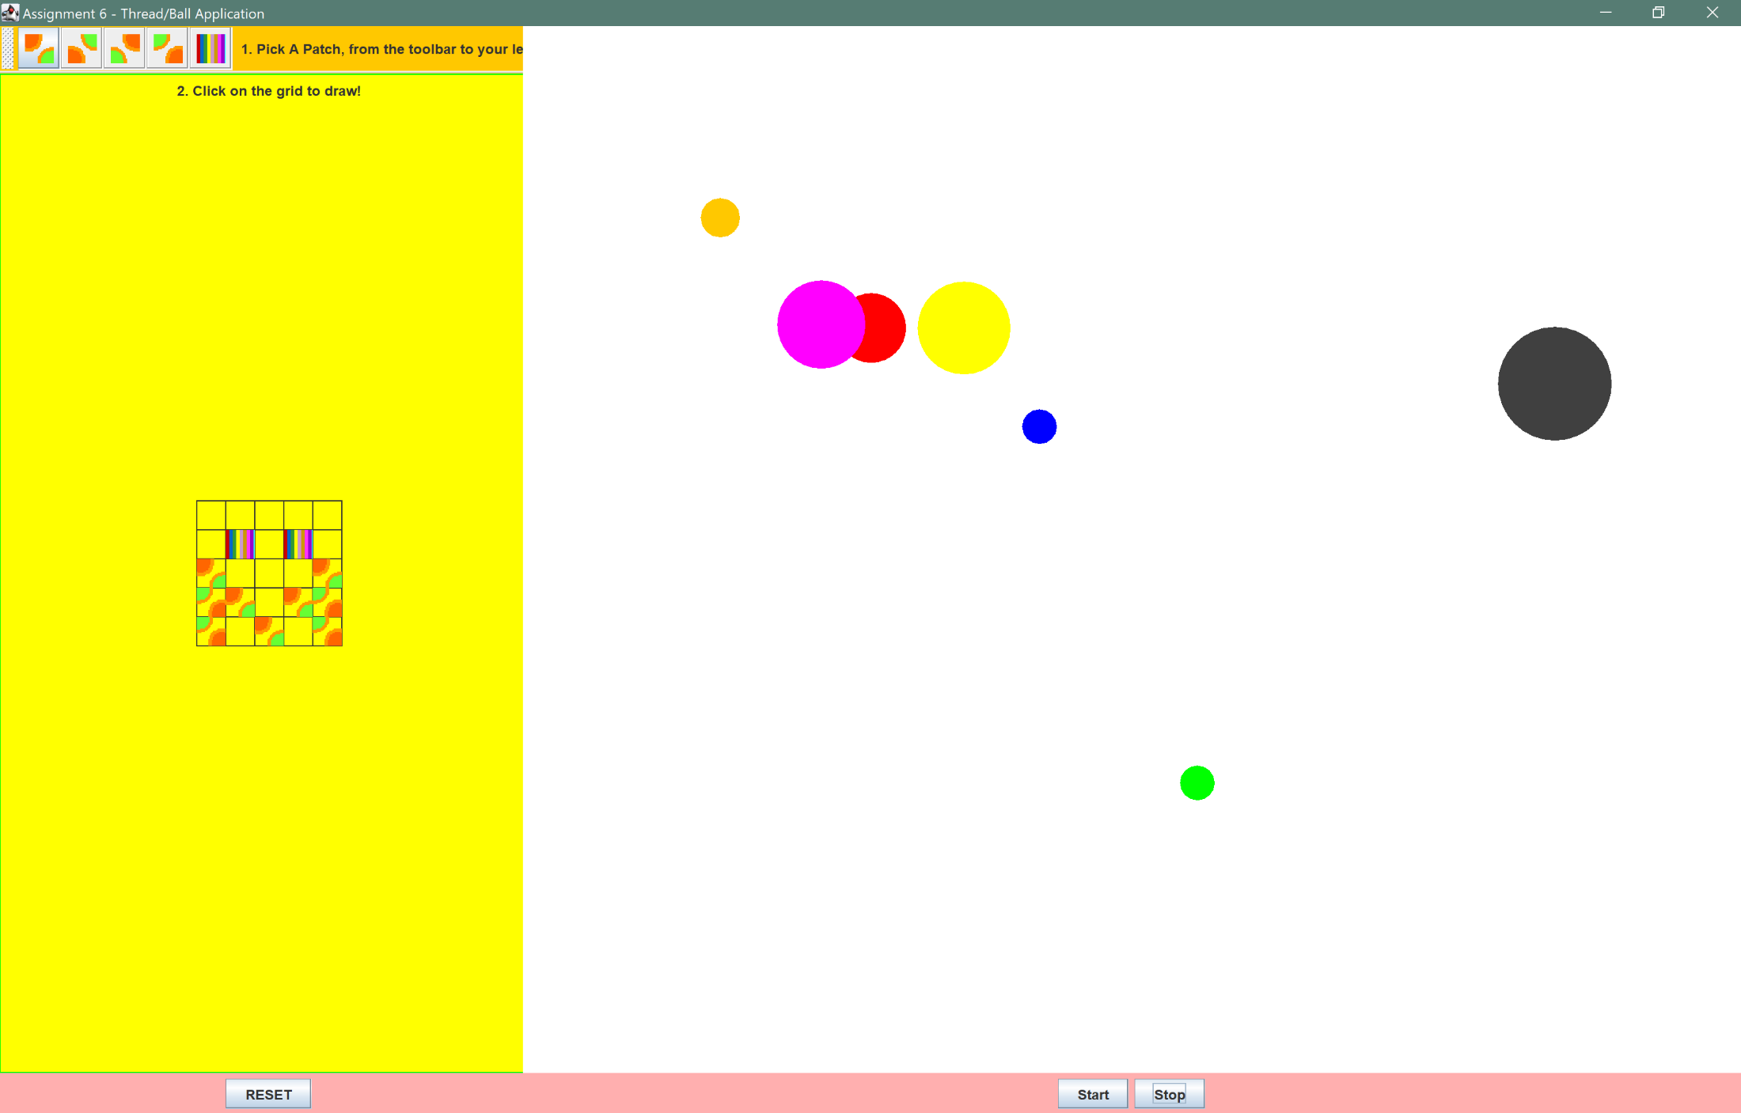

**The “reset” button has been pressed on the left-hand side the balls are still in the same position**

