2: Installing Chef Compliance

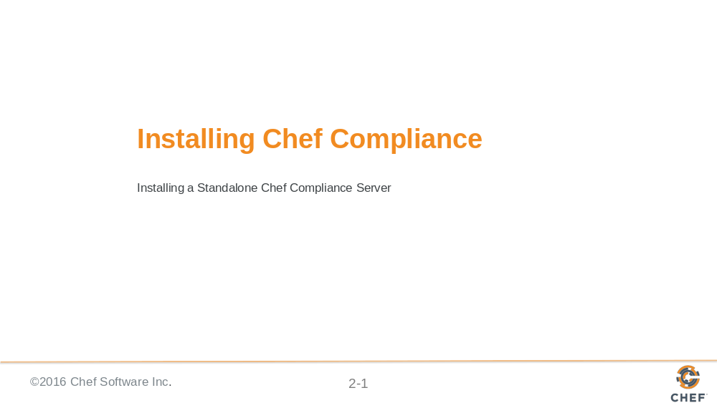

Slide 2

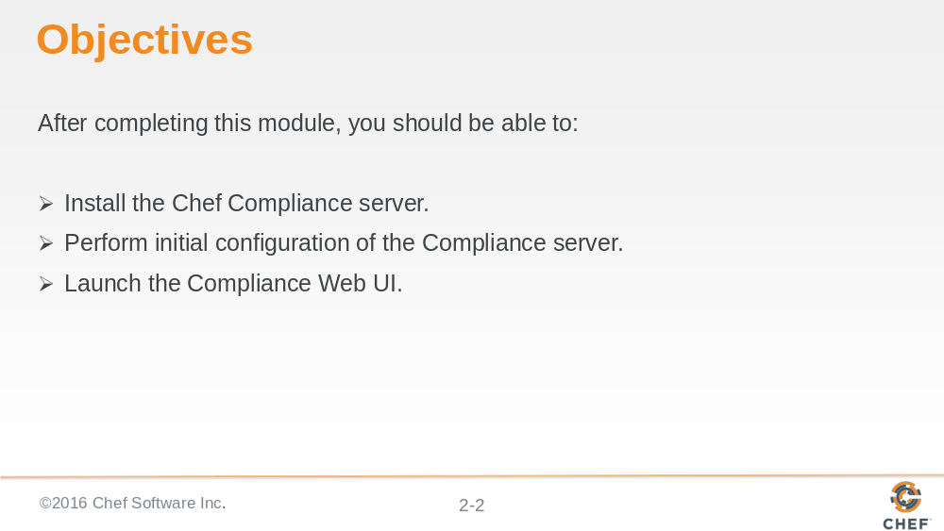

Slide 3

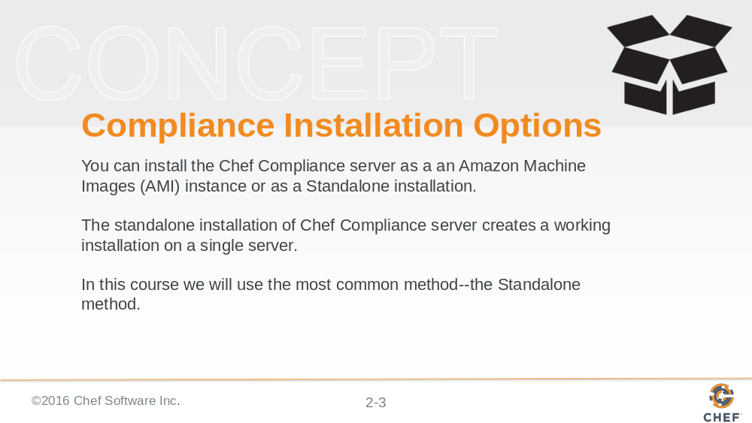
You can install the Chef Compliance server as a an Amazon Machine Images (AMI) instance or as a Standalone installation.

The standalone installation of Chef Compliance server creates a working installation on a single server.

This installation is also useful when you are installing Chef Compliance in a virtual machine, for proof-of-concept deployments, or as a part of a development or testing loop

Slide 4

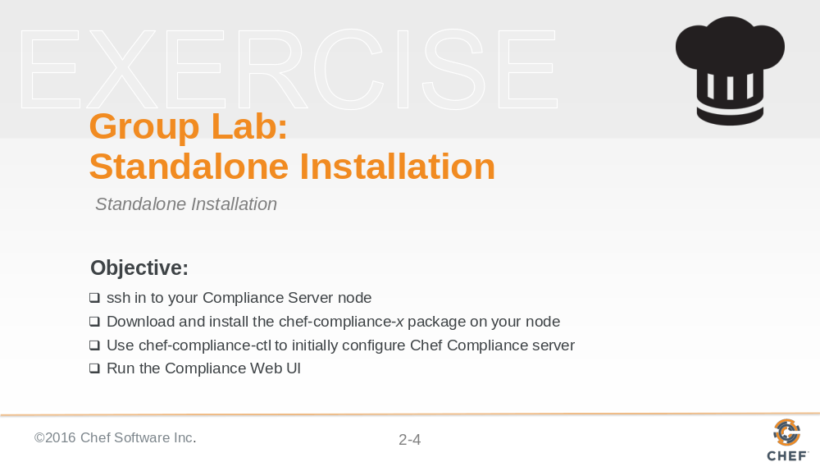

In this group lab you will perform the installation and initial configuration tasks listed in this slide.

Slide 5

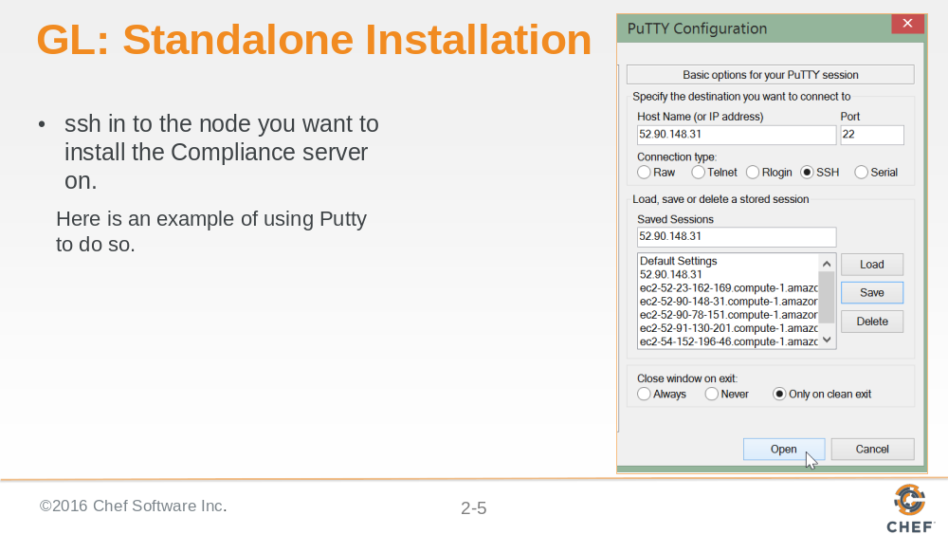

Slide 6

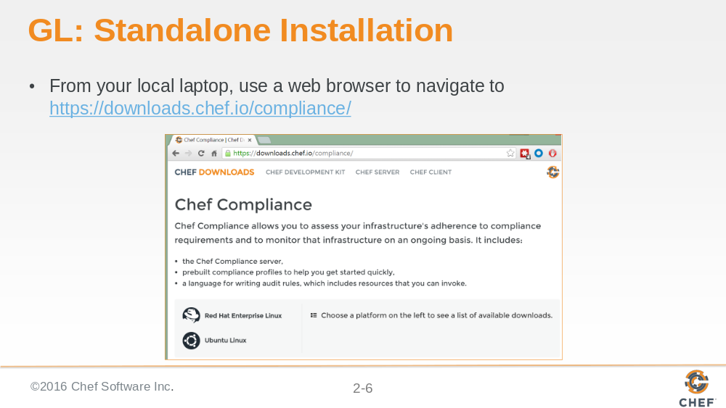

Slide 7

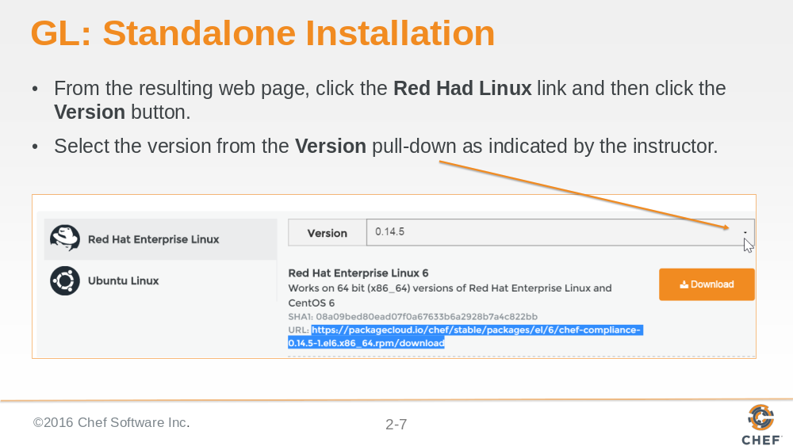

Slide 8

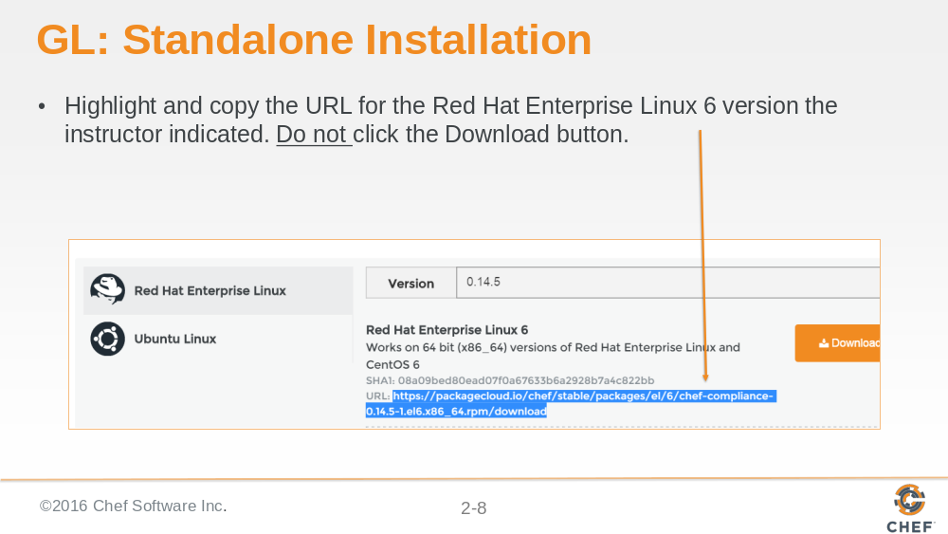

From the resulting web page, highlight and copy the URL for the Red Hat Enterprise Linux 6 version Do not click the Download button. We don't want to download this directly to your laptop but instead we will download it directly to our node.

Slide 9

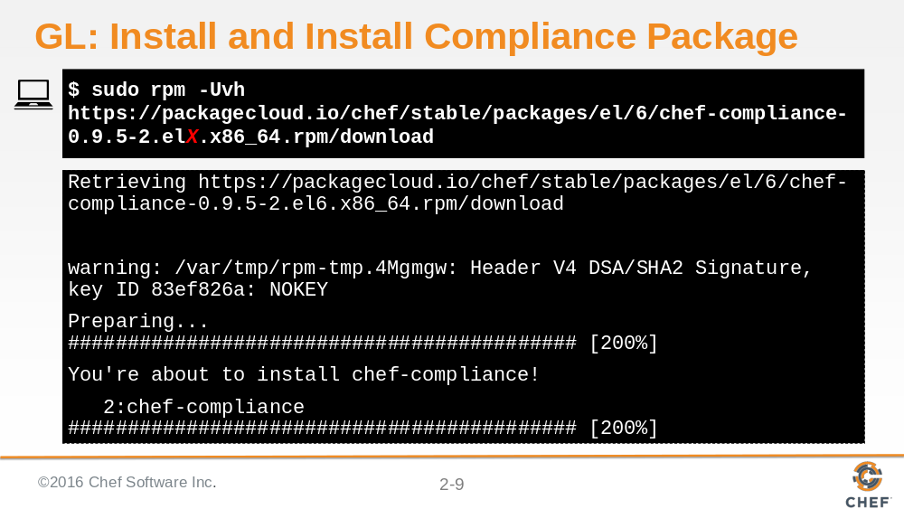

Execute sudo rpm -Uvh https://packagecloud.io/chef/stable/packages/el/6/chef-compliance-0.9.5-2.elX.x86_64.rpm/download but using the URL you just copied to download and install the Compliance package. This could take some time.

Note: The compliance package will be named download at this point.

Slide 10

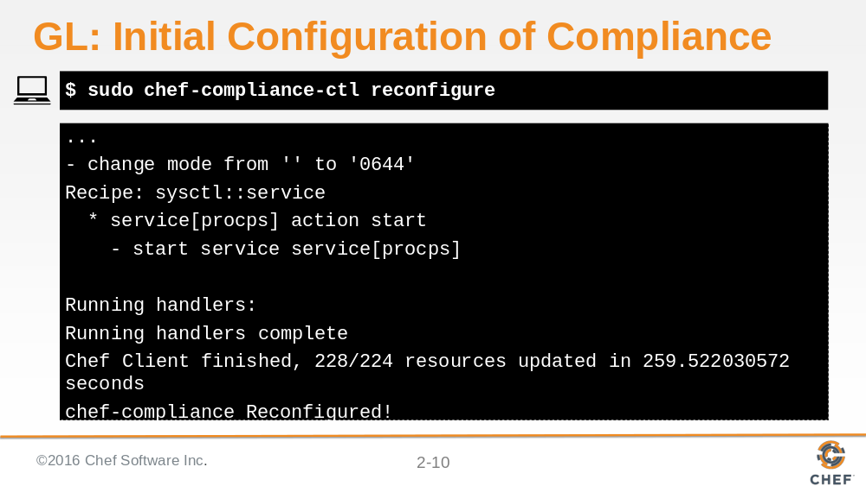

This reconfiguration process could take 5 or more minutes to complete.

Important: Do not use Ctrl c while this is running.

Slide 11

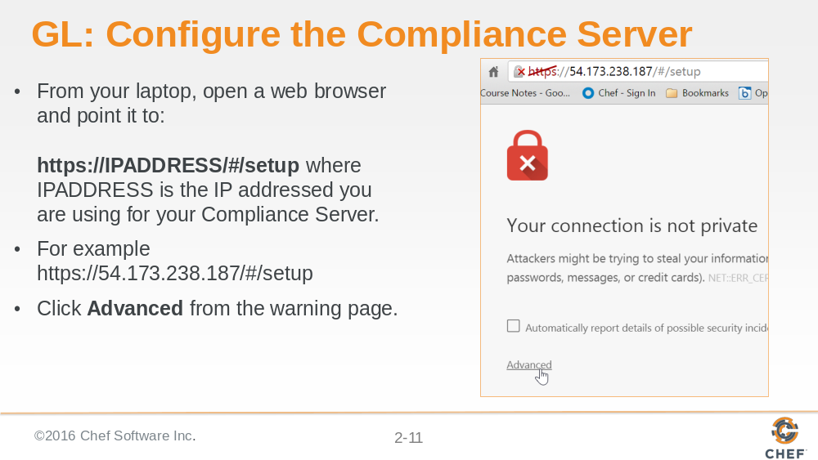

Slide 12

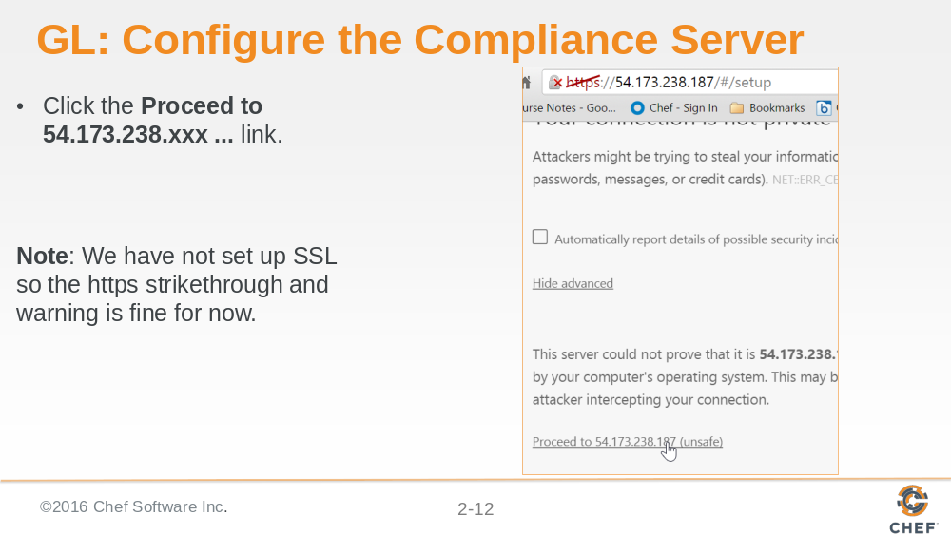

We have not set up SSL so the https strikethrough is fine for now. In the workplace you would want to use SSL for connections to your Compliance Web UI.

Slide 13

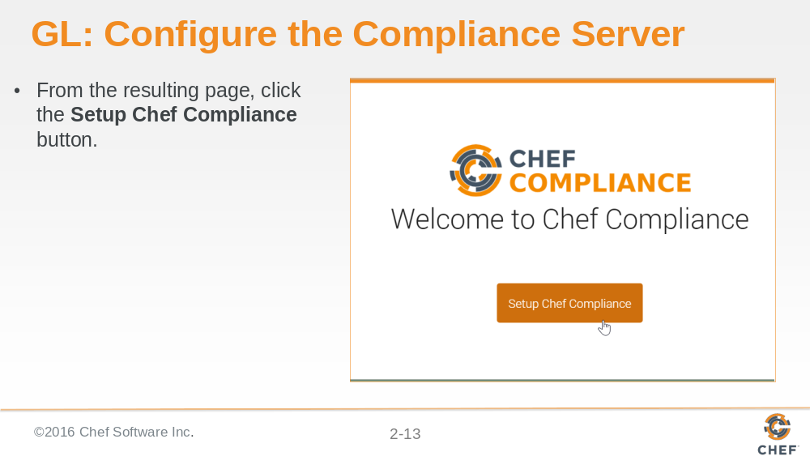

Slide 14

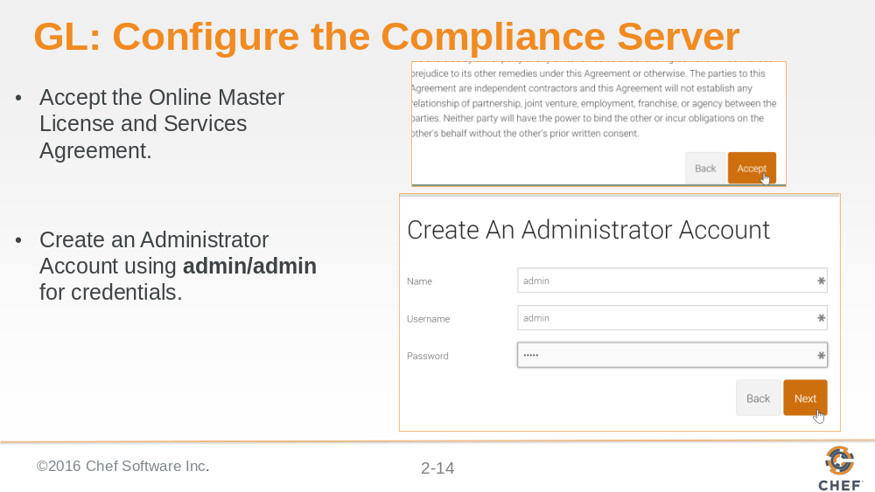

In the workplace you should of course create a more secure password.

Slide 15

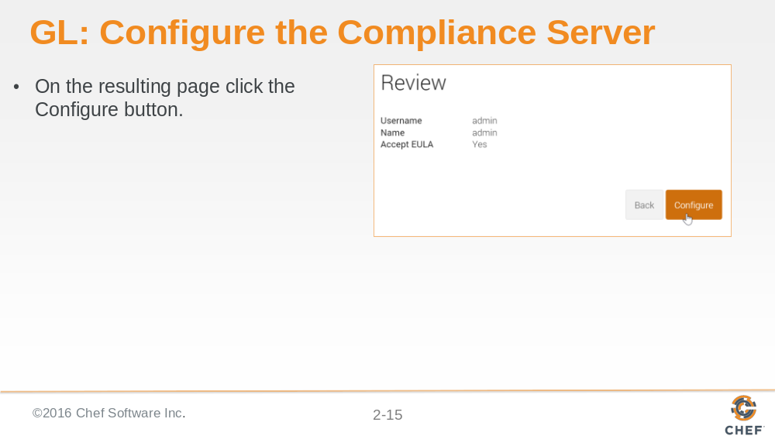

Slide 16

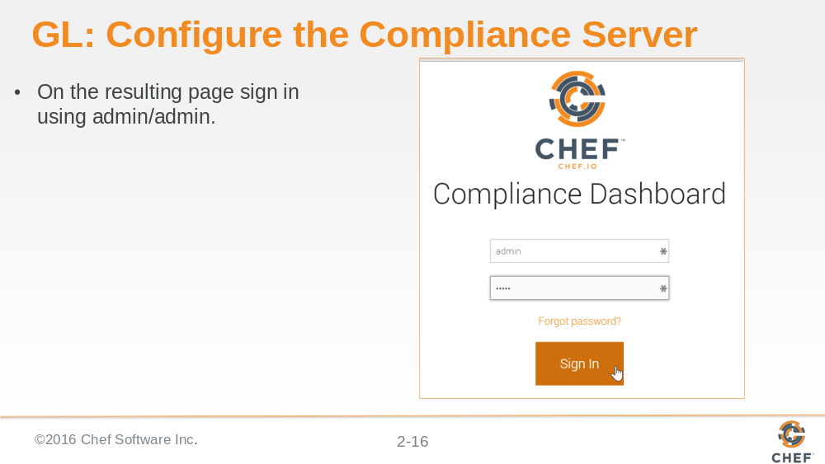

Slide 17

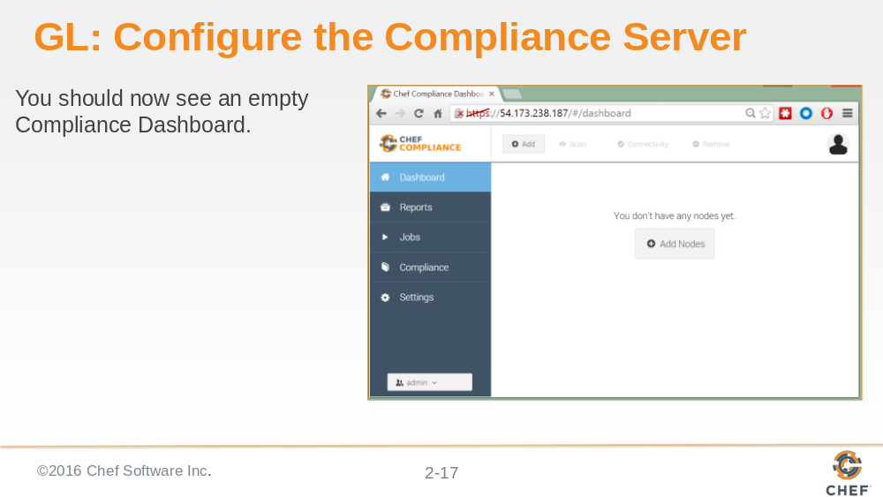

In the workplace you would want to use SSL for connections to your Compliance Web UI.

https://docs.chef.io/install_compliance.html > Configure SSL

Slide 18

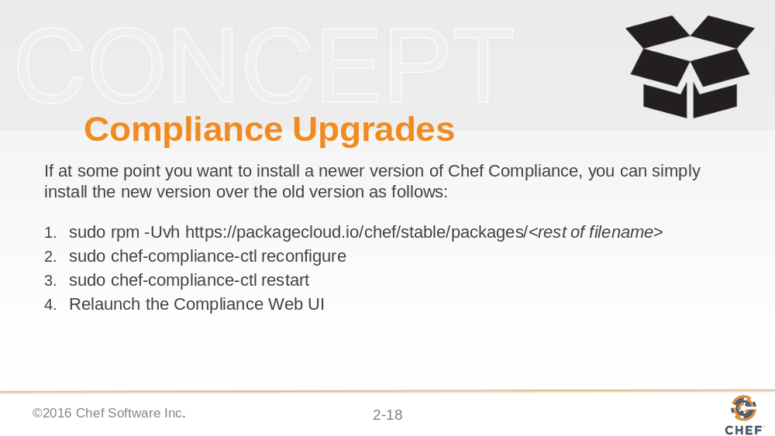

If you needed to downgrade Compliance to a previous version, the `--oldpackage' option will do that for you. In the following example, the `https://package...` would be the version of the old package that you want to downgrade to:

sudo rpm -Uvh --oldpackage https://packagecloud.io/chef/stable/packages/el/6/chef-compliance-0.9.6-1.el6.x86_64.rpm/download

...and then run these commands:
sudo chef-compliance-ctl reconfigure
sudo chef-compliance-ctl restart

Slide 19

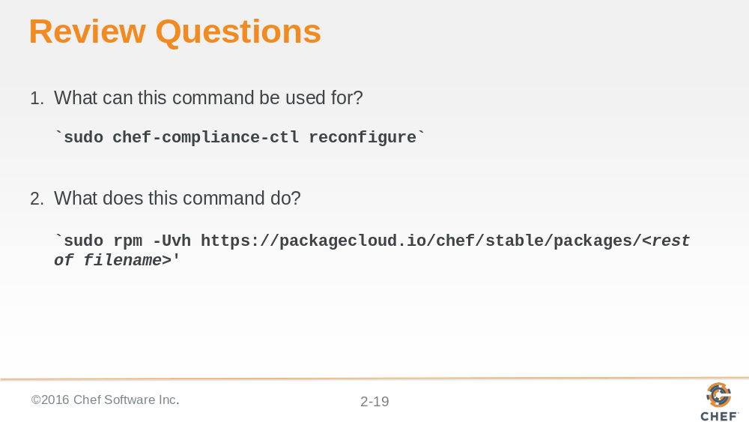

Slide 20

