5: Creating Custom Profiles

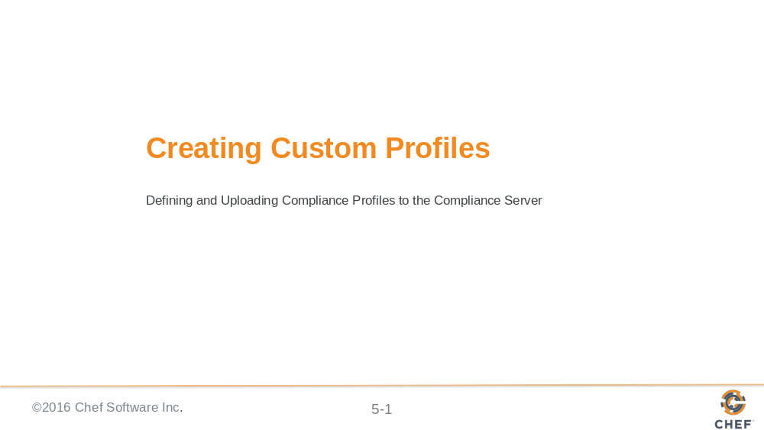

Slide 2

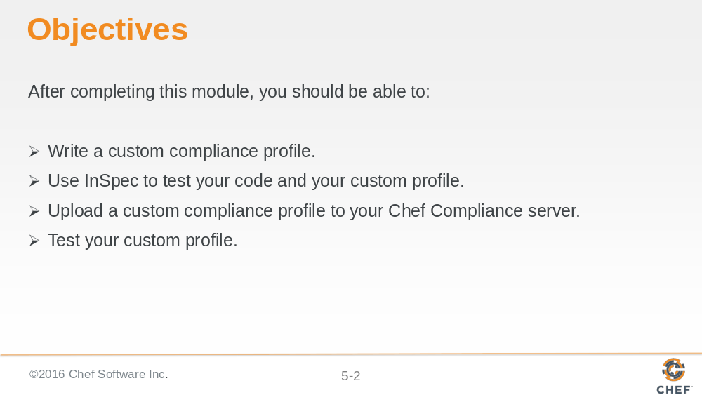

Slide 3

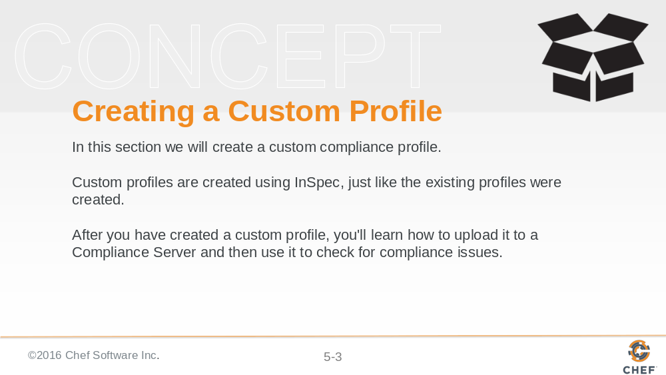

Slide 4

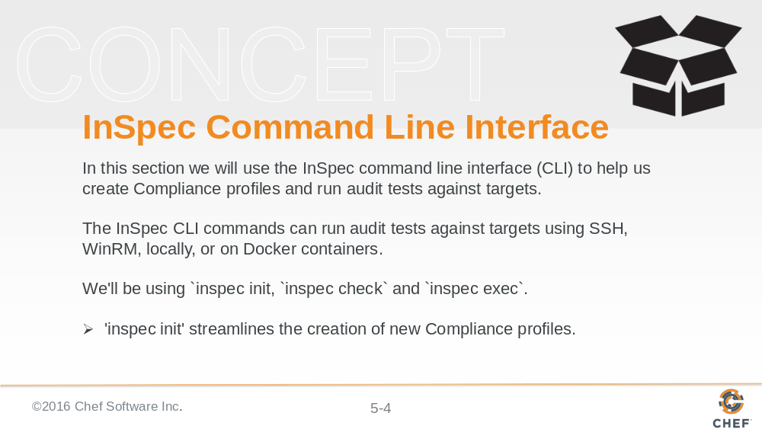
`inspec init` can create all the directories and basic files that the Compliance Server and `inspec check` and `inspec exec` require.

Slide 5

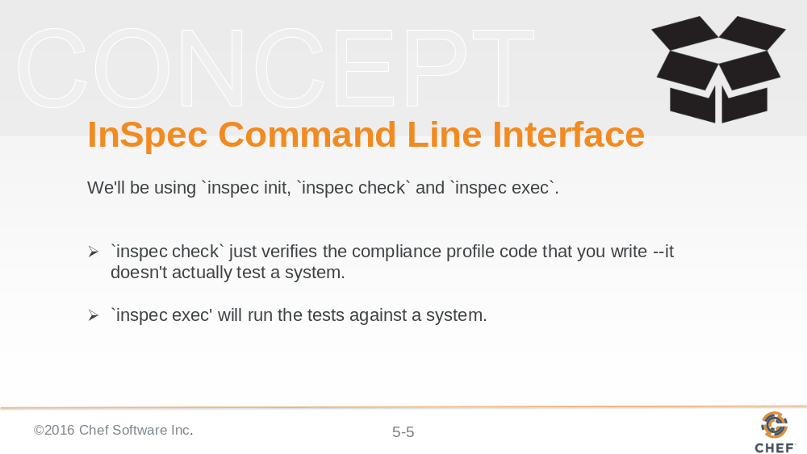

Slide 6

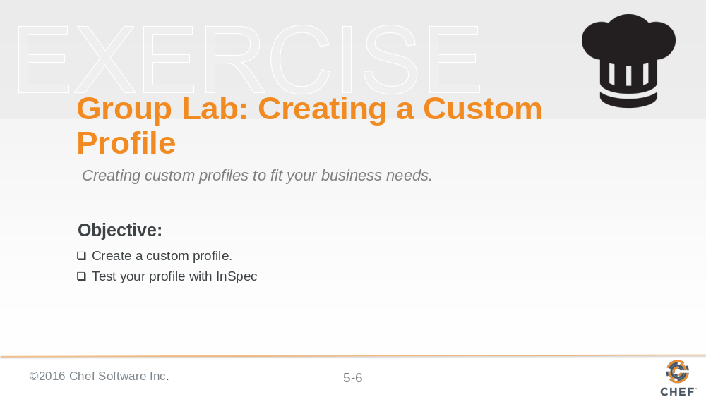

The custom profile you will create will scan nodes to ensure they have a '/tmp' directory and that directory should be owned by the root user.

Note: In the workplace you would likely perform these custom profile tasks on your local workstation and upload them to the Compliance Server. In this class we'll use our target nodes as a workstation to create the profile on since they already have Chef installed on them. Then we'll ultimately upload the customer profile to your Compliance Server.

Slide 7

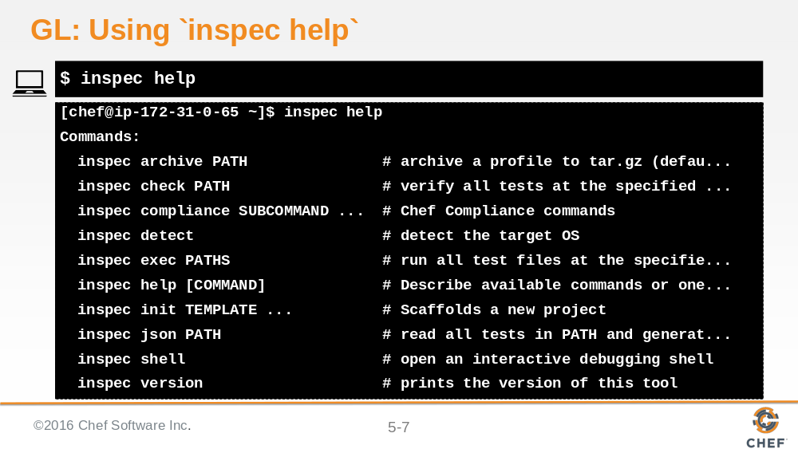

From your target Linux node/virtual workstation and from your home directory, run `inspec help`. Notice the `inspec` commands and sub commands that are available.

Slide 8

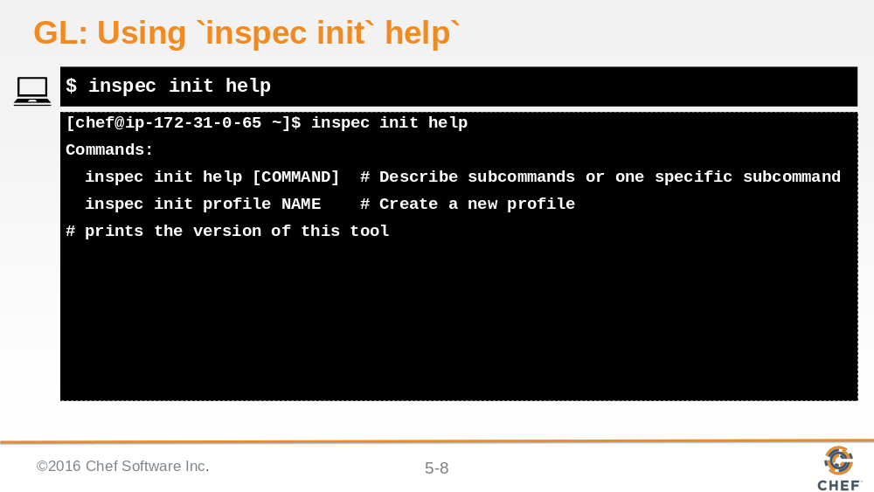

The `inspec init` command enables you to create new Compliance profiles with less manual intervention than in previous versions of inspec and Chef Compliance.

Slide 9

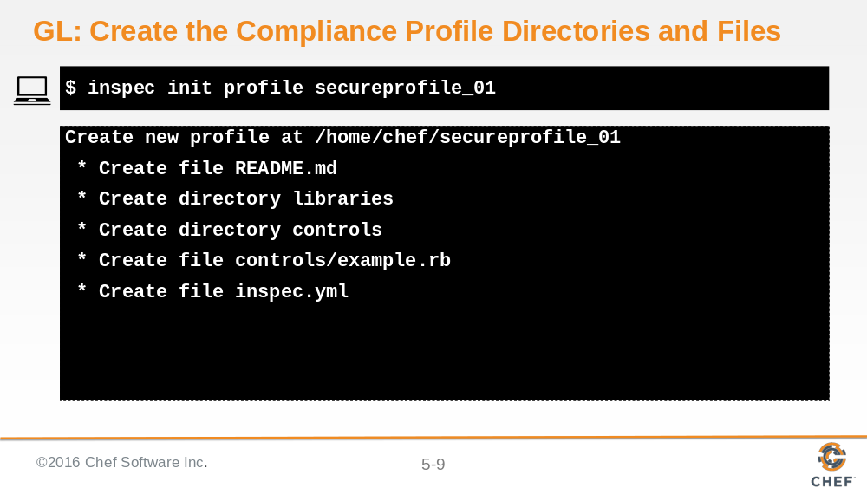

Notice the directories and the files that `inspec init profile` creates. The `secureprofile_01` is merely the name of the profile and could be named any way that makes sense in your organization.

Slide 10

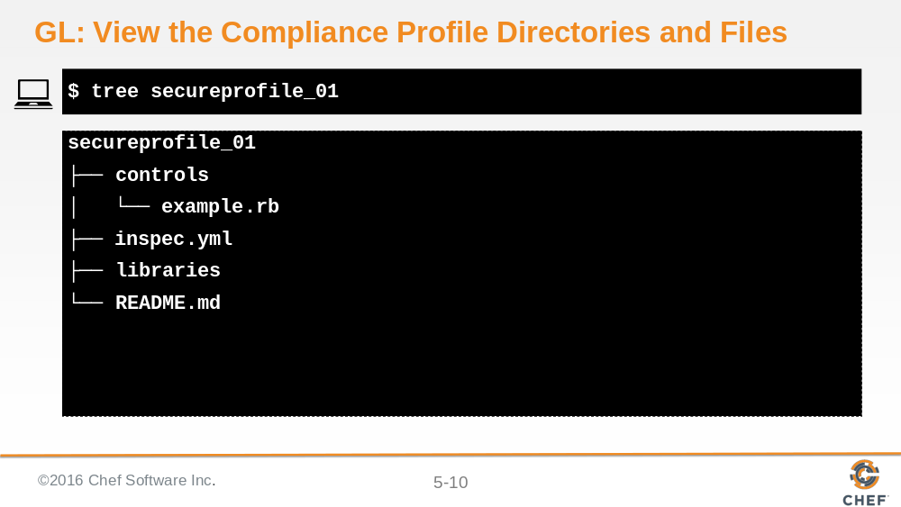

As you can see, the `tree secureprofile_01 ` command shows the new directories and files that inspec requires.

Slide 11

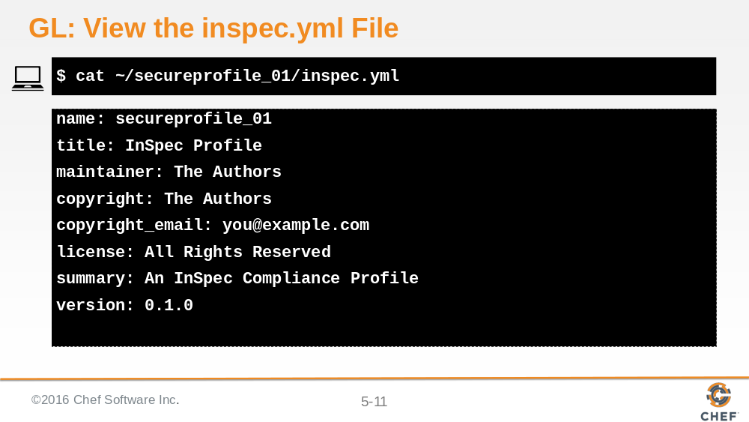

Let's read the inspec.yml file by issuing ~/secureprofile_01/inspec.yml.

In the workplace you should modify this file but we'll leave it as-is for now.

Slide 12

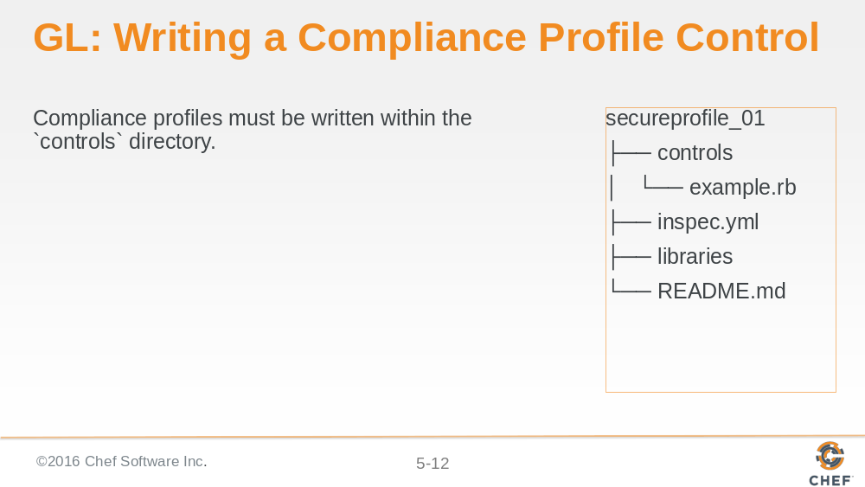

Slide 13

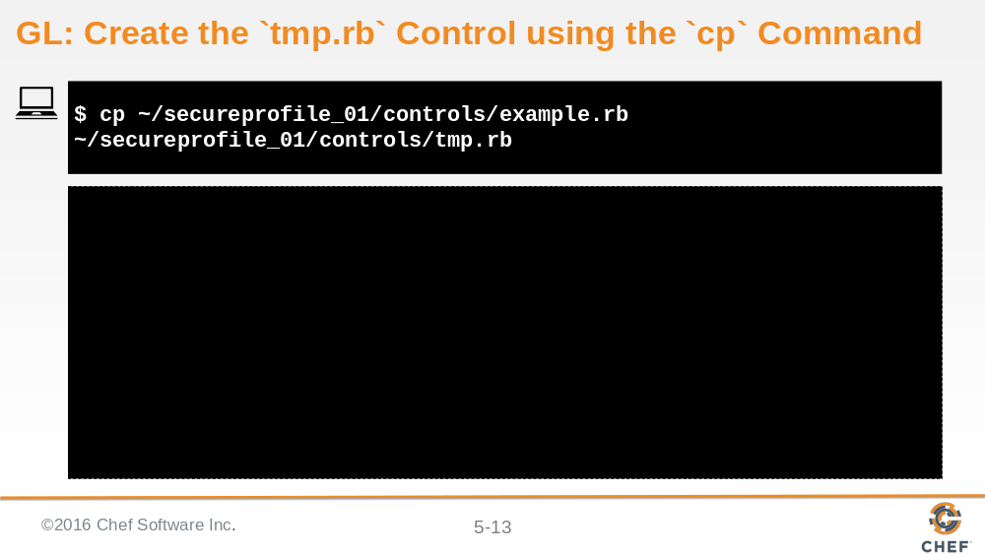

In this example you will use the `cp` command to make a copy of the `example.rb' control and name the copy `tmp/rb`.

Slide 14

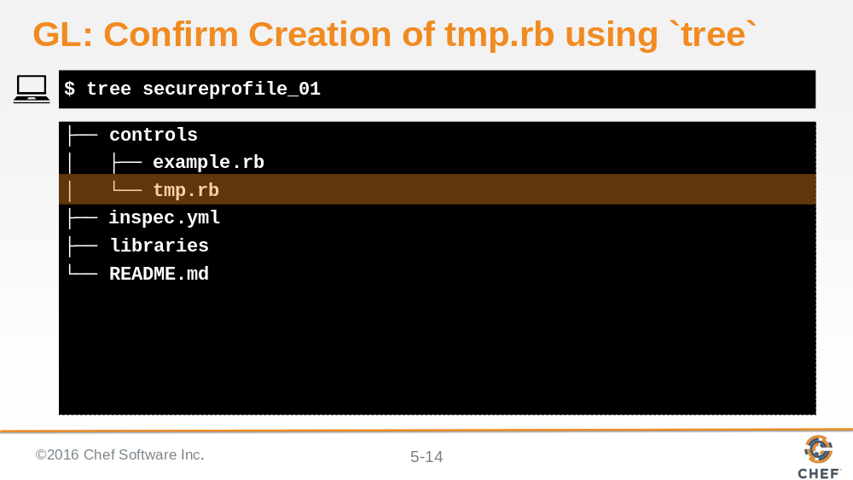

You should now see that `tmp.rb` resides next to the default `example.rb`.

Slide 15

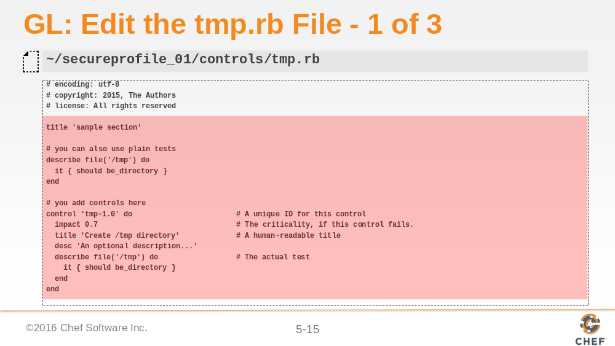

Delete everything highlighted in this example.

Slide 16

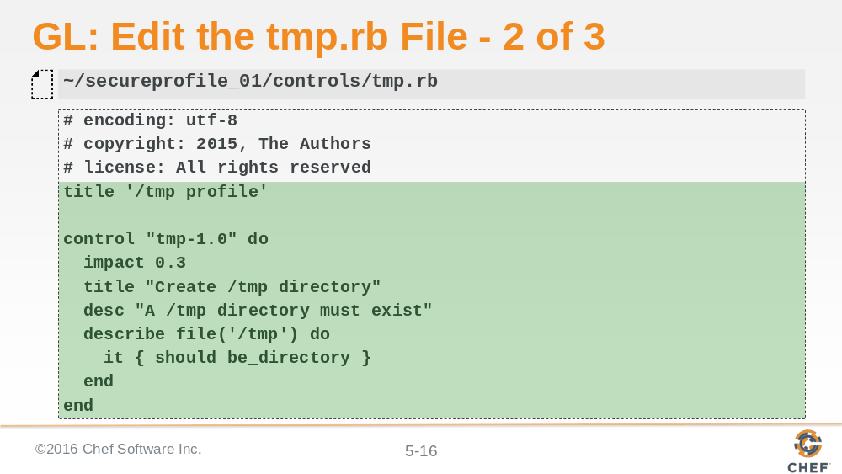

Write the first half of this control as shown here. You'll write the second half below this part in a moment.

Slide 17

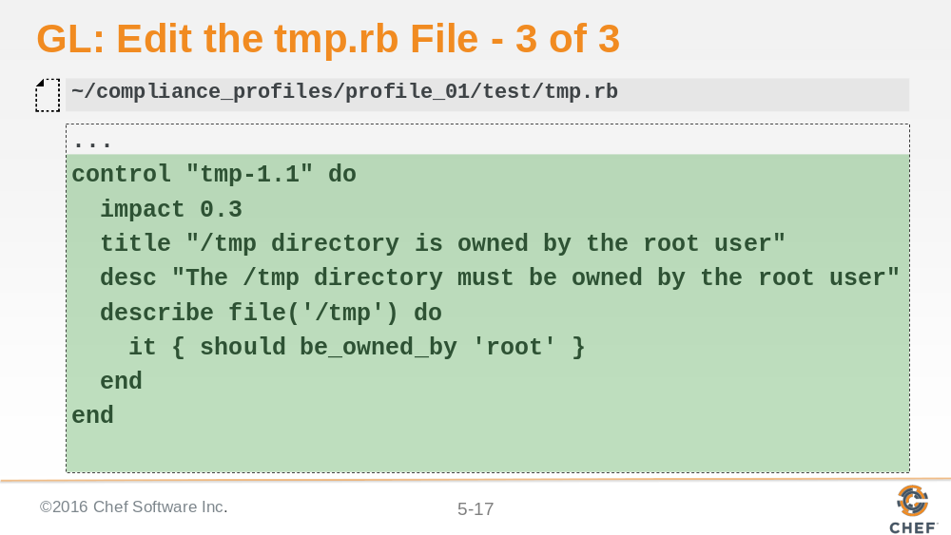

Write the second half of this control as shown here, just below the code you wrote on the preceding slide. We've pasted the entire control code below so you can see it better.

# encoding: utf-8
# copyright: 2015, The Authors
# license: All rights reserved
title '/tmp profile'

control "tmp-1.0" do

impact 0.3
title "Create /tmp directory"
desc "A /tmp directory must exist"
describe file('/tmp') do
it { should be_directory }
end
end

control "tmp-1.1" do
impact 0.3
title "/tmp directory is owned by the root user"
desc "The /tmp directory must be owned by the root user"
describe file('/tmp') do
it { should be_owned_by 'root' }
end
end

Slide 18

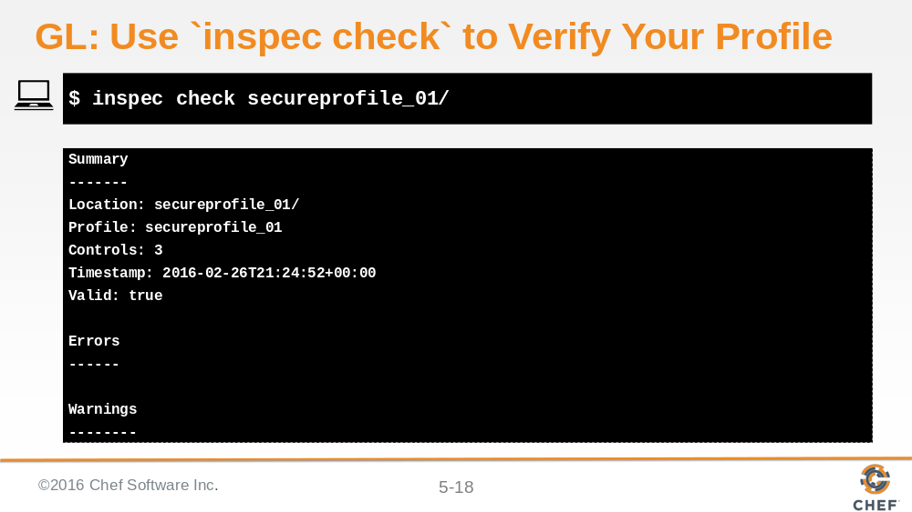

Now use 'inspec check` to verify the compliance profile code that you wrote. You should see no errors or warnings.

Slide 19

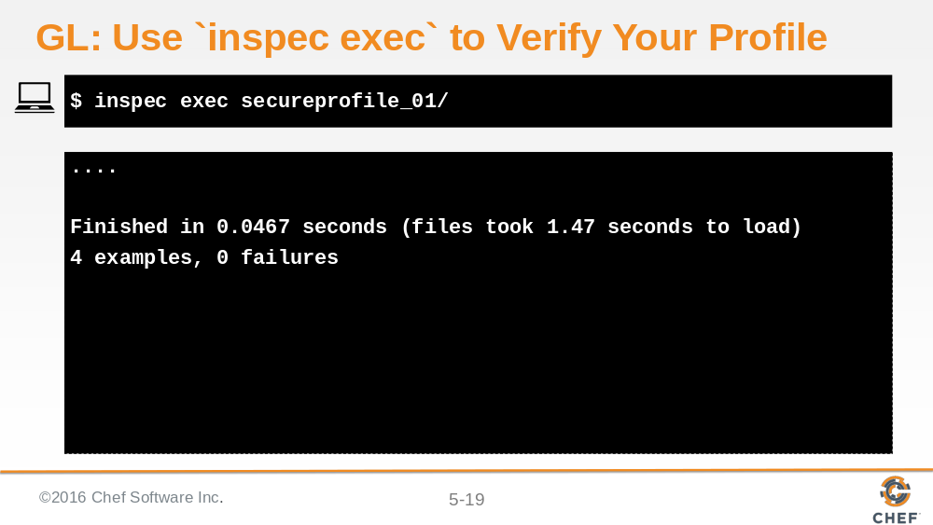

Now use 'inspec exec` to test your compliance profile against the node you are working on. You should see no failures.

Since your profile has passed the inspec tests, it is now ready to be uploaded to the Compliance Server. We can assume this new compl

Slide 20

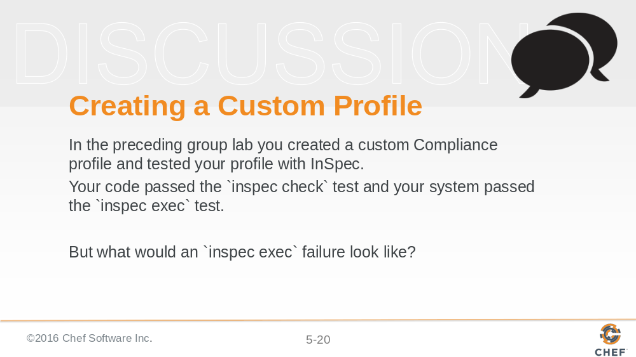

Slide 21

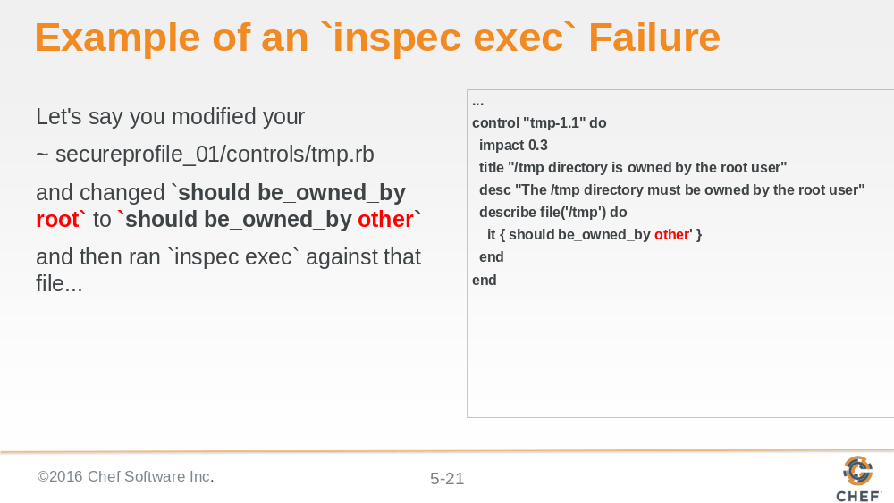

Slide 22

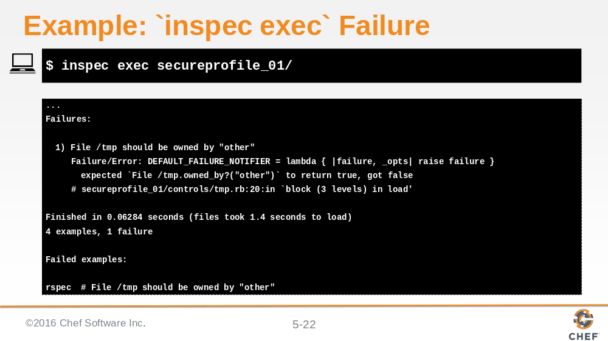

...this is an example of running `inspec exec` against the system using the `~/secureprofile_01/controls/tmp.rb' as modified on the preceding slide.

As you can see, based on the modified control, `inspec exec` expected the /tmp directory to be owned by `other` but in fact /tmp is owned by root.

Slide 23

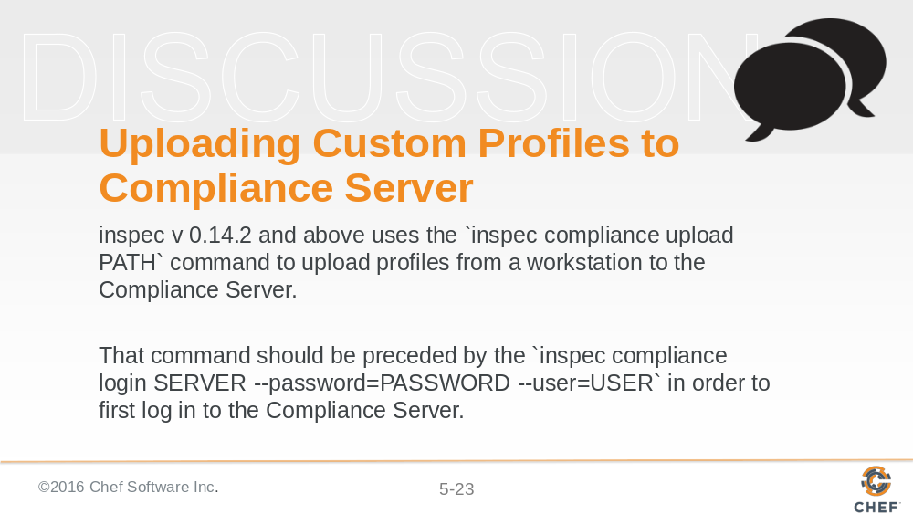

Slide 24

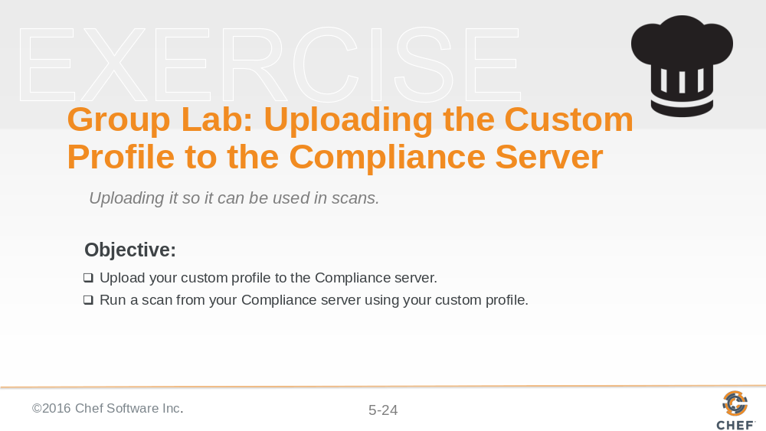

In addition to the uploading procedure we'll do in the exercise, in the workplace you could also upload custom profiles using an API.

Slide 25

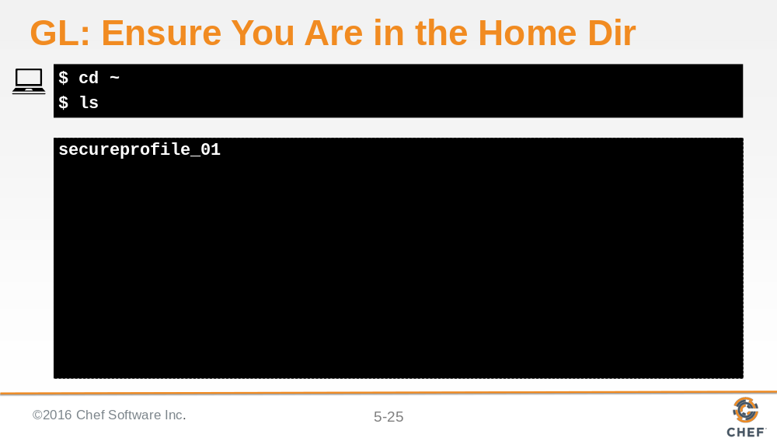

From your Linux node, ensure you are in your Home directory and type `ls` to see your compliance profile

Slide 26

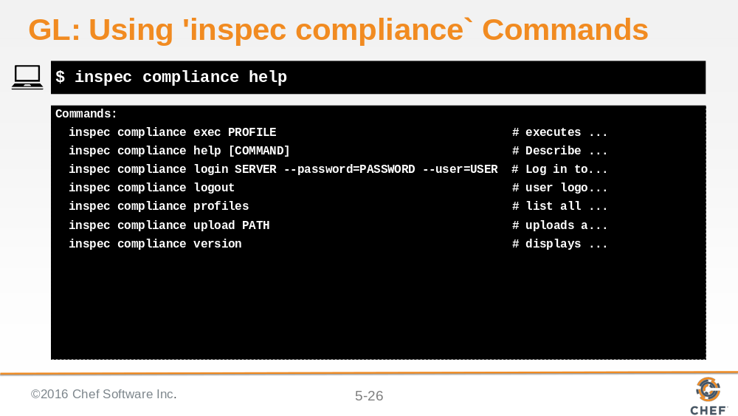

This example shows the options for the `inspec compliance` command. You'll be using the `inspec compliance login SERVER --password=PASSWORD --user=USER` in a moment to first log into your Compliance server.

Slide 27

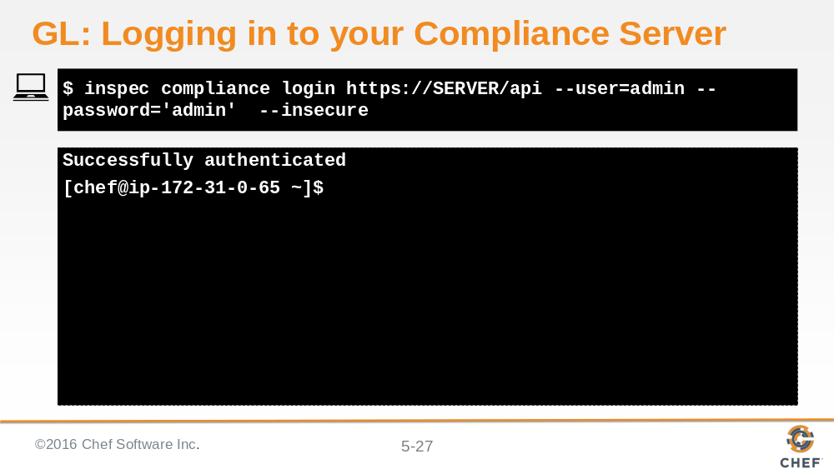

Use your compliance server's IP address in place of SERVER in this example.

Note that the credentials used here are the credentials you created for your Compliance Server UI (admin/admin), not the node's.

Note: We are using the `--insecure option` in this lab because we are not using valid self-signed certificates.

Slide 28

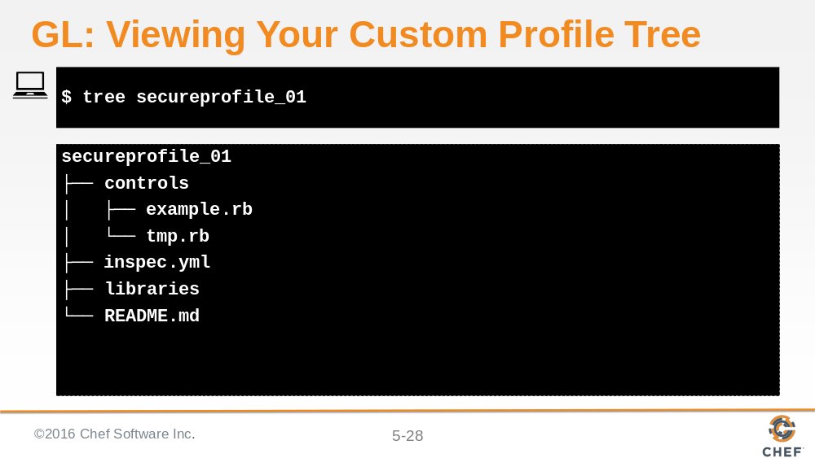

Notice that even though our VM is now logged into the Compliance server, commands such as `tree` are still executed against the VM we are on.

Slide 29

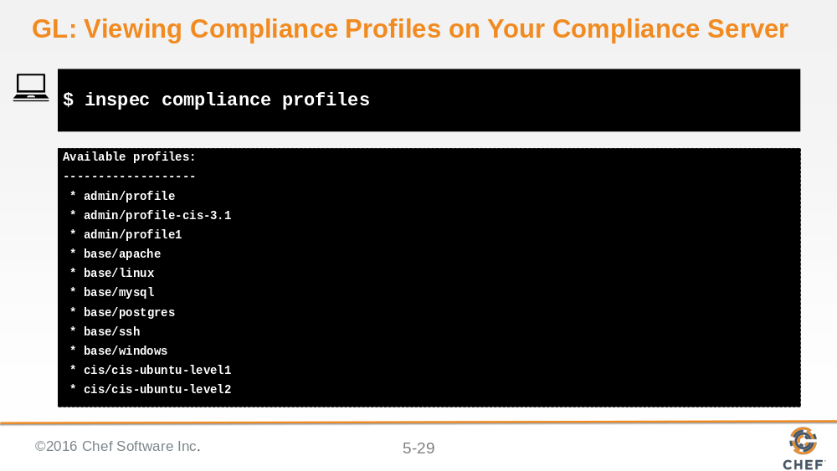

Again, this `inspec compliance profiles` command is executed against the VM we are on.

Slide 30

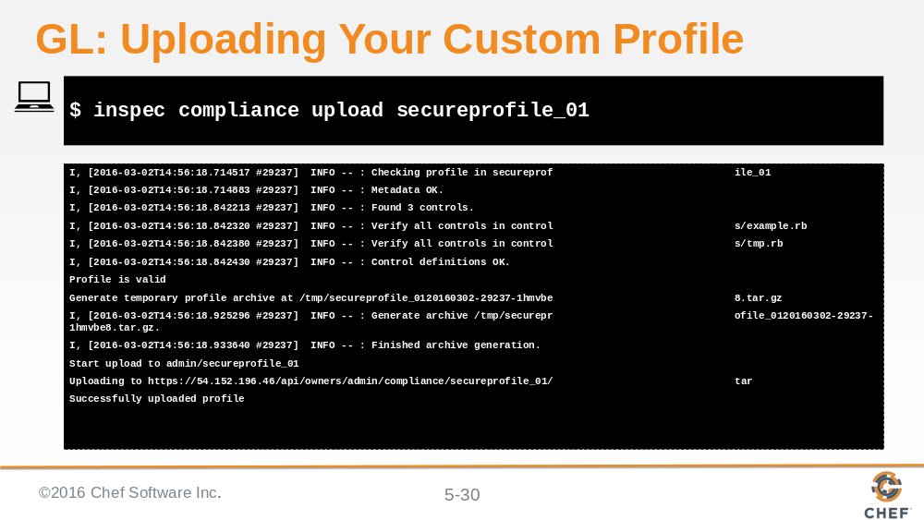

This `inspec compliance upload secureprofile_01` command is now uploading our custom profile to the Compliance server.

Slide 31

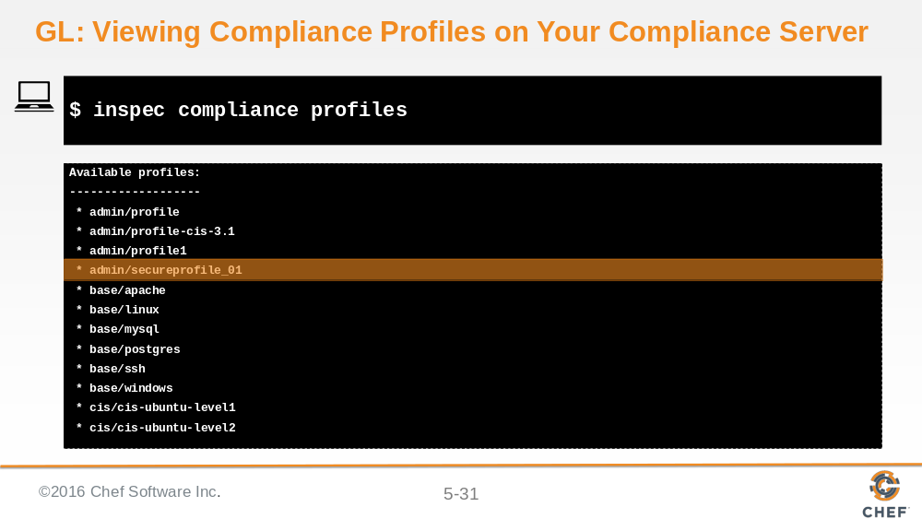

This `inspec compliance profiles` is now executing against our Compliance server, thus we are now looking at the Compliance profiles that reside on the Compliance server. Notice that your secureprofile_01 has been uploaded to the compliance server.

Slide 32

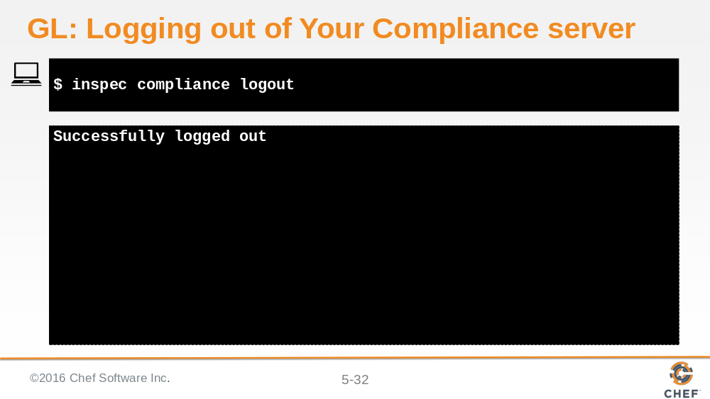

Slide 33

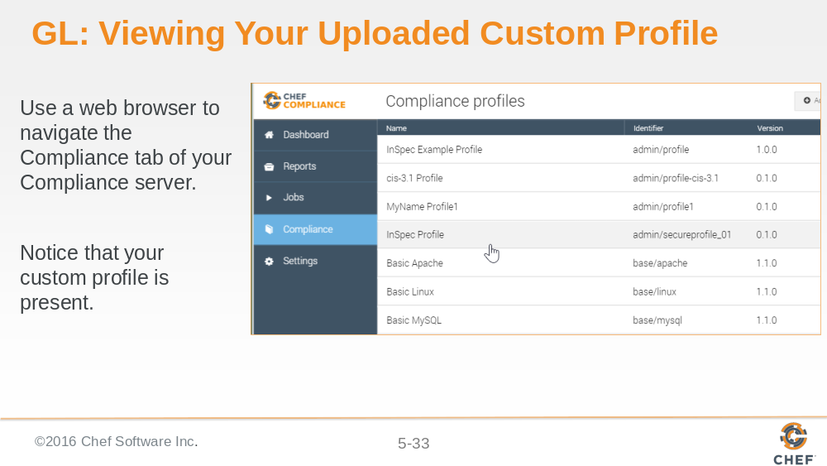

Slide 34

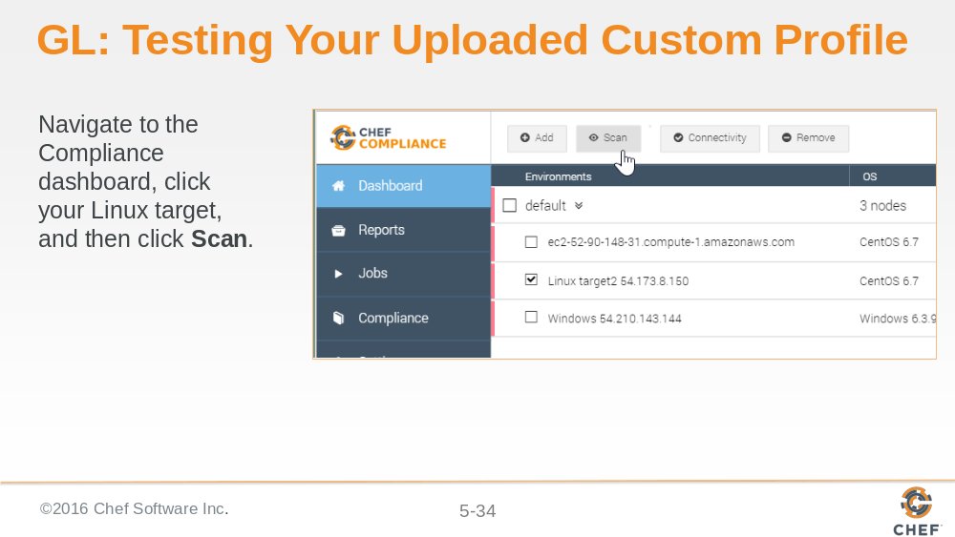

Slide 35

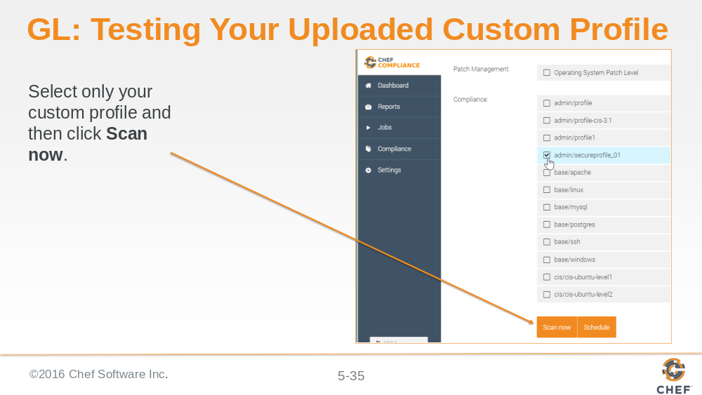

Slide 36

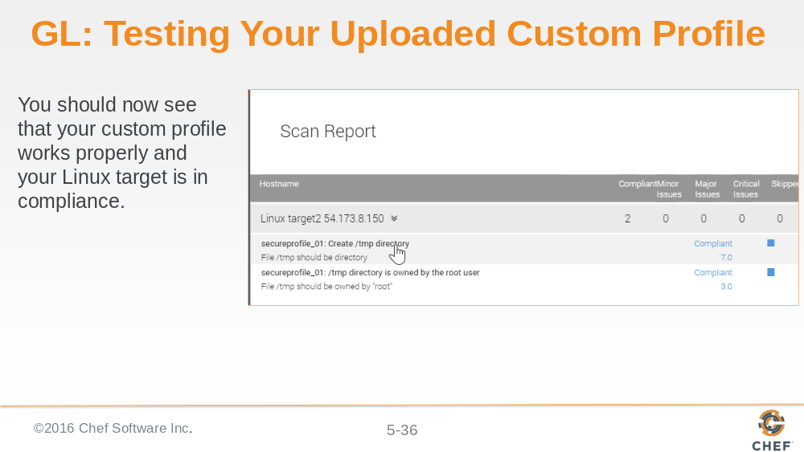

Slide 37

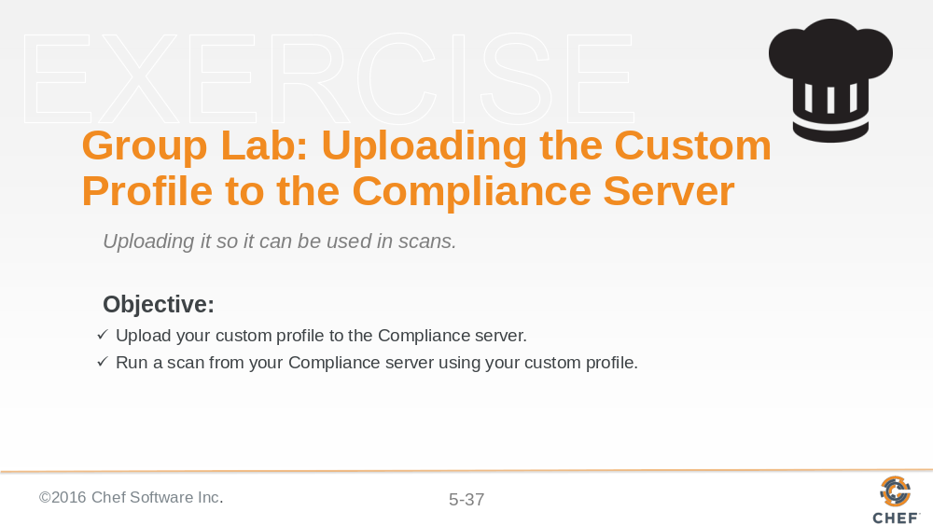

We have now completed this group lab.

Slide 38

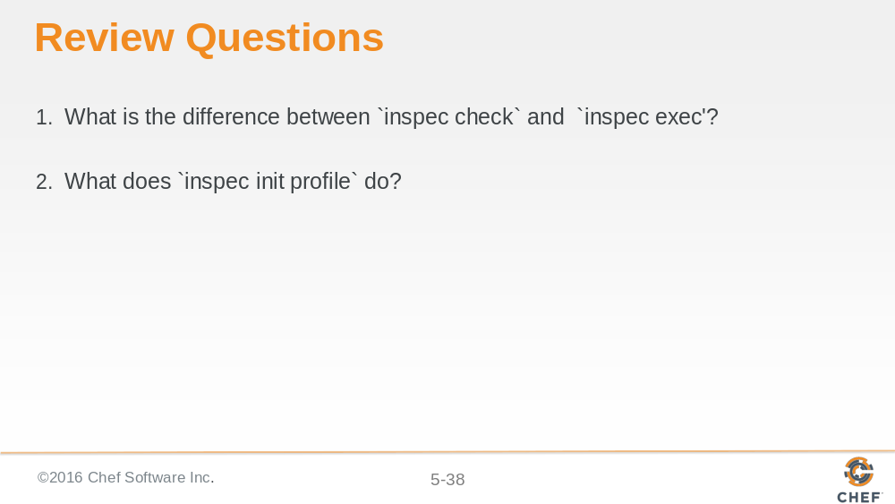

Slide 39



