7: Scheduling Scans and Running Reports

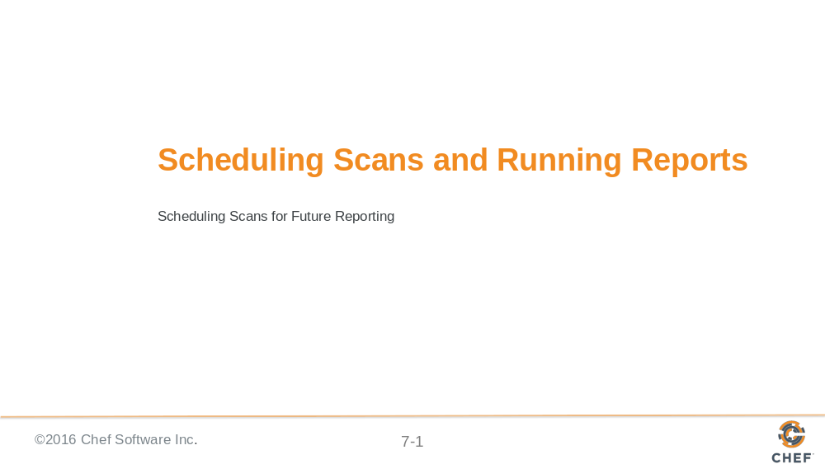

Slide 2

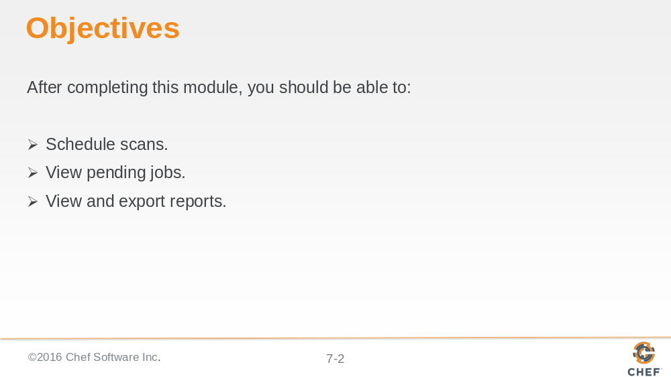

Slide 3

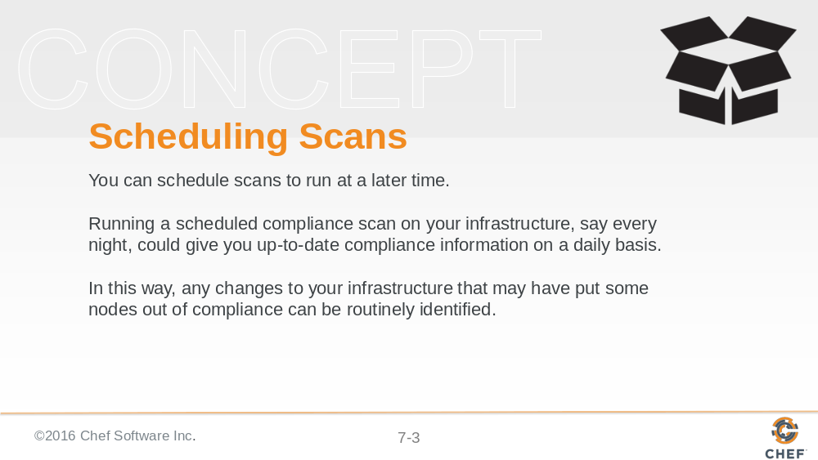

Slide 4

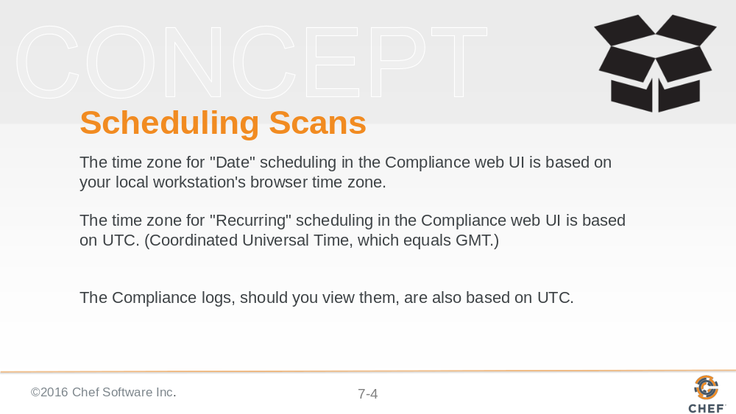
This time distinction is important when scheduling scans or if viewing the compliance logs.

Slide 5

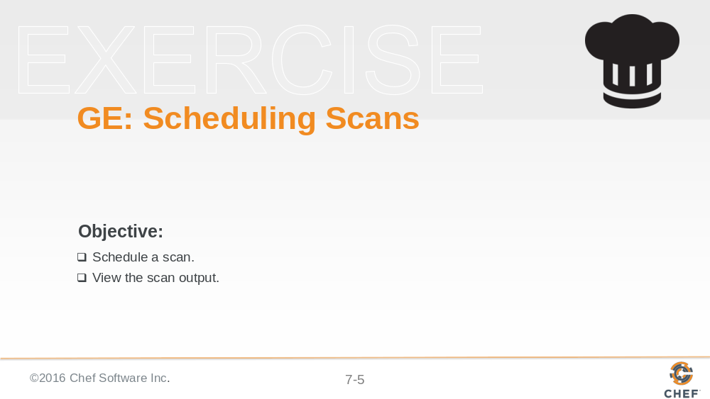

Slide 6

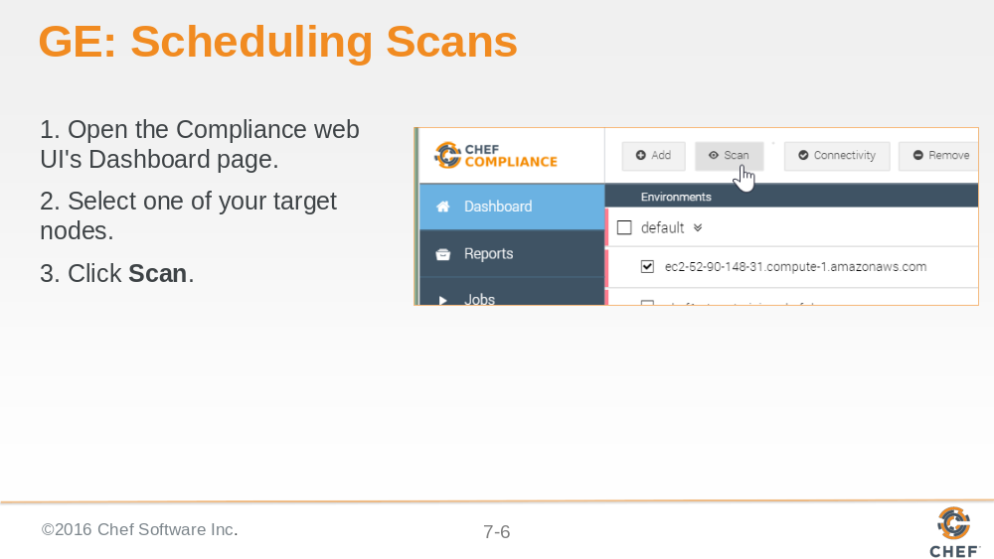

Slide 7

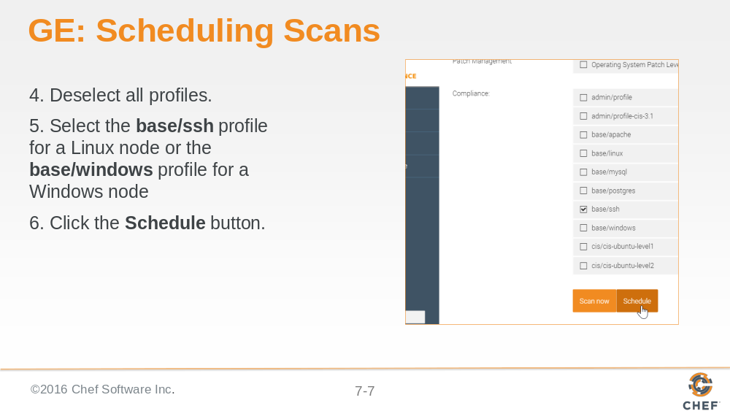

Slide 8

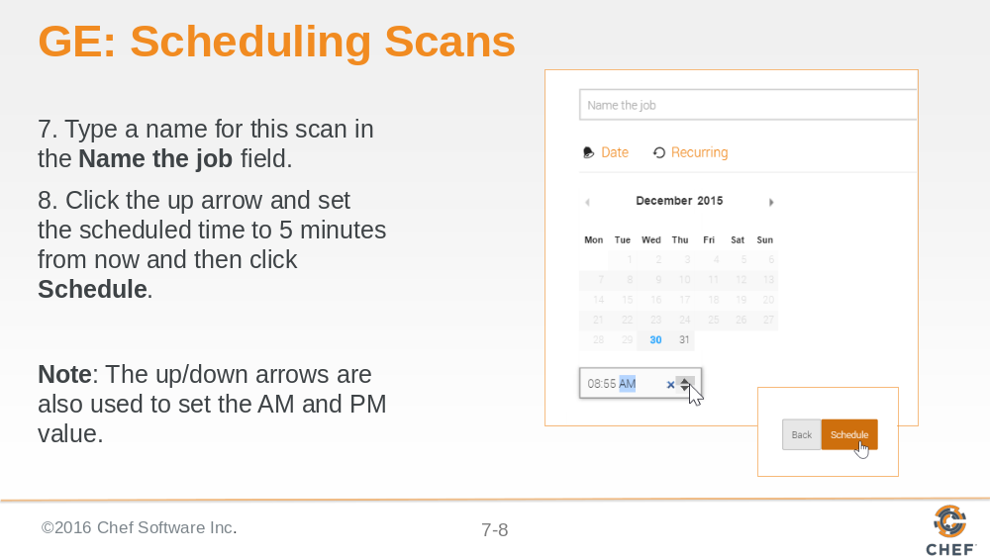

Slide 9

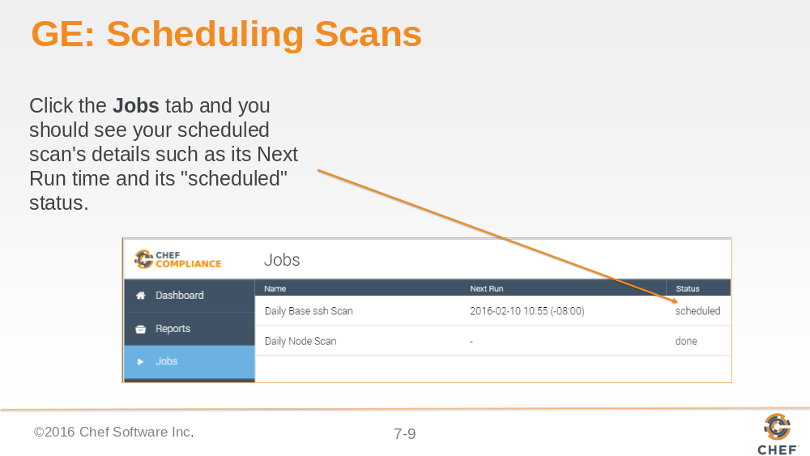

Slide 10

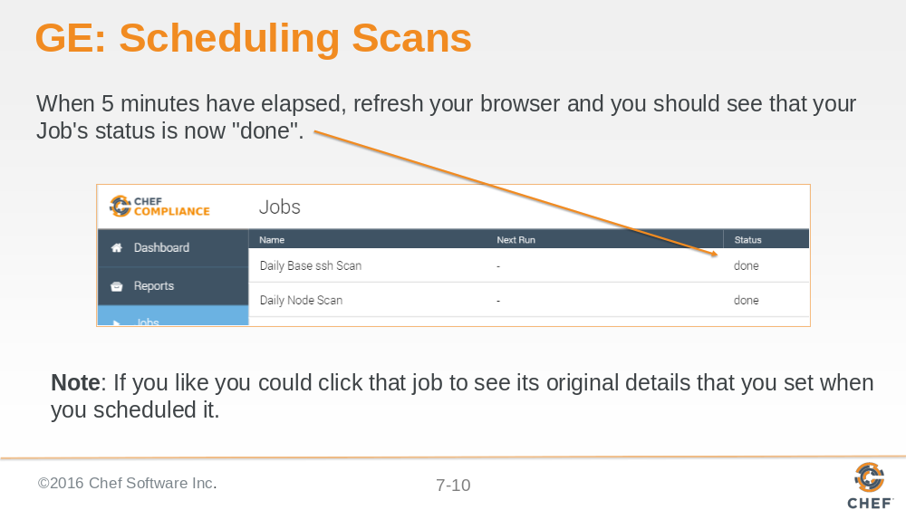

Slide 11

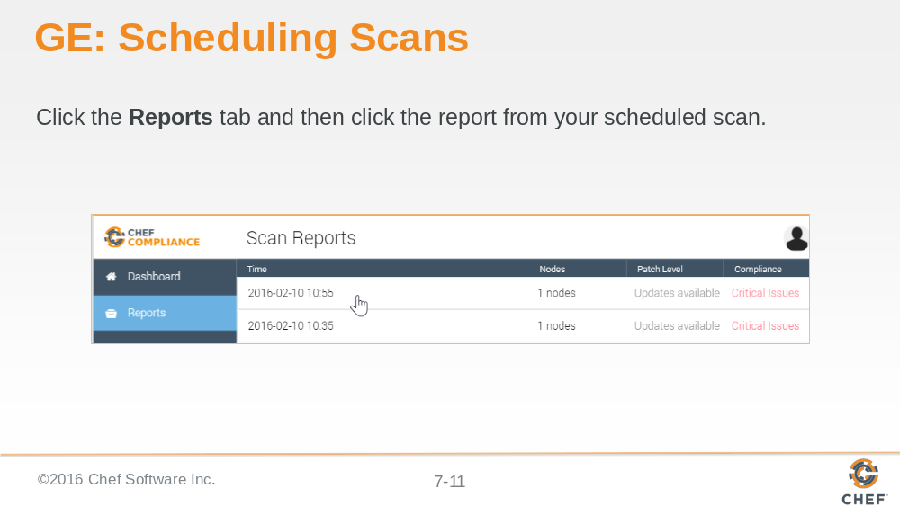

It may take a minute or two after the scan is run for the report to display.

Slide 12

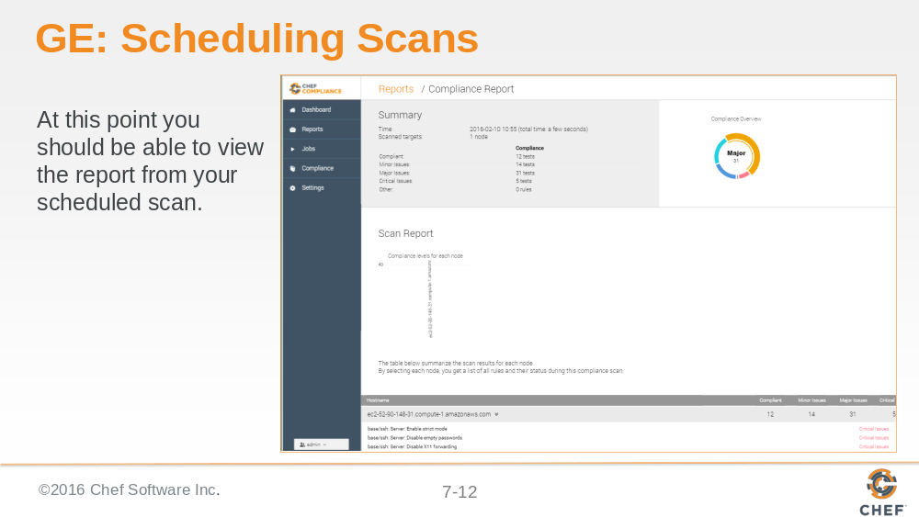

Slide 13

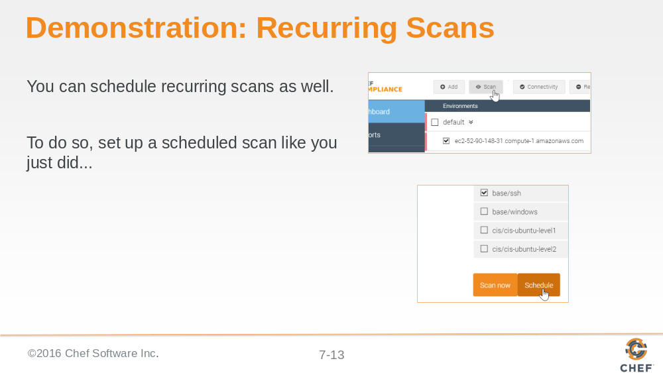

Slide 14

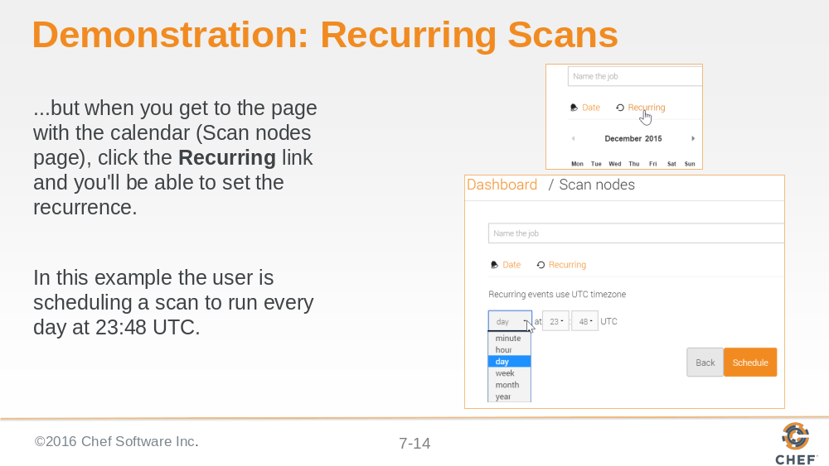

Slide 15

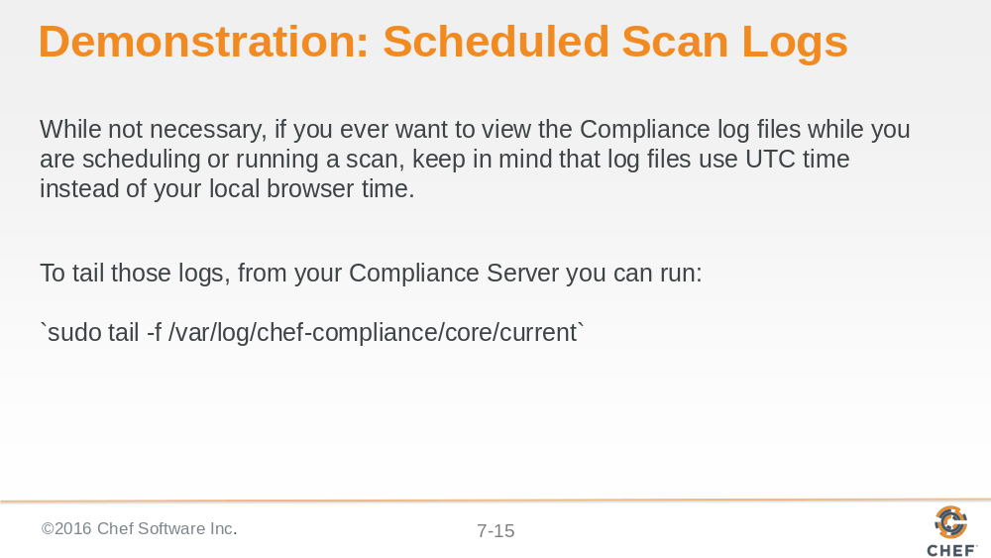

Slide 16

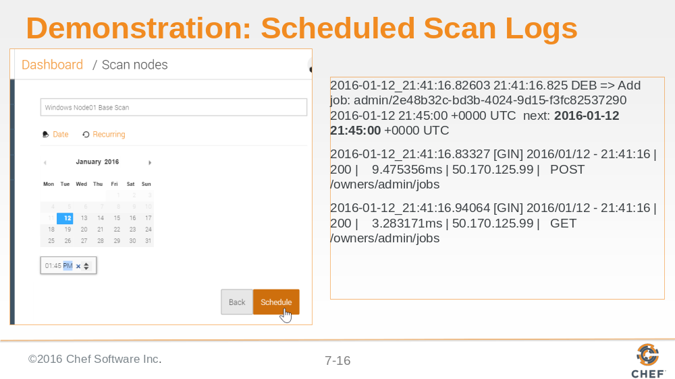

The image on the left shows the user setting the next scheduled scan for 1:45 P.M. local browser time.

The image on the right shows the output of `sudo tail -f /var/log/chef-compliance/core/current` taken at the very same time that the scan was scheduled. Notice the log file timestamps are in UTC and the next schedule scan is set for
UTC: 2016-01-12 21:45:00 +0000 UTC instead of the local browser time.

Slide 17

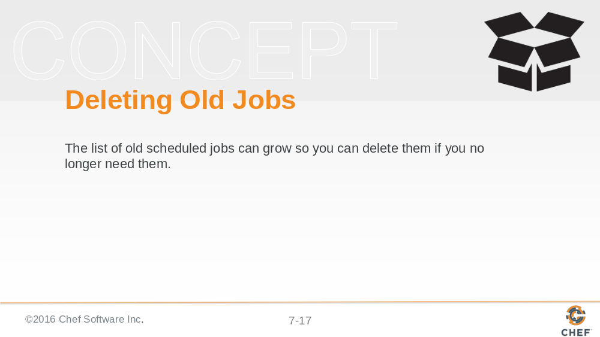

Slide 18

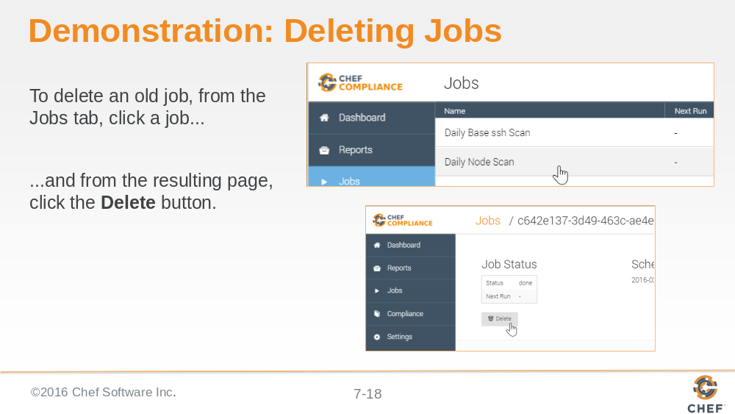

Slide 19

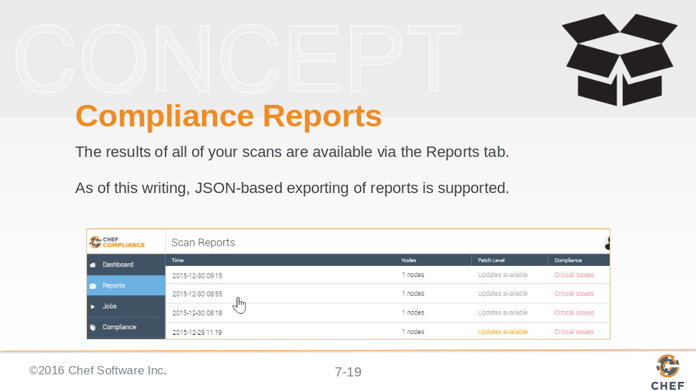

Slide 20

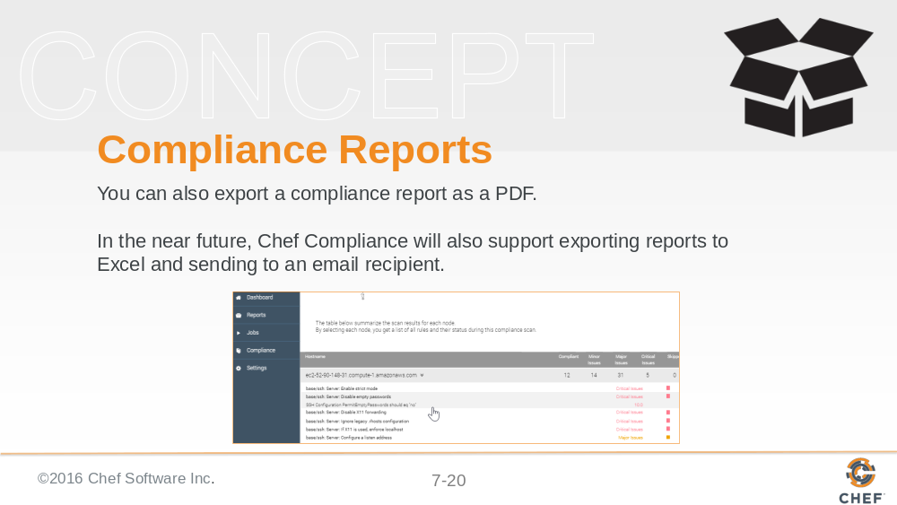

Slide 21

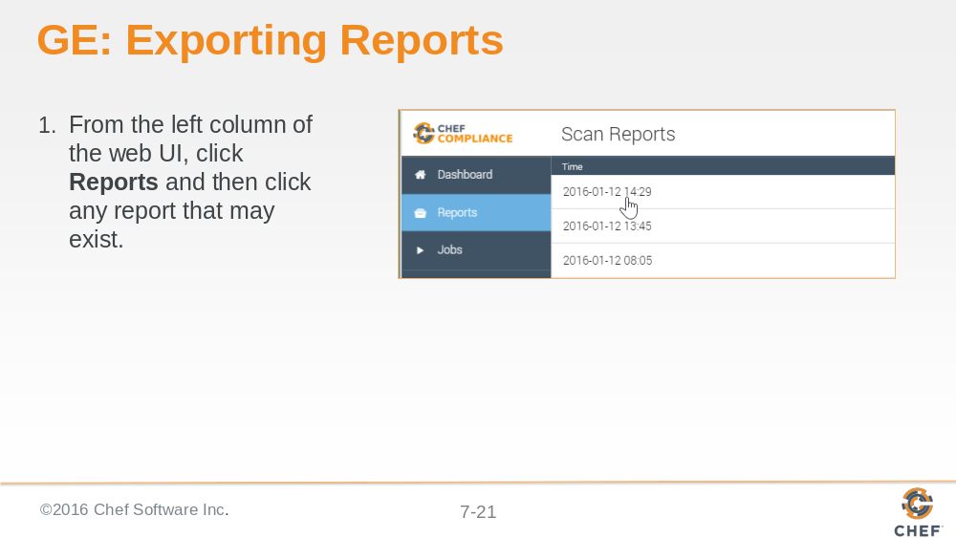

Slide 22

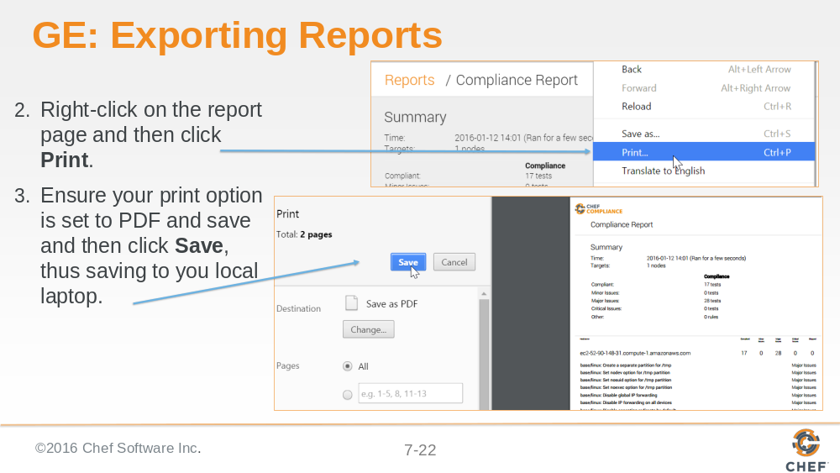

This example is from a Windows user. The exporting reports procedure is similar on a Mac.

Slide 23

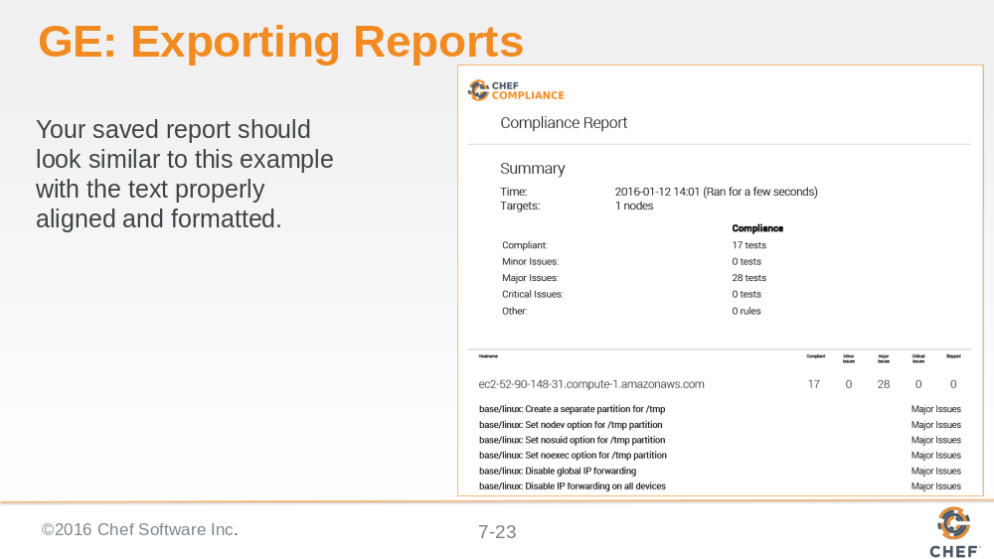

Additional methods for exporting reports will be available in the near future.

Slide 24

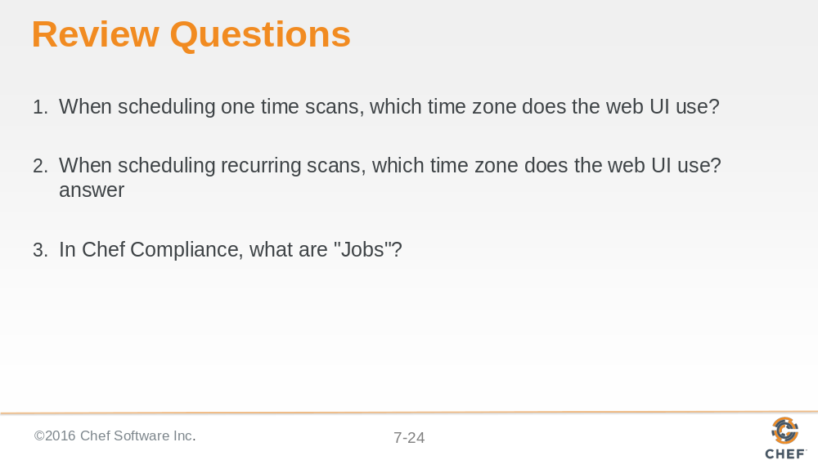

Slide 25

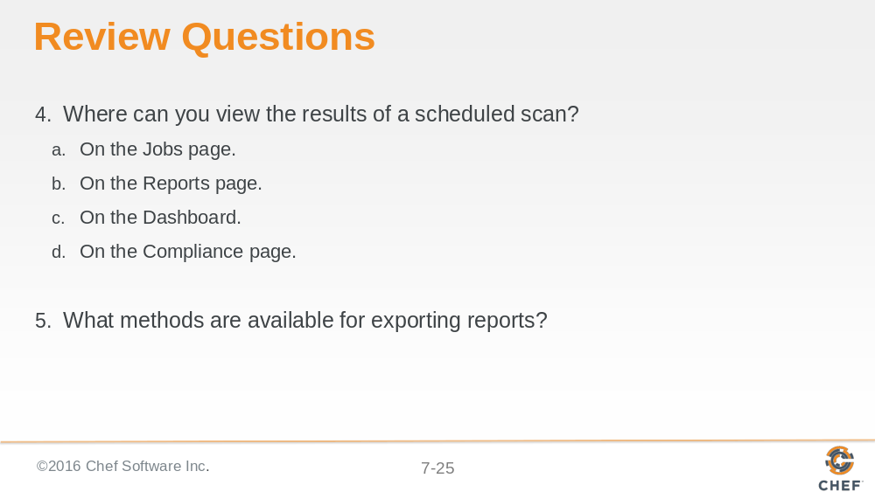

Slide 26

