8: Users, Organizations, Teams and Permissions

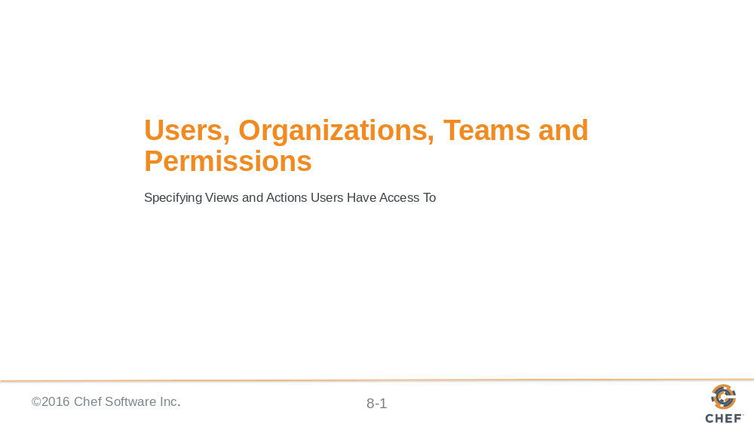

Slide 2

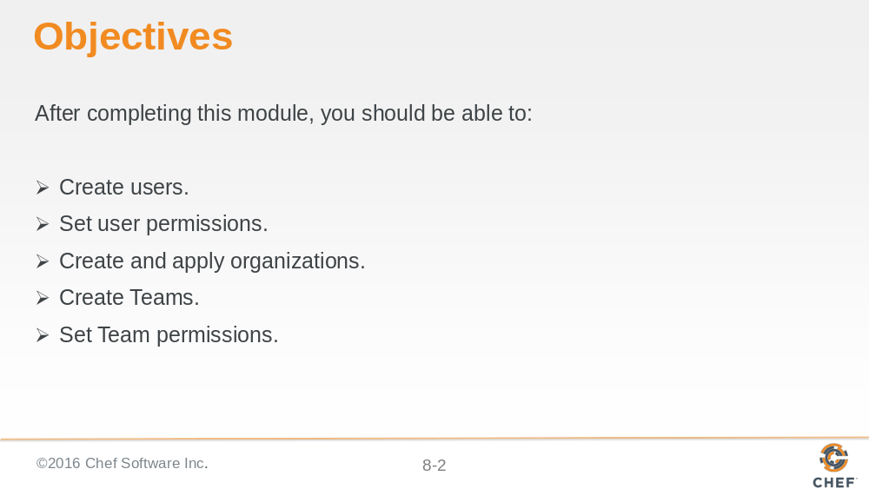

Slide 3

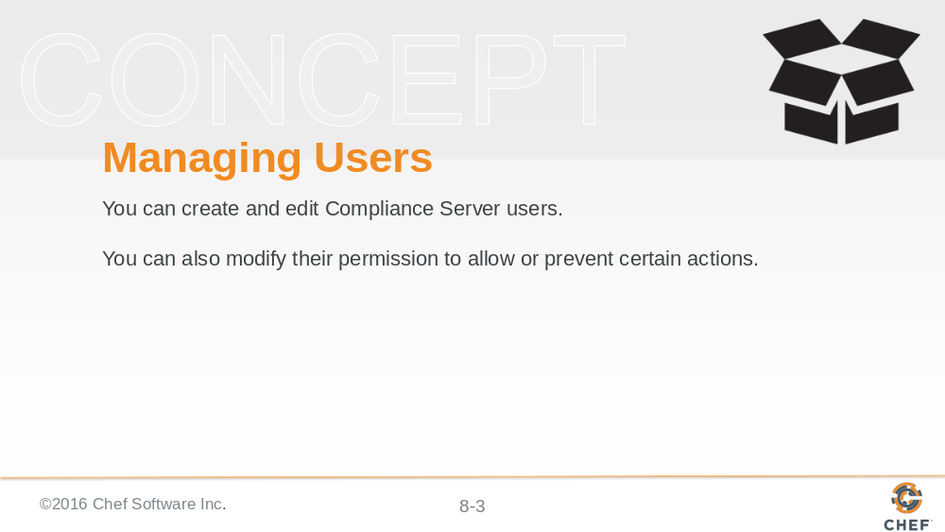

Permissions are used to control what users and organizations can do in the context of Chef Compliance. You can effectively enable or disable permissions to scan systems, update packages, or manage various aspects of Chef Compliance including users and organizations.

Slide 4

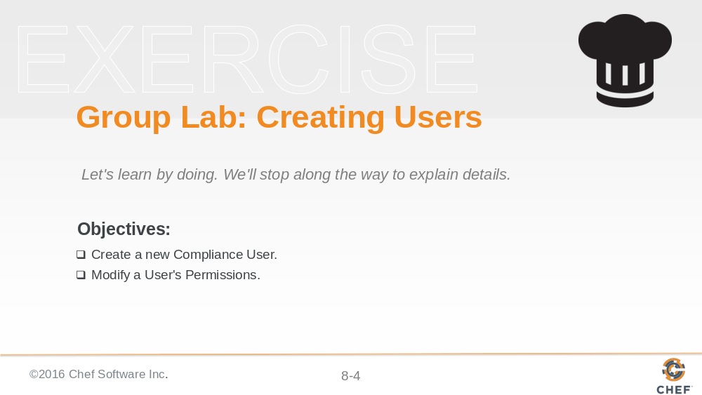

Slide 5

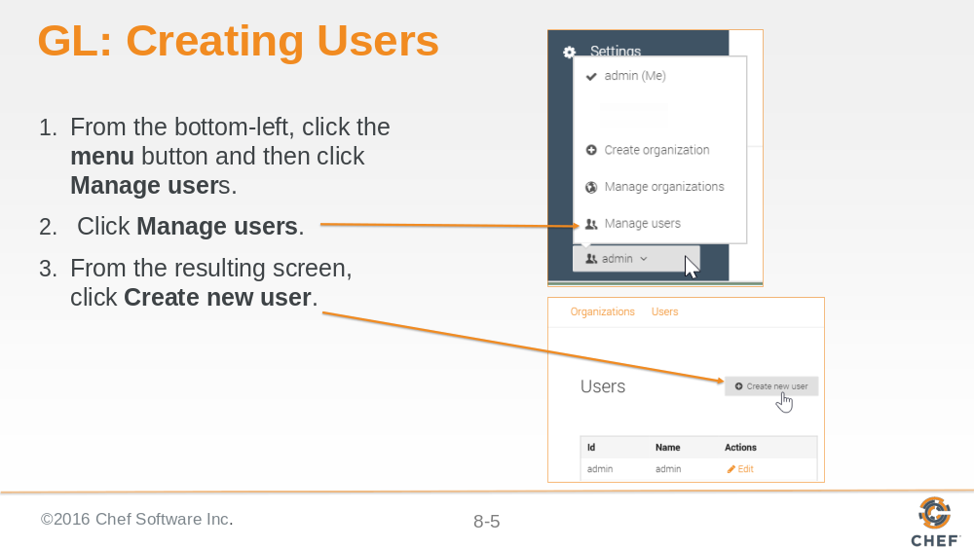

Slide 6

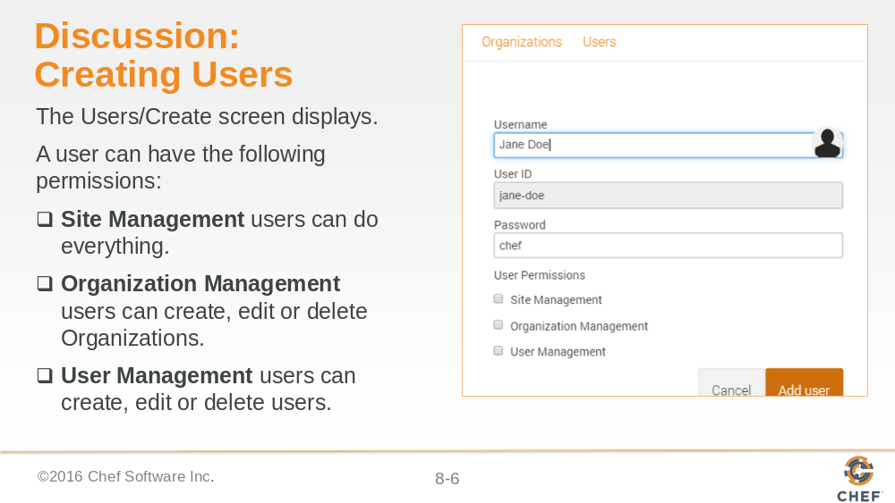

The Site Management permission can be thought of as Administrator-level permissions. It is like a superset of the Organization Management and the User Management permissions.

We will discuss Organizations and their purpose later in this module.

Slide 7

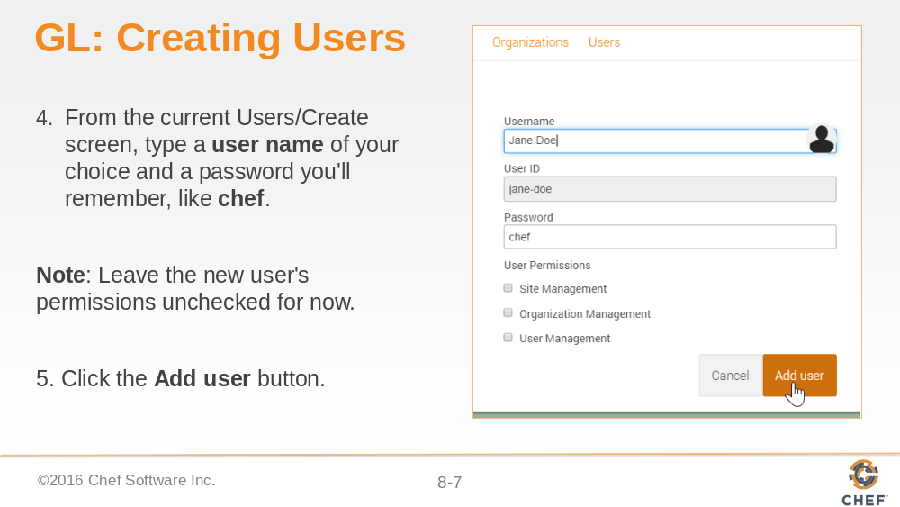

Slide 8

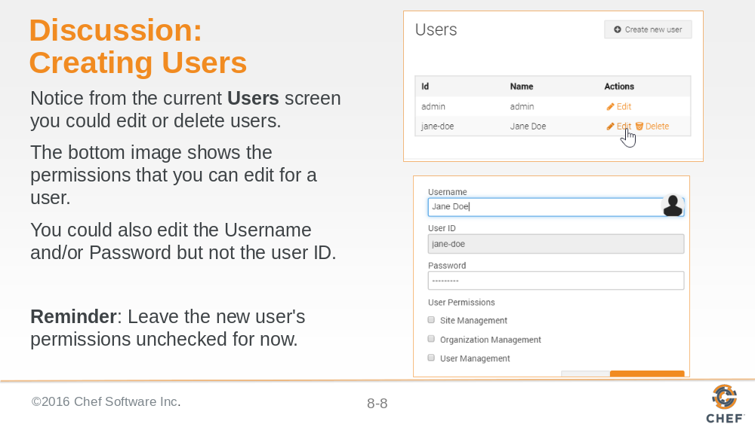

Notice that you can't delete the original admin user, however, since you always need at least an admin user.

We will use this new user in the up coming lab exercises.

Slide 9

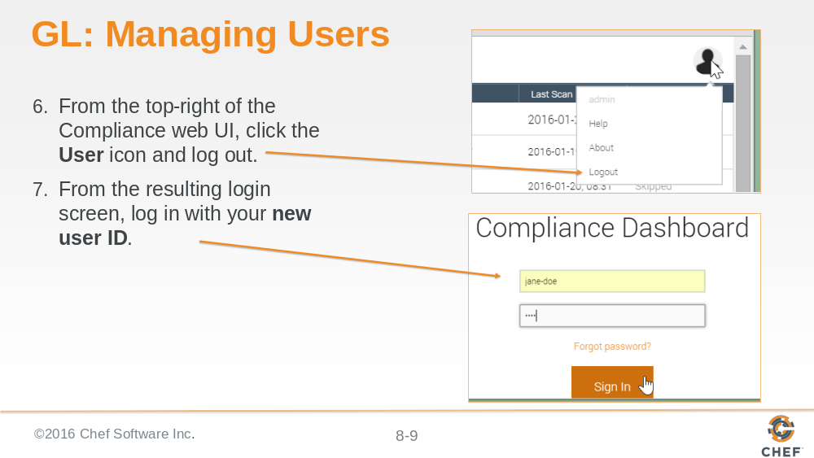

Slide 10

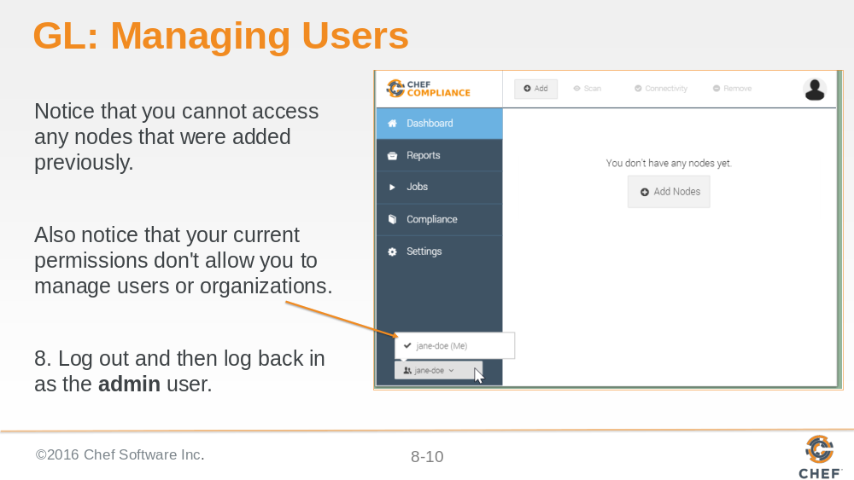

Slide 11

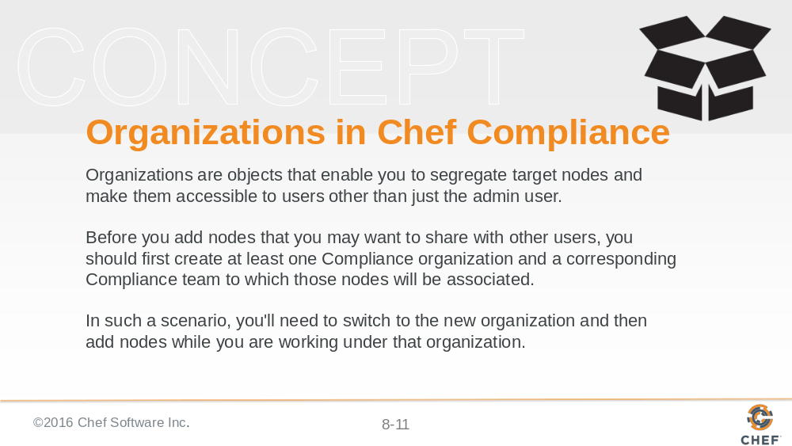

As of this writing, the only way to share access to nodes between different user accounts via a combination of an Organization object and its Team object.

Slide 12

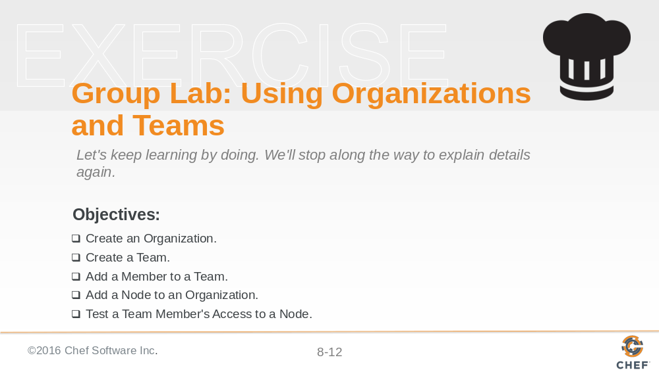

Slide 13

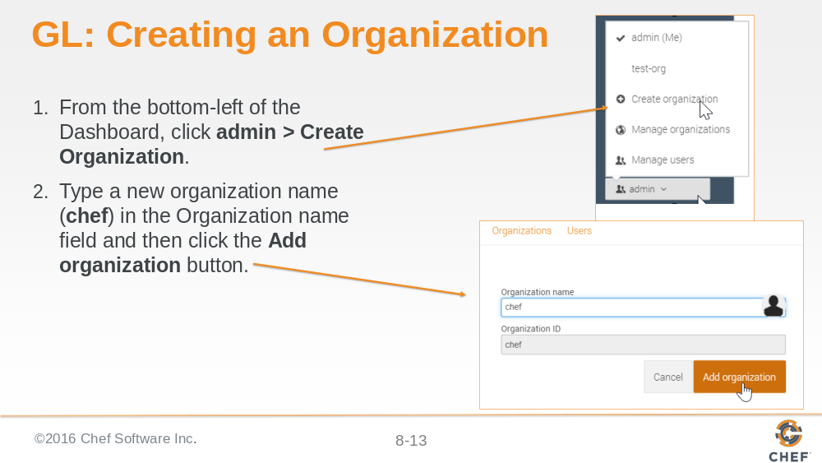

Slide 14

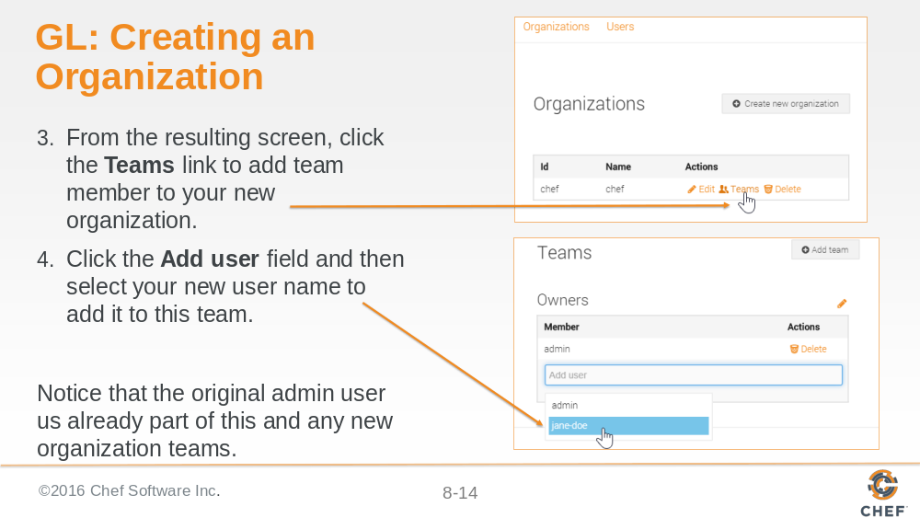

Slide 15

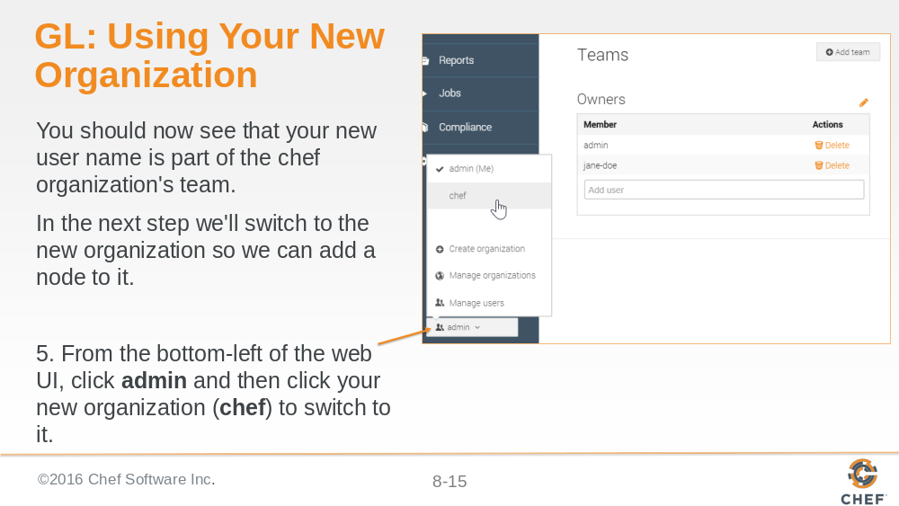

Slide 16

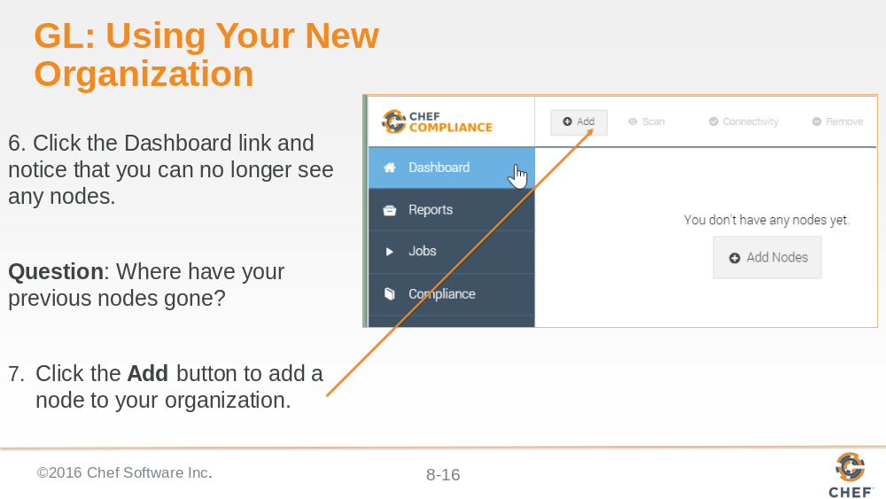

Slide 17

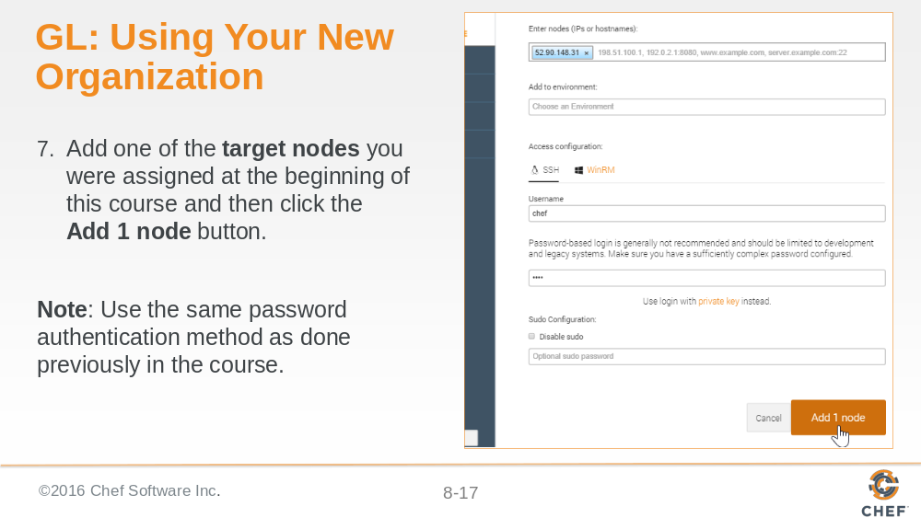

Slide 18

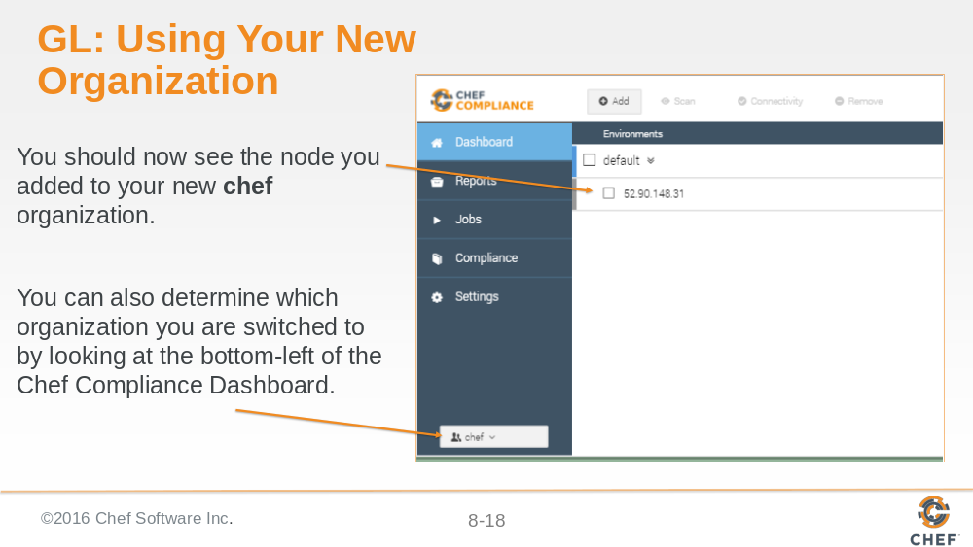

Slide 19

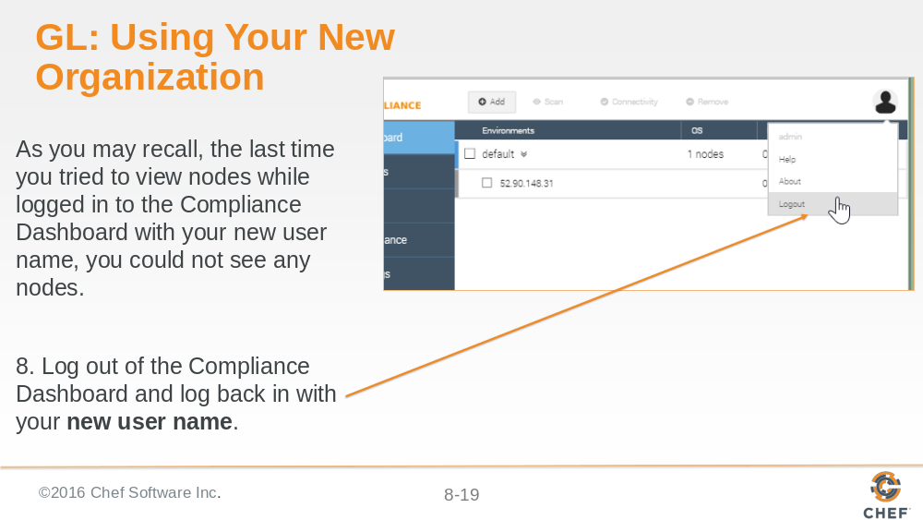

Slide 20

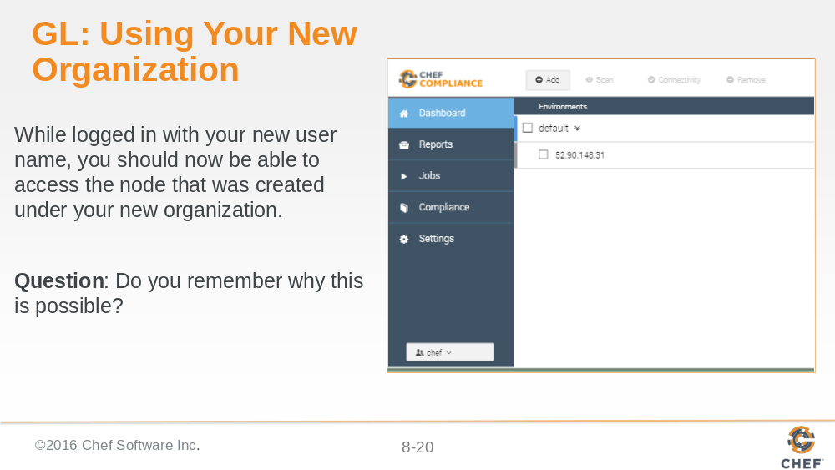

Slide 21

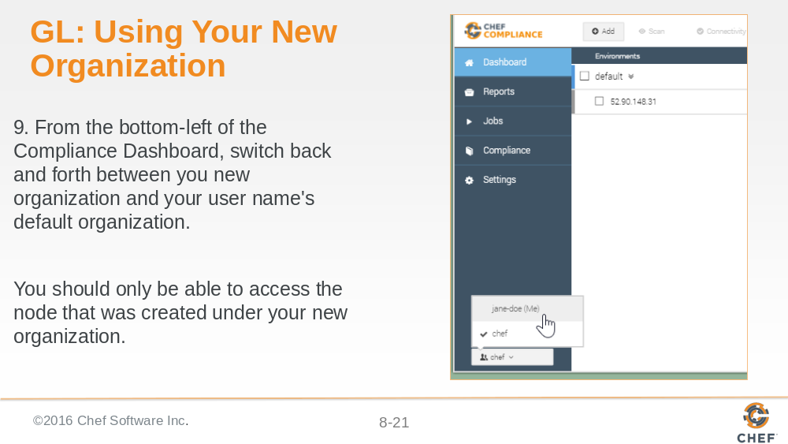

Slide 22

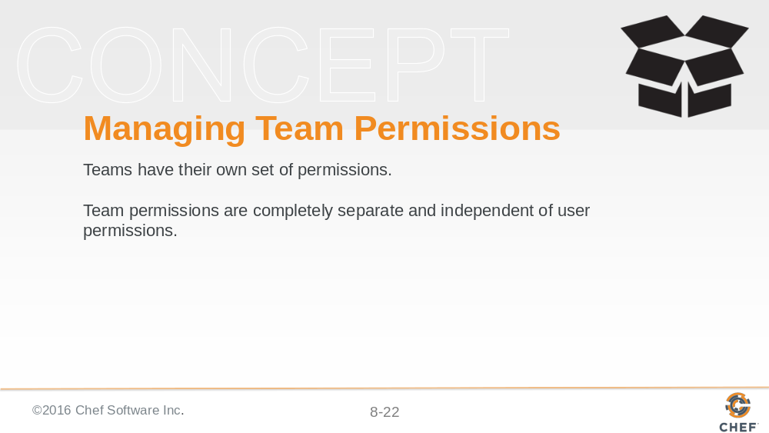

Slide 23

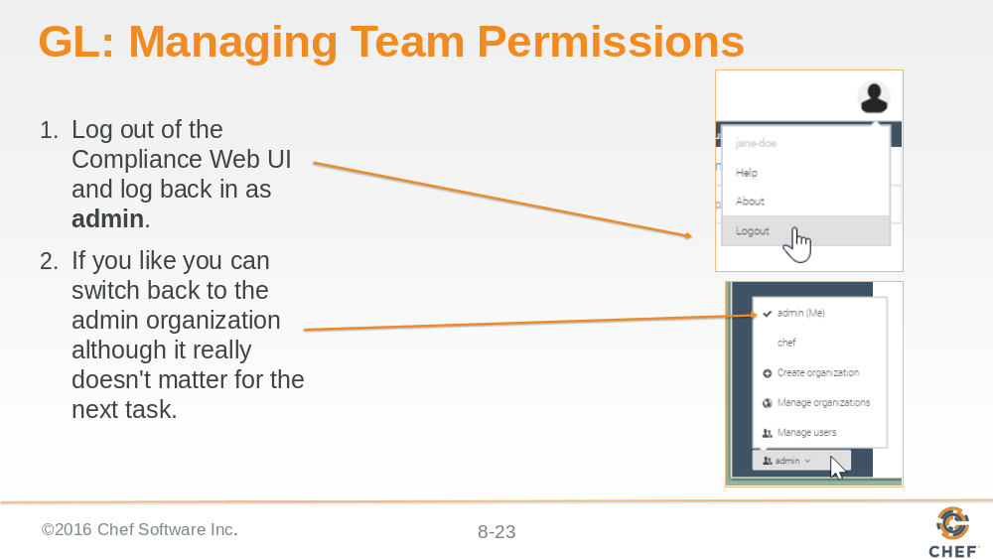

Slide 24

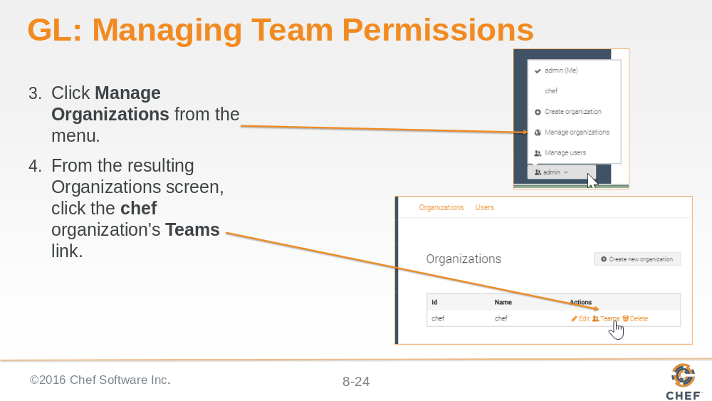

Slide 25

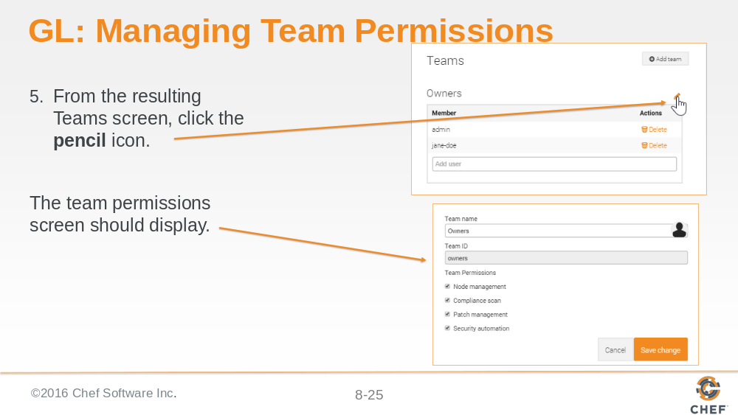

Slide 26

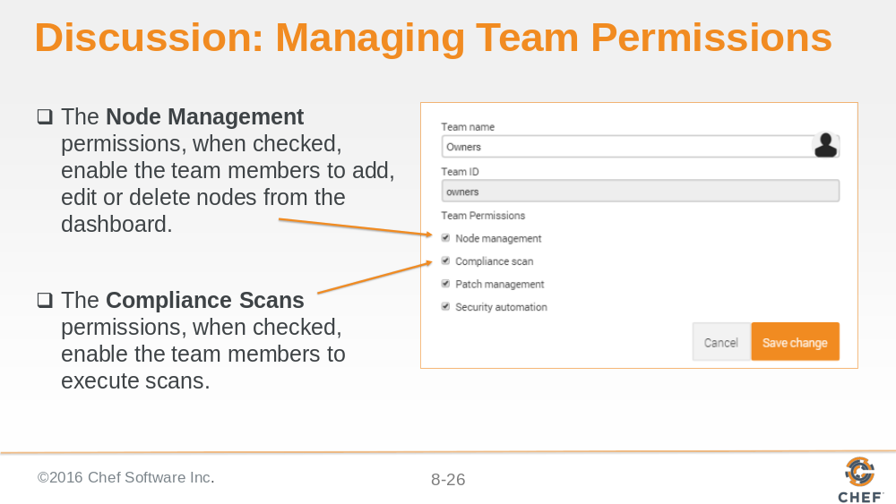

When you create a new team, all these permissions are enabled (checked) so if you want to limit team members' permissions listed here, you will need to disable them.

Slide 27

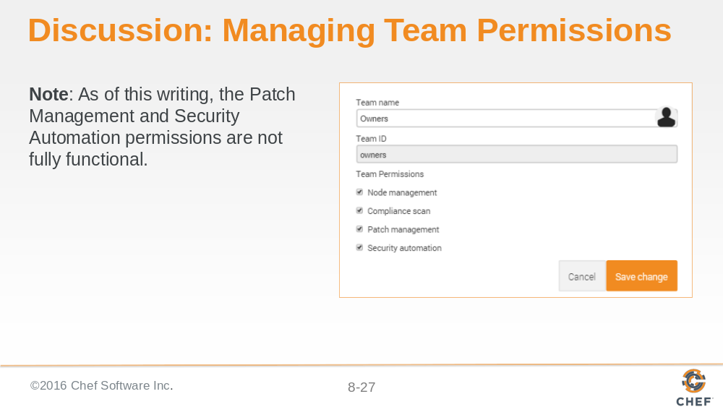

Slide 28

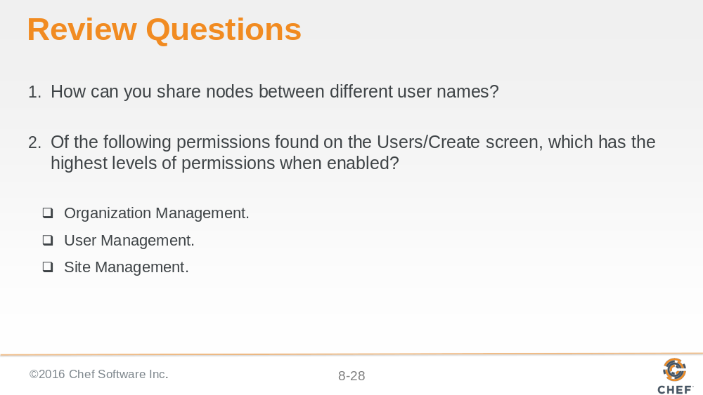

Slide 29

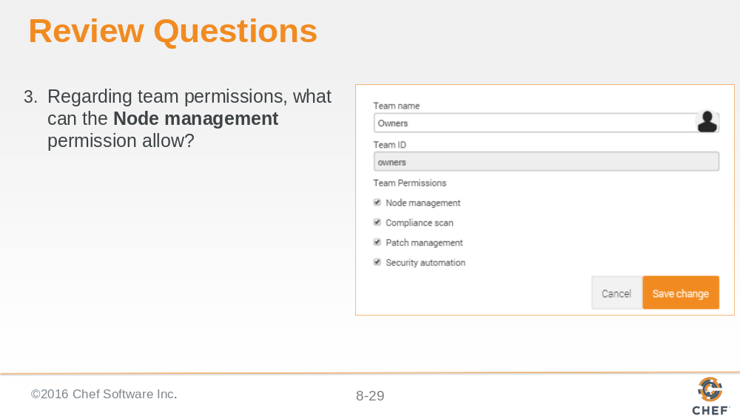

Slide 30

