1: Introduction

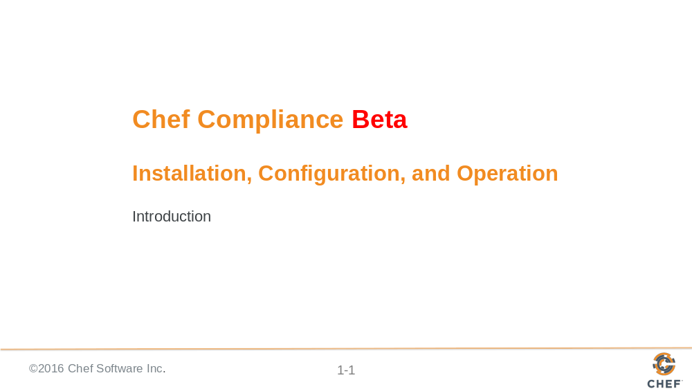

Instructor Note: Be sure to read Appendix Z at the end of this instructor guide for training lab set up notes and additional instructor notes. This course requires ChefDK 0.10.0 on or higher on the AMIs.

TBD IMPORTANT: We need to build the shell init stuff for chef dk in to the AMI images.

echo 'eval "$(chef shell-init bash)"' >> ~/.bash_profile then log out and in.

https://docs.chef.io/install_dk.html

Kennon thinks we need to put the chef user in the dockerroot group and make /var/run/docker.sock's group dockerroot in the future training images. We fix that in Module 03.

The issue is this: inspec exec ~/cookbooks/ssh/test/integration/client/inspec/client_spec.rb -t docker://CONTAINER_ID wont run witrhout permissions error nor ps docker without sudo.

See module 3 "GE: Running InSpec from the CLI" slide and notes.

Instructor Note: This course has been tested on Compliance Server v0.9.11.

Slide 2

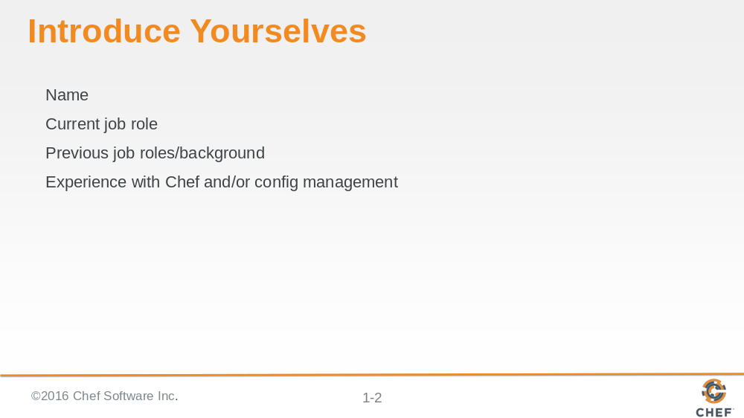

Slide 3

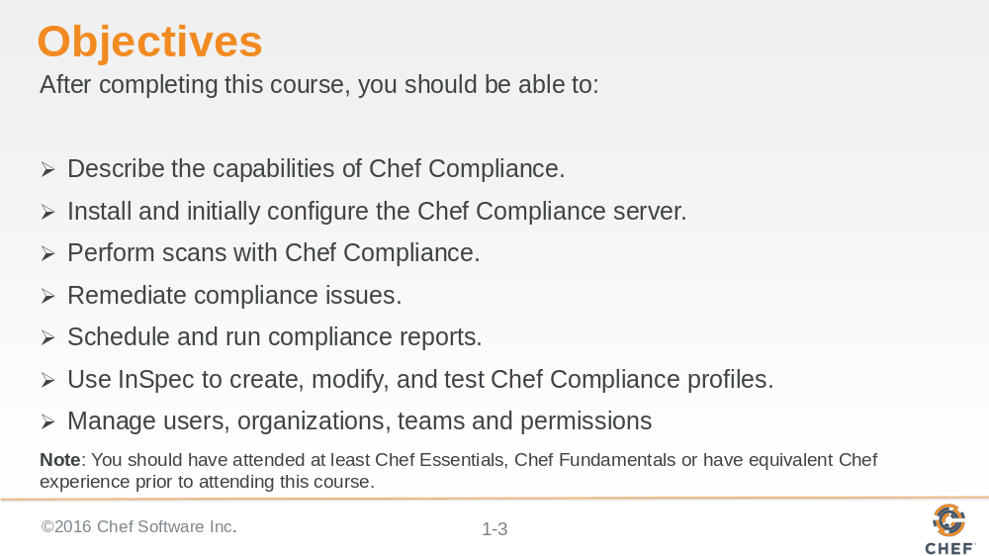

Instructor Note: You can tell the students that this course covers scanning and remediating both Linux and Windows nodes. For example, module 03 covers scanning and remediating Linux nodes and module 04 covers scanning and remediating Windows nodes. However, the Compliance server runs only on Linux.

Slide 4

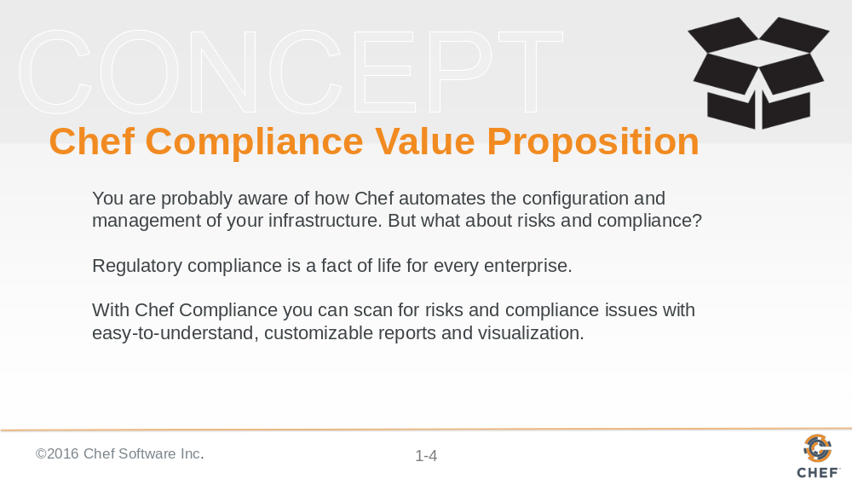

By now you are probably aware of how Chef automates the configuration and management of your infrastructure. But what about risks and compliance issues of your infrastructure?

Regulatory compliance is a fact of life for every enterprise. With Chef Compliance you can scan for risks and compliance issues with easy-to-understand, customizable reports and visualization.

You can then use Chef to automate the remediation of issues and use Chef Compliance to implement a continuous audit of applications and infrastructure.

Slide 5

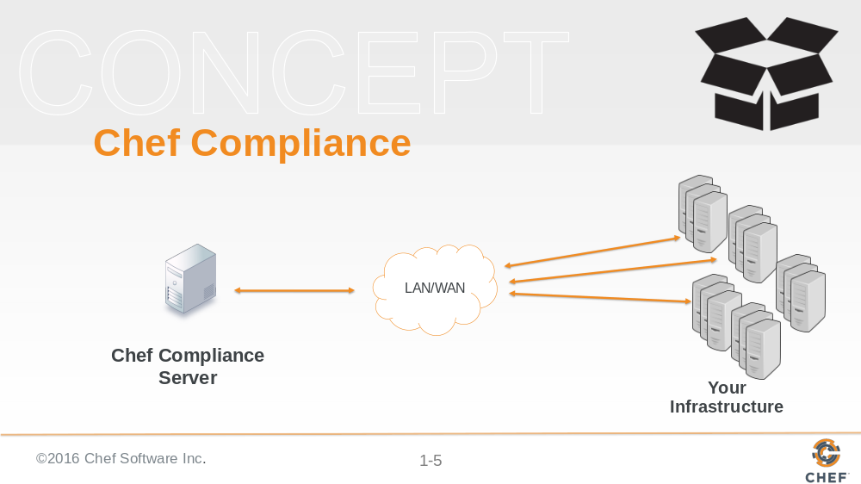

The Chef Compliance server is a centralized location from which all aspects of the state or your infrastructure’s compliance can be managed.

With Chef Compliance you can test any node in your infrastructure, including all of the common UNIX and Linux platforms and most versions of Microsoft Windows.

Chef Compliance can continuously test any node against the goals of your organization’s security management lifecycle for risks and compliance issues.

Slide 6

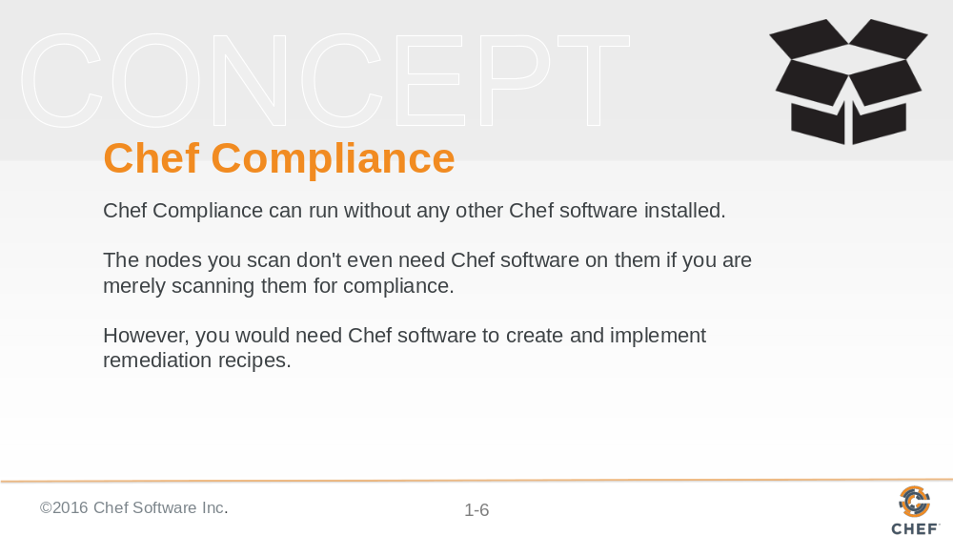

Chef Compliance can run without any other Chef software installed on the Chef Compliance server machine.

The nodes you scan don't even need Chef software on them if you are merely scanning them for compliance.

However, you would need Chef software to create and implement remediation recipes if you choose to use recipes to remediate compliance issues.

Slide 7

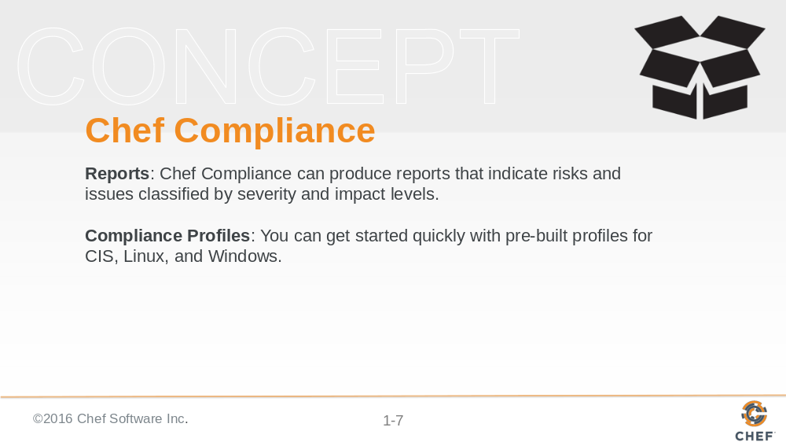

Slide 8

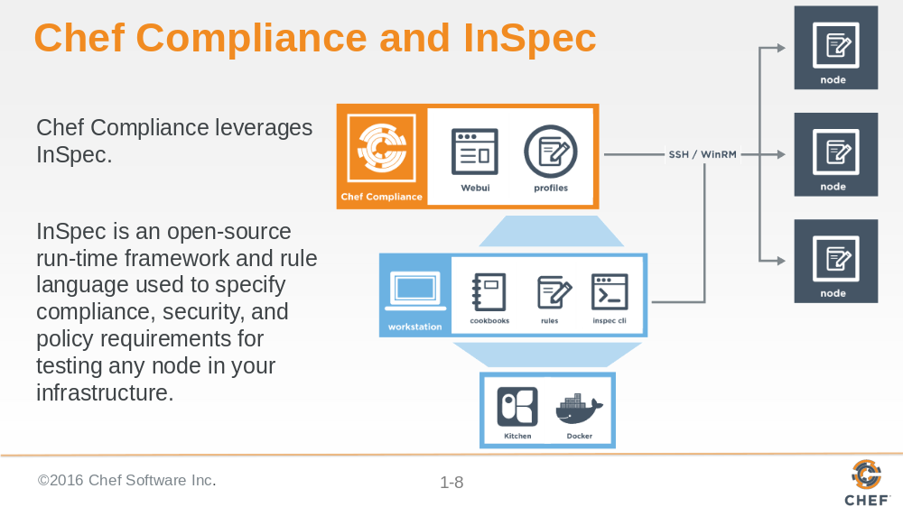

Chef Compliance leverages InSpec.

InSpec is an open-source run-time framework and rule language used to specify compliance, security, and policy requirements for testing any node in your infrastructure. The InSpec name refers to “infrastructure specification

InSpec includes a collection of resources to help you write auditing rules quickly and easily using the Compliance DSL.

Use InSpec to examine any node in your infrastructure; run the tests locally or remotely.

Any detected security, compliance, or policy issues are flagged in a log and displayed in reports.

The InSpec audit resource framework is fully compatible with Chef Compliance.

Instructor note: InSpec is similar to ServerSpec but learners who have no experience with Serverspec may be confused by the reference.

Slide 9

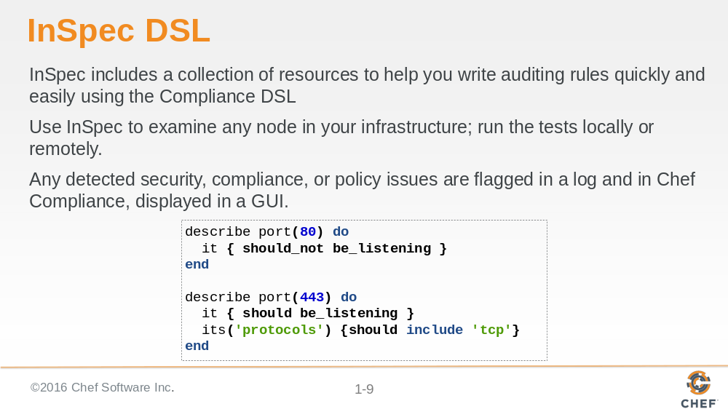

Slide 10

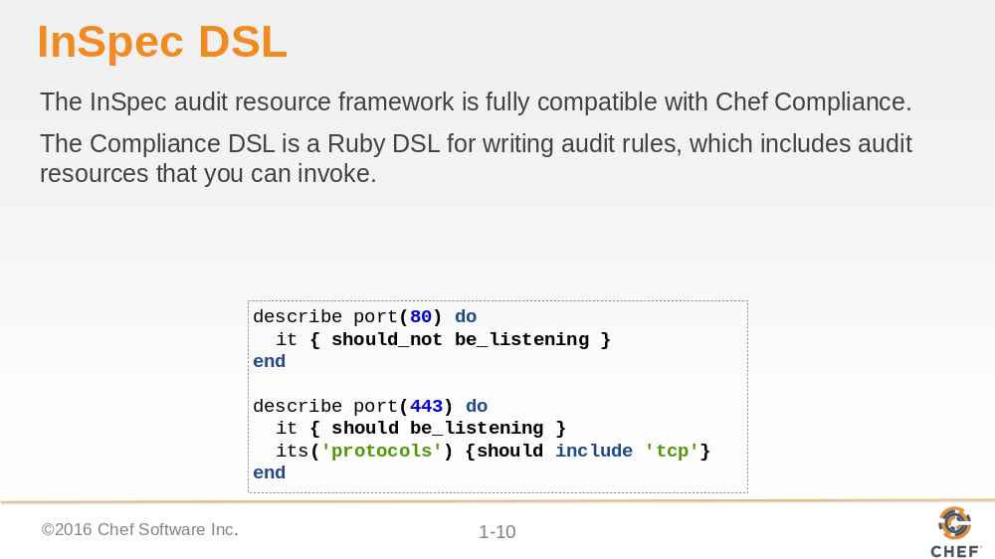

Slide 11

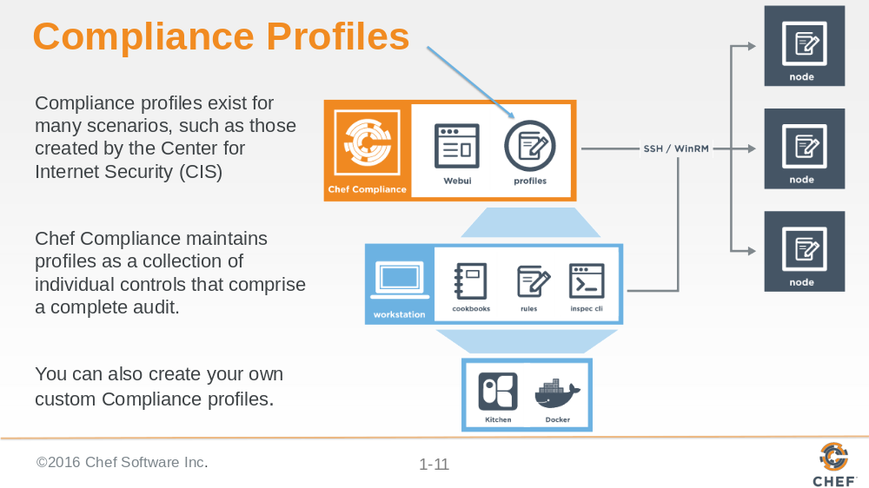

Compliance profiles exist for many scenarios, such as those created by the Center for Internet Security (CIS), a non-profit organization that is focused on enhancing the cyber security readiness and response of public and private sector entities.

Chef Compliance maintains profiles as a collection of individual controls that comprise a complete audit. For example, CIS benchmark 8.1.1.1 recommends testing for the maximum size of the audit log.

You can also create your own custom Compliance profiles.

Slide 12

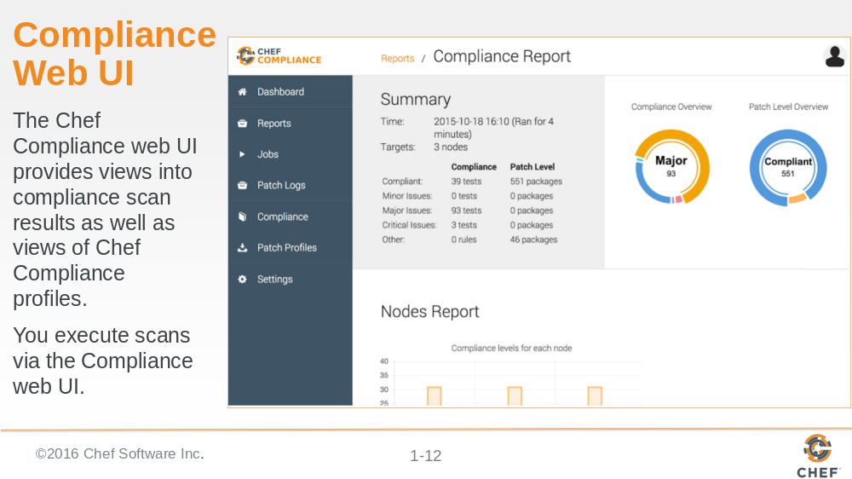

Slide 13

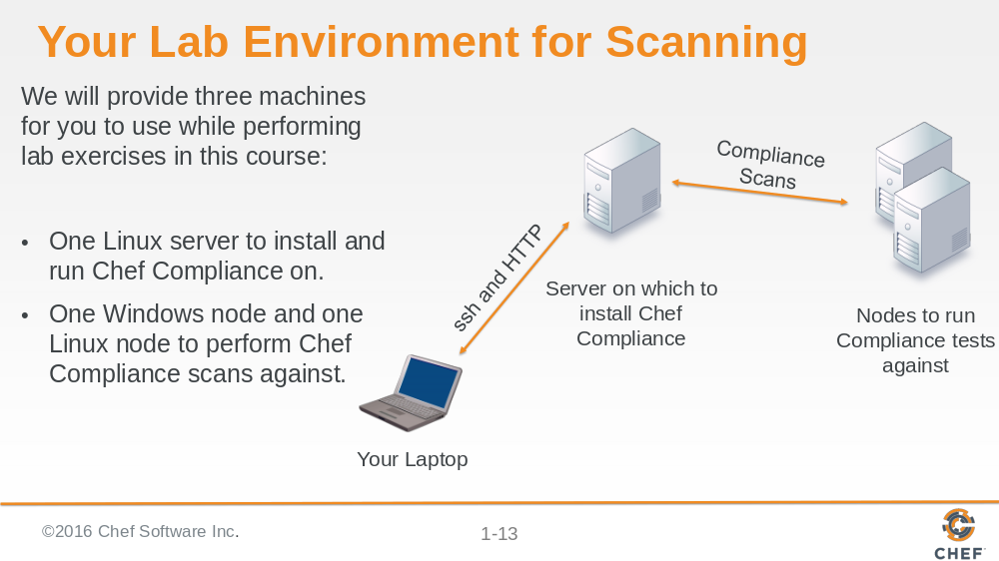

These are basic AWS AMIs that we use for Chef training. They have ChefDK installed on them although Chef does not actually need to be installed on these instances in order to run scans.

Instructor Note: Now would be a good time to distribute the hostnames of the three nodes you will assign to each student. You should ask the students to note which one they will use as their Compliance Server and which ones they will use as the target nodes for scans.
For example:
ec2-52-91-31-125.compute-1.amazonaws.com = Compliance server.
ec2-54-164-54-218.compute-1.amazonaws.com = Linux Target node.
ec2-54-164-54-210.compute-1.amazonaws.com = Windows Target node.

The login credentials for the Linux nodes is chef/chef.
The login credentials for the Windows nodes is Administrator/Cod3Can!

Slide 14

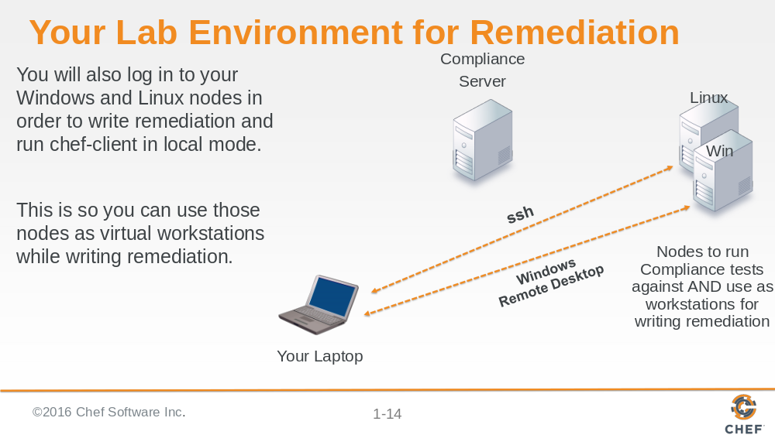

The dotted lines indicate that those sessions will only be used to write and test remediation. In this scenario, your target nodes will act as virtual workstations.

But all scans will only be run via the Compliance server as indicated in the previous slide.

Slide 15

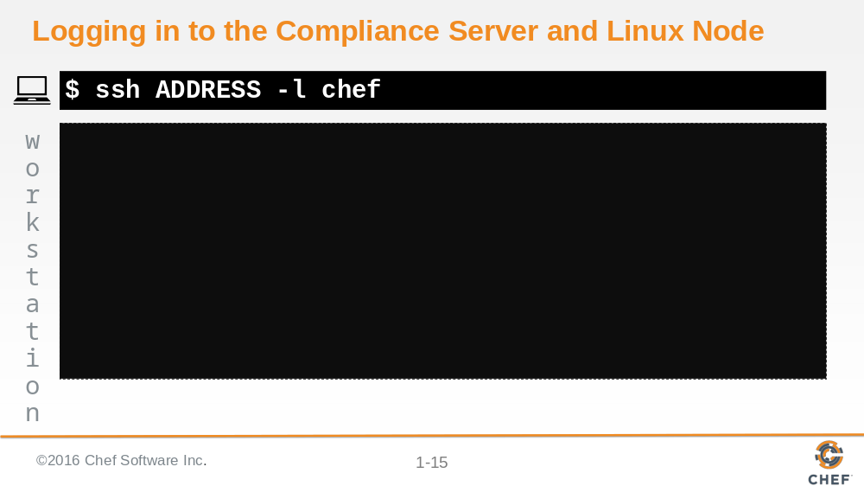

This is just an explanation. You don't need to log in to these machines at this time.

You should use an ssh client like PuTTY or a local command prompt to connect to the remote workstation that we assign to you.

Instead of the command shown in this slide, you could also use this command:

ssh chef@IPADDRESS

For example: ssh chef@52.90.140.22

Slide 16

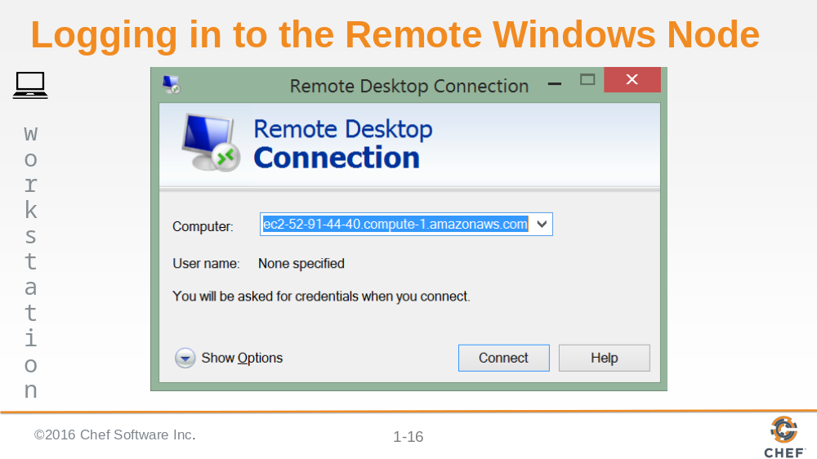

This is just an explanation. You don't need to log in to these machines at this time.

You should have installed on your laptop a Windows Remote Desktop Connection which you'll only use to write remediation later in this course.

Slide 17

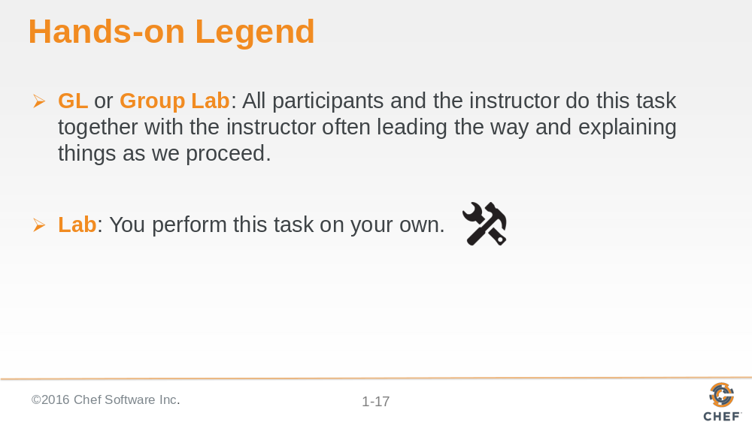

Slide 18

