13: Search

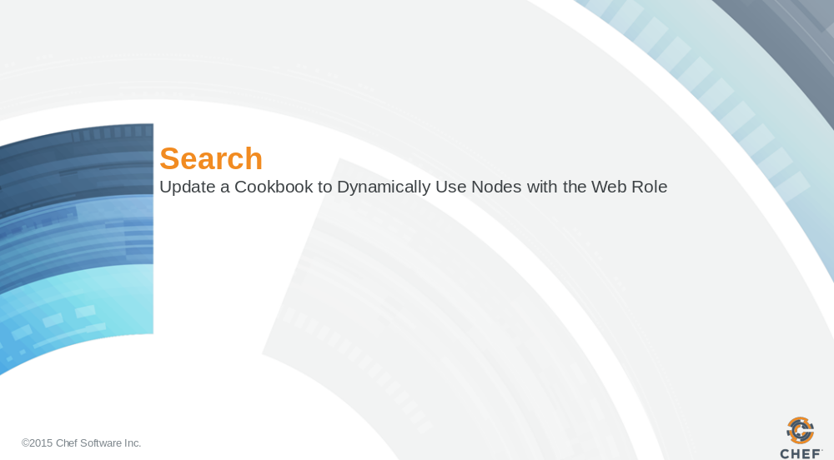

Slide 2

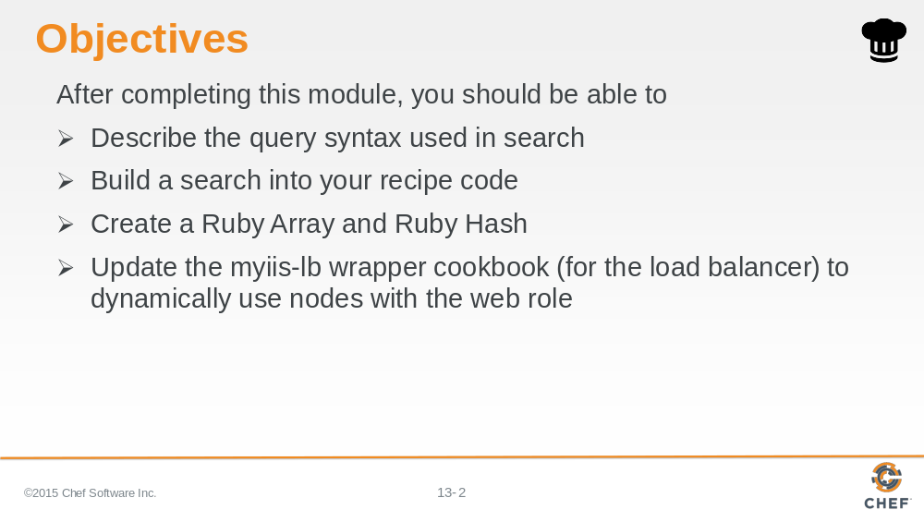

In this module you will learn how to describe the query syntax used in search, build a search into your recipe code, create a ruby array and ruby hash, and update the myiis-lb wrapper cookbook to dynamically use nodes with the web role

Slide 3

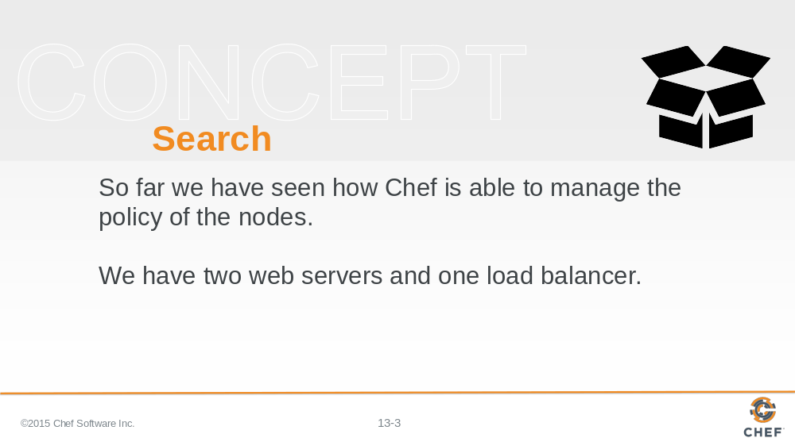

So far we have seen how Chef is able to manage the policy of the nodes within our infrastructure.

We have two web servers and one load balancer. As more customers come to our website we can continue scale up to meet that demand.

Slide 4

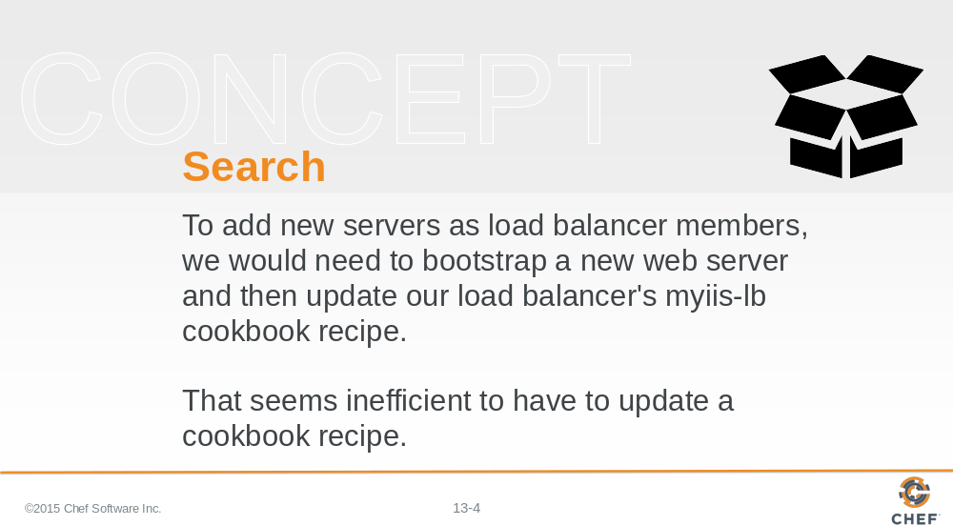

To add new servers as load balancer members, we would need to bootstrap a new web server and then update our myiis-lb cookbook to include that new web server. But that seems dramatically inefficient to have to update a cookbook recipe.

A more ideal solution would be for the recipe to instead discover all of the web servers within our organization and automatically add them list of available members for our load balancer.

Slide 5

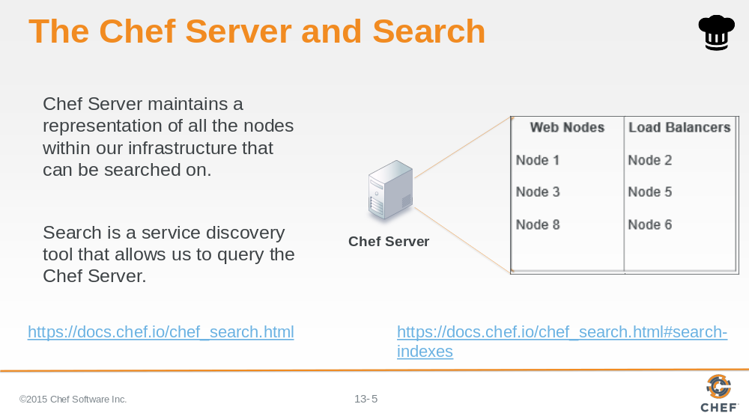

The Chef Server maintains a representation of all the nodes within an infrastructure and provides a way for us to discover these systems through Search.

Search is a service discovery tool that allows us to query the Chef Server across a few indexes. One such index is on our nodes.

Slide 6

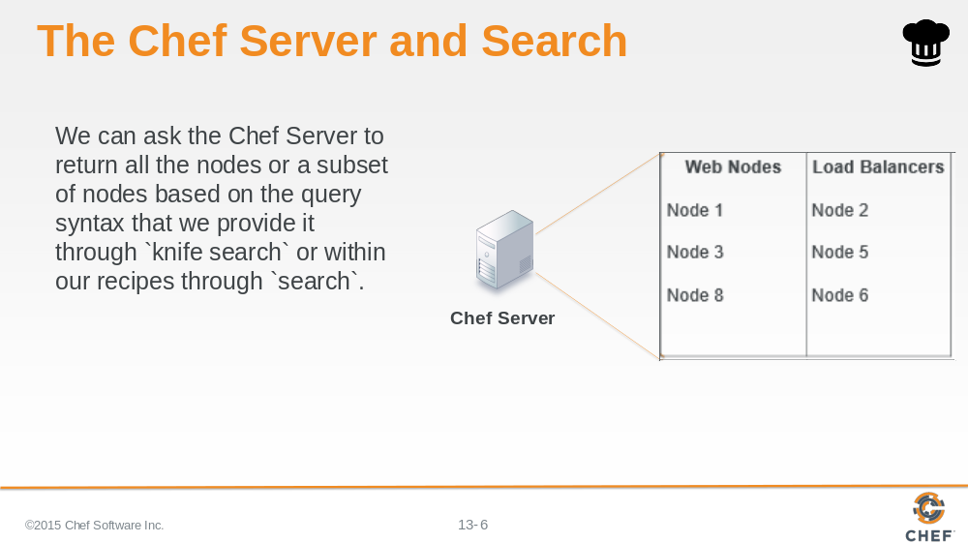

We can ask the Chef Server to return back to us all the nodes or a subset of nodes based on the query syntax that we provide it through the knife command `knife search` or within our recipes through the `search` method.

Slide 7

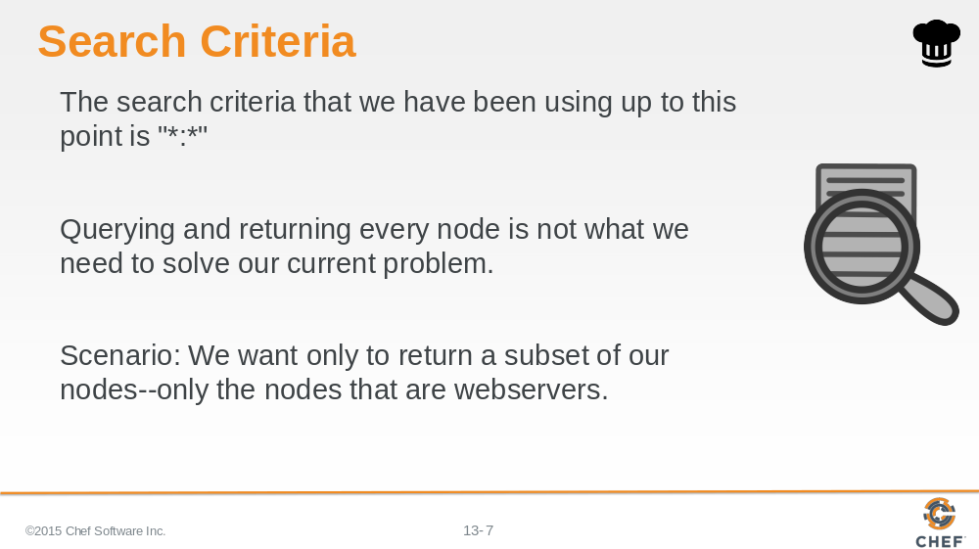

We have been using a form of the search criteria already when we have employed the `knife winrm` command. The search criteria that we have been using up to this point is "*:*" which we explained matched every node within our infrastructure.

Querying and returning every node is not exactly what we need to solve our current problem. Scenario: We want only to return a subset of our nodes--only the nodes that are webservers.

Let's examine the search criteria more so we can understand how it works and how we can use it to find a subset of the nodes--only the nodes that are webservers.

Slide 8

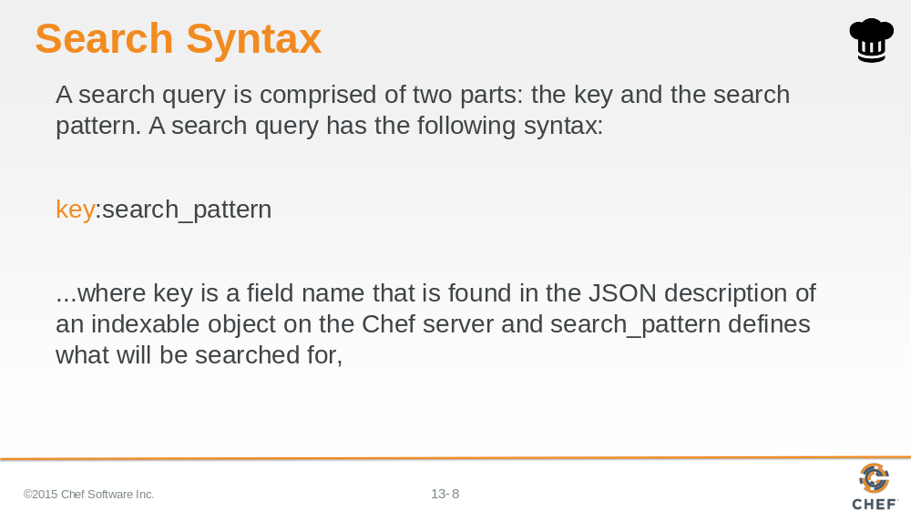

A search query is comprised of two parts: the key and the search pattern. A search query has the following syntax:

key:search_pattern

...where key is a field name that is found in the JSON description of an indexable object on the Chef server (a role, node, client, environment, or data bag) and search_pattern defines what will be searched for.

Slide 9

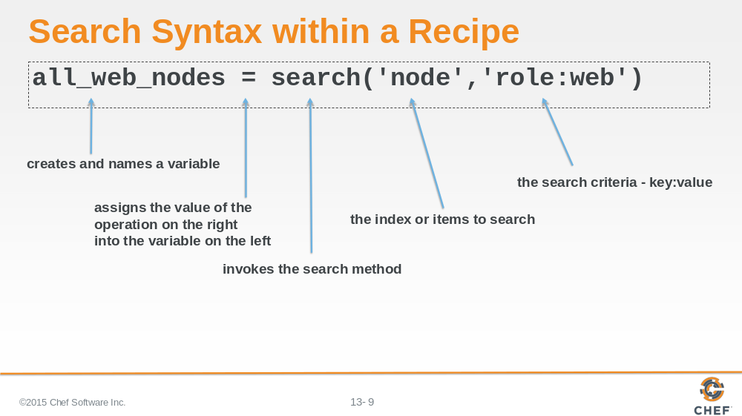

Search within a recipe is done through a `search` method that is available within the recipe.

The `search` method accepts two arguments. The first argument is a string or variable that contains the index or item to search on the Chef Server. These are: nodes; roles; and environments. The second argument is a string or variable that contains the search criteria to scope the results. This is using the notation 'key:value'.

The result of the search method is stored in a local variable that is named 'all_web_nodes'. Variables within Ruby are created immediately when you assign them.

Slide 10

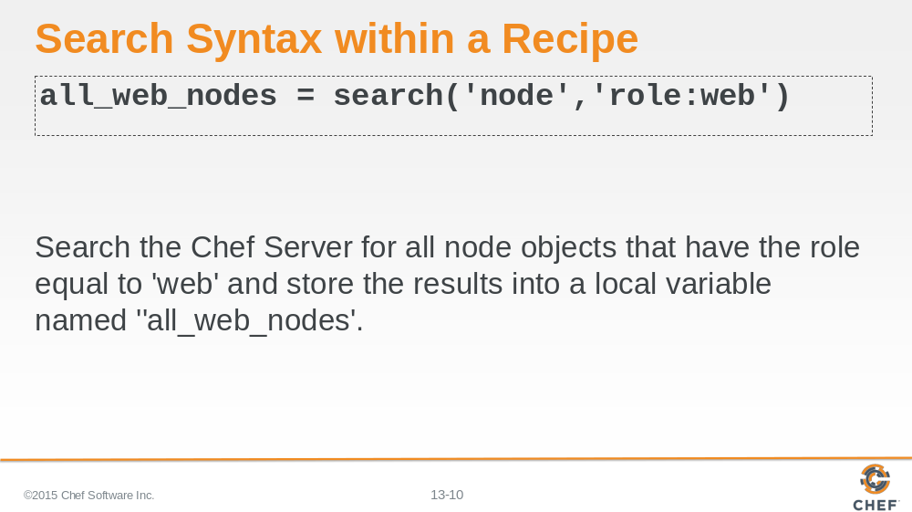

This example syntax could be translated to mean: Search the Chef Server for all node objects that have the role equal to 'web' and store the results into a local variable named 'all_web_nodes'.

Slide 11

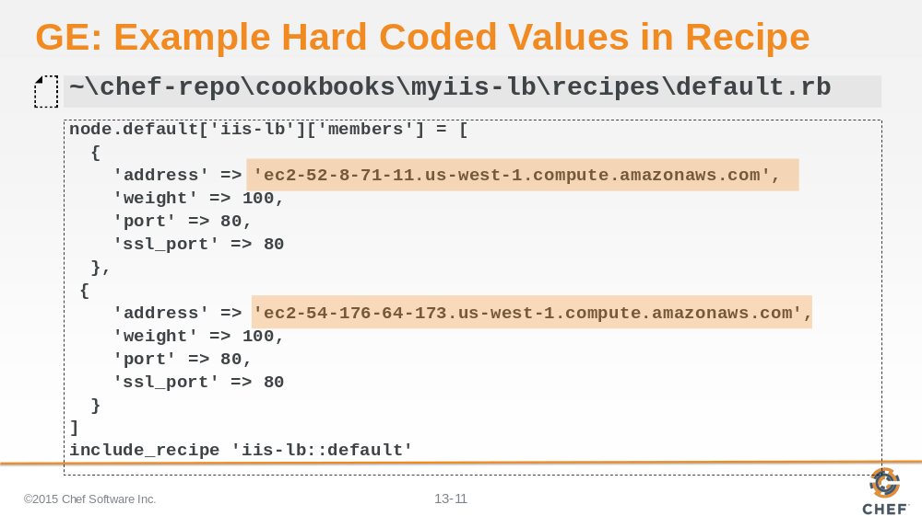

Previously, we had been hard coding the hostname and ipaddress values in our wrapped iis-lb recipe. We can request these values from the Chef Server through the `knife node show` command.

The hostname and ipaddress values are captured by Ohai and sent to the Chef Server. On the Chef Server we can query those values when we ask about specific attribute about the node.

We do that by providing the `-a` flag with the name of the attribute. Because the nodes that we manage are hosted in the cloud, these attributes are stored under a parent attribute named 'cloud'.

Slide 12

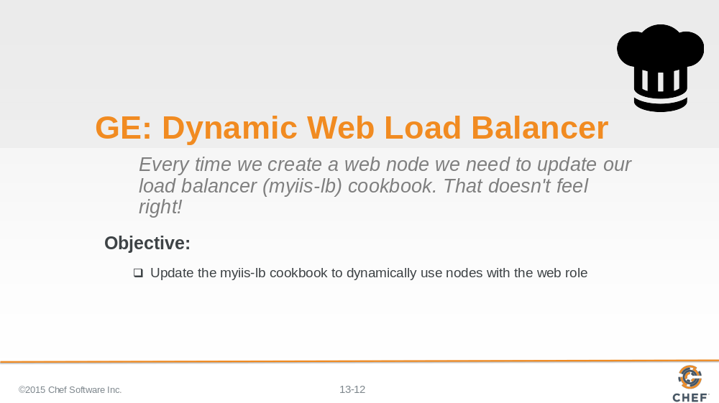

In this section we'll update the load balancer's myiis-lb cookbook to dynamically use nodes with the web role.

Slide 13

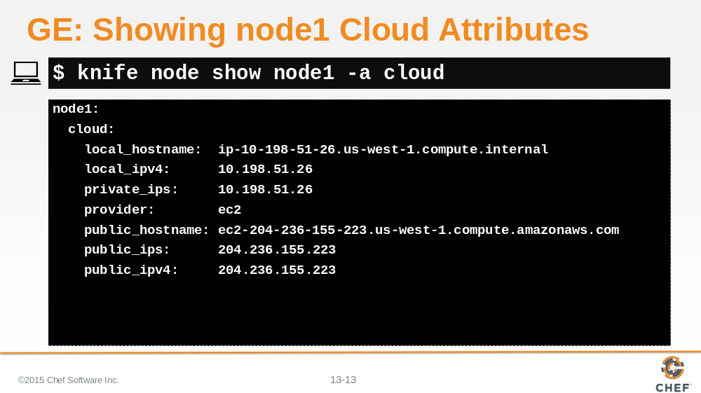

Here we are asking for all the 'cloud' attributes for 'node1'.

Slide 14

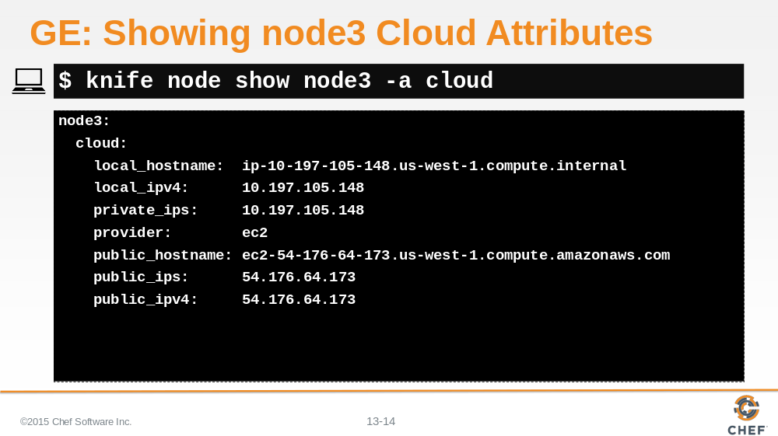

Here we are asking for all the 'cloud' attributes for 'node3'.

Slide 15

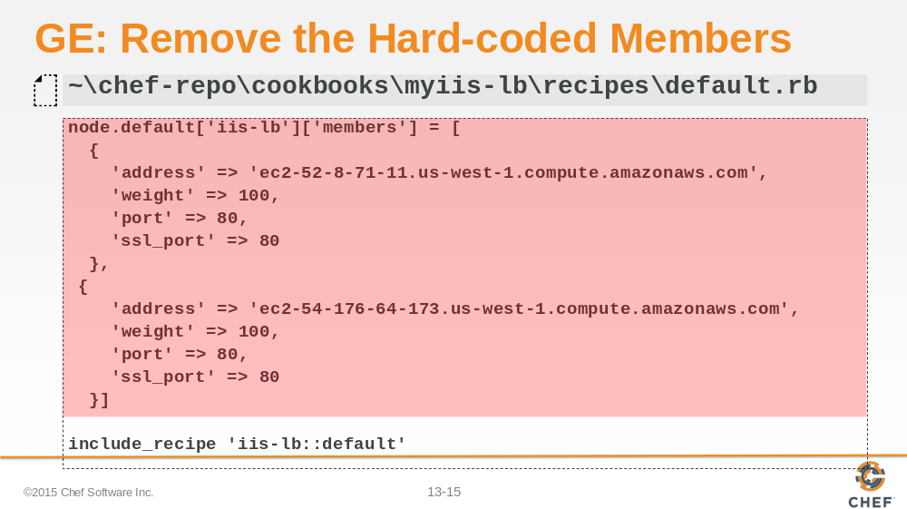

Edit the 'myiis-lb' cookbook's default recipe and remove the current default recipe where you hard-coded the members.

Slide 16

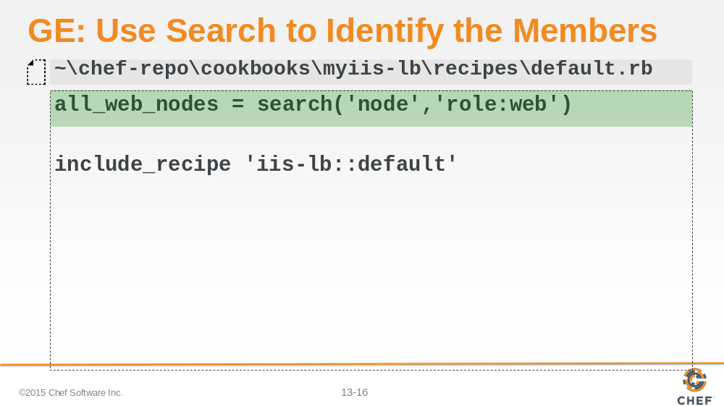

Replace it with an updated recipe that searches for all nodes that have the 'web' role defined.

The search method's first parameter is asking the Chef Server to look at all the nodes within our organization.

The search method's second parameter is asking the Chef Server to only return the nodes that have been assigned the role web.

All of those nodes are stored in a local variable named `all_web_nodes`. This is an array of node objects. It may contain zero or more nodes that match the search criteria.

Slide 17

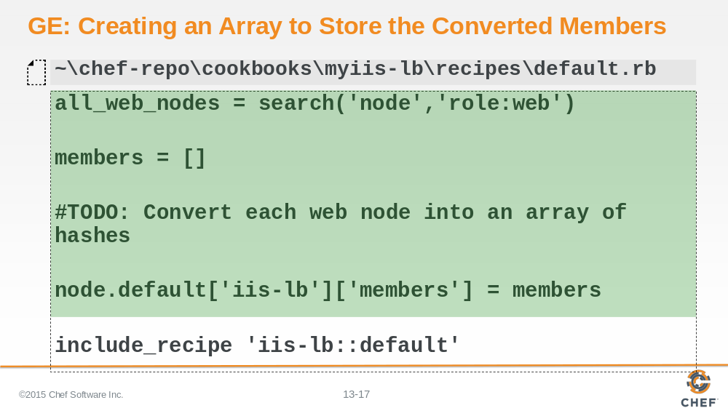

Unfortunately we cannot simply assign our array of web nodes into the iis-lb's members attributes because it needs a hash that contains the keys 'hostname', 'ipaddress', 'port', and 'ssl_port'.

We will need to convert each of the web node objects into a structure that the iis-lb member's attribute expects.

First we create an empty array and assign that empty array into a local variable named `members`. `members` is an array that we will populated with the hashes we will create later; until then we will write a TODO for us.

Then we will assign that array into the `node.default['iis-lb']['members']`.

Slide 18

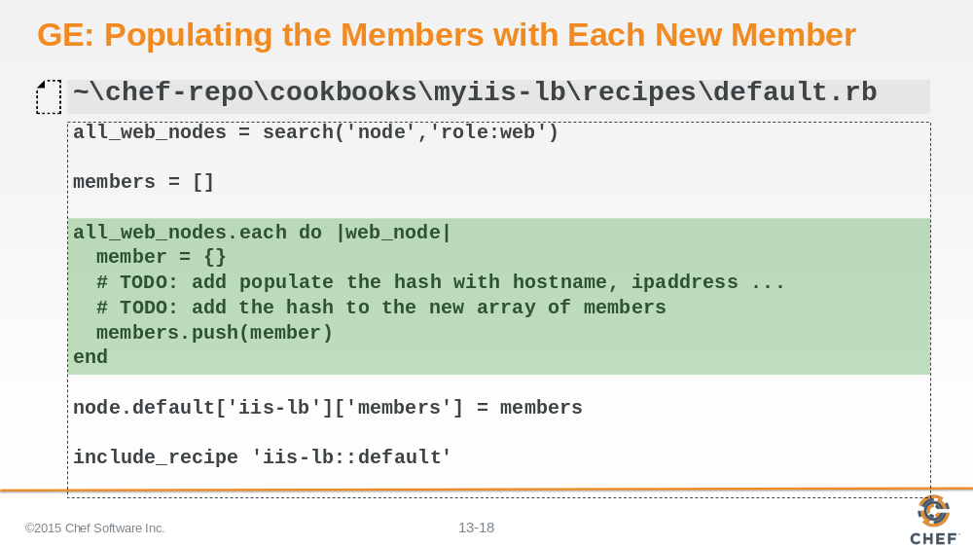

So we need to loop through the array of all the web nodes stored in `all_web_nodes`. We do that through a method available on every array object named 'each'. With the each method a block of code is provided -- you see it here from the first 'do' right after the each to the 'end' later in the file.

A block of code is an operation that you want perform on every item in the array. In our case we want to take each of the node objects and convert them into a hash object.

So every member of the array is visited and every member of the array runs through the block of code.

Slide 19

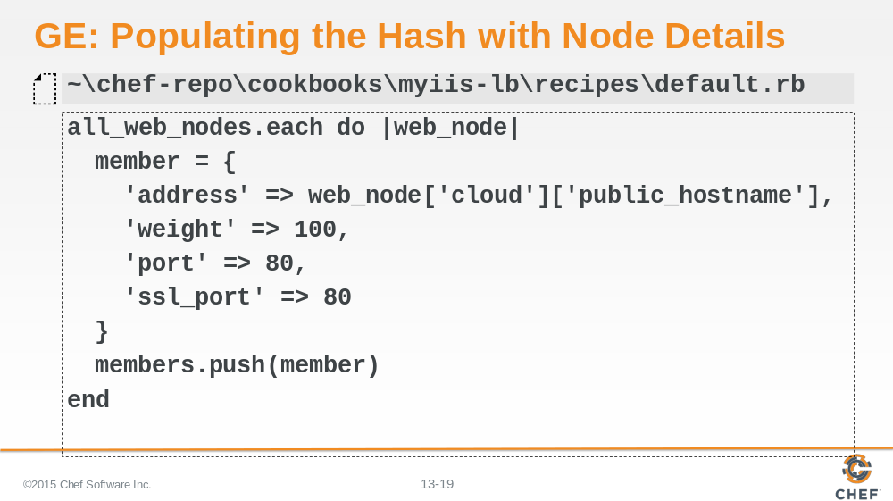
Between the pipes we see a local variable that we are defining that exists only in the block `web_node`. This local variable, `web_node`, is a name we came up with to refer to each node in our array of `all_web_nodes`.

Each web node in the array is sent through the block. When inside the block of code it is referred to as `web_node`.
Inside the block the first thing that is created is another local variable named `member` which is assigned a hash that contains the web_node's hostname and the web_node's ipaddress.
Then the local variable `member`, which contains that hash is pushed into the array of members. This adds the member to the end of the array.
When we are done looping through every web node the `members` array contains a list of all these hash objects.

Slide 20

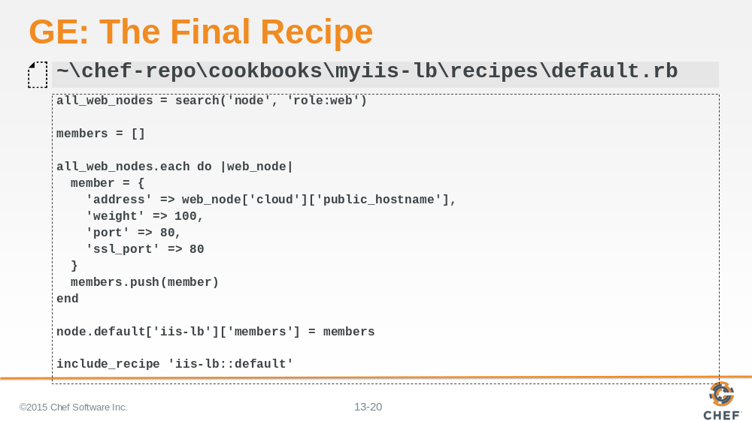

This is the complete recipe source code.

Slide 21

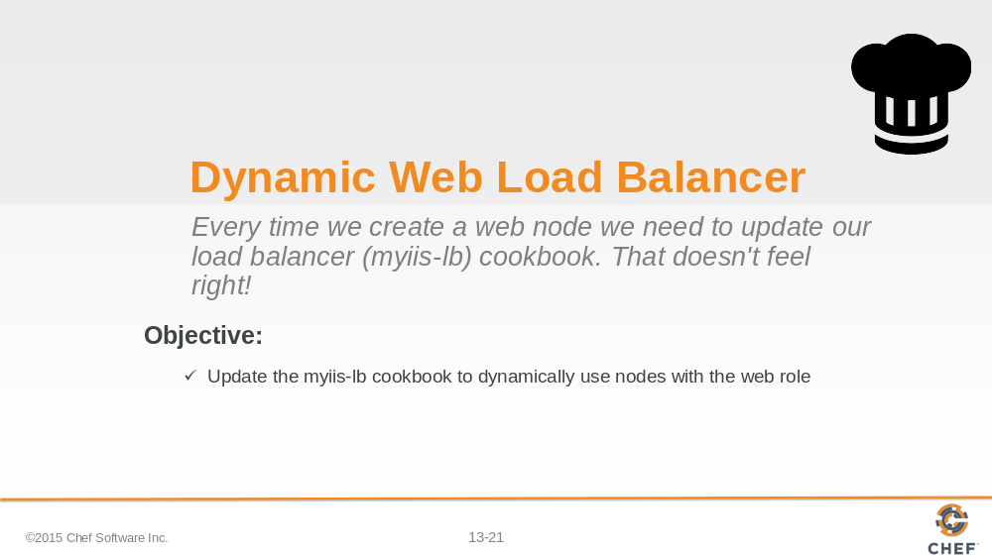

The default recipe of the myiis-lb recipe is now dynamic. Every time a load balancer checks in with the Chef Server, when you run `chef-client`, it will ask the Chef Server if there are any new nodes that are web servers.

As you add nodes, your load balancer will dynamically grow to accommodate them, returning them as node objects, which are then converted to hashes, and then assigned as members.

As you remove nodes, your load balancer will dynamically shrink to accommodate them, returning a smaller set of node objects, which are then converted to hashes, and then assigned as members.

Slide 22

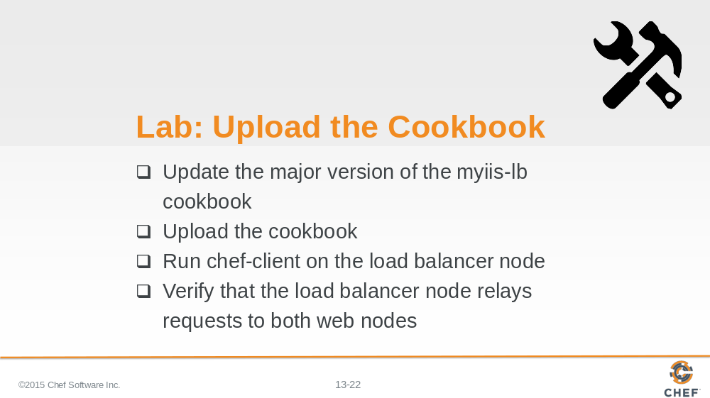

As a lab exercise:

* Update the major version of the cookbook
* Update the cookbook to the Chef Server
* Run `chef-client` on the load balancer node
* Verify that the load balancer node still relays requests to both of our web servers

Instructor Note: Allow 8 minutes to complete this exercise.

Slide 23

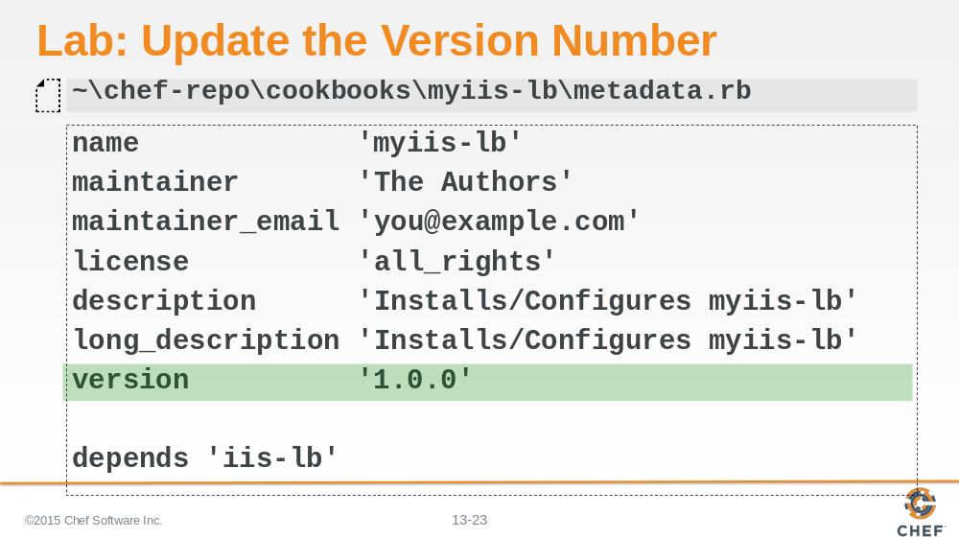

First we update the version to the next major release. We set the version number to 1.0.0.

Slide 24

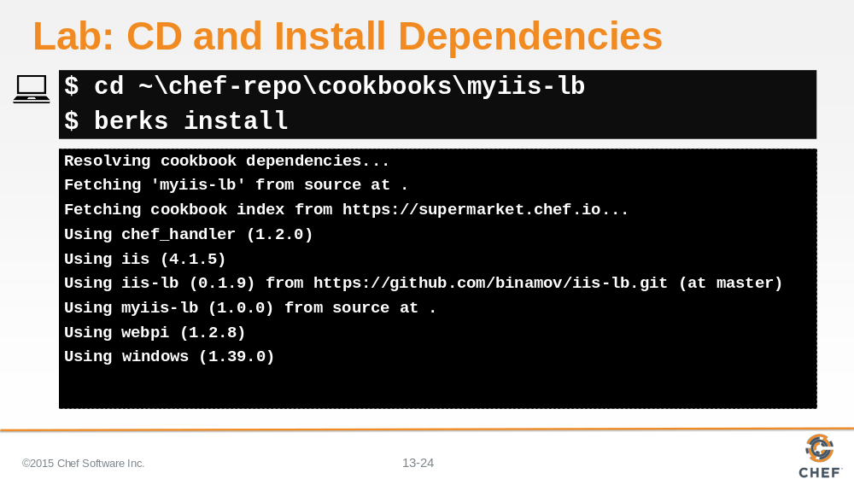

Change into the cookbook's directory and then install any new dependencies that your cookbook may need at version 1.0.0.

We have no new dependencies but this is required by berkshelf whenever you update the version of the cookbook.

Slide 25

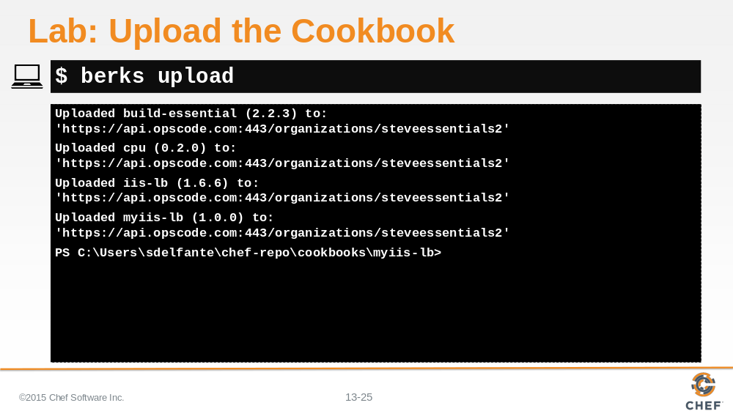

Upload the cookbook using the `berks upload` command.

Instructor Note: During the course the learner may find they have a mistake with the cookbook and need to re-upload the cookbook. Berkshelf will 'freeze' the versions of the cookbooks that you upload. This is to prevent you from accidently overriding cookbooks that you may have already created. It is a best practice to not re-upload a cookbook again with new changes if they share the same version. During this course, however, it is important that the version numbers be aligned to make future sections work correctly so it OK to do in the training environment. To re-upload a cookbook with Berkshelf replacing the existing cookbook can be done with `berks upload --force`

Slide 26

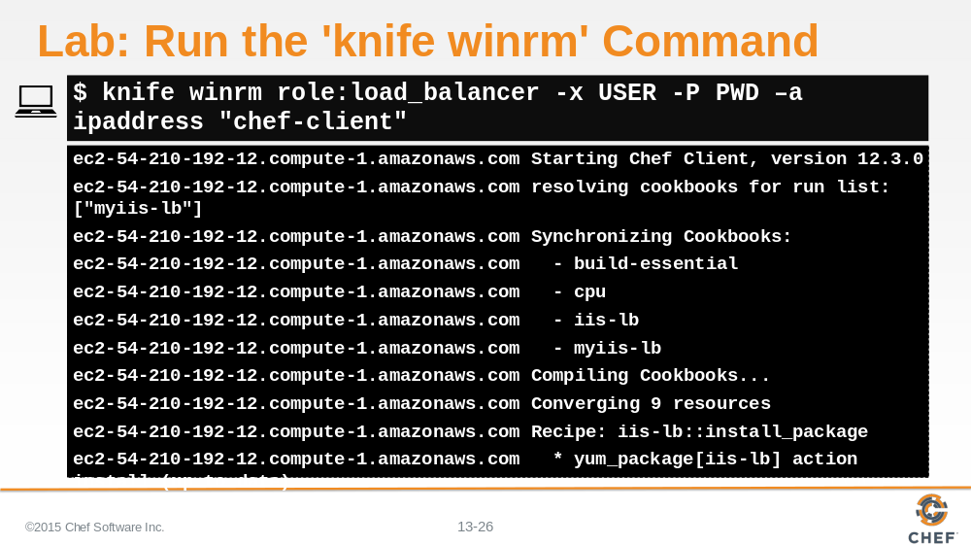

Use `knife winrm` and ask only the nodes with the role load_balancer' to run `chef-client`. This is more efficient than targeting all of the nodes as we did before and more accurate than targeting the node2 "name:node2".

This ensures that all nodes that are also load balancers check in with the Chef Server--similar to how we are targeting only the web server nodes in the recipe.

Slide 27

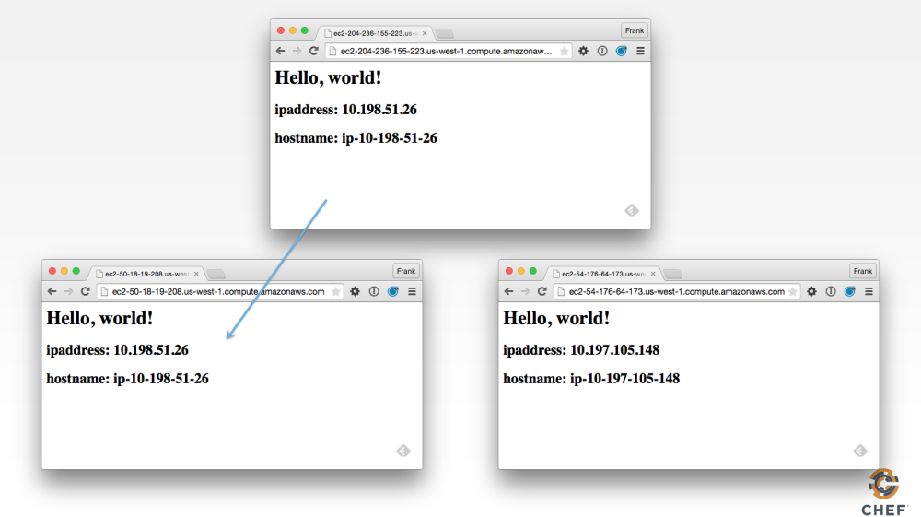

Nothing should change externally. You may see some differences in the logs as the load_balancer configuration file might change the order of the two entries but the end results is that our load balancer node is still delivering traffic to our two web server nodes.

Slide 28

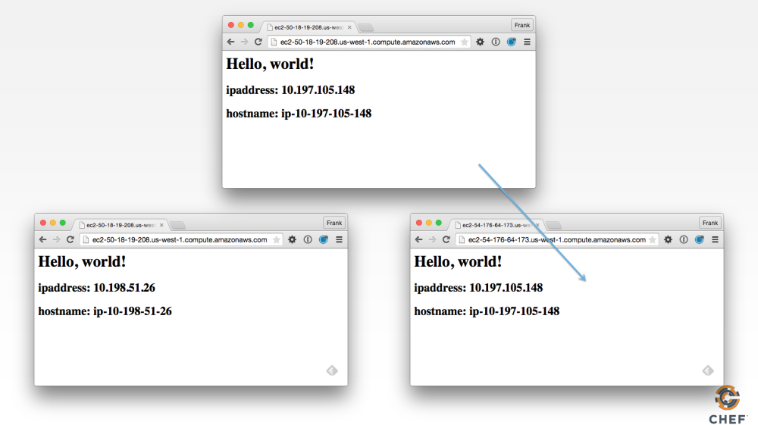

Slide 29

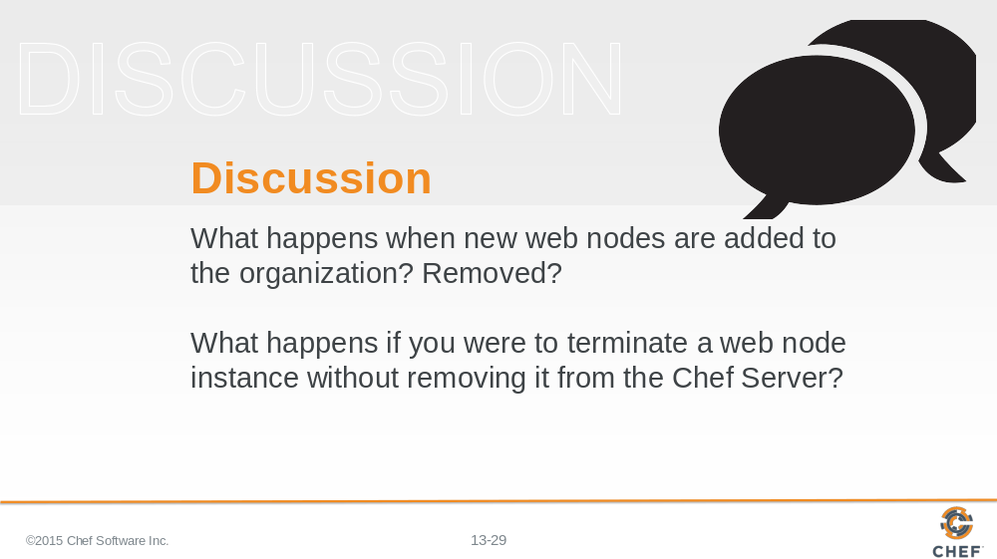

Answer these questions.

With your answers, turn to another person and alternate asking each other asking these questions and sharing your answers.

Slide 30

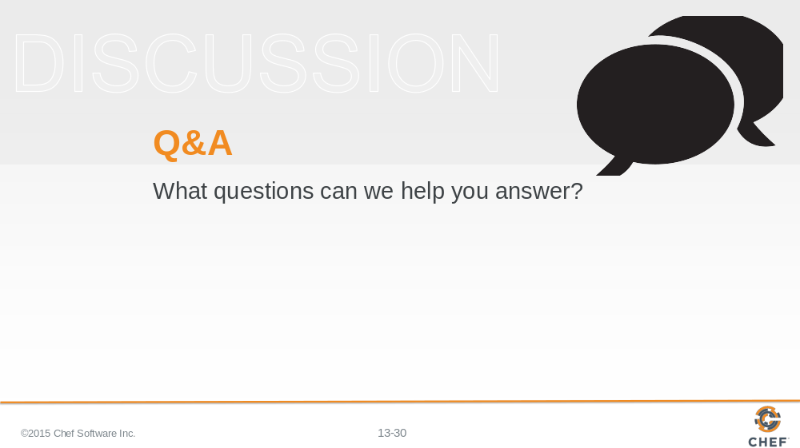

Slide 31



