5: Testing Cookbooks

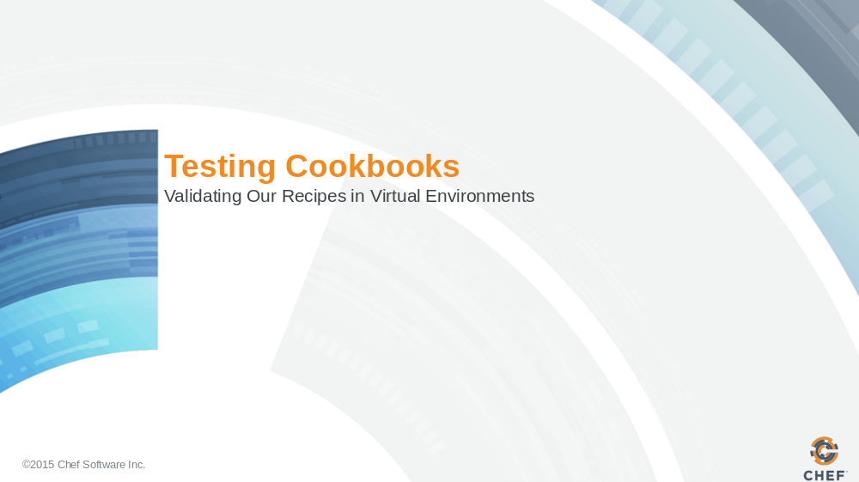

Slide 2

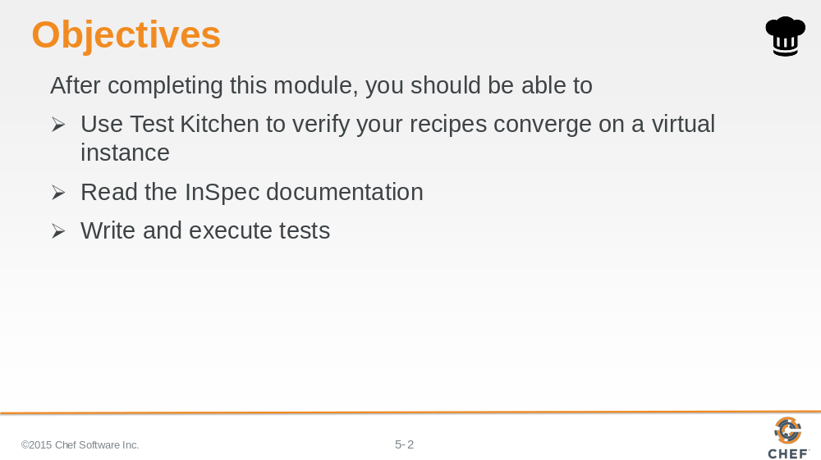

In this module you will learn how to use the Test Kitchen tool to execute your configured code, write and execute tests, and use InSpec to test your servers' actual state.

Slide 3

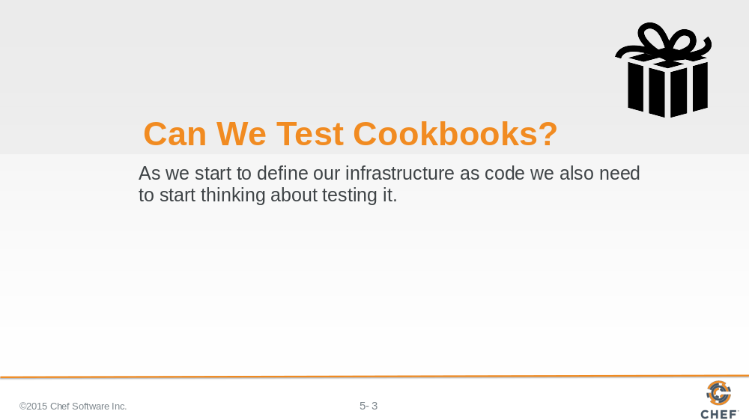

Will the recipes that we created work on another system similar to this one? Will they work in production?

When we develop our automation we need to start thinking about verifying it. Because it is all too common a story of automation failing when it reaches production because it was never validated against anything other than "my machine".

So how could we solve a problem like this?

Slide 4

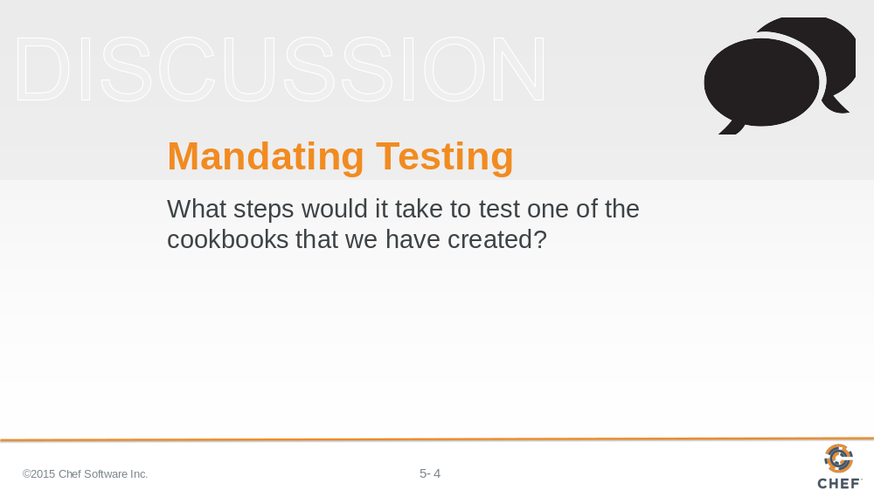

Write down or type out as many of the steps you can think of required to test one of the cookbooks.

When you are ready turn to another person and compare your lists. Create a complete list with all the steps that you have identified. Then as a group we will discuss all the steps necessary to test a cookbook.

Instructor Note: This exercise is useful in helping the learners visualize the each step of testing process and how Test Kitchen maps to each of those steps

Slide 5

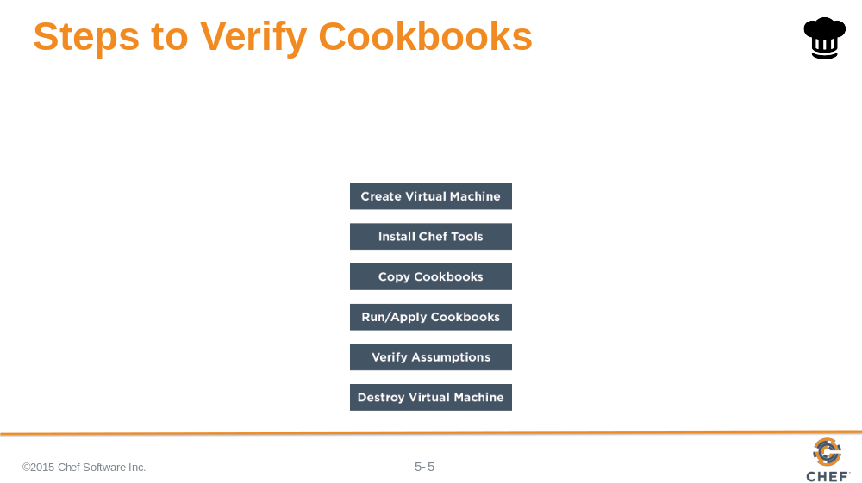

Here are the steps necessary to verify one of the cookbooks that you created.

Create a virtual machine or setup an instance that resembles your current production infrastructure
Install the necessary Chef tools
Copy the cookbooks to this new instance
Apply the cookbooks to the instance
Verify that the instance is the desired state by executing various commands
Clean up that instance by destroying it or rolling it back to a previous snapshot

Instructor Note: The class participant should be able to create a list of similar steps. The names and the detail may vary based on their experience or expertise. Instead of presenting this slide you may find it more engaging to invite the learners to share the list of steps that they created and create a list that represents the voice of the group. If you do, you may find it useful to hide this slide.

Slide 6

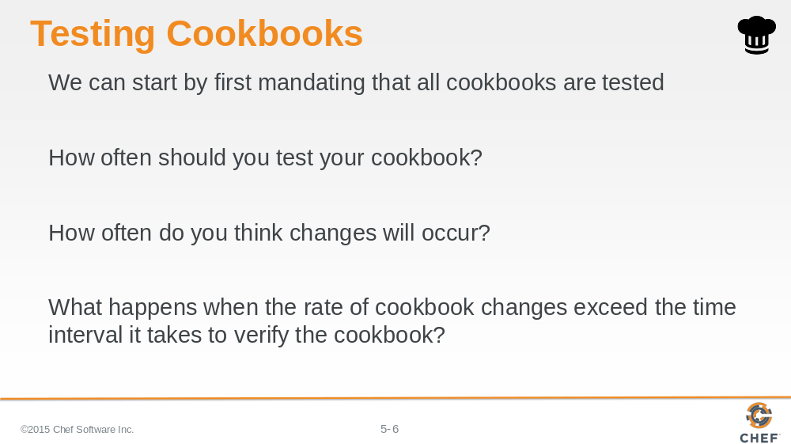

So we can start by mandating that all cookbooks are tested.

But we need to consider how often we need to test a cookbook and how often changes to our cookbooks will occur.

And what would happen if the rate of rate of cookbook changes exceed the time interval it takes to verify the cookbook?

Slide 7

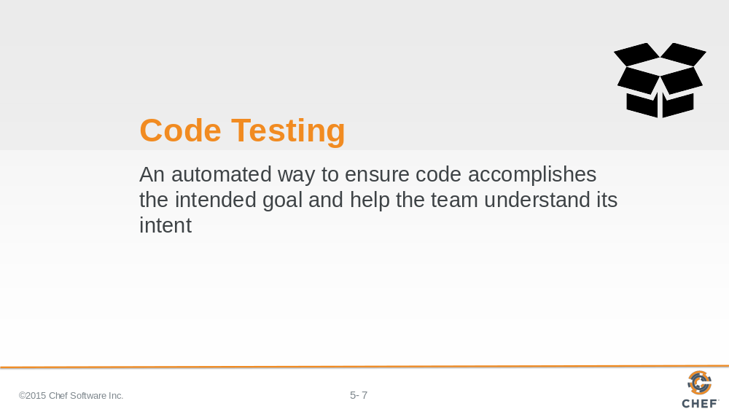

Testing tools provide automated ways to ensure that the code we write accomplishes its intended goal. It also helps us understand the intent of our code by providing executable documentation. We add new cookbook features and write tests to preserve this functionality.

This provides us, or anyone else on the team, the ability to make new changes with a less likely chance of breaking something. Whether returning to the cookbook code tomorrow or in six months.

Slide 8

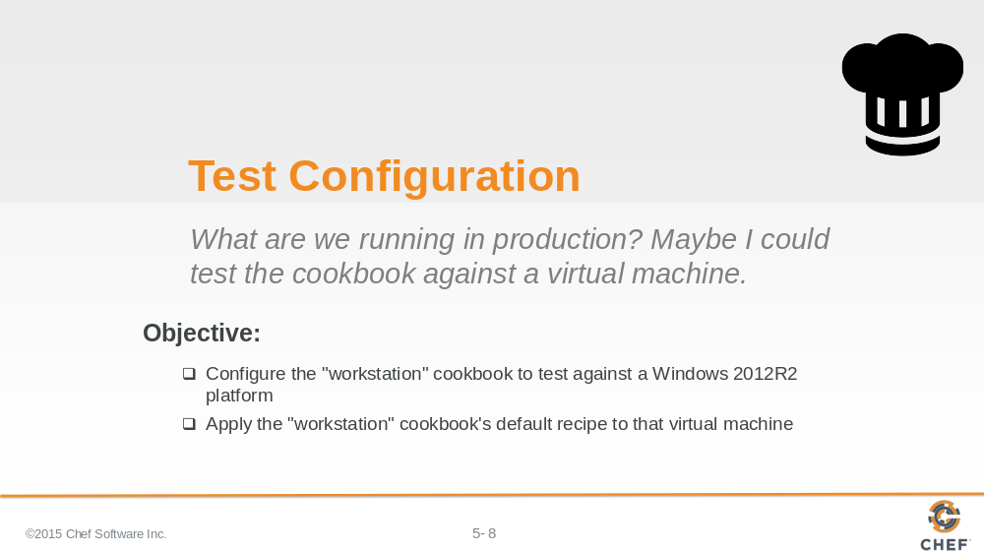

Well if Chef is to replace our existing tools, it is going to need to provide a way to make testing the policies more delightful.

Slide 9

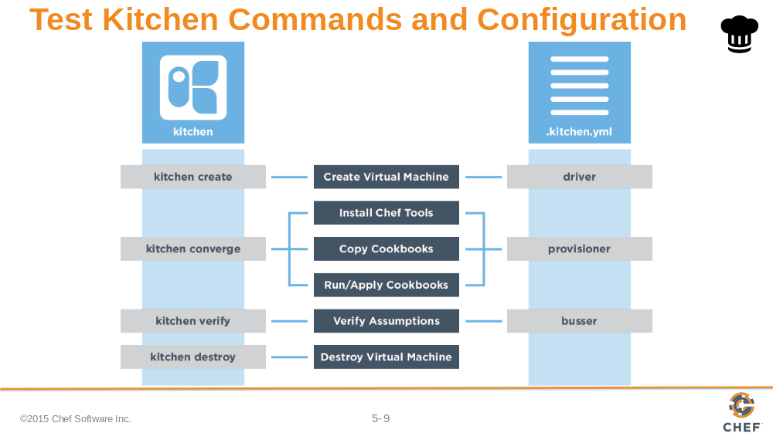

Test Kitchen allows us to create an instance solely for testing. On that created instance it will install Chef, converge a run list of recipes, verify that the instance is in the desired state, and then destroy the instance.

On the left are the kitchen commands that map to the stages of the testing lifecycle.

On the right are the kitchen configuration fields that map to the stages of the testing lifecycle.

These commands the configuration will be explained in more detail.

Instructor Note: If you created a custom list of steps with your learners use that custom list and overlay the following information over top of it.

Slide 10

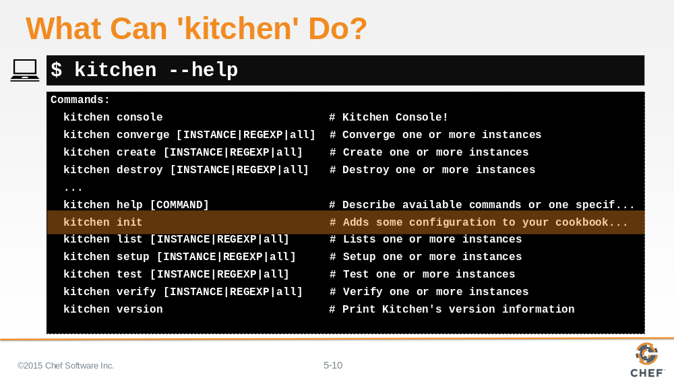

Kitchen is a command-line application that enables us to manage the testing lifecycle.

Similar to other tools within the ChefDK, we can ask for help to see the available commands.

The `init` command, by its name, seems like a good place to get started.

Slide 11

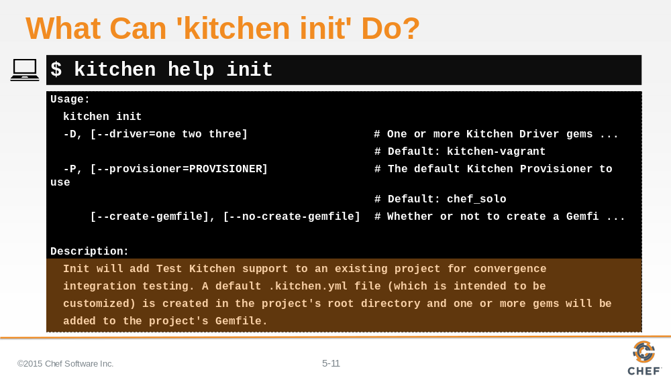

`kitchen help init` tells us that it will add Test Kitchen support to an existing project. It creates a .kitchen.yml file within the project's root directory.

There are a number of flags and other options but let's see if the cookbooks we created even needs us to initialize test kitchen.

Slide 12

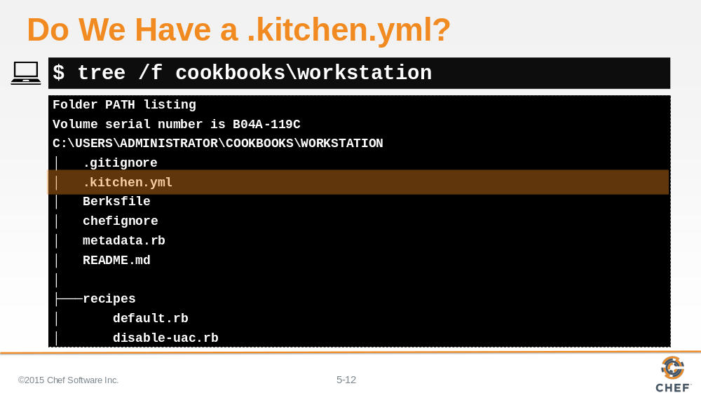

Using `tree` to look at the workstation cookbook, showing all hidden files and ignoring all git files, it looks like our cookbook already has a .kitchen.yml.

It was actually created alongside the other files when we ran the `chef generate cookbook` command when we originally created this cookbook.

Let's take a look at the contents of this file.

Slide 13

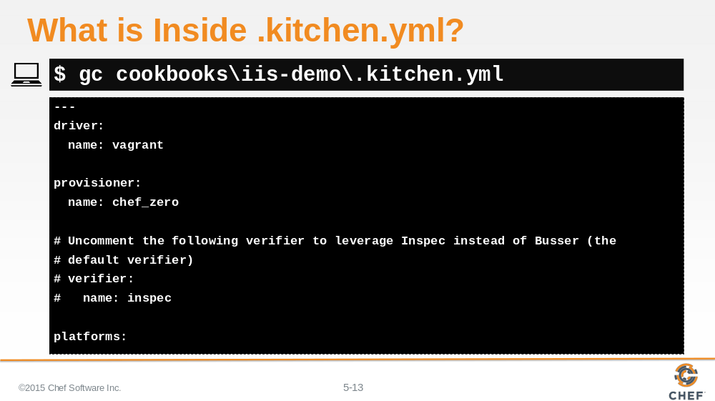

The .kitchen.yml file defines a number of configuration entries that the kitchen command uses during execution.

Slide 14

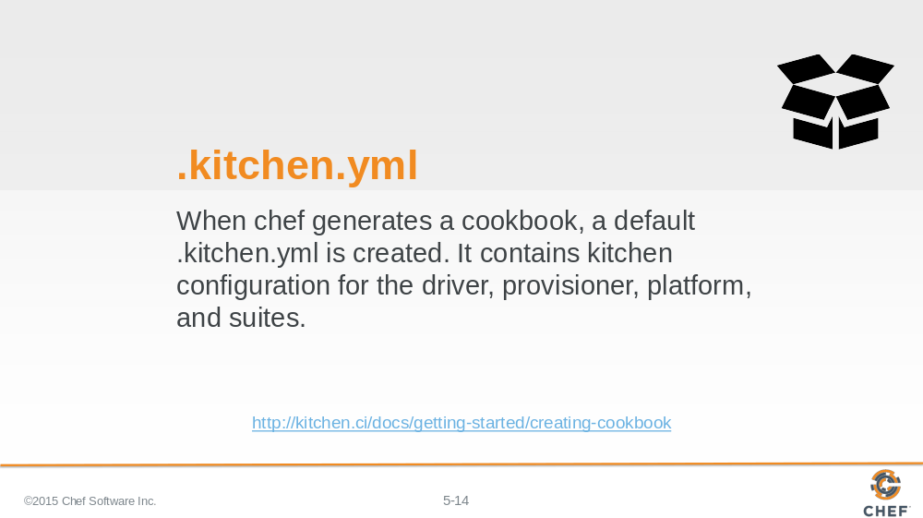

We don't need to run `kitchen init` because we already have a default kitchen file. We may still need to update it to accomplish our objectives so let’s learn more about the various fields in the configuration file.

Slide 15

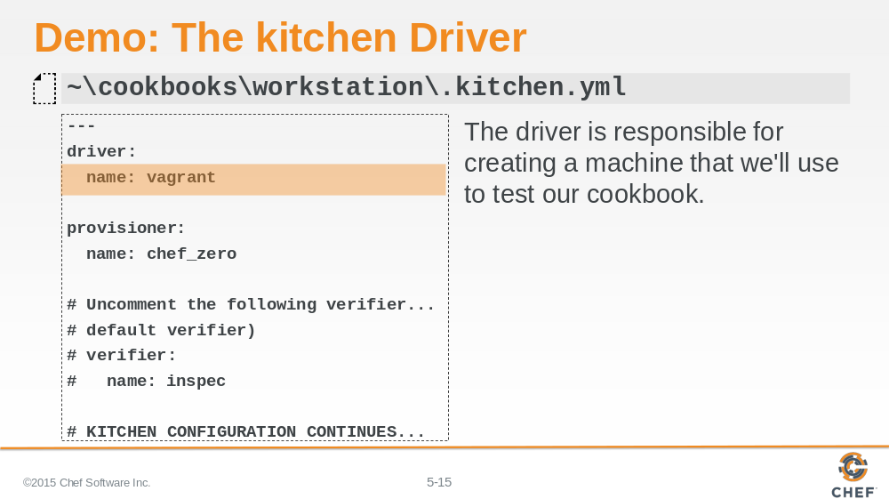

The first key is driver, which has a single key-value pair that specifies the name of the driver Kitchen will use when executed.

The driver is responsible for creating the instance that we will use to test our cookbook. There are lots of different drivers available.

Instructor Note: Testing on this remote workstation requires that we use a completely different kitchen configuration file. This configuration file is generated for use on local machines which is not ideal when working on a virtual machine in the cloud.

Slide 16

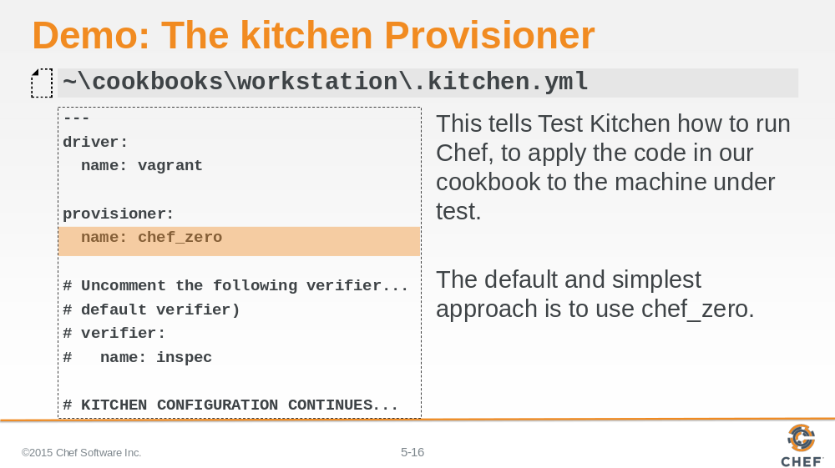

The second key is provisioner, which also has a single key-value pair which is the name of the provisioner Kitchen will use when executed. This provisioner is responsible for how it applies code to the instance that the driver created. Here the default value is chef_zero.

Slide 17

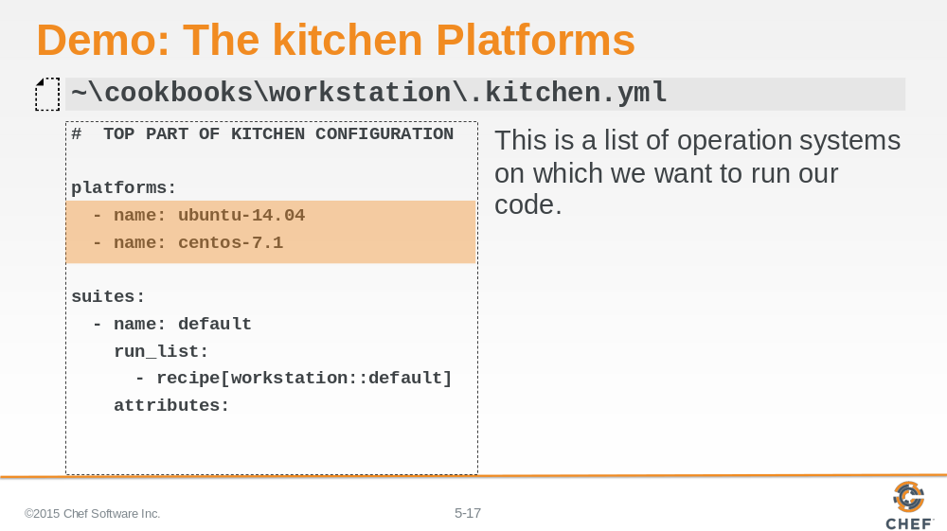

The third key is platforms, which contains a list of all the platforms that Kitchen will test against when executed. This should be a list of all the platforms that you want your cookbook to support.

None of these platforms are ones that we are interested in supporting. We can specify various different Operating Systems and Versions like Windows.

Slide 18

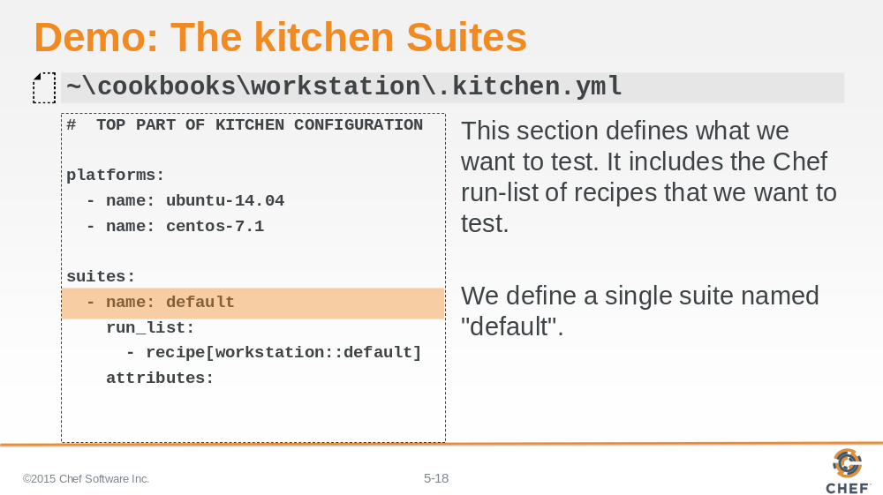

The fourth key is suites, which contains a list of all the test suites that Kitchen will test against when executed. Each suite usually defines a unique combination of run lists that exercise all the recipes within a cookbook.

In this example, this suite is named 'default'.

Slide 19

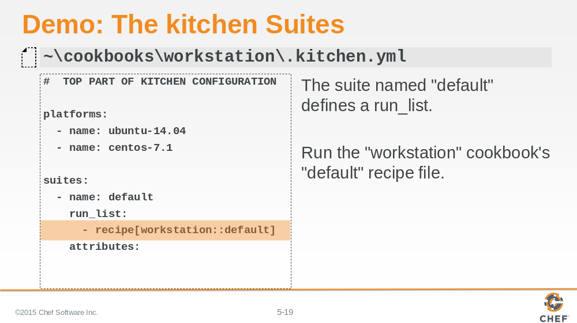

This default suite will execute the run list containing: The workstation cookbook's default recipe.

Slide 20

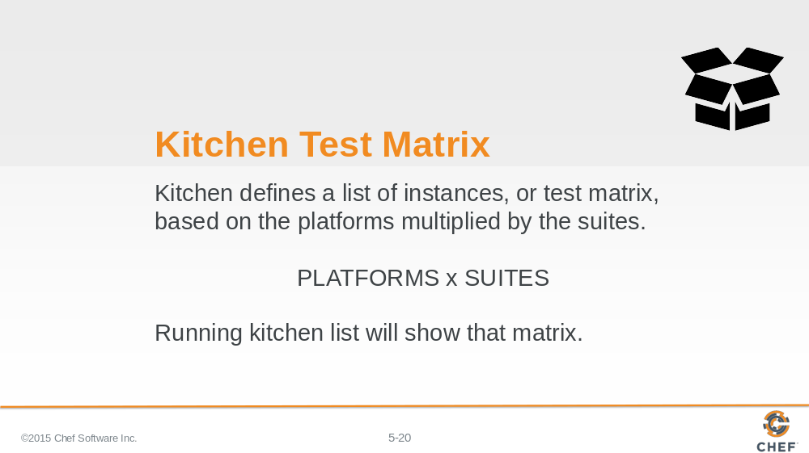

It is important to recognize that within the .kitchen.yml file we defined two fields that create a test matrix; The number of platforms we want to support multiplied by the number of test suites that we defined.

Slide 21

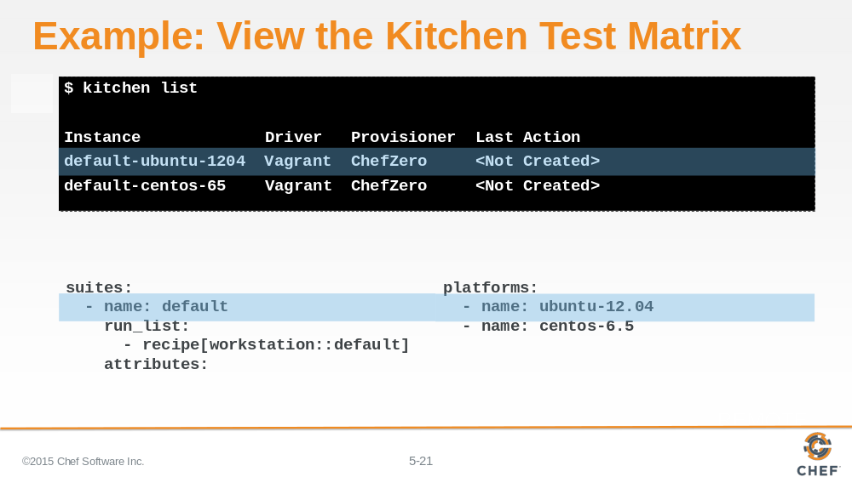

In this example, if we were to run this command on a local workstation, we can visualize this test matrix by running the command `kitchen list`.

In the output you can see that an instance is created in the list for every suite and every platform. In our current file we have one suite, named 'default', and two platforms. First the ubuntu 12.04 platform.

Instructor Note: This command will fail if ran on the workstations because the vagrant driver is still defined on the remote workstation. This is an example.

Slide 22

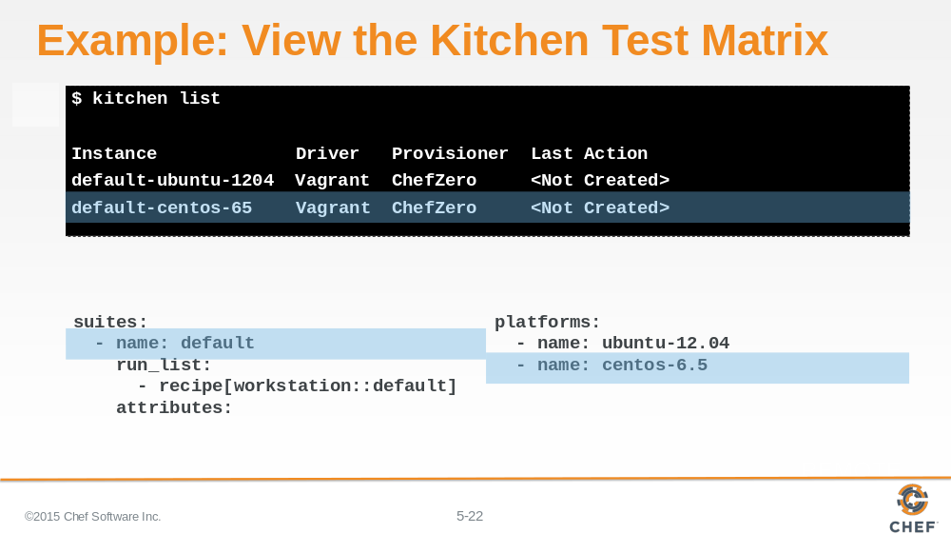

And the second centos 6.5 platform.

Instructor Note: This command will fail if run on the workstations because the vagrant driver is still defined on the remote workstation. This is an example.

Slide 23

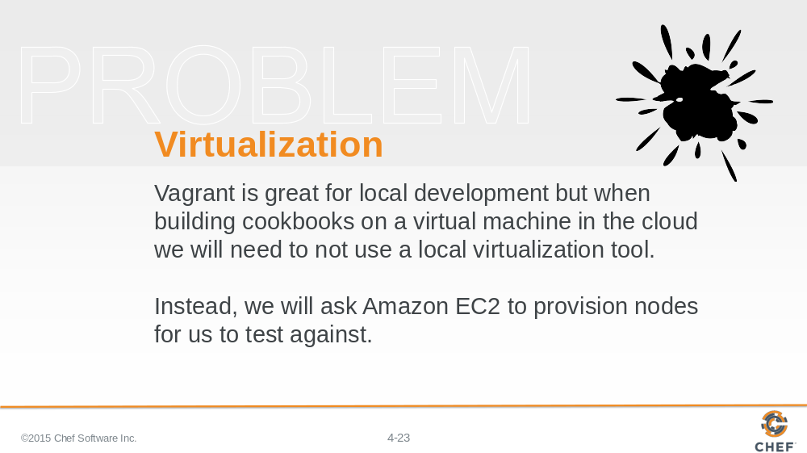

Test Kitchen is tool that you will often use on your local workstation. That is why the default configuration file uses vagrant. Vagrant allows Test Kitchen to communicate with VirtualBox to provision test instance that you can easily spin up and tear down. However, VirtualBox does not work on virtual instances. We are currently using a virtual instance in the Amazon EC2 cloud. So instead we are going to configure Test Kitchen to provision virtual instances for us in the Amazon EC2 cloud.

We have provided a template file that has all the settings properly configured for our Training Amazon EC2 cloud. In the next series of steps we are going to copy that file into the cookbook and edit it with specific values.

Slide 24

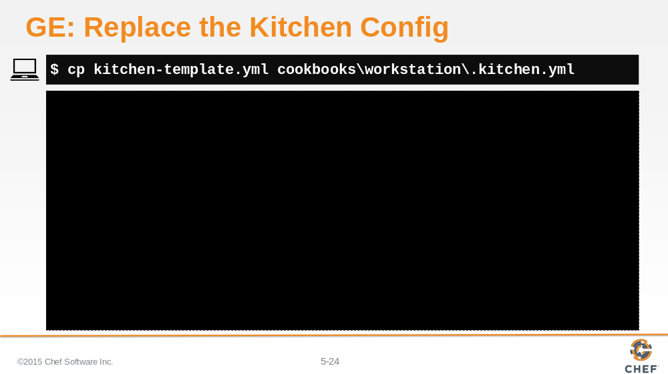

Copy the template kitchen configuration file from the home directory into the workstation cookbook directory. This will replace with the existing kitchen configuration with the one set up to work within Amazon EC2.

Slide 25

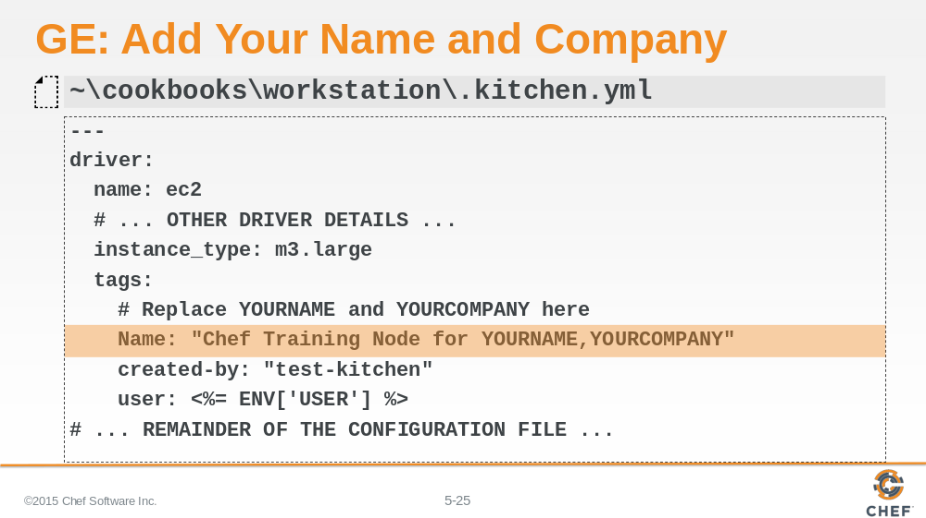

Edit the file to insert your name and company information.

Slide 26

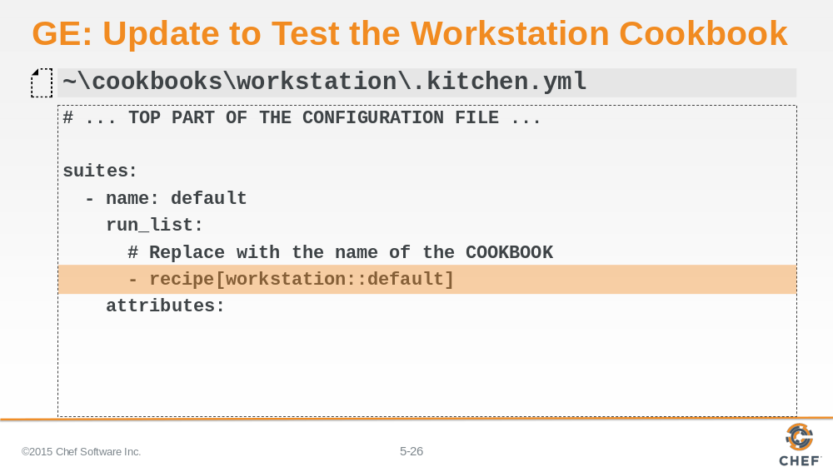

Edit the file to define the correct test suite. In this instance we want to test the 'workstation' cookbook's 'default' recipe.

Slide 27

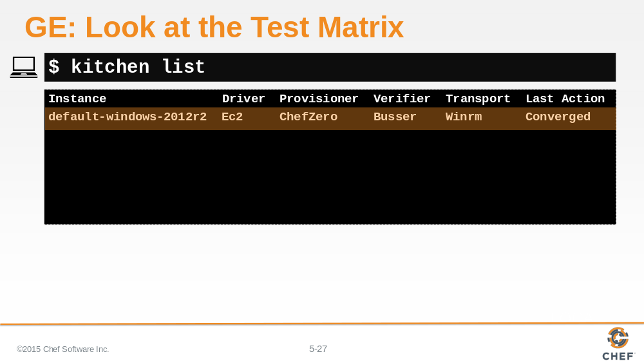

Run the `kitchen list` command to display our test matrix. You should see a single instance.

Slide 28

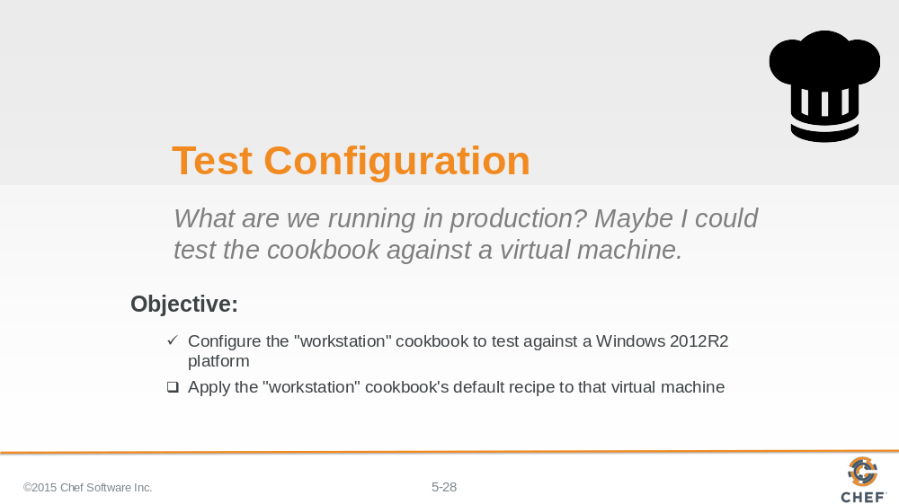

Alright the 'workstation' cookbook configuration has been update properly and we verified that with `kitchen list`. Now to test our cookbook's recipe against that system we are going

Slide 29

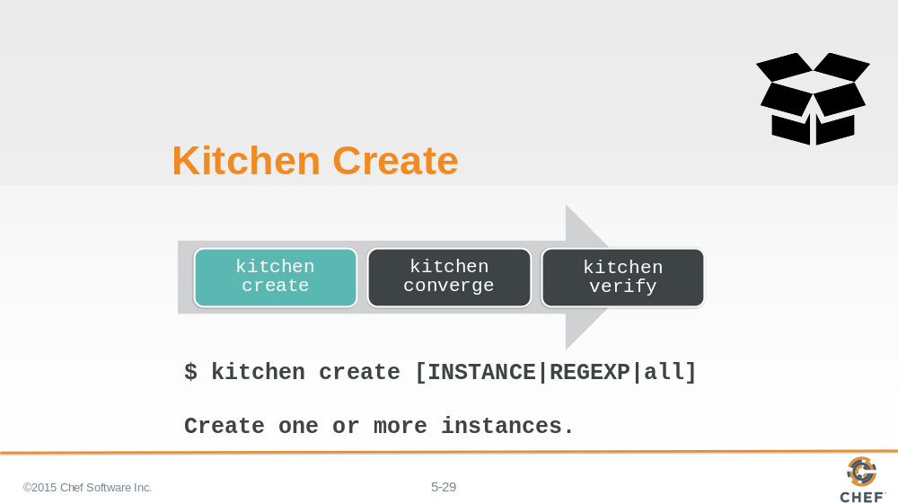

The first kitchen command is `kitchen create`.

To create an instance means to turn on virtual or cloud instances for the platforms specified in the kitchen configuration.

In our case, this command would use the ec2 driver to create a Windows 2012 R2 instance.

Instructor Note: The command does allow you to create specific instances by name or all instances that match a provided criteria.

Slide 30

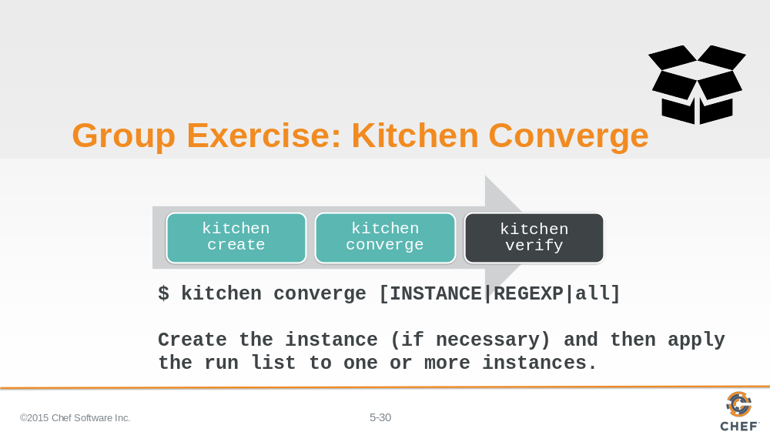

Creating an image gives us a instance to test our cookbooks but it still would leave us with the work of installing chef and applying the cookbook defined in our .kitchen.yml run list.
So let's introduce you to the second kitchen command: `kitchen converge`.
Converging an instance will create the instance if it has not already been created. Then it will install chef and apply that cookbook to that instance.
In our case, this command would take our image and install chef and apply the workstation cookbook's default recipe.
Instructor Note: It also, like the `kitchen create` commands, defaults to all instances when executed without any parameters. And is capable of accepting parameters to converge a specific instance or all instances that match the provided criteria.

Slide 31

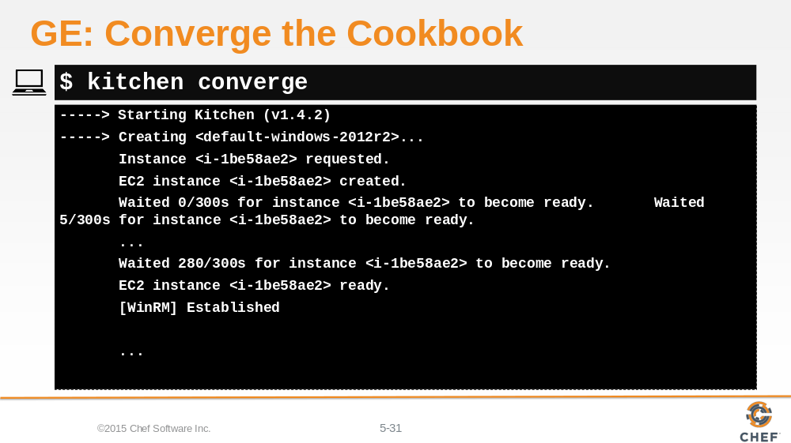

Execute `kitchen converge` to validate that our workstation cookbook's default recipe is able to converge on the Windows 2012 instance.

Instructor Note: This process can easily take 5 minutes before the instance is ready and able to be converged.

Slide 32

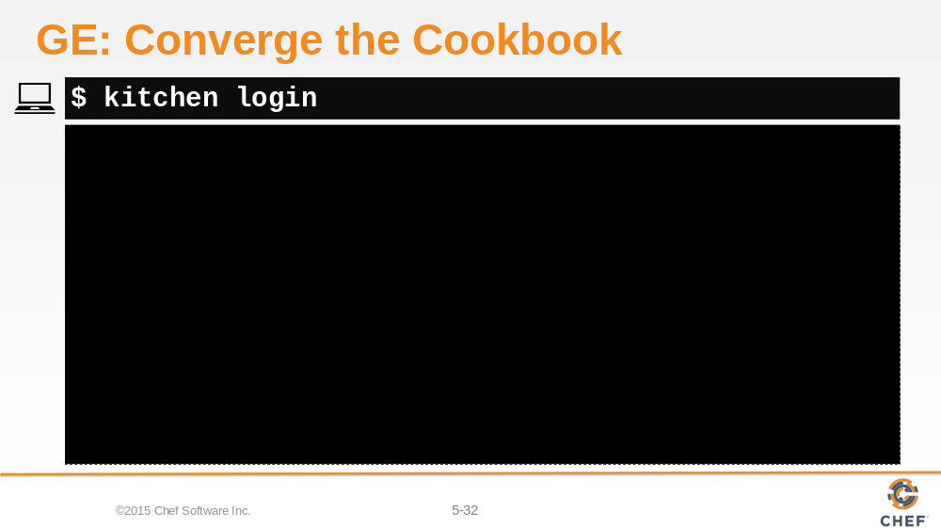

We can also login to the instance through the command `kitchen login`. This is useful to see the state of the system to ensure that UAC has been properly disabled.

Slide 33

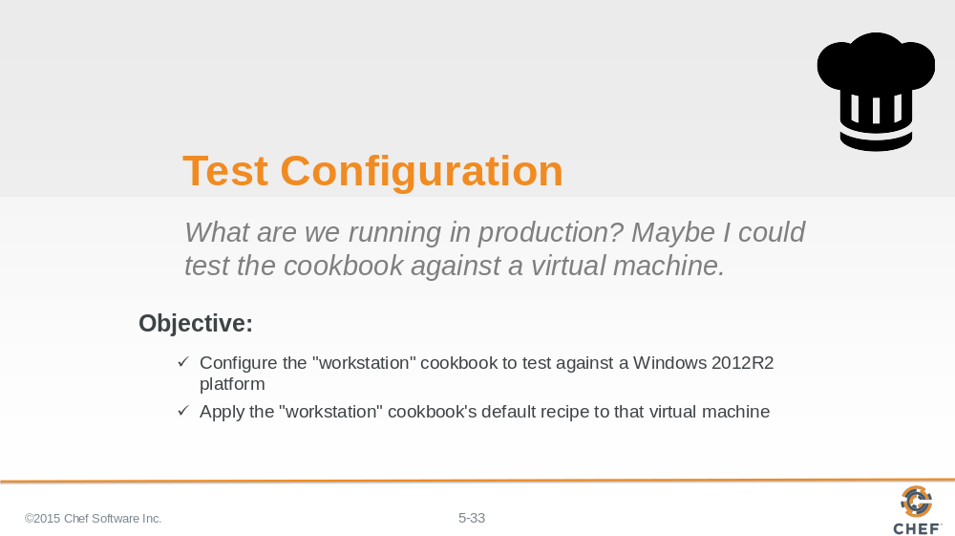

We successfully configured the workstation cookbook to use the Amazon EC2 driver and target a Windows 2012 R2 Instance.

Slide 34

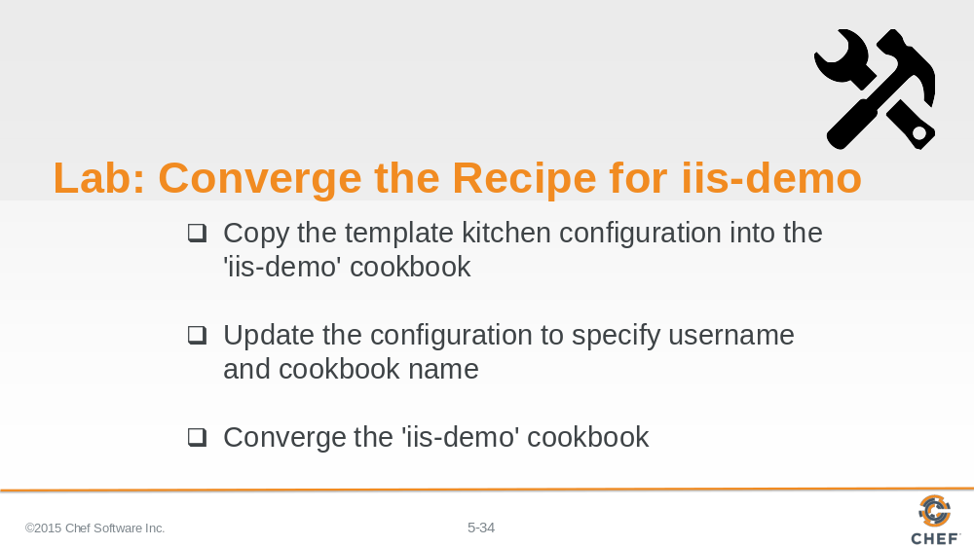

Do the same thing again for the 'iis-demo' cookbook. Update the .kitchen.yml file so that it converges the iis-demo cookbook's default recipe on a Windows 2012R2 instance through the EC2 driver.

Instructor Note: Allow 12 minutes to complete this exercise. Most of the time for this exercise is likely going to be spent waiting for the instance in Amazon EC2 to be ready.

Slide 35

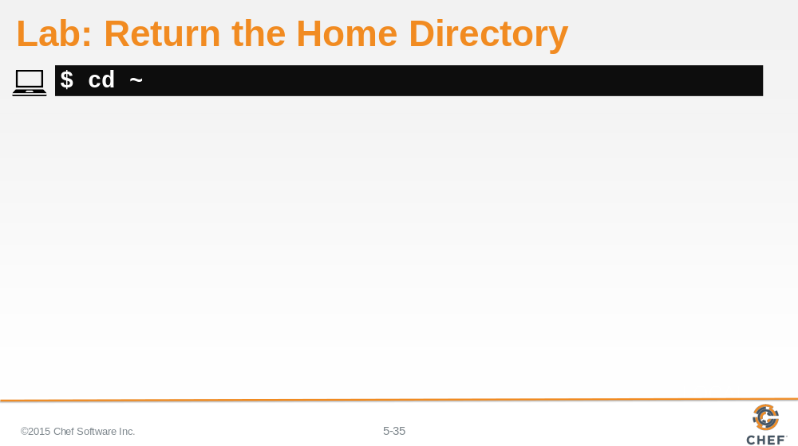

First, return to the home directory.

Slide 36

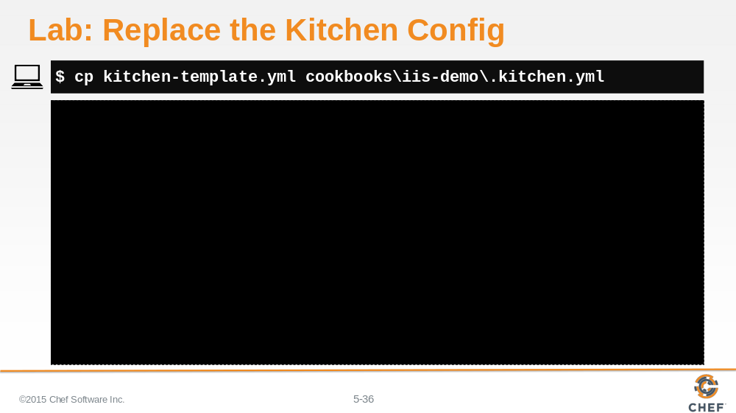

Copy the template kitchen configuration file from the home directory into the 'iis-demo' cookbook directory. This will replace with the existing kitchen configuration with the one set up to work within Amazon EC2.

Slide 37

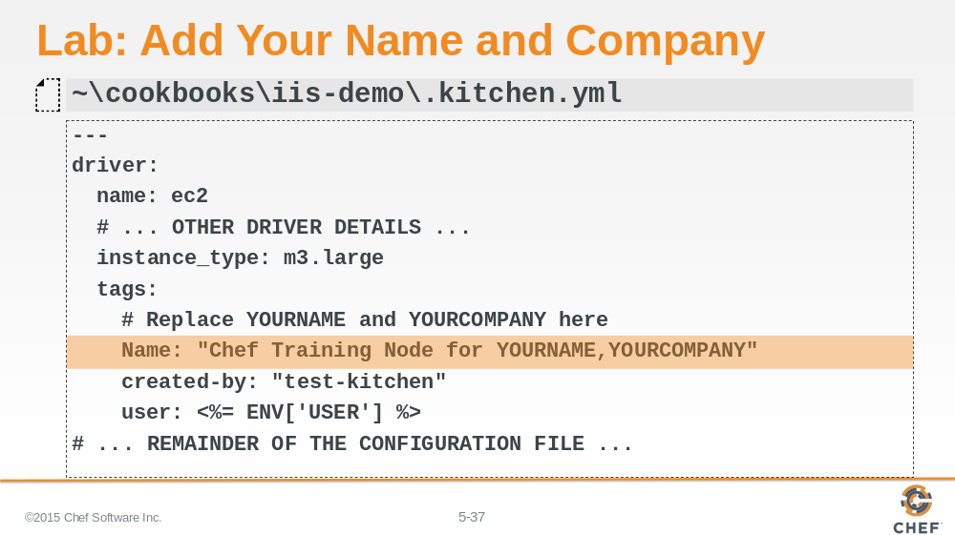

Edit the file to insert your name and company information.

Slide 38

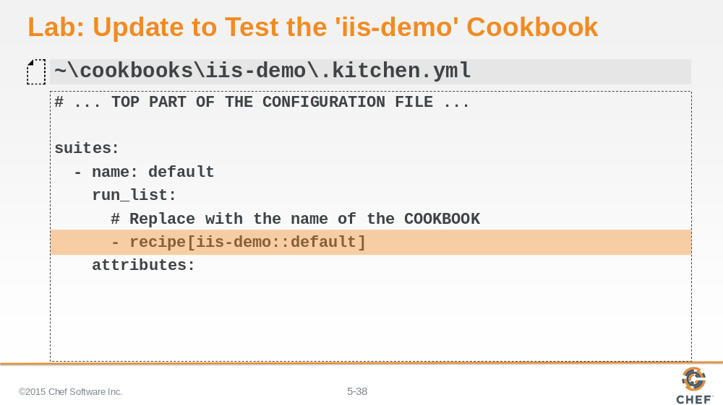

Edit the file to define the correct test suite. In this instance we want to test the 'workstation' cookbook's 'default' recipe.

Slide 39

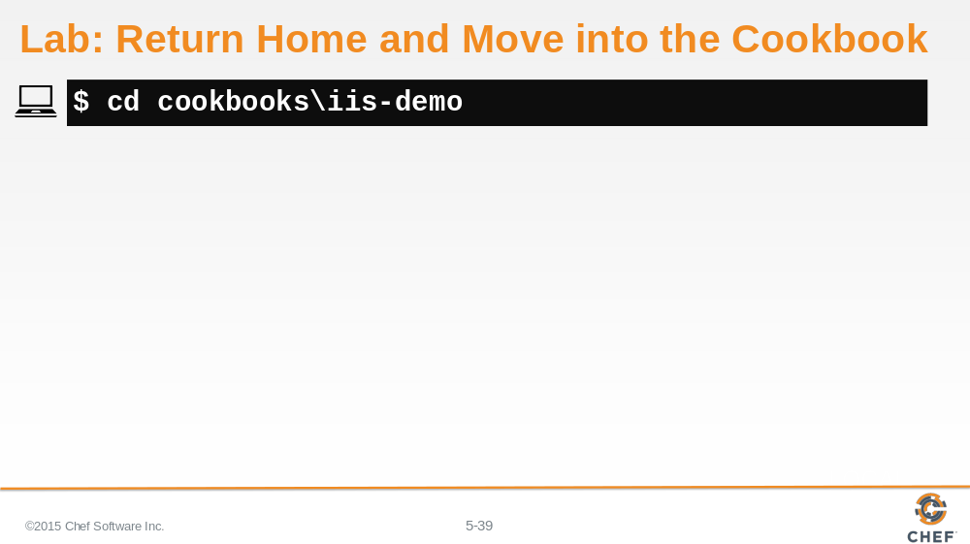

Change into the 'iis-demo' cookbook folder.

Slide 40

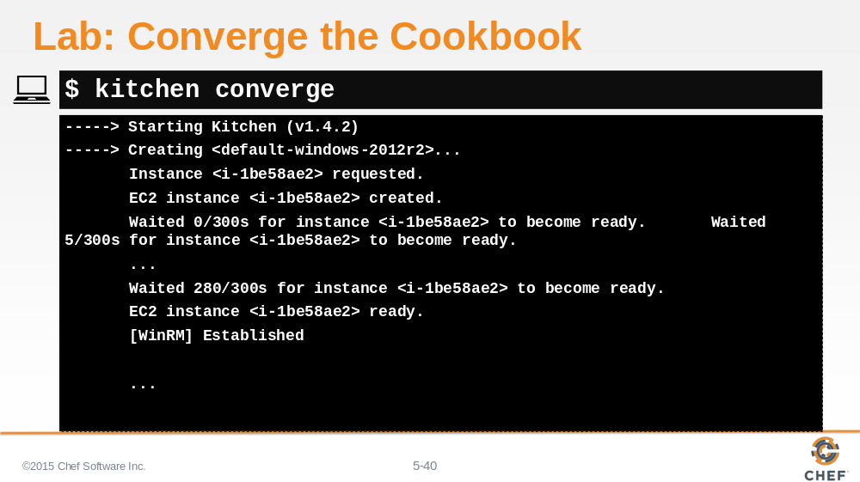

Execute `kitchen converge` to validate that our iis-demo cookbook's default recipe is able to converge on the Windows 2012 instance.

Slide 41

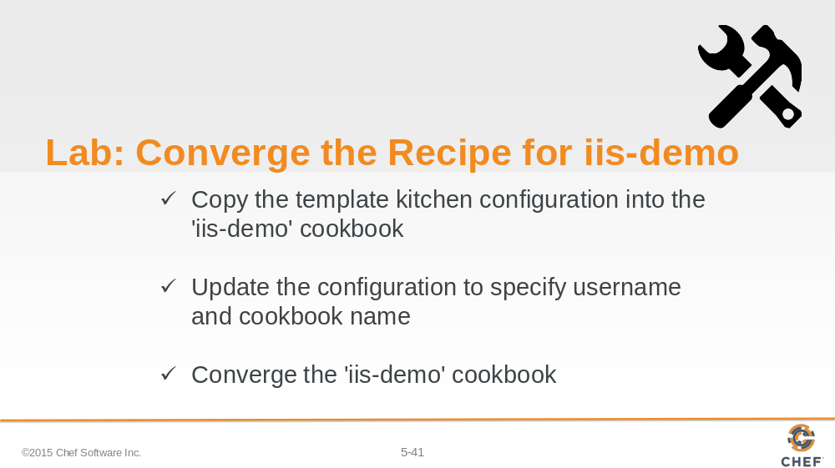

Congratulations you successfully converged the 'iis-demo' cookbook on a test instance that you created in Amazon EC2.

Slide 42

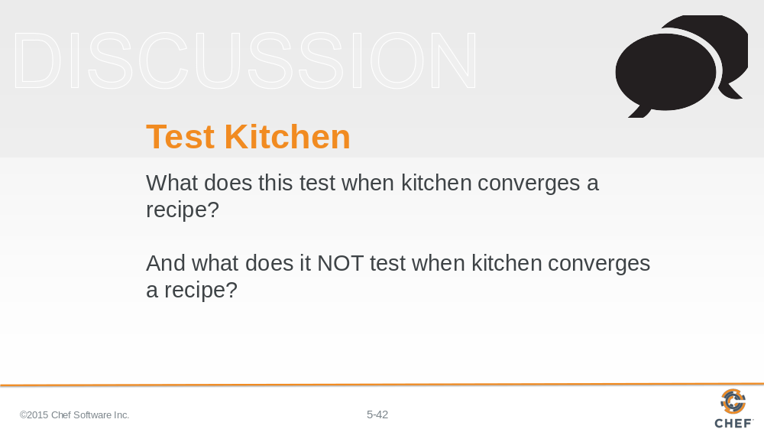

So what does this test when kitchen converges a recipe?

What does it NOT test when kitchen converges a recipe?

Instructor Note: Converging the recipe is able to validate that our recipe is defined without error. However, converging a particular recipe does not validate that the intended goal of the recipe has been successfully executed.

Slide 43

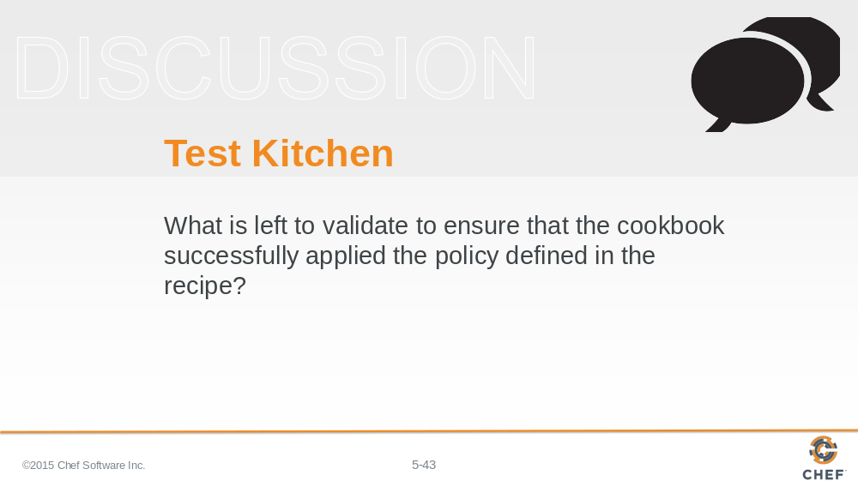

What is left to validate to ensure that the cookbook successfully applied the policy defined in the recipe?

Instructor Note: Converging the instance ensured that the recipe was able to install a package, write out a file, and start and enable a service. But what it was unable to check to see if the system was configured correctly -- is our instance serving up our custom home page.

Slide 44

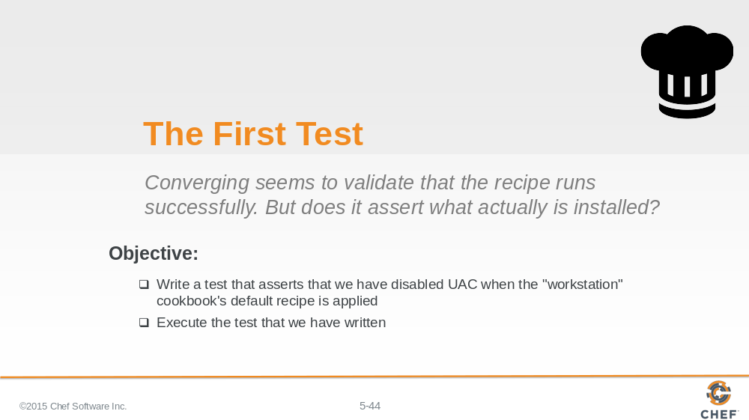

There is no automation that automatically understands the intention defined in the recipes we create. To do that we will define our own automated test.

Let’s explore testing by adding an expectation that will validate that UAC has been properly disabled on our test instance.

To do that we are going to need to learn a few more kitchen commands and a way to express our expectations in a language called InSpec.

Slide 45

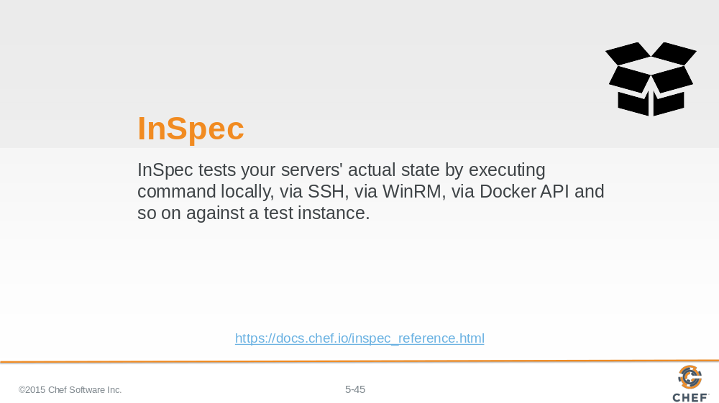

InSpec is one of many possible test frameworks that Test Kitchen supports. It is a popular choice for those doing Chef cookbook development because InSpec is written by Chef and is built on a Ruby testing framework named RSpec.

RSpec is similar to Chef - as it is a Domain Specific Language, or DSL, layered on top of Ruby. Where Chef gives us a DSL to describe the policy of our system, RSpec allows us to describe the expectations of tests that we define. InSpec adds a number of helpers to RSpec to make it easy to test the state of a system.

Slide 46

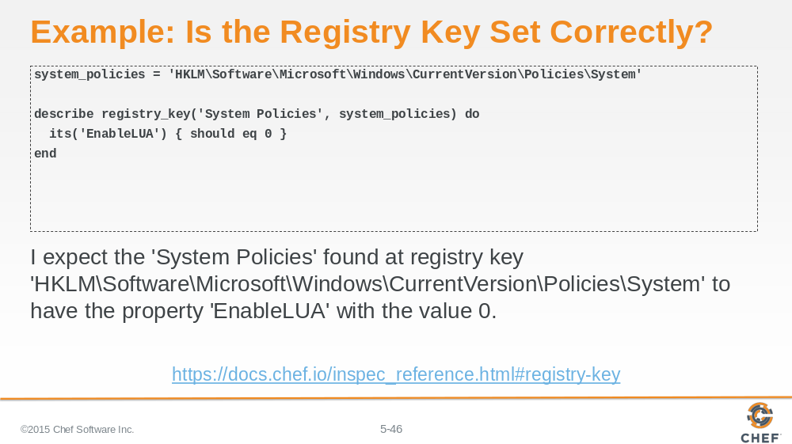

Here is an InSpec example.
We define a local variable named 'system_policies' that will store the registry key that stores our particular key we want to verify.
We use RSpec's 'describe' to begin to illustrate the element of our system that we are testing.
InSpec provids a helper method named 'registry_key' that allows to provide two parameters. The first parameter is a common name for the registry key. The second is the registry key itself which can be found inside the variable that we have defined.
Within the describe block we define an its block where we are targeting the particular key we are interested in examining. We want to ensure that the 'EnableLUA' key has a value that is equal to zero.

Slide 47

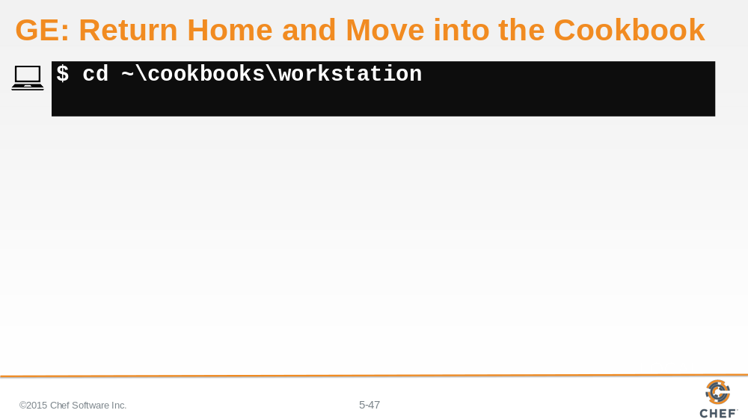

Change into the workstation cookbook directory.

Slide 48

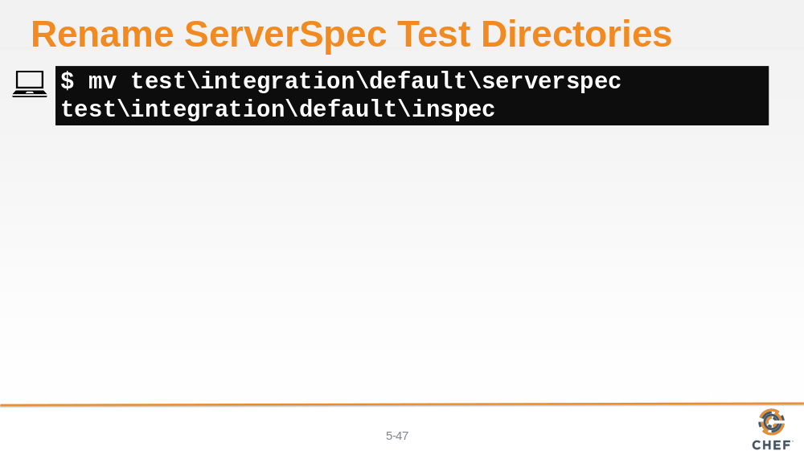

Chef Development Kit 0.10.0 assumes we want to use ServerSpec so it generated a number of folders with files in the test directory. ServerSpec is a similar verifier to InSpec .

To use InSpec we will need to manually rename the folder from 'serverspec' to to be called 'inspec'.

Instructor Note: This may not be necessary in future versions of the ChefDK that automatically assume InSpec as the Test Kitchen verifier.

Slide 49

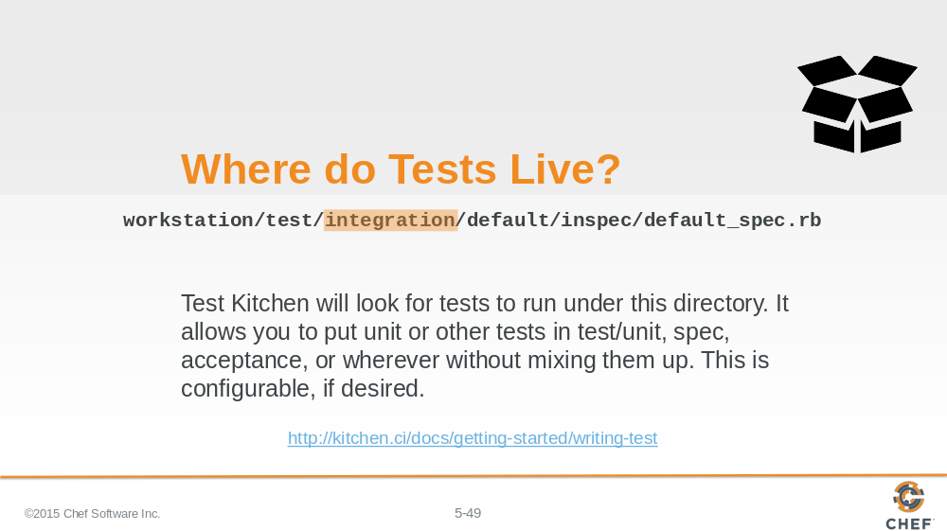

Let’s take a moment to describe the reason behind this long directory path. Within our cookbook we define a test directory and within that test directory we define another directory named 'integration'. This is the basic file path that Test Kitchen expects to find the specifications that we have defined.

Slide 50

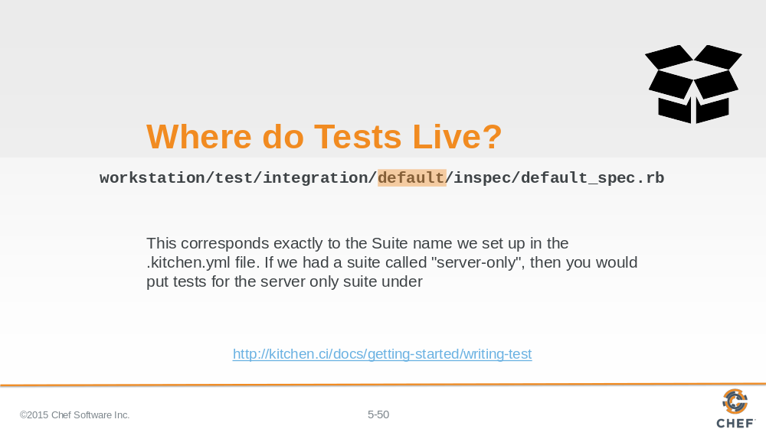

The next part the path, 'default', corresponds to the name of the test suite that is defined in the .kitchen.yml file. In our case the name of the suite is 'default' so when test kitchen performs a `kitchen verify` for the default suite it will look within the 'default' folder for the specifications to run.

Slide 51

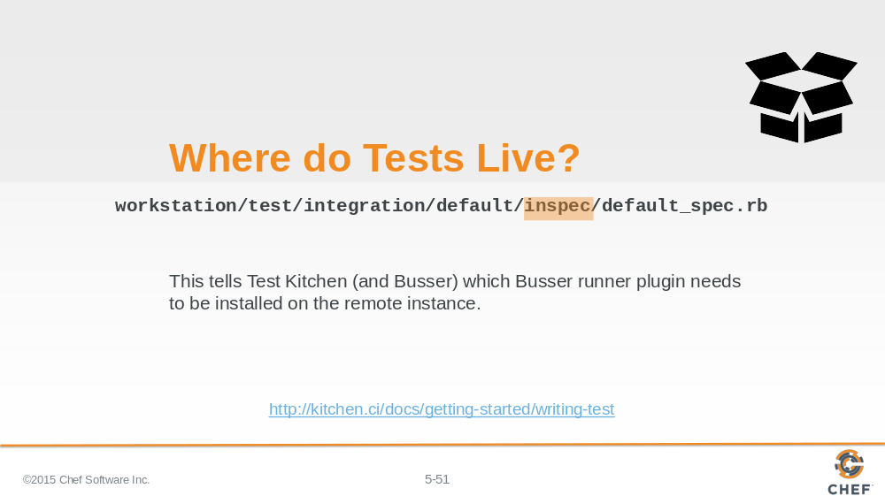

'inspec' is the kind of tests that we want to define. Test Kitchen supports a number of testing frameworks.

Slide 52

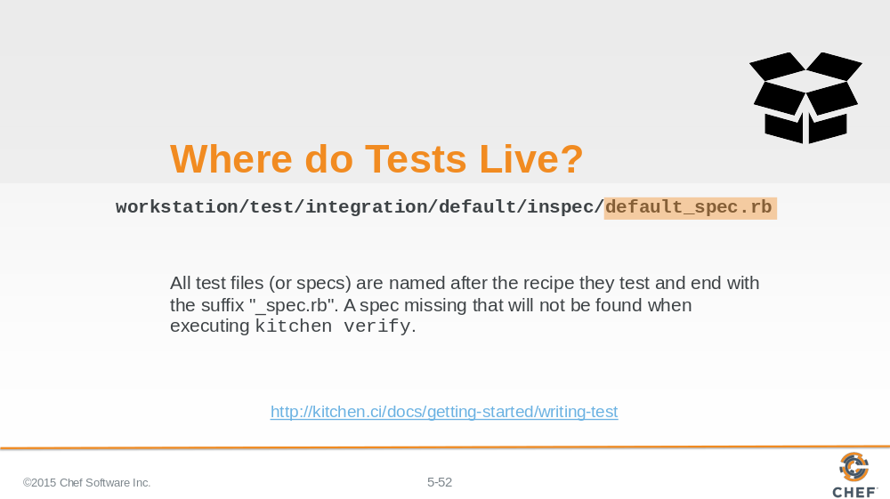

The final part of the path is the specification file. This is a ruby file. The naming convention for this file is the recipe name with the appended suffix of _spec.rb. All specification files must end with _spec.rb.

Instructor Note: Without the '_spec.rb' extension RSpec will simply ignore that file.

Slide 53

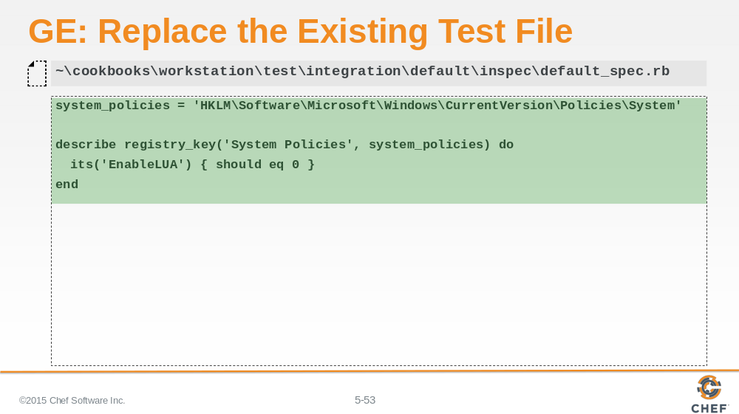

The content of the previous test file provided ServerSpec example. We need to replace the existing content with the above content.

Slide 54

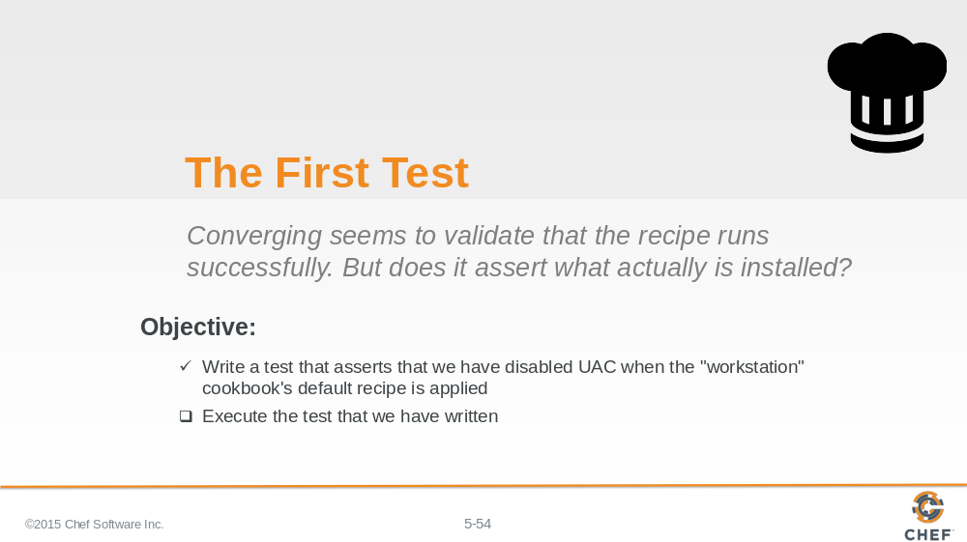

We have now defined our first test. Now it is time to execute that test against our test instance.

Slide 55

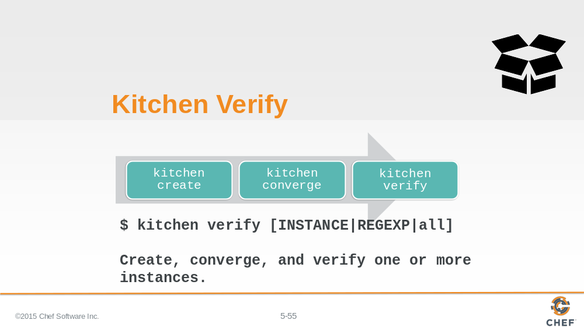

The third kitchen command is `kitchen verify`.
To verify an instance means to:
Create a virtual or cloud instances, if needed
Converge the instance, if needed
And then execute a collection of defined tests against the instance
In our case, our instance has already been created and converged so when we run `kitchen verify` it will execute the tests that we will later define.

Instructor Note: It works as the other commands do with regard to parameters and targeting instances.

Slide 56

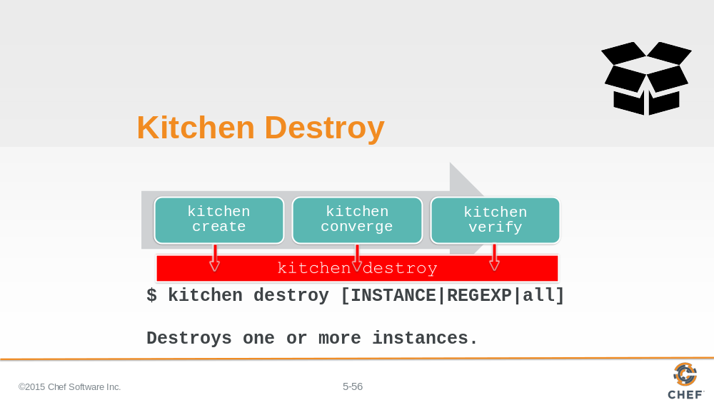

The fourth kitchen command is `kitchen destroy`.

Destroy is available at all stages and essentially cleans up the instance.

Instructor Note: It works as all the other commands do with regard to parameters and targeting instances.

Slide 57

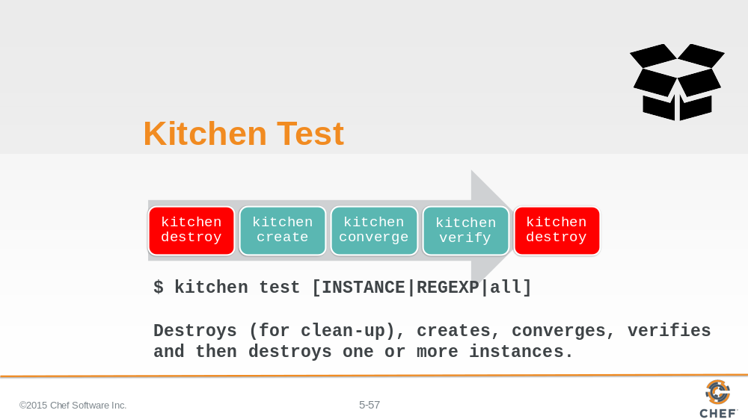

There a single command that encapsulates the entire workflow - that is `kitchen test`.

Kitchen test ensures that if the instance was in any state - created, converged, or verified - that it is immediately destroyed. This ensures a clean instance to perform all of the steps: create; converge; and verify. `kitchen test` completes the entire execution by destroying the instance at the end.

Traditionally this all encompassing workflow is useful to ensure that we have a clean state when we start and we do not leave a mess behind us.

Slide 58

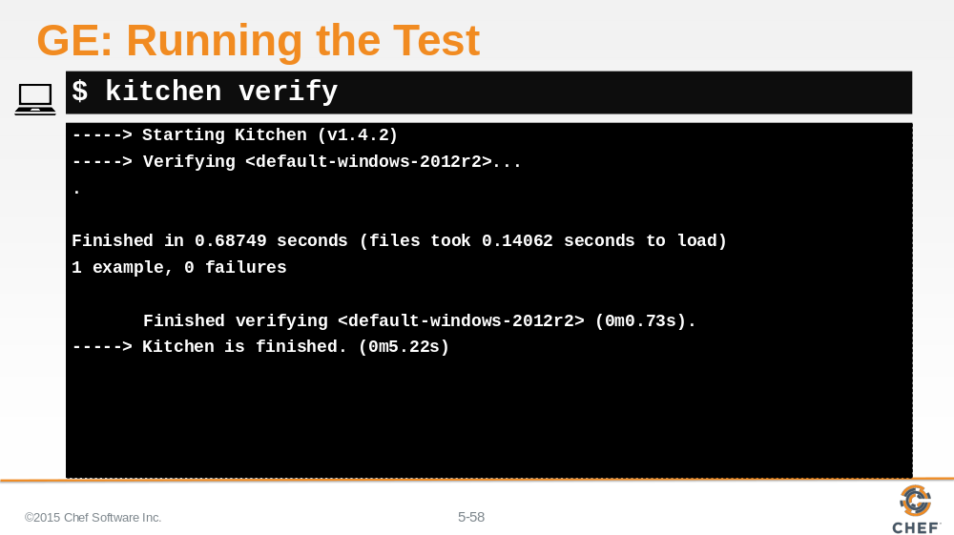

Now verify our expectation using the `kitchen verify` command. If you have defined the test correctly and the system is in the desired state you should see a summary of the execution. Showing 1 example completed with 0 failures.

Slide 59

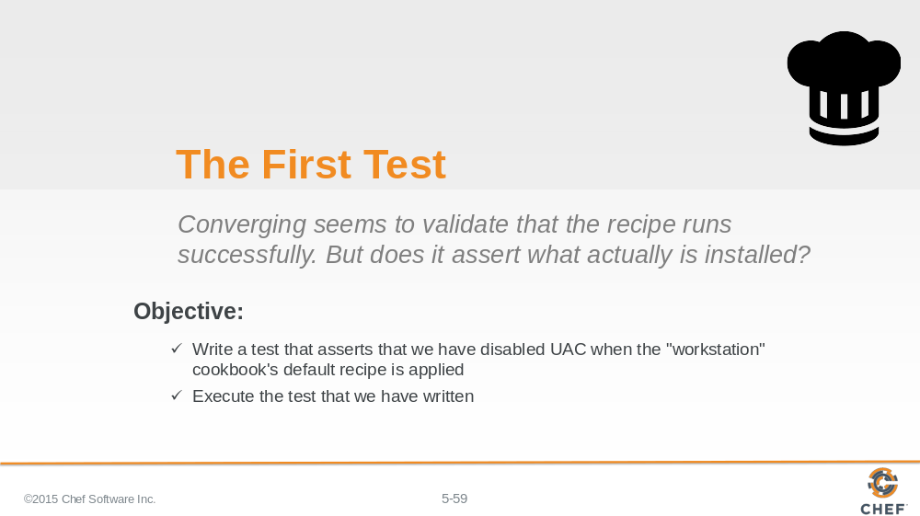

Congratulations you wrote and executed your first test.

Slide 60

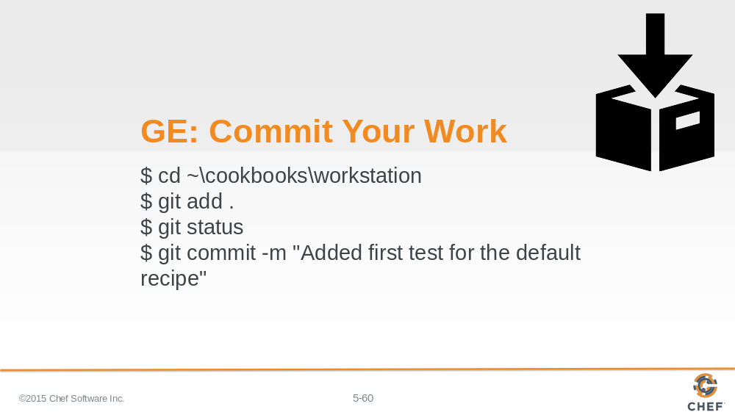

With the first test completed. It is time to commit the changes to source control.

Slide 61

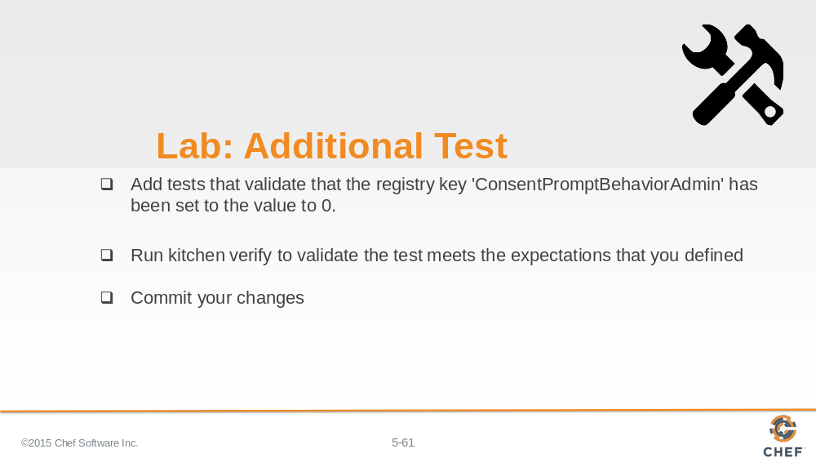

As a lab exercise, we want you to define an additional test to verify that the remaining registry key has been set properly.

Instructor Note: Allow 8 minutes to complete this exercise.

Slide 62

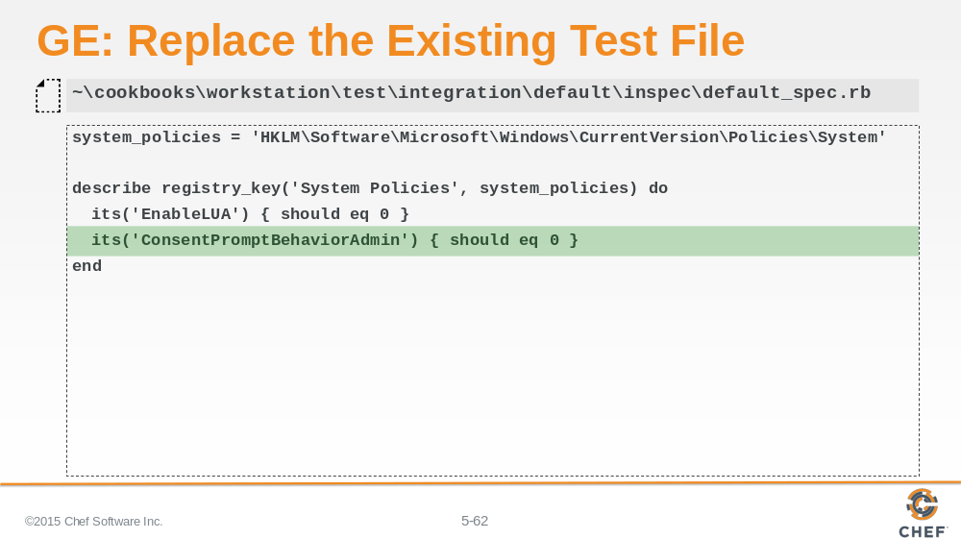

The content of the previous test file provided ServerSpec example. We need to replace the existing content with the above content.

Slide 63

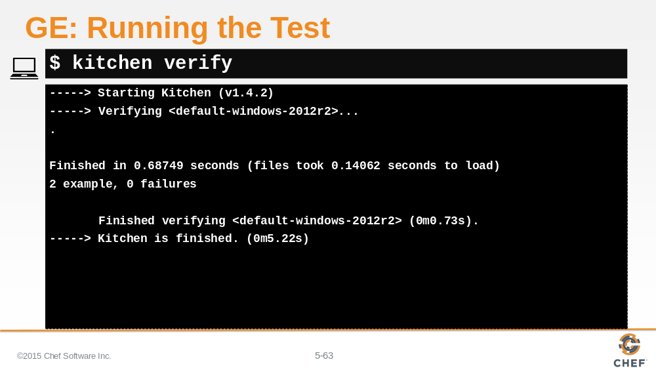

Now verify our expectation using the `kitchen verify` command. If you have defined the test correctly and the system is in the desired state you should see a summary of the execution. Showing 1 example completed with 0 failures.

Slide 64

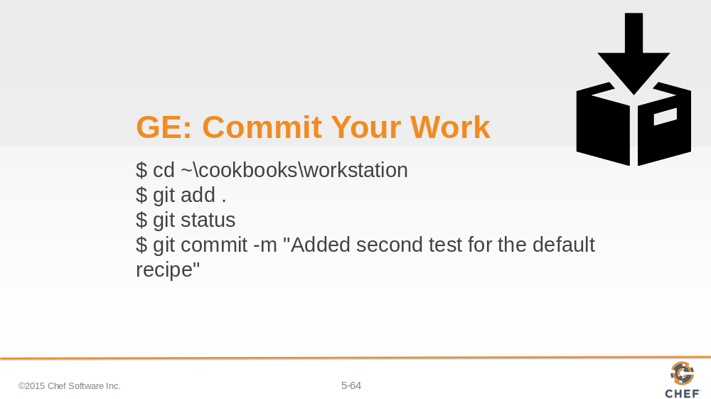

With the first test completed. It is time to commit the changes to source control.

Slide 65

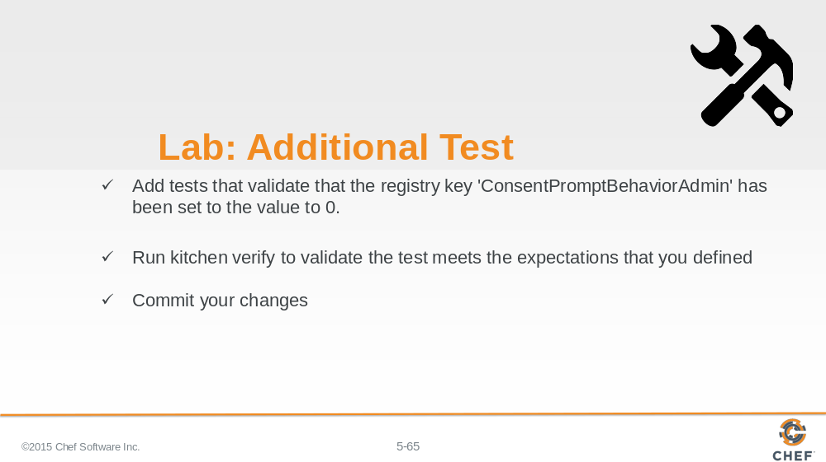

As a lab exercise, we want you to define an additional test to verify that the remaining registry key has been set properly.

Instructor Note: Allow 8 minutes to complete this exercise.

Slide 66

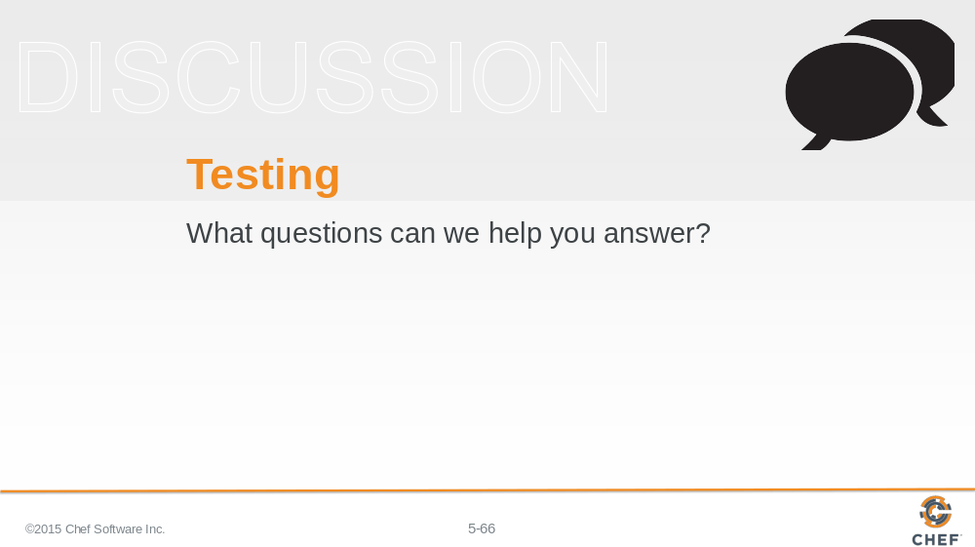

What questions can we help you answer?

Slide 67

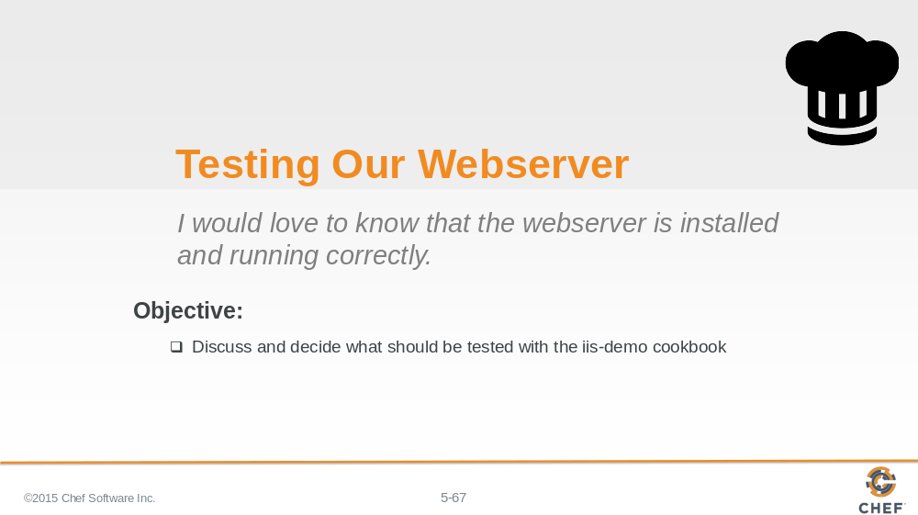

Now let’s turn our focus towards testing the iis-demo cookbook.

Slide 68

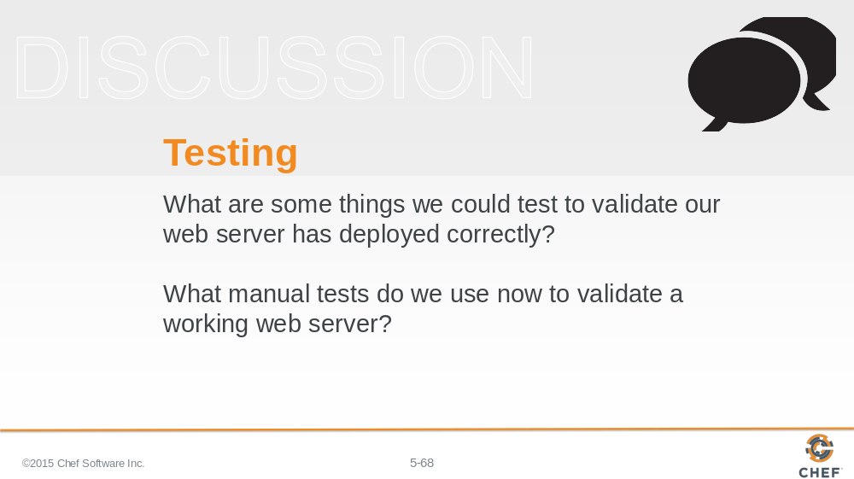

What are some things we could test to validate our web server has deployed correctly?

The iis-demo cookbook is similar to the workstation cookbook. It has a package and file which are things that we have already tested. The new thing is the service. We could review the InSpec documentation to find examples on how to test the service.
But does testing the package, file and service validate that iis-demo is hosting our static web page and returning the content to visitors of the instance?

What manual tests do we use now to validate a working web server?
After applying the recipes in the past we visited the site through a browser or verified the content through running the command 'curl localhost'.
Is that something that we could test as well? Does InSpec provide the way for us to execute a command and verify the results?

Slide 69

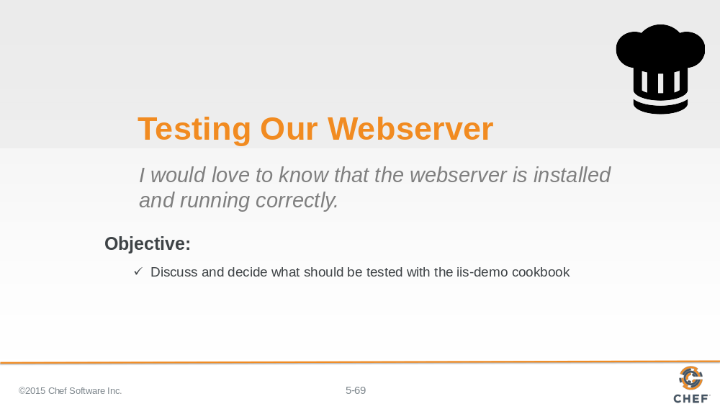

Now that we have decided on the important things to test for our webserver. It is not time to write those tests.

Slide 70

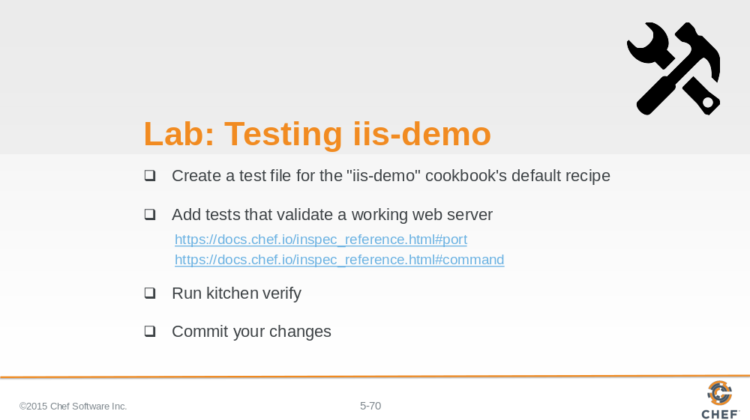

So for this final exercise, you are going to create a test file for the iis-demo cookbook's default recipe.

That test will validate that you have a working web server. This means I want you to add the tests that you feel are necessary to verify that the system is installed and working correctly.

When you are done execute your tests with `kitchen verify`.

Instructor Note: Allow 15 minutes to complete this exercise.

Slide 71

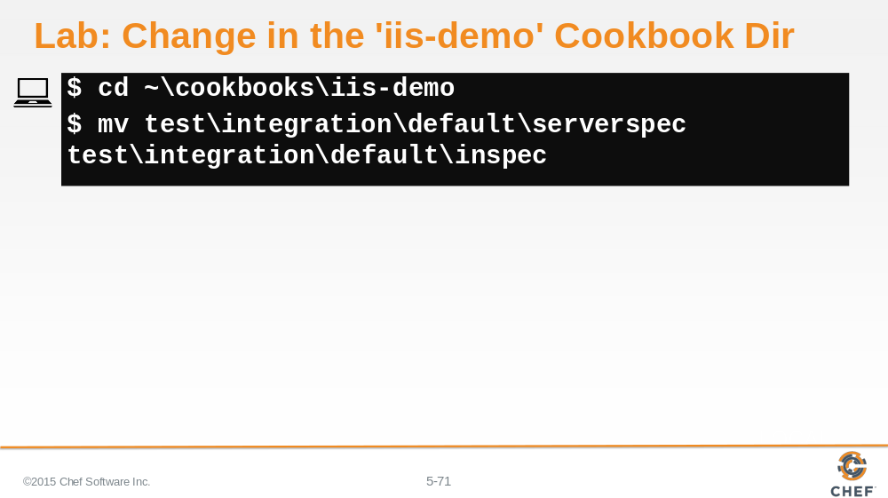

Move into the iis-demo cookbook. Rename the 'serverspec' directory to be called 'inspec'

Slide 72

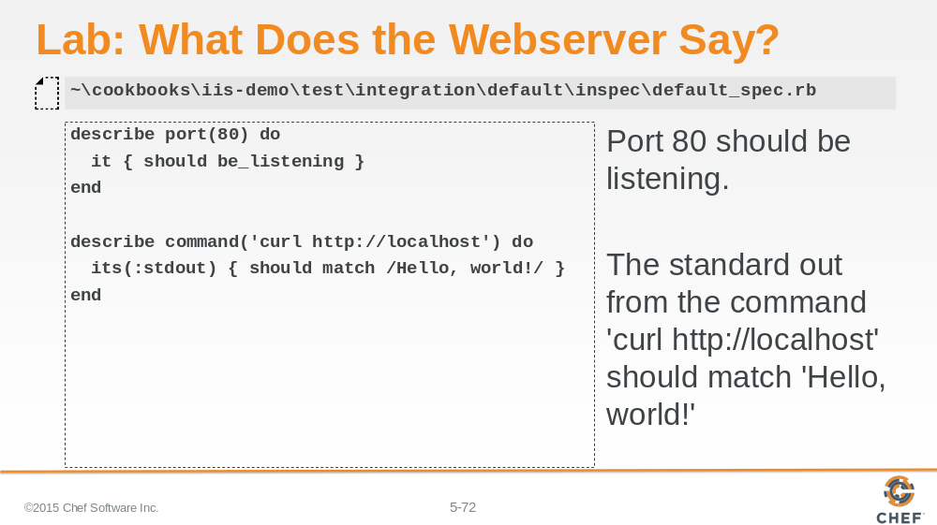

Here we chose to validate that port 80 should be listening for incoming connections.

And we also validated that the standard out from the command 'curl http://localhost' should match 'Hello, world!'.

Slide 73

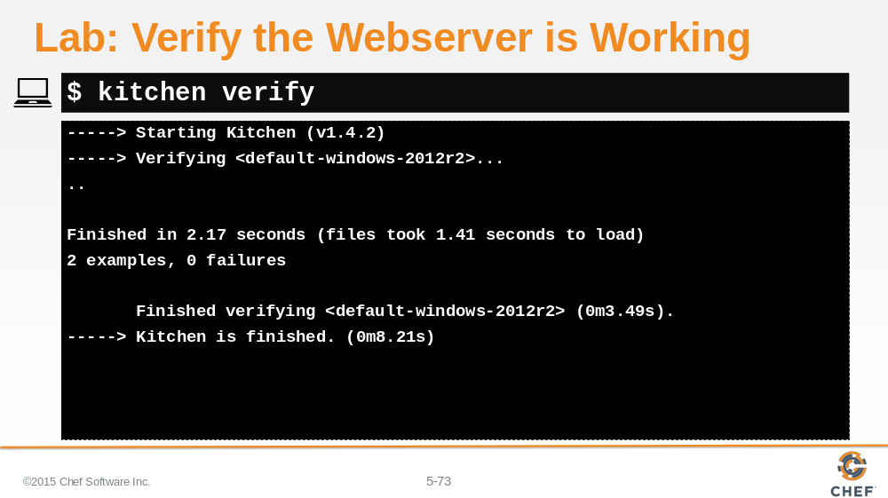

Slide 74

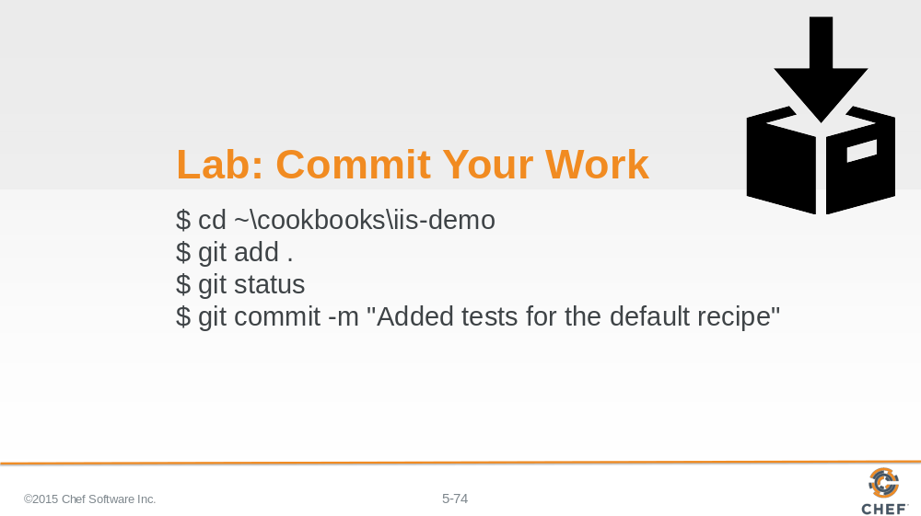

Again, let’s commit the work.

Slide 75

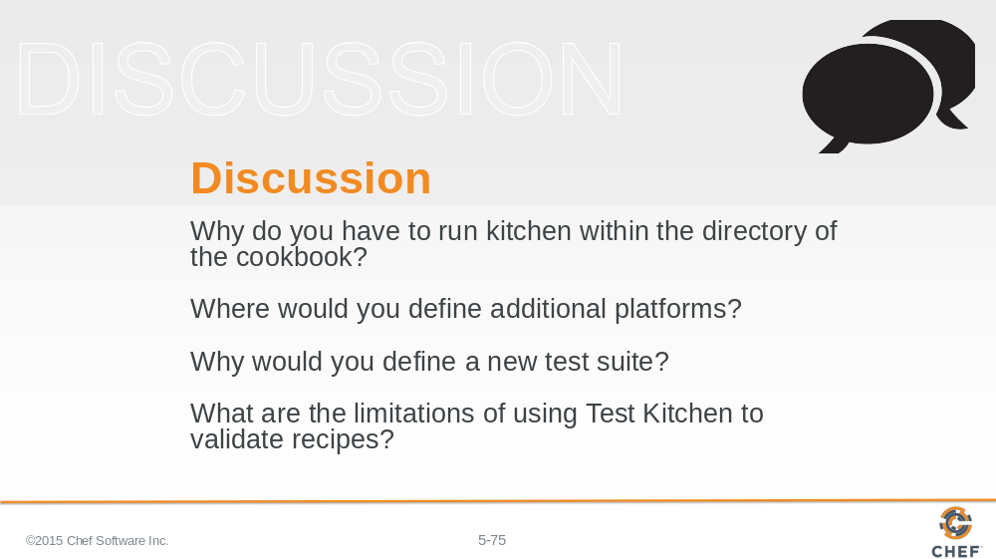

Answer these questions.

With your answers, turn to another person and alternate asking each other asking these questions and sharing your answers.

Slide 76

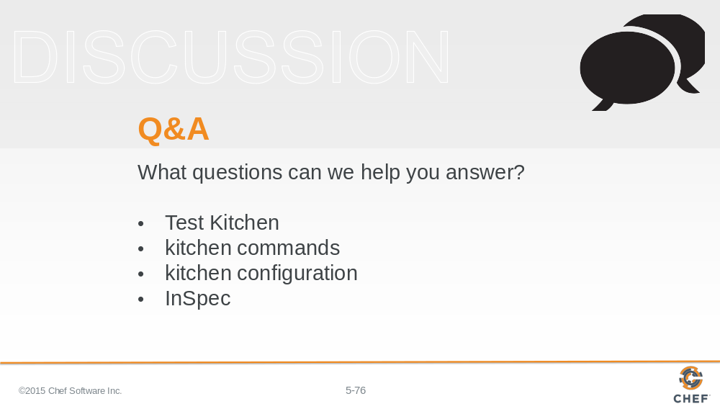

What questions can we help you answer?

Generally or specifically about test kitchen, kitchen commands, kitchen configuration, InSpec.

Slide 77



