11: Managing Multiple Nodes

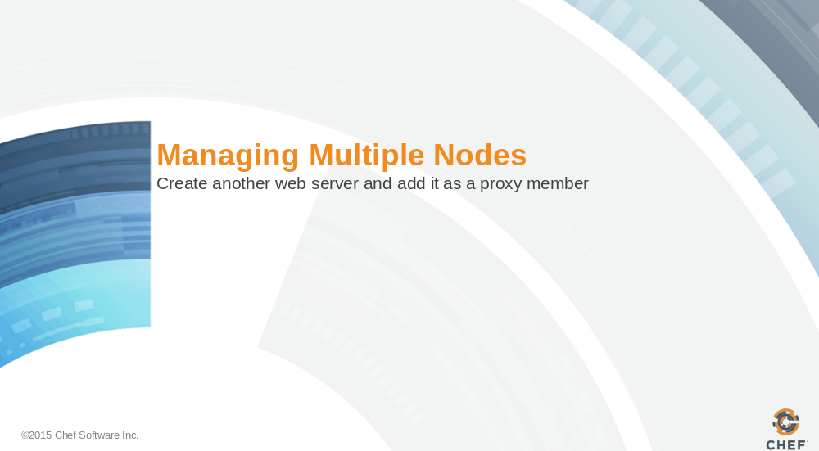

This section's goal is to have you bootstrap another node, this time a web server, and add it to the proxy members.

Slide 2

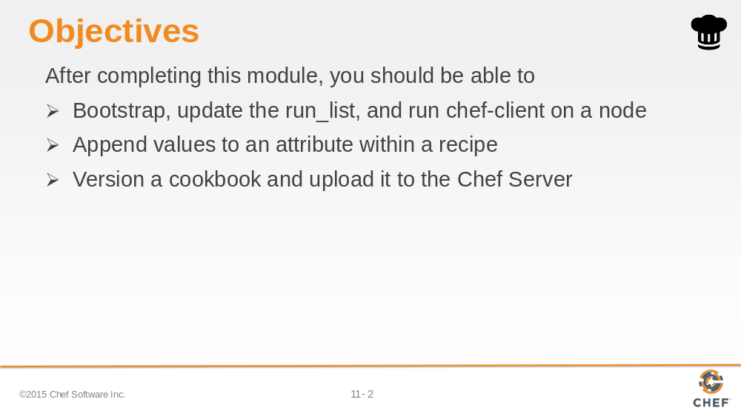

In this module you will learn how to bootstrap, update the run list, and run chef-client on a node. You will also learn how to update a default attribute within a recipe, version and upload a cookbook.

Slide 3

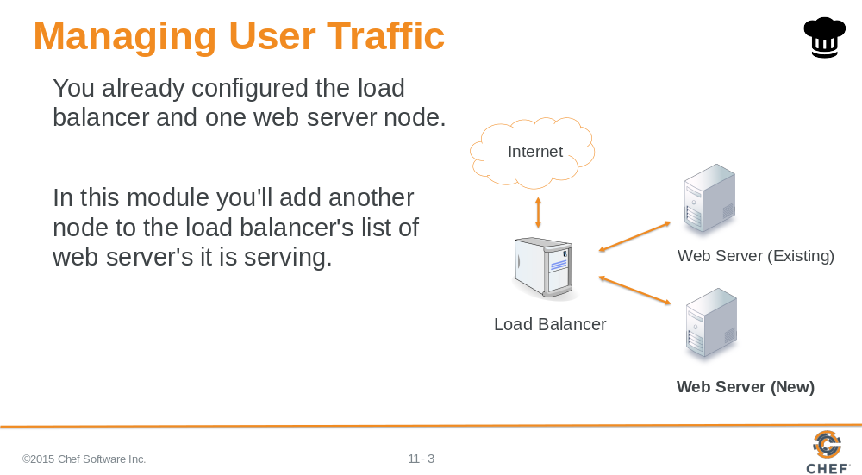

After completing this module, you will have configured three nodes:

Node 1: A web server
Node 2: The load balancer
Node 3: Another web server

Slide 4

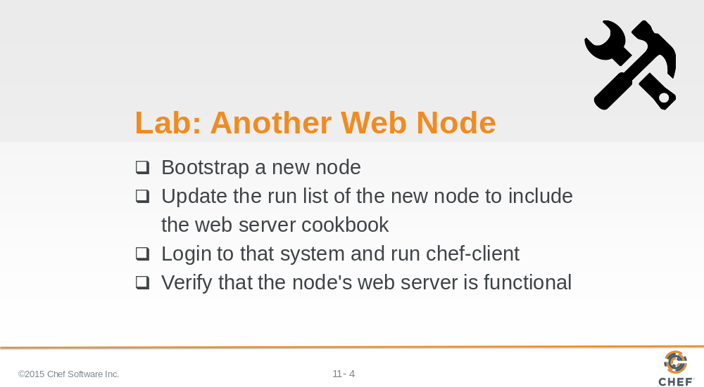

Now it’s time to create a third node. The third node will be the second web server node.

We will provide you with a new node for the following exercise.

Instructor Note: Allow 10 minutes to complete this exercise

Slide 5

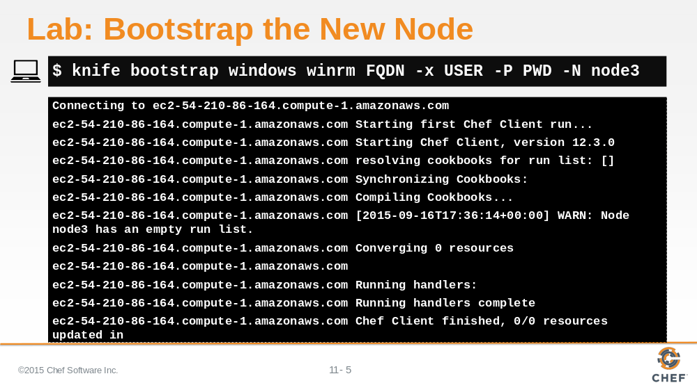

Bootstrap the new node and name it node3.

Slide 6

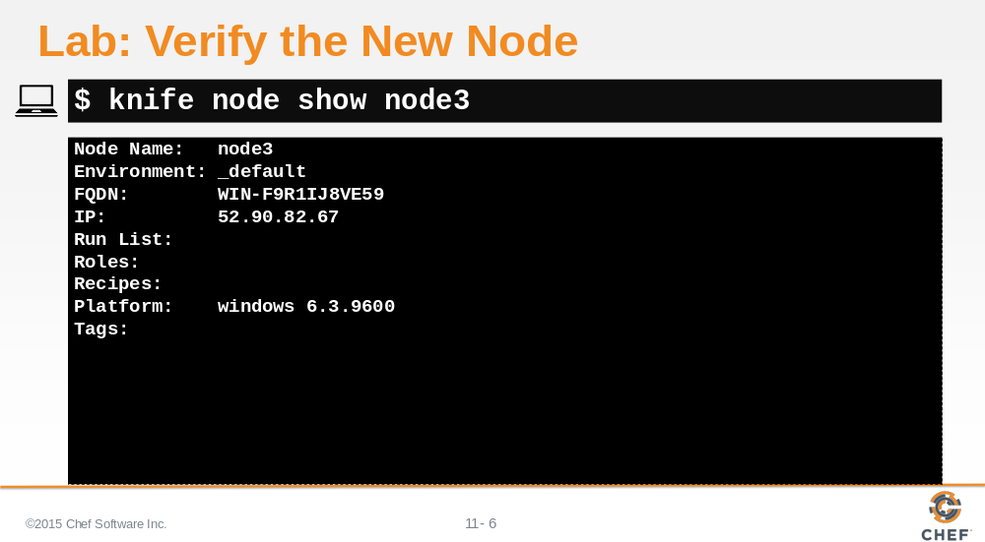

Verify that you bootstrapped the node.

Slide 7

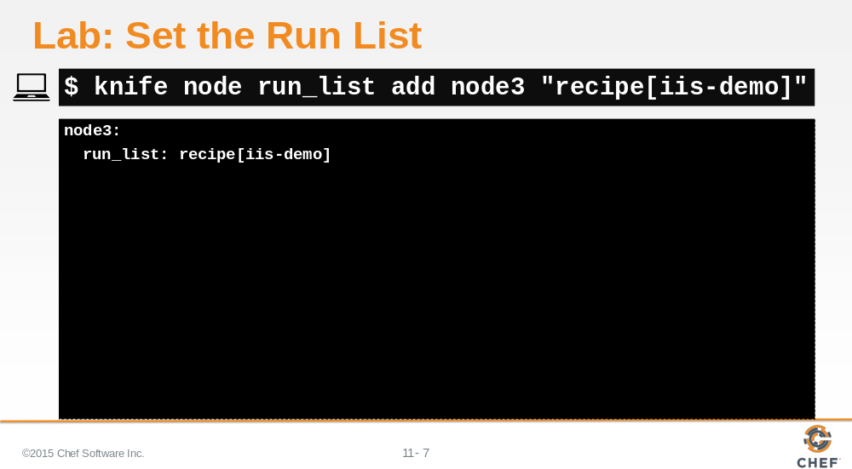

Set the run list for this node by running the iis-demo cookbook's default recipe.

Slide 8

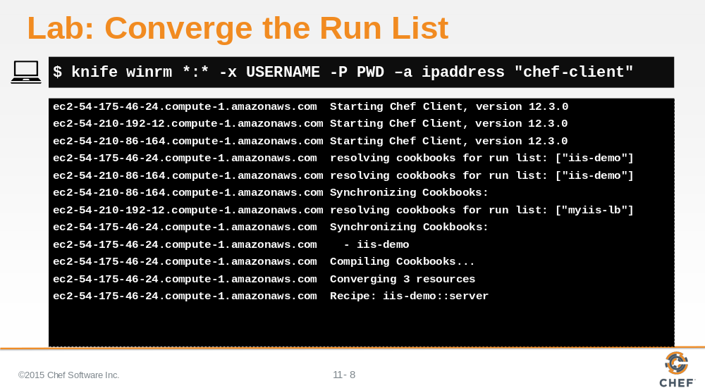

Apply that run list by logging into that node and running chef-client or remotely administer the node with the 'knife winrm' command as shown here.

Slide 9

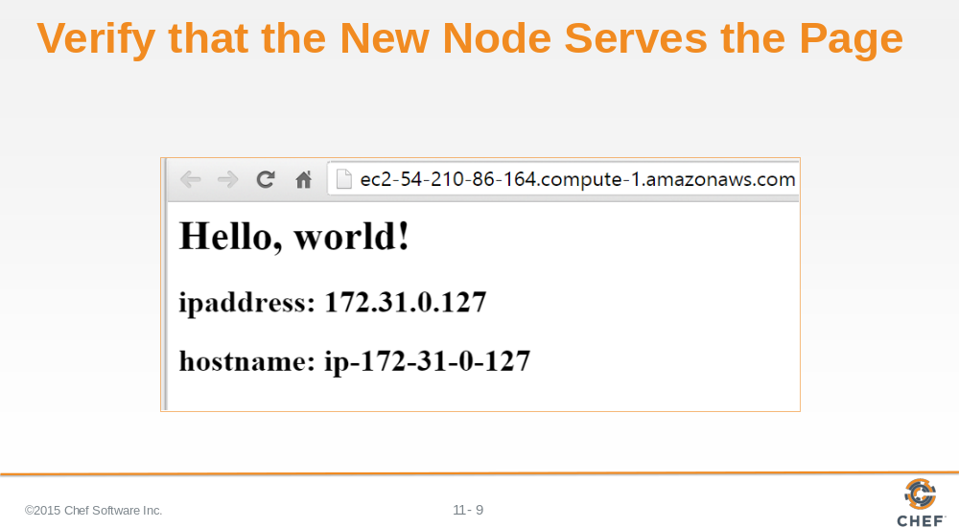

Verify that the node serves up the default html page that contains the node's internal IP address and hostname.

Slide 10

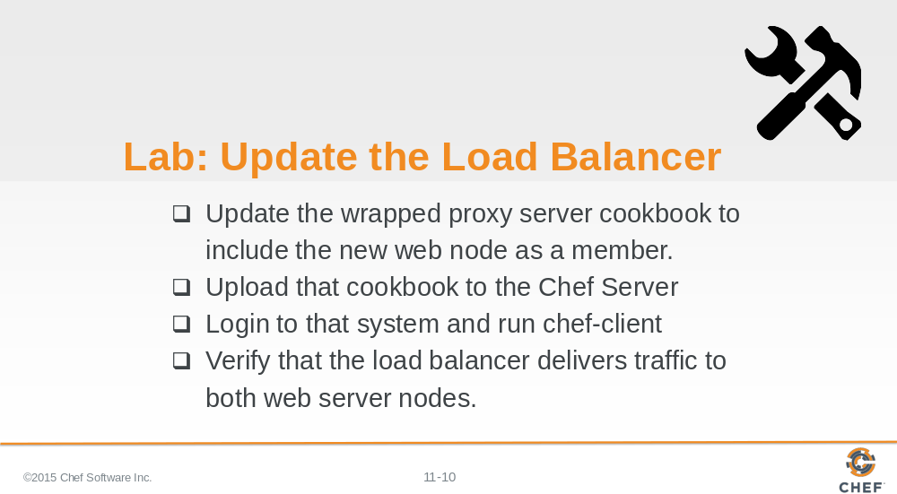

Now that you have the third node, it is time to add that node to the member's list for the load balancer.

Instructor Note: Allow 15 minutes to complete this exercise

Slide 11

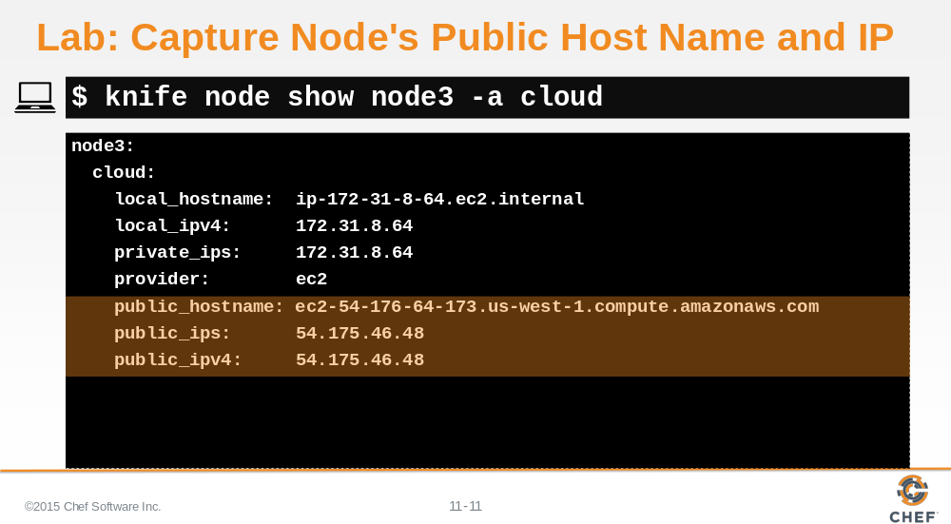

If you use 'knife node show' to display the 'cloud' attribute for node3, you will see the local, private, and public connection information.

Capture and write down the public hostname and the public ipv4 address of node3. You will need this in the recipe you are going to write.

Slide 12

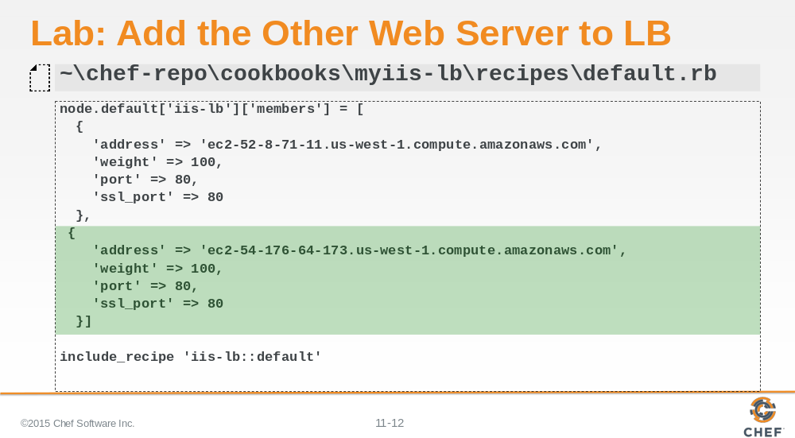

Add the second web server (node3) to the load balancer's (LB) members list. You may need to run 'knife node show node3 -a cloud' to get the hostname and ipaddress values.

Slide 13

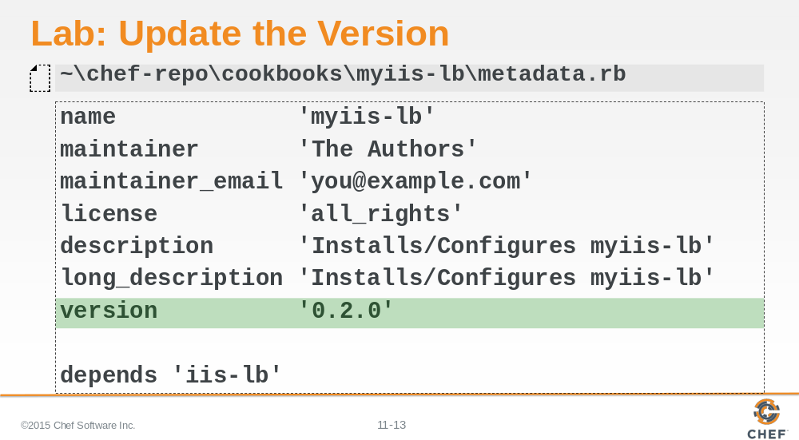

Update the version number in myiis-lb cookbook's metadata.

Slide 14

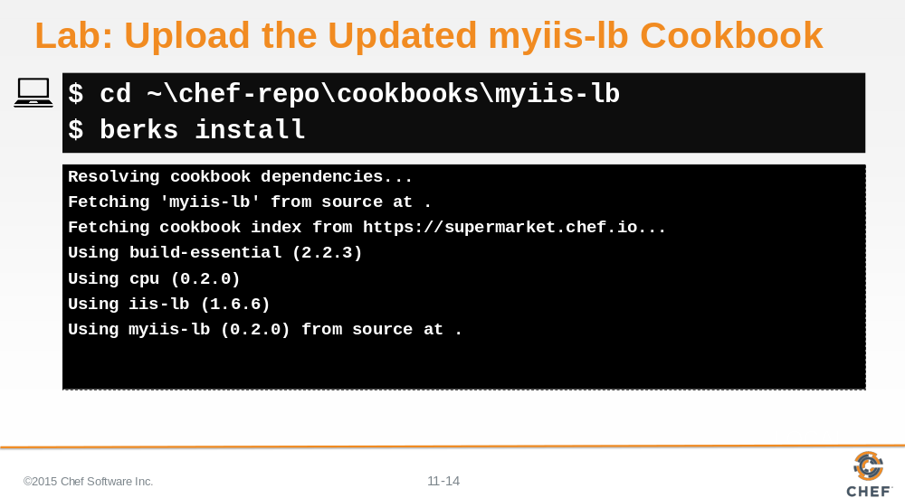

Change into the 'myiis-lb' cookbook directory and then run 'berks install' to install any dependencies for the 'myiis-lb' cookbook.

Instructor Note: Any time you change the version number of a cookbook Berkshelf requires you re-evaluate the dependencies even if they dependencies have not changed.

Slide 15

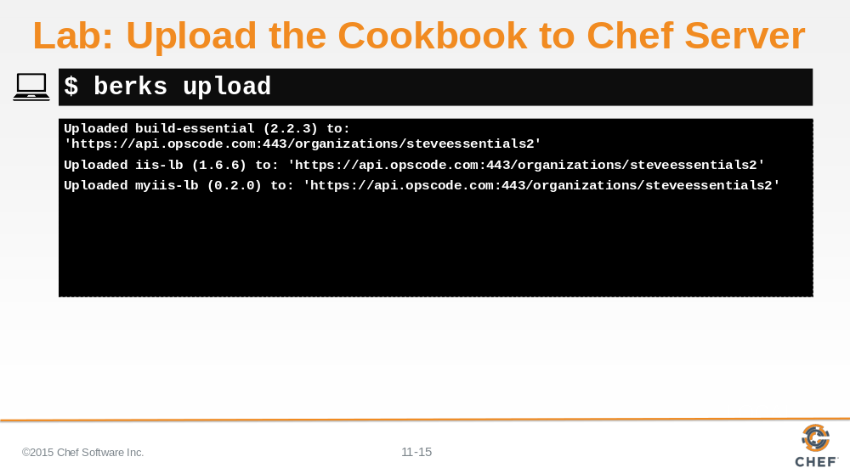

Run 'berks upload' to upload the myiis-lb cookbook to Chef Server.

Slide 16

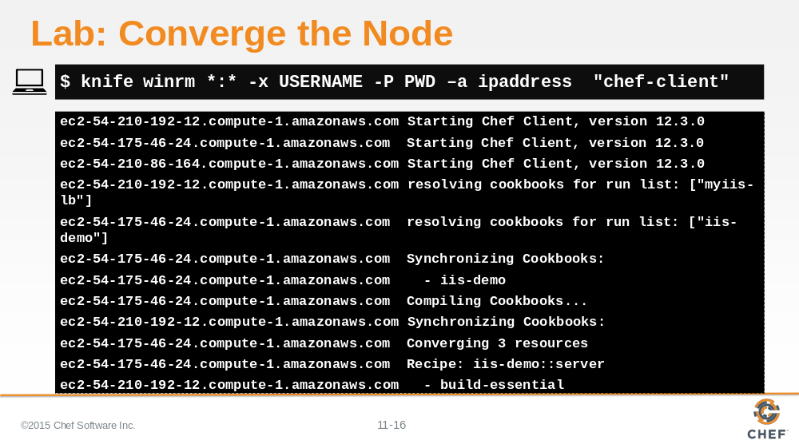

Converge the node by logging into that node and running 'chef-client' or remotely administer the node with the 'knife winrm' command as shown here.

Within the output you should see the iis-lb configuration file will update with a new entry that contains the information of the second member (node3).

Slide 17

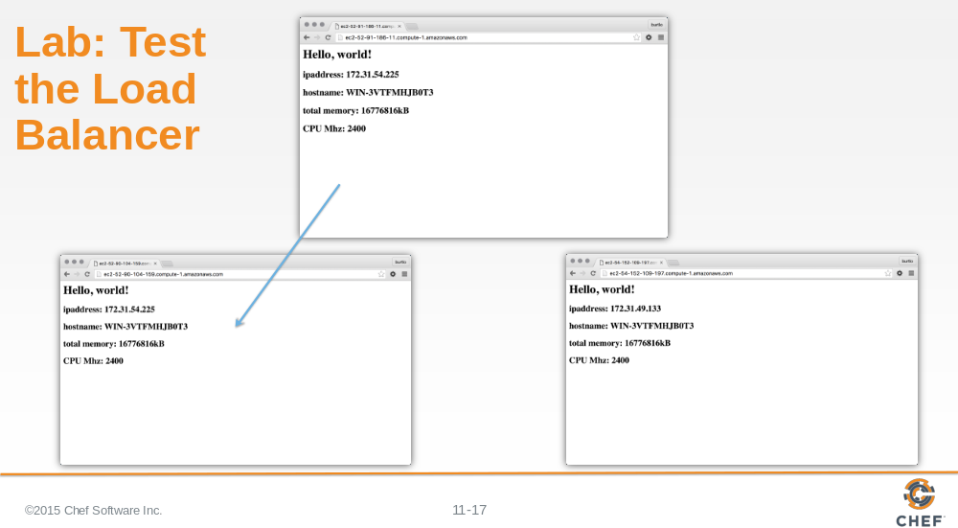

Point a web browser to the URL of your Proxy server and then click Refresh a few times. You should see each of your web server's HTML page as the Proxy server switches between each web server.

This is not a very scientific way of seeing that the proxy server is balancing requests between these two web nodes.

Slide 18

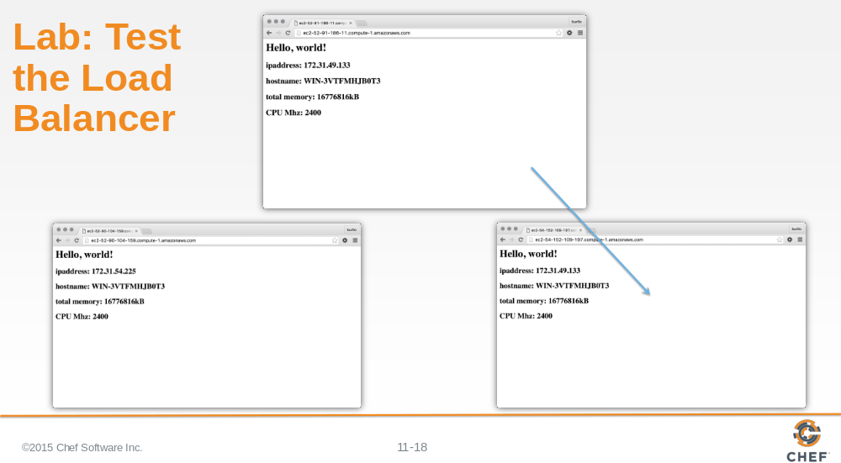

Slide 19

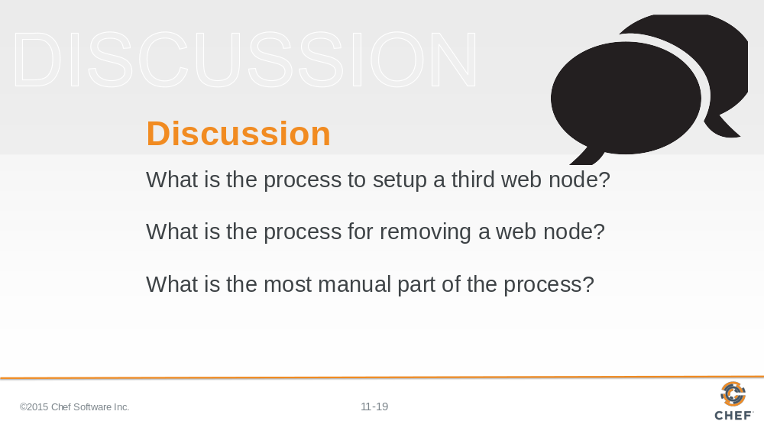

Answer these questions.

With your answers, turn to another person and alternate asking each other asking these questions and sharing your answers.

Slide 20

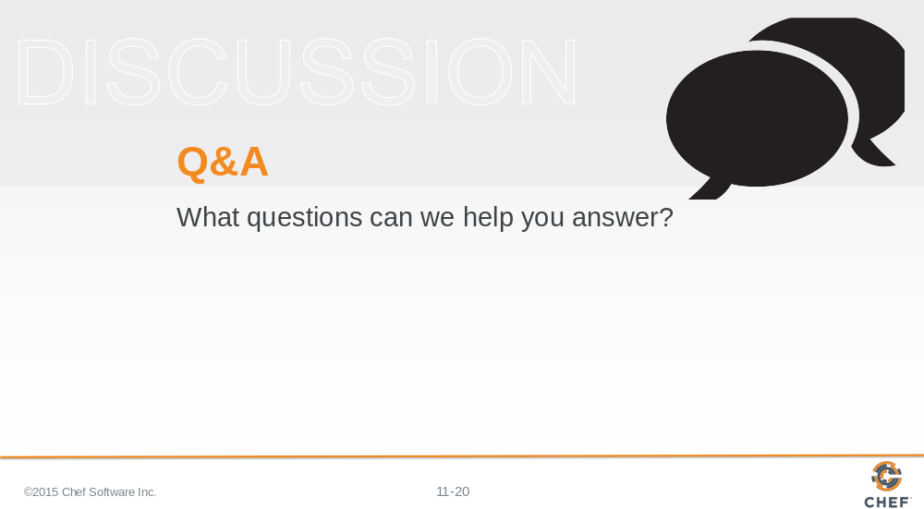

Slide 21



