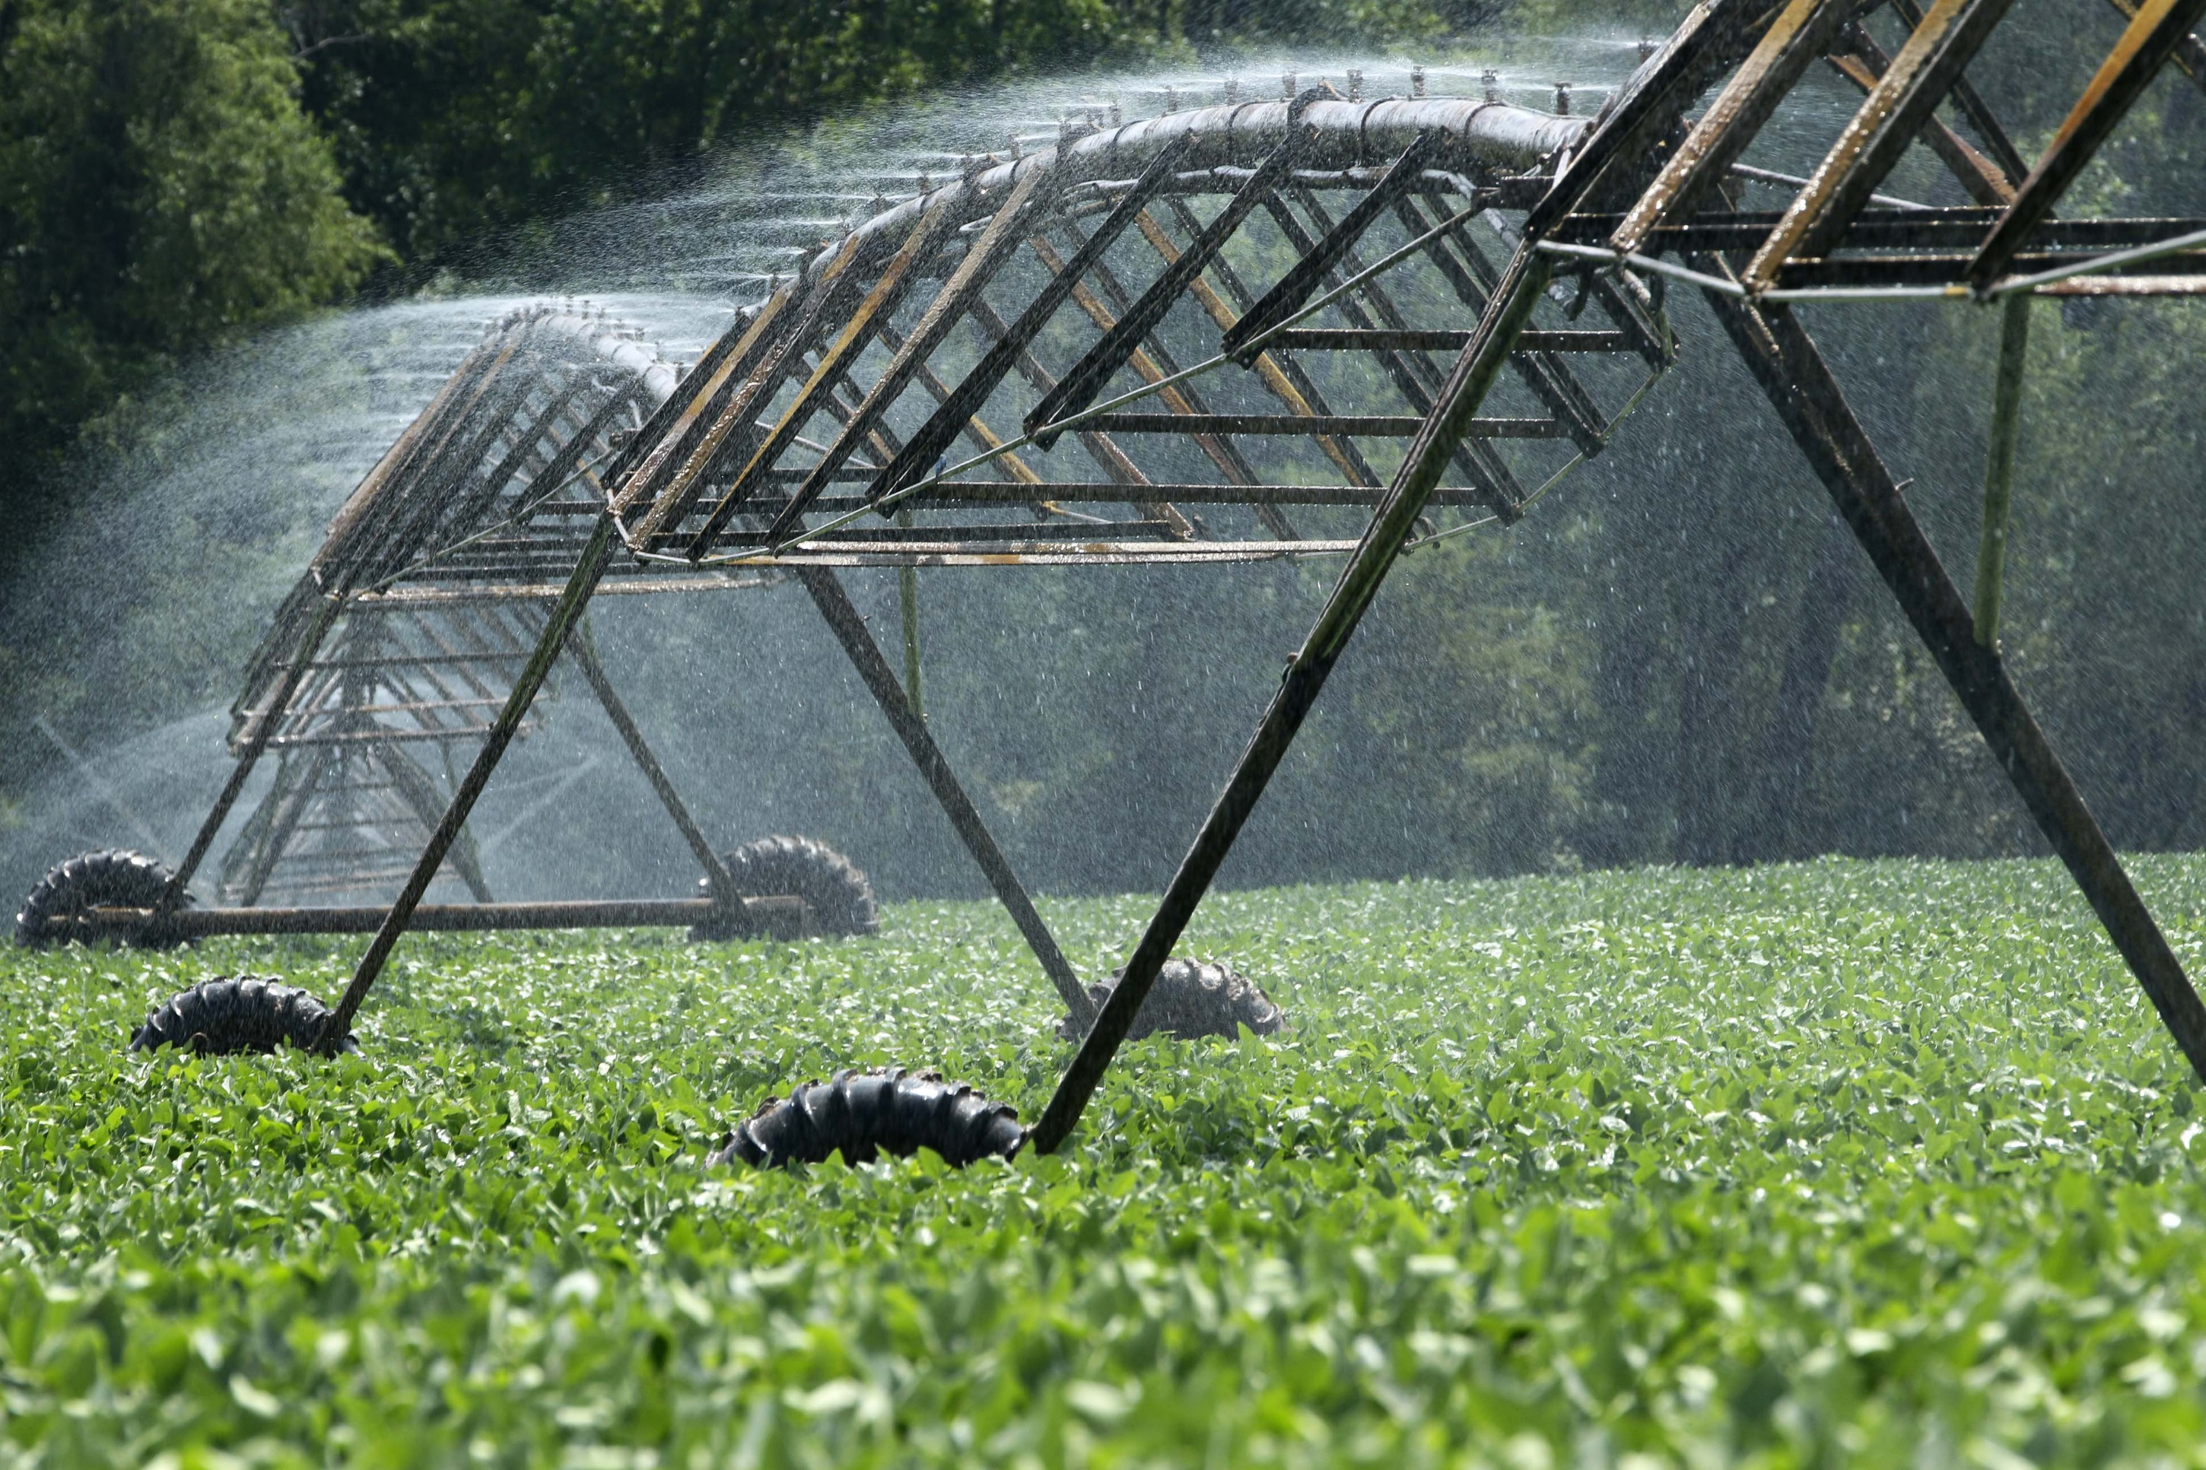

**AGRICUE:** PROCESS IDENTIFICATION ASSESSMENT

**Name:** Bishakha Chand

**Course:** DMIT1506

**Section:** A01

**Date**: September 26th, 2023

Contents

Part 1: Process Drill Down – The Process of Applying for a Grant 1

Process Analysis 1

Unit Analysis 1

Task Analysis 2

Action Analysis 4

Actions in Unit 1: 4

Tasks in Unit 2: 6

Part 2: Signing up for a Program at the Sanctuary 7

Glossary 8

Marking Guide 10

Reflection: 11

# Part 1: Process Drill Down – The Process of Applying for a Grant

## Process Analysis

|  |  |  |
| --- | --- | --- |
| Input | Transformation | Output |
| Proposed project info | **[Table 1]** Create project proposal | Submit project proposal |

Assumptions:

* In the process of applying for a grant, the preproposal author became a candidate for the grant after receiving a call for proposal from the AAC.

## Unit Analysis

1

|  |  |  |  |
| --- | --- | --- | --- |
| Process: Create project proposal | | | |
| Unit | **Input(s)** | **Transformation(s)** | **Output(s)** |
| [Table 2] Unit 1 | Project Information | Present Preproposal | Presented  preproposal |
| [Table 3] Unit 2 | Call for proposal,  Presented proposal, | Present proposal | Presented proposal |

Assumptions:

Unit 1:

* The candidate uses their knowledge of the project to present a preproposal.

Unit 2:

* The candidate receives a call for proposal after presenting their preproposal to the AAC.

## Task Analysis

2

|  |  |  |  |
| --- | --- | --- | --- |
| Unit 1: Present Preproposal | | | |
| Task | **Input(s)** | **Transformation(s)** | **Output(s)** |
| [Table 4] Task 1 | Proposed project information, | Create preproposal application | Created preproposal application |
| [Table 5] Task 2 | Created preproposal application,  Preproposal guidelines, | Create preproposal | Created preproposal |
| [Table 6] Task 3 | Created preproposal | Submit preproposal | Submitted preproposal |

Assumptions:

Task 1:

* The candidate has complete knowledge about the project they will propose before creating the preproposal application.
* The grant application is the same as a preproposal application in this scenario.

Task 2:

* The candidate will review the preproposal guideline provided on the Agricue website before creating their preproposal.

Task 3:

* The completed preproposal will be submitted along with the preproposal application.

3

|  |  |  |  |
| --- | --- | --- | --- |
| Unit 2: Submit proposal | | | |
| Task | **Input(s)** | **Transformation(s)** | **Output(s)** |
| [Table 7] Task 2 | Submitted preproposal,  Call for proposal  Proposal guidelines | Create proposal | Created proposal |
| [Table 8] Task 3 | Created proposal | Submit proposal | Submitted proposal |

Assumptions:

* No proposal application is required for the submission of the proposal.

Task 1:

* The candidate received a call for proposal from the AAC.

Task 2:

* The submission process of the proposal is the same as the submission process of the proposal.

## Action Analysis

### Actions in Unit 1:

4

|  |  |  |  |
| --- | --- | --- | --- |
| Task 1: Create preproposal application | | | |
| Action | **Input(s)** | **Transformation(s)** | **Output(s)** |
| Action 1 | Grant criteria | Determine grant program | Selected grant program |
| Action 2 | Selected grant program,  Preproposal application guidelines | Start Preproposal application | Completed Preproposal application |

Assumptions:

Action 1:

* The candidate will review all grant criteria before picking out the best one for their project.

Action 2:

* The candidate will review guidelines through the Agricue website before creating a preproposal application.

5

|  |  |  |  |
| --- | --- | --- | --- |
| Task 2: Create preproposal | | | |
| Action | **Input(s)** | **Transformation(s)** | **Output(s)** |
| Action 1 | Completed preproposal application | Create preproposal cover | Completed preproposal cover |
| Action 2 | Completed preproposal cover | Create preproposal body | Completed preproposal |

Assumptions:

Action 1:

* The candidate will use the information used to create the preproposal application to start creating the preproposal cover.

Action 2:

* Once the candidate has created the preproposal body, the preproposal is complete.

6

|  |  |  |  |
| --- | --- | --- | --- |
| Task 3: Submit preproposal | | | |
| Action | **Input(s)** | **Transformation(s)** | **Output(s)** |
| Action 1 | Demographic information | Create GMS account | Created GMS account |
| Action 2 | Created GMS account,  Completed preproposal | Hand in preproposal | Handed in preproposal |

Assumptions:

Action 1:

* The candidate is in a region that requires demographic information when creating a GMS account.
* The candidate does not have a previously opened GMS account.
* The GMS account creating takes place on the Agricue website.

Action 2:

* The candidate must first create an account before they are ready to submit their completed preproposal.

### Tasks in Unit 2:

7

|  |  |  |  |
| --- | --- | --- | --- |
| Task 1: Create proposal | | | |
| Action | **Input(s)** | **Transformation(s)** | **Output(s)** |
| Action 1 | Proposal guidelines  Handed in preproposal | Create proposal cover | Completed proposal cover |
| Action 2 | Completed proposal cover | Create proposal body | Completed proposal |

Assumptions:

Action 1:

* The candidate will review proposal guidelines through the Agricue website before creating their proposal.

Action 2:

* The proposal is complete after the proposal body has been created.

8

|  |  |  |  |
| --- | --- | --- | --- |
| Task 2: Submit proposal | | | |
| Action | **Input(s)** | **Transformation(s)** | **Output(s)** |
| Action 1 | Account information | Log into GMS account | Logged into account |
| Action 2 | Logged into account,  Completed proposal | Hand in proposal | Hand in proposal |

**Assumptions:**

Action 1:

* The candidate must log into their existing GMS account on the Agricue website before they may hand in their proposal.
* The candidate already has an existing GMS account.

Action 2:

* The candidate must first log into their existing GMS account before they can hand in their proposal.

# Part 2: Signing up for a Program at the Sanctuary

**Customer Name:** Participant

**Process Identification:**

|  |  |
| --- | --- |
| Trigger | Process Name |
| Participant head into learning center | Enroll in event. |
| Participants ask questions about program |
| Participants sign up for an event |
| Participants receive follow-up about reminders and preparations instructions. | Familiarize participants |
| Participants participate in icebreaker. |
| Participants go to garden. |
| Participant plant plants. | Prepare meal |
| Participants manage and handle harvest process. |
| Participant are preparing the meal |
| Participant help prepare the table. |
| Participants gather to celebrate and share experiences. | Provide feedback |
| Participant will complete a survey |

Assumptions:

The following activities are necessary in helping move various processes along, even though they are technically not a trigger. Therefore, will be included in the process.

* Participants receive follow-up about reminders and preparations instructions.
* Participants participate in icebreaker event.
* Participants manage and handle the harvest process.

**Process Timeline:**

|  |  |  |  |  |  |  |  |  |  |  |  |
| --- | --- | --- | --- | --- | --- | --- | --- | --- | --- | --- | --- |
| **Customer Process** | | | | | | | | | | | |
|  | | | | | | Enroll in event | Familiarize participants | Prepare meal | Provide feedback |  | |
| **Supporting Process** | | | | | | | | | | | |
| Setup sanctuary | | Manage sanctuary | | Setup events | Advertise events | | | | | | Analyze feedback |
|  | Hire staff | | | | | | | | | | |
|  | | | Train Staff | | | | | | | | |

# Glossary

|  |  |
| --- | --- |
| Term | Definition |
| Agricue Administrative Council (AAC). | Are a council of experts of various field based who select potential candidates to receive a call for proposal, and award select candidates to receive a grant. |
| Call for Preproposal | A ‘call for proposal’ is a notice of “u can now hand in a Preproposal” |
| Call for proposal | A ‘call for proposal’ is a notice of “u can now hand in a proposal” |
| Candidates | Are people whose proposals will be considered for funding. |
| Funding cycles | specific periods during which an organization allocates financial resources or grants to projects or initiatives. These cycles are typically structured and may have predetermined deadlines and review processes. |
| Grant | Monetary funding for a project provided by Agricue for projects that adhere to agriculture’s enhancements and sustainability. |
| Grant application | The information about the grant program they are applying for, including information about their demographic region if required based on the regulations in counties |
| Grant management system (GMS) | An Agricue website through which potential candidates may submit their grant applications, Preproposals, and proposal. Some users may need to provide their demographic information. |
| Potential candidates | Authors of Preproposals who may be considered towards becoming candidates for the grant. |
| Preproposal | A document that calls for funding by providing a brief overview about a potential project. It outlines the project’s initiatives towards agriculture’s enhancements and sustainability. |
| Preproposal application | The articulation of a project's initiatives in alignment with agriculture’s enhancements and sustainability. |
| Preproposal authors | People who create documents that call for action funding for a potential project. |
| Project coordinators | Individuals responsible for overseeing and managing the selected projects that have been awarded grants by the Agricue Administrative Council (AAC). |
| Proposal | A document that provides a description of a potential project and the funding required for its uptake. It must:  Adhere to criteria set in the region the project will take place.   * Address sustainable agriculture issues of current and potential importance to the specified region or country and have the intent to build a resilient agricultural system from these projects. * Clearly outline the expected outcome for the project and how they will assist the region/or country in working toward the broad-based outcomes defined by the Agricue. |
| Proposal authors | Individuals who create and submit project proposals to Agricue for funding. They are the initiators of grant applications and are tasked with outlining their project's goals, objectives, and requirements. |
| Proposed proposal authors | Potential candidates who have expressed an interest in submitting a project proposal but have not yet formally submitted their proposals. They are in the initial stage of applying for funding. |
| Registrants | Individuals who have completed the registration process on the Grant Management System (GMS) for the purpose of applying for grants. They are potential candidates in the grant application process. |
| The Technical Committee | Evaluate the technical aspects, feasibility, and quality of the proposal’s decisions such as award selection recommendation to the AAC based on their assessments. |

# Marking Guide

|  |  |  |
| --- | --- | --- |
| **Criteria** | **Comment** | **Marks** |
| **Spelling & Grammar** | To check for spelling errors, I used the Word spelling checker as well as reading it over a couple of times. I also used Grammarly to check over the assumption’s parts. (5/5) | **5** |
| * A mark of zero will be awarded if there are more than two spelling/grammar errors |
| **Document Formatting & Process** | For the formatting I utilized the previous standards from DMIT2012 to improve my formatting. I also played around with some features on Word to find new ones.  I added some parts onto the document such as the glossary to help improve my understanding as well as the user’s when looking over the document. I found it especially necessary because there were so many business terms, many of which overlapped with one another. (4/5) | **5** |
| * Title page contains all relevant information |
| * Title page is formatted in a usable manner |
| * Table of contents is complete |
| * Table of contents is accurate |
| * Document format is reader-centered |
| * Incorporated the self-assessment (checking quality of your work) |
| **Review Approach with Client** |  | **Y/N** |
| **Part 1 – Process Drill-Down** | | |
| **Review Drill-down with Client** |  | **Y/N** |
| **Drill-down (documented using tables)** | As I mention in my reflection, I had to redo this 5 times, including the night before the hand in date, until I finally got a result that satisfied me. It had me really thinking hard many times, and I had to take a break from it for my sanity often too. (28/40) | **40** |
| * Process, units, tasks, and actions are named correctly |
| * All relevant units, tasks and actions are included |
| * No irrelevant units, tasks, and actions are included |
| * Breakdown into units, tasks and actions is appropriate |
| * Level of abstraction is consistently applied |
| * Process, unit, task, and action names are documented consistently |
| * Transformations are correctly identified |
| * Relevant assumptions are clearly documented |
| **Review Inputs and Outputs with Client** |  | **Y/N** |
| **Inputs and outputs** | I also felt a little unsure when doing my assumptions and trying not to repeat them in other parts because typically that would also involve repeating units. | **20** |
| * Inputs and outputs for process and all units, tasks and actions are correctly identified |
| * Input and output names are consistently applied |
| **Part 2 – Process Identification** | | |
| **Review Customer Triggers with Client** |  | **Y/N** |
| **Customer Triggers** | Finding the triggers felt quite simple, until I had to find the actions that also helped move the process along. I felt unsure doing that and had to check in back to our in-class example quite a bit. (7/10) | **10** |
| * The customer is correctly identified |
| * Customer triggers are correctly identified |
| * Customer trigger list is complete |
| **Review Process Names with Client** |  | **Y/N** |
| **Process Names** | Process naming is not really the difficult part for me I found when doing the in-class activities, it was the grouping. And I tried to group them best I could be based on the triggers I got down. (8/10) | **10** |
| * Process names are correctly formatted |
| * Processes are correctly identified |
| **Review Timeline with Client** |  | **Y/N** |
| **Process Timeline** | I found the process of setting the table was difficult and to be frank, I got lazy when it came to completing this part. (5/10) | **10** |
| * Customer Processes are mapped correctly |
| * All supporting processes are identified |
| * Supporting processes are plotted in the correct places |
| **Total** | | **100** |

## Reflection:

Honestly, I truly despised this assignment by the end of it, and I know I’m only saying that because it forced me to work harder than what I that was my hardest. Unlike DMIT2012 I attempted to start this assignment three weeks ahead, yet due to some unforeseen circumstances, ended up starting in two. At first, I really didn’t quite understand where to start. I didn’t get how the action plan was supposed to look, neither did I get that the formatting could have been done later. What got me stuck for most of this project was not being able to escape my one-track mind. But once, I got past that and realized formatting didn’t have to be done first even though it was written first in the marking rubric, I got started on the actual assignment. I soon learned I needed to abandon most of my action plan to work through the assignment. The method I had originally planned to work was deterred, and with it, the dates I had set my milestones for. Three times I had to change the structure of my work because it didn’t seem to fit in, yet in some way they still appeared to be wrong because they didn’t seem to quite encompass everything and fit the isosceles or equilateral structure. I ended up taking a break on the weekend from my work completely to give myself some rest because I was unwell and for the life of me could not think of a solution as hard as I tried. This put me off track for many things and I was running behind on my classes now. Initially I felt quite guilty and ashamed about losing track, until someone commented something similar the same day in class. And Sunny, whom I only see pushing us to work hard every time, out of the ordinary commented out of the blue “why is that a bad thing?” That comment triggered a mindset shift in me by validating my efforts. My aim now became to get through everything that was upcoming by sunning into it like a bull when it sees red. So, I sacrificed my sleep pulling two, three all-nighters in a row to get my assignments. A day before the lab was due a likely solution popped up, one that involved abandoning the proposal part under the guise it wasn’t the main part when applying for a grant. It was an if-then situation which may not always occur for most potential candidates. Yet, Sunny seemed iffy when I presented it to even, even though he approved it. And so that night, I changed the whole structure again because a solution that fit the format well finally occurred to me! Yet it was under an assumption that still had to be verified by the stakeholder, it could still as well have been wrong and who knows how much time I’d get the next day to verify it. So, to save my butt I ended up doing double the work that night and creating two copies of the document the night/morning the lab was due. And when I finally thought I was on track, I was told that part two of the lab was not due separately as I had originally thought. So, in quick rush during class, I completed part 2 of the lab so I could verify something with my stakeholder on time. I truly ended up hating it, but I couldn’t help but be a little proud of myself too.