**CURRICULUM VITAE**

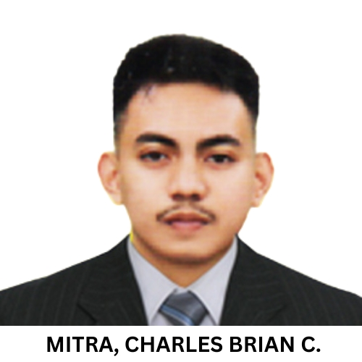

2 X 2

PICTURE

**Name:** Charles Brian C. Mitra

**Address:** Purok 1 Tangway Lipa City

**Contact no.:** 09621289931

**E-mail Add:** 2120585@ub.edu.ph



**OBJECTIVES:**

Seeking for Full-Stack Developer position for my OJT, I’m good for web developing especially in web designing and functionality of a website but I want to expand my knowledge and use my skills in your company.



**WORK EXPERIENCE:**

**(NAME OF COMPANY)**

(POSITION)

(ADDRESS)

(INCLUSIVE DATES)



**EDUCATIONAL BACKGROUND**

**TERTIARY** : **BS in INFORMATION TECHNOLOGY**

**UNIVERSITY OF BATANGAS LIPA CAMPUS**

MARAUOY-BALETE ROAD BALINTAWAK, LIPA CITY

2019 - 2025

**SECONDARY** : **TOMAS CLAUDIO COLLEGES**

TAGHANGIN MORONG, RIZAL

2017 – 2019

**TANAY NATIONAL HIGH SCHOOL**

TAGHANGIN MORONG, RIZAL

2012 - 2017

**PRIMARY** : **SIMEON R. BENDAÑA SR.**

**MEMORIAL ELEMENTARY SCHOOL**

M.H DELPILAR TANAY, RIZAL

2006 - 2012



**TRAININGS AND SEMINARS ATTENDED:**

**DEVCON PH iThink Code Camp**

UNIVERSITY OF BATANGAS LIPA CAMPUS

AUGUST 24, 2024

**IT AND ENGINEERING IN THE DIGITAL AGE**

**ADDRESSING THE SOCIAL AND ETHICAL IMPLICATIONS**

UNIVERSITY OF BATANGAS

AUGUST 16, 2024





**PERSONAL INFORMATION:**

DATE OF BIRTH : November 04, 2002

PLACE OF BIRTH : Tanay, Rizal

AGE : 22

CITIZENSHIP : Filipino

CIVIL STATUS : Single

GENDER : Male

RELIGION : Catholic

FATHER’S NAME : Carlito B. Mitra Jr.

OCCUPATION : OFW

MOTHER’S NAME : Mercy C. Mitra

OCCUPATION : Housewife

HEIGHT : 5’6

WEIGHT : 48

PERSON TO CONTACT : Carlito B. Mitra Jr.

INCASE OF EMERGENCY 09457205029



**SKILLS AND ABILITIES**

* Languages: JavaScript, PHP, SQL, C, C++, Java, Python, VB.Net
* Frameworks: React, Express
* Libraries: Node.js, GSAP
* Web Technologies: HTML, CSS
* Developer Tools: Git
* Hard Working
* Responsible
* Adaptability



**CHARACTER REFERENCES**

**Mr. Khristian Arce**

Faculty Teacher

Tanay National High School

09263865884

**Mr. Russel Reyes**

IT Instructor

University of Batangas Lipa Campus

09263865884

**Mrs. Kielly Chrizza Tojino-Lara**

IT Instructor

University of Batangas Lipa Campus

09263865884

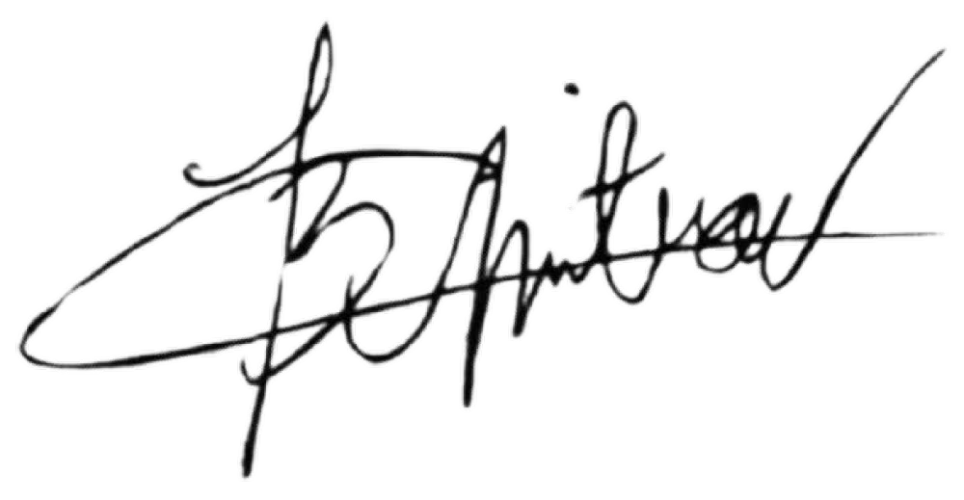**CONFORME:** *By signing below, I hereby voluntarily waive any and all rights I may have to privacy and/or confidentiality pertaining to the above-mentioned purposes insofar as the information is released solely to the authorized persons in accordance thereto.*

*CHARLES BRIAN C. MITRA*

Signature over Printed Name

12 / 11 / 2024

Date Signed