**AudiLearn: A Web-based Interactive Auditory Learning Platform for Law Students of UBLC**

**A Capstone Project Presented to the**

# College of Information Technology, Entertainment, and Communication University of Batangas – Lipa City

**In Partial Fulfillment**

# of the Requirements for the Degree in

# Bachelor of Science in Information Technology

**By:**

**Mitra, Charles Brian C.**

**Quinto, Gianne Francis P.**

**Rosales, Anthony Christian A.**

# 2025

# TABLE OF CONTENTS

**Chapter 1.**

Introduction

The Project Context 1

Objectives of the Study 3

Scope, Limitation, and Delimitation 4

Significance of the Study 6

Definition of Terms 7

**Chapter 2**

Review of Related Literature and Studies

Related Literature 9

Related Studies 12

Synthesis 21

**Chapter 3**

Research Methodology

Research Design 23

Research Method 23

Data Gathering Instrument 25

Data Gathering Procedure 25

Technical Background 26

ISO 9126 Software Evaluation 28

**Chapter 4**

**Analysis and Presentation of Data**

Conceptual Framework 29

Flowchart 31

Entity-Relationship Diagram 34

Data Flow Diagram 34

Survey Result 35

Part 1: Demographic 36

Part 2: Preference Towards Audio Based Learning 38

Part 3: Potential Use of AudiLearn as an Alternative or Supplementary Educational Tool in Studying 43

Part 4: Recommending the use of AudiLearn 44

ISO 9126 Software Evaluation Survey Results 47

**Chapter 5**

**Conclusion and Recommendation**

**List of Tables and Figures**

**Figures**

Figure 3.1 Agile SDLC Model 23

Figure 4.1 Conceptual Framework 29

Figure 4.2 Flowchart of AudiLearn Login 31

Figure 4.3 Flowchart of AudiLearn File Conversion 32

Figure 4.4 Flowchart of AudiLearn Audio Lesson 33

Figure 4.5 Entity-Relationship Diagram of AudiLearn 34

Figure 4.6 Level 0 Data Flow Diagram of AudiLearn 34

Figure 4.7 Level 1 Data Flow Diagram of AudiLearn 35

**Tables**

Table 3.1 Hardware Requirements 27

Table 3.2 Software Requirements 27

Table 4.1 Age of Respondents 36

Table 4.2 Sex of the Respondents 36

Table 4.3 Year Level of the Respondent 37

Table 4.4 Preference of Law Students in Studying Law Subjects 37

Table 4.5 Frequency of Using Audio Learning Tools for Studying Law Subjects 38

Table 4.6 Preferences of Law Students Towards Audio-based Learning 39

Table 4.7 Use of AudiLearn as an Alternative or Supplementary Educational Tool in Studying 42

Table 4.8 AudiLearn Recommendation 44

Table 4.9 Results of ISO 9126 Software Evaluation 46

Table 4.10 Voice Command Fault Tolerance Table 48

**CHAPTER 1**

**INTRODUCTION**

This chapter presents the project context, objectives, scope, limitation, delimitation, definition of terms, and the significance of the study.

**Project Context**

As the world is currently in the midst of a digital age, online learning materials have become prevalent. While the internet has made it easier than ever before to access various educational content, many students still face challenges in studying due to reliance on text-based resources. Auditory learning offers a way of learning that allows learners to study, learn, and absorb information through listening rather than reading. Auditory learning provides advantages for students who struggle with reading large amounts of text-based educational materials or have difficulty retaining information through traditional reading methods. Audio-based learning enables students to absorb information in an auditory manner. This method of learning enhances comprehension and improves retention of information by offering an alternative way for students to study in today’s digital environment (Locke et al., 2024).

               Learners and students who prefer learning by listening would be at a disadvantage from reading-heavy courses and may find it difficult to retain information from written texts alone. According to an online educational article written by Gupta (2023), studies suggest that auditory learners make up about 30% of the population. Despite advancements in how technology is being used in an educational setting, it is still not being used to its fullest. For instance, text-to-speech (TTS) technology and speech-to-text (STT) technology has seen significant improvements and usage in the last few years with the likes of popular audiobook applications like Audible and applications that enables the users to use voice commands, yet its application in educational settings is still not as widespread as it needed it to be. Auditory learning will allow students to not only access but also comprehend lessons with more understanding. Auditory learning can enable auditory learners to engage in learning that aligns with their preference (Keelor et. al., 2020). This points to using audio-based learning technologies as an alternative educational tool to be used in learning.

Law students, in particular, face challenges in text-based learning due to the large amount of reading required to study and learn the law such as statutes, legal theories, and other various law-related reading materials. Studies show that law students typically spend a significant time on reading and analyzing complex legal texts, which can contribute to information overload and diminished retention of information (Enns and Smith, 2015). The large amount of reading, combined with the technical language used in legal texts, may lead to mental fatigue and exhaustion, making it difficult for students to efficiently absorb and remember the lessons, studies, and information (University of Memphis, 2017). Audio-based learning provides a much-needed alternative that allows law students to listen to the lesson rather than reading it. Additionally, audio-based learning offers the flexibility when studying so that students can listen to lectures or legal readings while commuting or multitasking in order to optimize their study time.

Since the COVID-19 pandemic, the widespread use of online learning materials has become prominent for most of the different programs in schools. The pandemic accelerated the shift to online learning materials highlighted the need for various learning tools. The study looks to bridge the gap between using web technologies and its application and usage in an educational setting by developing a web application that offers a user-friendly and intuitive user interface with audio-based learning features. AudiLearn seeks to meet the needs of learners as an alternative, as well as, another support for ways a learner processes and digests learning materials. Additionally, the researchers look to incorporate interactivity to the development of the web application by incorporating voice recognition so that the learners will be able to use voice commands. This will prove to be beneficial to those who are used to using their voice in giving instructions and with those will physical disabilities. For example, the web application can be used by students to listen to lessons while performing other activities. Giving voice command will make the process much easier. Moreover, if the student is having difficulty memorizing or just prefers studying by listening, he or she can use AudiLearn to convert the text files to audio to be able to just listen to the lesson.

                The motivation for doing the study is to help law students and auditory learners in their studies by offering an audio-based learning web application. The development of AudiLearn represents a commitment by the researchers to build applications that will benefit people by providing an alternative learning tool. The researchers hope to make an impact on the educational landscape by developing the web application. Another reason is for the researchers to develop an application that will be the culmination of the researchers’ learnings from the past four years at UBLC of the information technology program. The study will not only test and improve the researcher’s skills and knowledge but also impact and help the auditory learners. This application will build a step towards a level playing field for each kind of learner, ensuring learning will be accessible and straightforward.

**Objectives of the Study**

The main objective of the study is to develop the web application, “AudiLearn.” The study can help law students of University of Batangas – Lipa City in their studies and learning by offering an audio-based learning web application.

The study aims to:

1. Analyze the concepts of interactive media for text-to-speech technology and web development such as Python, HTML, CSS, and JavaScript in relation to the development of “AudiLearn” for law students in UBLC that prefer audio-based learning.

2. Design and develop a web application for auditory learning that is capable of:

a. Read and Listen to auditory law lessons

b. Use of voice commands in lessons

c. Choose a voice when listening to the law lesson

d. Place a bookmark to the lesson

e. Convert digital text file such as docx, pdf, and txt to audio format

f. Listen to the converted digital text file

3. Test and evaluate the different functionalities of “AudiLearn” in order for it to be used by the students using ISO 9126 software evaluation criteria.

4. Implement the web application, “AudiLearn”, to be used by law students of UBLC.

**Scope, Limitation, and Delimitation**

The study is to develop an auditory learning web application for law students and learners who prefer learning by studying. The web application serves to convert digital text files to audio format and have the feature to listen to law lessons with the ability for the user to give voice commands in navigating the lessons. The following voice commands can be used:

a. Read Aloud – Reads the lessons

b. Stop – Stops reading

c. Pause – Pauses the reading

d. Resume – Resumes the reading from pause

e. Go to Page – Goes to the page issued

f. Next Page – Goes to the next page

g. Previous Page – Goes to the previous page

h. Go to Home – Goes to the Home Page

i. Go to Paragraph – Goes to the paragraph chosen in the current page

j. Go to Topic - Goes to the specified topic

The user can choose the voice they prefer before listening to the lessons. The users can bookmark a specific paragraph that will enable the user to come back to the part bookmarked with ease. The study will be conducted at UBLC with law students as its main target demographic. The study will assess the percentage of law students who prefer audio-based learning and studying in UBLC and how the use of AudiLearn will impact their studies.

The limitation of the study is the technological proficiency among the target participants, which could affect the usability and effectiveness of the web application. Another limitation is that the study is focused on the law students of UBLC meaning the application will be developed with intuitive features and lessons for UBLC law students in mind. The web application limits the proficiency of the text-to-speech technology in the English Language. Moreover, the proficiency of using voice commands is constrained by how much background noise is in the area and clearness of the diction of the voice of the user. Additionally, the development and testing of AudiLearn is constrained by the duration of the whole research period.

Since the lessons that will be incorporated to the AudiLearn are law lessons, the study’s primary focus is the impact of the web application to law students who prefer audio-based learning in UBLC and will exclude any leaners who are not law students. The use of earphone or headset is much preferred when using the voice commands. The web application focuses on the technologies used in web development and text-to-speech technology.

**Significance of the Study**

The study is significant to the University of Batangas Lipa City Campus, auditory learners, law students, professors and instructors, and future researchers. The significance of developing an application that will benefit people in an educational setting are the following:

**To the University of Batangas Lipa City Campus:** The study will provide the educational institution with a web-based educational platform. The study fosters the integration of technology in education and contributing to the improvement of the academic performance of the students of UBLC.

**To the auditory learners:** By using AudiLearn, auditory learners will benefit by having an educational tool to cater to their preferred learning style. This enables auditory learners to engage with the lesson in a way that aligns with their preference.

**To the law students of UBLC:** The study can provide law students of UBLC an alternative audio-based learning platform for their studies that will help in better understanding their lessons and retain information as well as listening to lessons while multitasking.

**To the professors:** The study can lead to more effective teaching strategies and AudiLearn can serve as a supplementary teaching tool.

**To the future researchers:** The study can serve as a guide or reference material of future studies with similar topics. Future researchers can build on the findings of this study to explore further applications of text-to-speech technology in education.

**Definition of Terms**

**Application:** Application is a program or software that performs a specific function for the user. (TechTarget, 2021).

**Audio Format:** Audio format defines the quality and loss of audio data. Based on the application, different types of audio format are used (Geeksforgeeks, 2023).

**Auditory Learning:** Auditory learning is a type of learning style where a person learns most effectively by listening. They would prefer listening to a lecture over reading a textbook, or hearing the instructions for a project instead of figuring it out hands-on (Western Governors University, 2020).

**CSS (Cascading Style Sheets):** is a programming design language that includes all relevant information relating to the display of a webpage. CSS defines the style and formatting of a website or page, including the layout, colors, fonts, padding (the space around each element) and more (Spivak, 2023).

**HTML (Hypertext Markup Language):** is a text-based approach to describing how content contained within an HTML file is structured. This markup tells a web browser how to display text, images and other forms of multimedia on a webpage. (Lutkevich, 2020).

**ISO 9126:** Introduced by the ISO (International Organization for Standardization), it is an international standard for evaluating software quality. It defines six key characteristics: functionality, reliability, usability, efficiency, maintainability, and portability. These standards help ensure the software fulfills user needs, performs reliably, is user-friendly, operates efficiently, can be easily updated, and works across various environments (UXTweak, 2023).

**JavaScript:** JavaScript is a single-threaded, synchronous programming and scripting language widely used in web development. It plays a crucial role in both front-end and back-end development, enabling dynamic and interactive user experiences. (GeeksforGeeks, 2024).

**PDF**: PDF is an abbreviation that stands for Portable Document Format. It's a versatile file format created by Adobe that gives people an easy, reliable way to present and exchange documents (Adobe, 2024).

**Python**: is a programming language that is interpreted, object-oriented, and considered to be high-level too. Python is one of the easiest yet most useful programming languages which is widely used in the software industry. People use Python for Competitive Programming, Web Development, and creating software. (GeeksforGeeks, 2024).

**Text-to-Speech Technology (TTS):** Text-to-Speech Technology (TTS) takes text as an input, and in the process, produces a sound taken from the text input as the output. (CourseArc, 2023).

**Voice Recognition:** Voice or speaker recognition is the ability of a machine or program to receive and interpret dictation or to understand and perform spoken commands. Voice recognition has gained prominence and use with the rise of artificial intelligence (AI) and intelligent assistants, such as Amazon's Alexa and Apple's Siri. (Gillis, 2024).

**Web Application:** Web application is an application that is stored on a server and delivered over the internet. It requires an internet connection to function and can be viewed or opened using a browser. (TechTarget, 2023).

**CHAPTER 2**

**REVIEW OF RELATED LITERATURE AND STUDIES**

This chapter presents the related literature and studies as well as the synthesis of the proposed study. This chapter shows the different definitions, discussions, and concepts related to the proposed study. The review of the related literature and studies will explore the different ideas of the research and the technology to be used in development of the system. The researchers have read and gathered related topics from books, journals, articles, college undergraduate thesis, and online references in order to further understand the research.

**Related Literature**

**Auditory Learning**

As auditory learners are the main focus of this research, it is important to expand on what auditory learning truly is. According to Alarifi (2023), auditory learning refers to a learning style where a person prefers learning by hearing and speaking. In a classroom setting, they benefit from listening and participating in lectures and discussions. Teachers and instructors can provide a better learning environment to auditory learners by having a variety of approaches in teaching. Some of these are providing audio recordings of the lecture and audiobooks and recorded lectures. These will help auditory learners in retaining information more effectively as well as improving their reading and learning comprehension. Students are more likely to develop a variety of learning styles because students are exposed to a variety of teaching formats and styles. Additionally, when students are presented with a wider range of options in acquiring and expanding their knowledge, they are likely to think creatively and with more flexibility. Furthermore, Tulabing (2018) said when there is a mismatch of the teaching method and the learning styles of the students, the academic performance becomes affected for better or worse. There is a relationship between the academic performance of the students to their preferred learning styles which are auditory, kinesthetic, and visual learning styles. Magulod (2018) said that auditory learning is a minor learning preference. Even with auditory learning being a minor preference, it should still be considered in the teaching strategy and could be integrated with the other learning styles as well as the use of audio-based applications or tools.

**Digital Audio**

Digital audio has improved the quality of sound and music due to better range and frequency. The development of the mp3 format and other audio formats, music players, smartphones, various audio and music applications, and affordable portable storage devices lead to more convenience, flexibility, and control to music and recently, audiobooks. The growth of digital audio coincides to the growth of the internet. Downloading digital audio files from the internet made it more accessible to everyone. Nowadays, there are many different software that can produce, edit, and play digital audio (B. Fries, M, Fries, 2005).

**File Conversion**

The main feature of the application of this research is converting digital text or document files to audio format. In a journal article by Situmorang and Panggabean (2021), conversion is changing one file format to another. Situmorang and Panggabean developed an application using Visual Basic that converts video files to audio files to another format. For example, the application can convert a video file in .mp4 format to .avi video file format. Converting files to another format has its advantages and disadvantages such as certain video file formats like .flv files that have to be converted into another file format for it to play on standard video players. One disadvantage is converting files into another format may increase its file size that may be cumbersome to users with limited storage.

**Text-to-Speech Technology**

Text-to-Speech has been around for a long time. According to Poojary et. al. (2023), text-to-speech technology is a system of generating audio speech from text enabling written input into audio output. Text-to-speech technology has made significant advancements in recent years. It has a variety of uses such as audiobooks, which have become popular instead of reading traditional books. Some other uses include providing audio output for people with disabilities like blindness or dyslexia, generating voiceovers for a variety of applications, and improving the accessibility for digital content to a wider range of users. Furthermore, Trivedi et. al. (2018) said that text-to-speech is a process in which input text is first analyzed, processed and understood, and then the text is converted to digital audio. The steps in the process of converting text to speech includes text processing, phonetic analysis, prosodic analysis, and lastly speech synthesis. The output will then be the digital audio of the text. Additionally, Policarpio and Guevara (2009) said that speech synthesis is the automatic generation of speech waveforms with the use of a machine. Use of a text-to-speech system helps convert this speech. The use of synthetic speech has so many helpful ways to help people especially those with disabilities. Synthesized speech can be used as an educational tool in teaching and learning such as helping in spelling and teaching pronunciation for different languages.

**Voice Recognition System**

According to Olamilekan et al. (2024), Voice recognition technology, often known as speech recognition, has become a crucial part of modern human-computer interaction. Voice Recognition allows for smooth communication between people and devices through spoken instructions. Voice recognition allows people to interact with technology in a simple way by allowing hand free-requests, reminders, and other simple tasks through speech. It states that in today’s world there are two types of voice recognition systems: the first one is “Text-Dependent” that depends on a specific set of words the person says which the user is required to say a necessary phrase to activate it. Another is “Text Independent” which does not depend on a specific phrase or text yet relies on conversion speech. Benefits of using voice recognition system include time-saving tasks, increase in productivity, and accessibility.

**Web Application**

With the continued convenience, accessibility, and reduction of cost of the internet, development and usage of different web applications has been on the rise. Esmeria and Seva (2017) said that dependence of using web applications has become very important for its users. With so many web applications to use, the development of web application has become more competitive. Websites are expected to provide a satisfying user experience. Different web applications provide different functionalities and design which means the developers must be equipped with the skills and listen to feedback from its users. Additionally, according to Esteban (2023), web development is an essential aspect in creating and maintaining websites and web applications. Front-end and back-end development plays a role in crafting a good user interface and a functional web application. There is a need for a solid understanding of technologies and frameworks to develop a responsive and secure web applications.

**Related Studies**

Using text-to-speech technology can enhance one’s learning. Most text-to-speech studies often correlate it with reading comprehension and reading disabilities. Oberembt (2019) found in her research that using text-to-speech technology improves the reading capabilities of the students who have reading difficulties or disabilities, potentially helping them complete more reading assignments while results in improvement in reading comprehension and writing skills has mixed results. Even though that is the case, text-to-speech technology has value in education. Furthermore, most students preferred the use of text-to-speech technology rather than traditional reading methods. This indicates that text-to-speech technology has a positive impact for students with reading disabilities. Additionally, the effectiveness of text-to-speech technology varies on a number of factors such as age, IQ, reading disabilities, and IQ levels. Text-to-speech technology can be an alternative assistance tool for teaching students. and can be beneficial in an educational setting for educators and teachers in their lesson planning. In contrast, the research highlighted the limited impact of text-to-speech technology on enhancing the students writing skills indicating there are still improvements that can be made on text-to-speech technology in order to improve this aspect of literacy skills. Although some parts in the learning aspect did not improve with the use of text-to-speech technology, text-to-speech technology can still be used as an effective learning and teaching tool for students with reading difficulties.

According to Wood et. al. (2018), text-to-speech technology and related read-aloud tools have positive impact on individuals with reading disabilities. The study aimed to investigate the effectiveness of using text-to-speech technology and its impact on people who have reading disabilities. They employed a variety of technologies and settings where participants engaged with oral presentation in order to assess the effects of text-to-speech tools on a variety of factors such as reading comprehension and difficulty level. The participants are individuals with reading disabilities. These are persons who have dyslexia. Their reading comprehension was assessed at different levels such as sentence and paragraph level. The result indicates an improvement on the reading comprehensions of the individuals with reading disabilities with the use of text-to-speech tools. Even though the results were positive, there are still a lot of different factors to determine on what is the best use of text-to-speech technology for each individual with reading disabilities.

In another study conducted by Dai et. al. (2022), they evaluated the usage of text-to-speech technology in K-12 education of the students in the Netherlands. Two classes of 44 children with ages 11-13 years old were used as the research participants. The participants had sufficient comprehension of the Dutch language thus, removing the barrier of limitation from reading comprehension and reading difficulties in the study. The participants were evaluated using 4 text-to-speech voices and a human voice. The text-to-speech technology used was the VITS architecture model implemented by an open speech technology company named Coqui. Five different voice models were used. One is a human voice from a Dutch audiobook and the others were four text-to-speech voices from the same audiobook. They evaluated the participants of the study by measuring their perceptions of the voices such as listening effort, comprehension problems, and speech sound articulation. Furthermore, the participants had to listen to the voice audio from the speaker in a classroom that lasted for about twenty minutes. The results showed that the participants preferred the human voice over the text-to-speech technology voices in terms of speech perception and recall. This indicates the importance of comprehensibility in text-to-speech technology for educational purposes. Additionally, the training of the text-to-speech voice models with more hours did not necessarily translate to better results since the participants still preferred the human voice. This study highlighted the significance of the quality of voices in text-to-speech technology that impacts the learning outcomes when it is used.

In correlation with the other studies, Pomintel (2023) conducted a study elevating the learning and reading skills of grade 9 students as well as evaluating the impact of audio-based learning. Pomintel aimed to know the level of features of audio-based learning language in terms of accuracy, comprehensibility, relevance, motivation, and catchiness. Grade 9 students with low scores in pretest reading skills from Pacita Complex National High School were chosen as the target respondents for the study. The study compared the reading skills of the students in terms of reading comprehension and reading speed. The study found out that audio-based language learning was effective in improving the reading skills of the students in terms of reading speed and comprehension. Pre-reading and post-reading assessments showed that students' reading skills significantly improved with higher levels of reading comprehension and reading speed. The results suggest that audio-based language learning is an effective way of helping the struggling students with difficulties in reading. This study highlighted the positive perception of students to audio-based language learning and how it elevates the reading proficiency of the students.

Podcasts have grown in popularity. It is a good way of listening and learning about certain topics by different people. In the study by Roda Jr. (2023), the topic is the impact of using podcasts in enhancing the learnings of senior high school students in the Filipino subject. Podcasts can be a video or audio file that are uploaded on online video or audio sharing platforms where the users can watch or listen such as Youtube or Spotify. It can either be watched or listened online or be downloaded for offline use. Roda sought in his research on how effective podcasts can be used as an assistive tool in teaching and as a method to improve the learning of students in the Filipino subject. The respondents were two sections of grade 11 students from President Corazon C. Aquino High School. One of the sections was assigned as the experimental group and the other was the controlled groups. The experimental group used the podcast intervention to teach the Filipino subject while the controlled group were taught using traditional teaching methods. Both groups had to undergo a pretest in order to establish a comparison with the post-test. The study compared the total scores of students in the experimental and controlled groups in order to determine the effectiveness of the podcast intervention against traditional teaching methods. The results of the study showed that students in the experimental group achieved higher scores in the Filipino subject compared to the controlled group who were taught using traditional teaching methods. This shows that using podcasts has a positive impact on the learning outcome of the students in learning the Filipino subject. Audio format files improved the learnings of students as shown by the results of this study supports the objective of this research in improving the learning outcomes of auditory learners.

According to the study of Craig and Schroeder (2019), the study aims to examine the efficacy of learning from an instructional animation where narration was provided by either an older text-to-speech engine, a modern text-to-speech engine, or a recorded human voice. The study implemented a randomized pretest and posttest to the participants of the study and were randomly assigned to different conditions. Various learning measures were done in order to evaluate the study such as multiple choice test and information retention test. The result of the study showed that participants who had the condition of using a modern text-to-speech engine and human voice has better efficiency compared to the older text-to-speech voice engine condition. Of all the three conditions, human voice was perceived as significantly more favorable compared to computer generated voices. This shows that human voice is still better in understanding and receiving information but with the advancements in text-to-speech technology, it will be an additional tool to be used in learning.

In correlation with the previous related study, Joquino et. al. (2024) conducted a study of using podcasts as a supplementary tool in enhancing the teachings and learnings in 21st century literature from the Philippines and the world. The study aimed to determine the mastery level of the learners. The respondents are grade 11 students in the STEM strand from Laguna University. The students are grouped into one in order to do a pretest and posttest on the same group and determine the effectiveness of using podcasts. Three podcast episodes about 21st century literature from the Philippines and the world. The respondents are then given questionnaires in order to assess the effectiveness and mastery level of the developed and evaluated podcasts as supplementary tools for enhancing student engagement. The study revealed that the majority of the grade 11 students showed improvement in their mastery in learning 21st Century Literature from the Philippines and the World after using podcasts as supplementary tools. Analysis of the pretest and posttest results indicated a difference. Posttest results were much better indicating the effectiveness of podcasts in enhancing student engagement and mastery of the subject. This shows audio-based tools can help in the learning of the students. On the other hand, the results of the pretest and posttest scores of the students who used traditional books have almost the same result as with the other group. When comparing the posttest scores between the two, the use of audiobooks has a slightly better score compared to the use of traditional books. The difference was not that significant indicating audiobooks could not replace traditional books. This means audiobooks cannot replace traditional books but instead be a supplementary tool for learning and both are effective in motivating young learners in listening comprehension.

In a similar study conducted by Magbanua et.al. (2023), Magbanua et.al. aimed to determine the use of audiobooks as motivation in the listening comprehension of students. The participants of the study were grade 3 students from two sections of Western Mindanao State University elementary department. Pretests were given to the two sections. After the pretest was done, one section used audio books while the other section used traditional books in a two-week period. Post-test was then given to the participants after the two-week period in order to determine the level of listening comprehension in using audio books and conventional and traditional books. The results of study showed that the scores of the posttest were higher compared to the pretest scores for the students who used audiobooks. This indicates that the use of audiobooks improved the score of the students and can be used as an additional educational tool for teaching.

In this research project by Pillai (2020), he developed an AI mobile application for auditory learning called ListenApp. ListenApp aimed to provide a more engaging and personalized learning for auditory learners as the application offered convenience by developing it for mobile platforms. The application utilized artificial intelligence that includes natural language processing and audio styles in order to convert written texts into audio format. The application has a variety of voices to choose from. Pillai integrated different text-to-speech technologies such

as IBM Watson TTS and FreeTTS, in order to enhance listening and reading comprehension for the auditory learners. The development of the ListenApp highlighted the difficulties in developing an application that incorporated text-to-speech technology such as interpreting special characters and symbols and dealing with multiple meanings of a word. This research project offers similar goals and functionalities of this research by offering an application that converts written text to audio files. These types of applications will help auditory learners in offering an alternative way of learning.

The research project by Garcia, Rojo, and Namoco Jr. (2015) titled “A Bisaya Text-to-Speech (TTS) System Utilizing Rule-Based Algorithm and Concatenative Speech Synthesis” developed a Text-to-Speech (TTS) system for Bisaya dialect by creating an algorithm based on the Bisaya syllabification. The system was developed with utilization of the general structure of the Bisaya dialect and involved processes such as input text analysis, phoneme selection, syllabification rule implementation, database speech retrieval, and speech concatenation for output. Native Bisaya speakers were interviewed in order to gather information on commonly spoken Bisaya words, which were used as input for the system. The system was developed using Java programming language and Audacity audio editing software for coding the algorithm, user interface, concatenation processes, and speech recording. Evaluation of the system involved native Bisaya speakers of various backgrounds who rated the system from 1-5 based on the intelligibility and naturalness. Furthermore, the research project assessed the intelligibility and naturalness of the synthesized speech in order to improve their text-to-speech system over existing English TTS systems like TextAloud. Around 1,100 speeches were recorded and stored in the database. The system's user interface included menus for file and options, with sample Bisaya words provided for easy access. Users could input words or sentences and click the 'play' button for speech output. The study emphasized the importance of enhancing the synthesized speech through the use of syllables instead of phonemes, offering potential benefits for researchers in Natural Language Processing (NLP) seeking to improve TTS systems. The study provided a foundation for future research in Bisaya Natural Language Processing (NLP) and Text-to-Speech systems, addressing the current lack of Bisaya TTS options in the market. The software and text-to-speech system developed by Garcia, Rojo, and Namoco Jr highlighted that text-to-speech technology can be improved for other languages and dialects with the right development.

According to Biktimirov and Gruzdev (2022), automatic voice recognition and speech-to-text technology have been growing in popularity. It has become an effective tool in translation, education, business, etc. Biktimirov and Gruzdev employed a variety of investigative methods such as comparative analysis, dictation experiment, and technical evaluation in order to know the efficiency and accuracy of a text-to-speech software called Dragon software by Nuance. The study found out that several factors impacted the efficiency and accuracy of the speech-to-text software such as influence of background noise and punctuation handling.

The study of Carter et. al. (2022) explores the implementation and effectiveness of electronic audio feedback in legal education compared to traditional written feedback. The study was conducted at an Australian University where electronic audio feedback was introduced to undergraduate and postgraduate law students. The results of the study showed that the transition from written to audio feedback allowed educators to provide more detailed and nuanced feedback in a shorter amount of time. This improvement in quality was significant, as it addressed common concerns about the depth of written feedback. The use of audio feedback simulated a more authentic feedback experience making it similar to what students might encounter in professional practice. When used alongside written feedback, audio feedback catered to a wider variety of learning styles by making sure that different students could benefit from the feedback in ways that suited their individual learning preferences.

In a similar study by Belgrove (2009), the study focuses on using of a variety of audio uses to supplement face to face teaching in the School of Law at University of East London. The study indicates that using audio supplements, such as podcasts, can significantly enhance the learning experience for law students. Podcasts are often viewed as a supplementary tool but it can play a more central role in legal education if used thoughtfully and strategically. This approach allows for a more flexible and engaging way to absorb complex legal concepts. The study highlights the potential for a variety of audio formats beyond traditional lectures such as interviews, discussions, and case studies, which can provide diverse perspectives and enhance understanding of legal principles.

**Synthesis**

The review of related literature and studies discussed in this chapter are related to the proposed study, AudiLearn: A Web-based Interactive Auditory Learning Platform for Law Students of UBLC, as it explores the themes, concepts, and impact of auditory learning and its educational benefits as well as providing useful information in the development of the web application.

Developing a web application that focuses on interactive auditory learning is the main objective of the researchers. Having an option to listen to lessons give students an alternate way on how they study their lessons. The studies that revolve around using audio-based learning and supplementary audio applications or tools in order to know if the educational outcomes were improved. The results of the studies showed that using audio applications or tools improved the learning of the respondents. The researchers have a similar goal with the study. The researchers aim to help students by providing an alternative or supplementary tool in their learnings with the development of AudiLearn web application that can have a positive impact in their learning and education. Meanwhile, one study has similar objectives but with different methods because of the usage of an old text-to-speech system and human voice. The results preferred the human voice but with modern text-to-speech technology still being helpful as a supplementary tool in improving the learning outcomes. With the advancements of audio tools, the researchers will be able to utilize a more human-like voice in the web application that will be able to satisfy the users.

The development of ListenApp offered a variety of voices to choose from as a text-to-speech mobile application. The web application offers similar functionalities as the proposed application since AudiLearn has a feature that converts text files to audio format in order to help the auditory learners. The difference is that the researchers aims for AudiLearn to be a computer web application rather than a mobile application. In contrast, the project that aimed to develop a text-to-speech system for the Bisaya dialect. The study is an example on how text-to-speech and speech-to-text can be improved in which the researchers will utilize the said technology for the development of AudiLearn. These studies are beneficial in the development of AudiLearn as it shows the challenges of developing an application that utilizes audio tools and voice recognition that the researchers need to overcome in order for the development of the web application will be a success.

Studies about the usage of text-to-speech technology as a tool in helping people with reading disabilities. The researchers’ proposed web application can be helpful for auditory learners and can be used by people with reading difficulties as voice commands and text highlighting will be incorporated to the web application. These features can be useful for people with disabilities.

The studies that focus on auditory learning specifically among law students. The studies show the effectiveness of that method of learning as it has a positive effect on the target demographic. The studies show different use of educational audio tools and speech-to-text technology in the field of education and law. The researchers will find these studies very helpful as the study’s target demographic will be law students. The positive results in these studies show that auditory learning can be a good supplementary tool to those students who prefer learning and studying by listening. With the development of AudiLearn, the researchers aim to have the same positive impact.

**CHAPTER 3**

**Research Methodology**

This chapter presents the research design, research method, data gathering procedures, technical background, hardware and software requirements, and the software evaluation needed to develop the web application.

**Research Design**

The study will make use of a quantitative descriptive research design in order to gather information about the use of auditory learning preferences of of law students at the University of Batangas – Lipa City Campus (UBLC). Descriptive quantitative research gathers quantifiable data to analyze a population sample statistically. This research design will allow the researchers to understand the current situation of the law students, which will be used to develop and design the functionalities needed to develop AudiLearn. This aims to understand the needs and challenges of the law students at the University of Batangas – Lipa City Campus and develop the application based on the collected data.

**Research Method**

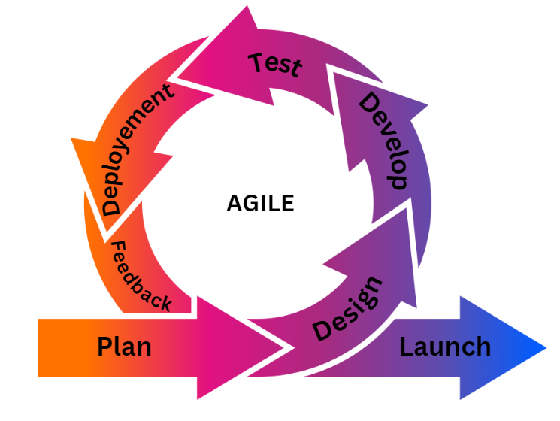

Figure 3.1 Agile SDLC Model

Figure 3.1 features a diagram for the Agile SDLC model. The researchers will follow the agile SDLC model in order to ensure the effective development and continuous improvement of AudiLearn.

Plan – In the planning phase, the researchers will define the project’s objectives as well as gather the information needed for the research and development of AudiLearn through interview and survey. A preliminary list of features will be created in this phase.

Design – In the designing phase, the researchers will conceptualize the overall design of the web application such as the user interface of the web application as well as set up the development environment and tools needed for the development of the web application, AudiLearn.

Develop – In the development phase, this is where the development and coding of the web application takes place. The features and functions of AudiLearn will be developed.

Testing – In the testing phase, AudiLearn will be continuously tested and troubleshooting will be done in order to ensure it is free of bugs and the features work as intended.

Deploy – In the deployment phase, the web application has met the standards necessary for it to be ready to be released and be used by the users. Continuous monitoring of the system will be done once it is deployed.

Review – In the review phase, the researchers will be gathering feedback from the users in order to improve the system and to know if it is working as intended for the users.

**Data Gathering Instrument**

The researchers will conduct an interview to the law students of UBLC in order to get insights on how auditory learning and studying will be beneficial to them. A survey questionnaire will be used as the main instrument for data collection for the study. The questionnaire will include close-ended questions. The close-ended questions will be used as data to be measured and analyzed in this study. Interview questions will be asked to law students of UBLC in order to get more in-depth information.

**Data Gathering Procedure**

Since the study will make use of a quantitative descriptive research design, a survey will be needed to gather data in order to know the target respondents’ demographics, preference towards audio-based learning, and the potential use of AudiLearn as an alternative or supplementary educational tool in studying, and recommending the use of AudiLearn. The quantitative method will be used in order to analyze and measure the data collected from the survey.

The researchers made an authorization letter in order to conduct a study at the College of Law in UBLC. The authorization letter was then signed by dean of the College of Information Technology, Entertainment, and Communication and the program head of the information technology program. The letter was then presented to the secretary of the College of Law and later approved the study.

The researchers will conduct a survey in order to gather data necessary for the research. The questionnaires will be distributed via Google Forms and paper questionnaires. Responses will be collected and compiled by Google Forms and manual counting from the paper questionnaires. The target respondents are law students of UBLC. Researchers will then analyze and interpret the data collected in order to obtain a clear picture of the general trends and preferences among the law students. Interview questions will be asked to select law students of UBLC in order to gather insights of their preference and understanding in auditory learning.

The researchers will use ISO 9126 software evaluation in order to know if AudiLearn meets the standard software quality as it provides comprehensive evaluation. For the ISO 9126 software evaluation, the researchers will use the standard questionnaires based on the ISO 9126 software evaluation. The researchers will conduct a survey in order to gather data. The questionnaires will be distributed via Google Forms and paper questionnaires.

**Technical Background (Hardware and Software Requirements)**

The study will feature law lessons that can be listened to, voice command for navigating the pages, and convert digital text files to audio format files. This will help law students in their studies who want to listen to the lessons from their lessons. The web application, AudiLearn, will use web technologies in developing a web application such as HTML which is a markup language and the integration of text-to-speech and speech-to-text technology into the web application.

Hardware: Computer devices with access to the internet and an internet browser.

Software: The web application will be developed using HTML, CSS, JavaScript, Python using Flask Framework, MongoDB database, and Text-to-Speech services.

|  |  |
| --- | --- |
| **Requirement** | **Specification** |
| PC/Desktop | * Processor Intel Core i3 or Higher * 4GB of RAM or Higher * Sufficient Storage Space * microphone |
| Smartphone (Android/IOS) | * Any modern smartphone with browser and internet connection * Sufficient Storage Space * Microphone |

Table 3.1 Hardware Requirements

Table 3.1 shows the hardware requirements needed to run the web application. Any modern computer or smartphone with a browser and access to the internet can access the system. An optional hardware requirement of a microphone can be used to use the voice command features of the web application.

|  |  |
| --- | --- |
| **Requirement** | **Specification** |
| Operating System | Windows 10/11, macOS 11.0 or later |
| Integrated Development Environment | Visual Studio Code, PyCharm |
| Programming Language | HTML, CSS, Javascript, Python |
| Database | MongoDB Database |

Table 3.2 Software Requirements

Table 3.2 shows the software requirements needed to run the web application and to develop the web application. Windows 10 or 11 is the most sufficient operating system in order for a smooth usage of the web application.

**ISO 9126 Software Evaluation**

The web application, AudiLearn, will be evaluated using the ISO 9126 model which ensures the quality of the software products. The web application will be rated based on: Functionality, Usability, Reliability, Efficiency, Portability, and Maintainability.

Functionality: The web application will be tested and evaluated based on its ability to perform its intended functions and features.

Reliability: The web application will be tested and evaluated based on its consistency and performance with minimal or without errors or bugs.

Usability: The web application will be tested and evaluated based on usability, accessibility and user-friendliness of its user interface in order to enhance the user-experience of the users.

Efficiency: The web application will be tested and evaluated based on its performance in terms of response time and resource usage in order to make sure it runs efficiently and quickly without taking up much resource from the device.

Maintainability: The web application will be tested and evaluated based on how errors are fixed quickly and maintain and improve its functionalities and features.

Portability: The web application will be tested and evaluated based on how it will run on a variety of devices that can run web browsers.

**CHAPTER 4**

**Analysis and Presentation of Data**

This chapter presents the analysis and presentation of the gathered data by the researchers for the development of the proposed web application, “AudiLearn.” This chapter will show the flowchart, entity-relationship diagram, data flow diagram, features, and the screenshots of the web application.

**Conceptual Framework**

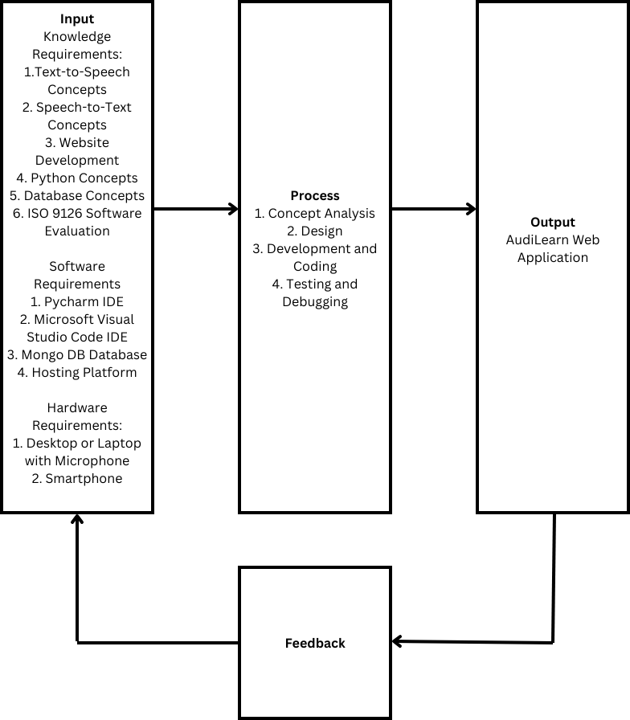

Figure 4.1 Conceptual Framework

Figure 4.1 shows the Conceptual Framework Diagram of how the proposed web application will be developed. This diagram shows the importance of the acquirement of knowledge requirements and researching about the various software and hardware requirements needed to develop the web application. The process of creating the web application starts from analyzing the different concepts. Next is the application design where the overall design of the proposed application such as the user interface of the web application as well as the setup of the development environment and tools. Next is the development where the researchers start coding. Lastly, testing and debugging in order to ensure the web application runs smooth without much error. After the process, the output will be the proposed web application and will be evaluated for feedback and suggesting in case of errors and bugs as well as the overall improvement of the web application.

**Flowchart**

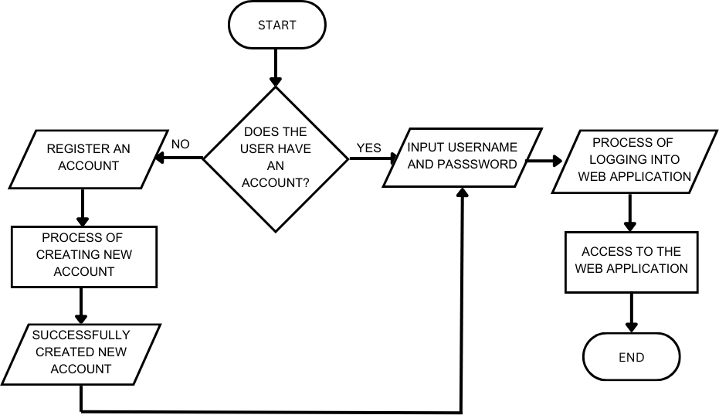

Figure 4.2 Flowchart of AudiLearn Login

Figure 4.2 Shows the creation of new account and login feature of AudiLearn. It starts with determining if the user logging has an already existing account or not. If not, the user must create a new account first and enter account details needed to create an application. The user must then log in using username and password to access the AudiLearn.

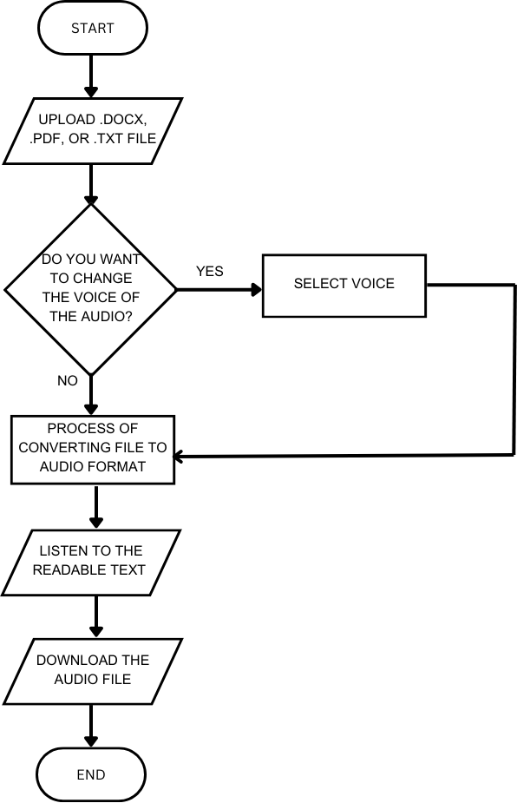

Figure 4.3 Flowchart of AudiLearn File Conversion

Figure 4.3 shows the process of converting the digital text files to audio format. The user will have to upload first the digital text file into the web application. The user will then be able to choose a voice of their choosing of the audio. After converting, the user will then be able to download the audio file and listen to the readable text within the web application.

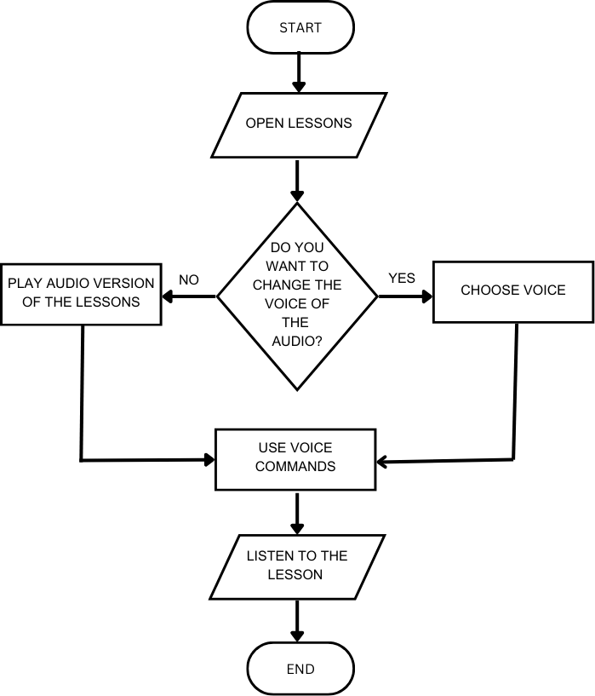

Figure 4.4 Flowchart of AudiLearn Audio Lesson

Figure 4.4 shows the feature of AudiLearn that enables the user to listen to lessons. The user will be able to choose from different voices and use voice commands to navigate the lesson such as start, pause, and go to next page.

**Entity-Relationship Diagram**

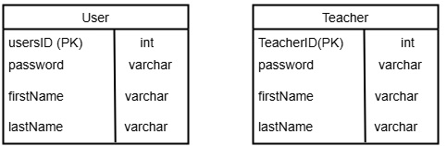

Figure 4.5 Entity-Relationship Diagram of AudiLearn

Figure 4.5 shows the entity-relationship diagram of the database of AudiLearn. This shows different types of entities and the relationships of AudiLearn as well as the different attributes and its types.

**Data Flow Diagram**

Level 0 Diagram

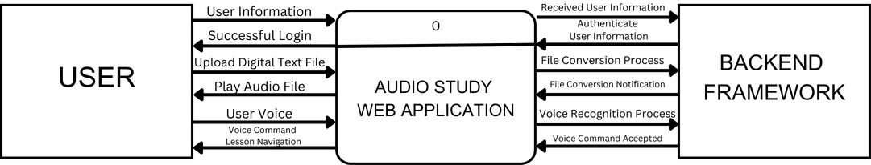

Figure 4.6 Level 0 Data Flow Diagram of AudiLearn

Figure 4.6 shows the level 0 data flow diagram of AudiLearn. The user will provide information in order to authenticate and login the web application. The user can upload digital text files such as pdf, docx, and txt files and the web application will convert those files to audio format. Lastly, the user can use their voice and the web application will capture the voice data and then it will be processed by the web application as a voice recognition command in navigating the audio lesson.

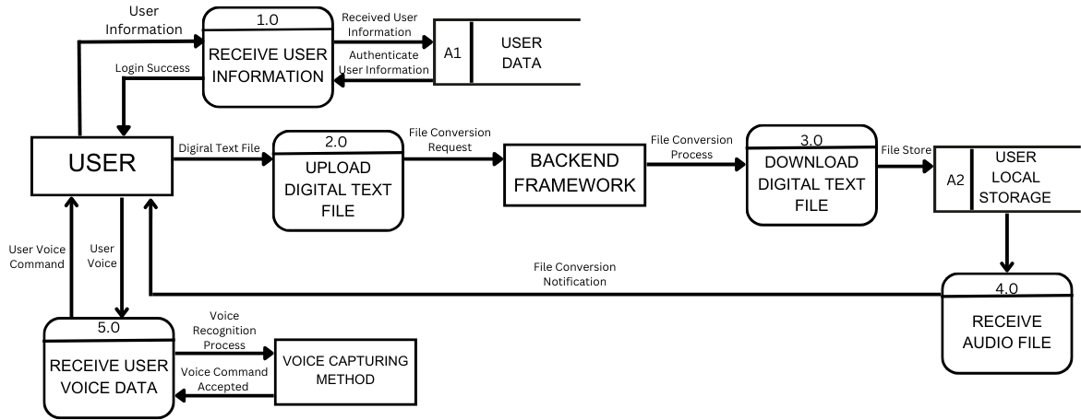Level 1 Data Flow Diagram

Figure 4.7 Level 1 Data Flow Diagram of AudiLearn

Figure 4.7 shows the level 1 data flow diagram of AudiLearn. This shows the additional processes, entities, and data stores necessary for the flow of data in the web application. The user must provide the information necessary to login to AudiLearn. The user can then upload digital text files and it will be processed and will be stored in the user’s local storage. Lastly, the web application can use the user’s voice for processing command for the voice recognition feature.

**Survey Results**

The survey had a total 33 respondents. The respondents consisted of law students from University of Batangas – Lipa City in different year levels.

The following were undertaken during the survey.

1. The researchers asked for permission at the College of Law at UBLC to conduct a survey for the research.

2. The survey questionnaire was distributed via Google Forms or paper questionnaire.

3. The researchers asked the respondents to answer the survey questionnaire via Google Forms or paper questionnaire.

4. The researchers tabulated and computed the data gathered from the survey questionnaire using appropriate statistical procedures.

5. The researchers interpreted the results using the equivalent descriptive rating.

**Part 1: Demographic**

|  |  |  |
| --- | --- | --- |
| Age | Number of Respondents | Percentage of Respondents |
| 21-25 years old | 13 | 39.39% |
| 26-30 years old | 12 | 36.46% |
| 31-35 years old | 5 | 15.15% |
| 36-40 years old | 2 | 6.06% |
| 40 years old and above | 1 | 3.03% |

Table 4.1 Age of Respondents

Table 4.1 shows the age of the respondents. Majority of the respondents are between the age 21-25 and 26-30 age groups.

|  |  |  |
| --- | --- | --- |
| Sex | Number of Respondents | Percentage of Respondents |
| Male | 10 | 30.30% |
| Female | 23 | 69.70% |

Table 4.2 Sex of the Respondents

Table 4.2 shows the sex of the respondents. Majority of the respondents are female.

|  |  |  |
| --- | --- | --- |
| Year Level | Number of Respondents | Percentage of Respondents |
| 1st Year | 19 | 57.58% |
| 2nd Year | 4 | 12.12% |
| 3rd Year | 6 | 18.18% |
| 4th Year | 4 | 12.12% |

Table 4.3 Year Level of the Respondent

Table 4.3 shows the year level of the respondents. Most of the respondents are 1st year while 2nd and 3rd year are the least of the respondents.

|  |  |  |
| --- | --- | --- |
| How do you prefer to study for your law subjects? | Number of Respondents | Percentage of Respondents |
| Reading textbooks or case materials | 15 | 45.45% |
| Listening to class lectures | 11 | 33.33% |
| Listening to audio materials, or recorded discussions | 6 | 18.18% |
| Participating in study groups | 1 | 3.03% |

Table 4.4 Preference of Law Students in Studying Law Subjects

Table 4.4 shows the preference of law students in studying law subjects. Most law students prefer reading textbooks or case materials when studying law subjects. Participating in study groups is the least preferred by law students.

|  |  |  |
| --- | --- | --- |
| How often do you use audio-based learning tools for studying law subjects? | Number of Respondents | Percentage of Respondents |
| Always | 3 | 9.09% |
| Often | 6 | 18.18% |
| Sometimes | 11 | 33.33% |
| Rarely | 10 | 30.30% |
| Never | 3 | 9.09% |

Table 4.5 Frequency of Using Audio Learning Tools for Studying Law Subjects

Table 4.5 shows the frequency of using audio-based learning tools for studying law subjects. “Sometimes” is the frequency most answered by the respondents followed by “Rarely”.

**Part 2: Preference Towards Audio-based Learning**

Numerical Rating Rating Interpretation

1 Strongly Disagree

2 Disagree

3 Neither Agree nor Disagree

4 Agree

5 Strongly Agree

|  |  |  |  |  |  |  |  |  |  |  |
| --- | --- | --- | --- | --- | --- | --- | --- | --- | --- | --- |
| Questions | 1 | 2 | 3 | 4 | 5 | % of 1 | % of 2 | % of 3 | % of 4 | % of 5 |
| I believe that audio-based learning can significantly improve my study habits. | 1 | 2 | 9 | 11 | 10 | 3.03% | 6.06% | 27.27% | 33.33% | 30.30% |
| I believe that normal text-based learning is sufficient for my legal studies. | 0 | 4 | 7 | 12 | 10 | 0% | 12.12% | 21.21% | 36.36% | 30.30% |
| I have trouble remembering information acquired from learning materials that are primarily written in text. | 6 | 8 | 11 | 7 | 1 | 18.18% | 24.24% | 33.33% | 21.21% | 3.03% |
| Using an application that converts texts into audio would save time in studying. | 2 | 5 | 8 | 11 | 7 | 6.06% | 15.15% | 24.24% | 33.33% | 21.21% |
| I prefer listening to lectures or recorded discussions over reading. | 4 | 7 | 8 | 10 | 4 | 12.12% | 21.21% | 24.24% | 30.30% | 12.12% |
| A combination of reading lessons and listening to audio-based lessons will allow me to improve my studies. | 1 | 1 | 5 | 11 | 15 | 3.03% | 3.03% | 15.15% | 33.33% | 45.45% |
| An application that converts text to audio would make studying more tolerable. | 2 | 4 | 6 | 12 | 9 | 6.06% | 12.12% | 18.18% | 36.36% | 27.27% |
| Listening to audio lessons allows me to multitask more effectively while studying. | 2 | 2 | 7 | 14 | 8 | 6.06% | 6.06% | 21.21% | 42.42% | 24.24% |
| Listening to audio-based law book that has voice recognition commands for traversing pages will allow me to study more efficiently. | 2 | 5 | 6 | 13 | 7 | 6.06% | 15.15% | 18.18% | 39.39% | 21.21% |
| Audio-based learning will help me better retain legal concepts and principles. | 2 | 4 | 11 | 10 | 6 | 6.06% | 12.12% | 33.33% | 30.30% | 18.18% |
| I feel confident that using audio-based learning tools will improve my exam performance. | 2 | 4 | 10 | 12 | 5 | 6.06% | 12.12% | 30.30% | 36.36% | 15.15% |

|  |  |  |  |  |  |  |  |  |  |  |
| --- | --- | --- | --- | --- | --- | --- | --- | --- | --- | --- |
| Audio-based learning tools will help me focus better during long study sessions. | 3 | 5 | 7 | 13 | 5 | 9.09% | 15.15% | 21.21% | 39.39% | 15.15% |

Table 4.6 Preferences of Law Students Towards Audio-based Learning

Table 4.6 shows the different preferences of law students in audio-based or auditory learning. The results show that law students has inclination towards auditory learning but not entirely replacing the text-based approach.

**Part 3: Potential Use of AudiLearn as an Alternative or Supplementary Educational Tool in Studying**

|  |  |  |  |  |
| --- | --- | --- | --- | --- |
| Question | Yes | No | % of Yes | % of No |
| Do you want to use a web application that helps in audio-based studying? | 26 | 7 | 78.79% | 21.21% |
| Do you believe **AudiLearn** will be helpful for law students in studying? | 29 | 4 | 87.88% | 12.12% |
| Do you think using **AudiLearn** could improve your overall study performance? | 27 | 6 | 81.82% | 18.18% |
| Do you believe integrating **AudiLearn** into your study routine will have its educational benefits? | 29 | 4 | 87.88% | 12.12% |
| Do you think **AudiLearn** would be more effective for auditory learners compared to traditional text-based study methods? | 25 | 8 | 75.76% | 24.24% |
| Would you use **AudiLearn** to supplement or support your reading of textbooks and case materials? | 28 | 5 | 84.85% | 15.15% |
| Would you prefer using **AudiLearn** over reading legal textbooks and case materials when studying? | 14 | 19 | 42.42% | 57.58% |
| Would you use **AudiLearn** while commuting or multitasking? | 25 | 8 | 75.76% | 24.24% |

Table 4.7 Use of AudiLearn as an Alternative or Supplementary Educational Tool in Studying

Table 4.7 shows the results of the potential use of AudiLearn as an alternative in studying law. The results show that AudiLearn has the potential to be used by law students as a supplement in their current study routine in addition to their current studying and learning methods in studying law.

**Part 4: Recommending the use of AudiLearn**

|  |  |  |  |  |  |  |  |  |  |  |
| --- | --- | --- | --- | --- | --- | --- | --- | --- | --- | --- |
| Questions | 1 | 2 | 3 | 4 | 5 | % of 1 | % of 2 | % of 3 | % of 4 | % of 5 |
| Would you potentially recommend the use of Audio Study to your fellow law students? | 0 | 0 | 9 | 15 | 9 | 0% | 0% | 27.27% | 45.45% | 27.27% |
| Are the questions asked in this survey necessary for the development of Audio Study? | 0 | 1 | 3 | 13 | 16 | 0% | 3.03% | 9.09% | 39.39% | 48.48% |
| How would you rate this survey? | 0 | 1 | 2 | 8 | 22 | 0% | 3.03% | 6.06% | 24.24% | 66.67% |

Table 4.8 AudiLearn Recommendation

Table 4.8 shows that the law students will recommend AudiLearn to other law students. The questions asked in the survey are essential to the development of AudiLearn.

**ISO 9126 Software Evaluation Survey Results**

The survey had a total of X respondents.

The following were undertaken during the ISO 9126 Software Evaluation:

1. The web application is presented and demonstrated to the respondents before the testing.

2. The features are explained to the respondents before the testing.

3. The respondents tested the web application.

4. The researchers asked the respondents to answer the ISO 9126 Software Evaluation Survey via paper questionnaires.

5. The researchers tabulated and computed the data gathered from the survey questionnaire using appropriate statistical procedures.

6. The researchers interpreted the results using the equivalent descriptive rating.

Numerical Rating Rating Interpretation

1 Poor

2 Fair

3 Good

4 Very Good

5 Excellent

Getting the weighted mean:



**X** = weighted mean

**X** = frequency

**W** =weight

|  |  |  |  |  |  |  |  |  |  |
| --- | --- | --- | --- | --- | --- | --- | --- | --- | --- |
| **CRITERIA** | **RATING** | | | | | **Weighted Mean** | | **Equivalent Interpretation** | |
| **A. Functionality** | **1** | **2** | **3** | **4** | **5** |  | | | |
| 1. Suitability. Software performs the tasks required. | 0 | 1 | 0 | 10 | 9 | 4.35 | | Very Good | |
| 2. Accurateness. The result is as expected. | 0 | 1 | 2 | 7 | 10 | 4.30 | | Very Good | |
| 3. Interoperability. System interacts with other systems. | 0 | 1 | 2 | 10 | 7 | 4.15 | | Very Good | |
| 4. Security. Software prevents unauthorized access. | 0 | 1 | 4 | 6 | 9 | 4.15 | | Very Good | |
| **B. Usability** | | | | | | | | | | |
| 1. Understandability. The software is easy to use | 1 | 0 | 3 | 9 | 7 | 4.05 | | Very Good | |
| 2. Learnability. The system is easily learned. | 1 | 0 | 1 | 7 | 11 | 4.35 | | Very Good | |
| 3. Operability. The system is used without much effort. | 0 | 1 | 1 | 7 | 11 | 4.40 | | Very Good | |
| 4. Attractiveness. GUI interface looks good. | 0 | 1 | 5 | 6 | 8 | 4.05 | | Very Good | |
| **C. Reliability** | | | | | | | | | | |
| 1. Maturity. Most of the faults in the software been eliminated over time. | 0 | 3 | 3 | 7 | 7 | 3.90 | | Good | |
| 2. Fault Tolerance. Software handles errors. | 0 | 2 | 3 | 10 | 5 | 3.90 | | Good | |
| 3. Recoverability. Software resumes working and restores lost data | 0 | 1 | 5 | 9 | 5 | 3.90 | | Good | |
| **D. Efficiency** | | | | | | | | | | |
| 1. Time Behavior. The system responds quickly. | 0 | 1 | 2 | 12 | 5 | 4.05 | | Very Good | |
| 2. Resource Utilization. System utilizes resources efficiently. | 1 | 0 | 4 | 6 | 9 | 4.10 | | Very Good | |
| **E. Portability** | | | | | | | | | | |
| 1. Adaptability. The software can be moved to other environments. | 0 | 1 | 6 | 6 | 7 | 3.95 | | Good | |
| 2. Installability. The software is installed easily. | 0 | 2 | 5 | 5 | 8 | 3.95 | | Good | |
| 3. Conformance. The software complies with portability standards. | 0 | 1 | 1 | 12 | 6 | 4.15 | | Very Good | |
| 4. Replaceability. The software is easily replaced with other software. | 3 | 2 | 5 | 5 | 5 | 3.35 | | Good | |
| **F. Maintainability** | | | | | | | | | | |
| 1. Analyzability. Faults are easily diagnosed. | 0 | 1 | 5 | 9 | 5 | 3.90 | | Good | |
| 2. Changeability. The software is easily modified. | 0 | 1 | 5 | 7 | 7 | 4.00 | | Very Good | |
| 3. Stability. The software continues to function if changes are made. | 0 | 2 | 4 | 6 | 8 | 4.00 | | Very Good | |
| 4. Testability. The software is tested easily. | 0 | 1 | 4 | 3 | 12 | 4.30 | | Very Good | |
| *OVERALL* | | | | | | | **4.06** | | **Very Good** | |

Table 4.9 Results of ISO 9126 Software Evaluation

Table 4.9 shows the result of ISO 9126 Software Evaluation survey. The web application, AudiLearn, got an overall of 4.06 which is a “Very Good” based on the equivalent interpretation. This result indicates that AudiLearn meets the standard quality of the ISO 9126 software evaluation.

|  |  |  |  |
| --- | --- | --- | --- |
| Fault | Possible Cause | Fault Tolerance | Solution |
| No Voice Input Detected | Faulty microphone or user did not speak | Microphone timeout if no voice input detected | Check if microphone is faulty or use button command instead |
| Unsupported Voice Command | Command not recognized by the system | Detect unrecognized voice commands | Display list of available voice commands and inform the user that the voice command is not available |
| Voice Command Misrecognition | Background noise and unclear user voice input | Detect and notify user with the incorrect voice input | Prompt user to repeat voice command. Use of earphone is recommended. |
| Slow or No Internet Connection | Slow server response or connection failure | Monitor response time and retry failed processes | Connect to the internet and retry the voice command |
| Multiple Commands Given | User issues overlapping voice commands | Detect Overlapping Commands | Let the web application process and execute the voice command before issuing another one. |

Table 4.10 Voice Command Fault Tolerance Table

Table 4.10 shows the fallowing faults tolerance during the voice recognition. It shows the how the voice command was tested for the following faults and the possible solutions.

**Features and Screenshots of AudiLearn**

Screenshots and features to be followed.

**CHAPTER 5**

**Summary, Findings, Conclusion and Recommendation**

This chapter presents summary, findings, conclusion and recommendation of the capstone research titled “AudiLearn: A Web-based Interactive Auditory Learning Platform for Law Students of UBLC”.

**Summary**

The capstone research titled “AudiLearn: A Web-based Interactive Auditory Learning Platform for Law Students of UBLC” aims to help law students of University of Batangas – Lipa City in their studies and learning by offering an audio-based learning web application.

The researchers used quantitative descriptive in order to gather information about the use of audio-based learning and preferences of learning of law students at the University of Batangas – Lipa City Campus. The researchers made use of survey and interview in order to gather data for the study. The researchers used the agile model to develop AudiLearn.

The researchers analyzed the data that were collected during the duration of the capstone research for the development of AudiLearn and assess auditory learning and how it helps law students in their studies. There were 33 respondents that answered the survey consisting of law students from University of Batangas – Lipa City. Survey questionnaire via Google Forms and paper questionnaires were used as data gathering instruments. The percentage of each answer were computed in order to interpret the data of the survey.

**Findings**

The result of the survey determined that the law students of UBLC has different preferences in audio-based or auditory learning. Most law students prefer using text-based approach in their studies but are willing to use other platforms that can support them in their studies. The results show that law students has inclination towards auditory learning but not entirely replacing the text-based approach. The results show that AudiLearn has the potential to be used by law students as a supplement in their studies.

The interview to the law students provided the researchers with insights on how law students tackle their studies. Law students primarily use law books and cases in regards to their studies as well as having an efficient time management to understand the cases. Law students use auditory learning tools when they cannot understand deeper concepts or terms in their studies. Some use other audio-based learning tools concurrently while reading books or cases to better retain the information when studying. Law students biggest challenge when reading large amount of texts from books and cases is that it can become boring and frustrating especially when they are trying to catch up in their studies. Law students suggested that auditory learning tools or platforms may help in lessening the processing of information and help them to understand the information much better. Some law students use auditory learning tools or platforms once or twice a month while others use it once a week.

**Conclusion**

The capstone research has achieved its main objective in developing a web application that helps the learning and studying of law students of University of Batangas – Lipa City. The researchers developed the web application, AudiLearn, using the Agile method.

After the completion of the web application, AudiLearn, and from the data gathered from the results of the survey and interview, the researchers have reached the following conclusions:

1. The web application, AudiLearn, is not a substitute or replacement to current text-based books or lessons used by law students.

2. Law students prefer using AudiLearn as a supplement to their current study methods.

3. The conceptual framework, Entity-Relationship Diagram, Data Flow Diagram, and Flowchart of the web application has been successfully used to design and develop the web application.

4. Using Python Flask framework, HTML, CSS, and JavaScript, the researchers were able to fully implement the core features of AudiLearn using text-to-speech technology, voice recognition, and converting digital text files to audio format.

a. Read and Listen to auditory law lessons

b. Use of voice commands in lessons

c. Choose a voice when listening to the law lesson

d. Place a bookmark to the lesson

e. Convert digital text file such as docx, pdf, and txt to audio format

f. Listen to the converted digital text file

5. The web application has successfully met the objectives of the capstone research.

**Recommendations:**

Upon completing the study and the web application, AudiLearn, the researchers can recommend the following:

1. Expanding the conversion feature to support other file formats for wider accessibility.

2. Exploring other technologies used in web development and text-to-speech technology that will greatly enhance the current features in the future.

3. To fully implement AudiLearn to different college programs that will tailor to other learners.

**APPENDICES**

**References**

**Article:**

* Gupta, P., (2023, March 24). What is Auditory Learning (Audio Based Learning)? *EdTechReview*. <https://www.edtechreview.in/dictionary/what-is-auditory-learning/>
* University of Memphis. (2017). *Critical reading for law students: Strategies for success*. University of Memphis.<https://www.memphis.edu/law/student-affairs/criticalreadingforlawstudents2017r.pdf>
* Olamilekan, R. Q., Oduroye, A., & Akanni, A. (2024b). VOICE RECOGNITION SYSTEM. *ResearchGate.*

<https://www.researchgate.net/publication/379890958_VOICE_RECOGNITION_SYSTEM>

**Journal:**

* Locke, K., Ellis, K., & Wolf, K. (2024). Auditory learner. *M/C Journal, 27*(2). <https://doi.org/10.5204/mcj.3029>
* Enns, T. L., & Smith, M. (2015). Take a (cognitive) load off: Creating space to allow first-year legal writing students to focus on analytical and writing processes*. Journal of Legal Writing Institute, 20(1)*, 109-130.
* Magulod, G. C. (2019). Learning styles, study habits and academic performance of Filipino University students in applied science courses: Implications for instruction. *Journal of Technology and Science Education*, *9*(2), 184. <https://doi.org/10.3926/jotse.504>
* Situmorang, S., & Panggabean, J. F. (2021). Design and Development of Video and Audio File Converter Applications. *Jurnal ICT: Information and Communication Technologies*, *12*(2), 8-12.
* Poojary, N. R., & Ashish, K. H. (2023). Text To Speech with Custom Voice. *International Journal for Research in Applied Science and Engineering Technology*, *11*(4), 4523–4530. <https://doi.org/10.22214/ijraset.2023.51217>
* Trivedi, A., Pant, N., Shah, P., Sonik, S., & Agrawal, S. (2018). Speech to text and text to speech recognition systems-Areview. *IOSR J. Comput. Eng*, *20*(2), 36-43.
* Lazaro, L. R. S., Policarpio, L. L., & Guevara, R. C. L. (2009, October). Incorporating duration and intonation models in Filipino speech synthesis. In *Proceedings: APSIPA ASC 2009: Asia-Pacific Signal and Information Processing Association, 2009 Annual Summit and Conference* (pp. 45-49). Asia-Pacific Signal and Information Processing Association, 2009 Annual Summit and Conference, International Organizing Committee.
* Esmeria, G. J., & Seva, R. R. (2017, June). Web usability: a literature review. In *DLSU research congress*.
* Esteban, A. P. (2023). *Web engineering and E-Commerce: Bridging Technology and Business in the Philippines*. Nueva Ecija University of Science and Technology.
* Wood, S. G., Moxley, J. H., Tighe, E. L., & Wagner, R. K. (2018). Does use of text-to-speech and related read-aloud tools improve reading comprehension for students with reading disabilities? A meta-analysis. *Journal of learning disabilities*, *51*(1), 73-84.
* Craig, S. D., & Schroeder, N. L. (2019). Text-to-speech software and learning: Investigating the relevancy of the voice effect. *Journal of Educational Computing Research*, *57*(6), 1534-1548.
* Pillai, B., & Kumar, A. *Listenapp: An AI-Based Mobile Application Platform for Auditory Learning* (Doctoral dissertation, Toronto Metropolitan University).
* Biktimirov Andrey R., & Gruzdev Dmitry Yu. (2022). BOOSTING SPEECH-TO-TEXT SOFTWARE POTENTIAL. Научный результат. Вопросы теоретической и прикладной лингвистики, 8 (4), 72-89.
* Carter, D. J., Vogl, A., Methven, E., & Billington, L. (2022). Electronic audio feedback in legal education. *Legal Education Review*, 32, 161-181.
* Keelor, J. L., Creaghead, N., Silbert, N., & Horowitz-Kraus, T. (2020). Text-to-speech technology: Enhancing reading comprehension for students with reading difficulty. *Assistive Technology Outcomes & Benefits*, 14(1), 19-35.

**Thesis:**

* Oberembt, M. (2019). The effects of text-to-speech on students with reading disabilities.
* Dai, L., Kritskaia, V., van der Velden, E., Jung, M. M., Postma, M., & Louwerse, M. M. (2022, November). Evaluating the usage of Text-To-Speech in K12 education. In *Proceedings of the 2022 6th International Conference on Education and E-Learning* (pp. 182-188).
* POMINTEL, L. M. B. (2023). ADOPTING AUDIO-BASED LANGUAGE LEARNING IN ELEVATING THE READING SKILLS OF GRADE 9 STUDENTS. *ADOPTING AUDIO-BASED LANGUAGE LEARNING IN ELEVATING THE READING SKILLS OF GRADE 9 STUDENTS*, *124*(1), 11-11.
* RODA JR, A. A. (2023). Use of Podcast Intervention in Enriching the Learning of Senior High School Students in Filipino Subject. *Use of Podcast Intervention in Enriching the Learning of Senior High School Students in Filipino Subject*, *121*(1), 7-7.
* Joquino, C. H., Esguerra, S. M., Helera, A. I., Saguinsin, N. S. M., Sombillo, J. J. C., & Sabado, R. D. (2024). Podcasts as supplementary tools in enhancing teaching-learning in the 21st century literature from the Philippines and the world. *International Journal of Science and Research Archive*, *11*(2), 1435-1439.
* Magbanua, J.M., Emata, K.M., Aquino, C., Padayhag, H., Sonny, R., Tan, F., (2023). Audio Books as Motivation in the Listening Comprehension Among Grade 3 Learners. *Psychology and Education: A Multidisciplinary Journal, 15*(9), 974-980. <https://doi.org/10.5281/zenodo.10427962>
* Garcia, A. B., Rojo, J. N. N., & NAMOCO JR, C. S. (2015). A bisaya text-to-speech (TTS) system utilizing rulebased algorithm and concatenative speech synthesis. *European Academic Research*, *2*(10), 12997-13012.
* Belgrove, M. (2009). Legal Speak: Observations on the use of audio in teaching law. In Nunes, M.B. & McPherson, M. (Eds.), Proceedings of the IADIS International Conference E-Learning 2009 Portugal, June 17-20 (Vols. 2–2, pp. 245–248). IADIS Press. <http://www.iadisportal.org>

**Book:**

* Alarifi, I. M. (2023). *Learning limitless knowledge: Transformative Learning Pathway to Unlocking and Harnessing the Endless Power of Knowledge*. Balboa Press.
* Fries, B., & Fries, M. (2005). *Digital Audio Essentials*. O’Reilly Media Inc.

**Educational Blog:**

* Sheldon, R. (2023, October 31). *app*. Mobile Computing. <https://www.techtarget.com/searchmobilecomputing/definition/app#:~:text=App%20is%20an%20abbreviated%20form,cases%2C%20for%20another%20software%20program>.
* *Audio Format*. (2023, June 14). GeeksForGeeks. <https://www.geeksforgeeks.org/audio-format/>
* *Auditory Learning Style Explained*. (2020b, August 10). Western Governors University.<https://www.wgu.edu/blog/2020/08/auditory-learning-style.html#:~:text=What%20is%20auditory%20learning%3F,figuring%20it%20out%20hands-on>.
* Spivak, E. (2023, October 20). *CSS (Cascading Style Sheets) wix-encyclopedia*. <https://www.wix.com/encyclopedia/definition/cascading-style-sheets-css>
* Lutkevich, B. (2020, February 17). *HTML (Hypertext Markup Language)*. TheServerSide.com. <https://www.theserverside.com/definition/HTML-Hypertext-Markup-Language>
* UXtweak. (2023, August 11). *ISO 9126 | UX Glossary | UXTweak*. Guides - Learn User Testing & UX Research | UXtweak. <https://www.uxtweak.com/ux-glossary/iso-9126/>
* GeeksforGeeks. (2024e, June 9). *What is JavaScript ?* GeeksforGeeks. <https://www.geeksforgeeks.org/what-is-javascript/?ref=lbp>
* *What does PDF mean?* (n.d.). Adobe. Retrieved August 4, 2024, from <https://www.adobe.com/acrobat/about-adobe-pdf.html>
* GeeksforGeeks. (2024e, September 12). *What is Python? Its Uses and Applications*. GeeksforGeeks. <https://www.geeksforgeeks.org/what-is-python/>
* *Text-to-Speech Basics: What Is TTS and Who Uses It?* (2023, April 19). CourseArc.<https://www.coursearc.com/guest-post-readspeaker-text-to-speech/>
* Gillis, A. S. (2024, August 28). *What is voice recognition and how does it work? Search Customer Experience*. <https://www.techtarget.com/searchcustomerexperience/definition/voice-recognition-speaker-recognition>
* GeeksforGeeks. (2024, January 12). *What is Web App?* GeeksforGeeks. <https://www.geeksforgeeks.org/what-is-web-app/>

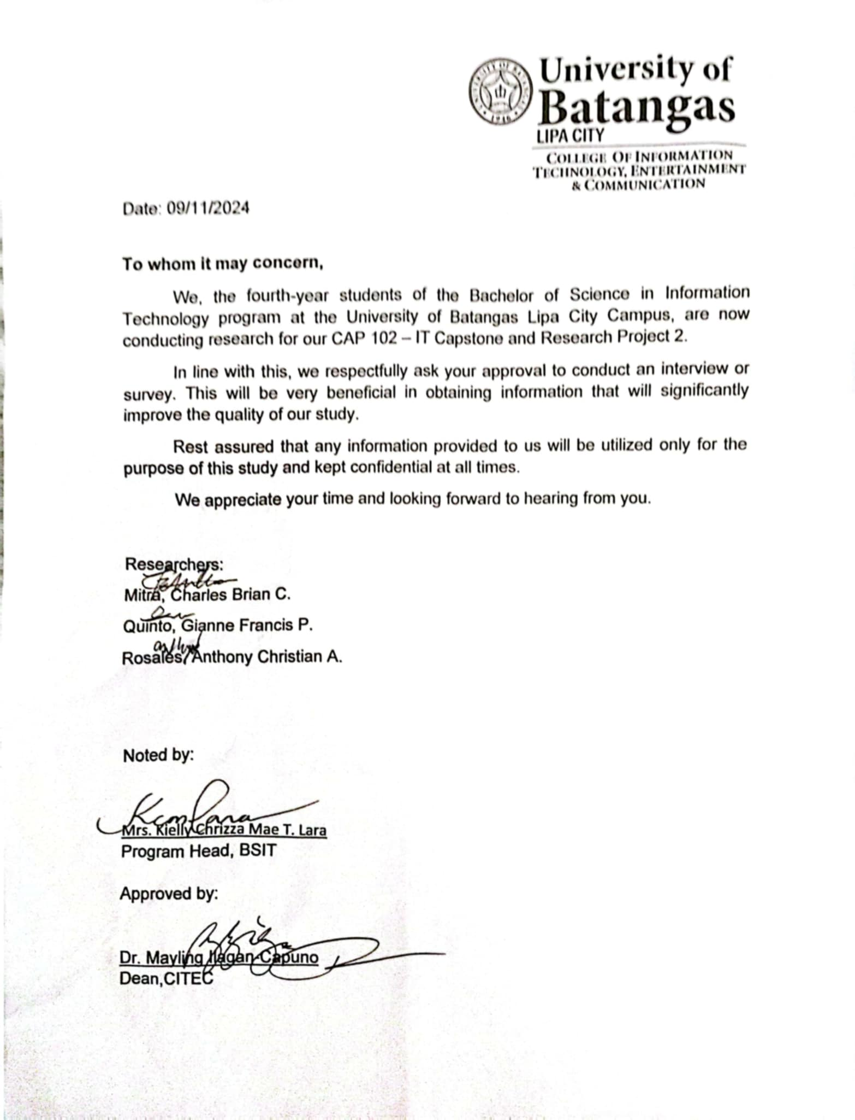**Interview and Survey Letter**

**Survey Questionnaire**

This is the survey questionnaire for the capstone research from the 4th year students of the CITEC department titled "AudiLearn: A Web-based Interactive Auditory Learning Platform for Law Students of UBLC" The proposed web application, Audio Study, lets users convert digital text files such as.pdf,.docx, and.txt files to audio format and listen to audio-based versions of law books and lessons with the option of using voice commands for navigation and instruction. The results from this survey will greatly contribute to the research. The data gathered from this survey will be utilized only for the purpose of this research and will be kept confidential at all times. The researchers sincerely appreciate you taking the time to answer the survey questionnaire. Have a great day!

Members:

Mitra, Charles Brian C. 4th Year IT4A

Quinto, Gianne Francis P. 4th Year IT4A

Rosales, Anthony Christian A. 4th Year IT4A

Part 1: Demographic

**1. What is your age?**

21-25 26-30 31-35 36-40 40 and above

**2. What is your sex?**

Male Female

**3. What is your year level in school?**

First year Second Year Third Year Fourth Year

**4. How do you prefer to study for your law subjects? (One answer only)**

Reading textbooks or case materials

Listening to class lectures

Listening to audio materials, or recorded discussions

Participating in study groups

**5. How often do you use audio-based learning tools (e.g., audiobooks, recorded lectures, podcasts) for studying law subjects? (One answer only)**

Always Often Sometimes Rarely Never

Part 2:Preference Towards Audio-based Learning(Check the number of your choice)

* 1 (Strongly Disagree)
* 2 (Disagree)
* 3 (Neither Agree nor Disagree)
* 4 (Agree)
* 5 (Strongly Agree

|  |  |  |  |  |  |
| --- | --- | --- | --- | --- | --- |
| Questions | 1 | 2 | 3 | 4 | 5 |
| I believe that audio-based learning can significantly improve my study habits. |  |  |  |  |  |
| I believe that normal text-based learning is sufficient for my legal studies. |  |  |  |  |  |
| I have trouble remembering information acquired from learning materials that are primarily written in text. |  |  |  |  |  |
| Using an application that converts texts into audio would save time in studying. |  |  |  |  |  |
| I prefer listening to lectures or recorded discussions over reading. |  |  |  |  |  |
| A combination of reading lessons and listening to audio-based lessons will allow me to improve my studies. |  |  |  |  |  |
| An application that converts text to audio would make studying more tolerable. |  |  |  |  |  |
| Listening to audio lessons allows me to multitask more effectively while studying. |  |  |  |  |  |
| Listening to audio-based law book that has voice recognition commands for traversing pages will allow me to study more efficiently. |  |  |  |  |  |
| Audio-based learning will help me better retain legal concepts and principles. |  |  |  |  |  |
| I feel confident that using audio-based learning tools will improve my exam performance. |  |  |  |  |  |
| Audio-based learning tools will help me focus better during long study sessions. |  |  |  |  |  |

Part 3: Potential use of Audio Study as an alternative or supplementary educational tool in studying (Check the answer of your choice)

|  |  |  |
| --- | --- | --- |
| Question | Yes | No |
| Do you want to use a web application that helps in audio-based studying? |  |  |
| Do you believe AudiLearn will be helpful for law students in studying? |  |  |
| Do you think using AudiLearn could improve your overall study performance? |  |  |
| Do you believe integrating AudiLearn into your study routine will have its educational benefits? |  |  |
| Do you think AudiLearn would be more effective for auditory learners compared to traditional text-based study methods? |  |  |
| Would you use AudiLearn to supplement or support your reading of textbooks and case materials? |  |  |
| Would you prefer using AudiLearn over reading legal textbooks and case materials when studying? |  |  |
| Would you use AudiLearn while commuting or multitasking? |  |  |

Part 4: Recommending the use of Audio Study (Check the number of your choice)

|  |  |  |  |  |  |
| --- | --- | --- | --- | --- | --- |
| Question | 1 | 2 | 3 | 4 | 5 |
| Would you potentially recommend the use of AudiLearn to your fellow law students? |  |  |  |  |  |
| Are the questions asked in this survey necessary for the development of AudiLearn? |  |  |  |  |  |
| How would you rate this survey? |  |  |  |  |  |

**ISO 9126 Software Evaluation Survey Questionnaire**

This is the survey of ISO 9126 Software Evaluation for the capstone research from the 4th year students of the CITEC department titled "AudiLearn: A Web-based Interactive Auditory Learning Platform for Law Students of UBLC" The proposed web application, AudiLearn, lets users convert digital text files such as.pdf,.docx, and.txt files to audio format and listen to audio-based versions of lessons with the option of using voice commands for navigation and instruction. The results from this evaluation will greatly contribute to the research. The data gathered from this survey will be utilized only for the purpose of this research and will be kept confidential at all times. The researchers sincerely appreciate you taking the time to test and answer the evaluation questionnaire. Have a great day!

Members:

Mitra, Charles Brian C. 4th Year IT4A

Quinto, Gianne Francis P. 4th Year IT4A

Rosales, Anthony Christian A. 4th Year IT4A

Instructions: Please rate your evaluation of the project by checking on the column of your preferred assessment. Below are the numerical rating and its equivalent.

| 1 – Poor | 2 – Fair | 3 – Good | 4 - Very Good | 5 – Excellent |

|  |  |  |  |  |  |
| --- | --- | --- | --- | --- | --- |
| **CRITERIA** | **RATING** | | | | |
| **A. Functionality** | **1** | **2** | **3** | **4** | **5** |
| 1. Suitability. Software performs the tasks required. |  |  |  |  |  |
| 2. Accurateness. The result is as expected. |  |  |  |  |  |
| 3. Interoperability. System interacts with other systems. |  |  |  |  |  |
| 4. Security. Software prevents unauthorized access. |  |  |  |  |  |
| **B. Usability** | **1** | **2** | **3** | **4** | **5** |
| 1. Understandability. The software is easy to use |  |  |  |  |  |
| 2. Learnability. The system is easily learned. |  |  |  |  |  |
| 3. Operability. The system is used without much effort. |  |  |  |  |  |
| 4. Attractiveness. GUI interface looks good. |  |  |  |  |  |
| **C. Reliability** | **1** | **2** | **3** | **4** | **5** |
| 1. Maturity. Most of the faults in the software been eliminated over time. |  |  |  |  |  |
| 2. Fault Tolerance. Software handles errors. |  |  |  |  |  |
| 3. Recoverability. Software resumes working and restores lost data |  |  |  |  |  |
| **D. Efficiency** | **1** | **2** | **3** | **4** | **5** |
| 1. Time Behavior. The system responds quickly. |  |  |  |  |  |
| 2. Resource Utilization. System utilizes resources efficiently. |  |  |  |  |  |
| **E. Portability** | **1** | **2** | **3** | **4** | **5** |
| 1. Adaptability. The software can be moved to other environments. |  |  |  |  |  |
| 2. Installability. The software is installed easily. |  |  |  |  |  |
| 3. Conformance. The software complies with portability standards. |  |  |  |  |  |
| 4. Replaceability. The software is easily replaced with other software. |  |  |  |  |  |
| **F. Maintainability** | **1** | **2** | **3** | **4** | **5** |
| 1. Analyzability. Faults are easily diagnosed. |  |  |  |  |  |
| 2. Changeability. The software is easily modified. |  |  |  |  |  |
| 3. Stability. The software continues to function if changes are made. |  |  |  |  |  |
| 4. Testability. The software is tested easily. |  |  |  |  |  |

Comments/Suggestions:

**ABSTRACT**

Title: AudiLearn: A Web-based Interactive Auditory Learning Platform for Law Students of UBLC

Researchers:

Mitra, Charles Brian C.

Quinto, Gianne Francis P.

Rosales, Anthony Christian A.

Degree: Bachelor of Science in Information Technology

School: University of Batangas – Lipa City

Type of Document: Thesis

Academic Year: 2024-2025

Law students face challenges in text-based learning due to the large amount of reading required to study and learn the law such as cases, legal theories, and other various law-related reading materials. The large amount of reading may lead to difficulty in efficiently absorbing information for law students. AudiLearn has been developed to address the challenges faced by law students of the University of Batangas – Lipa City in coping with the text-heavy requirements reading of legal studies. AudiLearn makes use of text-to-speech and voice commands for an interactive way of auditory learning.

AudiLearn aims to help law students of University of Batangas – Lipa City in their studies and learning by offering an audio-based learning web application. The main features by AudiLearn is listening to the lessons, changing the voice, using various voice commands, and converting digital text files to audio format. The Agile methodology is used in the development of AudiLearn. Python Flask Framework, HTML, CSS, and JavaScript are the main web technologies used in order to fully implement and develop the web application.

Interview and survey are conducted in order to gather data from the law students of UBLC. Findings revealed that while most law students rely on text-based approach in their studies, there is a strong inclination to use AudiLearn as a supplement in their current study routine. This study emphasizes the value of auditory learning in legal education.

**Submitted by:**

Mitra, Charles Brian C.

Quinto, Gianne Francis P.

Rosales, Anthony Christian A.

**Thesis Advisor:**

Mr. Russel G. Reyes

BMMA Program Head – College of Information, Technology, Entertainment, and Communication

**Approved by:**

Dr. Mayling Ilagan-Capuno

Dean – College of Information, Technology, Entertainment, and Communication

**Curriculum Vitae**