# Competition is king: tradeoffs between increasing marine mammal predation and fisheries harvest of Chinook salmon

# Target journal: Scientific Reports <http://www.nature.com/srep/>

# Note this journal places Methods *after* Discussion

Brandon Chasco1,9, Isaac C. Kaplan2, Austen Thomas3, Alejandro Acevedo-Gutiérrez4, Dawn Noren2, Michael J. Ford2, M. Bradley Hanson2, Jonathan Scordino5, Steve Jeffries6, Kristin N. Marshall8, Andrew Ole Shelton, Laurie Weitkamp2, Craig Matkin, Brian Burke7, Eric J. Ward2 *add your name and affiliation*

1 Contractor to Conservation Biology Division, NOAA NMFS Northwest Fisheries Science Center, National Marine Fisheries Service, National Oceanic and Atmospheric Administration, 2725 Montlake Blvd. East, Seattle, WA 98117, U.S.

2 Conservation Biology Division, NOAA NMFS Northwest Fisheries Science Center, National Marine Fisheries Service, National Oceanic and Atmospheric Administration, 2725 Montlake Blvd. East, Seattle, WA 98117, U.S.

3 Smith-Root, Vancouver WA 98686, U.S.

4 Department of Biology, Western Washington University, Bellingham WA 98225, U.S.

5 Makah Fisheries Management, Neah Bay WA 98357, U.S.

6 Washington Department of Fish and Wildlife, Olympia WA 98501, U.S.

7 Fish Ecology Division, NOAA NMFS Northwest Fisheries Science Center, National Marine Fisheries Service, National Oceanic and Atmospheric Administration, 2725 Montlake Blvd. East, Seattle, WA 98117, U.S.

8 Cascade Ecology LLC, P.O. Box 25104, Seattle, WA 98165, U.S.

9 Department of Fisheries and Wildlife, Oregon State University, Corvallis, OR 97331, U.S.

# Abstract

Many marine mammal predators, particularly pinnipeds, have increased in abundance in recent decades, generating new challenges for balancing human uses with recovery goals via ecosystem-based management. We used a spatio-temporal bioenergetics model of the Northeast Pacific Ocean to quantify how predation by three species of pinnipeds and killer whales (*Orcinus orca*) on Chinook salmon (*Oncorhynchus tshawytscha*) has changed since the 1970s along the west coast of North America, and how this compares to salmon caught by commercial and recreational fisheries. We find that from 1975 to 2015, biomass of Chinook salmon consumed by pinnipeds and killer whales increased from 5,700 to 14,400 metric tons (from 4.9 to 31.2 million individual salmon). Though there is variation across the seven regions in our model, overall, killer whales consume the largest biomass of Chinook salmon, but harbor seals (*Phoca vitulina*) consume the largest number of individuals. The decrease in adult Chinook salmon harvest from 1975-2015 was 16,400 to 9,600 metric tons. Thus, Chinook salmon mortality increased in the past 30 years despite catch reductions by fisheries, due to consumption by recovering pinnipeds and endangered killer whales. Long-term management strategies for Chinook salmon may need to consider potential conflicts between rebounding predators or endangered predators and prey.

[200 words] [200 words max]

# Introduction

## Since the mid-20th century, many populations of marine mammals have increased in the coastal waters of North America. These recoveries followed the passage of the US Marine Mammal Protection Act (MMPA) in 1972, which protected these species from hunting, harassment, and sub-lethal effects of some human activities. For some marine mammal populations, further protections were added under the US Endangered Species Act (ESA). Examples of species recoveries since the implementation of these acts include populations of humpback whales (*Megaptera novaeangliae*, 81 FR 62260; September 8 2016), and Steller sea lions (*Eumetopias jubatus*, 78 FR 66139; November 4 2013). Marine mammal populations never threatened with extinction have also benefited from protection of the MMPA with some populations recovering to carrying capacity (e.g. harbor seals, Jeffries et al. 2003, Brown et al. 2005). These recovery trends in North America have largely been mirrored around the world, and the rates of recovery have been particularly strong for coastal species with relatively short generation times, such as pinnipeds: seals and sea lions (Magera et al. 2013).

Although these predator recoveries can be viewed as success stories, the recovery of marine mammals has had unintended consequences and created new tradeoffs for ecosystem-based management (EBM) (Marshall et al. 2015). Higher trophic level consumers may affect other species in the food web in three main ways. First, increases in marine mammal populations may create greater demand for forage fish species at the base of the food web, such as Pacific herring (*Clupea pallasii*) (Surma and Pitcher 2015). These increased predator needs may impede the recovery of lower trophic level fishes (Cook et al. 2015). Second, increased competition can occur between recovering marine mammal species that share the same prey, such as pinnipeds and killer whales (*Orcinus orca*) in the Northeast Pacific (Marshall et al. 2016). Third, increased marine mammal populations lead to more direct competition and interaction with fisheries (Sigler et al. 2007; Read 2015). The potential impacts of recovering top predators on fisheries has been controversial. For example, within the International Whaling Commission (IWC), some argue that rebounding baleen whale populations are responsible for reductions in commercially fished prey populations and certain whale species should therefore be culled, whereas others argue that natural fluctuations and fisheries management are responsible for declines in yield (Gerber et al. 2009).

The recovery of pinnipeds in the coastal ecosystems of North America demonstrates all three of these potential conflicts. Current populations of harbor seals (*Phoca vitulina richardii*) or grey seals (*Halichoerus grypus*) on the east coast of North America have increased dramatically since the 1970s. Recent work using ecosystem models highlights the potential impacts that these recoveries may have on commercially fished species (Chasco et al. in press, Smith et al. 2015). Like other generalist predators, quantifying impact of these pinnipeds on prey species can be challenging, because pinnipeds may consume fish at a variety of ages. For example, anadromous fish such as salmon may be consumed in estuaries as juveniles (as they leave streams to migrate to the ocean) or up to several years later as adults as they return to freshwater to spawn. A second challenge in quantifying the impact of these pinnipeds is that their diets vary in space and time, as predators alter their foraging to exploit local concentrations of prey.

In many other ecosystems around the world, there have been long-standing concerns about the potential impacts of marine predators on fisheries. On the west coast of the US and Canada, these concerns have been heightened because of external pressures on salmon populations (e.g. habitat loss). For example, over the last 20 years, multiple populations of Chinook salmon (*Oncorhynchus tshawytscha*), as well as two populations of salmon-eating killer whales have been listed under the ESA or Canadian Species at Risk Act (SARA). Studies examining conflicts between marine mammals and fisheries were initiated in the NE Pacific in the late 1970s, after marine mammals caused losses in salmon fisheries (excluding gear losses, several hundred thousand dollars per year; DeMaster et al. 1985). Of the salmon species present on the west coast of North America, Chinook salmon are the largest and most valuable by weight. Chinook migrate thousands of kilometers from their natal streams on the U.S. west coast to Alaska as juvenile fish, before returning 2-4 years later. The majority of salmon predation studies have focused on ‘hotspots’, including Puget Sound and the Columbia River, where there are apparent tradeoffs between local populations of pinnipeds and threatened or endangered salmon (see summary by Scordino 2010). In most of these regions, new genetic methods have recently been used to quantify the importance of salmon in diets of salmon-eating killer whales (Ford et al. 2016) and pinnipeds (Thomas et al. 2016).

The objectives of our work were to quantify how marine mammal predation on Chinook salmon has changed since the 1970s along the west coast of North America (California to Alaska, including US and Canadian waters), and compare this to salmon production and fishing mortality from commercial and recreational fisheries. Though Chinook salmon are consumed by a wide variety of predators, including birds, mammals, and other fish, the focus of our analysis is on the four marine mammal predators that have been previously documented to consume juvenile or adult Chinook salmon: harbor seals, fish-eating killer whales, California sea lions (*Zalophus californianus*), and Steller sea lions. Motivated in part by a recent peer-review of science to quantify the impact of fisheries changes on southern resident killer whales (Hilborn et al. 2012), we place particular emphasis on interspecific competition between marine mammal species and implications for killer whales.

# Results

Total Chinook salmon smolt production on the west coast increased from the 1970s to the 1990s and has been relatively constant over the subsequent two decades (Figure 2). Between 1975 and 2015 the estimated production of wild and hatchery Chinook salmon increased from 225 to 406 million juveniles (Figure 2). In the 1970's and 1980's this was driven by an increase in production of hatchery fish. Since the mid 1980's, a decline in hatchery production has been offset by an increase in smolt production from some wild stocks, such as in the Columbia River.

Consumption of Chinook salmon biomass by the marine mammal predators was estimated to have increased steadily over the entire study period from 5,700 to 14,400 metric tons (Figure 3). The estimated increase in predation was directly related to increasing predator abundance. Killer whale populations increased from 292 to 644 individuals, harbor seals increased from 210,000 to 355,000 , California sea lions ages (6 years of age) increased from 5,900 to 47,000, and Steller sea lions increased from 74,400 to 78,500. Killer whales consumed the most Chinook salmon biomass (from 5,100 metric tons in 1975 to 10,300 metric tons in 2015), followed by harbor seals (400 to 2,500 metric tons), Steller sea lions (200 to 1,100 metric tons), and California sea lions (50 to 600 metric tons). Numerically, the predator consumption increased from 4.9 to 31.2 million individual Chinook salmon of varying ages (Figure 3). This was largely driven by increased consumption by harbor seals (from 3.5 million to 27.4 million individual Chinook salmon), followed by killer whales (1.2 to 2.5 million) Brandon – still impossible to see KW in this figure, California sea lions (0.1 to 0.7 million), and Steller sea lions (0.1 to 0.6 million).

Pinniped consumption of juvenile Chinook salmon was a substantial component of predation mortality coastwide, but particularly in the Salish Sea. Of the estimated 27.4 million Chinook salmon consumed coastwide by harbor seals in 2015 (Figure 3), 23.2 million were smolts consumed in the Salish Sea. The percentage of the total coastwide smolt production consumed by harbor seals increased from 1.6% (3.5 million of 224.6 million estimated total production) in 1975 to 6.7% (27.4 million of 406.2 million estimated total production) in 2015. Harbor seals in the Salish Sea (i.e. Puget Sound, Strait of Georgia, and Strait of San Juan de Fuca) accounted for 86.4 % of the total coast wide smolt consumption in 2015, due to large increases in the harbor seal abundance in this region between 1975 and 2015 (8,600 to 77,800), as well as a large diet fraction of Chinook salmon smolts relative to other regions.

While predation on Chinook salmon by marine mammal predators increased, annual harvest by commercial and recreational fisheries decreased from 3.6 million to 2.1 million individuals, equivalent to 16,400 to 9,600 metric tons (Figure 4a). At the same time, predator consumption of Chinook salmon increased from 1.2 to 2.9 million adults (we exclude smolts and jacks from the estimate because they are not retained in fisheries), or from 5,500 to 13,400 metric tons. The change in predation and harvest was not evenly distributed across Chinook salmon from different areas (Figure 4). Generally, for Chinook salmon from natal stocks in the south (Central California, Northern California/Oregon, and Columbia River), predation exceeds harvest and has increased strongly over time. These stocks' longer migrations northward expose them to a gauntlet of predators throughout our modeled regions. Predation has also increased on northern Chinook salmon stocks (Washington, W.Coast Vancouver Island/BC, and SE Alaska), but for these stocks predation is presently near or below the harvest. For Salish Sea Chinook salmon, strong increases in predation greatly exceed harvest; this is driven largely by local increases in pinniped abundance in the Salish Sea. Similarly, Chinook salmon from Gulf of Alaska stocks have experienced increasing predation (which exceeds harvest), due to local abundance of killer whales (including Gulf of Alaska and SE Alaska killer whales).

Killer whales are the largest consumers of Chinook salmon biomass among the predators in our model, accounting for 10,300 (Figure 5b) of the total 14,400 metric tons of Chinook salmon consumed in 2015. Since 1975, the largest increase in consumption has been from the northern resident killer whales along coastal British Columbia , approximately 2,300 metric tons. The combined increase in consumption for the southeast Alaska residents and Gulf ofAlaska residents from 1975 to 2015 was equal to about 2,700 metric tons. The southern resident population in the Salish Sea has remained relatively stable, and therefore the annual consumption within Salish Sea waters has been relatively constant at 800 to 1,100 metric tons, equivalent to about 180,000 to 250,000 adult Chinook salmon annually.

All regions exhibited declines in availability of Chinook salmon as prey for killer whales, even though killer whales in each region depend upon different Chinook salmon stocks. The ratio between Chinook salmon available as prey and the diet needs of the killer whales is estimated to have declined along the entire west coast during the last 40 years (Figure 5a), although ratios for coastal British Columbia and southeast Alaska were consistently higher than for the Salish Sea. We estimated that killer whales within each region depend upon Chinook salmon from distinct populations: the southern resident killer whale diets are dominated by Salish Sea Chinook salmon (Figure 5c), northern resident killer whale diets are primarily Salish Sea and Columbia River Chinook salmon (Figure 5d), southeast Alaska resident diets are more uniformly distributed across Chinook stocks from all regions (Figure 5e), and Gulf of Alaska resident diets are likely to be dominated by western Alaska and Columbia River Chinook salmon stocks (Figure 5f).

The Columbia River has previously been identified as an area with high marine mammal consumption of salmon (Stansell et al. 2010), and our results for this region illustrate the relative impacts of different predators and how this varies across salmon life stages. In 2015, harbor seal consumed just 14 metric tons of Chinook salmon versus the 213 and 205 metric tons consumed by California and Steller sea lion, respectively. Considering the consumption of just adult (ocean age two and older) Chinook salmon in 2015, we estimated that harbor seals consumed 1,000 adult Chinook salmon, California sea lions consumed 44,000, and Steller sea lions consumed 43,000. Harbor seals, however, likely prey substantially on out-migrating smolts, and we estimate they would have eaten 311,000 smolts in 2015.

Considering uncertainty in four key parameters related to predator abundance, diets, and bioenergetics does not qualitatively change the trends and relative impacts of the predators described above. Given uncertainty in these parameters, the estimated total biomass of Chinook salmon consumed in 2015 was between 11,500 and 17,900 metric tons for 95% of the simulations. The total number consumed varied between 10.6 million and 65.3 million individuals; this has higher relative uncertainty than biomass because it additionally incorporates uncertainty in smolt size and smolt fraction parameters. In 2015, approximately half of the uncertainty in the estimated total biomass of Chinook salmon consumed can be attributed to killer whales (8,400 to 12,900 metric tons, Figure 6a), while almost all of the uncertainty in the total number of Chinook salmon consumed can be attributed to harbor seals (7.4 to 60.1 million individuals, Figure 6-b). Across areas there is a similar pattern of uncertainty related to these predators (Figure 7): in 2015 the west coast of Vancouver Island had the largest killer whale population among areas (261) and it also had the largest uncertainty in biomass consumed (4,000 to 6,200 metric tons), while Salish Sea had the largest harbor seal population (78,000) and largest uncertainty in the number of Chinook salmon consumed (6.6 to 51.5 million).

# Discussion

Competition between fisheries and predators, such as marine mammals, has been a concern around the world, particularly as recent increases in predator populations have coincided with declines in some of their fish prey populations. Most studies attempting to quantify fishery losses to predation or damage to fishing gear caused by marine mammals have been localized to hotspot areas of conflicts. Our spatio-temporal model of marine mammal – Chinook salmon interactions is novel in that we quantified consumption of a highly migratory fish species by marine mammals over a broad spatial range, and across its entire life cycle. We found that marine mammal consumption of Chinook salmon has increased dramatically over the past 50 years, and may now substantially exceed combined harvest by commercial and recreational fisheries, despite nuanced differences between spatial regions (Figure 4).

Our main finding, that marine mammal consumption of Chinook salmon has increased dramatically over the last 40 years and likely exceeds removals by fisheries, was robust to a range of uncertainties in input parameters. Link et al. (2012)identify the need and challenge of addressing uncertainty in ecological models; in the framework of those authors we primarily addressed parameter uncertainty stemming from observation error and natural variability in key aspects of Chinook salmon and marine mammal biology. Though we did not address structural uncertainty in the model formulation, for instance by applying a multi-model framework (Hill et al. 2007, Link et al. 2012, Ianelli et al. 2015), this would be possible by comparing our bioenergetics approach to other methods such as an individual-based models (Fiechter et al. 2016) or time series modeling approach ( CItE ) . Best practices for applications of ecological models (FAO 2012) suggest consideration of multiple models, addressing parameter uncertainty, and understanding that models such as ours are strategic tools to identify major tradeoffs and explore hypotheses.

***Implications for salmon recovery***

Increased consumption demand of growing marine mammal populations in the Northeast Pacific could be masking the success of coastwide salmon recovery efforts. For example, long term reductions in the salmon available for commercial and recreational fisheries may not reflect lower abundance of salmon, but rather a reallocation from human harvest to marine mammal consumption. Because many populations of Chinook salmon in the Northeast Pacific are of conservation concern, substantial resources have been invested to improve salmon passage through hydropower dams (Rechisky et al. 2012), restore salmon habitat (Feist et al. 2003), reduce fishing (Review of 2015 Ocean Salmon Fisheries: Stock Assessment and Fishery Evaluation Document for the Pacific Coast Salmon Fishery Management Plan 2016), and otherwise improve conditions in rivers and streams. Collectively, these recovery efforts may have increased Chinook salmon survival or recovery, but these increases in salmon populations may be offset by salmon consumption by marine mammals and other predators.

Predation of Chinook salmon by marine mammals in well-studied ‘hotspots’ (e.g. Salish Sea, Columbia River) is well known, but our results suggest additional predation in the ocean may be greater than previously documented. For instance, our estimates of in-river consumption of adult Chinook salmon by sea lions in the Columbia River during 2014 (68,600 (46,000 – 80,000) adults in 2014) are similar to the most recent estimates by other researchers (22,500 - 57,500; Rub et al. 2016). Because Chinook salmon are highly migratory, our model allows salmon to be susceptible to predation throughout their range. Each salmon population has a unique distribution in the ocean (Weitkamp et al. 2010), which affects the encounter rates by fisheries and predators; for example, southern Chinook salmon populations in our model have longer migrations and generally were susceptible to a larger number of marine mammal populations and associated predation. From the perspective of predator populations or fisheries, northern regions have a wider portfolio of Chinook salmon populations available to harvest (Griffiths et al. 2014).

Though not a direct focus of our analysis, approximately half of the Chinook salmon consumed by marine mammals or available to fisheries are of hatchery origin (hatchery releases exist to increase fishing opportunities and assist salmon recovery efforts by helping supplement wild populations of conservation concern). An unintended effect of these programs is that they may contribute to apparent competition between wild and hatchery origin fish. Though our model did not include different predation rates depending on salmon origin (hatchery, wild), it is possible that hatchery origin salmon provide a subsidy for marine mammals, leading to a numerical response in these predators and ultimately an increase in predation rates on wild fish. Alternatively, if marine mammals are generalist predators that lack a strong numerical response to increased salmon abundance, but nonetheless prefer Chinook salmon and seek them out relative to other prey, then hatchery Chinook salmon could lessen predation rates on wild fish. Exploring these dynamics would require modeling the functional response between Chinook and marine mammal predators, and may be a fruitful avenue for future research.

***Implications for killer whale recovery***

The abundance and diversity of Chinook salmon populations available as prey may have particular significance to predator populations that specialize on these populations as prey, such as fish-eating killer whales. Multiple populations of killer whales occur throughout the migratory range of Chinook salmon; as most of the salmon populations originating from natal streams on the west coast of the US and Canada migrate northward to Alaska, killer populations inhabiting Alaskan waters have a much broader range of salmon populations available as prey. In contrast, the most southern population of killer whales (Southern Resident killer whales), distributed in the Salish Sea and west coast of the US, is the most at-risk population with a growth rate close to zero (Hilborn et al. 2012), but also a much smaller diversity of salmon populations available as prey. This narrower selection of Chinook salmon stocks available to Southern Resident killer whales may be a competitive disadvantage compared to higher latitude killer whale populations.

*Future work*

Though we conducted full sensitivities on important model parameters, there are some potential sources of error that were not included. One obvious uncertainty is the ocean distribution of Chinook salmon. Available data on Chinook salmon distribution (following (Weitkamp 2010)) may not fully describe the temporal and spatial overlap between predators and Chinook salmon (particularly juveniles), especially during the period of rapid growth during the first months in salt water (Duffy and Beauchamp 2011); While higher resolution of the temporal and spatial distribution of salmon populations would be useful, the geographic range and high rates of mortality make tracking fine scale movement and distributions difficult. Currently the best available information is based on coded wire tags recovered from commercial and recreational fisheries, not a systematic sample of the Chinook salmon distribution. Further, these distributions are assumed constant across years, which may be unrealistic, particularly if Chinook salmon have experienced distribution shifts in response to recent fluctuations in marine conditions (Bond et al. 2015). A second potential source of error is in the proportion of predator diets that derives from Chinook salmon. Data on diet fraction are informed by recent syntheses (Adams et al. 2016, Chasco et al. in press) and updated field and laboratory methods (e.g. Thomas et al. 2016), but nonetheless future work could consider more ecologically realistic (but complex) functional responses that include flexible diets of predators. For generalist predators such as pinnipeds, this would necessitate modeling multiple prey species. A third important assumption is that individual populations of Chinook salmon have not experienced trends in mean length or weight. Long term studies of Chinook salmon sizes in the ocean have shown significant reductions in growth rates (length-at-age (Ricker 1981) and weight-at-age (Bigler et al. 1996, Jeffery et al. 2016) of adult Chinook salmon with the exact mechanism for this decline not known. Because the relationship between fish length and weight (or energy) is non-linear, small decreases in adult length can lead to large differences in the number of salmon consumed – this is particularly true for killer whales (Ford and Ellis 2006, Hanson et al. 2010).

Bioenergetics models such as ours are dependent on both historic and contemporary data collection efforts. This is particularly true for our spatially and temporally explicit model, because many parameters vary seasonally or over geographic regions. In using models such as ours to provide guidance to decision makers about tradeoffs, it is important for estimates to be both accurate and precise. Though it may be unrealistic to collect data on predators and prey at a fine scale, overall uncertainties would be reduced by balancing samples between historic predation hotspots and regions that have lower densities of predators but nonetheless substantial predation rates (e.g. coastal British Columbia, pinnipeds in the lower Columbia River) . This will improve predictions about future impacts of predation on salmon and salmon fishing, and about tradeoffs and conflicting objectives of mandates such as the Marine Mammal Protection Act and the Endangered Species Act.

# Methods Note this journal places Methods *after* Discussion

*Model overview*

We estimated the consumption of Chinook salmon by killer whales, harbor seals, and California and Steller sea lions to determine the location, source, and timing of predation mortality in the eastern Pacific, 1975-2015. Using bioenergetics models and information regarding marine mammal diets, we calculated this predation demand, and we then transformed the amount of energy each predator derived from Chinook salmon into estimates of biomass and numbers of Chinook consumed. Because marine mammal predators consume Chinook salmon of different sizes/ages, we use a Chinook salmon life cycle model to link the cohort abundance to predation demands in space and time. We provide a more detailed description of the data in the appendix, and reserve the methods for describing how the data are incorporated into the bioenergetics model.

*Predator dynamics, distribution, and energy demands*

Estimates of marine mammal abundance were based on surveys by state and federal agencies (see supplemental material of model input). Years with missing survey data were interpolated fitting logistic or exponential models to the survey data. Killer whales and sea lions are highly mobile, including migrations beyond their core ranges, and we therefore assembled information in the literature to determine temporal/spatial distribution of these species across areas and over seasons. Examples of detailed temporal/spatial patterns include that southern resident killer whales (SRKW) feed in the Salish Sea during the summer but leave during the winter months (Hauser et al. 2007), northern resident killer whales occupy the waters of west Vancouver Island and British Columbia coast (Barrett-Lennard et al. 1995, Nichol and Shackleton 1996), and southeast Alaska residents and Gulf of Alaska residents split their time in different areas of Alaska (Matkin et al. 2014). California and Steller sea lion populations in the Salish Sea and Columbia River areas exhibit a bi-modal distribution – feeding on spring and fall runs of returning adult salmon and returning to colonies along the outer coasts in summer and winter. Harbor seals in each region were assumed to be resident (Suryan and Harvey 1998) with no exchange between populations in adjacent areas.

Because a predator’s energy demand is determined by its mass (Kleiber 1975), we combined weight-at-age models with information about the abundance, sex and age structure of the population to determine the total mass of the predator population in each area. For southern resident killer whales the age and sex distributions are known with perfect detection (Center for Whale Research 2016), but populations in northern British Columbia and southeastern and the central Gulf of Alaska (Matkin et al. 2014) are estimated based on mark-recapture observation with imperfect detection. Sex and age distributions for harbor seals (Bigg 1969), California sea lions (Hernández-Camacho et al. 2008) and Steller sea lions (Winship et al. 2002) were estimated from survival tables; however, only California sea lions age six and older are assumed to consume Chinook salmon (pers. comm. J. Laake). In some regions, such as the Salish Sea (Akmajian et al. 2014) or Columbia River, populations of sea lions are thought to be predominantly male, and thus females were excluded from these model regions.

In Chasco et al. (*in press*), we developed a modeling framework that calculated bioenergetics (energy) needs for the four marine mammals in Puget Sound, and here we apply an extended version of that model for the eight regions in the broader northeast Pacific. The daily energy demands($ED_{p,h,j,y,t,i,a,s}$; Eq. 1; kcal/day) derived from Chinook salmon for a predator population was estimated using the Kleiber model (Kleiber 1975) with species specific scaling factors ($α_{p,i,s}$) for killer whales (Noren 2011), harbor seals (Howard et al. 2013), California sea lions (Weise and Harvey 2008) and Steller sea lions (Winship et al. 2002). Total needs were calculated by multiplying these factors by the product of the predator abundance ($N_{p,h,y}$), the age distribution ($PA_{p,h,y,i}$), sex ratio (${PF}_{p,h,y,i}$), fraction of total energy derived from Chinook salmon (${FEC}_{p,j,t}$), the selectivity of different age Chinook salmon (${SEL}_{p,j,t,a}$), and the matrix describing the temporal and spatial distribution (),

Eq. .

Where the subscripts for the model are: predator *p*, predator age *i*, sex *s*, that originated from area *h*, and occupies location *j* during year *y* time-step *t,* and prey on Chinook salmon of age *a*. The mass-at-age ($M_{p,h,i,s}^{}$) for killer whales (Noren 2011), harbor seals (Pitcher and Calkins 1979), and California sea lions (Winship et al. 2006) and Steller sea lions (Winship et al. 2001) are all based on published estimates in the literature. The bioenergetics constant in the power function is assumed to be 0.75 for all predators (Nielsen 1964). We used an average digestive efficiency (Efp) of 0.875 (see Winship et al. 2002) for California and Steller sea lions and 0.825 for harbor seals (Howard et al. 2013). For killer whales, digestive efficiency was accounted for in the bioenergetics parameterization that represented daily prey energy requirement (Noren 2011), so Efp was set to one.

Selectivity (${SEL}_{p,j,t,a}$) and fraction of energy comprised of Chinook salmon (${FEC}_{p,j,t}$) for predators was based on a search of over 300 peer-reviewed journals and scientific reports (Adams et al. 2016), and updated in 2017 with additional publications and technical reports as indicated in the Appendix . Selectivity describes the size classes of salmon consumed by each predator species, and is relevant because a juvenile Chinook salmon has about three orders of magnitude less energy than the average adult Chinook salmon (Chasco et al. 2017). Fraction of energy comprised of Chinook salmon (${FEC}_{p,j,t}$) would ideally be based on diet composition by % energy or % weight. However, the majority of the diet composition information in the literature is based instead on frequency of occurrence (FO) observations, which is problematic because FO data do not sum to one, and many studies reporting FO do not partition salmon to species level. To transform FO into split sample frequency of occurrence (SSFO), a more useful proxy because the diet fractions sum to one, we used paired observations between FO and SSFO in Thomas et al. (2016). To disaggregate observations of total salmon consumed into Chinook salmon and other salmonids, we assumed the ratio of Chinook salmon to other salmonids from available species-specific harvest data in each area.

*Salmon production, timing and distribution*

Our model uses a monthly time-step *t* to track the number of Chinook salmon of age *a* in location *j* that originated from area *h* based on the attributes of run type *r* and origin *o*. The production of the Chinook salmon for a particular cohort ($S_{h,j,r,o, m,y,t,a=1}$) in the model is based on the annual smolt production ($R_{h,r,o,y}$) reported in the Regional Mark Information System database (RMIS 2012) for hatchery fish, and spawner escapement estimates from agency reports (Pacific Fishery Management Council 2016, Pacific Salmon Commission 2016) for naturally spawning fish. Natural smolt production was estimated to be the spawner abundance, divided by two to yield female spawners, then multiplied by the average number of smolts produced-per-female Chinook salmon. There are very limited data on the smolts produced-per-female, and they are highly variable both within and between area tributaries (see review in supplemental material): we assumed an average of 200 smolts produced-per-female across all years and areas. The timing of juvenile Chinook salmon emigration from freshwater to the marine environment was based on hatchery release coded-wire-tag (CWT) information in the RMIS database. We assumed that hatchery and natural origin fish had the same migration timing for a given run type. We also assumed that the average lag between release date and their arrival in the near-shore areas was less than a month: that is, the month that a juvenile was released was the month that it entered the ocean.

The size of the juvenile Chinook salmon is important in estimating the number of juveniles consumed. Not only do juveniles grow during their down river migration, but they also grow during the occupancy in each area (areas A-H, Figure 1) which can last for several months (Teel et al. 2015). Although our model consists of monthly time-steps related to predator consumption, tracking monthly cohorts of juvenile salmon from each of the tributaries along the eastern Pacific is beyond the scope of this analysis. We assumed that the average juvenile spends 10 days migrating down river and an additional one month (30 days) in each area. To account for this period of growth we assumed the average juveniles grows 1.0 mm/day (Weitkamp et al. 2015), thus adding an additional 40 mm of length to the average juvenile release size. To account for variability in juvenile size, we assume the juvenile lengths are log-normally distributed with a standard deviation of 0.5 in our sensitivity analysis.

*Predator-prey dynamics*

The combination of predator and prey movement, as well as both natural and predation mortality, make the order of operations within a time-step important. From the Chinook salmon’s perspective, the order in each time-step is as follows: 1) Chinook salmon distribute themselves across the areas based on the spatial transition matrix, followed by 2) natural mortality, 3) predation morality, and finally 4) escapement. The number of Chinook salmon at the beginning of each time-step ($S$) is the equal to the total abundance of wild and hatchery salmon at the end of the previous time step ($S''$), times the fraction of Chinook salmon from area *h* that are distributed to location *j* (),

Eq.

The spatial transition matrix, $Θ_{h,j,r}$, is based on Weitkamp (2010) and describes the recovery location for tagged hatchery Chinook salmon in commercial and recreational fisheries throughout the eastern Pacific. The migratory state (*m*) of a Chinook salmon in a particular age class is determined at the beginning of the year ($t=1$) and describes the conditional probability of a Chinook salmon maturing at age *a* ($MAT_{h,r,a}$) based on the Fishery Regulation Assessment Model (FRAM; (Clemons et al. 2006)). When a Chinook salmon changes from an immature to a mature state, it remains in that state throughout the year. Escapement refers to the mature salmon that leave the ocean pool to return to spawn in the natal tributaries. The number at the end of the time-step is equal to the number of salmon after predation ($S'$) minus the escapement,

Eq. .

where, is the fraction of the mature (m = 2) population leaving marine waters in that time-step. The average escapement timing was based on the summaries of west coast Chinook salmon populations (Myers et al. 1998): escapement timing was assumed to vary by run type, but not area or year.

The number of Chinook salmon remaining after predation is equal to number at the beginning of the time-step times natural survival ($surv_{t,a}$), minus the number consumed by predators (),

Eq.

The natural mortality $surv_{t,a}$ was assumed to vary by age and time-step (Clemons et al. 2006), but not by run, origin, year, or migratory state. To avoid instances where the total consumption across all predators may exceed the available numbers of Chinook salmon, we assumed that the maximum consumption rate was 95%. The predation mortality is defined as,

Eq. .

where, the number of Chinook salmon consumed (${NC}_{p,h,j,r,o, m,y,t,a}$) was based on: 1) the amount of energy derived from Chinook salmon ($ED_{p,h,j,y,t,s,i,a}$), 2) the energetic content of an individual Chinook salmon from a particular cohort (${EC}_{h,r,o,t,a}$; see O’Neill et al. 2014) which is a function of length-at-age throughout the year (Clemons et al. 2006), and 3) the relative abundance of Chinook salmon cohorts in area *j* during time-step *t* ().

Eq. .

*Sensitivity analysis*

We conducted a sensitivity analysis using Monte Carlo simulations to draw random deviates for four model inputs or parameters that affect both the biomass and numbers of Chinook salmon consumed: pinniped abundance ($N)$, Kleiber multipliers ($α$), diet fraction (*FEC*), and salmon condition factor (*CCOND*). We also tested sensitivity to two parameters that affect only the calculation of the number of Chinook salmon consumed: fraction of Chinook salmon in the pinnipeds diets that are juveniles (*SEL*;) and the length of the juveniles when they enter the ocean areas (*SMTL*). We did not vary killer whale abundance, since it is known with near perfect detection (Matkin et al. 2014, Center for Whale Research 2016, Ward et al. 2016), and we did not vary the fraction of juvenile Chinook salmon in killer whale diets (killer whales do not consume juveniles).

Random deviations from the mean input values were assumed to be log-normally distributed for all the variables with a standard deviation of 0.1 for variables related to both biomass and numbers Chinook salmon consumed (*N*, $α$, *FEC*, *CCOND*), and a standard deviation of 0.5 for inputs related to strictly numbers consumed (*SEL* and *SMTL*). The random deviates for *FEC* and *SEL* were constrained to be between zero and one. Within a simulation the same deviate was applied to all values for a particular model input. For instance, the pinniped abundance (harbor seals, California sea lions, and Steller sea lions) would all deviate by the same proportion, and similarly, the diet fractions would all deviate by another proportion.

Figure . The eight areas in the study: central California (A), northern California/Oregon (B), Columbia River (C), outer Washington coast (D), Salish Sea (E), west coast of Vancouver Island/British Columbia (F), southeast Alaska (G), and the Gulf of Alaska (H).

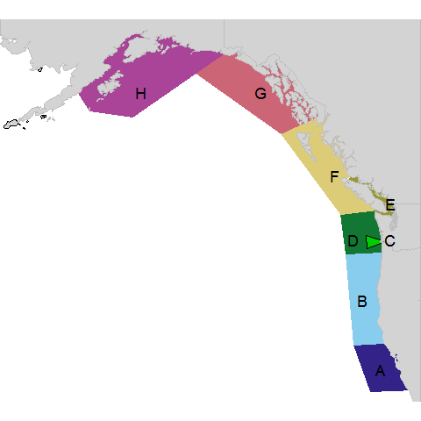

Figure 2. Natural (hatched) and hatchery (solid) Chinook salmon production by area between 1970 and 2015 for central California (Cen.CA), northern California/Oregon (N.CA/OR), Columbia River (Col. Riv.), outer Washington Coast (WA), Salish Sea (Sal. Sea), west coast Vancouver Island/ northern British Columbia (WCVI/N.BC), southeast Alaska (SEAK), and Gulf of Alaska (GoA).

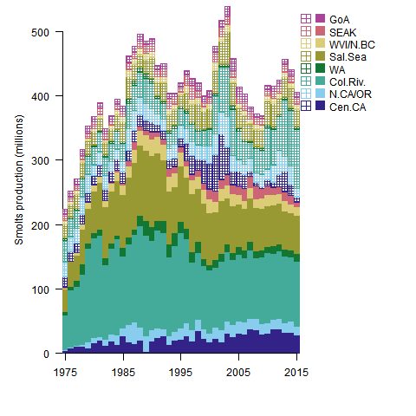

Figure . Consumption of Chinook salmon biomass (a) and total numbers (b) including smolts by killer whales (KW), harbor seals (HS), California sea lions (CSL), and Steller sea lions (SSL) from 1975 to 2015. Consumption is summed across all eight model areas.

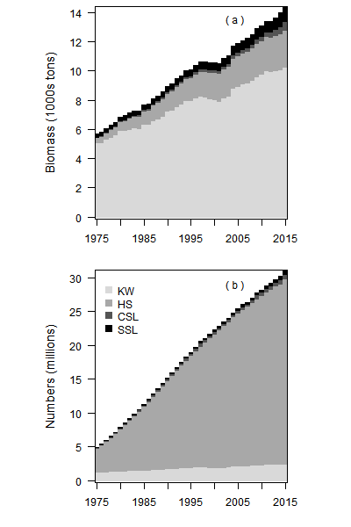

Figure . Total numbers (millions; primary axis) and biomass (thousands of metric tons; secondary axis) of adult Chinook salmon removed by fisheries (line) and marine mammal predators (shaded areas) from 1975 to 2015. The top left panel sums over the whole model domain; each other panel represents hatchery and natural Chinook salmon stocks from a single area of origin. Note that estimates of predation in these panels include Chinook salmon consumed by marine mammals throughout the migratory range of that salmon stock.

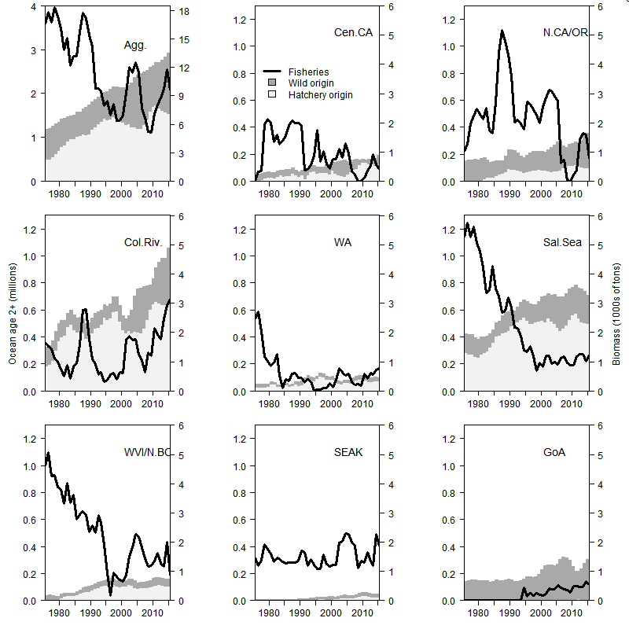

Figure . Estimates of the relative ratio of available prey to predator demands (a), estimated total consumption by killer whales from each area (b), and the estimated consumption by killer whales of each Chinook salmon stock for the Salish Sea (c), coastal British Columbia (d), southeast Alaska (e), and Gulf of Alaska (f).

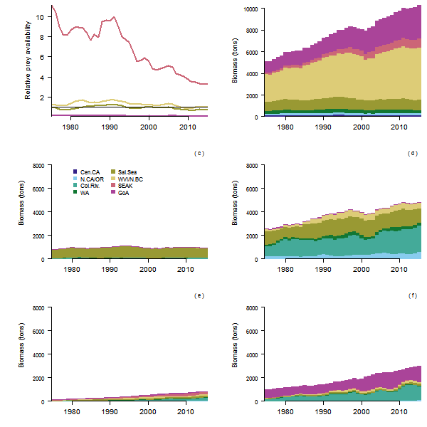

Figure . Estimates of consumption of Chinook salmon, with uncertainty, in terms of the annual biomass (primary axis) and number (secondary axis). Consumption by killer whales (a), harbor seals (b), California sea lions (c), and Steller sea lions (d).

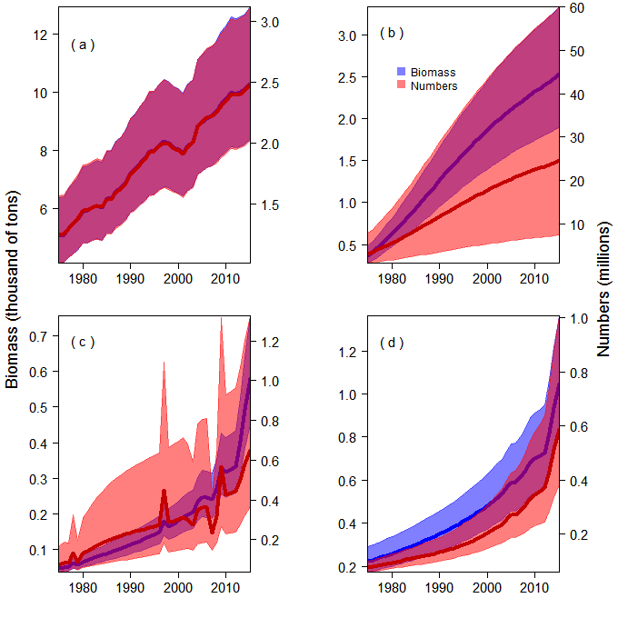

Figure . Estimates of consumption of Chinook salmon, with uncertainty, in terms of the biomass (primary axis) and number (secondary axis) of Chinook salmon consumed per region: central California (a), northern California/coastal Oregon (b), Columbia River (c), Washington coast (d), Salish Sea (e), west coast Vancouver Island (f), southeast Alaska (g), and Gulf of Alaska (h).

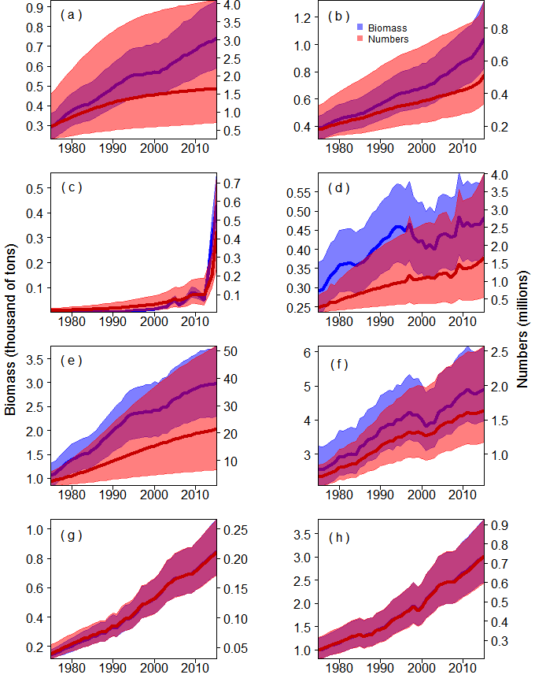

Supplemental Figure 1:

Estimated coastwide biomass of Chinook salmon relative to the average biomass for the base period of 1979 to 1982 for each of the eight areas in our model.

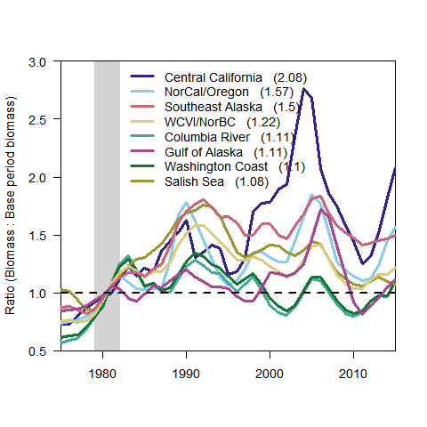

Supplemental Figure 2:

The estimated deficit of Chinook salmon (predator needs versus prey availability) aggregated by ocean age (a), predator (b), region (c), and month of the year (d).

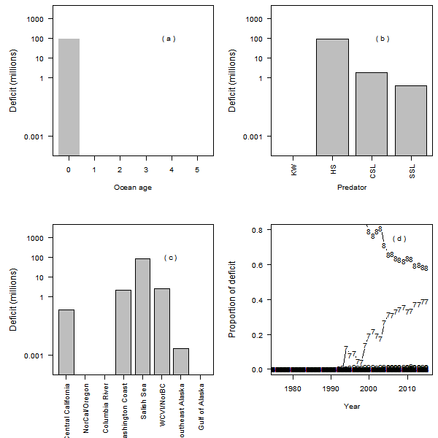

Adams, J., Kaplan, I.C., Chasco, B., Marshall, K.N., Acevedo-Gutiérrez, A., and Ward, E.J. 2016. A century of Chinook salmon consumption by marine mammal predators in the Northeast Pacific Ocean. Ecol. Inform. **34**: 44–51.

Akmajian, A.M., Lambourn, D., Hundrup, E., Gearin, P., Gaydos, J., Klope, M., Jeffries, S., and Scordino, J. 2014. Chapter 12: The occurrence of California Sea Lion (Zalophus californianus) females and first recorded pupping in Washington State, USA. Makah Tribe, Neah Bay, WA. Available from Contact author.

Barrett-Lennard, L.G., Heise, K., Saulitis, E., Ellis, G., and Matkin, C. 1995. The impact of killer whale predation on Steller sea lion populations in British Columbia and Alaska. Rep. North Pac. Univ. Mar. Mammal Res. Consort. Univ. Br. Columbia Vanc. BC Can.

Bigg, M.A. 1969. The harbour seal in British Columbia. Fisheries Research Board of Canada Ottawa. Available from http://library.wur.nl/WebQuery/clc/409938 [accessed 13 March 2016].

Bigler, B.S., Welch, D.W., and Helle, J.H. 1996. A review of size trends among North Pacific salmon (Oncorhynchus spp.). Can. J. Fish. Aquat. Sci. **53**(2): 455–465.

Bond, N.A., Cronin, M.F., Freeland, H., and Mantua, N. 2015. Causes and impacts of the 2014 warm anomaly in the NE Pacific. Geophys. Res. Lett. **42**(9): 3414–3420.

Brown, R.F., Wright, B.E., Riemer, S.D., and Laake, J. 2005. Trends in abundance and current status of harbor seals in Oregon: 1977–2003. Mar. Mammal Sci. **21**(4): 657–670.

Center for Whale Research. 2016. Study of Southern Resident Killer Whales. Available from http://www.whaleresearch.com/ [accessed 13 March 2016].

Chasco, B., Kaplan, I., Thomas, A., Acevedo-Gutiérrez, A., Noren, D.P., Ford, M.J., Hanson, M.B., Scordino, J., Jeffries, S.J., Pearson, S.F., and others. 2017. Estimates of Chinook salmon consumption in Washington State inland waters by four marine mammal predators from 1970–2015. Can. J. Fish. Aquat. Sci. (ja). Available from http://www.nrcresearchpress.com/doi/abs/10.1139/cjfas-2016-0203 [accessed 13 March 2017].

Clemons, E., Conrad, R., Simmons, C.D., Sharma, R., Grover, A., and Yuen, H. 2006. FISHERY REGULATION ASSESSMENT MODEL (FRAM). Available from http://www.pcouncil.org/bb/2006/0606/G1a_FRAM_Att_2.pdf [accessed 13 March 2016].

DeMaster, D., Miller, D., Henderson, J.R., and Coe, J.M. 1985. 7. Conflicts between marine mammals and fisheries off the coast of Ca lif ornia. Available from http://137.110.142.7/publications/CR/1985/8525.PDF [accessed 3 January 2017].

FAO. 2012. Fisheries management. 2. The ecosystem approach to fisheries. 2.1 Best practices in ecosystem modelling for informing an ecosystem approach to fisheries. FAO, Rome. Available from http://www.fao.org/docrep/003/w4230e/w4230e00.htm.

Feist, B.E., Steel, E.A., Pess, G.R., and Bilby, R.E. 2003. The influence of scale on salmon habitat restoration priorities. Anim. Conserv. **6**(3): 271–282.

Fiechter, J., Huckstadt, L.A., Rose, K.A., and Costa, D.P. 2016. A fully coupled ecosystem model to predict the foraging ecology of apex predators in the California Current. Mar. Ecol. Prog. Ser. **556**. Available from http://escholarship.org/uc/item/46p1d130.pdf [accessed 30 March 2017].

Ford, J.K., and Ellis, G.M. 2006. Selective foraging by fish-eating killer whales Orcinus orca in British Columbia. Mar. Ecol. Prog. Ser. **316**: 185–199.

Ford, M.J., Hempelmann, J., Hanson, M.B., Ayres, K.L., Baird, R.W., Emmons, C.K., Lundin, J.I., Schorr, G.S., Wasser, S.K., and Park, L.K. 2016. Estimation of a Killer Whale (Orcinus orca) Population’s Diet Using Sequencing Analysis of DNA from Feces. PloS One **11**(1): e0144956.

Gerber, L.R., Morissette, L., Kaschner, K., and Pauly, D. 2009. Should whales be culled to increase fishery yield. Science **323**(5916): 880–881.

Griffiths, J.R., Schindler, D.E., Armstrong, J.B., Scheuerell, M.D., Whited, D.C., Clark, R.A., Hilborn, R., Holt, C.A., Lindley, S.T., Stanford, J.A., and others. 2014. Performance of salmon fishery portfolios across western North America. J. Appl. Ecol. **51**(6): 1554–1563.

Hanson, Mb., Baird, R.W., Ford, J.K., Hempelmann-Halos, J., Van Doornik, D.M., Candy, J.R., Emmons, C.K., Schorr, G.S., Gisborne, B., Ayres, K.L., and others. 2010. Species and stock identification of prey consumed by endangered southern resident killer whales in their summer range. Endanger. Species Res. **11**(1): 69–82.

Hauser, D.D., Logsdon, M.G., Holmes, E.E., VanBlaricom, G.R., and Osborne, R.W. 2007. Summer distribution patterns of southern resident killer whales Orcinus orca: core areas and spatial segregation of social groups. Mar. Ecol.-Prog. Ser.- **351**: 301.

Hernández-Camacho, C.J., Aurioles-Gamboa, D., and Gerber, L.R. 2008. Age-specific birth rates of California sea lions (Zalophus californianus) in the Gulf of California, Mexico. Mar. Mammal Sci. **24**(3): 664–676.

Hilborn, R., Cox, S., Gulland, F., Hankin, D., Hobbs, N.T., Schindler, D.E., and Trites, A.W. 2012. The effects of salmon fisheries on Southern Resident killer whales: Final report of the independent science panel. Prep. Assist. DR Marmorek AW Hall ESSA Technol. Ltd Vanc. BC Natl. Mar. Fish. Serv. Seattle WA Fish. Oceans Can. Vanc. BC Xv.

Hill, S.L., Watters, G.M., Punt, A.E., McAllister, M.K., Quéré, C.L., and Turner, J. 2007. Model uncertainty in the ecosystem approach to fisheries. Fish Fish. **8**(4): 315–336.

Howard, S., Lance, M.M., Jeffries, S.J., and Acevedo-Gutiérrez, A. 2013. Fish consumption by harbor seals (Phoca vitulina) in the San Juan Islands, Washington. Fish. Bull. **111**(1): 27.

Ianelli, J., Holsman, K.K., Punt, A.E., and Aydin, K. 2015. Multi-model inference for incorporating trophic and climate uncertainty into stock assessments. Deep Sea Res. Part II Top. Stud. Oceanogr. Available from http://www.sciencedirect.com/science/article/pii/S0967064515001058 [accessed 30 March 2017].

Jeffery, K., Cote, I., Irvine, J., and Reynolds, J.D. 2016. Changes in body size of Canadian Pacific salmon over six decades. Can. J. Fish. Aquat. Sci. doi:10.1139/cjfas-2015-0600.

Jeffries, S., Huber, H., Calambokidis, J., and Laake, J. 2003. Trends and status of harbor seals in Washington State: 1978-1999. J. Wildl. Manag.: 207–218.

Kleiber, M. 1975. The fire of life. Robert E. Kreiger N. Y.

Link, J.S., Ihde, T.F., Harvey, C.J., Gaichas, S.K., Field, J.C., Brodziak, J.K.T., Townsend, H.M., and Peterman, R.M. 2012. Dealing with uncertainty in ecosystem models: the paradox of use for living marine resource management. Prog. Oceanogr. **102**: 102–114.

Magera, A.M., Flemming, J.E.M., Kaschner, K., Christensen, L.B., and Lotze, H.K. 2013. Recovery trends in marine mammal populations. PloS One **8**(10): e77908.

Marshall, K.N., Stier, A.C., Samhouri, J.F., Kelly, R.P., and Ward, E.J. 2015. Conservation challenges of predator recovery. Conserv. Lett. Available from http://onlinelibrary.wiley.com/doi/10.1111/conl.12186/full [accessed 12 March 2016].

Matkin, C.O., Ward Testa, J., Ellis, G.M., and Saulitis, E.L. 2014. Life history and population dynamics of southern Alaska resident killer whales (Orcinus orca). Mar. Mammal Sci. **30**(2): 460–479.

Myers, J.M., Kope, R.G., Bryant, G.J., Teel, D., Lierheimer, L.J., Wainwright, T.C., Grant, W.S., Waknitz, F.W., Neely, K., Lindley, S.T., and others. 1998. Status review of chinook salmon from Washington, Idaho, Oregon, and California. Available from http://www.fws.gov/yreka/HydroDocs/Myers_etal_1998.pdf [accessed 22 March 2016].

Nichol, L.M., and Shackleton, D.M. 1996. Seasonal movements and foraging behaviour of northern resident killer whales (Orcinus orca) in relation to the inshore distribution of salmon (Oncorhynchus spp.) in British Columbia. Can. J. Zool. **74**(6): 983–991.

Nielsen, K.S. 1964. Animal physiology. Prentice-Hall of India (Private) Limited.

Noren, D.P. 2011. Estimated field metabolic rates and prey requirements of resident killer whales. Mar. Mammal Sci. **27**(1): 60–77.

O’Neill, S.M., Ylitalo, G.M., and West, J.E. 2014. Energy content of Pacific salmon as prey of northern and southern resident killer whales. Endanger. Species Res. **25**(3): 265.

Pitcher, K.W., and Calkins, D.G. 1979. Biology of the harbor seal, Phoca vitulina richardsi, in the Gulf of Alaska. Outer Continental Shelf Environmental Assessment Program, US Department of Interior, Bureau of Land Management. Available from http://www.data.boem.gov/PI/PDFImages/ESPIS/0/313.pdf [accessed 13 March 2016].

Rechisky, E.L., Welch, D.W., Porter, A.D., Jacobs-Scott, M.C., Winchell, P.M., and McKern, J.L. 2012. Estuarine and early-marine survival of transported and in-river migrant Snake River spring Chinook salmon smolts. Sci. Rep. **2**: 448.

Review of 2015 Ocean Salmon Fisheries: Stock Assessment and Fishery Evaluation Document for the Pacific Coast Salmon Fishery Management Plan, M. 2016. Pacific Fishery Management Council. Pacific Fishery Management Council, 7700 NE Ambassador Place, Suite 101, Portland, Oregon 97220- 1384. Available from http://www.pcouncil.org/salmon/background/document-library/historical-data-of-ocean-salmon-fisheries/.

Ricker, W. 1981. Changes in the average size and average age of Pacific salmon. Can. J. Fish. Aquat. Sci. **38**(12): 1636–1656.

RMIS. 2012. Regional Mark Information System User Guide. Pacific Fishery Management Council, Portland, Oregon. Available from http://www.rmpc.org/files/RMIS_UserGuide_V3.pdf.

Rub, A.M.W., Gilbreath, L., Teel, D., Sandford, B., Van Doornik, D., Frick, K., Burke, B., Rambo, S., Nesbit, M., Sorel, D.H., and Zabel, R. 2016. Adult spring/summer Chinook salmon estuarine and lower Columbia River survival and run timing. Portland, Oregon.

Scordino, J. 2010. West coast pinniped program investigations on California sea lion and Pacific Harbor seal impacts on salmonids and other fishery resources. Pacific States Marine Fisheries Commission. Available from http://www.westcoast.fisheries.noaa.gov/publications/protected_species/marine_mammals/pinnipeds/sea_lion_removals/expand_pinniped_report_2010.pdf [accessed 13 July 2016].

Smith, L., Gamble, R., Gaichas, S., and Link, J. 2015. Simulations to evaluate management trade-offs among marine mammal consumption needs, commercial fishing fleets and finfish biomass. Mar. Ecol. Prog. Ser. **523**: 215.

Surma, S., and Pitcher, T.J. 2015. Predicting the effects of whale population recovery on Northeast Pacific food webs and fisheries: an ecosystem modelling approach. Fish. Oceanogr. **24**(3): 291–305.

Suryan, R.M., and Harvey, J.T. 1998. TRACKING HARBOR SEALS (PHOCA VITULINA RICHARDSI) TO DETERMINE DIVE BEHAVIOR, FORAGING ACTIVITY, AND HAUL-OUT SITE USE. Mar. Mammal Sci. **14**(2): 361–372.

Teel, D.J., Burke, B.J., Kuligowski, D.R., Morgan, C.A., and Van Doornik, D.M. 2015. Genetic identification of Chinook Salmon: stock-specific distributions of juveniles along the Washington and Oregon coasts. Mar. Coast. Fish. **7**(1): 274–300.

Thomas, A.C., Nelson, B., Lance, M.M., Deagle, B., and Trites, A. 2016. Harbour seals target juvenile salmon of conservation concern. Can. J. Fish. Aquat. Sci.

Ward, E.J., Dahlheim, M.E., Waite, J.M., Emmons, C.K., Marshall, K.N., Chasco, B.E., and Balcomb, K.C. 2016. Long-distance migration of prey synchronizes demographic rates of top predators across broad spatial scales. Ecosphere **7**(2). Available from http://onlinelibrary.wiley.com/doi/10.1002/ecs2.1276/full [accessed 5 July 2016].

Weise, M.J., and Harvey, J.T. 2008. Temporal variability in ocean climate and California sea lion diet and biomass consumption: implications for fisheries management. Mar. Ecol. Prog. Ser. **373**: 157–172.

Weitkamp, L.A. 2010. Marine distributions of Chinook salmon from the west coast of North America determined by coded wire tag recoveries. Trans. Am. Fish. Soc. **139**(1): 147–170.

Weitkamp, L.A., Teel, D.J., Liermann, M., Hinton, S.A., Van Doornik, D.M., and Bentley, P.J. 2015. Stock-specific size and timing at ocean entry of Columbia River juvenile Chinook salmon and steelhead: implications for early ocean growth. Mar. Coast. Fish. Available from http://www.tandfonline.com/doi/abs/10.1080/19425120.2015.1047476 [accessed 25 July 2016].

Winship, A.J., Hunter, A.M., Rosen, D.A., and Trites, A.W. 2006. Food consumption by sea lions: existing data and techniques. Sea Lions World Alsk. Sea Grant Coll. Program: 177–191.

Winship, A.J., Trites, A.W., and Calkins, D.G. 2001. Growth in body size of the Steller sea lion (Eumetopias jubatus). J. Mammal. **82**(2): 500–519.

Winship, A.J., Trites, A.W., and Rosen, D.A. 2002. A bioenergetic model for estimating the food requirements of Steller sea lions Eumetopias jubatus in Alaska, USA. Mar. Ecol. Prog. Ser. **229**: 291–312.