# Abstract

Many marine mammal predators, particularly pinnipeds, have increased in abundance in recent decades, generating new challenges for balancing human uses with recovery goals via ecosystem-based management. We used a spatio-temporal bioenergetics model of the Northeast Pacific Ocean to quantify how predation by three species of pinnipeds and killer whales (Orcinus orca) on Chinook salmon (Oncorhynchus tshawytscha) has changed since the 1970s along the west coast of North America, and how this compares to salmon caught by commercial and recreational fisheries. We find that from 1975 to 2015, biomass of Chinook salmon consumed by pinnipeds and killer whales increased from 5,700 to 14,400 metric tons (from 4.9 to 31.2 million individual salmon). Though there is variation across the seven regions in our model, overall, killer whales consume the largest biomass of Chinook salmon, but harbor seals (Phoca vitulina) consume the largest number of individuals. The decrease in adult Chinook salmon harvest from 1975-2015 was 16,400 to 9,600 metric tons. Thus, Chinook salmon mortality increased in the past 30 years despite catch reductions by fisheries, due to consumption by recovering pinnipeds and endangered killer whales. Long-term management strategies for Chinook salmon may need to consider potential conflicts between rebounding predators or endangered predators and prey.

# Results

Total Chinook salmon smolt production on the west coast increased from the 1970s to the 1990s and has been relatively constant over the subsequent two decades (Figure 2). Between 1975 and 2015 the estimated production of wild and hatchery Chinook salmon increased from 225 to 406 million juveniles (Figure 2). In the 1970's and 1980's this was driven by an increase in production of hatchery fish. Since the mid 1980's, a decline in hatchery production has been offset by an increase in smolt production from some wild stocks, such as in the Columbia River.

Chinook salmon biomass consumed by the marine mammal predators was estimated to have increased steadily over the entire study period from 5,700 to 14,400 metric tons (Figure 3). The estimated increase in predation was directly related to increasing predator abundance. Killer whales increased from 292 to 644 individual resident killer whales, harbor seals increased from 210,000 to 355,000 , California sea lions ages (6 years of age) increased from 5,900 to 47,000, and Steller sea lions increased from 74,400 to 78,500 . Killer whales consumed the most Chinook salmon biomass (from 5,100 metric tons in 1975 to 10,300 metric tons in 2015), followed by harbor seals (400 to 2,500 metric tons), Steller sea lions (200 to 1,100 metric tons), and California sea lions (50 to 600 metric tons). Numerically, the predator consumption increased from 4.9 to 31.2 million individual Chinook salmon of varying ages (Figure 3). This was largely driven by increased consumption by harbor seals (from 3.5 million to 27.4 million individual Chinook salmon), followed by killer whales (1.2 to 2.5 million), California sea lions (0.1 to 0.7 million), and Steller sea lions (0.1 to 0.6 million).

Pinniped consumption of juvenile Chinook salmon was a substantial component of predation mortality coastwide, but particularly in the Salish Sea. Of the estimated 27.4 million Chinook salmon consumed coastwide by harbor seals in 2015 (Figure 3), 23.2 million were smolts consumed in the Salish Sea. The percentage of the total coastwide smolt production consumed by harbor seals increased 1.6% (3.5 million of 224.6 million estimated total production) in 1975 to 6.7% (27.4 million of 406.2 million estimated total production) in 2015. Harbor seals in the Salish Sea (i.e. Puget Sound, Strait of Georgia, and Strait of San Juan de Fuca) accounted for 86.4 % of the total coast wide smolt consumption in 2015, due to large increases in the harbor seal abundance in this region between 1975 and 2015 (8,600 to 77,800), as well as a large diet fraction of Chinook salmon smolts relative to other regions.

While predation on Chinook salmon by marine mammal predators increased, annual harvest by commercial and recreational fisheries decreased from 3.6 million to 2.1 million individuals, equivalent to 16,400 to 9,600 metric tons (Figure 4a). At the same time, predator consumption of Chinook salmon increased from 1.2 to 2.9 million adults (we exclude smolts and jacks from the estimate because they are not retained in fisheries), or from 5,500 to 13,400 metric tons. The change in predation and harvest was not evenly distributed across Chinook salmon from different areas (Figure 4). Generally, for Chinook salmon from natal stocks in the south (Central California, Northern California/Oregon, and Columbia River), predation exceeds harvest and has increased strongly over time. These stocks' longer migrations northward expose them to a gauntlet of predators throughout our modeled regions. Predation has also increased on Northern Chinook salmon stocks (Washington, W.Coast Vancouver Island/BC, and SE Alaska), but for these stocks predation is presently near or below the harvest. For Salish Sea Chinook salmon, strong increases in predation greatly exceed harvest; this is driven largely by local increases in pinniped abundance in the Salish Sea. Similarly, Chinook salmon from Western Alaska stocks have experienced increasing predation (which exceeds harvest), due to local abundance of killer whales (including Western Alaska and SE Alaska killer whales).

Killer whales are the largest consumers of Chinook salmon biomass among the predators in our model, accounting for 10,300 of the total 14,400 metric tons biomass consumed in 2015 (Figure 5b). Since 1975, the largest increase in consumption has been from the northern resident killer whales along coastal British Columbia (Figure 5c), approximately 2,300 metric tons. The combined increase in consumption for the southeast Alaska residents and western Alaska residents from 1975 to 2015 was equal to about 2,700 metric tons. The southern resident population in the Salish Sea has remained relatively stable, and therefore the annual consumption within Salish Sea waters has been relatively constant at 800 to 1,100 metric tons, equivalent to about 180,000 to 250,000 adult Chinook salmon annually.

All regions exhibited declines in availability of Chinook salmon as prey for killer whales, even though killer whales in each region depend upon different Chinook salmon stocks. The ratio between Chinook salmon available as prey and the diet needs of the killer whales is estimated to have declined along the entire west coast during the last 40 years (Figure 5a), although ratios for coastal British Columbia and southeast Alaska were consistently higher than for the Salish Sea. We estimated that killer whales within each region depend upon Chinook salmon from distinct populations: the southern resident killer whale diets are dominated by Salish Sea Chinook salmon (Figure 5c), northern resident killer whale diets are primarily Salish Sea and Columbia River Chinook salmon (Figure 5d), southeast Alaska resident diets are more uniformly distributed across Chinook stocks from all regions (Figure 5e), and western Alaska resident diets are likely to be dominated by western Alaska and Columbia River Chinook salmon stocks (Figure 5f).

The Columbia River has previously been identified as an area with high marine mammal consumption of salmon (Stansell et al. 2010), and our results for this region illustrate the relative impacts of different predators and how this varies across salmon life stages. In 2015, harbor seal consumed just 14 metric tons of Chinook salmon versus the 213 and 205 metric tons consumed by California and Steller sea lion, respectively. Considering the consumption of just adult (ocean age two and older) Chinook salmon in 2015, we estimated that harbor seals consumed 1,000 adult Chinook salmon, California sea lions consumed 44,000, and Steller sea lions consumed 43,000. Harbor seals, however, likely prey substantially on out-migrating smolts, and we estimate they would have eaten 311,000 smolts in 2015 (roughly <1% of total Columbia River smolt production).

Considering uncertainty in four key parameters related to predator abundance, diets, and bioenergetics does not qualitatively change the trends and relative impacts of the predators described above. Given uncertainty in these parameters, the estimated total biomass of Chinook salmon consumed in 2015 was between 11,500 and 17,900 metric tons for 95% of the simulations. The total number consumed varied between 10.6 million and 65.3 million individuals; this has higher relative uncertainty than biomass because it additionally incorporates uncertainty in smolt size and smolt fraction parameters. In 2015, approximately half of the uncertainty in the estimated total biomass of Chinook salmon consumed can be attributed to killer whales (8,400 to 12,900 metric tons, Figure 6a), while almost all of the uncertainty in the total number of Chinook salmon consumed can be attributed to harbor seals (7.4 to 60.1 million individuals, Figure 6-b). Across areas there is a similar pattern of uncertainty related to these predators (Figure 7): in 2015 coastal British Columbia had the largest killer whale population among areas (261) and it also had the largest uncertainty in biomass consumed (4,000 to 6,200 metric tons; panel e), while Salish Sea had the largest harbor seal population (78,000) and largest uncertainty in the number of Chinook salmon consumed (6.6 to 51.5 million).

# Discussion

Competition between fisheries and predators, such as marine mammals, has been a concern in ecosystems around the world where predator populations have increased as fish populations have declined. The majority of studies attempting to quantify the losses (predation) or damage (gear loss) caused by interactions with marine mammals have been localized around hotspot areas of conflicts. The spatio-temporal model of marine mammal - Chinook salmon interactions developed here is novel in that we attempt to evaluate the consumption of a highly migratory fish species over a broad spatial range, and across its entire life cycle. Our main result is that though there are slight differences between spatial regions, marine mammal consumption of Chinook salmon is estimated to have increased dramatically over the past 50 years, and may now substantially exceed take from commercial and recreational fisheries (Figure 4).

## Uncertainty

Our primary finding, that marine mammal abundance has increased dramatically over the last 40 years and therefore that their consumption of Chinook salmon may now exceed removals by fisheries, was robust to a range of uncertainties in input parameters.. Challenges of sampling diets and abundance for ecosystem and bioenergetics models... yet need to quantify this uncertainty (Link et al. 2012 Progress in Oceanography 102).

An additional uncertainty in our model that was not addressed in the sensitivity analysis include : the Chinook salmon distribution (following (Weitkamp 2010)) may not fully describe the temporal and spatial overlap between predators and Chinook salmon (particularly juveniles), especially during the period of rapid growth during the first months in salt water (Duffy and Beauchamp 2011), constant diet fractions of Chinook salmon by salmon age class, and constant length and weight of adult salmon across years. While higher resolution of the temporal and spatial distribution of salmon populations would be useful, the geographic range and high rates of mortality make tracking fine scale tracking difficult. Currently the best available information is based on coded wire tags recovered from commercial and recreational fisheries which is not a systematic sample of the Chinook salmon distribution. The data on diet fraction are informed by recent data syntheses (Adams et al. 2016, Chasco et al. in press) and updated field and laboratory methods (e.g. Thomas et al. 2016), but nonetheless future work could consider more ecologically realistic (but complex) functional responses that include flexible diets of predators. Lastly, long term studies of Chinook salmon sizes in the ocean have shown significant reductions in growth rates (length-at-age (Ricker 1981) and weight-at-age (Bigler et al. 1996, Jeffery et al. 2016) of adult Chinook salmon with the exact mechanism for this decline not known. Because the relationship between fish length and weight (or energy) is non-linear, small decreases in adult length can lead to larges differences in the number of prey consumed, particularly for resident type killer whales that select for adult Chinook salmon (Ford and Ellis 2006, Hanson et al. 2010).

## Implications for salmon status and recovery

The increased demand of marine mammal consumption in the Northeast Pacific has implications for the current status of Chinook salmon, as well as other species. For example, long term reductions in the salmon available for commercial and recreational fisheries may not reflect declining status per se but rather a reallocation from human to marine mammal consumption. Despite efforts to improve salmon passage through dams (Rechisky et al. 2012), restore salmon habitat (Feist et al. 2003), reduce fishing (maybe cite PFMC?), or otherwise improve in-river conditions, some portion of benefits from these efforts may be offset by salmon consumption by marine mammals and other predators. Our estimates of in-river consumption of adult Chinook salmon by sea lions in 2015 67 to 113) are similar to other estimates by other researchers (cite Rub??). However, our spatial model suggests that migratory Chinook salmon may be susceptible to predation from marine mammals throughout their range; predation in well studied 'hotspots' (Salish Sea, Columbia River) affects mortality, but predation in the ocean may be greater than previously documented. As each salmon population has a slightly different distribution in the ocean (Weitkamp et al. 2010), each is likely subject to varying encounter rates by fisheries and predators. To understand how predation risk varies over time and space, it is important to use models like ours that are spatially and temporally explicit.

## Implications for killer whale status and recovery

Results from our model can be used to evaluate the abundance and diversity of salmon populations available to both predators and fisheries. Several populations of killer whales occur throughout the migratory range of Chinook salmon; as most of the salmon populations originating from natal streams on the west coast of the US and Canada migrate northward to Alaska, populations of killer whales inhabiting Alaskan waters have a much broader range of salmon populations available as prey. The most southern population of killer whales (Southern Resident killer whales), distributed in the Salish Sea and west coast of the US, is the most at risk population with a growth rate close to zero, but also has a much smaller diversity of salmon populations available as prey. Because some of the same southern-origin salmon populations consumed by Southern Residents are also consumed by higher latitude killer whale populations, these more northern killer whales may be at a competitive advantage over whales at lower latitudes. This difference implies that Columbia River salmon populations may be contributing a greater proportion of the total Chinook in killer whale diets, and is consistent with some recent trends of these killer whales frequenting the Salish Sea to a lesser extent.

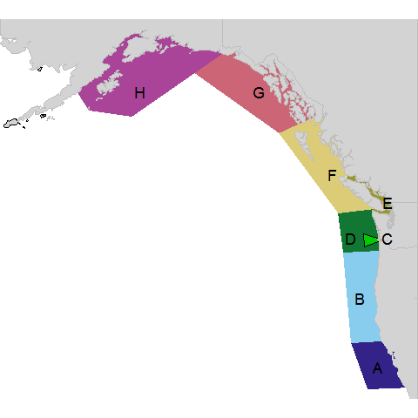 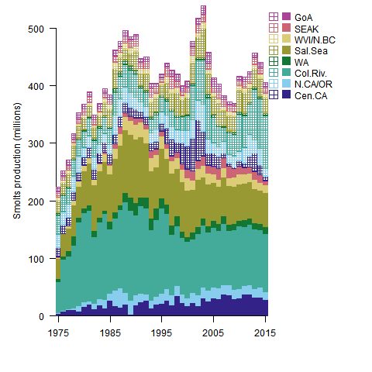 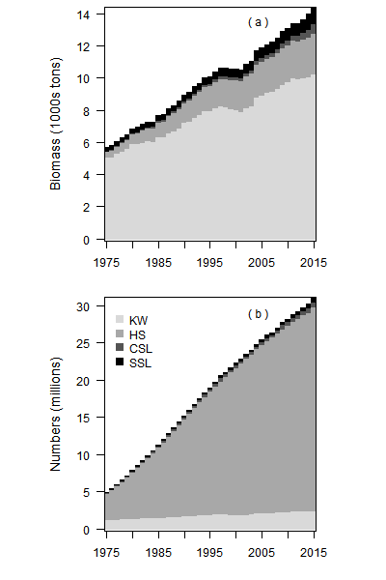 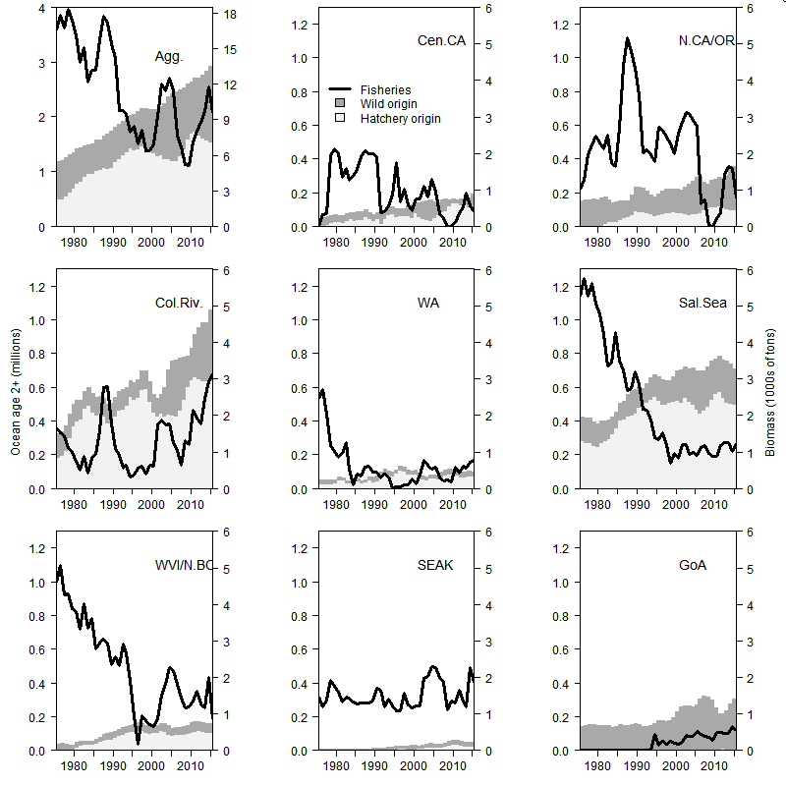 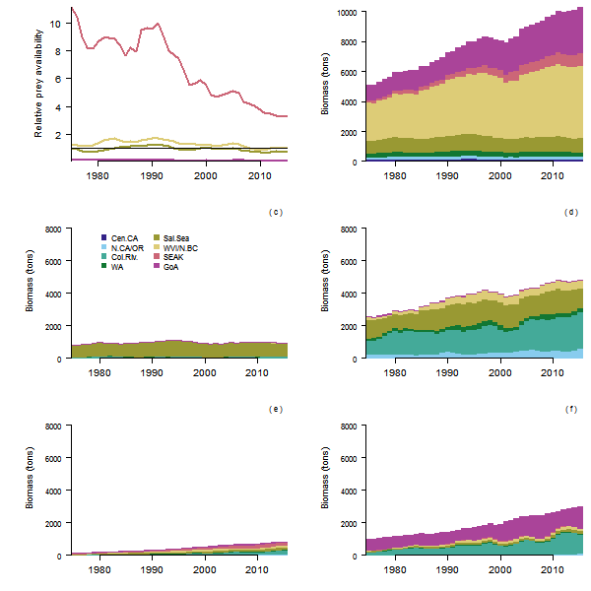 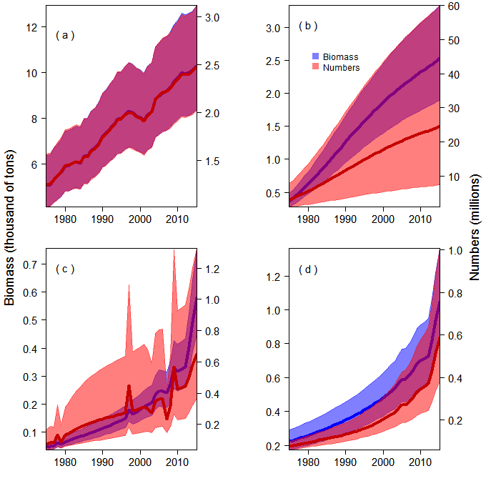 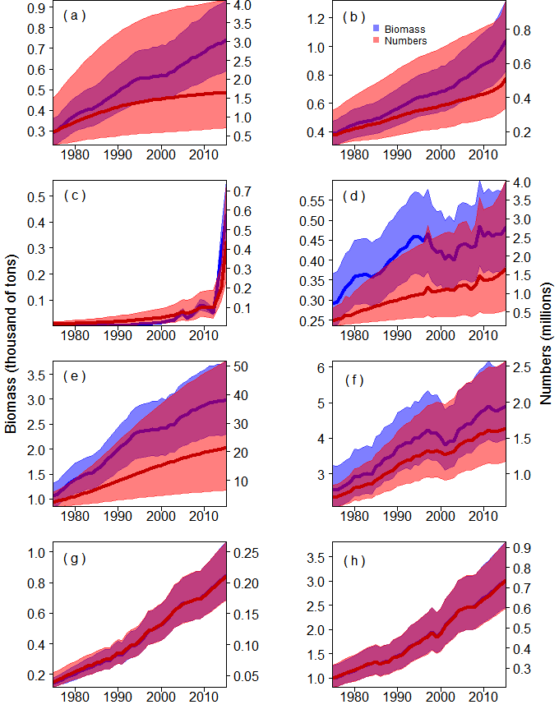 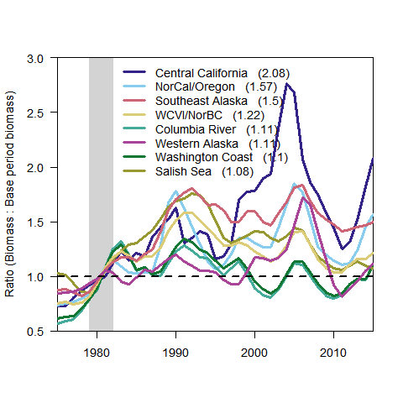

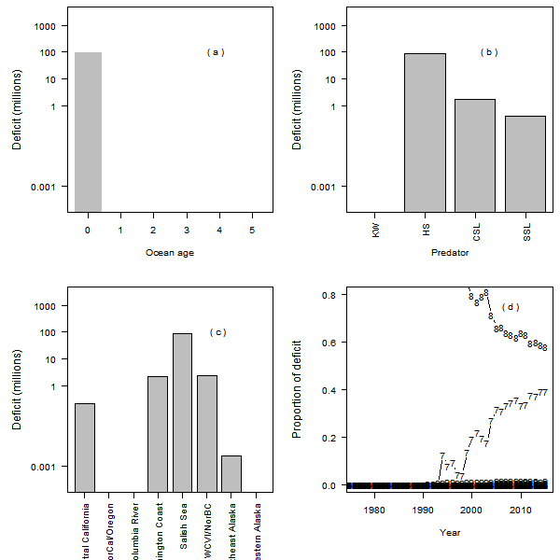

Deficit