Title:

A model of Chinook salmon consumption by marine mammals in Puget Sound inland waters from 1970 -2015

Authors: Brandon Chasco1, Isaac C. Kaplan2, Eric J. Ward2, Austen Thomas3, Alejandro Acevedo-Gutiérrez4, Dawn Noren2, Jonathan Scordino5, Steve Jefferies6, Scott Pearson6, Kristin Marshall7

1 Oregon State University, Department of Fisheries and Wildlife, Corvallis OR 97330, USA

2 Conservation Biology Division, NOAA NMFS Northwest Fisheries Science Center, National Marine Fisheries Service, National Oceanic and Atmospheric Administration, 2725 Montlake Blvd. East, Seattle, WA 98117, USA

3 Smith-Root, Vancouver WA 98686, USA

4 Department of Biology, Western Washington University, Bellingham WA 98225, USA

5 Makah Fisheries Management, Neah Bay WA 98357, USA

6 Washington Department of Fish and Wildlife, Olympia WA 98501, USA

7 University of Washington, School of Fishery and Aquatic Sciences, Seattle WA 98105, USA

Abstract

# Introduction

The recovery of many marine mammals around the world is a conservation success story (Magera et al. 2013), but it has also created new challenges for managing coastal ecosystems (Marshall et al. 2015, Smith et al. 2015). Similar to recent trends in global temperature, the abundances of marine mammals have exhibited non-stationary trends rather than fluctuating around constant values (Burek et al. 2008, Hunter et al. 2010). These non-stationary changes require management models (fisheries assessment models, spatial models predicting suitable habitat, etc.) that incorporate long-term changes in abundance. Including predation in estimates of fish natural mortality yields a better understanding of predator - prey relationships and improves the management by adjusting reference points (Hollowed et al. 2000, Tyrrell et al. 2011). However, until recently many of the fisheries assessment models used around the world have generally ignored ecosystem processes, including predation (Skern-Mauritzen et al. 2015).

Predation by marine mammals may be affecting the recovery or productivity of commercially important fish stocks worldwide. Examples include Cape fur seal (*Arctocephalus pusillus pusillus*) predation on hake (*Merluccius poli*) in South Africa (Punt and Butterworth 1995), consumption of cod (*Gadus morhua*) by harp (*Pagophilus groenlandicus*) and grey (*Halichoerus grypus*) seals in eastern Canada (Mohn and Bowen 1996, Shelton et al. 2006), consumption of herring (*Clupea harengus*) and forage fish by large whales in the northeastern US (Overholtz and Link 2007), consumption of icefish by Antarctic fur seals (*Arctocephalus gazella*) (Woehler and Green 1992), harbor seal (*Phoca vitulina*) predation on Atlantic salmon (*Clupea harengus*) in Scottish rivers (Butler et al. 2006), consumption of salmon and forage fishes by pinnipeds in the northwestern US (Wright et al. 2007, Thomas et al. 2011), consumption of pollock (*Gadus chalcogrammus*) by ribbon seals (*Histriphoca fasciata*) in Japan (Deguchi et al. 2004), and consumption of pollock and cod (*Gadus macrocephalus*) by Steller sea lions (*Eumetopias jubatus*) in Alaska (Rosen and Trites 2000, Winship and Trites 2003).

The number of marine predator species and the mechanisms by which they are integrated into fisheries models varies considerably, and broadly speaking there are often two decisions to be made regarding the structure of a multi-species model: how many species to include in the model, and whether the parameters of the model are estimated or fixed. Determining the number of species within the model should be based on the context of the problem and the questions that are most important to the stake-holders within the ecosystem (Plagányi et al. 2014). While Plagányi et al. (2014) advocate a statistical approach to fitting ecosystem models, there is often a temporal or spatial disconnect between the availability of data for the models and the scale of the current management question. For many multi-species ecosystem problems, estimating the parameters of the models may not be an option and we must draw inferences from mechanistic models (e.g. bioenergetics and forward projections of population dynamics) that use parameter values from the published literature.

As a case study, we focus on the consumption of Chinook salmon (*Oncorhynchus tshawytscha*) on the west coast of the United States. Chinook salmon are an iconic species for the region, are ecologically important because their life history connects freshwater and terrestrial ecosystems (Hocking and Reynolds 2011), serve as prey for top predators in the region (Hanson et al. 2010), and are commercially and recreationally valuable. From a conservation perspective, many stocks of Chinook salmon are at historically low levels (Ruckelshaus et al. 2002), and are thought to be impacted by climate change (Battin et al. 2007, Ward et al. 2015).

The objective of our paper is to quantify predation on Chinook salmon by four species of marine mammals (California sea lions *Zalophus californianus*, Steller sea lions, harbor seals, and killer whales *Orcinus orca*). The geographic focus of our model is the Pacific Northwest of the U.S.A, and in particular the inland waters of Puget Sound. In this region, resident killer whales are known to be highly specialized predators on salmon (Ford et al. 1998, 2016), and previous authors have quantified the magnitude of this predation (Williams et al. 2011). However, harbor seals, Steller sea lions, California sea lions, and killer whales all likely prey on Chinook salmon, as well as on other threatened salmonid stocks. In particular, this region is thought to have one of the highest densities of harbor seals in the world, with abundance spurred by rapid population growth over the period 1970 - 2000 (Jeffries et al. 2003). Management challenges are further complicated by potential tradeoffs between protected salmonids and these four predators, which are protected under the US Marine Mammal Act, US Endangered Species Act, or Canadian Species at Risk Act (Marshall et al. 2015). These predators differ in their foraging characteristics, such as reliance on Chinook salmon as prey, size of salmon they target, and the season and spatial location of feeding.

# Methods

The inland waters of Puget Sound include the Strait of Juan de Fuca, Hood Canal and the San Juan Islands in northwest Washington State, U.S.A. The model we develop below consists of a set of nested equations that reflect the life history of the prey (salmon) and the level of specialization by the predators based on their age, sex, activity level, and their presence within the Puget Sound waters. The specific bioenergetics parameters for individual species are based on published literature (). Rather than describe the details of each species-specific model for the individual predators, we provide general forms of the equations, and refer the reader to our simulation code which is provided on the github site (<https://github.com/bchasco/PSC>), and the equations and data in the appendix. The methods are organized as follows: predator bioenergetics models, predator population dynamics, number of Chinook consumed, and Chinook salmon population dynamics. A full list of the variables and parameters is provided in .

## Modeling energetic demands of the predators

The energetic demands of the four predator species were based on the general Kleiber (1975) model for basal metabolism, which is a power function that depends on the body mass (*Mb*) of the predator.

Equation 1. $E=M_{b}^{β}$

The energy model is often disaggregated into different energy costs,

Equation .

where, the variable $P_{h,i,s,t}$ is the reproductive cost, $GC_{h,i,s,t}$ is the growth cost associated with an increase in body mass, $AC_{h,i,j,s,t}$ is the sum of all activity costs, and $Ef_{h,i,s,t}$ is the fraction of total energy not lost to heat or excretion. Refer to appendix Tables A- 1, A- 2, A- 3, and Figures A- 1, A-2, and A-3 for species-specific calculations of the energetics costs and the github site for model implementation. Parameter values for each species were taken from existing bioenergetics literature (Table 3); this literature assumes that energetic costs for California sea lions and killer whales are due to activity costs only (reproductive and growth costs set to 0, and efficiency *E* set to 1).

The energy model () can be modified to account for age ($i$), activity ($j$), and sex ($s$) specific differences for predator ($h$) throughout the year (i.e., day $t$), as well as the fraction of the time spent doing activity $j$ ($f_{h,j,i,s,t}$), and the body mass ($M_{b,h,i,s}$) of predator $h$,

Equation 3. ${AC}_{h,j,i,s,t}=f_{h,j,i,s,t}×α_{h,i,j,s}×{\left(M_{b,h,i,s}\right)}^{β_{h,j}}$

This equation is a modification of the Kleiber model that allows for the scaling of the basal metabolic rate due to the amount of time spent doing various activities. The parameter $β_{h,j}$ is equal to 0.75 for killer whales, California sea lions, and Steller sea lions; however, for harbor seals the power parameter ranges between 0.76 and 0.87, depending on their activity state (Howard et al. 2013).

By modeling the body mass at age of the predators, our model retains the flexibility to track the impacts of individual predator cohorts. However, the bioenergetics literature often uses coarser stages (e.g., pup, juvenile, adult). To map the stage-based parameters in the literature to our age-based models we used information about the maturity-at-age. Parameters related to the pup stage were mapped directly to age zero ($i=0$) individuals, such that $θ_{i=0}=θ_{pup}^{*}$ where $θ^{*}$ is any generic stage-specific parameter in the literature. Parameters for ages > 0 were a weighted average of the juvenile ($θ_{juvenile}^{*}$) and adult ($θ_{adult}^{*}$) parameters based on the maturity at age ($m_{i}$)

Equation 4. $θ_{i}=\left(1-m_{i}\right)θ_{juveniles}^{*}+m_{i}θ_{adult}^{*}$

As described below, we address uncertainty in our model projections, but focused on the largest source of uncertainty (diets of predators) rather than uncertainty in bioenergetics parameters. Our simple approach focuses on the relative impacts of changing predator populations and their consumption rates of Chinook salmon. Furthermore, including uncertainty in bioenergetics parameters would not alter the expected outcomes of the modeling exercise, given that all bioenergetics parameter values were based on mean values from the literature.

## Predator population dynamics

The daily energetic demand of predator $h$, age $i$, and sex $s$ is the product of the numbers-at-age ($N_{h,y}$) in year *y* (Appendix Figure A- 3)*,* the proportion of the animals in each age class by sex and year ($p_{h,i,s,y}$), and the fraction of the population present in inland waters on day $t$ ($ψ_{h,t}$) (Appendix Figure A- 4),and the daily energetic demands ($E_{h,i,s,t}$; Equation 2).

Equation 5. $E_{h,i,s,t,y}=E_{h,i,s,t}N_{h,y}p_{h,i,s,y}ψ_{h,t}$

The age, sex and abundance of killer whales in inland waters is assumed to be known without error since 1976 when detailed records of the birth of individuals was recorded (Center 2016). For pinnipeds, time series of sex and age structure don’t exist, but we do have estimates of abundance from aerial surveys of haulouts. In inland waters, there is a consistent time series of harbor seals since 1978 (Jeffries et al. 2003). For Steller sea lions, there are long time-series of haul-out surveys for the Washington coast (Wiles 2015) but very few inland waters surveys. For California sea lions there is a long time series of pup counts in California that are used for stock assessment purposes (NMFS 2015), and occasional estimates from surveys in inland waters.

To generate estimates of harbor seal abundance, we used haul-out counts for the five population segments that make up the inland stock of harbor seals in Washington, for the years 1978-1999 (Jeffries et al. 2003). We also included a more recent count from 2013 for each of these regions (Pearson 2016, pers. comm.) that suggested the population had not decreased or increased over the last decade. Because these time series included missing values (particularly in later years), we fit univariate state space models to the data from each population segment (Ward et al. 2010, Holmes et al. 2012) using the MARSS package in R (Holmes et al. 2012; R Core Development Team 2015). We assumed that all five population segments had the same observation error variance (because they were conducted from the same survey platform), but allowed each time series to have unique trends, carrying capacities, and process variances. The estimated states from each of the five population segments were then summed to create an estimate for the total inland stock of harbor seals in Washington. Because these time series represent haul-outs only, we multiplied the estimate by 1.53 to account for individuals in the water (Huber et al. 2001). To determine the stable age distribution and sex ratio for harbor seals, we assume a 50/50 sex ratio for the pups and use stage-based mortality and fecundity estimates by Bigg (1969).

Estimates of Steller sea lion abundance in inland waters are based on a time series of haul-out surveys along the outer coast of Washington State from 1989-2015 (Wiles 2015), and aerial surveys of inland haulouts during 2013 (Jefferies et al. 2014). Similar to harbor seals, we estimated the abundance for years with missing surveys using univariate time-series model in the MARSS package. To extrapolate haulout abundance from the outer coast to inland waters, we assumed the ratio between the peak outer coast count (1,790) and peak inland count (109) in 2013 was the same for all years. To account for sea lions that are not hauled out during the surveys, we apply a correction factor for sea lions of 2 (NOAA TM-28). The sex and age ratio is based on age-specific survival estimates by Winship et al. (2002), and we assumed there are no pups because there are no rookeries in Puget Sound.

California sea lion abundance was based on relative population trends along the U.S. West Coast, which we then scaled based on local observations within Puget Sound. Specifically, we first obtained the time-series of pup counts from rookeries along the California coast, and a correction of 4.317 was used to calculate the number of adults (NMFS 2015). To account for missing years in the coastal survey we implemented a MARSS model similar to the one developed for harbor seals and Steller sea lions. Within Puget Sound, we know of three estimates of California sea lion abundance: Everitt et al. (1981) – 108 individuals, Fox et al. (1996)– 1,113, and Jefferies et al. (2014) – 348 individuals; however, none of these surveys overlap in space. To qualitatively capture these estimates we assume an initial value of zero sea lions in 1978, and then scale the outer coast time series by the peak abundance estimate of 1,200 in 2005 and a leveling off of abundance since then (R. DeLong, NOAA NMML, Seattle, Washington, pers. comm., 2016). Finally, we adjusted this abundance estimate by a factor of 2 to account for seals that are not hauled out during the surveys (NOAA TM-28). The only California sea lions present in inland waters are non-pup males.

The fraction of each the predator’s population in inland waters ($ψ_{h,t}$) changes throughout the year. Harbor seals are the only year round predator ($ψ_{h,t}=1, ∀t$). Killer whales have a seasonal presence in inland water from May to September and are absent during the winter months (Hauser et al. 2007), and studies suggest that even during the summer months resident whales only occupy inland waters about 80% of the time. Based on continuous monitoring of haul-outs throughout the year, Steller sea lions have a bimodal distribution with a peak in early fall and winter and again in late spring through early summer, while California sea lions are only present from late fall through winter (Jefferies et al. 2014). The differences in abundance between surveys can be rather large, so to smooth the seasonal observations of sea lion presence by Jefferies et al. (2014) we average each abundance survey with the one before and after. To transform these average survey abundances to presence probabilities between zero and one, we divide each average abundance by the maximum average abundance.

## Number of Chinook consumed

The number of Chinook salmon of age $a$ that are consumed by predator $h$ is a function of the daily energetic demands of the predator (; ), the fraction of predator's energy derived from Chinook salmon ($ϕ_{h,t}$), the proportion of the diet energy that is comprised of each age class of Chinook salmon ($ν_{h,a}$), and the age-specific energetic content of the Chinook salmon ($E_{a}^{Ch}$),

Equation .

The fraction of prey species in the scat samples of predators is assumed to be proportional to the amount of energy derived from those prey species. Within Puget Sound, the diet fraction of Chinook salmon in resident killer whales has been estimated to range from 0.51 in the fall to 0.95 in the spring/summer based on observational studies and genetic analysis of the scats (Ford et al. 1998, 2016). The fraction of Chinook salmon in harbor seal diets is estimated to be 0.068 based on combination of morphological identification of bones and genetic analysis (Thomas et al. 2016).

Steller and California sea lion diet data in Puget Sound is dominated by frequency of occurrence (FO) studies (Wiles 2015) which only identify salmon to genus. Additionally, FO quantifies the fraction of times prey were identified in a group of scat samples, which means the prey FO do not sum to one and are not representative of the diet fraction of prey (Tollit et al. 2015). Split-sample frequency of occurrence (SSFO) does estimate the fraction of prey within a sample, and it is assumed to be a better representation the fraction of energy obtained from a prey species. Previous analyses of harbor seals in Puget Sound have been conducted that estimate the bias in FO data relative to SSFO (Austen source??). In the absence of direct SSFO data for sea lions, we applied the bias corrections from harbor seal FO data to sea lion FO data, to derive sea lion SSFO. This suggests Chinook salmon diet fractions for Steller sea lion to be 0.065 and for California sea lions to be 0.063.

The energy content of the different ages of Chinook salmon was based on work by O'Neil et al. (2014),

Equation .

where, is the average length-at-age for the Puget Sound populations. Table 4 shows the average length of the different age salmon, the energy content in kcal, and the energy content relative to a smolt (i.e., smolt equivalents). A five year old salmon that is 92 cm has the energetic equivalent of 1,418 smolts that are 9.5 cm long.

The rapid increase in energy content from smolt to age one can have major implications on the number of salmon consumed. To account for the growth of smolts during their time in inland waters we used models developed to approximate juvenile Chinook growth (Beauchamp and Duffy 2011). On average, smolts in Puget Sound are about 9.5 cm during the spring release and reach about 14-15 cm by September. We therefore increased the length of the smolts by about 2.5 cm a month, such that the smolts reach ~40 cm by the following spring. To simplify our model, we do not assume any intra-annual growth for salmon ages one to four.

The distribution of the Chinook salmon age classes in the predator diets ($ν_{h,a}$) is based on diet studies by Ford et al. (1998) for killer whales, Thomas et al. (2016) for harbor seals, and Wiles (2015) for Steller and California sea lions (Table 5). Killer whales feed almost exclusively on mature salmon and the age composition of Chinook in their diet is 4% age one, 35% age two, 52% age three, and 9% age four. Based on scat samples, the composition of Chinook salmon consumed by pinnipeds is only described as juvenile or adult. Approximately 31% of the Chinook salmon in harbor seal diets is derived from juveniles (Thomas et al. 2016), while 31% and 16% of the diets for Steller and California sea lions, respectively, are juveniles (Scordino et al. 2014). Without additional information about the size of the adult Chinook in the pinniped diets, we assume that the adult Chinook diet fraction is distributed evenly across the four adult age classes for the sea lions diets. We restricted the Chinook ages in the harbor seal diet to ages one to three because it seems unlikely that an 80 kg harbor seal would target a 15 kg age four Chinook (Tollit et al. 1997).

## Chinook population dynamics and movement

To quantify effects of smolt consumption on the future returns of mature fish, we adopted a simple forward projection model. This is a heuristic approach with a single stock model and annual time-steps, and it is meant to act as a starting point for a future, more complex temporally and spatially explicit multi-stock Chinook salmon model.

The annual consumption of smolts by the pinniped populations, $C_{y,0}^{h}$, is the sum across all days within a year ($\sum_{s}{\sum_{t}{C_{h,s,a=0,y,t}^{Ch}}})$, where is *h* is the predator type. Projecting the smolts forward as if they had remained in the ocean and had not been consumed, is a function of the age-specific ocean survival and maturation schedule,

Equation .

where, is the survival from $a-1$ to $a$, and $r_{a}$ is the conditional probability of maturing at age $a$. The number of the smolts returning to inland waters (IW) is the number surviving up to year *y* times the conditional probability of returning at age *a,*

Equation .

Estimates of the ocean survival and age composition can vary across Chinook stocks within Puget Sound. Some coarse estimates of ocean mortality are from Argue et al. ( 1983): the bi-monthly instantaneous mortality rates are 0.035, 0.015, and 0.0075 for ocean ages 1, 2, and 3+, respectively. These translate into annual survival estimates of 0.43, 0.69, and 0.83. The conditional probability of maturing at age $a$ given that the fish has survived and remained in the ocean is 0.02, 0.5, 0.8, 1.0, for ocean ages 1, 2, 3, and 4, respectively, based on age composition data from catch and escapement (Act 1997).

# Results

## Daily consumption rates

The maximum daily energetic demands for male and female predators in inland waters ranged from 3,539 kcal for female harbor seals to 281,085 kcal for male killer whales (). Estimates of the average number of juvenile Chinook salmon consumed daily by pinnipeds ranged from 0.2 individual fish for male California sea lions to 5.3 smolts per day for male and female harbor seals (Table 6). The daily consumption of adult Chinook across all predators ranged from 0.03 for male and female harbor seals to 19.8 for male killer whales. Consumption estimates for male predators of a given age were consistently higher than females because of their size. The exception was the peak energetic demands of female harbor seals during lactation and pup rearing, which was comparable to the peak energetic demands of the larger male harbor seals.

## Comparing numbers to biomass consumed

The time-series of Chinook salmon consumption by predator showed considerable differences depending on whether the unit of currency is numbers (, column 1) or biomass (, column 2). Summed across all seasons, beginning in 1970 the harbor seals were estimated to consume a total of 970,000 individual Chinook, approximately ten times greater in number than the 92,000 Chinook salmon consumed by killer whales that year. By 2015, the number of Chinook consumed by harbor seals was estimated to have increased to eight million, or more than 80 times the 96,000 Chinook estimated to be consumed by killer whales. Numerically, Steller and California sea lion consumption is closer to killer whales, with 100 and 48 thousand individuals consumed. The biomass of Chinook salmon consumed has remained relatively constant for killer whales, ranging from 490 to 510 metrics tons between 1970 and 2015. While biomass of Chinook salmon consumed by killer whales remains larger than pinnipeds, the ratio of consumption by killer whales to pinnipeds during the summer months (when whales are present) has decreased from 33:1 in 1970 to 4:1 in 2015.

also displays the seasonal variability in Chinook salmon consumption based on predator occupancy. Killer whales are nearly absent during the late fall through winter months, and as a result their consumption of Chinook salmon decreases from an average 495 metric tons during spring and summer in 2015, to just 12 thousand metric tons during the fall and winter. Conversely, sea lion abundance peaks during the fall and winter months, and consequently their consumption decreased from 43 metric tons during fall and winter of 2015 to 3 metric tons during spring and summer. Harbor seals are year round residents so their consumption is evenly distributed, with between 1.0 to 1.6 tons per month depending on their breeding/pupping activity.

## Pinniped effects on future returns

Between 1970 and 2015, we estimate that most of the increased consumption resulted from pinniped predation on smolts (Figure 2). Smolt consumption for harbor seals has increased from 920,000 to 7,870,000, while consumption of adult Chinook increased from 11,500 to 99,000. The smolt consumption by Steller and California sea lions increased from zero in 1970 to 97,300 and 39,400, respectively. The consumption of adult Chinook salmon increased from 40 to 2,300 for Steller sea lions, and from zero to 8,900 for California sea lions.

Based on our simple salmon life history model, we translated from smolt consumption by pinnipeds to potential adult returns. We found that adult returns were diminished by 1,000 individuals due to California sea lions, 2,000 due to Steller sea lions, and 144,000 due to harbor seals (Figure 3, panels a – c). Summed across all pinnipeds, the total annual potential losses range from 18,000 in 1970 up to 147,000 in 2015. The total potential loss from pinniped predation in 2015 is about 50% greater than the estimated consumption of 96,000 Chinook salmon by killer whales (Figure 3, panel d).

# Discussion

Our modeling demonstrates the dynamic nature of marine mammal impacts on Chinook salmon in Puget Sound waters. Our bioenergetics modeling results show that although harbor seals likely consume far less Chinook salmon biomass compared to fish-eating ‘resident’ killer whales, seals consume many more Chinook salmon in terms of numbers of fish. The selectivity or size preferences of the two species are very different, however -- the Chinook salmon in pinniped diets are almost entirely smolts, so when delayed effects of Chinook maturation are accounted for, predicted impacts of seals on future adult salmon returns is comparable to the annual consumption by killer whales.

A considerable amount of work has examined the bottom up forces affecting Chinook survival (e.g., climate change (Scheuerell and Williams 2005), habitat (Kareiva et al. 2000), nutrients (Scheuerell et al. 2005)), but top down forcing is also suspected to play an important role in early marine survival within Puget Sound. Recently, Duffy and Beauchamp (2011) and Beamish et al. (2012) concluded that much of the marine mortality of Chinook salmon occurs during the early life stage as the result of local conditions in the river estuaries, but attributing this to specific predators can be difficult. Based on our bioenergetics model that accounts for size selectivity of the predators, we found that pinnipeds – and in particular harbor seals - are a possible factor in this early marine mortality as they prey on smolts.

Our bioenergetics modeling assumes there is temporal and spatial overlap of harbor seals with outmigrating Chinook smolts; however, seals do not feed exclusively in river mouths or estuaries (Orr et al. 2004, Lance and Jeffries 2007, Luxa and Acevedo-Gutiérrez 2013) and composition of Chinook salmon in the diet can be highly variable (Thomas et al. 2016). When scaled up to the population level, the predicted daily consumption of Chinook salmon by an individual seal in our bioenergetics models is about 5.3 smolts per day during the spring outmigration. The plausibility of these estimates depends in part on harbor seal feeding behavior – individual seals may differ in their preference or encounter rate of smolts, with some individuals having a disproportionately large impact on the population. Harbor seals alter their feeding behavior in response to seasonal pulses of other species like herring (Thomas et al. 2011), where frequency of occurrence of herring increases to about 40% during the spawning season. Following the pulse of herring spawn in in mid-April, harbor seals in inland waters may switch to smolts released by hatcheries (~40 million annually) into Puget Sound between May and July.

In addition to the mechanistic relationship between smolt mortality and pinniped bioenergetics, the decline in marine survival (i.e., 2.0% to <0.3% from 1970 to 2010; Beamish et al. 2011) coincides directly with the increase in the abundance of these predators. While several factors like increasing temperatures in inland waters (Beamish et al. 2012), competition (Ruggerone and Goetz 2004), and changes in productivity (Mantua et al. 1997) have also been correlated with the declines, the scale and consistent longer term trend of harbor seal abundance should not be overlooked as a reason for declining marine survival. Based on smolt release data (Puget Sound Chinook Salmon Hatcheries 2004), and assuming that Puget Sound hatchery smolts comprised 100% of the smolt in the diet of resident Puget Sound harbor seals (an overestimate, given that Chinook smolts originating from British Columbia are also present in inland waters), the annual consumption rate of hatchery smolts has increased from 1% in 1970 to 20% in 2015 ().

The impacts of increasing pinniped abundance (and subsequent impacts on populations of fish prey) are not confined to just Chinook salmon. Many other potential pinniped prey are species of concern or listed under the US Endangered Species Act (herring, rockfishes, steelhead) and may be affected by the increasing energetic demands of growing marine mammal populations (Ward et al. 2012). Additionally, these changing demands may also impact other top predators. Adult Chinook salmon are an important part of the Puget Sound commercial and recreational fishery, and they are also the preferred prey of endangered Southern Resident killer whales (Ford and Ellis 2006). There is strong evidence to suggest that declining birth rates of southern resident killer whales are strongly linked to decreased Chinook salmon abundance (Ward et al. 2009). Our estimate of potential reductions to future adult Chinook salmon abundance, due to pinnipeds (), could lead to reduction in the productivity or carrying capacity of Southern Resident killer whales. As a comparison, potential losses from pinnipeds are comparable to commercial catches in Washington State inland waters, which have declined from 250,000 adult Chinook in 1980 to 100,000 presently, and recreational catches that have declined from 150,000 to 50,000 (Comprehensive Management Plan for Puget Sound Chinook: Harvest Management Component 2010).

Our main results regarding both biomass and numbers of Chinook salmon consumed (Figures 1-2) depend critically on our parameterization of predator diets. Our estimates of consumption of Chinook salmon are a linear function of diet fraction and size selectivity (); therefore, any change in either of those parameters will lead to a proportional change in the consumption. Our results regarding numbers (but not biomass) of Chinook salmon consumed also depend upon assumptions regarding the ratio of juveniles and adults in the diets, and the size of the juvenile Chinook salmon in inland waters. The effects of juvenile fish size can have a profound effect, because the energy content of a fish increases with the cube of its length (Equation 7). If we reduce the smolt length at release from 95 mm to 60 mm, the energy content of a smolt is reduced by 75%, and therefore the number of smolts needed to meet the energy demands of a predator is increased by a factor of four.

# Future research

This analysis represents a bioenergetics model within a portion of the range of Chinook salmon from Puget Sound. Puget Sound harbor seals may be one cause of the steep drop in the survival of local Chinook salmon stocks, but other predator populations may also consume substantial numbers of salmon. Juvenile Chinook salmon from Puget Sound generally migrate north in the Northeast Pacific to Alaska, where they may encounter a wide range of other sources of mortality. The harbor seal population in southern British Columbia, for example, is thought to be much larger than that of Puget Sound (Population assessment Pacific harbour seal(*Phoba vitulina Richardsi*) 2010). Furthermore, there are other populations of salmon-eating killer whales that inhabit the inland waters of southern British Columbia and southeast Alaska. These northern populations of killer whales are also increasing in abundance and could be an increasing source of mortality for Chinook salmon originating from more southern rivers. The California sea lion range does not extend north of Puget Sound, thus they are unlikely to be an additional source of mortality, but the southeast Alaska Steller sea lions population has increased to ~50,000 individuals since 1979 and could provide a significant source predation based on the diet fractions of Tollit et al. (2015). Future research will extend our analysis to include additional spatial components for the predators in the British Columbia and southeast Alaska inland waters. This will necessitate a salmon migration model to determine the temporal-spatial overlap of Puget Sound Chinook with predators in northern regions.

# Conclusion

This study concludes that based on bioenergetics modeling, the relative impacts of different marine mammal predators on Chinook salmon has changed since the passage of the Marine Mammal Protection Act (1972). More recently, some of these changes indicate that predation in general (and specifically due to harbor seals) may be having an adverse impact on Chinook salmon runs within Puget Sound. Large increases in harbor seal predation on smolts have potential impacts that are larger than either the commercial and recreational fisheries, or predation by endangered Southern Resident killer whales. Sea lions also consume smolts; however, these impacts are low compared to those from harbor seals. Our model only examines a subset of predators within Puget Sound inland waters and assumes their consumption is derived from only Puget Sound Chinook stocks. In reality the Chinook salmon in inland waters are a mixture of US and Canadian stocks, and the marine mammals predators on the outer coast (from California to Alaska) may also be impacting these US Chinook stocks. Further, there are other potential predators (harbor porpoise, cormorants) that are not included in our modeling efforts. We believe this research is a valuable step toward decoupling the mechanisms that lead toward trends in marine survival in endangered Chinook salmon, and provides a framework for coast-wide understanding of predation impacts on Chinook salmon.

# References

Act, E.S. 1997. Review of the Status of Chinook Salmon (Oncorhynchus tshawytscha) from Washington, Oregon. Available from http://spfgtsn.krisweb.com/biblio/gen_nmfs_myersetal_1998_tm35chinook.pdf [accessed 13 March 2016].

Argue, A.W. 1983. Strait of Georgia chinook and coho fishery. Dept. of Fisheries and Oceans. Available from http://agris.fao.org/agris-search/search.do?recordID=US201300358949 [accessed 13 March 2016].

Battin, J., Wiley, M.W., Ruckelshaus, M.H., Palmer, R.N., Korb, E., Bartz, K.K., and Imaki, H. 2007. Projected impacts of climate change on salmon habitat restoration. Proc. Natl. Acad. Sci. **104**(16): 6720–6725.

Beamish, R.J., Sweeting, R.M., Neville, C.M., Lange, K.L., Beacham, T.D., and Preikshot, D. 2012. Wild chinook salmon survive better than hatchery salmon in a period of poor production. Environ. Biol. Fishes **94**(1): 135–148.

Beauchamp, D.A., and Duffy, E.J. 2011. Stage-specific growth and survival during early marine life of Puget Sound Chinook Salmon in the context of temporal-spatial environmental conditions and trophic interactions. Wash. Coop. Fish Wildl. Res. Unit. Available from http://s3.amazonaws.com/file-storage.INDIVIDUAL-ACTIVITIES-CooperativeResearchUnits.digitalmeasures.usgs.edu/davebea/tech_publications/Beauchamp%20%20Duffy%202011%20Chinook%20Growth%20%20Survival-PSC%20Rept-1.pdf [accessed 13 March 2016].

Bigg, M.A. 1969. The harbour seal in British Columbia. Fisheries Research Board of Canada Ottawa. Available from http://library.wur.nl/WebQuery/clc/409938 [accessed 13 March 2016].

Boulva, J., McLaren, I.A., and others. 1979. Biology of the harbor seal, Phoca vitulina, in eastern Canada. Dept. of Fisheries and Oceans. Available from http://agris.fao.org/agris-search/search.do?recordID=US201300581218 [accessed 13 March 2016].

Burek, K.A., Gulland, F.M., and O’Hara, T.M. 2008. Effects of climate change on Arctic marine mammal health. Ecol. Appl. **18**(sp2): S126–S134.

Butler, J.R., Middlemas, S.J., Graham, I.M., Thompson, P.M., and Armstrong, J.D. 2006. Modelling the impacts of removing seal predation from Atlantic salmon, Salmo salar, rivers in Scotland: a tool for targeting conflict resolution. Fish. Manag. Ecol. **13**(5): 285–291.

Center for Whale Research - Study of Southern Resident Killer Whales. 2016. Available from http://www.whaleresearch.com/ [accessed 13 March 2016].

Clemons, E., Conrad, R., Simmons, C.D., Sharma, R., Grover, A., and Yuen, H. 2006. FISHERY REGULATION ASSESSMENT MODEL (FRAM). Available from http://www.pcouncil.org/bb/2006/0606/G1a_FRAM_Att_2.pdf [accessed 13 March 2016].

Comprehensive Management Plan for Puget Sound Chinook: Harvest Management Component. 2010. Puget Sound Indian Tribes & Washington Department of Fish and Wildlife, Olympia, WA.

Duffy, E.J., and Beauchamp, D.A. 2011. Rapid growth in the early marine period improves the marine survival of Chinook salmon (Oncorhynchus tshawytscha) in Puget Sound, Washington. Can. J. Fish. Aquat. Sci. **68**(2): 232–240.

Everitt, R.D., Gearin, P.J., Skidmore, J.S., and DeLong, R.L. 1981. Prey items of harbor seals and California sea lions in Puget Sound, Washington. The Murrelet **62**(3): 83–86.

Ford, J.K., and Ellis, G.M. 2006. Selective foraging by fish-eating killer whales Orcinus orca in British Columbia. Mar. Ecol. Prog. Ser. **316**: 185–199.

Ford, J.K., Ellis, G.M., Barrett-Lennard, L.G., Morton, A.B., Palm, R.S., and Balcomb III, K.C. 1998a. Dietary specialization in two sympatric populations of killer whales (Orcinus orca) in coastal British Columbia and adjacent waters. Can. J. Zool. **76**(8): 1456–1471.

Ford, J.K., Ellis, G.M., Barrett-Lennard, L.G., Morton, A.B., Palm, R.S., and Balcomb III, K.C. 1998b. Dietary specialization in two sympatric populations of killer whales (Orcinus orca) in coastal British Columbia and adjacent waters. Can. J. Zool. **76**(8): 1456–1471.

Ford, M.J., Hempelmann, J., Hanson, M.B., Ayres, K.L., Baird, R.W., Emmons, C.K., Lundin, J.I., Schorr, G.S., Wasser, S.K., and Park, L.K. 2016. Estimation of a Killer Whale (Orcinus orca) Population’s Diet Using Sequencing Analysis of DNA from Feces. PloS One **11**(1): e0144956.

Fox, W.W., Delong, B., Dygert, P., Foley, S., Gearin, P., Jeffries, S., and Scordino, J. 1996. Environmental assessment on conditions for lethal removal of California sea lions at the Ballard Locks to protect winter steelhead (Supplement). NOAA NMFS Seattle Wash.

Hanson, Mb., Baird, R.W., Ford, J.K., Hempelmann-Halos, J., Van Doornik, D.M., Candy, J.R., Emmons, C.K., Schorr, G.S., Gisborne, B., Ayres, K.L., and others. 2010. Species and stock identification of prey consumed by endangered southern resident killer whales in their summer range. Endanger. Species Res. **11**(1): 69–82.

Hauser, D.D., Logsdon, M.G., Holmes, E.E., VanBlaricom, G.R., and Osborne, R.W. 2007. Summer distribution patterns of southern resident killer whales Orcinus orca: core areas and spatial segregation of social groups. Mar. Ecol.-Prog. Ser.- **351**: 301.

Hocking, M.D., and Reynolds, J.D. 2011. Impacts of salmon on riparian plant diversity. Science **331**(6024): 1609–1612.

Hollowed, A.B., Bax, N., Beamish, R., Collie, J., Fogarty, M., Livingston, P., Pope, J., and Rice, J.C. 2000. Are multispecies models an improvement on single-species models for measuring fishing impacts on marine ecosystems? ICES J. Mar. Sci. J. Cons. **57**(3): 707–719.

Holmes, E.E., Ward, E.J., and Wills, K. 2012. Marss: Multivariate autoregressive state-space models for analyzing time-series data. R J. **4**: 11–19.

Howard, S., Lance, M.M., Jeffries, S.J., and Acevedo-Gutiérrez, A. 2013. Fish consumption by harbor seals (Phoca vitulina) in the San Juan Islands, Washington. Fish. Bull. **111**(1): 27.

Huber, H.R., Jeffries, S.J., Brown, R.F., Delong, R.L., and Vanblaricom, G. 2001. Correcting aerial survey counts of harbor seals (Phoca vitulina richardsi) in Washington and Oregon. Mar. Mammal Sci. **17**(2): 276–293.

Hunter, C.M., Caswell, H., Runge, M.C., Regehr, E.V., Amstrup, S.C., and Stirling, I. 2010. Climate change threatens polar bear populations: a stochastic demographic analysis. Ecology **91**(10): 2883–2897.

Jefferies, S., Smultea, M., Bacon, C., Jefferson, T., Mate, B., Irvine, L., and Follett, T. 2014. Aerial Surveys of Pinniped Haulout Sites in the PNW; Marine Mammal Aerial Surveys Conducted in the PNW, IPSW; and Offshore Large Whale Satellite Tagging in the NWTRC. Draft report, Naval Facilities Engineering Command, Northwest (NAVFAC NW), Silverdale, WA.

Jeffries, S., Huber, H., Calambokidis, J., and Laake, J. 2003. Trends and status of harbor seals in Washington State: 1978-1999. J. Wildl. Manag.: 207–218.

Kareiva, P., Marvier, M., and McClure, M. 2000. Recovery and management options for spring/summer chinook salmon in the Columbia River Basin. Science **290**(5493): 977–979.

Kleiber, M. 1975. The fire of life. Robert E. Kreiger N. Y.

Lance, M.M., and Jeffries, S.J. 2007. Temporal and spatial variability of harbor seal diet in the San Juan Island archipelago. Contract Rep. SeaDoc Soc. Res. Agreem. (K004431-25).

Luxa, K., and Acevedo-Guti/’errez, A. 2013. Food habits of harbor seals (Phoca vitulina) in two estuaries in the central Salish Sea. Aquat. Mamm. **39**(1): 10–22.

Magera, A.M., Flemming, J.E.M., Kaschner, K., Christensen, L.B., and Lotze, H.K. 2013. Recovery trends in marine mammal populations. PloS One **8**(10): e77908.

Mantua, N.J., Hare, S.R., Zhang, Y., Wallace, J.M., and Francis, R.C. 1997. A Pacific interdecadal climate oscillation with impacts on salmon production. Bull. Am. Meteorol. Soc. **78**(6): 1069–1079.

Marshall, K.N., Stier, A.C., Samhouri, J.F., Kelly, R.P., and Ward, E.J. 2015. Conservation challenges of predator recovery. Conserv. Lett. Available from http://onlinelibrary.wiley.com/doi/10.1111/conl.12186/full [accessed 12 March 2016].

Mathisen, O.A., and Lopp, R.J. 1963. Photographic census of the Steller sea lion herds in Alaska, 1956-58. US Department of Interior, Fish and Wildlife Service.

Mohn, R., and Bowen, W.D. 1996. Grey seal predation on the eastern Scotian Shelf: modelling the impact on Atlantic cod. Can. J. Fish. Aquat. Sci. **53**(12): 2722–2738.

Muelbert, M.M.C., Bowen, W.D., and Iverson, S.J. 2003. Weaning mass affects changes in body composition and food intake in harbour seal pups during the first month of independence. Physiol. Biochem. Zool. **76**(3): 418–427.

NMFS, N. 2015. California sea lion (Zalophus californianus): U.S. Stock. NMFS, NOAA. Available from http://www.fisheries.noaa.gov/pr/species/mammals/sealions/california-sea-lion.html [accessed 13 March 2016].

O’Neill, S.M., Ylitalo, G.M., and West, J.E. 2014. Energy content of Pacific salmon as prey of northern and southern resident killer whales. Endanger. Species Res. **25**(3): 265.

Orr, A.J., Banks, A.S., Mellman, S., Huber, H.R., DeLong, R.L., and Brown, R.F. 2004. Examination of the foraging habits of Pacific harbor seal (Phoca vitulina richardsi) to describe their use of the Umpqua River, Oregon, and their predation on salmonids. Fish. Bull. **102**(1): 108–117.

Overholtz, W.J., and Link, J.S. 2007. Consumption impacts by marine mammals, fish, and seabirds on the Gulf of Maine–Georges Bank Atlantic herring (Clupea harengus) complex during the years 1977–2002. ICES J. Mar. Sci. J. Cons. **64**(1): 83–96.

Pearson, S. 2016, March 1. Tasks and notes - Feb 12, 9am-noon: Puget Sound Salmon predators/predation rates discussion.

Pitcher, K.W., and Calkins, D.G. 1979. Biology of the harbor seal, Phoca vitulina richardsi, in the Gulf of Alaska. Outer Continental Shelf Environmental Assessment Program, US Department of Interior, Bureau of Land Management. Available from http://www.data.boem.gov/PI/PDFImages/ESPIS/0/313.pdf [accessed 13 March 2016].

Pitcher, K.W., and Calkins, D.G. 1981. Reproductive biology of Steller sea lions in the Gulf of Alaska. J. Mammal. **62**(3): 599–605.

Plagányi, É.E., Punt, A.E., Hillary, R., Morello, E.B., Thébaud, O., Hutton, T., Pillans, R.D., Thorson, J.T., Fulton, E.A., Smith, A.D., and others. 2014. Multispecies fisheries management and conservation: tactical applications using models of intermediate complexity. Fish Fish. **15**(1): 1–22.

Population assessment Pacific harbour seal ( Phoba vitulina Richardsi). 2010. Fisheries and Oceans Canada, Pacific Region. Available from https://www.google.com/search?q=DFO+harbor+seal+assessment&ie=utf-8&oe=utf-8 [accessed 13 March 2016].

Puget Sound Chinook Salmon Hatcheries. 2004. Washington Department of Fish and Wildlife & Puget Sound Treaty Tribes.

Punt, A.E., and Butterworth, D.S. 1995. The effects of future consumption by the Cape fur seal on catches and catch rates of the Cape hakes. 4. Modelling the biological interaction between Cape fur seals Arctocephalus pusillus pusillus and the Cape hakes Merluccius capensis and M. paradoxus. South Afr. J. Mar. Sci. **16**(1): 255–285.

Rosen, D.A., and Trites, A.W. 2000. Pollock and the decline of Steller sea lions: testing the junk-food hypothesis. Can. J. Zool. **78**(7): 1243–1250.

Ruckelshaus, M.H., Levin, P., Johnson, J.B., and Kareiva, P.M. 2002. The Pacific salmon wars: what science brings to the challenge of recovering species. Annu. Rev. Ecol. Syst.: 665–706.

Ruggerone, G.T., and Goetz, F.A. 2004. Survival of Puget Sound Chinook salmon (Oncorhynchus tshawytscha) in response to climate-induced competition with pink salmon (Oncorhynchus gorbuscha). Can. J. Fish. Aquat. Sci. **61**(9): 1756–1770.

Scheuerell, M.D., Levin, P.S., Zabel, R.W., Williams, J.G., and Sanderson, B.L. 2005. A new perspective on the importance of marine-derived nutrients to threatened stocks of Pacific salmon (Oncorhynchus spp.). Can. J. Fish. Aquat. Sci. **62**(5): 961–964.

Scheuerell, M.D., and Williams, J.G. 2005. Forecasting climate-induced changes in the survival of Snake River spring/summer Chinook salmon (Oncorhynchus tshawytscha). Fish. Oceanogr. **14**(6): 448–457.

Scordino, J., Akmajian, A.M., and Riemer, S.D. 2014. California and Steller sea lion diets in northwest Washington, 2010-2013.

Shelton, P.A., Sinclair, A.F., Chouinard, G.A., Mohn, R., and Duplisea, D.E. 2006. Fishing under low productivity conditions is further delaying recovery of Northwest Atlantic cod (Gadus morhua). Can. J. Fish. Aquat. Sci. **63**(2): 235–238.

Skern-Mauritzen, M., Ottersen, G., Handegard, N.O., Huse, G., Dingsør, G.E., Stenseth, N.C., and Kjesbu, O.S. 2015. Ecosystem processes are rarely included in tactical fisheries management. Fish Fish. Available from http://onlinelibrary.wiley.com/doi/10.1111/faf.12111/abstract [accessed 12 March 2016].

Smith, L., Gamble, R., Gaichas, S., and Link, J. 2015. Simulations to evaluate management trade-offs among marine mammal consumption needs, commercial fishing fleets and finfish biomass. Mar. Ecol. Prog. Ser. **523**: 215.

Temte, J.L. 1991. Precise birth timing in captive harbor seals (Phoca vitulina) and California sea lions (Zalophus californianus). Mar. Mammal Sci. **7**(2): 145–156.

Temte, J.L. 1994. Photoperiod control of birth timing in the harbour seal (Phoca vitulina). J. Zool. **233**(3): 369–384.

Thomas, A.C., Lance, M.M., Jeffries, S.J., Miner, B.G., and Acevedo-Gutiérrez, A. 2011. Harbor seal foraging response to a seasonal resource pulse, spawning Pacific herring. Mar. Ecol. Prog. Ser. **441**: 225–239.

Tollit, D.J., Thompson, P.M., and Greenstreet, S.P. 1997. Prey selection by harbour seals, Phoca vitulina, in relation to variations in prey abundance. Can. J. Zool. **75**(9): 1508–1518.

Tollit, D.J., Wong, M.A., and Trites, A.W. 2015. Diet composition of Steller sea lions (Eumetopias jubatus) in Frederick Sound, southeast Alaska: a comparison of quantification methods using scats to describe temporal and spatial variabilities. Can. J. Zool. **93**(5): 361–376.

Tyrrell, M.C., Link, J.S., and Moustahfid, H. 2011. The importance of including predation in fish population models: implications for biological reference points. Fish. Res. **108**(1): 1–8.

Ward, E.J., Anderson, J.H., Beechie, T.J., Pess, G.R., and Ford, M.J. 2015. Increasing hydrologic variability threatens depleted anadromous fish populations. Glob. Change Biol. **21**(7): 2500–2509.

Ward, E.J., Chirakkal, H., Gonz/’alez-Su/’arez, M., Aurioles-Gamboa, D., Holmes, E.E., and Gerber, L. 2010. Inferring spatial structure from time-series data: using multivariate state-space models to detect metapopulation structure of California sea lions in the Gulf of California, Mexico. J. Appl. Ecol. **47**(1): 47–56.

Ward, E.J., Holmes, E.E., and Balcomb, K.C. 2009. Quantifying the effects of prey abundance on killer whale reproduction. J. Appl. Ecol. **46**(3): 632–640.

Ward, E.J., Levin, P.S., Lance, M.M., Jeffries, S.J., and Acevedo-Gutiérrez, A. 2012. Integrating diet and movement data to identify hot spots of predation risk and areas of conservation concern for endangered species. Conserv. Lett. **5**(1): 37–47.

Weise, M.J., and Harvey, J.T. 2008. Temporal variability in ocean climate and California sea lion diet and biomass consumption: implications for fisheries management. Mar. Ecol. Prog. Ser. **373**: 157–172.

Wiles, G.J. 2015. Periodic Status Review for the Steller Sea Lion. Washington Department of Fish and Wildlife, Olympia, WA. Available from http://wdfw.wa.gov/publications/01641/wdfw01641.pdf [accessed 13 March 2016].

Williams, R., Krkošek, M., Ashe, E., Branch, T.A., Clark, S., Hammond, P.S., Hoyt, E., Noren, D.P., Rosen, D., and Winship, A. 2011a. Competing conservation objectives for predators and prey: estimating killer whale prey requirements for Chinook salmon. PloS One **6**(11): e26738.

Williams, R., Krko/vsek, M., Ashe, E., Branch, T.A., Clark, S., Hammond, P.S., Hoyt, E., Noren, D.P., Rosen, D., and Winship, A. 2011b. Competing conservation objectives for predators and prey: estimating killer whale prey requirements for Chinook salmon. PloS One **6**(11): e26738.

Winship, A.J., Hunter, A.M., Rosen, D.A., and Trites, A.W. 2006. Food consumption by sea lions: existing data and techniques. Sea Lions World Alsk. Sea Grant Coll. Program: 177–191.

Winship, A.J., and Trites, A.W. 2003. Prey consumption of Steller sea lions (Eumetopias jubatus) off Alaska: how much prey do they require? Fish. Bull. **101**(1): 147–167.

Winship, A.J., Trites, A.W., and Calkins, D.G. 2001. Growth in body size of the Steller sea lion (Eumetopias jubatus). J. Mammal. **82**(2): 500–519.

Winship, A.J., Trites, A.W., and Rosen, D.A. 2002a. A bioenergetic model for estimating the food requirements of Steller sea lions Eumetopias jubatus in Alaska, USA. Mar. Ecol. Prog. Ser. **229**: 291–312.

Winship, A.J., Trites, A.W., and Rosen, D.A. 2002b. A bioenergetic model for estimating the food requirements of Steller sea lions Eumetopias jubatus in Alaska, USA. Mar. Ecol. Prog. Ser. **229**: 291–312.

Woehler, E.J., and Green, K. 1992. Consumption of marine resources by seabirds and seals at Heard Island and the McDonald Islands. Polar Biol. **12**(6-7): 659–665.

Wright, B.E., Riemer, S.D., Brown, R.F., Ougzin, A.M., and Bucklin, K.A. 2007. Assessment of harbor seal predation on adult salmonids in a Pacific Northwest estuary. Ecol. Appl. **17**(2): 338–351.

Zier, J.C., and Gaydos, J.K. 2014. Harbor seal species profile. Encycl. Puget Sound June **9**: 2014.

Figure .

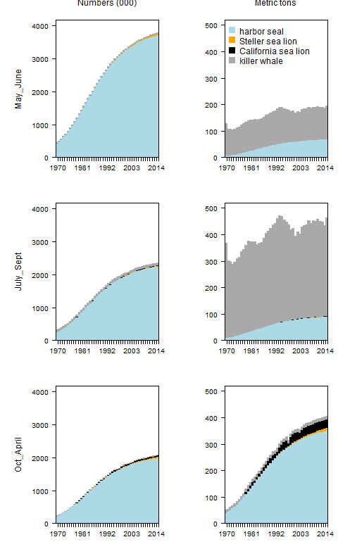

Figure .

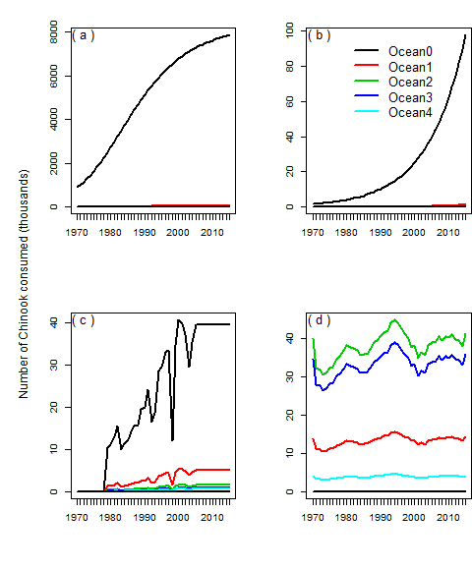

Figure .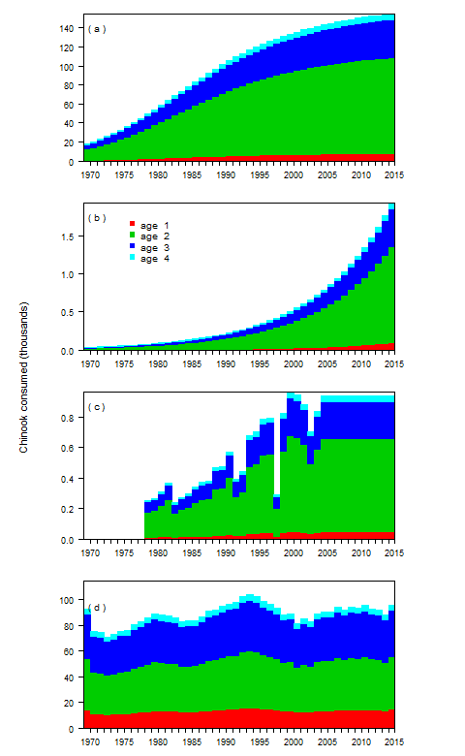

Figure

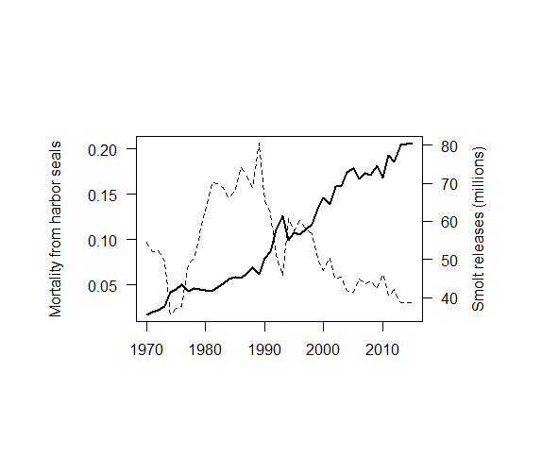

Figure 1. Annual consumption of Chinook salmon in numbers (left column, in thousands) and metric tons (right column) by season for the four predator species. Seasons match those used within the FRAM model used for salmon management (Clemons et al. 2006).

Figure 2. Comparison of the annual consumption of Chinook salmon in numbers (upper) and kilograms (lower) by harbor seals (a), Steller sea lions (b), California sea lions (c), and killer whales (d).

Figure 3. Potential reductions in the number of adult Chinook salmon (thousands) returning to Puget Sound inland waters due to smolt consumption by harbor seals (a), Steller sea lions (b), and California sea lions (c), and the predicted adult Chinook predation by killer whales based on the bioenergetics model (d).

Figure 4. The number of juvenile Chinook salmon released (in millions) by Puget Sound hatcheries (dashed line) and the mortality as a function of the estimated harbor seal consumption (solid line), assuming that harbor seals in inland waters feed exclusively on Puget Sound Chinook salmon stocks.

Table . List of reference that were used to build the bioenergetics model.

|  |  |  |  |  |
| --- | --- | --- | --- | --- |
| Data | Harbor seals | Steller sea lions | California sea lions | killer whales |
| Max age | Howard et al. (2013) | Winship et al. (2001) | Bob de Long (pers. comm.) | 25+ |
|  |  |  |  |  |
| Weight at age | Pitcher and Calkins (1979) | Winship et al. (2001) | Winship et al. (2006) | Williams et al. (2011) |
|  | Boulva and McLaren (1979) |  |  |  |
|  |  |  |  |  |
| Maturity at age | Pitcher and Calkins (1979) | Winship et al. (2002) | Winship et al. (2002) | NA |
|  |  |  |  |  |
| Sex and age ratios | Bigg (1969) | Winship et al. (2002) | Winship et al. (2002) | NA |
|  | Zier and Gaydos (2014) |  | Bob deLong (pers. comm.) |  |
|  |  |  |  |  |
| Predator presence | NA | Jeffries et al. (2014) | Jeffries et al. (2014) | Hauser et al. (2007) |
|  |  |  |  |  |
|  |  |  |  |  |
| Predator abundance | Jeffries et al. (2003) | Jeffries et al. (2014) | Jeffries et al. (2014) | Center (2016) |
|  |  | Wiles (2015) | NMFS (2015) |  |
|  |  |  | Bob deLong (pers. comm.) |  |
|  |  |  |  |  |
| Prey selectivity | Thomas et al. (2016) | Thomas et al. (2016) | Thomas et al. (2016) | Ford et al. (1998) |
|  |  | Scordino et al. (2014) | Scordino et al. (2014) |  |
|  |  |  |  |  |
| Enegertic demands | Howard et al. (2013) | Winship et al. (2002) | Weise and Harvey (2008) | Noren (2011) |
|  |  |  |  |  |

Table . List of subscripts, variables, and papers of the model.

|  |  |  |
| --- | --- | --- |
| Type | Name | Symbol |
| Subscript | Predator | $$h$$ |
|  | Predator age | $$i$$ |
|  | Chinook age | $$a$$ |
|  | Predator acitivty type | $$j$$ |
|  | Predator sex | $$s$$ |
|  | Day | $$t$$ |
|  | Year | $$y$$ |
|  |  |
| Superscript | Chinook | Ch |
|  | Inland waters | IW |
|  |  |  |
| Variable | Energetic demand | $$E$$ |
|  | Reproduction costs | $$P$$ |
|  | Growth costs | $$GC$$ |
|  | Activity costs | $$AC$$ |
|  | Lactation costs | LC |
|  | Chinook energetic content | $$E^{Ch}$$ |
|  | Chinook consumed | $$C^{Ch}$$ |
|  | Predator abundance | $$N$$ |
|  | Predator weight | $$wt$$ |
|  | Chinook weight | $$wt^{Ch}$$ |
|  | Maturity | $$m$$ |
|  | Fecundity | F |
|  |  |
| Parameter | Predator age and sex proportions | $$p$$ |
|  | Fraction of predator population in inland waters | $$ψ$$ |
|  | Activity fraction | $$f$$ |
|  | Allometric constant for metabolism | $$α$$ |
|  | Allometric constant for metabolism | $$β$$ |
|  | Diet fraction | $$ϕ$$ |
|  | Age composition of Chinook in predator diet |  |

Table . Variables of the bioenergetics models by species.

|  |  |  |  |  |  |
| --- | --- | --- | --- | --- | --- |
| Species | $$P$$ | $$GC$$ | $$Ef$$ | $$AC$$ | Source |
| Harbor seal | $$×$$ | $$×$$ | $$×$$ | $$×$$ | Howard et al. (2013) |
| Steller sea lion | $$×$$ | $$×$$ | $$×$$ | $$×$$ | Winship et al. (2002) |
| California sea lion |  |  |  | $$×$$ | Weise and Harvey (2008) |
| Killer whales |  |  |  | $$×$$ | Noren et al. (2011) |

Table . Length (cm), energy content (kcal) and energy based on smolt equivalents for Chinook salmon with ocean ages from zero to five within the Puget Sound inland waters.

|  |  |  |  |  |  |
| --- | --- | --- | --- | --- | --- |
|  | smolt | age 1 | age 2 | age 3 | age 4 |
| Length (cm) | 9.5 | 50 | 71 | 84 | 92 |
| energy (kcal) | 13 | 2,935 | 8,770 | 14,825 | 19,694 |
| smolt equivalents | 1 | 211 | 631 | 1,067 | 1,418 |

Table . Fraction and age distribution of Chinook in the diets of marine mammal predators in Puget Sound.

|  |  |  |  |  |  |  |
| --- | --- | --- | --- | --- | --- | --- |
|  |  | Chinook age composition | | | | |
|  | % diet | smolt | one | two | Three | four |
| harbor seals | 6.8% | 31.0% | 23.0% | 23.0% | 23.0% | 0.0% |
| Steller sea lion | 6.5% | 31.0% | 17.3% | 17.3% | 17.3% | 17.3% |
| California sea lion | 6.3% | 16.0% | 21.0% | 21.0% | 21.0% | 21.0% |
| killer whale | 51-95% | 0.0% | 4.0% | 35.0% | 52.0% | 9.0% |

Table . Maximum daily energetics demands by sex for adult predators, and the maximum daily number of juvenile and adult Chinook salmon that are consumed.

|  |  |  |  |  |  |  |  |  |
| --- | --- | --- | --- | --- | --- | --- | --- | --- |
|  | Daily energy demands (kcal) | |  | Juvenile consumption | |  | Adult consumption | |
|  | male | female |  | male | Female |  | male | female |
| harbor seals | 3,563 | 3,539 |  | 5.4 | 5.3 |  | 0.03 | 0.03 |
| Steller sea lion | 42,343 | 22,592 |  | 2.1 | 1.1 |  | 0.25 | 0.13 |
| California sea lion | 16,959 | 6,416 |  | 0.2 | NA |  | 0.12 | NA |
| killer whale | 281,085 | 154,685 |  | 0.0 | 0.0 |  | 19.82 | 10.90 |

## Appendix:

## Reproduction and growth costs for harbor seals and Steller sea lions

### Reproduction costs

The daily production cost can be disaggregated into the gestation/pupping cost ($PC$) and lactation cost ($LC$). Depending on the time of year the reproductive costs ( $PC$ and $LC$) will change for predators of different ages and sex. To account for these temporal effects we include an additional set of time-varying estimates,



where the variables $p_{h,s,t}^{PC}$ and $p_{h,s,t}^{LC}$ are the conditional probability of predator $p$ gestating or lacatating on day $t$ given that it is both mature ($m_{h,i,s}^{}$) and fecund ($F_{h,s}^{}$).

Since males neither lactate nor give birth, $F_{h,male}^{}$ is equal to zero.

The lactation and gestation costs listed below are conditional on a female actually producing offspring. For harbor seals the fecundity rate is 0.91 (Howard et al. 2013) and for Steller sea lions the fecundity rate is 0.63 (Winship et al. 2002). There are no gestation or lactation costs calculated for killer whales.

In most instances, the models in the literature (Table 8) describe the annual costs of reproduction. Since $p_{h,s,t}^{LC}$ and $p_{h,s,t}^{PC}$ are the daily probability of a reproduction cost, then and are the daily fraction of the annual reproduction costs. The killer whale literature does not separate the production costs from the activity costs, since they are such a minimal cost compared to the activity costs. The gestation periods of the pinnipeds are based on the following literature,

Table A- . Summary of reproduction costs by predator.

|  |  |  |  |
| --- | --- | --- | --- |
| Variable | Predator | Model | Source |
| $$PC_{h,i,s}$$ | Harbor seal | $$93,000,000\frac{joules}{year}$$ | Howard et al. (2013) |
|  | Steller sea lion | $$wt_{h,i=0}×[p_{lip}ED_{lip}+(1-p_{lip})(1-p_{w})ED_{pro}]×\frac{1}{d_{h}*d_{a}}\frac{joules}{day}$$ | Winship et al. (2002) |
|  | California sea lion | NA | Weise and Harvey (2008) |
|  | Killer whales | NA | Noren (2011) |
|  |  |  |
| $$LC_{h,i,s}$$ | Harbor seal | $$24,000,000×(wt_{h,i,s})^{0.75}\frac{joules}{year}$$ | Howard et al. (2013) |
|  | Steller sea lion ${}^{*}$ | | Winship et al. (2002) |
|  | California sea lion | NA | Weise and Harvey (2008) |
|  | Killer whales | NA | Noren (2011) |
|  |  |  |
| $$p_{h,s}^{F}$$ | Harbor seal | 0.91 | Howard et al. (2013) |
|  | Steller sea lion | 0.63 | Winship et al. (2002) |
|  | California sea lion | NA |  |
|  | Killer whales | NA |  |
|  |  |  |

Table A- . Lactation and gestation periods for the each of the predator species.

|  |  |  |  |  |
| --- | --- | --- | --- | --- |
| Parameter | Species | Initial day | Ndays | Source |
| $$p_{h,i,s}^{PC}$$ | Harbor seal | 9 mos. before pupping | 214 (9 months) | Temte (1991, 1994) |
|  | Steller sea lion | 9 mos. before pupping | 214 (9 months) | Pitcher and Calkins (1981) |
| $$p_{h,i,s}^{LC}$$ | Harbor seal | May 25th | 28 – 42 | Muelbert et al. (2003) |
|  | Steller sea lion | May | six months | Mathisen and Lopp (1963) |

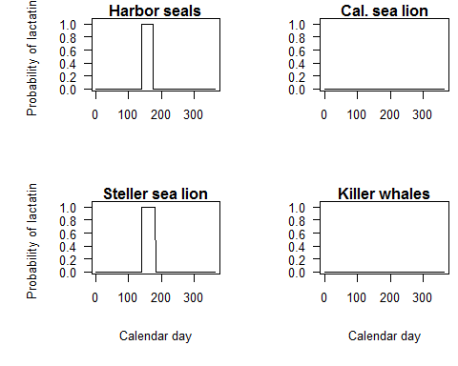

Figure A- . Periods for which lactation costs are factored into the bioenergetics model.

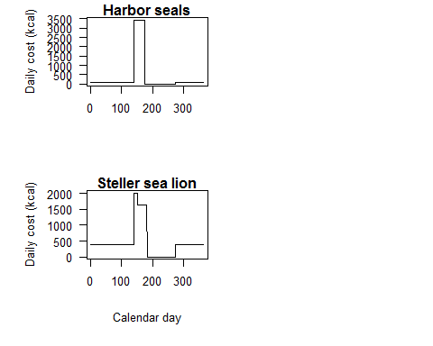

Figure A- . Periods for which lactation costs are included in the bioenergetics model.

### Growth costs

The models for growth costs ($GC$) are different for each predator. The Steller sea lion model is an annual estimate based the change in body mass, while the Harbor seal model is daily estimate for immature individuals. The growth costs for killer whales are integrated into the activity costs.

Table A- . The sources and model for determining growth costs for the predators.

|  |  |  |  |
| --- | --- | --- | --- |
| Variable | Predator | Model | Source |
| $$GC_{h,i,s}$$ | Harbor seal | $$p_{i,s}^{m}*0.0165×321×86400$$ | Howard et al. (2013) |
|  | Steller sea lion | $$(wt_{h,i,s}-wt_{h,i-1,s})[p_{lip}ED_{lip}+(1-p_{lip})(1-p_{w})ED_{pro}]$$ | Winship et al. (2002) |
|  | California sea lion | NA | Weise and Harvey (2008) |
|  | Killer whales | NA | Noren (2011) |

### Efficiency

Efficiency measures the energy that is lost through excretion and metabolic heat before it can be converted to maintenance or growth. Our estimate of efficiency ($Ef$) is the percentage energy left after waste ($d_{a}$) and digestive heat ($d_{h}$). Calculating the conversion efficieny for the species is sightly different based on how the parameters were reported in the literature. The efficiency for killer whales is integrated into the activity costs.

Table A- . Efficiency calculations for the predator species.

|  |  |  |  |  |
| --- | --- | --- | --- | --- |
| Species | Efficiency calculation | $$d_{a}$$ | $$d_{h}$$ | Source |
| Harbor seal | $$Ef=d_{a}-d_{h}$$ | 0.90 | 0.08 | Howard et al. (2013) |
| Steller sea lion | $$Ef=d_{a}×d_{h}$$ | (pup, others) 0.95, 0.85 | 0.88 | Winship et al. (2002) |
| California sea lion |  | NA | NA | Weise and Harvey (2008) |
| Killer whale |  | NA | NA | Noren (2011) |

## Population abundance

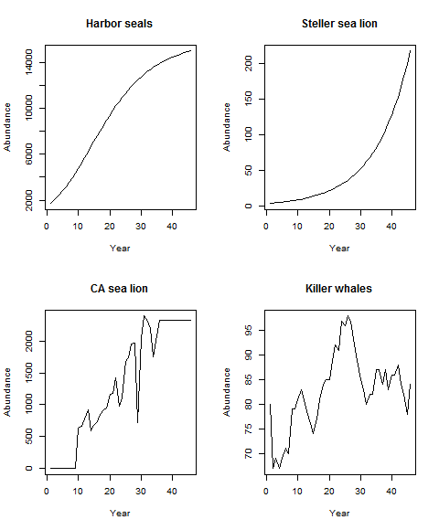

Figure A- . Estimated annual predator abundance.

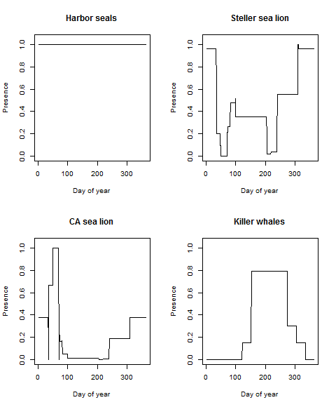

Figure A- . The probability of the predators being present in inland waters.