Title:

Estimates of Chinook salmon consumption in inland waters by four marine mammal predators from 1970 – 2015

Authors: Brandon Chasco1, Isaac C. Kaplan2, Austen Thomas3, Alejandro Acevedo-Gutiérrez4, Dawn Noren2, Michael J. Ford2, M. Bradley Hanson2, Jonathan Scordino5, Steve Jeffries6, Scott Pearson6, Kristin N. Marshall7, Eric J. Ward2

1 Contractor to Conservation Biology Division, NOAA NMFS Northwest Fisheries Science Center, National Marine Fisheries Service, National Oceanic and Atmospheric Administration, 2725 Montlake Blvd. East, Seattle, WA 98117, U.S.

2 Conservation Biology Division, NOAA NMFS Northwest Fisheries Science Center, National Marine Fisheries Service, National Oceanic and Atmospheric Administration, 2725 Montlake Blvd. East, Seattle, WA 98117, U.S.

3 Smith-Root, Vancouver WA 98686, U.S.

4 Department of Biology, Western Washington University, Bellingham WA 98225, U.S.

5 Makah Fisheries Management, Neah Bay WA 98357, U.S.

6 Washington Department of Fish and Wildlife, Olympia WA 98501, U.S.

7 University of Washington, School of Fishery and Aquatic Sciences, Seattle WA 98105, U.S.

Abstract

# Conflicts can arise when the recovery of one protected species limits the recovery of another through competition or predation. The recovery of many marine mammal populations on the west coast of the United States (U.S.) has been viewed as a success; however, within Puget Sound in Washington State (U.S.) the increased abundance of three protected pinniped species may be adversely affecting the recovery of threatened Chinook salmon (*Oncoryhnchus tshawytchsa*) and endangered killer whales (*Orcinus orca*) within the region. Between 1970 and 2015, we estimate the annual biomass of Chinook salmon consumed by pinnipeds has increased from 68 to 625 metric tons. Converting juvenile Chinook salmon into adult equivalents, we found that by 2015 pinnipeds consumed double that of resident killer whales, and six times greater than the combined commercial and recreational catches. We demonstrate the importance of interspecific interactions when evaluating species recovery. As more protected species respond positively to recovery efforts, managers should attempt to evaluate trade-offs between these recovery efforts and the unintended ecosystem consequences of predation and competition on other protected species. Introduction

The recovery of many marine mammals around the world is a conservation success story (Magera et al. 2013), but it has also created new challenges for managing coastal ecosystems (Marshall et al. 2015, Smith et al. 2015). The often increasing abundances of marine mammals, and the associated potential for increasing consumption of fish and invertebrate prey, creates the potential for conflicts between marine mammals and fisheries through competitive interactions. Therefore, adapting fishery stock assessment models and other natural resource management models to incorporate the effects of consumption by marine mammal predators may be needed to account for these trends and interactions in management decisions (Marshall et al. 2015).

Estimating predation mortality improves our understanding of predator - prey relationships and can inform fishery management reference points (Hollowed et al. 2000, Tyrrell et al. 2011). Until recently many fisheries assessment models used around the world have ignored or made overly simplistic assumptions about trends in predation and other ecosystem processes that affect the productivity of commercially important fish stocks (Skern-Mauritzen et al. 2015). Some examples of well documented marine mammal predation on harvested fish stocks include Cape fur seal (*Arctocephalus pusillus pusillus*) predation on hake (*Merluccius poli*) in South Africa (Punt and Butterworth 1995), consumption of cod (*Gadus morhua*) by harp (*Pagophilus groenlandicus*) and grey (*Halichoerus grypus*) seals in eastern Canada (Mohn and Bowen 1996, Shelton et al. 2006), consumption of herring (*Clupea harengus*) and forage fish by large whales in the northeastern U.S. (Overholtz and Link 2007), harbor seal (*Phoca vitulina*) predation on Atlantic salmon (*Salmo salar*) in Scottish rivers (Butler et al. 2006), and consumption of salmon (*Oncorhynchus spp.*) and forage fishes by pinnipeds in the northwestern U.S. (Wright et al. 2007, Thomas et al. 2011).

We focus here on marine mammal predation on Chinook salmon (*O. tshawytscha*), a culturally and ecologically important species of the northeastern Pacific. Chinook salmon are the largest of the Pacific salmon, and their anadromous life history connects freshwater and terrestrial ecosystems throughout the Pacific Rim (Hocking and Reynolds 2011). Chinook salmon serve as prey for top predators (e.g., Hanson et al. 2010), and contribute millions of dollars to both commercial and recreational salmon fishing (T. C. W. Economics 2008). However, many natural stocks of Chinook salmon in the contiguous U.S. have been extirpated (Gustafson et al. 2007) or are at historically low levels and are protected under the U.S. Endangered Species Act (Ford 2011). Chinook salmon biomass in much of the region has been maintained largely through the use of fish hatcheries, but even so, abundance remains well below historical levels (Naish et al. 2007). Causes for the decline of natural stocks include loss and degradation of freshwater spawning and rearing habitat, loss of habitat access due to hydropower dams and other blockages, historical overfishing, and interactions with artificially propagated fish (Ruckelshaus et al. 2002). In addition to marine mammals, other non-marine mammal predators may be also limiting Chinook salmon recovery: aggregations of avian predators along the Columbia River are thought to consume 5-12 million Chinook salmon juveniles annually (Roby et al. 2003), and spiny dogfish that congregate near hatcheries in British Columbia are thought to consume between 0.5 - 7 million juvenile salmon annually (Beamish et al. 1992). Additional Chinook salmon predators include herring (Ito and Parker 1971) and salmon sharks (Nagasawa 1998). Quantifying the magnitude of marine mammal predation and putting this in the context of other factors impacting Chinook salmon is therefore becoming increasingly important.

The objective of our paper is to estimate temporal trends in both numbers and biomass of Chinook salmon consumed in the waters in and around Puget Sound, Washington, U.S. by four species of marine mammals (California sea lions *Zalophus californianus*, Steller sea lions *Eumetopias jubatus*, harbor seals *Phoca vitulina*, and killer whales *Orcinus orca*). Fish-eating ‘resident’ killer whales in the region, which are listed as Endangered in the U.S. (the Southern Resident population), are highly specialized predators on salmon (Ford et al. 1998, Hanson et al. 2010, Ford et al. 2016), and previous authors have estimated the magnitude of this predation (Williams et al. 2011). However, harbor seals, Steller sea lions, and California sea lions also prey on Chinook salmon, and prey-limitation has been identified as one of the biggest threats to resident killer whales (Ward et al. 2009). In particular, the inland waters of Washington state and British Columbia are thought to have one of the highest densities of harbor seals in the world, with abundance spurred by rapid population growth over the period 1970 - 2000 (Jeffries et al. 2003). The marine mammal species in the region differ in their foraging characteristics, such as reliance on Chinook salmon as prey, size of salmon they target, and the spatial and temporal distribution of foraging on salmon. Here we develop a model to evaluate the relative importance of these four species as sources of mortality on Chinook salmon, and to understand temporal trends in predation mortality. We are particularly interested in understanding whether competition for a shared prey resource may be an important factor limiting the population growth of endangered Southern Resident killer whales.

We focus our analysis on the Puget Sound region because the policy context is representative of many nearshore ecosystems (Marshall et al. 2015) and because this is a data-rich region (particularly with respect to diet samples) that can serve as a case study to later expand to the broader U.S. and Canadian West Coast. Our study region encompasses Puget Sound and nearby U.S. waters, including the Strait of Juan de Fuca, Hood Canal and the San Juan Islands. Both predators and prey in this area are federally protected and subject to ongoing recovery efforts. Chinook salmon from Puget Sound were listed as threatened under the U.S. Endangered Species Act (ESA) in 1999 (“Federal Register 64(56):14307-14328” 2005). Six years later, the Southern Resident killer whale population was listed as endangered, in part due to concerns about an adequate prey base (“Federal Register 70(222):69903-69912” 2009). Potential competitors with the killer whales include California sea lions, Steller sea lions, and harbor seals, which are all protected under the U.S. Marine Mammal Protection Act. By developing a flexible bioenergetics and diet modeling framework, we hope to eventually see this framework expanded to evaluate trends in marine mammals and tradeoffs with Chinook salmon at a coast-wide level.

# Methods

Though the Salish Sea consists of U.S. and Canada waters, we focused our initial modeling efforts on the inland waters of Puget Sound (U.S.) and the surrounding areas (encompassing the Strait of Juan de Fuca, Hood Canal, and the San Juan Islands). The primary rationale for this constraint is that the temporal and spatial coverage of marine mammal surveys and marine mammal diet samples (e.g. scat samples) is more complete relative to other areas on the west coast. The bioenergetics model we develop below consists of a set of nested equations that reflect the life history of the focal prey (Chinook salmon) and the level of specialization by the predators based on their age, sex, activity level, and their presence within Washington State waters. The specific bioenergetics parameters for each predator species are based on published literature (Table 1). Rather than describe the details of the particular parameterization for each species-specific model, we provide general forms of the equations, and refer the reader to Appendix A and the publicly available code illustrating detailed implementations of the model (<https://github.com/bchasco/Inland>, built by running the buildModel.r script for base case scenario and output for this paper). A full list of the variables and all model parameters is provided in .

## Modeling energetic demands of the predators

Individual models for the energetic demands of the four predator species vary considerably between species (Table 3). We model basal metabolism based on the general Kleiber (1975) equation, which is a power function that depends on the body mass (*Mb*) of the predator.

Equation .

Depending on the species, this model of energetic demands may be disaggregated into different energy costs,

Equation .

where, the variable is the reproductive cost, is the growth cost associated with an increase in body mass, is the sum of all activity costs, and is the fraction of total energy not lost to digestive heat or excretion (for species-specific calculations of each variable please refer to Appendices Tables A1-A3, Figure A-1, Figure A-2 which provide the equations used in the papers). We allowed each of our four predator species (killer whales, harbor seals, California sea lions, Steller sea lions) to have unique parameter values related to basal metabolism (Table 3); but published estimates assume that reproductive and growth costs for California sea lions and killer whales are sufficiently small and that the majority of the energetics costs are accounted for by the activity costs (i.e., the reproductive and growth costs are implicitly included in activity costs). Consistent with the published bioenergetics literature (Table 1), we assume thermoregulatory costs are also implicitly included in activity costs.

The basal energy model (Equation 1) can be extended to account for age (), activity (), and sex () specific differences for a predator () throughout the year. Energetic costs are modeled on a daily time step (day ), and activities can be broken down into proportions of the total time engaged in each activity (), and the cost of that activity as a function of body mass () of predator , resulting in a modified Kleiber equation (allowing for scaling of the basal metabolic rate):

Equation .

The parameter has been set to 0.75 for killer whales (Noren 2011), California sea lions (Weise and Harvey 2008), and Steller sea lions (Winship et al. 2002); however, for harbor seals the power parameter ranges between 0.76 and 0.87, depending on their activity state (Howard et al. 2013). The body mass for the predators was taken from life history tables or estimated based on growth models in the published literature (see Table 1 for references). Overall, the core energetic equations are Equation 2 for total energetic demand, combined with detailed representation of activity costs (Equation 3).

By modeling the body mass at age of the predators, our model retains the flexibility to track the impacts of individual predator cohorts. Bioenergetics models of marine mammals often use coarser stages (e.g., pup, juvenile, adult), so to map the stage-based parameters in the literature to our age-based models we used information about maturity-at-age. Parameters related to the pup stage were mapped directly to age zero () individuals, such that where is any stage-specific parameter in the literature. Parameters for individual animals older than age 0 were a weighted average of the juvenile () and adult () parameters based on the maturity at age ()

Equation .

## Predator population dynamics, 1970-2015

The daily energetic demand of predator , age , and sex is the product of the numbers-at-age () in year *y* (Appendix Figure A-2)*,* the proportion of the animals in each age class by sex and year (), the fraction of the population present in inland waters on day () (Appendix Figure A-3),and the daily energetic demands (; Equation 2).

Equation .

For each of the predators in the model, we estimated the numbers-at-age from 1970 to 2015. The age, sex and abundance of Southern Resident killer whales in inland waters were based on annual mark-recapture surveys with perfect detection probability (Center for Whale Research 2016), providing a complete census of the population since 1976 (though some neonate calves may have not been accounted for in the census). Time series of age and sex structure do not exist for pinnipeds, but there are estimates of stage-specific ratios for harbor seals (Howard et al. 2013) and estimates of sea lion age-specific mortality (Winship et al. 2002), from which we inferred a stable age distribution.

To generate estimates of harbor seal abundance, we used haul-out counts for the five population segments that make up the inland stock of harbor seals in Washington, for the years 1978-1999 (Jeffries et al. 2003). Because these time series included missing values (particularly in later years), we fit univariate state space models to the data from each population segment (Ward et al. 2010, Holmes et al. 2012) using the MARSS package in R (Holmes et al. 2012; R Core Development Team 2015).

Equation. 6

Equation 7.

Because they were conducted from the same aerial survey platform, we assumed that all five population segments had the same observation error variance (i.e., ), where is the observed survey abundance of population segment *s,* and is the true population state. We allowed each time series to have unique trends (), density dependence (), and process variances (). The estimated states from each of the five population segments were then summed to create an abundance estimate for the total inland stock of harbor seals in Washington. The time series represent haul-outs only, so we have multiplied the estimates by 1.53 to account for individuals in the water (Huber et al. 2001). Because uncertainty exists in both the correction factor and harbor seal numbers (specifically, whether the population has been stable or declined slightly since 2000), we performed a sensitivity test to these assumptions. Although uncertainty in this correction factor exists (varying between 1.43 and 1.85 depending on regional location; (Huber et al. 2001)), the linear properties of Equation 5 assume that any change in the correction factor results in a proportional change in the estimated consumption of Chinook salmon by harbor seals. In other words, a 2% change in the correction factor translates to a 2% change in the estimated energy derived from Chinook salmon. To examine sensitivities to the assumption about a flat or gradual decline in harbor seal numbers over the last 15 years, we imposed a 4% decline consistent with other surveys (Pearson unpub. data (2016)). Results from this scenario are included in the Appendix (Figure A-4, Figure A-5). To determine the stable age distribution and sex ratio for harbor seals, we assume an initial 50/50 sex ratio for the pups and use stage-based mortality and fecundity estimates by Biggs (1969) to estimate the sex ratio for older ages.

Estimates of Steller sea lion abundance in inland waters are based on time series of haul-out surveys along the outer coast of Washington State from 1989-2015 (Wiles 2015), and aerial surveys of inland haul-outs during 2013 (Jeffries et al. 2014). Similar to harbor seals (Equations 6 and 7), we estimated abundance for years with missing surveys using univariate time-series model in the MARSS package (assuming that inland and coastal trends in sea lion numbers are the same). This time series was then scaled to peak counts from inland waters (109 in 2013). To account for Steller sea lions that are not hauled out during the surveys, we applied a correction factor of 2 (National Marine Fisheries Service (NMFS) 1997). The sex and age ratio is based on age-specific survival estimates by Winship et al. (2002).

California sea lion abundance was based on relative population trends and point estimates of counts occurring in inland waters. To account for missing years in the California sea lion stock assessment (NMFS 2015), we implemented a univariate state-space model similar to the one applied for harbor seals and Steller sea lions (Equations 6 and 7). We assumed that the overall trend of California sea lions in Puget Sound was the same as the population trend of the entire stock, but we have little information for sea lion abundance within Puget Sound to scale the coast-wide estimate. There are minimum counts in inland waters in 1978 (no California sea lions were observed) and a peak abundance estimate of 1200 in 2005 (R. DeLong, NOAA MML, Seattle, Washington, pers. comm., 2016) which we used to scale the coast-wide estimate. Finally, to account for seals that are not hauled out during the surveys we again applied the correction factor of 2 (National Marine Fisheries Service (NMFS) 1997). The only California sea lions present in inland waters are non-pup males (Akmajian et al. 2014).

Because of availability of prey, and behavior (e.g., seasonal breeding seasons) the fraction of each predator’s population in inland waters () changes throughout the year. Harbor seals are the only predator that does not migrate outside of the Puget Sound region (). Killer whales have a seasonal presence in inland waters from May to November and are present infrequently and in small numbers during the winter months (Hauser et al. 2007, National Marine Fisheries Service 2008); additionally, studies suggest that even during the summer months resident whales only occupy inland waters about 80% of the time. Based on continuous monitoring of haul-outs throughout the year, Steller sea lions have a bimodal distribution with a peak in early fall and winter and again in late spring through early summer, while California sea lions are only present from late fall through winter (Jeffries et al. 2014). The differences in abundance between surveys can be rather large, so to smooth the seasonal observations of sea lion presence by Jeffries et al. (2014) we averaged each abundance survey with the one before and after. To transform these average survey abundances to presence probabilities between zero and one, we divided each average abundance by the maximum average abundance.

## Number of Chinook salmon consumed, 1970-2015

The number of Chinook salmon of age that are consumed by predator is a function of the daily energetic demands of the predator (; Equation 5), the fraction of predator's energy demand derived from Chinook salmon (), the proportion of the diet energy that is comprised of each age class of Chinook salmon (), and the age-specific energetic content of the Chinook salmon (),

Equation 8.

This method assumes a single spatial box where the predator’s ability to capture the Chinook salmon is not influenced by competition from other predators, or the densities of the salmon within Puget Sound.

The fraction of prey species in the scat samples of predators is assumed to be proportional to the amount of energy derived from those prey species. Within Puget Sound, the diet fraction of Chinook salmon in resident killer whales has been estimated to range from 51% in the fall to 95% in the spring/summer based on observational studies and genetic analysis of scats (Ford et al. 1998, Hanson et al. 2010, Ford et al. 2016). The fraction of Chinook salmon in harbor seal diets is estimated to be 6.8% based on genetic analysis of scat samples, and that percentage can be disaggregated in to 2.1% juveniles and 4.7% adults based hard parts such as bones and otoliths (Thomas et al. 2016). Steller and California sea lion diet data in Puget Sound are dominated by frequency of occurrence (FO) studies (Scordino et al. 2014) which only identify salmon to genus. Additionally, FO quantifies the fraction of times prey that were identified in a group of scat samples, which means the prey FO do not sum to one and are not representative of the diet fraction of prey (Tollit et al. 2015). Because the data collected by Thomas et al. (2016) for harbor seals has both aggregated genus-level information from FO data and the species-level information from genetic data, we estimated the Chinook salmon conversion factors between FO and genetic data to be equal to 0.25 for juveniles and 0.16 for adults. That is, for every four percent of juvenile salmon FO in a pinniped diet, there is one percent of juvenile Chinook salmon in the pinniped diet. After applying these conversion factors to the raw FO data collected by Scordino et al. (2014) for sea lions, the estimated of Chinook salmon diet percentages are equal to 1.0% juveniles and 5.3% adults for California sea lions, and 2.0% juveniles and 4.5% adults for Steller sea lions. This approach relies on the assumption that the relationship between salmon bone FO and Chinook salmon diet fraction is the same for all three pinniped species. While this is a large assumption, it is reasonable given their common habitat and the absence of superior diet information.

The energy content of the different ages of Chinook salmon was based on work by O'Neill et al. (2014),

Equation 9.

where, is the average length-at-age for the Puget Sound populations (Table 4). The conversion of energy content to a common currency (smolt equivalents) makes comparison possible across predators that target different aged prey. For example, a five year old salmon (ocean age 4) that is 92 cm has the energetic equivalent of 1,418 smolts (ocean age 0) that are 9.0 cm long (Table 4).

The rapid increase in energy content from smolt to age one can have major implications on the number of salmon consumed. To account for the growth of smolts during their time in inland waters we used previously developed models to approximate juvenile Chinook salmon growth (Beauchamp and Duffy 2011). On average, hatchery smolts in Puget Sound are about 9.0 cm during their release in spring and reach about 14-15 cm by September. Over their first year, we allowed the length of the smolts to increase by about 2.5 cm a month, such that the smolts become ~40 cm juveniles by the following spring. By assuming only a single size at release, this model simplifies many of the stock-specific differences related to migration timing and juvenile life histories (i.e., yearling vs. sub-yearling, or hatchery vs. wild), and treats all salmon in Washington state inland waters as originating from a single stock. To further simplify our model, we do not assume any intra-annual growth for salmon ages one to four.

The distribution of the Chinook salmon age classes in the predator diets () is based on diet studies by Ford et al. (1998) and Ford and Ellis (2006) for killer whales, Thomas et al. (2016) for harbor seals, and Wiles (2015) for Steller and California sea lions (Table 5). Killer whales feed almost exclusively on mature salmon and the age composition (based on years in the ocean) of Chinook salmon in their diet is 2% age one, 18% age two, 55% age three, and 25% age four (Ford and Ellis 2006, Hanson et al. 2010). Based on scat samples, the composition of Chinook salmon consumed by pinnipeds is only described as juvenile or adult. Previous studies have estimated that approximately 31% of the Chinook salmon in harbor seal diet is derived from juveniles (Thomas et al. 2016), while 31% and 16% of the diets for Steller and California sea lions, respectively, are juveniles (Scordino et al. 2014). Without additional information about the size of the adult Chinook salmon in the pinniped diets, we assume that the adult Chinook salmon diet fraction is distributed evenly across the four adult age classes.

## Chinook salmon population dynamics and movement

To quantify effects of smolt consumption on the future returns of mature fish, we adopted a simple forward projection model. This is a single stock model with annual time-steps, and is meant to act as a starting point for a future, more complex multi-stock Chinook projection model.

The annual consumption of smolts by the pinniped populations, , is the sum across all days within a year (, where *h* is the predator type. Comparing the effects of predation across predators with different preferences (smolts, adults) requires using a common currency, and accounting for the survival between juvenile and adult stages. In order to compare these effects on the same scale, the adult equivalent of smolt consumption was estimated by subjecting smolts that would have been lost to predation to natural mortality and maturation. We did not assume mortality was compensatory; fish that would have been lost to predation were subjected to the same natural mortality rates as fish that escaped predation. Survival and maturation are a function of the age-specific rates,

Equation 10.

where, is the survival from to , and is the conditional probability of maturing at age . The number of the adult Chinook salmon returning to inland waters (IW) is the number surviving up to year *y* times the conditional probability of returning at age *a,*

Equation 11.

There are 21 distinct stocks of Chinook salmon in Puget Sound (Ward et al. 2015), each of them with varying levels of ocean survival and age composition (Myers et al. 1998). Coarse estimates of ocean mortality are from Argue et al. (1983): the bi-monthly instantaneous mortality rates were estimated as 0.035, 0.015, and 0.0075 for ocean ages 1, 2, and 3+, respectively. These translate into annual survival estimates of 0.43, 0.69, and 0.83, which are estimates of the aggregated sources of natural mortality, and not attributable to any species-specific sources of mortality. While these estimates are lower than the Chinook Fishery and Assessment Model (FRAM, Clemons et al. 2006), our goal was to roughly match the average age composition seen across stocks in Myers et al. (1998) prior to the large increases in the pinniped populations within Puget Sound, and treat the Chinook salmon population in Puget Sound as a single stock. We assumed a single aggregate population with conditional probabilities of maturing at ocean ages 1, 2, 3, and 4 equal to 0.02, 0.45, 0.85, 1.0, respectively. From these survival and proportion-at-age estimates, the average age distribution (by ocean ages one to four) of adult fish returning to Puget Sound would be 0.05, 0.52, 0.37, and 0.06. These estimates are similar to the age composition of returning Puget Sound Chinook salmon averaged across stocks (Myers et al. 1998). For our forward projection model, we assumed these ratios were constant for each cohort and year.

## Sensitivity analysis

We evaluated the sensitivity of the bioenergetics model output to input parameters using the methods of individual parameter perturbation (IPP) and relative partial sums of squares (RPSS) as described in Bartell et al. (1986) and Harvey (2009). Though our model predicts consumption for years 1970-2015, for simplicity the sensitivity analysis focused on numbers and biomass of Chinook salmon consumed in 2015, summed over all four predators. These methods test sensitivities of model output to model input CVs of 2%, 10% and 20%. IPP measures the variance in the 2015 consumption estimates after perturbing a particular parameter, and the RPSS uses multiple linear regression to measure how much of the variance in the 2015 consumption estimates can be explained by a particular input relative to the variance explained by all inputs being examined.  The sum across all the RPSS for the different model inputs being tested is equal to the R2.  For either the IPP or RPSS, larger values imply that the model is more sensitive to a particular input. Several of the model inputs are not parameters, but are a vector of outputs from previous studies, and in these cases we treated deviations for a particular vector of model inputs as affecting all elements of the vector equally. For example, if the random deviate for killer whale mass was +10% for a particular simulation, the masses of all killer whale ages would increase by +10%. We tested model sensitivity to two attributes related to salmon, length when they enter the ocean (smolt length) and intercept for the condition factor (i.e., salmon condition; 0.000011 in Equation 9), and five attributes related to the pinnipeds: Kleiber multiplier (), population abundance (), fraction of Chinook salmon in the diet, composition of age-0 salmon in the diets, and pinniped weight-at-age. Because southern resident killer whales do not target age-0 smolts and their abundance is known without error, we only examined model sensitivity to their Kleiber multiplier, abundance, and weight-at-age.

Distinct from model sensitivity, there is also substantial uncertainty in key parameters and data sources, for instance related to diet fractions, pinniped abundance, and bioenergetics parameters; in many cases these uncertainties exceed the 20% CVs tested in systematic sensitivity tests such as IPP or RPSS. We therefore explored the predicted number and biomass of Chinook salmon consumed for all years, varying two-way combinations of the following model inputs, each by +/- 50% : 1) the length of the juvenile Chinook salmon between April and June, 2) the fraction of Chinook salmon smolts in the predator diets, 3) total pinniped abundance, and 4) predator activity multipliers (𝛼 in Equation 3). When changing the fraction of smolts in the predator diets, we assumed that the difference was applied evenly over the other Chinook salmon age classes. For instance, a 50% decrease in harbor seal smolt fraction results in a 4% increase in the diet fractions of the other four Chinook salmon adult ages.

# Results

## Daily consumption rates

The daily energetic demands for male and female predators in Washington state inland waters ranged from 3,539 kcal (1.48 x 104 kJ) for female harbor seals to 247,364 kcal (1.03x 106 kJ) for male killer whales (). The peak period of occupancy within inland waters varies among predators (Figure A-3), thus estimates of the average number of juvenile Chinook salmon consumed daily by pinnipeds is affected by the growth of Chinook salmon throughout the year. Based on their period of peak occupancy within inland waters, numbers consumed ranged from 0.24 individual fish for male California sea lions during the winter months, to 5.4 smolts per day for male and female harbor seals during the spring and summer months (Table 6). The daily consumption of adult Chinook salmon (not including adult equivalents) across all predators ranged from 0.02 for male and female harbor seals to 14.1 for male killer whales. Consumption estimates for male predators of a given age were consistently higher than females because of sexual dimorphism. Exceptions were that peak energetic demands of female harbor seals during lactation and pup rearing were comparable to the peak energetic demands of the larger male harbor seals.

## Comparing numbers to biomass consumed

The time-series of Chinook salmon consumption by predators showed considerable differences depending on whether the unit of currency is numbers (, left) or biomass (, right). Summed across all seasons, beginning in 1970 harbor seals were estimated to consume a total of 1.1 million individual Chinook salmon, approximately thirteen times greater in number than the 84,500 Chinook salmon consumed by killer whales that year. By 2015, the number of Chinook salmon consumed by harbor seals was estimated to have increased to 8.6 million, or more than 104 times the 83,200 Chinook salmon estimated to be consumed by killer whales. One of our sensitivity tests included a scenario in which harbor seal populations declined by 4% annually after 1999 – this results in a decline in total harbor seal Chinook salmon consumption in 2015 to 4.1 million individuals (Appendix Figure A-5). In 2015, estimated consumption of numbers of Chinook salmon by Steller and California sea lions was closer to that of killer whales, with 104,000 and 55,700 individuals consumed, respectively. Because the killer whale population has remained relatively constant over the last 40 years, the estimated annual biomass of Chinook salmon consumed has also remained nearly constant, ranging from 576 to 567 metric tons between 1970 and 2015. Over this same time period, the estimated consumption by pinnipeds has increased from 68 to 625 metric tons. The ratio of biomass consumed by killer whales to pinnipeds during the summer months (May through September when whales are most likely present) has decreased from 26:1 in 1970 to 3:1 by 2015.

In inland Washington State waters, killer whales are nearly absent during the late fall through winter months, and as a result their consumption of Chinook salmon decreases from an average 554 metric tons during spring and summer in 2015, to just 13 metric tons during the fall and winter (Figure 1). Conversely, sea lion abundance peaks during the fall and winter months (when killer whales are rarely present in large numbers), and consequently their consumption decreased from 54 metric tons during fall and winter of 2015 to 3 metric tons during spring and summer. Harbor seals are year-round residents, and their consumption of Chinook salmon is evenly distributed throughout the year, with between 38.0 to 55.0 tons per month depending on their breeding/pupping activity.

**Sensitivity analysis**

The systematic IPP (Figure 2) and RPSS (Figure 3) sensitivity tests identified that model predictions of the numbers of Chinook salmon consumed in 2015 were most sensitive to smolt length, and the predictions of biomass consumed were most sensitive to the intercept for Chinook salmon condition factor (green bars in Figures 2). Model predictions were more sensitive to parameterization of harbor seals than they were to parameterization of other marine mammal predators. However, total biomass consumed responded substantially when parameters for killer whales had a high CV of 20% (grey bars in Figures 2 and 3).

The effects of uncertainty in key inputs and data is shown as a 3x3 contingency plot based on changes in the predator characteristics (Figures A-6 and A-7) and Chinook salmon characteristics (Figure A-8). A 50% increase or decrease in either the predator activity multipliers or the predator abundance led to the same proportional changes in the biomass (Figure A-6) or number (Figure A-7) of Chinook salmon consumed. Conversely, there was a non-linear response in the number of Chinook salmon consumed as a function of smolt length (Figure A-8); a 50% decrease in smolt length led to an ~300% increase in the number of Chinook salmon consumed (left column relative to middle column Figure A-8), whereas a 50% increase in smolt length led to a ~50% decrease in the number of Chinook salmon consumed (right column to middle column Figure A-8). Similar to the changes in the predator abundance and predator activity, changes in the smolt fraction in the pinnipeds diets led to the same proportional change in the number of smolts consumed.

## Pinniped effects on future returns

Between 1970 and 2015, most of the estimated increase in consumption on salmon resulted from pinniped predation on juvenile salmon smolts (Figure 4). Smolt consumption for harbor seals was estimated to increase from 1.1 million in 1970 to a peak of 7.8 million in 2015, while consumption of adult Chinook salmon increased from 10,400 to 89,000. The combined smolt consumption by Steller and California sea lions was estimated to have increased from 1,800 in 1970 to 143,900 in 2015, while their consumption of adult Chinook salmon increased from 42 in 1970 to 14,400 in 2015.

Based on our simple salmon life history model, which does not include density dependent mortality or compensatory mortality from predation (e.g., piscivorous birds, porpoises, etc.), we estimate the adult equivalents from smolt consumption by pinnipeds. Our results suggest that the total adult returns within Washington State inland waters during 2015 would be diminished by 1,000 individuals due to California sea lions, 1,900 due to Steller sea lions, and 158,700 due to harbor seals (Figure 4a-c). Summed across all pinnipeds, the total annual potential mortality increased from 18,800 in 1970 to 161,600 in 2015. The total potential mortality expressed as adult equivalents from pinniped predation in 2015 is double the estimated consumption of 83,200 adult Chinook salmon by killer whales (Figure 4d). The estimates are similar to the commercial (Figure 4e) and recreational catches (Figure 4f) from the early 1990s to the early 2000s; however, due to large decreases in the number of returning adults, both fisheries have since been reduced. Since 2007, the average annual catches by tribal fisheries have been about 5,000-10,000 adults, and the average recreational catches in marine waters are approximately 20,000 adults – fewer than are consumed by killer whales or potentially harbor seals.

# Discussion

Our modeling demonstrates the dynamic nature of marine mammal impacts on Chinook salmon in Puget Sound waters. Our bioenergetics modeling results suggests that although harbor seals likely consume less Chinook salmon biomass compared to fish-eating ‘resident’ killer whales, seals consume many more Chinook salmon in terms of numbers of fish. The selectivity or size preferences of the two species are very different, however -- the Chinook salmon in pinniped diets are almost entirely smolts, so when delayed effects of Chinook salmon maturation are accounted for, predicted impacts of seals on future adult salmon returns is potentially double the annual consumption by killer whales.

A considerable amount of work has examined the bottom-up forces affecting Chinook salmon survival (e.g., climate change (Scheuerell and Williams 2005), habitat (Kareiva et al. 2000), nutrients (Scheuerell et al. 2005)), but top-down forcing is also suspected to play an important role in early marine survival within Puget Sound. Recently, Duffy and Beauchamp (2011) and Beamish et al. (2012) concluded that much of the marine mortality of Chinook salmon occurs during the first several months as the result of local conditions in the river estuaries, but attributing this to specific predators can be difficult. Based on our bioenergetics model that accounts for size selectivity of the predators, we found that pinnipeds – and in particular harbor seals - are a possible factor in this early marine mortality as they prey on smolts.

Our bioenergetics modeling assumes there is temporal and spatial overlap of harbor seals with outmigrating Chinook salmon smolts; however, seals do not feed exclusively in river mouths or estuaries (Orr et al. 2004, Lance et al. 2012, Luxa and Acevedo-Gutiérrez 2013) and the proportion of Chinook salmon in the diet can be highly variable (Thomas et al. 2016). When scaled up to the population level, the predicted daily consumption of Chinook salmon by an individual seal in our bioenergetics models is about 5.4 smolts per day during the spring outmigration. These estimates depend in part on harbor seal feeding behavior – individual seals may differ in their preference or encounter rate of smolts, with some individuals having a disproportionately larger impact on the population. Harbor seals alter their feeding behavior in response to seasonal pulses of other species like herring (Thomas et al. 2011), where frequency of occurrence of herring increases to about 40% during their spawning season. Following the pulse of herring spawning from February to April, harbor seals in inland waters may switch to wild and hatchery released smolts (~40 million annually, (PSIT (Puget Sound Indian Tribes) and WDFW (Washington Department of Fish and Wildlife) 2010)) entering Puget Sound between May and July.

In addition to the mechanistic relationship between smolt mortality and pinniped bioenergetics, the decline in Salish Sea Chinook salmon marine survival (i.e., ~4.0% to <0.5% from the mid-1970s to late 1990s, respectively; Quinn et al. 2005) coincides directly with the increase in the abundance of harbor seals. While several factors such as increasing temperatures in inland waters (Beamish et al. 2012), competition (Ruggerone and Goetz 2004), and changes in productivity (Mantua et al. 1997) have also been correlated with the declines, the scale and consistent abundance trend suggest that harbor seals should not be overlooked as potential contributors to declining marine survival. Assuming that Puget Sound Chinook salmon comprised 100% of the smolt in the diet of resident Puget Sound harbor seals (an overestimate, given that Chinook salmon smolts originating from British Columbia are also present in inland waters), we estimate the annual consumption rate of just hatchery smolts (based on smolt release data from Puget Sound Chinook Salmon Hatcheries (2004))has increased from 1.8% in 1970 to 22.4% in 2015 (Figure 5).

One of the strong assumptions made by our model is that Chinook mortality is additive (rather than compensatory), following the competing risks of death framework proposed by Hilborn et al. (2012). Compensatory mortality may arise when the mortality associated with one predator is replaced by another (consequently, altering the abundance of the first predator would have no impact on survival rates). In inland Washington waters, much of the Chinook mortality is thought to occur during early life stages. If harbor seals represent a major source of mortality for juvenile Chinook, and harbor seal numbers were to decline, it is unclear which other predators may increase their consumption of juvenile Chinook. Many avian predators, such as cormorants, have also declined in the region (Vilchis et al. 2015). Though compensatory mortality is difficult to quantify, future seal abundance surveys and Chinook returns may help us test these hypotheses.

The impacts of increasing pinniped abundance (and subsequent impacts on populations of fish prey) are not confined to just Chinook salmon. Many other potential pinniped prey are species of concern or listed under the U.S. Endangered Species Act (herring, rockfishes *Sebastes* spp., steelhead *Oncorhynchus mykiss*) and may be affected by the increasing energetic demands of growing marine mammal populations (Ward et al. 2012). Additionally, these changing demands may also impact other top predators. Adult Chinook salmon are an important part of the Puget Sound commercial and recreational fishery, and they are also the preferred prey of endangered Southern Resident killer whales (Ford and Ellis 2006, Hanson et al. 2010, Ford et al. 2016). There is evidence to suggest that variation in birth and death rates of Southern Resident killer whales is linked to changes in Chinook salmon abundance (Ward et al. 2009, Ford et al. 2010). Our estimate of potential reductions to adult Chinook salmon abundance due to predation on smolts and sub-adults by pinnipeds (Figure 4) could lead to reduction in the productivity or carrying capacity of Southern Resident killer whales. As a comparison, potential mortality from pinnipeds based on adult equivalents are comparable to commercial catches of Chinook salmon from Washington State inland waters, which have declined from approximately 250,000 adult salmon in 1980 to 100,000 in 2007, and recreational catches within Puget Sound have declined from approximately 150,000 to 50,000 (Comprehensive Management Plan for Puget Sound Chinook salmon: Harvest Management Component 2010). Though our model is sensitive to assumptions regarding both marine mammals and Chinook salmon, the main results consistently suggest that across a broad range of parameter values, harbor seals and fish-eating ‘resident’ killer whales account for the large majority of consumption of Chinook salmon biomass, and harbor seals consume many more Chinook salmon in terms of numbers of fish.

The ranking of harbor seals versus killer whale consumption of Chinook salmon biomass depends on uncertainty in pinniped abundance (killer whale abundance is known with high precision), but consistently across our scenarios these two species had higher Chinook salmon consumption than did California or Steller sea lions. Our model is linearly sensitive to uncertainty in most parameters. For instance, estimates of biomass and numbers of Chinook salmon consumed (Figures 1) depend on the predator diet fraction and size selectivity (Equation 8, Figures 2 and 3); therefore, changes in either of those parameters will lead to a proportional change in the consumption. Our results regarding numbers (but not biomass) of Chinook salmon consumed also depend upon assumptions regarding the ratio of juveniles and adults in the diets, and the size of the juvenile Chinook salmon in inland waters. The parameterization of juvenile fish size can have a profound and nonlinear effect, because the energy content of a fish increases with the cube of its length (Equation 9). If we reduce the smolt length at release from 95 mm to 45 mm (the difference between releasing fingerlings or fry), the energy content of a juvenile is reduced by ~90%, and therefore the number of individual Chinook salmon needed to meet the energy demands of a predator is increased by a factor of 10. Similarly, the model is particularly sensitive to uncertainty in the fish condition (i.e., lean vs high lipid fish) and this can have impacts on both the biomass and numbers of salmon required to meet predator energetic demands (Figures 2 and 3).

# Conclusion

Based on bioenergetics modeling, the relative impacts of different marine mammal predators on Chinook salmon have changed substantially since the passage of the Marine Mammal Protection Act (1972). Primarily due to increases in harbor seal abundance, since 1970 predation on Chinook salmon runs within Puget Sound has increased approximately nine-fold in terms of numbers and doubled in terms of biomass. Large increases in harbor seal predation on smolts have potential impacts that are larger than either current commercial and recreational fisheries, or predation by endangered Southern Resident killer whales. Sea lions also consume Chinook salmon; however, these impacts are estimated to be low compared to those from harbor seals. Our model only examines a subset of predators within Puget Sound inland waters and assumes their Chinook salmon consumption is derived from only Puget Sound Chinook salmon stocks. In reality the Chinook salmon in inland waters are a mixture of U.S. and Canadian stocks, and the marine mammals predators on the outer coast (from California to Alaska) and their consumption of Chinook salmon (Adams et al. 2016) may also be impacting these U.S. stocks. Further, there are other potential predators (harbor porpoise (*Phocoena phocoena*), cormorants (*Phalacrocorax* spp.)) that are not included in our modeling efforts. We believe this research is a valuable step toward decoupling the mechanisms that lead toward trends in marine survival in threatened Chinook salmon, and provides a framework for coast-wide understanding of predation impacts on Chinook salmon and dependent predators such as Southern Resident killer whales.

# Acknowledgements

We thank Chris Harvey, and three anonymous reviewers for reviewing versions of this manuscript. We also thank Adrianne Akmajian and the Makah Tribe for providing diet data for the California and Steller sea lions, and Neala Kendall and Jake Shapley for help with the Puget Sound juvenile release data. This work was supported by the Pacific Salmon Commission through the funded project “*A spatially-explicit ecosystem model for quantifying marine mammal impacts on Chinook salmon in the Northeast Pacific Ocean*.”

# References

Adams, J., Kaplan, I.C., Chasco, B., Marshall, K.N., Acevedo-Gutiérrez, A., and Ward, E.J. 2016. A century of Chinook salmon consumption by marine mammal predators in the Northeast Pacific Ocean. Ecol. Inform. **34**: 44–51.

Akmajian, A.M., Lambourn, D., Hundrup, E., Gearin, P., Gaydos, J., Klope, M., Jeffries, S., and Scordino, J. 2014. Chapter 12: The occurrence of California Sea Lion (Zalophus californianus) females and first recorded pupping in Washington State, USA. Makah Tribe, Neah Bay, WA. Available from Contact author.

Argue, A.W. 1983. Strait of Georgia chinook and coho fishery. Dept. of Fisheries and Oceans. Available from http://agris.fao.org/agris-search/search.do?recordID=US201300358949 [accessed 13 March 2016].

Bartell, S.M., Breck, J.E., Gardner, R.H., and Brenkert, A.L. 1986. Individual parameter perturbation and error analysis of fish bioenergetics models. Can. J. Fish. Aquat. Sci. **43**(1): 160–168.

Beamish, R.J., Sweeting, R.M., Neville, C.M., Lange, K.L., Beacham, T.D., and Preikshot, D. 2012. Wild chinook salmon survive better than hatchery salmon in a period of poor production. Environ. Biol. Fishes **94**(1): 135–148.

Beamish, R.J., Thomson, B.L., and McFarlane, G.A. 1992. Spiny dogfish predation on chinook and coho salmon and the potential effects on hatchery-produced salmon. Trans. Am. Fish. Soc. **121**(4): 444–455.

Beauchamp, D.A., and Duffy, E.J. 2011. Stage-specific growth and survival during early marine life of Puget Sound Chinook Salmon in the context of temporal-spatial environmental conditions and trophic interactions. Wash. Coop. Fish Wildl. Res. Unit. Available from http://s3.amazonaws.com/file-storage.INDIVIDUAL-ACTIVITIES-CooperativeResearchUnits.digitalmeasures.usgs.edu/davebea/tech_publications/Beauchamp%20%20Duffy%202011%20Chinook%20Growth%20%20Survival-PSC%20Rept-1.pdf [accessed 13 March 2016].

Bigg, M.A. 1969. The harbour seal in British Columbia. Fisheries Research Board of Canada Ottawa. Available from http://library.wur.nl/WebQuery/clc/409938 [accessed 13 March 2016].

Boulva, J., McLaren, I.A., and others. 1979. Biology of the harbor seal, Phoca vitulina, in eastern Canada. Dept. of Fisheries and Oceans. Available from http://agris.fao.org/agris-search/search.do?recordID=US201300581218 [accessed 13 March 2016].

Butler, J.R., Middlemas, S.J., Graham, I.M., Thompson, P.M., and Armstrong, J.D. 2006. Modelling the impacts of removing seal predation from Atlantic salmon, Salmo salar, rivers in Scotland: a tool for targeting conflict resolution. Fish. Manag. Ecol. **13**(5): 285–291.

Canadian Science Advisory Secretariat. 2010. Population assessment Pacific harbour seal ( Phoba vitulina Richardsi). Scientific Advisory Report, Fisheries and Oceans Canada, Pacific Region. Available from http://www.dfo-mpo.gc.ca/Library/338997.pdf [accessed 13 March 2016].

Center for Whale Research. 2016. Study of Southern Resident Killer Whales. Available from http://www.whaleresearch.com/ [accessed 13 March 2016].

Clemons, E., Conrad, R., Simmons, C.D., Sharma, R., Grover, A., and Yuen, H. 2006. FISHERY REGULATION ASSESSMENT MODEL (FRAM). Available from http://www.pcouncil.org/bb/2006/0606/G1a_FRAM_Att_2.pdf [accessed 13 March 2016].

Duffy, E.J., and Beauchamp, D.A. 2011. Rapid growth in the early marine period improves the marine survival of Chinook salmon (Oncorhynchus tshawytscha) in Puget Sound, Washington. Can. J. Fish. Aquat. Sci. **68**(2): 232–240.

Federal Register 64(56):14307-14328. 2005. Available from https://www.gpo.gov/fdsys/pkg/FR-1999-03-24/html/FR-1999-03-24-FrontMatter.htm [accessed 3 April 2016].

Federal Register 70(222):69903-69912. 2009. Available from https://www.gpo.gov/fdsys/granule/FR-2005-11-18/05-22859 [accessed 3 April 2016].

Ford, J.K., and Ellis, G.M. 2006. Selective foraging by fish-eating killer whales Orcinus orca in British Columbia. Mar. Ecol. Prog. Ser. **316**: 185–199.

Ford, J.K., Ellis, G.M., Barrett-Lennard, L.G., Morton, A.B., Palm, R.S., and Balcomb III, K.C. 1998. Dietary specialization in two sympatric populations of killer whales (Orcinus orca) in coastal British Columbia and adjacent waters. Can. J. Zool. **76**(8): 1456–1471.

Ford, J.K., Ellis, G.M., Olesiuk, P.F., and Balcomb, K.C. 2010. Linking killer whale survival and prey abundance: food limitation in the oceans’ apex predator? Biol. Lett. **6**(1): 139–142.

Ford, M.J. 2011. Status review update for Pacific salmon and steelhead listed under the Endangered Species Act: Pacific Northwest. US Department of Commerce, National Oceanic and Atmospheric Administration, National Marine Fisheries Service, Northwest Fisheries Science Center. Available from http://www.nwfsc.noaa.gov/publications/scipubs/display_doctrack_allinfo.cfm?doctrackmetadataid=1730 [accessed 2 April 2016].

Ford, M.J., Hempelmann, J., Hanson, M.B., Ayres, K.L., Baird, R.W., Emmons, C.K., Lundin, J.I., Schorr, G.S., Wasser, S.K., and Park, L.K. 2016. Estimation of a Killer Whale (Orcinus orca) Population’s Diet Using Sequencing Analysis of DNA from Feces. PloS One **11**(1): e0144956.

Gustafson, R.G., Waples, R.S., Myers, J.M., Weitkamp, L.A., Bryant, G.J., Johnson, O.W., and Hard, J.J. 2007. Pacific salmon extinctions: quantifying lost and remaining diversity. Conserv. Biol. **21**(4): 1009–1020.

Hanson, Mb., Baird, R.W., Ford, J.K., Hempelmann-Halos, J., Van Doornik, D.M., Candy, J.R., Emmons, C.K., Schorr, G.S., Gisborne, B., Ayres, K.L., and others. 2010. Species and stock identification of prey consumed by endangered southern resident killer whales in their summer range. Endanger. Species Res. **11**(1): 69–82.

Harvey, C.J. 2009. Effects of temperature change on demersal fishes in the California Current: a bioenergetics approach. Can. J. Fish. Aquat. Sci. **66**(9): 1449–1461.

Hauser, D.D., Logsdon, M.G., Holmes, E.E., VanBlaricom, G.R., and Osborne, R.W. 2007. Summer distribution patterns of southern resident killer whales Orcinus orca: core areas and spatial segregation of social groups. Mar. Ecol.-Prog. Ser.- **351**: 301.

Hilborn, R., Cox, S., Gulland, F., Hankin, D., Hobbs, T., Schindler, D.E. and Trites, A., 2012. The effects of salmon fisheries on Southern Resident killer whales: Final report of the independent science panel. Prepared with the assistance of DR Marmorek and AW Hall, ESSA Technologies Ltd., Vancouver, BC for National Marine Fisheries Service (Seattle. WA) and Fisheries and Oceans Canada (Vancouver. BC). xv. http://www.raincoast.org/wp-content/uploads/2009/07/kw-effects_of_salmon_fisheries_on_srkw-final-rpt.pdf

Hocking, M.D., and Reynolds, J.D. 2011. Impacts of salmon on riparian plant diversity. Science **331**(6024): 1609–1612.

Hollowed, A.B., Bax, N., Beamish, R., Collie, J., Fogarty, M., Livingston, P., Pope, J., and Rice, J.C. 2000. Are multispecies models an improvement on single-species models for measuring fishing impacts on marine ecosystems? ICES J. Mar. Sci. J. Cons. **57**(3): 707–719.

Holmes, E.E., Ward, E.J., and Wills, K. 2012. Marss: Multivariate autoregressive state-space models for analyzing time-series data. R J. **4**: 11–19.

Howard, S., Lance, M.M., Jeffries, S.J., and Acevedo-Gutiérrez, A. 2013. Fish consumption by harbor seals (Phoca vitulina) in the San Juan Islands, Washington. Fish. Bull. **111**(1): 27.

Huber, H.R., Jeffries, S.J., Brown, R.F., Delong, R.L., and Vanblaricom, G. 2001. Correcting aerial survey counts of harbor seals (Phoca vitulina richardsi) in Washington and Oregon. Mar. Mammal Sci. **17**(2): 276–293.

Ito, J., and Parker, R.R. 1971. A record of Pacific herring (Clupea harengus pallasi) feeding on juvenile Chinook salmon (Oncorhynchus tshawytscha) in a British Columbia estuary. J. Fish. Board Can. **28**(12): 1921–1921.

Jeffries, S., Huber, H., Calambokidis, J., and Laake, J. 2003. Trends and status of harbor seals in Washington State: 1978-1999. J. Wildl. Manag.: 207–218.

Jeffries, S., Smultea, M., Bacon, C., Jefferson, T., Mate, B., Irvine, L., and Follett, T. 2014. Aerial Surveys of Pinniped Haulout Sites in the PNW; Marine Mammal Aerial Surveys Conducted in the PNW, IPSW; and Offshore Large Whale Satellite Tagging in the NWTRC. Draft report, Naval Facilities Engineering Command, Northwest (NAVFAC NW), Silverdale, WA.

Kareiva, P., Marvier, M., and McClure, M. 2000. Recovery and management options for spring/summer chinook salmon in the Columbia River Basin. Science **290**(5493): 977–979.

Kleiber, M. 1975. The fire of life. Robert E. Kreiger N. Y.

Lance, M.M., Chang, W.Y., Jeffries, S.J., Pearson, S.F. and Acevedo-Gutiérrez, A., 2012. Harbor seal diet in northern Puget Sound: implications for the recovery of depressed fish stocks. Marine Ecology Progress Series, **464**: 257-271.

Magera, A.M., Flemming, J.E.M., Kaschner, K., Christensen, L.B., and Lotze, H.K. 2013. Recovery trends in marine mammal populations. PloS One **8**(10): e77908.

Mantua, N.J., Hare, S.R., Zhang, Y., Wallace, J.M., and Francis, R.C. 1997. A Pacific interdecadal climate oscillation with impacts on salmon production. Bull. Am. Meteorol. Soc. **78**(6): 1069–1079.

Marshall, K.N., Stier, A.C., Samhouri, J.F., Kelly, R.P., and Ward, E.J. 2015. Conservation challenges of predator recovery. Conserv. Lett. Available from http://onlinelibrary.wiley.com/doi/10.1111/conl.12186/full [accessed 12 March 2016].

Mathisen, O.A., and Lopp, R.J. 1963. Photographic census of the Steller sea lion herds in Alaska, 1956-58. US Department of Interior, Fish and Wildlife Service.

Mohn, R., and Bowen, W.D. 1996. Grey seal predation on the eastern Scotian Shelf: modelling the impact on Atlantic cod. Can. J. Fish. Aquat. Sci. **53**(12): 2722–2738.

Muelbert, M.M.C., Bowen, W.D., and Iverson, S.J. 2003. Weaning mass affects changes in body composition and food intake in harbour seal pups during the first month of independence. Physiol. Biochem. Zool. **76**(3): 418–427.

Myers, J.M., Kope, R.G., Bryant, G.J., Teel, D., Lierheimer, L.J., Wainwright, T.C., Grant, W.S., Waknitz, F.W., Neely, K., Lindley, S.T., and others. 1998. Status review of chinook salmon from Washington, Idaho, Oregon, and California. Available from http://www.fws.gov/yreka/HydroDocs/Myers_etal_1998.pdf [accessed 22 March 2016].

Nagasawa, K. 1998. Predation by salmon sharks (Lamna ditropis) on Pacific salmon (Oncorhynchus spp.) in the North Pacific Ocean. North Pac. Anadromous Fish Comm. Bull. **1**: 419–433.

Naish, K.A., Taylor, J.E., Levin, P.S., Quinn, T.P., Winton, J.R., Huppert, D., and Hilborn, R. 2007. An evaluation of the effects of conservation and fishery enhancement hatcheries on wild populations of salmon. Adv. Mar. Biol. **53**: 61–194.

National Marine Fisheries Service. 2008. Recovery Plan for Southern Resident Killer Whales (Orcinus orca). National Marine Fisheries Service, Northwest Region, Seattle, Washington. Available from http://www.beamreach.org/data/101/Science/processing/Nora/Papers/SRKW-Recov-Plan-Final.pdf [accessed 3 September 2016].

National Marine Fisheries Service (NMFS). 1997. Investigation of Scientific Information on the Impacts of California Sea Lions and Pacific Harbor Seals on Salmonids and on the Coastal Ecosystems of Washington, Oregon, and California. Available from http://www.nwfsc.noaa.gov/publications/scipubs/techmemos/tm28/mammal.htm [accessed 13 March 2016].

NMFS, N. 2015. California sea lion (Zalophus californianus): U.S. Stock. NMFS, NOAA. Available from http://www.fisheries.noaa.gov/pr/species/mammals/sealions/california-sea-lion.html [accessed 13 March 2016].

Noren, D.P. 2011. Estimated field metabolic rates and prey requirements of resident killer whales. Mar. Mammal Sci. **27**(1): 60–77.

O’Neill, S.M., Ylitalo, G.M., and West, J.E. 2014. Energy content of Pacific salmon as prey of northern and southern resident killer whales. Endanger. Species Res. **25**(3): 265.

Orr, A.J., Banks, A.S., Mellman, S., Huber, H.R., DeLong, R.L., and Brown, R.F. 2004. Examination of the foraging habits of Pacific harbor seal (Phoca vitulina richardsi) to describe their use of the Umpqua River, Oregon, and their predation on salmonids. Fish. Bull. **102**(1): 108–117.

Overholtz, W.J., and Link, J.S. 2007. Consumption impacts by marine mammals, fish, and seabirds on the Gulf of Maine–Georges Bank Atlantic herring (Clupea harengus) complex during the years 1977–2002. ICES J. Mar. Sci. J. Cons. **64**(1): 83–96.

Pearson, S. 2016, March 1. Tasks and notes - Feb 12, 9am-noon: Puget Sound Salmon predators/predation rates discussion.

Pitcher, K.W., and Calkins, D.G. 1979. Biology of the harbor seal, Phoca vitulina richardsi, in the Gulf of Alaska. Outer Continental Shelf Environmental Assessment Program, US Department of Interior, Bureau of Land Management. Available from http://www.data.boem.gov/PI/PDFImages/ESPIS/0/313.pdf [accessed 13 March 2016].

Pitcher, K.W., and Calkins, D.G. 1981. Reproductive biology of Steller sea lions in the Gulf of Alaska. J. Mammal. **62**(3): 599–605.

PSIT (Puget Sound Indian Tribes) and WDFW (Washington Department of Fish and Wildlife). 2010. Comprehensive Management Plan for Puget Sound Chinook: Harvest Management Component. Puget Sound Indian Tribes & Washington Department of Fish and Wildlife, Olympia, WA.

Puget Sound Chinook Salmon Hatcheries. 2004. Washington Department of Fish and Wildlife & Puget Sound Treaty Tribes.

Punt, A.E., and Butterworth, D.S. 1995. The effects of future consumption by the Cape fur seal on catches and catch rates of the Cape hakes. 4. Modelling the biological interaction between Cape fur seals Arctocephalus pusillus pusillus and the Cape hakes Merluccius capensis and M. paradoxus. South Afr. J. Mar. Sci. **16**(1): 255–285.

Quinn, T.P., Dickerson, B.R., and Vøllestad, L.A. 2005. Marine survival and distribution patterns of two Puget Sound hatchery populations of coho (Oncorhynchus kisutch) and chinook (Oncorhynchus tshawytscha) salmon. Fish. Res. **76**(2): 209–220.

Roby, D.D., Lyons, D.E., Craig, D.P., Collis, K., and Visser, G.H. 2003. Quantifying the effect of predators on endangered species using a bioenergetics approach: Caspian terns and juvenile salmonids in the Columbia River estuary. Can. J. Zool. **81**(2): 250–265.

Ruckelshaus, M.H., Levin, P., Johnson, J.B., and Kareiva, P.M. 2002. The Pacific salmon wars: what science brings to the challenge of recovering species. Annu. Rev. Ecol. Syst.: 665–706.

Ruggerone, G.T., and Goetz, F.A. 2004. Survival of Puget Sound Chinook salmon (Oncorhynchus tshawytscha) in response to climate-induced competition with pink salmon (Oncorhynchus gorbuscha). Can. J. Fish. Aquat. Sci. **61**(9): 1756–1770.

Scheuerell, M.D., Levin, P.S., Zabel, R.W., Williams, J.G., and Sanderson, B.L. 2005. A new perspective on the importance of marine-derived nutrients to threatened stocks of Pacific salmon (Oncorhynchus spp.). Can. J. Fish. Aquat. Sci. **62**(5): 961–964.

Scheuerell, M.D., and Williams, J.G. 2005. Forecasting climate-induced changes in the survival of Snake River spring/summer Chinook salmon (Oncorhynchus tshawytscha). Fish. Oceanogr. **14**(6): 448–457.

Scordino, J., Akmajian, A.M., and Riemer, S.D. 2014. California and Steller sea lion diets in northwest Washington, 2010-2013.

Shelton, P.A., Sinclair, A.F., Chouinard, G.A., Mohn, R., and Duplisea, D.E. 2006. Fishing under low productivity conditions is further delaying recovery of Northwest Atlantic cod (Gadus morhua). Can. J. Fish. Aquat. Sci. **63**(2): 235–238.

Skern-Mauritzen, M., Ottersen, G., Handegard, N.O., Huse, G., Dingsør, G.E., Stenseth, N.C., and Kjesbu, O.S. 2015. Ecosystem processes are rarely included in tactical fisheries management. Fish Fish. Available from http://onlinelibrary.wiley.com/doi/10.1111/faf.12111/abstract [accessed 12 March 2016].

Smith, L., Gamble, R., Gaichas, S., and Link, J. 2015. Simulations to evaluate management trade-offs among marine mammal consumption needs, commercial fishing fleets and finfish biomass. Mar. Ecol. Prog. Ser. **523**: 215.

T. C. W. Economics. 2008. Economic analysis of the non-treaty commercial and recreational fisheries in Washington State. Washington Department of Fish and Wildlife. Available from http://wdfw.wa.gov/publications/00464/wdfw00464.pdf.

Temte, J.L. 1991. Precise birth timing in captive harbor seals (Phoca vitulina) and California sea lions (Zalophus californianus). Mar. Mammal Sci. **7**(2): 145–156.

Temte, J.L. 1994. Photoperiod control of birth timing in the harbour seal (Phoca vitulina). J. Zool. **233**(3): 369–384.

Thomas, A.C., Lance, M.M., Jeffries, S.J., Miner, B.G., and Acevedo-Gutiérrez, A. 2011. Harbor seal foraging response to a seasonal resource pulse, spawning Pacific herring. Mar. Ecol. Prog. Ser. **441**: 225–239.

Thomas, A.C., Nelson, B., Lance, M.M., Deagle, B., and Trites, A. 2016. Harbour seals target juvenile salmon of conservation concern. Can. J. Fish. Aquat. Sci. Accepted. CJFAS-2015-0558.

Tollit, D.J., Wong, M.A., and Trites, A.W. 2015. Diet composition of Steller sea lions (Eumetopias jubatus) in Frederick Sound, southeast Alaska: a comparison of quantification methods using scats to describe temporal and spatial variabilities. Can. J. Zool. **93**(5): 361–376.

Tyrrell, M.C., Link, J.S., and Moustahfid, H. 2011. The importance of including predation in fish population models: implications for biological reference points. Fish. Res. **108**(1): 1–8.

Vilchis, L.I., Johnson, C.K., Evenson, J.R., Pearson, S.F., Barry, K.L., Davidson, P., Raphael, M.G. and Gaydos, J.K., 2015. Assessing ecological correlates of marine bird declines to inform marine conservation. Conservation Biology, 29(1): 154-163.

Ward, E.J., Chirakkal, H., Gonzalez-Suarez, M., Aurioles-Gamboa, D., Holmes, E.E., and Gerber, L. 2010. Inferring spatial structure from time-series data: using multivariate state-space models to detect metapopulation structure of California sea lions in the Gulf of California, Mexico. J. Appl. Ecol. **47**(1): 47–56.

Ward, E.J., Holmes, E.E., and Balcomb, K.C. 2009. Quantifying the effects of prey abundance on killer whale reproduction. J. Appl. Ecol. **46**(3): 632–640.

Ward, E.J., Levin, P.S., Lance, M.M., Jeffries, S.J., and Acevedo-Gutiérrez, A. 2012. Integrating diet and movement data to identify hot spots of predation risk and areas of conservation concern for endangered species. Conserv. Lett. **5**(1): 37–47.

Weise, M.J., and Harvey, J.T. 2008. Temporal variability in ocean climate and California sea lion diet and biomass consumption: implications for fisheries management. Mar. Ecol. Prog. Ser. **373**: 157–172.

Wiles, G.J. 2015. Periodic Status Review for the Steller Sea Lion. Washington Department of Fish and Wildlife, Olympia, WA. Available from http://wdfw.wa.gov/publications/01641/wdfw01641.pdf [accessed 13 March 2016].

Williams, R., Krkovsek, M., Ashe, E., Branch, T.A., Clark, S., Hammond, P.S., Hoyt, E., Noren, D.P., Rosen, D., and Winship, A. 2011. Competing conservation objectives for predators and prey: estimating killer whale prey requirements for Chinook salmon. PloS One **6**(11): e26738.

Williams, T.M., Estes, J.A., Doak, D.F. and Springer, A.M., 2004. Killer appetites: assessing the role of predators in ecological communities. Ecology, **85**(12), pp.3373-3384.

Winship, A.J., Hunter, A.M., Rosen, D.A., and Trites, A.W. 2006. Food consumption by sea lions: existing data and techniques. Sea Lions World Alsk. Sea Grant Coll. Program: 177–191.

Winship, A.J., Trites, A.W., and Calkins, D.G. 2001. Growth in body size of the Steller sea lion (Eumetopias jubatus). J. Mammal. **82**(2): 500–519.

Winship, A.J., Trites, A.W., and Rosen, D.A. 2002. A bioenergetic model for estimating the food requirements of Steller sea lions Eumetopias jubatus in Alaska, USA. Mar. Ecol. Prog. Ser. **229**: 291–312.

Wright, B.E., Riemer, S.D., Brown, R.F., Ougzin, A.M., and Bucklin, K.A. 2007. Assessment of harbor seal predation on adult salmonids in a Pacific Northwest estuary. Ecol. Appl. **17**(2): 338–351.

Zier, J.C., and Gaydos, J.K. 2014. Harbor seal species profile. Encycl. Puget Sound June **9**: 2014.

Figure .



Figure 2.

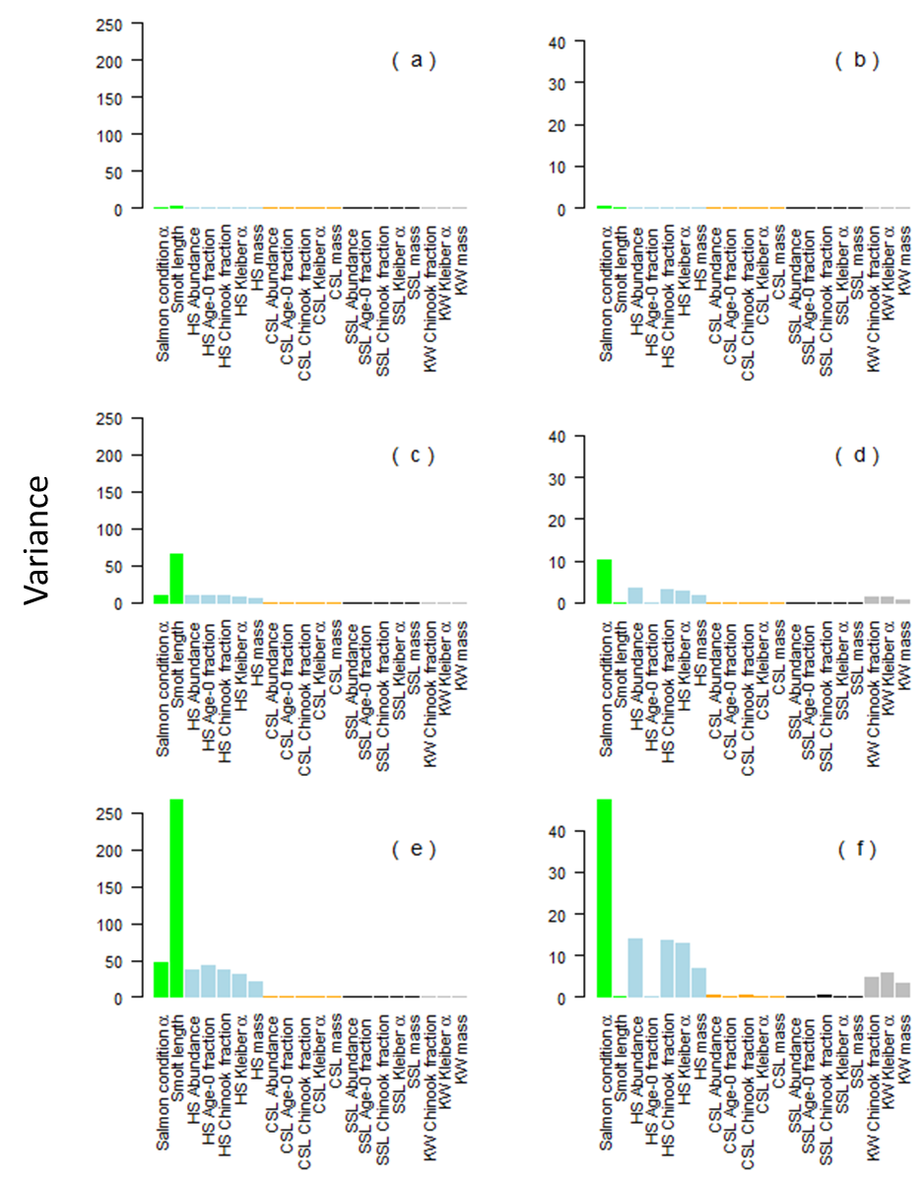

Figure 3.

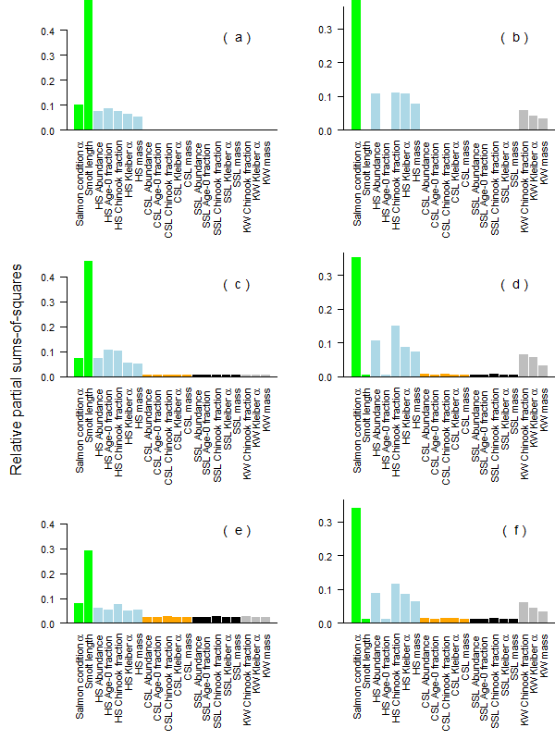

Figure 4.



Figure 5.

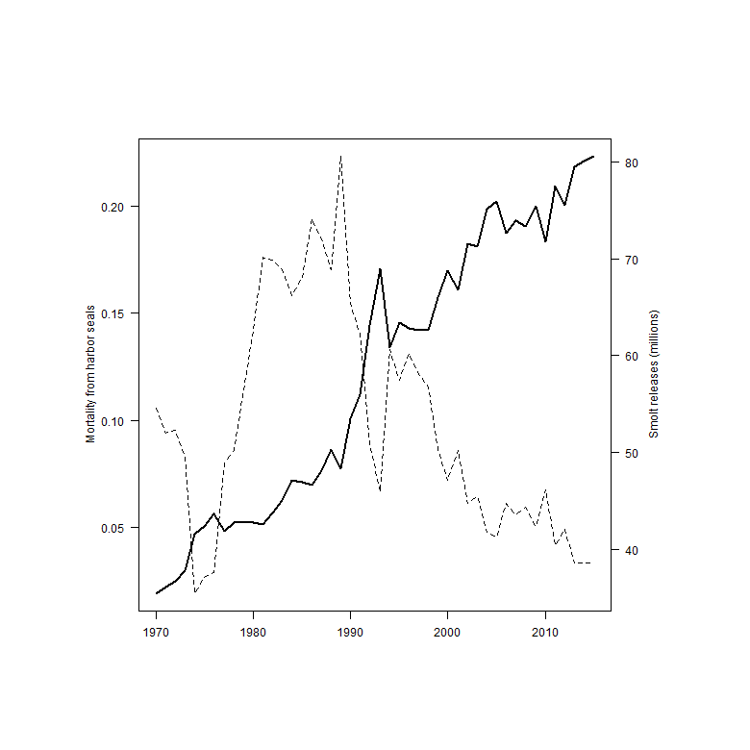

Figure 1. Annual consumption of Chinook salmon in Puget Sound by numbers (left column, in thousands) and metric tons (right column) by season for the four predator species. Seasons match those used within the FRAM model used for salmon management (Clemons et al. 2006).

Figure 2. Individual parameter perturbation (IPP) sensitivity analysis of the numbers (panels a, c, and d) and biomass (panels b, d, and f) of Chinook salmon consumed in 2015 based CVs of 0.02 (panels a and b), 0.1 (panels c and d), 0.2 (panels e and f) for the parameters and variables in the model. The colored bar group parameters related to salmon growth (green), and attributes related to harbor seals (blue), California sea lions (orange), Steller sea lions (black), and killer whales (grey).

Figure 3. Relative partial sums of squares (RPSS) sensitivity analysis of the numbers (panels a, c, and d) and biomass (panels b, d, and f) of Chinook salmon consumed in 2015 based CVs of 0.02 (panels a and b), 0.1 (panels c and d), 0.2 (panels e and f) for the parameters and variables in the model. The colored bar group parameters related to salmon growth (green), and attributes related to harbor seals (blue), California sea lions (orange), Steller sea lions (black), and killer whales (grey).

Figure 4. Potential mortality of adult Chinook salmon (thousands) returning to Puget Sound inland waters due to smolt consumption by harbor seals (a), Steller sea lions (b), and California sea lions (c), the predicted adult Chinook predation by killer whales based on the bioenergetics model (d), and the total catches in Puget Sound waters by commercial (e) and recreational (f) fisheries. Harvest between 2010 and 2015 are based on averages (PSIT (Puget Sound Indian Tribes) and WDFW (Washington Department of Fish and Wildlife) 2010) and estimates of age composition are based escapement data without ocean age 1 individuals which are below the legal size limit.

Figure 5. The number of juvenile Chinook salmon released (in millions) by Puget Sound hatcheries (dashed line) and the mortality as a function of the estimated harbor seal consumption (solid line), assuming that harbor seals in inland waters feed exclusively on Puget Sound hatchery Chinook salmon stocks.

Table . List of references that were used to build the bioenergetics model.

|  |  |  |  |  |
| --- | --- | --- | --- | --- |
| Data | Harbor seals | Steller sea lions | California sea lions | killer whales |
| Max age | Howard et al. (2013) | Winship et al. (2001) | R. de Long (pers. comm.) | 25+ |
|  |  |  |  |  |
| Weight at age | Pitcher and Calkins (1979) | Winship et al. (2001) | Winship et al. (2006) | Noren (2011) |
|  | Boulva and McLaren (1979) |  |  |  |
|  |  |  |  |  |
| Maturity at age | Pitcher and Calkins (1979) | Winship et al. (2002) | Winship et al. (2002) |  |
|  |  |  |  |  |
| Sex and age ratios | Bigg (1969) | Winship et al. (2002) | Winship et al. (2002) |  |
|  | Zier and Gaydos (2014) |  | R. DeLong (pers. comm.) |  |
|  |  |  |  |  |
| Predator presence |  | Jeffries et al. (2014) | Jeffries et al. (2014) | Hauser et al. (2007) |
|  |  |  |  |  |
|  |  |  |  |  |
| Predator abundance | Jeffries et al. (2003) | Jeffries et al. (2014) | Jeffries et al. (2014) | Center for whale |
|  |  | Wiles (2015) | NMFS (2015) | research (2016) |
|  |  |  | R. DeLong (pers. comm.) |  |
|  |  |  |  |  |
| Prey selectivity | Thomas et al. (2016) | Thomas et al. (In review) | Thomas et al. (In review) | Ford et al. (1998) |
|  |  | Scordino et al. (2014) | Scordino et al. (2014) | Hanson et al. (2010) |
|  |  |  |  |  |
| Energetic demands | Howard et al. (2013) | Winship et al. (2002) | Weise and Harvey (2008) | Noren (2011) |
|  |  |  | Winship et al. (2002) |  |

Table . List of subscripts, variables, and parameters of the model.

|  |  |  |
| --- | --- | --- |
| Type | Name | Symbol |
| Subscript | Predator |  |
|  | Predator age |  |
|  | Chinook age |  |
|  | Predator activity type |  |
|  | Predator sex |  |
|  | Day |  |
|  | Year |  |
|  |  |
| Superscript | Chinook | Ch |
|  | Inland waters | IW |
|  |  |  |
| Variable | Energetic demand |  |
|  | Reproduction costs |  |
|  | Growth costs |  |
|  | Activity costs |  |
|  | Lactation costs | LC |
|  | Chinook energetic content |  |
|  | Chinook consumed |  |
|  | Predator abundance |  |
|  | Predator weight |  |
|  | Chinook weight |  |
|  | Maturity |  |
|  | Fecundity | F |
|  |  |
| Parameter | Predator age and sex proportions |  |
|  | Fraction of predator population in inland waters |  |
|  | Activity fraction |  |
|  | Allometric constant for metabolism |  |
|  | Allometric constant for metabolism |  |
|  | Diet fraction |  |
|  | Age composition of Chinook in predator diet |  |

Table . Processes of the bioenergetics models by species where “” denotes the process is explicitly included in the energetic models: P = reproductive costs; GC = growth costs; Ef = metabolic efficiency; AC = activity costs. Parameter values and functional forms are detailed in Tables A1, A3, and A4. †The daily prey energy requirements in Noren (2011) - equations 3 and 4 - account for metabolic efficiency based on estimates from Williams et al. (2004).

|  |  |  |  |  |  |
| --- | --- | --- | --- | --- | --- |
| Species |  |  |  |  | Source |
| Harbor seal |  |  |  |  | Howard et al. (2013) |
| Steller sea lion |  |  |  |  | Winship et al. (2002) |
| California sea lion |  |  |  |  | Weise and Harvey (2008) |
|  |  |  |  |  | Winship et al. (2002) |
| Killer whales |  |  | † |  | Noren (2011) |

Table . Length (cm), energy content (kJ) and energy based on smolt equivalents for Chinook salmon with ocean ages from zero to five within the Puget Sound inland waters.

|  |  |  |  |  |  |
| --- | --- | --- | --- | --- | --- |
|  | smolt | age 1 | age 2 | age 3 | age 4 |
| Length (cm) | 9.0 | 50 | 71 | 84 | 92 |
| energy (kJ) | 54 | 12,280 | 36,694 | 62,028 | 82,400 |
| smolt equivalents | 1 | 211 | 631 | 1,067 | 1,418 |

Table . Fraction and ocean age distribution of Chinook in the diets of marine mammal predators in Puget Sound.

|  |  |  |  |  |  |  |
| --- | --- | --- | --- | --- | --- | --- |
|  |  | Chinook age composition | | | | |
|  | % diet | smolt | one | two | Three | four |
| harbor seals | 6.8% | 31.0% | 17.0% | 17.0% | 17.0% | 17.0% |
| Steller sea lion | 6.4% | 31.0% | 17.0% | 17.0% | 17.0% | 17.0% |
| Cal. sea lion | 6.1% | 16.0% | 21.0% | 21.0% | 21.0% | 21.0% |
| killer whale | 51-95% | 0.0% | 2.0% | 18.0% | 55.0% | 25.0% |

Table . Maximum daily energetic demands by sex for adult predators, and the maximum daily number of juvenile (ocean age 0) and adult (integrated across all ocean ages 1 to 4) Chinook salmon that are consumed during the predator’s period of peak occupancy.

|  |  |  |  |  |  |  |  |  |
| --- | --- | --- | --- | --- | --- | --- | --- | --- |
|  | Daily energy demands (kJ) | |  | Juveniles consumed | |  | Adults consumed | |
|  | male | Female |  | male | female |  | male | female |
| harbor seals | 14,908 | 14,807 |  | 5.32 | 5.37 |  | 0.02 | 0.02 |
| Steller sea lion | 177,163 | 104,621 |  | 2.09 | 1.24 |  | 0.25 | 0.15 |
| California sea lion | 95,408 | 36,091 |  | 0.26 |  |  | 0.14 |  |
| killer whale | 1,033,404 | 875,284 |  |  |  |  | 14.14 | 11.42 |

## Appendix:

## Reproduction and growth costs for harbor seals and Steller sea lions

### Reproduction costs

The daily production cost can be disaggregated into the gestation/pupping cost () and lactation cost (). Depending on the time of year the reproductive costs ( and ) will change for predators of different ages and sex. To account for these temporal effects we include an additional set of time-varying estimates,

where the variables and are the conditional probability of predator gestating or lacatating on day given that it is both mature () and fecund ().

Since males neither lactate nor give birth, is equal to zero.

The lactation and gestation costs listed below are conditional on a female actually producing offspring. For harbor seals the fecundity rate is 0.91 (Howard et al. 2013) and for Steller sea lions the fecundity rate is 0.63 (Winship et al. 2002). For killer whales, gestation and lactation costs are implicitly assumed to be included within other modeled metabolic costs.

In most instances, the models in the literature (Table 8) describe the annual costs of reproduction. Since and are the daily probability of a reproduction cost, then and are the daily fraction of the annual reproduction costs. The killer whale literature does not separate the production costs from the activity costs, since at the population level they are such a minimal cost compared to the activity costs. The gestation periods of the pinnipeds are based on the following literature,

Table A- . Summary of reproduction costs by predator.

|  |  |  |  |
| --- | --- | --- | --- |
| Variable | Predator | Model | Source |
|  | Harbor seal |  | Howard et al. (2013) |
|  | Steller sea lion |  | Winship et al. (2002) |
|  | California sea lion | implicit1 | Weise and Harvey (2008) |
|  | Killer whales | implicit1 | Noren (2011) |
|  |  |  |
|  | Harbor seal |  | Howard et al. (2013) |
|  | Steller sea lion |  | Winship et al. (2002) |
|  | California sea lion | implicit1 | Weise and Harvey (2008) |
|  | Killer whales | implicit1 | Noren (2011) |
|  |  |  |
|  | Harbor seal | 0.91 | Howard et al. (2013) |
|  | Steller sea lion | 0.63 | Winship et al. (2002) |
|  | California sea lion | implicit1 |  |
|  | Killer whales | implicit1 |  |

1The assumption is that these costs are implicit in bioenergetics models.

Table A- . Lactation and gestation periods for the each of the predator species.

|  |  |  |  |  |
| --- | --- | --- | --- | --- |
| Parameter | Species | Initial day | Ndays | Source |
|  | Harbor seal | 9 mos. before pupping | 214 (9 months) | Temte (1991, 1994) |
|  | Steller sea lion1 | 9 mos. before pupping | 214 (9 months) | Pitcher and Calkins (1981) |
|  | Harbor seal | May 25th | 28 – 42 | Muelbert et al. (2003) |
|  | Steller sea lion1 | May | six months | Mathisen and Lopp (1963) |

1Although, some studies indicate that sea lions lactate for up to nine months, many sea lions are seen lactating with 1-2 year old juveniles.

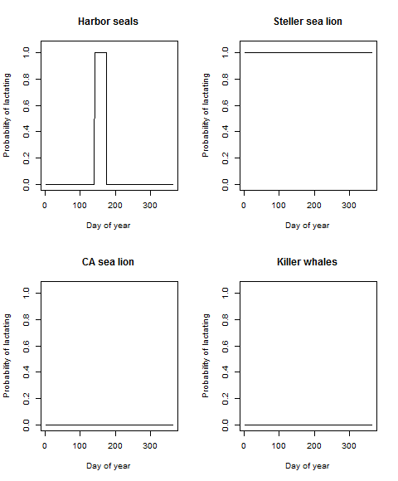

Figure A- . Periods for which lactation costs are factored into the bioenergetics model.

### Growth costs

The models for growth costs () are different for each predator. The Steller sea lion model is an annual estimate based the change in body mass, while the Harbor seal model is daily estimate for immature individuals. The growth costs for killer whales are integrated into the activity costs.

Table A- . The sources and model for determining growth costs for the predators.

|  |  |  |  |
| --- | --- | --- | --- |
| Variable | Predator | Model | Source |
|  | Harbor seal |  | Howard et al. (2013) |
|  | Steller sea lion |  | Winship et al. (2002) |
|  | California sea lion | implicit1 | Weise and Harvey (2008) |
|  | Killer whales | implicit1 | Noren (2011) |

1The assumption is that these costs are implicit in bioenergetics models.

### Efficiency

Efficiency measures the energy that is lost through excretion and digestive heat before it can be converted to maintenance or growth. Our estimate of efficiency () is the percentage energy left after waste () and digestive heat (). Calculating the conversion efficiency for each species is slightly different based on how the parameters were reported in the literature. Digestive efficiency for killer whales (84.7%) was accounted for in equations used to calculate daily prey energy requirements from field metabolic rates in Noren (2011).

Table A- . Efficiency calculations for the predator species.

|  |  |  |  |  |
| --- | --- | --- | --- | --- |
| Species | Efficiency calculation |  |  | Source |
| Harbor seal |  | 0.90 | 0.08 | Howard et al. (2013) |
| Steller sea lion |  | (pup, others) 0.95, 0.85 | 0.88 | Winship et al. (2002) |
| California sea lion |  | (pup, others) 0.95, 0.85 | 0.88 | Winship et al. (2002) |
| Killer whale | Ef = 0.847 |  |  | Noren (2011) |

## Population abundance

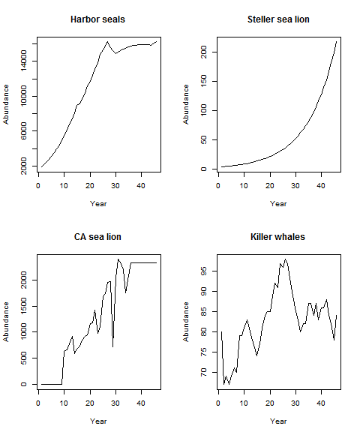

Figure_A-2. Estimated annual predator abundance.

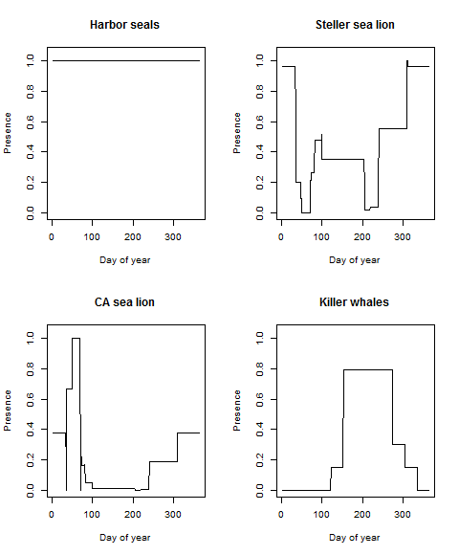

Figure A- 3. The probability of the predators being present in inland waters.

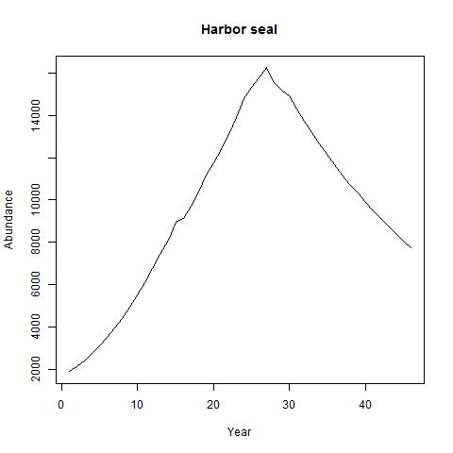

Figure A-4. Population abundance of harbor seals, 1970-2015, in Puget Sound based on an annual 4% decline beginning in 1999.

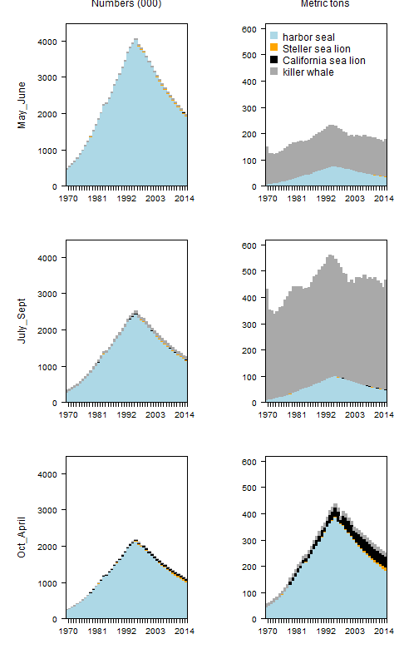

Figure A-5. Estimates of the annual consumption in numbers (left column) and biomass (right column) of Chinook salmon by marine mammal predators in Puget Sound between 1970 and 2015, assuming a 4% decline in harbor seal abundance beginning in 1999.

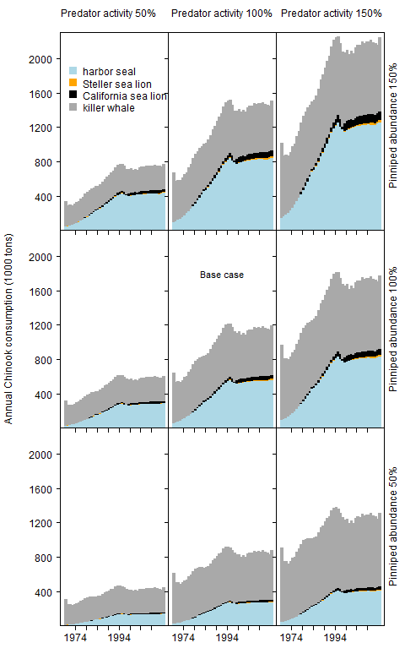

Figure A-6. The annual biomass of Chinook salmon consumed by each predator based on given combinations of pinniped abundance and predator activity.

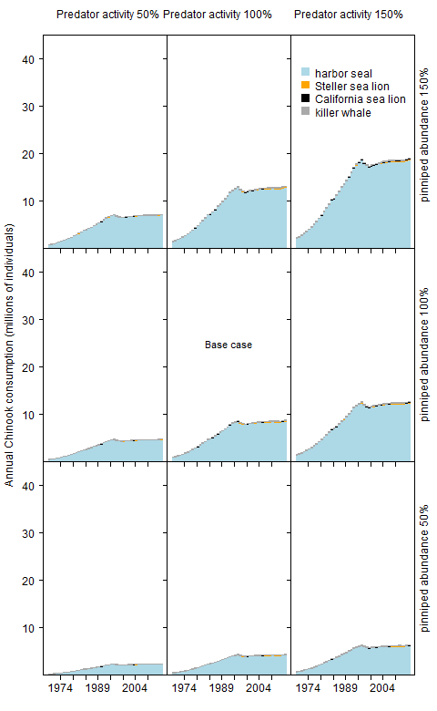

Figure A-7. The annual number of Chinook salmon consumed by the predators based on given combinations of pinniped abundance and predator activity.

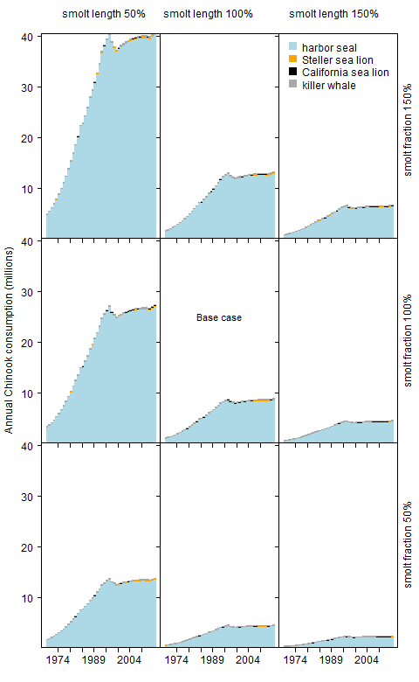

Figure A-8. The annual number of Chinook salmon consumed by the predators based on a given combination of smolt length and smolt fraction in the predator diets.