Title:

Estimates of Chinook salmon consumption in Puget Sound area waters by four marine mammal predators from 1970 – 2015

Authors: Brandon Chasco1, Isaac C. Kaplan2, Eric J. Ward2, Austen Thomas3, Alejandro Acevedo-Gutiérrez4, Dawn Noren2, Michael J. Ford2, M. Bradley Hanson2, Jonathan Scordino5, Steve Jeffries6, Scott Pearson6, Kristin N. Marshall7

1 Contractor to Conservation Biology Division, NOAA NMFS Northwest Fisheries Science Center, National Marine Fisheries Service, National Oceanic and Atmospheric Administration, 2725 Montlake Blvd. East, Seattle, WA 98117, USA

2 Conservation Biology Division, NOAA NMFS Northwest Fisheries Science Center, National Marine Fisheries Service, National Oceanic and Atmospheric Administration, 2725 Montlake Blvd. East, Seattle, WA 98117, USA

3 Smith-Root, Vancouver WA 98686, USA

4 Department of Biology, Western Washington University, Bellingham WA 98225, USA

5 Makah Fisheries Management, Neah Bay WA 98357, USA

6 Washington Department of Fish and Wildlife, Olympia WA 98501, USA

7 University of Washington, School of Fishery and Aquatic Sciences, Seattle WA 98105, USA

Abstract

Conflicts can arise when the recovery of one protected species limits the recovery of another through competition or predation. The recovery of many marine mammal populations on the west coast of the United States has been viewed as a success; however, within Puget Sound in northwest Washington State, USA, the increased abundance of three protected pinniped species, may be adversely affecting the recovery of threatened Chinook salmon and endangered killer whales within the region. Between 1970 and 2015, we estimate the annual biomass of Chinook salmon consumed by pinnipeds has increased from 68 to 625 metric tons. Because the diets of pinnipeds contain significant numbers of juveniles Chinook salmon, we transformed these juveniles into adult equivalents and found that by 2015 pinnipeds consume roughly double that of resident killer whales. Our analysis demonstrates the importance of an ecosystem perspective when evaluating species recovery. As more protected species respond positively to recovery efforts, managers should evaluate the trade-offs from these efforts with the unintended ecosystem consequences of predation and competition on other protected species.

# Introduction

The recovery of many marine mammals around the world is a conservation success story (Magera et al. 2013), but it has also created new challenges for managing coastal ecosystems (Marshall et al. 2015, Smith et al. 2015). The often increasing abundances of marine mammals, and the associated potential for increasing consumption of fish and invertebrate prey, creates the potential for conflicts between marine mammals and fisheries through competitive interactions. Therefore, adapting fishery stock assessment models and other natural resource management models to incorporate the effects of consumption by marine mammal predators may be needed to account for these trends and interactions in management decisions (Marshall et al. 2015).

Estimating predation mortality improves our understanding of predator - prey relationships and can inform fishery management reference points (Hollowed et al. 2000, Tyrrell et al. 2011). However, until recently many fisheries assessment models used around the world have ignored or made overly simplistic assumptions about trends in predation and other ecosystem processes (Skern-Mauritzen et al. 2015) that affect the productivity of commercially important fish stocks. Some examples of well documented marine mammal predation impacts on harvested fish stocks include Cape fur seal (*Arctocephalus pusillus pusillus*) predation on hake (*Merluccius poli*) in South Africa (Punt and Butterworth 1995), consumption of cod (*Gadus morhua*) by harp (*Pagophilus groenlandicus*) and grey (*Halichoerus grypus*) seals in eastern Canada (Mohn and Bowen 1996, Shelton et al. 2006), consumption of herring (*Clupea harengus*) and forage fish by large whales in the northeastern USA (Overholtz and Link 2007), harbor seal (*Phoca vitulina*) predation on Atlantic salmon (*Salmo salar*) in Scottish rivers (Butler et al. 2006), and consumption of salmon and forage fishes by pinnipeds in the northwestern USA (Wright et al. 2007, Thomas et al. 2011).

We focus here on marine mammal predation on Chinook salmon (*Oncorhynchus tshawytscha*), a culturally and ecologically important species of the north eastern Pacific. Chinook salmon are the largest of the Pacific salmon species, and their anadromous life history connects freshwater and terrestrial ecosystems throughout the Pacific Rim (Hocking and Reynolds 2011). The species serves as prey for top predators in the region (e.g., Hanson et al. 2010), and contributes to an $11.6 million commercial salmon fishery in Puget Sound and to a $47 million statewide recreational saltwater salmon fishery (T. C. W. Economics 2008). However, many natural stocks of Chinook salmon have been extirpated (Gustafson et al. 2007) or are at historically low levels and are protected under the Endangered Species Act (Ford 2011). Chinook salmon biomass in many systems has been maintained largely through releases of juvenile fish from hatcheries, but even so abundance remains well below historical levels (Naish et al. 2007). Causes for the decline of natural stocks include loss and degradation of freshwater spawning and rearing habitat, loss of habitat access due to hydropower dams and other blockages, historical overfishing, and interactions with artificially propagated fish (Ruckelshaus et al. 2002). More recently, predation by marine mammal and avian predators has been identified as a potential factor limiting recovery (Roby et al. 2003). Quantifying the magnitude of marine mammal predation and putting this in the context of other factors impacting Chinook salmon is therefore becoming increasingly important.

The objective of our paper is to estimate temporal trends in both numbers and biomass of Chinook salmon consumed in the waters in and around Puget Sound, Washington, USA by four species of marine mammals (California sea lions *Zalophus californianus*, Steller sea lions *Eumetopias jubatus*, harbor seals *Phoca vitulina*, and killer whales *Orcinus orca*). In this region, endangered resident killer whales are known to be highly specialized predators on salmon (Ford et al. 1998, Hanson et al. 2010, Ford et al. 2016), and previous authors have estimated the magnitude of this predation (Williams et al. 2011). However, harbor seals, Steller sea lions, and California sea lions also prey on Chinook salmon, and prey-limitation has been identified as one of the biggest threats to resident killer whales (Ward et al. 2009). In particular, this region is thought to have one of the highest densities of harbor seals in the world, with abundance spurred by rapid population growth over the period 1970 - 2000 (Jeffries et al. 2003). These predators differ in their foraging characteristics, such as reliance on Chinook salmon as prey, size of salmon they target, and the season and spatial location of feeding. Here we develop a model to evaluate the relative importance of these four species as sources of mortality on Chinook salmon. We are particularly interested in understanding temporal trends in predation mortality, in the context of understanding whether competition for a shared prey resource is an important factor limiting the population growth of endangered Southern Resident killer whales.

We focus our analysis on Puget Sound region because the policy context is representative of many nearshore ecosystems (Marshall et al. 2015) and because this is a data-rich region that can serve as a case study to later expand to the broader United States and Canadian West Coast. Our study region encompasses Puget Sound and nearby U.S. waters, including the Strait of Juan de Fuca, Hood Canal and the San Juan Islands area. Both predators and prey in this area are federally protected and subject to ongoing recovery efforts. Chinook salmon from Puget Sound was listed as threatened under the Endangered Species Act (ESA) in 1999 (“Federal Register 64(56):14307-14328” 2005). Six years later, the Southern Resident killer whale population was listed as endangered, in part due to concerns about an adequate prey base (“Federal Register 70(222):69903-69912” 2009). Potential competitors with the killer whales, such as California sea lions, Steller sea lions, and harbor seals, are protected under the USA Marine Mammal Protection Act. The Puget Sound region provides a good case study for examining trends in marine mammal predation both because of the challenges associated with simultaneously recovering a group of interacting predator and prey species, and because it has more precise estimates of marine mammal abundance trends and diets (e.g. scat samples) than many other regions. In the future, the flexible bioenergetics and diet modeling framework we develop here will be expanded to evaluate trends in marine mammals and tradeoffs with Chinook salmon at a coast-wide level.

# Methods

Though the Salish Sea consists of USA and Canada waters, we focused our initial modeling efforts to geographically include the inland waters of Puget Sound and the surrounding area, which encompasses the Strait of Juan de Fuca, Hood Canal, eastern bays, and the San Juan Islands in northwest Washington State, USA. The primary rationale for this constraint is that the temporal and spatial coverage of marine mammal survey counts and marine mammal diets (e.g. scat samples) that are published in peer reviewed literature or government reports is more complete relative to other areas on the west coast where these predators are known to overlap with Chinook salmon. The model we develop below consists of a set of nested equations that reflect the life history of the focal prey species (Chinook salmon) and the level of specialization by the predators based on their age, sex, activity level, and their presence within Puget Sound waters. The specific bioenergetics parameters for each predator species are based on published literature (Table 1). Rather than describe the details of each species-specific model for the individual predators, we provide general forms of the equations, and refer the reader to Appendix A and to our simulation code for detailed implementations for each species (<https://github.com/bchasco/PSC>). A full list of the variables and all model parameters is provided in .

## Modeling energetic demands of the predators

The energetic demands of the four predator species were based on the general Kleiber (1975) model for basal metabolism, which is a power function that depends on the body mass (*Mb*) of the predator.

Equation .

The model of energetic demands is often disaggregated into different energy costs,

Equation .

where, the variable $P_{h,i,s,t}$ is the reproductive cost, $GC_{h,i,s,t}$ is the growth cost associated with an increase in body mass, $AC_{h,i,j,s,t}$ is the sum of all activity costs, and $Ef_{h,i,s,t}$ is the fraction of total energy not lost to heat or excretion (Appendices Tables A1-A3, Figure A-1, Figure A-2). We allowed each of our four predator species (killer whales, harbor seals, California sea lions, Steller sea lions) to have unique parameter values taken from existing bioenergetics literature (Table 3); these previously published estimates assume that reproductive and growth costs for California sea lions and killer whales are sufficiently small and that the majority of the energetics costs are accounted for by the activity costs (i.e., the reproductive and growth costs implicitly included in activity costs).

The energy model (Equation 1) can be extended to account for age ($i$), activity ($j$), and sex ($s$) specific differences for a predator ($h$) throughout the year. Energetic costs are modeled on a daily time step (day $t$), and activities can be broken down into proportions of the total time doing each activity $j$ ($f_{h,j,i,s,t}$), and the body mass ($M_{b,h,i,s}$) of predator $h$, resulting in a modified Kleiber model (allowing for scaling of the basal metabolic rate):

Equation .

The parameter $β_{h,j}$ has been set to 0.75 for killer whales, California sea lions, and Steller sea lions; however, for harbor seals the power parameter ranges between 0.76 and 0.87, depending on their activity state (Howard et al. 2013). The body mass for the predators was taken from life history tables or estimated based on growth models in the published literature (see Table 1 for references).

By modeling the body mass at age of the predators, our model retains the flexibility to track the impacts of individual predator cohorts. The marine mammal bioenergetics literature often uses coarser stages (e.g., pup, juvenile, adult), so to map the stage-based parameters in the literature to our age-based models we used information about the maturity-at-age. Parameters related to the pup stage were mapped directly to age zero ($i=0$) individuals, such that $θ_{i=0}=θ_{pup}^{*}$ where $θ^{*}$ is any generic stage-specific parameter in the literature. Parameters for individual animals older than age 0 were a weighted average of the juvenile ($θ_{juvenile}^{*}$) and adult ($θ_{adult}^{*}$) parameters based on the maturity at age ($m_{i}$)

Equation .

Each component of the bioenergetics models (Equation 1) likely has associated uncertainty, however many of these parameters are often reported without error, or fixed (e.g., $β_{h,j}=$ 0.75). Because the focus of this analysis is on predation, we focused our modeling work on the largest source of uncertainty (fraction of Chinook salmon in the diet of each predator) rather than uncertainty in bioenergetics parameters. Sensitivities to uncertainty in other model parameters could also be explored, but this uncertainty would not alter the average consumption estimates from our models, given that all bioenergetics parameter values were based on mean values from the literature.

## Predator population dynamics, 1970-2015

The daily energetic demand of predator $h$, age $i$, and sex $s$ is the product of the numbers-at-age ($N_{h,y}$) in year *y* (Appendix Figure A-2)*,* the proportion of the animals in each age class by sex and year ($p_{h,i,s,y}$), and the fraction of the population present in inland waters on day $t$ ($ψ_{h,t}$) (Appendix Figure A-3),and the daily energetic demands ($E_{h,i,s,t}$; Equation 2).

Equation .

For each of the predators in the model, we estimate the numbers-at-age from 1970 to 2015. The age, sex and abundance of Southern Resident killer whales in inland waters were based on mark-recapture surveys (Center for Whale Research 2016), and since 1976 there has been a complete census of the population . For pinnipeds, time series of sex and age structure do not exist, but time series of abundance at the sub-population scale can be combined with point estimates from inland waters.

To generate estimates of harbor seal abundance, we used haul-out counts for the five population segments that make up the inland stock of harbor seals in Washington, for the years 1978-1999 (Jeffries et al. 2003). Because these time series included missing values (particularly in later years), we fit univariate state space models to the data from each population segment (Ward et al. 2010, Holmes et al. 2012) using the MARSS package in R (Holmes et al. 2012; R Core Development Team 2015). We assumed that all five population segments had the same observation error variance (because they were conducted from the same aerial survey platform), but allowed each time series to have unique trends, carrying capacities, and process variances. The estimated states from each of the five population segments were then summed to create an abundance estimate for the total inland stock of harbor seals in Washington. The time series represent haul-outs only, so we have multiplied the estimates by 1.53 to account for individuals in the water (Huber et al. 2001). Because uncertainty exists in both the correction factor and harbor seal numbers (specifically, whether the population has been stable or declined slightly since 2000), we performed a sensitivity test to these assumptions. Although uncertainty in this correction factor exists (varying between 1.43 and 1.85 depending on regional location; (Huber et al. 2001)), the linear properties of Equation 5 assume that any change in the correction factor results in a proportional change in the energy derived from Chinook salmon. To model the scenario where harbor seals declined after 1999, we imposed a 4% decline consistent with other surveys (Pearson unpub. data (2016)). Results from this scenario are included in the Appendix (Figure A-4, Figure A-5). To determine the stable age distribution and sex ratio for harbor seals, we assume an initial 50/50 sex ratio for the pups and use stage-based mortality and fecundity estimates by Biggs (1969) to estimate the sex ratio for older ages.

Estimates of Steller sea lion abundance in inland waters are based on a time series of haul-out surveys along the outer coast of Washington State from 1989-2015 (Wiles 2015), and aerial surveys of inland haul-outs during 2013 (Jeffries et al. 2014). Similar to harbor seals, we estimated abundance for years with missing surveys using univariate time-series model in the MARSS package (assuming that inland and coastal trends in sea lion numbers are the same). This time series was then scaled to peak counts from inland waters (109 in 2013). To account for Steller sea lions that are not hauled out during the surveys, we applied a correction factor of 2 (National Marine Fisheries Service (NMFS) 1997). The sex and age ratio is based on age-specific survival estimates by Winship et al. (2002).

California sea lion abundance was based on relative population trends and point estimates of counts occurring in inland waters. To account for missing years in the California sea lion stock assessment (NMFS 2015), we implemented a univariate state-space model similar to the one applied for harbor seals and Steller sea lions. We assumed that the overall trend of California sea lions in Puget Sound was the same as the population trend of the entire stock, but we have little information for sea lion abundance within Puget Sound to scale the coast-wide estimate. There are minimum counts occurring in 1978 (no California sea lions were observed) and a peak abundance estimate of 1200 in 2005 (R. DeLong, NOAA MML, Seattle, Washington, pers. comm., 2016) which we use to scale the coast-wide estimate. Finally, we adjusted this index of abundance by a factor of 2 to account for seals that are not hauled out during the surveys (National Marine Fisheries Service (NMFS) 1997). The only California sea lions present in inland waters are non-pup males (Akmajian et al. 2014).

Because of availability of prey, and behavior (e.g. seasonal breeding seasons) the fraction of each predator’s population in inland waters ($ψ_{h,t}$) changes throughout the year. Harbor seals are the only predator that does not migrate outside of the Puget Sound region ($ψ_{h,t}=1, ∀t$). Killer whales have a seasonal presence in inland waters from May to September and are absent during the winter months (Hauser et al. 2007), and studies suggest that even during the summer months resident whales only occupy inland waters about 80% of the time. Based on continuous monitoring of haul-outs throughout the year, Steller sea lions have a bimodal distribution with a peak in early fall and winter and again in late spring through early summer, while California sea lions are only present from late fall through winter (Jeffries et al. 2014). The differences in abundance between surveys can be rather large, so to smooth the seasonal observations of sea lion presence by Jeffries et al. (2014) we average each abundance survey with the one before and after. To transform these average survey abundances to presence probabilities between zero and one, we divide each average abundance by the maximum average abundance.

## Number of Chinook consumed, 1970-2015

The number of Chinook salmon of age $a$ that are consumed by predator $h$ is a function of the daily energetic demands of the predator ($E_{h,i,s,y,t}$; Equation 5), the fraction of predator's energy derived from Chinook salmon ($ϕ_{h,t}$), the proportion of the diet energy that is comprised of each age class of Chinook salmon ($ν_{h,a}$), and the age-specific energetic content of the Chinook salmon ($E_{a}^{Ch}$),

Equation .

This method assumes a single spatial box where the predator’s ability to capture the Chinook salmon is not influenced by competition from other predators, or the densities of the salmon within Puget Sound.

The fraction of prey species in the scat samples of predators is assumed to be proportional to the amount of energy derived from those prey species. Within Puget Sound, the diet fraction of Chinook salmon in resident killer whales has been estimated to range from 0.51 in the fall to 0.95 in the spring/summer based on observational studies and genetic analysis of scats (Ford et al. 1998, Hanson et al. 2010, Ford et al. 2016). The fraction of Chinook salmon in harbor seal diets is estimated to be 0.068 based on combination of morphological identification of bones and genetic analysis (Thomas et al. 2016).

Steller and California sea lion diet data in Puget Sound are dominated by frequency of occurrence (FO) studies (Wiles 2015), which only identify salmon to genus. Additionally, FO quantifies the fraction of times prey were identified in a group of scat samples, which means the prey FO do not sum to one and are not representative of the diet fraction of prey (Tollit et al. 2015). In the absence of salmon species-specific diet fraction data for sea lions, we applied conversion factors derived from harbor seals to sea lion FO data (Thomas et al. 2016), to derive sea lion Chinook salmon diet percentages. This approach relies on the assumption that the relationship between salmon bone FO and Chinook salmon diet fraction is the same for all three pinniped species. While this is a large assumption, it is reasonable given their common habitat and the absence of superior diet information. Based on these calculations, the FO data suggest Chinook salmon diet fractions for Steller sea lion to be 0.064 and for California sea lions to be 0.061.

The energy content of the different ages of Chinook salmon was based on work by O'Neill et al. (2014),

Equation .

where, is the average length-at-age for the Puget Sound populations. Table 4 shows the average length of the different age salmon, the energy content in kcal, and the energy content relative to a smolt (i.e., smolt equivalents). A five year old salmon that is 92 cm has the energetic equivalent of 1,418 smolts that are 9.5 cm long.

The rapid increase in energy content from smolt to age one can have major implications on the number of salmon consumed. To account for the growth of smolts during their time in inland waters we used models developed to approximate juvenile Chinook growth (Beauchamp and Duffy 2011). On average, hatchery smolts in Puget Sound are about 9.5 cm during the spring release and reach about 14-15 cm by September. We therefore increased the length of the smolts by about 2.5 cm a month, such that the smolts become ~40 cm juveniles by the following spring. By assuming only a single size at release, this model simplifies many of the stock-specific differences related to migration timing and juvenile life histories (i.e., yearling vs. sub-yearling, or hatchery vs. wild), and treats all salmon in Puget Sound as originating from a single stock. To further simplify our model, we do not assume any intra-annual growth for salmon ages one to four.

The distribution of the Chinook salmon age classes in the predator diets ($ν_{h,a}$) is based on diet studies by Ford et al. (1998) and Ford and Ellis (2006) for killer whales, Thomas et al. (2016) for harbor seals, and Wiles (2015) for Steller and California sea lions (Table 5). Killer whales feed almost exclusively on mature salmon and the age composition (based on years in the ocean) of Chinook in their diet is 2% age one, 18% age two, 55% age three, and 25% age four(Ford and Ellis 2006, Hanson et al. 2010). Based on scat samples, the composition of Chinook salmon consumed by pinnipeds is only described as juvenile or adult. Approximately 31% of the Chinook salmon in harbor seal diets is derived from juveniles (Thomas et al. 2016), while 31% and 16% of the diets for Steller and California sea lions, respectively, are juveniles (Scordino et al. 2014). Without additional information about the size of the adult Chinook in the pinniped diets, we assume that the adult Chinook diet fraction is distributed evenly across the four adult age classes.

## Chinook population dynamics and movement

To quantify effects of smolt consumption on the future returns of mature fish, we adopted a simple forward projection model. This is a heuristic approach with a single stock model and annual time-steps, and it is meant to act as a starting point for a future, more complex temporally and spatially explicit multi-stock Chinook salmon model.

The annual consumption of smolts by the pinniped populations, $C_{y,0}^{h}$, is the sum across all days within a year ($\sum_{s}{\sum_{t}{C_{h,s,a=0,y,t}^{Ch}}})$, where is *h* is the predator type. Comparing the effects of predation across predators with different preferences (smolts, adults) requires using a common currency, and accounting for the survival between juvenile and adult stages. In order to compare these effects on the same scale, the adult equivalent of smolt consumption was estimated subjecting smolts that would have been lost to predation to natural mortality and maturation. Survival and maturation are a function of the age-specific ocean survival and maturation schedule,

Equation 8. $C_{y,a}^{h}=C_{y-1,a-1}^{h}×{surv}_{a-1}×\left(1-r_{a}\right), ∀a>0$

where, $surv_{a-1}$ is the survival from $a-1$ to $a$, and $r_{a}$ is the conditional probability of maturing at age $a$. The number of the adult Chinook salmon returning to inland waters (IW) is the number surviving up to year *y* times the conditional probability of returning at age *a,*

Equation 9. $C_{y,a}^{IW}={surv}_{a-1}×r_{a}×\sum_{h}{C_{y-1,a-1}^{h}}$

There are 27 distinct stocks of Chinook salmon in Puget Sound, each of them with varying levels of ocean survival and age composition (Myers et al. 1998). Some coarse estimates of ocean mortality are from Argue et al. (1983): the bi-monthly instantaneous mortality rates are 0.035, 0.015, and 0.0075 for ocean ages 1, 2, and 3+, respectively. These translate into annual survival estimates of 0.43, 0.69, and 0.83, which are estimates of the aggregated sources of natural mortality, and not attributable to any species-specific sources of mortality. Our goal was to roughly match the average age composition seen across stocks in Myers et al. (1998) prior to the large increases in the pinniped populations within Puget Sound, and treat the Chinook salmon population in Puget Sound as a single stock. We assume a single aggregate population with conditional probabilities of maturing at ocean ages 1, 2, 3, and 4 equal to 0.02, 0.45, 0.85, 1.0, respectively. From this, we estimate the average proportional age distribution (by ocean ages one to four) of adult fish returning to Puget Sound would be 0.05, 0.52, 0.37, and 0.06. These estimates are similar to the age composition of returning Puget Sound Chinook salmon averaged across stocks (Myers et al. 1998). For our forward projection model, we assume these ratios are constant for each cohort and year.

## Sensitivity analysis

We explored the sensitivity of the estimated number and biomass of Chinook salmon consumed to the following model inputs: 1) the length of the juvenile Chinook between April and June, 2) the fraction of Chinook smolts in the predator diets, 3) the total pinniped abundance, and 4) the predator activity multipliers (𝛼 in Equation 3). When changing the fraction of smolts in the predator diets, we assumed that difference was applied evenly over the other Chinook age classes. For instance, a 50% decrease in harbor seal smolt fraction from 31% to 16% results in a 4% increase in the diet fractions of the other Chinook ages. We attempt to bracket a reasonable level of uncertainty by varying these smolt fraction inputs by ±50% of their mean values used in our base case model.

# Results

## Daily consumption rates

The maximum daily energetic demands for male and female predators in inland waters ranged from 3,539 kcal (1.48 x 104 kJ) for female harbor seals to 247,364 kcal (1.03x 106 kJ) for male killer whales (). Estimates of the average number of juvenile Chinook salmon consumed daily by pinnipeds ranged from 0.24 individual fish for male California sea lions to 5.4 smolts per day for male and female harbor seals (Table 6). The daily consumption of adult Chinook across all predators ranged from 0.02 for male and female harbor seals to 14.1 for male killer whales. Consumption estimates for male predators of a given age were consistently higher than females because of their size. The exception was the peak energetic demands of female harbor seals during lactation and pup rearing, which was comparable to the peak energetic demands of the larger male harbor seals.

## Comparing numbers to biomass consumed

The time-series of Chinook salmon consumption by predator showed considerable differences depending on whether the unit of currency is numbers (, left) or biomass (, right). Summed across all seasons, beginning in 1970 the harbor seals were estimated to consume a total of 1.1 million individual Chinook, approximately thirteen times greater in number than the 84,500 Chinook salmon consumed by killer whales that year. By 2015, the number of Chinook salmon consumed by harbor seals was estimated to have increased to 8.6 million, or more than 104 times the 80,000 Chinook estimated to be consumed by killer whales. As a sensitivity test, we also ran a scenario in which harbor seal populations declined by 4% annually after 1999, resulting in decline in their total Chinook salmon consumption in 2015 to 4.1 million individuals (Appendix Figure A-5). In 2015, Steller and California sea lion consumption of individual Chinook is closer to killer whales, with 104,000 and 55,700 individuals consumed, respectively. The annual biomass of Chinook salmon consumed has remained relatively constant for killer whales, ranging from 576 to 567 metric tons between 1970 and 2015, but the consumption by pinnipeds has increased from 68 to 625 metric tons. The ratio of biomass consumption by killer whales to pinnipeds during the summer months (May through September when whales are most likely present) has decreased from 26:1 in 1970 to 3:1 by 2015.

also displays the seasonal variability in Chinook salmon consumption based on predator occupancy within the spatial confines of the Puget Sound and surrounding inland waters. Killer whales are nearly absent during the late fall through winter months, and as a result their consumption of Chinook salmon decreases from an average 554 metric tons during spring and summer in 2015, to just 13 thousand metric tons during the fall and winter. Conversely, sea lion abundance peaks during the fall and winter months, and consequently their consumption decreased from 54 metric tons during fall and winter of 2015 to 3 metric tons during spring and summer. Harbor seals are year-round residents so their consumption is evenly distributed, with between 38.0 to 55.0 tons per month depending on their breeding/pupping activity.

**Sensitivity analysis**

Sensitivity results are shown as 3x3 contingency plots based on changes in the predator characteristics (Figures A-6 and A-7) and Chinook salmon characteristics (Figure A-8). A 50% increase or decrease in either the predator activity multipliers or the predator abundance leads to the same proportional changes in the biomass (Figure A-6) or number (Figure A-7) of Chinook consumed. Conversely, there is a non-linear response in the number of Chinook salmon consumed as a function of smolt length (Figure A-8); a 50% decrease in smolt length leads to an ~300% increase the number of Chinook consumed (left column relative to middle column Figure A-8), whereas a 50% increase in smolt length leads to an ~50% decrease in the number of Chinook consumed (right column to middle column Figure A-8). Similar to the changes in the predator abundance and predator activity, changes in the smolt fraction in the pinnipeds diets leads to the same proportional change in the number of smolts consumed.

## Pinniped effects on future returns

Between 1970 and 2015, most of the estimated increase in consumption on salmon resulted from pinniped predation on juvenile salmon smolts (Figure 2). Smolt consumption for harbor seals was estimated to increase from 1.1 million in 1970 to a peak of 7.8 million in 2015, while consumption of adult Chinook increased from 10,400 to 89,000. The combined smolt consumption by Steller and California sea lions was estimated to have increased from 1,800 in 1970 to 143,900 in 2015, while their consumption of adult Chinook salmon increased from 42 in 1970 to 14,400 in 2015.

Based on our simple salmon life history model, which does not include density dependent mortality or other sources of predation (e.g., piscivorous birds, porpoises, etc.), we estimate the adult equivalents from smolt consumption by pinnipeds. Our results suggest that the total adult returns within Puget Sound during 2015 would be diminished by 1,000 individuals due to California sea lions, 1,900 due to Steller sea lions, and 158,700 due to harbor seals (Figure 3a-c). Summed across all pinnipeds, the total annual potential losses increased from 18,800 in 1970 to 161,600 in 2015. The total potential loss from pinniped predation in 2015 is double the estimated consumption of 83,200 adult Chinook salmon by killer whales (Figure 3d).

# Discussion

Our modeling demonstrates the dynamic nature of marine mammal impacts on Chinook salmon in Puget Sound waters. Our bioenergetics modeling results show that although harbor seals likely consume less Chinook salmon biomass compared to fish-eating ‘resident’ killer whales, seals consume many more Chinook salmon in terms of numbers of fish. The selectivity or size preferences of the two species are very different, however -- the Chinook salmon in pinniped diets are almost entirely smolts, so when delayed effects of Chinook maturation are accounted for, predicted impacts of seals on future adult salmon returns is potentially double the annual consumption by killer whales.

A considerable amount of work has examined the bottom-up forces affecting Chinook survival (e.g., climate change (Scheuerell and Williams 2005), habitat (Kareiva et al. 2000), nutrients (Scheuerell et al. 2005)), but top-down forcing is also suspected to play an important role in early marine survival within Puget Sound. Recently, Duffy and Beauchamp (2011) and Beamish et al. (2012) concluded that much of the marine mortality of Chinook salmon occurs during the first several months as the result of local conditions in the river estuaries, but attributing this to specific predators can be difficult. Based on our bioenergetics model that accounts for size selectivity of the predators, we found that pinnipeds – and in particular harbor seals - are a possible factor in this early marine mortality as they prey on smolts.

Our bioenergetics modeling assumes there is temporal and spatial overlap of harbor seals with outmigrating Chinook smolts; however, seals do not feed exclusively in river mouths or estuaries (Orr et al. 2004, Lance and Jeffries 2007, Luxa and Acevedo-Gutiérrez 2013) and the proportion of Chinook salmon in the diet can be highly variable (Thomas et al. In review). When scaled up to the population level, the predicted daily consumption of Chinook salmon by an individual seal in our bioenergetics models is about 5.4 smolts per day during the spring outmigration. The plausibility of these estimates depends in part on harbor seal feeding behavior – individual seals may differ in their preference or encounter rate of smolts, with some individuals having a disproportionately large impact on the population. Harbor seals alter their feeding behavior in response to seasonal pulses of other species like herring (Thomas et al. 2011), where frequency of occurrence of herring increases to about 40% during their spawning season. Following the pulse of herring spawning from February to April, harbor seals in inland waters may switch to wild and hatchery released (~40 million annually) smolts entering Puget Sound between May and July.

In addition to the mechanistic relationship between smolt mortality and pinniped bioenergetics, the decline in Salish Sea Chinook salmon marine survival (i.e., ~4.0% to <0.5% from the mid-1970s to late 1990s; Quinn et al. 2005) coincides directly with the increase in the abundance of harbor seals. While several factors such as increasing temperatures in inland waters (Beamish et al. 2012), competition (Ruggerone and Goetz 2004), and changes in productivity (Mantua et al. 1997) have also been correlated with the declines, the scale and consistent longer term trend of harbor seal abundance should not be overlooked as a potential contributor for declining marine survival. Assuming that Puget Sound Chinook comprised 100% of the smolt in the diet of resident Puget Sound harbor seals (an overestimate, given that Chinook smolts originating from British Columbia are also present in inland waters), we estimate the annual consumption rate of just hatchery smolts (based on smolt release data from Puget Sound Chinook Salmon Hatcheries (2004))has increased from 1.8% in 1970 to 22.4% in 2015 ().

The impacts of increasing pinniped abundance (and subsequent impacts on populations of fish prey) are not confined to just Chinook salmon. Many other potential pinniped prey are species of concern or listed under the USA Endangered Species Act (herring, rockfishes *Sebastes* spp., steelhead *Oncorhynchus mykiss*) and may be affected by the increasing energetic demands of growing marine mammal populations (Ward et al. 2012). Additionally, these changing demands may also impact other top predators. Adult Chinook salmon are an important part of the Puget Sound commercial and recreational fishery, and they are also the preferred prey of endangered Southern Resident killer whales (Ford and Ellis 2006, Hanson et al. 2010, Ford et al. 2016). There is evidence to suggest that variation in birth and death rates of Southern Resident killer whales is linked to changes in Chinook salmon abundance (Ward et al. 2009, Ford et al. 2010). Our estimate of potential reductions to adult Chinook salmon abundance due to predation on smolts and sub-adults by pinnipeds () could lead to reduction in the productivity or carrying capacity of Southern Resident killer whales. As a comparison, potential losses from pinnipeds are comparable to commercial catches in Washington State inland waters, which have declined from 250,000 adult Chinook in 1980 to 100,000 presently, and recreational catches that have declined from 150,000 to 50,000 (Comprehensive Management Plan for Puget Sound Chinook: Harvest Management Component 2010).Though our model is sensitive to assumptions regarding both marine mammals and Chinook salmon, the main results are robust to these uncertainties: across a broad range of parameter values for predators and prey, harbor seals and fish-eating ‘resident’ killer whales account for the large majority of consumption of Chinook salmon biomass, and harbor seals consume many more Chinook salmon in terms of numbers of fish. The ranking of harbor seals versus killer whale consumption of Chinook salmon biomass depends on uncertainty in pinniped abundance (killer whale abundance is known with high precision), but consistently across our scenarios these two species had higher Chinook salmon consumption than did California or Steller sea lions. Our model is linearly sensitive to uncertainty in most parameters. For instance, results regarding both biomass and numbers of Chinook salmon consumed (Figures 1-2) depend critically on our parameterization of predator diet fraction and size selectivity (); therefore, any change in either of those parameters will lead to a proportional change in the consumption. Our results regarding numbers (but not biomass) of Chinook salmon consumed also depend upon assumptions regarding the ratio of juveniles and adults in the diets, and the size of the juvenile Chinook salmon in inland waters. The parameterization of juvenile fish size can have a profound and nonlinear effect, because the energy content of a fish increases with the cube of its length (Equation 7). If we reduce the smolt length at release from 95 mm to 45 mm (the difference between releasing fingerlings or fry), the energy content of a juvenile is reduced by ~90%, and therefore the number of individual Chinook needed to meet the energy demands of a predator is increased by a factor of 10.

# Future research

This analysis represents a bioenergetics model within a portion of the range of Chinook salmon from Puget Sound. Puget Sound harbor seals may be one cause of the steep drop in the survival of local Chinook salmon stocks, but other predator populations may also consume substantial numbers of salmon. Juvenile Chinook salmon from Puget Sound generally migrate north in the Northeast Pacific to coastal waters in the Gulf of Alaska, where they may encounter a wide range of other sources of mortality. The harbor seal population in southern British Columbia, for example, is thought to be much larger than that of Puget Sound (Population assessment Pacific harbour seal(*Phoca vitulina Richardsi*) 2010). Furthermore, there are other populations of salmon-eating killer whales that inhabit the inland waters of southern British Columbia and southeast Alaska. These northern populations of killer whales are also increasing in abundance and could be an increasing source of mortality for Chinook salmon originating from more southern rivers. The California sea lion range does not extend north of Puget Sound, thus they are unlikely to be an additional source of mortality, but the southeast Alaska Steller sea lions population has increased to ~50,000 individuals since 1979 and could provide a significant source of predation based on the diet studies of Tollit et al. (2015). Future research will extend our analysis to include additional spatial components for the predators in the British Columbia and southeast Alaska inland waters. This will necessitate a salmon migration model to determine the temporal-spatial overlap of Puget Sound Chinook with predators in northern regions.

# Conclusion

Based on bioenergetics modeling, the relative impacts of different marine mammal predators on Chinook salmon have changed substantially since the passage of the Marine Mammal Protection Act (1972). Primarily due to increases in harbor seal abundance, since 1970 predation on Chinook salmon runs within Puget Sound has increased approximately nine-fold in terms of numbers and doubled in terms of biomass. Large increases in harbor seal predation on smolts have potential impacts that are larger than either current commercial and recreational fisheries, or predation by endangered Southern Resident killer whales. Sea lions also consume Chinook salmon; however, these impacts are estimated to be low compared to those from harbor seals. Our model only examines a subset of predators within Puget Sound inland waters and assumes their Chinook salmon consumption is derived from only Puget Sound Chinook stocks. In reality the Chinook salmon in inland waters are a mixture of USA and Canadian stocks, and the marine mammals predators on the outer coast (from California to Alaska) may also be impacting these USA Chinook stocks. Further, there are other potential predators (harbor porpoise, cormorants) that are not included in our modeling efforts. We believe this research is a valuable step toward decoupling the mechanisms that lead toward trends in marine survival in threatened Chinook salmon, and provides a framework for coast-wide understanding of predation impacts on Chinook salmon and dependent predators such as Southern Resident killer whales.

# Acknowledgements

We wanted to thank Chris Harvey for reviewing versions of this manuscript. We also thank Adrianne Akmajian and the Makah Tribe for providing diet data for the California and Steller sea lions, and Neala Kendall and Jake Shapley for help with the Puget Sound juvenile release data. This work was supported by the Pacific Salmon Commission through the funded project “*A spatially-explicit ecosystem model for quantifying marine mammal impacts on Chinook salmon in the Northeast Pacific Ocean*.”

# References

Akmajian, A.M., Lambourn, D., Hundrup, E., Gearin, P., Gaydos, J., Klope, M., Jeffries, S., and Scordino, J. 2014. Chapter 12: The occurrence of California Sea Lion (Zalophus californianus) females and first recorded pupping in Washington State, USA. Makah Tribe, Neah Bay, WA. Available from Contact author.

Argue, A.W. 1983. Strait of Georgia chinook and coho fishery. Dept. of Fisheries and Oceans. Available from http://agris.fao.org/agris-search/search.do?recordID=US201300358949 [accessed 13 March 2016].

Beamish, R.J., Sweeting, R.M., Neville, C.M., Lange, K.L., Beacham, T.D., and Preikshot, D. 2012. Wild chinook salmon survive better than hatchery salmon in a period of poor production. Environ. Biol. Fishes **94**(1): 135–148.

Beauchamp, D.A., and Duffy, E.J. 2011. Stage-specific growth and survival during early marine life of Puget Sound Chinook Salmon in the context of temporal-spatial environmental conditions and trophic interactions. Wash. Coop. Fish Wildl. Res. Unit. Available from http://s3.amazonaws.com/file-storage.INDIVIDUAL-ACTIVITIES-CooperativeResearchUnits.digitalmeasures.usgs.edu/davebea/tech_publications/Beauchamp%20%20Duffy%202011%20Chinook%20Growth%20%20Survival-PSC%20Rept-1.pdf [accessed 13 March 2016].

Bigg, M.A. 1969. The harbour seal in British Columbia. Fisheries Research Board of Canada Ottawa. Available from http://library.wur.nl/WebQuery/clc/409938 [accessed 13 March 2016].

Boulva, J., McLaren, I.A., and others. 1979. Biology of the harbor seal, Phoca vitulina, in eastern Canada. Dept. of Fisheries and Oceans. Available from http://agris.fao.org/agris-search/search.do?recordID=US201300581218 [accessed 13 March 2016].

Butler, J.R., Middlemas, S.J., Graham, I.M., Thompson, P.M., and Armstrong, J.D. 2006. Modelling the impacts of removing seal predation from Atlantic salmon, Salmo salar, rivers in Scotland: a tool for targeting conflict resolution. Fish. Manag. Ecol. **13**(5): 285–291.

Center for Whale Research. 2016. Study of Southern Resident Killer Whales. Available from http://www.whaleresearch.com/ [accessed 13 March 2016].

Clemons, E., Conrad, R., Simmons, C.D., Sharma, R., Grover, A., and Yuen, H. 2006. FISHERY REGULATION ASSESSMENT MODEL (FRAM). Available from http://www.pcouncil.org/bb/2006/0606/G1a_FRAM_Att_2.pdf [accessed 13 March 2016].

Comprehensive Management Plan for Puget Sound Chinook: Harvest Management Component. 2010. Puget Sound Indian Tribes & Washington Department of Fish and Wildlife, Olympia, WA.

Duffy, E.J., and Beauchamp, D.A. 2011. Rapid growth in the early marine period improves the marine survival of Chinook salmon (Oncorhynchus tshawytscha) in Puget Sound, Washington. Can. J. Fish. Aquat. Sci. **68**(2): 232–240.

Federal Register 64(56):14307-14328. 2005. Available from https://www.gpo.gov/fdsys/pkg/FR-1999-03-24/html/FR-1999-03-24-FrontMatter.htm [accessed 3 April 2016].

Federal Register 70(222):69903-69912. 2009. Available from https://www.gpo.gov/fdsys/granule/FR-2005-11-18/05-22859 [accessed 3 April 2016].

Ford, J.K., and Ellis, G.M. 2006. Selective foraging by fish-eating killer whales Orcinus orca in British Columbia. Mar. Ecol. Prog. Ser. **316**: 185–199.

Ford, J.K., Ellis, G.M., Barrett-Lennard, L.G., Morton, A.B., Palm, R.S., and Balcomb III, K.C. 1998a. Dietary specialization in two sympatric populations of killer whales (Orcinus orca) in coastal British Columbia and adjacent waters. Can. J. Zool. **76**(8): 1456–1471.

Ford, J.K., Ellis, G.M., Barrett-Lennard, L.G., Morton, A.B., Palm, R.S., and Balcomb III, K.C. 1998b. Dietary specialization in two sympatric populations of killer whales (Orcinus orca) in coastal British Columbia and adjacent waters. Can. J. Zool. **76**(8): 1456–1471.

Ford, J.K., Ellis, G.M., Olesiuk, P.F., and Balcomb, K.C. 2010. Linking killer whale survival and prey abundance: food limitation in the oceans’ apex predator? Biol. Lett. **6**(1): 139–142.

Ford, M.J. 2011. Status review update for Pacific salmon and steelhead listed under the Endangered Species Act: Pacific Northwest. US Department of Commerce, National Oceanic and Atmospheric Administration, National Marine Fisheries Service, Northwest Fisheries Science Center. Available from http://www.nwfsc.noaa.gov/publications/scipubs/display_doctrack_allinfo.cfm?doctrackmetadataid=1730 [accessed 2 April 2016].

Ford, M.J., Hempelmann, J., Hanson, M.B., Ayres, K.L., Baird, R.W., Emmons, C.K., Lundin, J.I., Schorr, G.S., Wasser, S.K., and Park, L.K. 2016. Estimation of a Killer Whale (Orcinus orca) Population’s Diet Using Sequencing Analysis of DNA from Feces. PloS One **11**(1): e0144956.

Gustafson, R.G., Waples, R.S., Myers, J.M., Weitkamp, L.A., Bryant, G.J., Johnson, O.W., and Hard, J.J. 2007. Pacific salmon extinctions: quantifying lost and remaining diversity. Conserv. Biol. **21**(4): 1009–1020.

Hanson, Mb., Baird, R.W., Ford, J.K., Hempelmann-Halos, J., Van Doornik, D.M., Candy, J.R., Emmons, C.K., Schorr, G.S., Gisborne, B., Ayres, K.L., and others. 2010. Species and stock identification of prey consumed by endangered southern resident killer whales in their summer range. Endanger. Species Res. **11**(1): 69–82.

Hauser, D.D., Logsdon, M.G., Holmes, E.E., VanBlaricom, G.R., and Osborne, R.W. 2007. Summer distribution patterns of southern resident killer whales Orcinus orca: core areas and spatial segregation of social groups. Mar. Ecol.-Prog. Ser.- **351**: 301.

Hocking, M.D., and Reynolds, J.D. 2011. Impacts of salmon on riparian plant diversity. Science **331**(6024): 1609–1612.

Hollowed, A.B., Bax, N., Beamish, R., Collie, J., Fogarty, M., Livingston, P., Pope, J., and Rice, J.C. 2000. Are multispecies models an improvement on single-species models for measuring fishing impacts on marine ecosystems? ICES J. Mar. Sci. J. Cons. **57**(3): 707–719.

Holmes, E.E., Ward, E.J., and Wills, K. 2012. Marss: Multivariate autoregressive state-space models for analyzing time-series data. R J. **4**: 11–19.

Howard, S., Lance, M.M., Jeffries, S.J., and Acevedo-Gutiérrez, A. 2013. Fish consumption by harbor seals (Phoca vitulina) in the San Juan Islands, Washington. Fish. Bull. **111**(1): 27.

Huber, H.R., Jeffries, S.J., Brown, R.F., Delong, R.L., and Vanblaricom, G. 2001. Correcting aerial survey counts of harbor seals (Phoca vitulina richardsi) in Washington and Oregon. Mar. Mammal Sci. **17**(2): 276–293.

Jeffries, S., Huber, H., Calambokidis, J., and Laake, J. 2003. Trends and status of harbor seals in Washington State: 1978-1999. J. Wildl. Manag.: 207–218.

Jeffries, S., Smultea, M., Bacon, C., Jefferson, T., Mate, B., Irvine, L., and Follett, T. 2014. Aerial Surveys of Pinniped Haulout Sites in the PNW; Marine Mammal Aerial Surveys Conducted in the PNW, IPSW; and Offshore Large Whale Satellite Tagging in the NWTRC. Draft report, Naval Facilities Engineering Command, Northwest (NAVFAC NW), Silverdale, WA.

Kareiva, P., Marvier, M., and McClure, M. 2000. Recovery and management options for spring/summer chinook salmon in the Columbia River Basin. Science **290**(5493): 977–979.

Kleiber, M. 1975. The fire of life. Robert E. Kreiger N. Y.

Lance, M.M., and Jeffries, S.J. 2007. Temporal and spatial variability of harbor seal diet in the San Juan Island archipelago. Contract Rep. SeaDoc Soc. Res. Agreem. (K004431-25).

Luxa, K., and Acevedo-Gutierrez, A. 2013. Food habits of harbor seals (Phoca vitulina) in two estuaries in the central Salish Sea. Aquat. Mamm. **39**(1): 10–22.

Magera, A.M., Flemming, J.E.M., Kaschner, K., Christensen, L.B., and Lotze, H.K. 2013. Recovery trends in marine mammal populations. PloS One **8**(10): e77908.

Mantua, N.J., Hare, S.R., Zhang, Y., Wallace, J.M., and Francis, R.C. 1997. A Pacific interdecadal climate oscillation with impacts on salmon production. Bull. Am. Meteorol. Soc. **78**(6): 1069–1079.

Marshall, K.N., Stier, A.C., Samhouri, J.F., Kelly, R.P., and Ward, E.J. 2015. Conservation challenges of predator recovery. Conserv. Lett. Available from http://onlinelibrary.wiley.com/doi/10.1111/conl.12186/full [accessed 12 March 2016].

Mathisen, O.A., and Lopp, R.J. 1963. Photographic census of the Steller sea lion herds in Alaska, 1956-58. US Department of Interior, Fish and Wildlife Service.

Mohn, R., and Bowen, W.D. 1996. Grey seal predation on the eastern Scotian Shelf: modelling the impact on Atlantic cod. Can. J. Fish. Aquat. Sci. **53**(12): 2722–2738.

Muelbert, M.M.C., Bowen, W.D., and Iverson, S.J. 2003. Weaning mass affects changes in body composition and food intake in harbour seal pups during the first month of independence. Physiol. Biochem. Zool. **76**(3): 418–427.

Myers, J.M., Kope, R.G., Bryant, G.J., Teel, D., Lierheimer, L.J., Wainwright, T.C., Grant, W.S., Waknitz, F.W., Neely, K., Lindley, S.T., and others. 1998. Status review of chinook salmon from Washington, Idaho, Oregon, and California. Available from http://www.fws.gov/yreka/HydroDocs/Myers_etal_1998.pdf [accessed 22 March 2016].

Naish, K.A., Taylor, J.E., Levin, P.S., Quinn, T.P., Winton, J.R., Huppert, D., and Hilborn, R. 2007. An evaluation of the effects of conservation and fishery enhancement hatcheries on wild populations of salmon. Adv. Mar. Biol. **53**: 61–194.

National Marine Fisheries Service (NMFS). 1997. Investigation of Scientific Information on the Impacts of California Sea Lions and Pacific Harbor Seals on Salmonids and on the Coastal Ecosystems of Washington, Oregon, and California. Available from http://www.nwfsc.noaa.gov/publications/scipubs/techmemos/tm28/mammal.htm [accessed 13 March 2016].

NMFS, N. 2015. California sea lion (Zalophus californianus): U.S. Stock. NMFS, NOAA. Available from http://www.fisheries.noaa.gov/pr/species/mammals/sealions/california-sea-lion.html [accessed 13 March 2016].

O’Neill, S.M., Ylitalo, G.M., and West, J.E. 2014. Energy content of Pacific salmon as prey of northern and southern resident killer whales. Endanger. Species Res. **25**(3): 265.

Orr, A.J., Banks, A.S., Mellman, S., Huber, H.R., DeLong, R.L., and Brown, R.F. 2004. Examination of the foraging habits of Pacific harbor seal (Phoca vitulina richardsi) to describe their use of the Umpqua River, Oregon, and their predation on salmonids. Fish. Bull. **102**(1): 108–117.

Overholtz, W.J., and Link, J.S. 2007. Consumption impacts by marine mammals, fish, and seabirds on the Gulf of Maine–Georges Bank Atlantic herring (Clupea harengus) complex during the years 1977–2002. ICES J. Mar. Sci. J. Cons. **64**(1): 83–96.

Pearson, S. 2016, March 1. Tasks and notes - Feb 12, 9am-noon: Puget Sound Salmon predators/predation rates discussion.

Pitcher, K.W., and Calkins, D.G. 1979. Biology of the harbor seal, Phoca vitulina richardsi, in the Gulf of Alaska. Outer Continental Shelf Environmental Assessment Program, US Department of Interior, Bureau of Land Management. Available from http://www.data.boem.gov/PI/PDFImages/ESPIS/0/313.pdf [accessed 13 March 2016].

Pitcher, K.W., and Calkins, D.G. 1981. Reproductive biology of Steller sea lions in the Gulf of Alaska. J. Mammal. **62**(3): 599–605.

Population assessment Pacific harbour seal ( Phoba vitulina Richardsi). 2010. Fisheries and Oceans Canada, Pacific Region. Available from https://www.google.com/search?q=DFO+harbor+seal+assessment&ie=utf-8&oe=utf-8 [accessed 13 March 2016].

Puget Sound Chinook Salmon Hatcheries. 2004. Washington Department of Fish and Wildlife & Puget Sound Treaty Tribes.

Punt, A.E., and Butterworth, D.S. 1995. The effects of future consumption by the Cape fur seal on catches and catch rates of the Cape hakes. 4. Modelling the biological interaction between Cape fur seals Arctocephalus pusillus pusillus and the Cape hakes Merluccius capensis and M. paradoxus. South Afr. J. Mar. Sci. **16**(1): 255–285.

Quinn, T.P., Dickerson, B.R., and Vøllestad, L.A. 2005. Marine survival and distribution patterns of two Puget Sound hatchery populations of coho (Oncorhynchus kisutch) and chinook (Oncorhynchus tshawytscha) salmon. Fish. Res. **76**(2): 209–220.

Roby, D.D., Lyons, D.E., Craig, D.P., Collis, K., and Visser, G.H. 2003. Quantifying the effect of predators on endangered species using a bioenergetics approach: Caspian terns and juvenile salmonids in the Columbia River estuary. Can. J. Zool. **81**(2): 250–265.

Ruckelshaus, M.H., Levin, P., Johnson, J.B., and Kareiva, P.M. 2002. The Pacific salmon wars: what science brings to the challenge of recovering species. Annu. Rev. Ecol. Syst.: 665–706.

Ruggerone, G.T., and Goetz, F.A. 2004. Survival of Puget Sound Chinook salmon (Oncorhynchus tshawytscha) in response to climate-induced competition with pink salmon (Oncorhynchus gorbuscha). Can. J. Fish. Aquat. Sci. **61**(9): 1756–1770.

Scheuerell, M.D., Levin, P.S., Zabel, R.W., Williams, J.G., and Sanderson, B.L. 2005. A new perspective on the importance of marine-derived nutrients to threatened stocks of Pacific salmon (Oncorhynchus spp.). Can. J. Fish. Aquat. Sci. **62**(5): 961–964.

Scheuerell, M.D., and Williams, J.G. 2005. Forecasting climate-induced changes in the survival of Snake River spring/summer Chinook salmon (Oncorhynchus tshawytscha). Fish. Oceanogr. **14**(6): 448–457.

Scordino, J., Akmajian, A.M., and Riemer, S.D. 2014. California and Steller sea lion diets in northwest Washington, 2010-2013.

Shelton, P.A., Sinclair, A.F., Chouinard, G.A., Mohn, R., and Duplisea, D.E. 2006. Fishing under low productivity conditions is further delaying recovery of Northwest Atlantic cod (Gadus morhua). Can. J. Fish. Aquat. Sci. **63**(2): 235–238.

Skern-Mauritzen, M., Ottersen, G., Handegard, N.O., Huse, G., Dingsør, G.E., Stenseth, N.C., and Kjesbu, O.S. 2015. Ecosystem processes are rarely included in tactical fisheries management. Fish Fish. Available from http://onlinelibrary.wiley.com/doi/10.1111/faf.12111/abstract [accessed 12 March 2016].

Smith, L., Gamble, R., Gaichas, S., and Link, J. 2015. Simulations to evaluate management trade-offs among marine mammal consumption needs, commercial fishing fleets and finfish biomass. Mar. Ecol. Prog. Ser. **523**: 215.

T. C. W. Economics. 2008. Economic analysis of the non-treaty commercial and recreational fisheries in Washington State. Washington Department of Fish and Wildlife. Available from http://wdfw.wa.gov/publications/00464/wdfw00464.pdf.

Temte, J.L. 1991. Precise birth timing in captive harbor seals (Phoca vitulina) and California sea lions (Zalophus californianus). Mar. Mammal Sci. **7**(2): 145–156.

Temte, J.L. 1994. Photoperiod control of birth timing in the harbour seal (Phoca vitulina). J. Zool. **233**(3): 369–384.

Thomas, A.C., Lance, M.M., Jeffries, S.J., Miner, B.G., and Acevedo-Gutiérrez, A. 2011. Harbor seal foraging response to a seasonal resource pulse, spawning Pacific herring. Mar. Ecol. Prog. Ser. **441**: 225–239.

Tollit, D.J., Wong, M.A., and Trites, A.W. 2015. Diet composition of Steller sea lions (Eumetopias jubatus) in Frederick Sound, southeast Alaska: a comparison of quantification methods using scats to describe temporal and spatial variabilities. Can. J. Zool. **93**(5): 361–376.

Tyrrell, M.C., Link, J.S., and Moustahfid, H. 2011. The importance of including predation in fish population models: implications for biological reference points. Fish. Res. **108**(1): 1–8.

Ward, E.J., Chirakkal, H., Gonz/’alez-Su/’arez, M., Aurioles-Gamboa, D., Holmes, E.E., and Gerber, L. 2010. Inferring spatial structure from time-series data: using multivariate state-space models to detect metapopulation structure of California sea lions in the Gulf of California, Mexico. J. Appl. Ecol. **47**(1): 47–56.

Ward, E.J., Holmes, E.E., and Balcomb, K.C. 2009. Quantifying the effects of prey abundance on killer whale reproduction. J. Appl. Ecol. **46**(3): 632–640.

Ward, E.J., Levin, P.S., Lance, M.M., Jeffries, S.J., and Acevedo-Gutiérrez, A. 2012. Integrating diet and movement data to identify hot spots of predation risk and areas of conservation concern for endangered species. Conserv. Lett. **5**(1): 37–47.

Weise, M.J., and Harvey, J.T. 2008. Temporal variability in ocean climate and California sea lion diet and biomass consumption: implications for fisheries management. Mar. Ecol. Prog. Ser. **373**: 157–172.

Wiles, G.J. 2015. Periodic Status Review for the Steller Sea Lion. Washington Department of Fish and Wildlife, Olympia, WA. Available from http://wdfw.wa.gov/publications/01641/wdfw01641.pdf [accessed 13 March 2016].

Williams, R., Krkošek, M., Ashe, E., Branch, T.A., Clark, S., Hammond, P.S., Hoyt, E., Noren, D.P., Rosen, D., and Winship, A. 2011a. Competing conservation objectives for predators and prey: estimating killer whale prey requirements for Chinook salmon. PloS One **6**(11): e26738.

Williams, R., Krko/vsek, M., Ashe, E., Branch, T.A., Clark, S., Hammond, P.S., Hoyt, E., Noren, D.P., Rosen, D., and Winship, A. 2011b. Competing conservation objectives for predators and prey: estimating killer whale prey requirements for Chinook salmon. PloS One **6**(11): e26738.

Winship, A.J., Hunter, A.M., Rosen, D.A., and Trites, A.W. 2006. Food consumption by sea lions: existing data and techniques. Sea Lions World Alsk. Sea Grant Coll. Program: 177–191.

Winship, A.J., Trites, A.W., and Calkins, D.G. 2001. Growth in body size of the Steller sea lion (Eumetopias jubatus). J. Mammal. **82**(2): 500–519.

Winship, A.J., Trites, A.W., and Rosen, D.A. 2002a. A bioenergetic model for estimating the food requirements of Steller sea lions Eumetopias jubatus in Alaska, USA. Mar. Ecol. Prog. Ser. **229**: 291–312.

Winship, A.J., Trites, A.W., and Rosen, D.A. 2002b. A bioenergetic model for estimating the food requirements of Steller sea lions Eumetopias jubatus in Alaska, USA. Mar. Ecol. Prog. Ser. **229**: 291–312.

Wright, B.E., Riemer, S.D., Brown, R.F., Ougzin, A.M., and Bucklin, K.A. 2007. Assessment of harbor seal predation on adult salmonids in a Pacific Northwest estuary. Ecol. Appl. **17**(2): 338–351.

Zier, J.C., and Gaydos, J.K. 2014. Harbor seal species profile. Encycl. Puget Sound June **9**: 2014.

Figure .

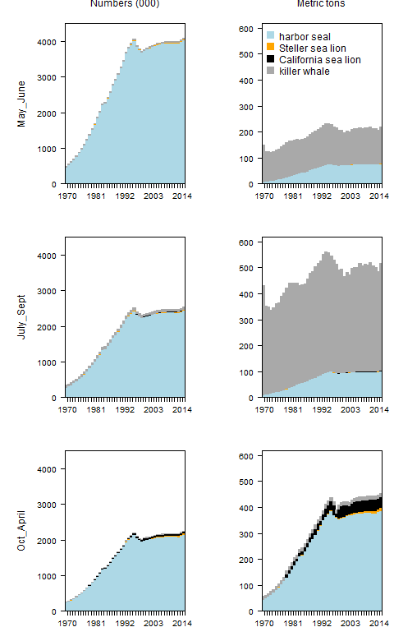

Figure .

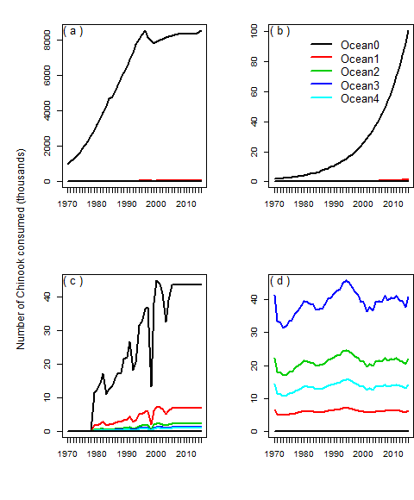

Figure .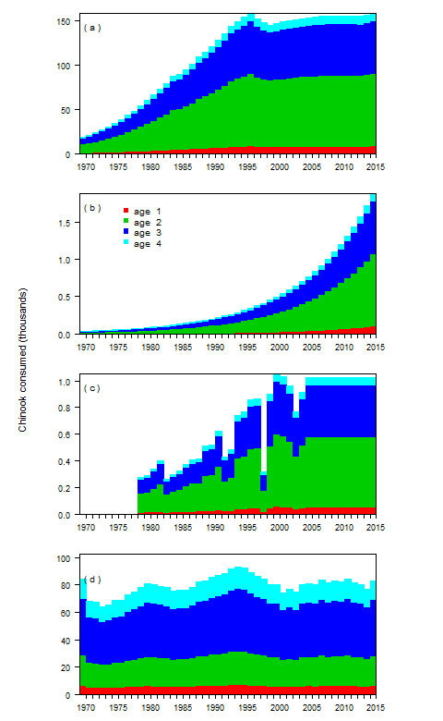

Figure

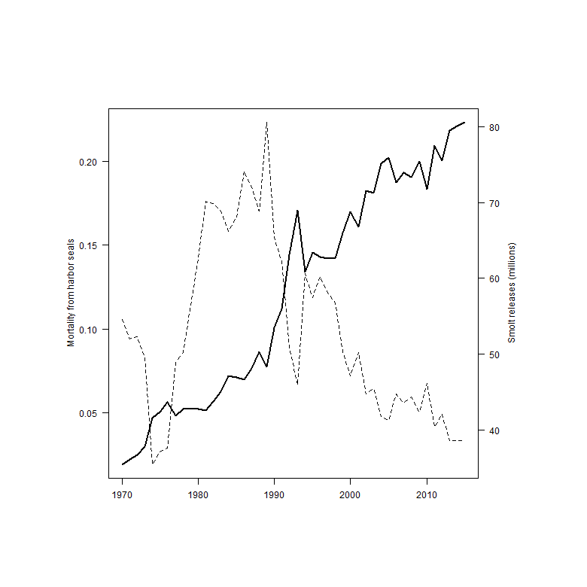

Figure 1. Annual consumption of Chinook salmon in Puget Sound by numbers (left column, in thousands) and metric tons (right column) by season for the four predator species. Seasons match those used within the FRAM model used for salmon management (Clemons et al. 2006).

Figure 2. Comparison of the annual consumption of Chinook salmon (in thousands) by harbor seals (a), Steller sea lions (b), California sea lions (c), and killer whales (d).

Figure 3. Potential reductions in the number of adult Chinook salmon (thousands) returning to Puget Sound inland waters due to smolt consumption by harbor seals (a), Steller sea lions (b), and California sea lions (c), and the predicted adult Chinook predation by killer whales based on the bioenergetics model (d).

Figure 4. The number of juvenile Chinook salmon released (in millions) by Puget Sound hatcheries (dashed line) and the mortality as a function of the estimated harbor seal consumption (solid line), assuming that harbor seals in inland waters feed exclusively on Puget Sound hatchery Chinook salmon stocks.

Table . List of references that were used to build the bioenergetics model.

|  |  |  |  |  |
| --- | --- | --- | --- | --- |
| Data | Harbor seals | Steller sea lions | California sea lions | killer whales |
| Max age | Howard et al. (2013) | Winship et al. (2001) | Bob de Long (pers. comm.) | 25+ |
|  |  |  |  |  |
| Weight at age | Pitcher and Calkins (1979) | Winship et al. (2001) | Winship et al. (2006) | Noren (2011) |
|  | Boulva and McLaren (1979) |  |  |  |
|  |  |  |  |  |
| Maturity at age | Pitcher and Calkins (1979) | Winship et al. (2002) | Winship et al. (2002) |  |
|  |  |  |  |  |
| Sex and age ratios | Bigg (1969) | Winship et al. (2002) | Winship et al. (2002) |  |
|  | Zier and Gaydos (2014) |  | R. DeLong (pers. comm.) |  |
|  |  |  |  |  |
| Predator presence |  | Jeffries et al. (2014) | Jeffries et al. (2014) | Hauser et al. (2007) |
|  |  |  |  |  |
|  |  |  |  |  |
| Predator abundance | Jeffries et al. (2003) | Jeffries et al. (2014) | Jeffries et al. (2014) | Center for whale |
|  |  | Wiles (2015) | NMFS (2015) | research (2016) |
|  |  |  | R. DeLong (pers. comm.) |  |
|  |  |  |  |  |
| Prey selectivity | Thomas et al. (In review) | Thomas et al. (In review) | Thomas et al. (In review) | Ford et al. (1998) |
|  |  | Scordino et al. (2014) | Scordino et al. (2014) | Hanson et al. (2010) |
|  |  |  |  |  |
| Energetic demands | Howard et al. (2013) | Winship et al. (2002) | Weise and Harvey (2008) | Noren (2011) |
|  |  |  | Winship et al. (2002) |  |

Table . List of subscripts, variables, and papers of the model.

|  |  |  |
| --- | --- | --- |
| Type | Name | Symbol |
| Subscript | Predator | $$h$$ |
|  | Predator age | $$i$$ |
|  | Chinook age | $$a$$ |
|  | Predator acitivty type | $$j$$ |
|  | Predator sex | $$s$$ |
|  | Day | $$t$$ |
|  | Year | $$y$$ |
|  |  |
| Superscript | Chinook | Ch |
|  | Inland waters | IW |
|  |  |  |
| Variable | Energetic demand | $$E$$ |
|  | Reproduction costs | $$P$$ |
|  | Growth costs | $$GC$$ |
|  | Activity costs | $$AC$$ |
|  | Lactation costs | LC |
|  | Chinook energetic content | $$E^{Ch}$$ |
|  | Chinook consumed | $$C^{Ch}$$ |
|  | Predator abundance | $$N$$ |
|  | Predator weight | $$wt$$ |
|  | Chinook weight | $$wt^{Ch}$$ |
|  | Maturity | $$m$$ |
|  | Fecundity | F |
|  |  |
| Parameter | Predator age and sex proportions | $$p$$ |
|  | Fraction of predator population in inland waters | $$ψ$$ |
|  | Activity fraction | $$f$$ |
|  | Allometric constant for metabolism | $$α$$ |
|  | Allometric constant for metabolism | $$β$$ |
|  | Diet fraction | $$ϕ$$ |
|  | Age composition of Chinook in predator diet |  |

Table . Variables of the bioenergetics models by species where “X” denotes the variables in the energetic models: P = reproductive costs; GC = growth costs; Ef = metabolic efficiency; AC = activity costs.

|  |  |  |  |  |  |
| --- | --- | --- | --- | --- | --- |
| Species | $$P$$ | $$GC$$ | $$Ef$$ | $$AC$$ | Source |
| Harbor seal | $$×$$ | $$×$$ | $$×$$ | $$×$$ | Howard et al. (2013) |
| Steller sea lion | $$×$$ | $$×$$ | $$×$$ | $$×$$ | Winship et al. (2002) |
| California sea lion |  |  | $$×$$ | $$×$$ | Weise and Harvey (2008) |
|  |  |  |  |  | Winship et al. (2002) |
| Killer whales |  |  |  | $$×$$ | Noren et al. (2011) |

Table . Length (cm), energy content (kcal) and energy based on smolt equivalents for Chinook salmon with ocean ages from zero to five within the Puget Sound inland waters.

|  |  |  |  |  |  |
| --- | --- | --- | --- | --- | --- |
|  | smolt | age 1 | age 2 | age 3 | age 4 |
| Length (cm) | 9.5 | 50 | 71 | 84 | 92 |
| energy (kcal) | 13 | 2,935 | 8,770 | 14,825 | 19,694 |
| smolt equivalents | 1 | 211 | 631 | 1,067 | 1,418 |

Table . Fraction and ocean age distribution of Chinook in the diets of marine mammal predators in Puget Sound.

|  |  |  |  |  |  |  |
| --- | --- | --- | --- | --- | --- | --- |
|  |  | Chinook age composition | | | | |
|  | % diet | smolt | one | two | Three | four |
| harbor seals | 6.8% | 31.0% | 17.0% | 17.0% | 17.0% | 17.0% |
| Steller sea lion | 6.4% | 31.0% | 17.0% | 17.0% | 17.0% | 17.0% |
| Cal. sea lion | 6.1% | 16.0% | 21.0% | 21.0% | 21.0% | 21.0% |
| killer whale | 51-95% | 0.0% | 2.0% | 18.0% | 55.0% | 25.0% |

Table . Maximum daily energetic demands by sex for adult predators, and the maximum daily number of juvenile and adult Chinook salmon that are consumed.

|  |  |  |  |  |  |  |  |  |
| --- | --- | --- | --- | --- | --- | --- | --- | --- |
|  | Daily energy demands (kcal) | |  | Juveniles consumed | |  | Adults consumed | |
|  | male | female |  | male | female |  | male | female |
| harbor seals | 3,563 | 3,539 |  | 5.32 | 5.37 |  | 0.02 | 0.02 |
| Steller sea lion | 42,343 | 25,005 |  | 2.09 | 1.24 |  | 0.25 | 0.15 |
| California sea lion | 22,803 | 8,626 |  | 0.26 |  |  | 0.14 |  |
| killer whale | 247,364 | 199,905 |  |  |  |  | 14.14 | 11.42 |

## Appendix:

## Reproduction and growth costs for harbor seals and Steller sea lions

### Reproduction costs

The daily production cost can be disaggregated into the gestation/pupping cost ($PC$) and lactation cost ($LC$). Depending on the time of year the reproductive costs ( $PC$ and $LC$) will change for predators of different ages and sex. To account for these temporal effects we include an additional set of time-varying estimates,



where the variables $p_{h,s,t}^{PC}$ and $p_{h,s,t}^{LC}$ are the conditional probability of predator $p$ gestating or lacatating on day $t$ given that it is both mature ($m_{h,i,s}^{}$) and fecund ($F_{h,s}^{}$).

Since males neither lactate nor give birth, $F_{h,male}^{}$ is equal to zero.

The lactation and gestation costs listed below are conditional on a female actually producing offspring. For harbor seals the fecundity rate is 0.91 (Howard et al. 2013) and for Steller sea lions the fecundity rate is 0.63 (Winship et al. 2002). For killer whales, gestation and lactation costs are implicitly assumed to be included within other modeled metabolic costs.

In most instances, the models in the literature (Table 8) describe the annual costs of reproduction. Since $p_{h,s,t}^{LC}$ and $p_{h,s,t}^{PC}$ are the daily probability of a reproduction cost, then and are the daily fraction of the annual reproduction costs. The killer whale literature does not separate the production costs from the activity costs, since at the population level they are such a minimal cost compared to the activity costs. The gestation periods of the pinnipeds are based on the following literature,

Table A- . Summary of reproduction costs by predator.

|  |  |  |  |
| --- | --- | --- | --- |
| Variable | Predator | Model | Source |
| $$PC_{h,i,s}$$ | Harbor seal | $$93,000,000\frac{joules}{year}$$ | Howard et al. (2013) |
|  | Steller sea lion | $$wt_{h,i=0}×[p_{lip}ED_{lip}+(1-p_{lip})(1-p_{w})ED_{pro}]×\frac{1}{d_{h}*d_{a}}\frac{joules}{day}$$ | Winship et al. (2002) |
|  | California sea lion | implicit1 | Weise and Harvey (2008) |
|  | Killer whales | implicit1 | Noren (2011) |
|  |  |  |
| $$LC_{h,i,s}$$ | Harbor seal | $$24,000,000×(wt_{h,i,s})^{0.75}\frac{joules}{year}$$ | Howard et al. (2013) |
|  | Steller sea lion |  | Winship et al. (2002) |
|  | California sea lion | implicit1 | Weise and Harvey (2008) |
|  | Killer whales | implicit1 | Noren (2011) |
|  |  |  |
| $$p_{h,s}^{F}$$ | Harbor seal | 0.91 | Howard et al. (2013) |
|  | Steller sea lion | 0.63 | Winship et al. (2002) |
|  | California sea lion | implicit1 |  |
|  | Killer whales | implicit1 |  |

1The assumption is that these costs are implicit in bioenergetics models.

Table A- . Lactation and gestation periods for the each of the predator species.

|  |  |  |  |  |
| --- | --- | --- | --- | --- |
| Parameter | Species | Initial day | Ndays | Source |
| $$p_{h,i,s}^{PC}$$ | Harbor seal | 9 mos. before pupping | 214 (9 months) | Temte (1991, 1994) |
|  | Steller sea lion1 | 9 mos. before pupping | 214 (9 months) | Pitcher and Calkins (1981) |
| $$p_{h,i,s}^{LC}$$ | Harbor seal | May 25th | 28 – 42 | Muelbert et al. (2003) |
|  | Steller sea lion1 | May | six months | Mathisen and Lopp (1963) |

1Although, some studies indicate that sea lion lactate for up to nine months, many sea lions are seen lactating with 1-2 year old juveniles.

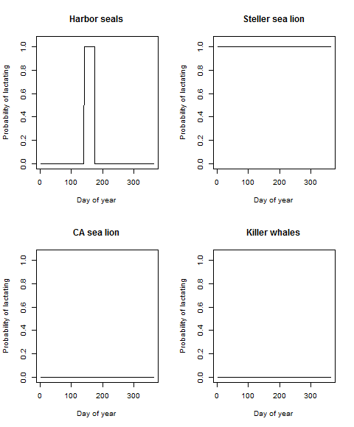

Figure A- . Periods for which lactation costs are factored into the bioenergetics model.

### Growth costs

The models for growth costs ($GC$) are different for each predator. The Steller sea lion model is an annual estimate based the change in body mass, while the Harbor seal model is daily estimate for immature individuals. The growth costs for killer whales are integrated into the activity costs.

Table A- . The sources and model for determining growth costs for the predators.

|  |  |  |  |
| --- | --- | --- | --- |
| Variable | Predator | Model | Source |
| $$GC_{h,i,s}$$ | Harbor seal | $$p_{i,s}^{m}*0.0165×321×86400$$ | Howard et al. (2013) |
|  | Steller sea lion | $$(wt_{h,i,s}-wt_{h,i-1,s})[p_{lip}ED_{lip}+(1-p_{lip})(1-p_{w})ED_{pro}]$$ | Winship et al. (2002) |
|  | California sea lion | implicit1 | Weise and Harvey (2008) |
|  | Killer whales | implicit1 | Noren (2011) |

1The assumption is that these costs are implicit in bioenergetics models.

### Efficiency

Efficiency measures the energy that is lost through excretion and metabolic heat before it can be converted to maintenance or growth. Our estimate of efficiency ($Ef$) is the percentage energy left after waste ($d_{a}$) and digestive heat ($d_{h}$). Calculating the conversion efficiency for the species is sightly different based on how the parameters were reported in the literature. The efficiency for killer whales is implicitly accounted for in the activity costs.

Table A- . Efficiency calculations for the predator species.

|  |  |  |  |  |
| --- | --- | --- | --- | --- |
| Species | Efficiency calculation | $$d_{a}$$ | $$d_{h}$$ | Source |
| Harbor seal | $$Ef=d_{a}-d_{h}$$ | 0.90 | 0.08 | Howard et al. (2013) |
| Steller sea lion | $$Ef=d_{a}×d_{h}$$ | (pup, others) 0.95, 0.85 | 0.88 | Winship et al. (2002) |
| California sea lion | $$Ef=d_{a}×d_{h}$$ | (pup, others) 0.95, 0.85 | 0.88 | Winship et al. (2002) |
| Killer whale |  | implicit1 | implicit1 | Noren (2011) |

1The assumption is that these costs are implicit in bioenergetics models.

## Population abundance

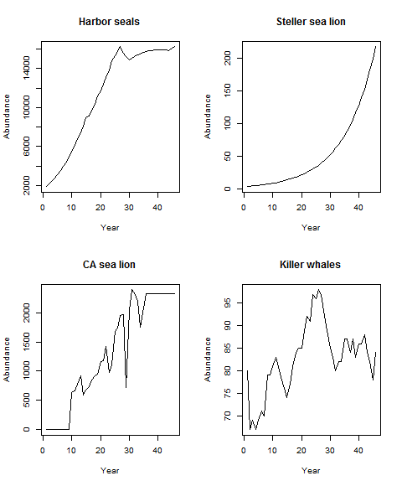

Figure_A-2. Estimated annual predator abundance.

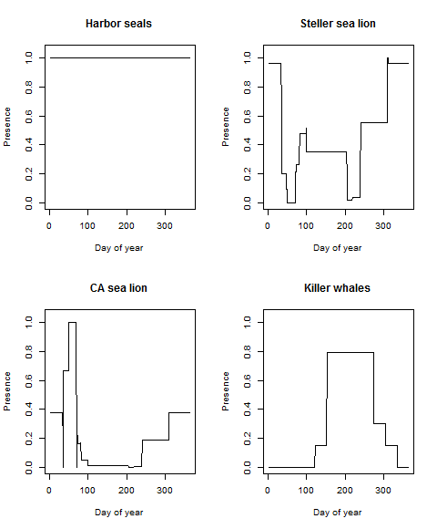

Figure A- 3. The probability of the predators being present in inland waters.

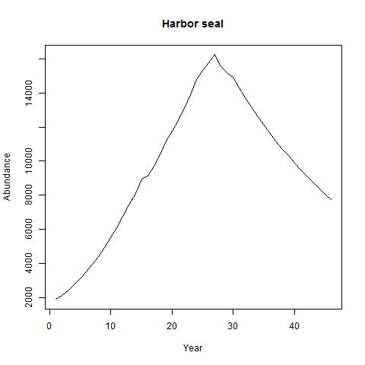

Figure A-4. Population abundance of harbor seals, 1970-2015, in Puget Sound based on an annual 4% decline beginning in 1999.

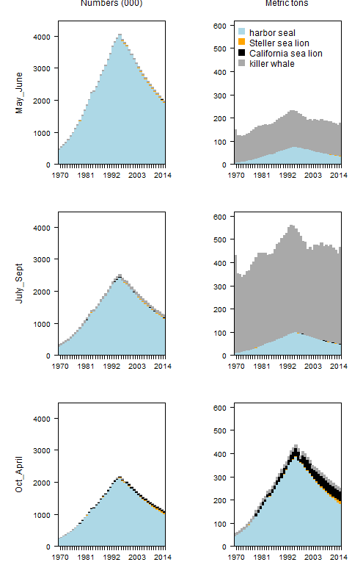

Figure A-5. Estimates of the annual consumption in numbers (left column) and biomass (right column) of Chinook salmon by marine mammal predators in Puget Sound between 1970 and 2015, assuming a 4% decline in harbor seal abundance beginning in 1999.

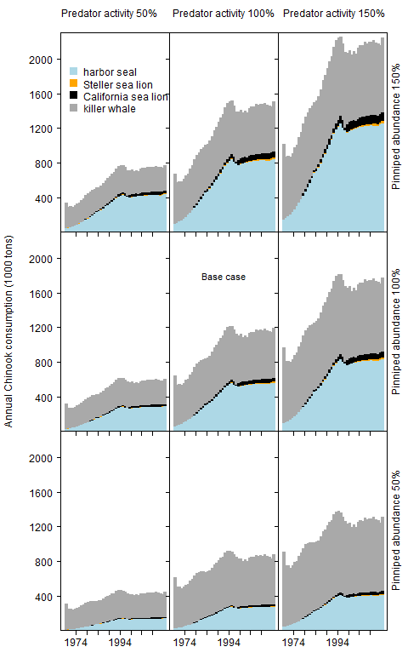

Figure A-6. The annual biomass of Chinook salmon consumed by each predator based on given combinations of pinniped abundance and predator activity.

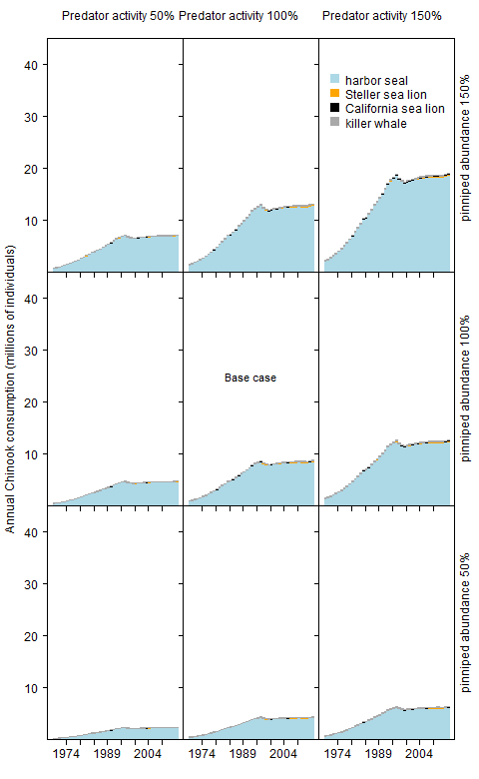

Figure A-7. The annual number of Chinook salmon consumed by the predators based on given combinations of pinniped abundance and predator activity.

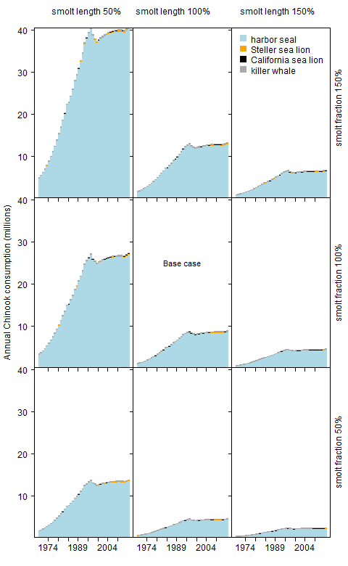

Figure A-8. The annual number of Chinook salmon consumed by the predators based on a given combination of smolt length and smolt fraction in the predator diets.