Title:
Authors: Brandon Chasco et al. , others TBD

Abstract

Introduction
The recovery of many marine mammals around the world is a conservation success story (Magera et al. 2013), but has created new challenges for managing coastal ecosystems (Marshall et al. 2015; Smith et al. 2015). Like recent trends in global temperature, changes in abundance of marine mammals has exhibited a non-stationary trend (rather than fluctuating around a constant value). These types of change require management models (fisheries assessment models, spatial models predicting suitable habitat, etc) to incorporate the long term changes in abundance, perhaps explicitly including predation (Hollowed et al. 2000). Many of the fisheries assessment models used around the world have generally ignored ecosystem processes, including predation, until recently (Skern-Mauritzen et al. 2015). Including predation in estimates of fish natural mortality yields a better understanding of predator - prey relationships, but also creates the opportunity to improve management by adjusting reference points (Tyrrell et al. 2011).
There are numerous examples around the world - many controversial - where marine mammal populations may be affecting the recovery or productivity of commercially important fish stocks. Examples include Cape fur seal predation on hake in South Africa (Punt and Butterworth 1995), consumption of cod by harp and grey seals in eastern Canada (Shelton et al. 2006, Mohn & Bowen 1996), large whale consumption of herring and forage fish in the northeastern US (Overholtz & Link 2007), consumption of icefish by Antarctic fur seals (Woehler & Green 1992), harbor seal predation on Atlantic salmon in Scottish rivers (Butler et al. 2006), consumption of salmon and forage fishes by pinnipeds in the northwestern US (Wright et al. 2007 ; Thomas et al. 2011 ), consumption of pollock by ribbon seals in Japan (Deguchi et al. 2004), and consumption of pollock and cod by sea lions in Alaska (Rosen and Trites 2000, Winship and Trites 2003).
Our research builds on much of the previous work by integrating trends in predator abundance with mechanistic bioenergetics models informed by diet studies. While correlative studies simply examine the degree to which time seriesof predator and prey are related, mechanistic studies allow us to improve our understanding of the ecosystem and can motivate future research objectives. By tracking the flow of energy using bioenergetics model we can decouple the demographic and species specific effects of predators and prey. For instance, we can examine how the size and number of prey consumed changes in relation to the size and activity of the predators, or how the temporal and spatial overlap of predator and prey affect population dynamics.
As a case study, we focus our model on the consumption of Chinook salmon (Oncorhynchus tshawytscha) on the west coast of the United States. Chinook salmon are an iconic species for the region, are ecologically important because their life history connects freshwater and terrestrial ecosystems (Hocking and Reynolds 2011), they serve as prey for top predators in the region (Hanson et al. 2010), and are commercially valuable. From a conservation perspective, many stocks of Chinook salmon are at historically low levels (Ruckelshaus et al. 2002), and are thought to be impacted by climate change (Battin et al. 2007 ; Ward et al. 2015 ).
The first objective of our paper is to quantify predation on Chinook salmon by four species of marine mammals (California sea lions Zalophus californianus, Steller sea lions Eumetopias jubatuss, harbor seals Phoca vitulina, killer whales Orcinus orca). The geographic focus of our model is the Pacific Northwest, and in particular the inland Puget Sound. This region is thought to have one of the highest densities of harbor seals in the world, with abundance spurred by rapid population growth over the period 1970 - 2000 (Jeffries et al. 2003). Harbor seals, steller sea lions, California sea lions, and killer whales are likely to prey not only on Chinook salmon but also on other threatened salmonid stocks. Management challenges are further complicated by potential tradeoffs between protected salmonids and these four predators, which also are protected under the US Marine Mammal Act, US Endangered Species Act, or Canadian Species at Risk Act; Marshall et al. 2015). These predators differ in their foraging characteristics, such as reliance on Chinook salmon as prey, size of salmon they target, and the season and spatial location of feeding. Below, we quantify predation on Chinook salmon by combining estimates of marine mammal abundance and energetic needs with these foraging characteristics. Secondary objectives of our analysis are to (1) examine the likelihood of pinnipeds having a negative impact on higher trophic level killer whales, and (2) examine the relative impacts on predation mortality and harvest mortality of Chinook salmon.
Methods
Our study area includes the inland waters of Puget Sound (Strait of Juan de Fuca, Hood Canal and San Juan Islands) in northwest Washington State, U.S., and examines the impacts of four marine mammal species (killer whales, California sea lion, Steller sea lions, and harbor seals) on endangered populations of Chinook salmon (Oncorhynchus tshawytscha) using bioenergetics models.
Modeling energetic demands of the predators
The energetic demands of the predators are based on the general Kleiber (1975) model which is a power function that depends on the weight of the predator and the parameters and (Table 1).
Equation 1.
The parameters and weight in the Kleiber model (X) can be disaggregated to account for age (), activity (), and sex () specific effects for the different predator () throughout the year (i.e., day ),
Equation 2. 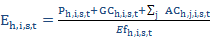
The variable is the reproductive cost, is the growth cost associated with an increase in body mass, is the sum of all activity costs, and is fraction of total energy not lost to heat or excretion. The activity costs are based on the and of the Kleiber model (Equation ), the fraction of the time spent doing activity (; Table 2), and weight (; Supplemental 5.1) of predator ,
Equation 3.

By modeling the weight at age of the predators, rather than the staged-based weights in the literature (e.g., pup, juvenile, adult), we can track individual cohorts and have greater flexibility to examine future management actions. To map the stage-based parameters in the literature to our age-based models we use information about the maturity-at-age. Parameters related to the pup stage are mapped directly to age zero () individuals, such that where is any generic stage-specific parameter in the literature. Parameters for ages greater than zero are a weighted average the juvenile () and adult () parameters based on the maturity at age ()
Equation 4.
Weight-at-age by sex is based on the following sources (Table 3). A functional growth relationship was unavailable for harbor seals; however, we used previously published estimates of weight at age (Pitcher and Calkins, Table XX).

The variables of daily growth and reproductive costs, and efficiency in Equation are not a standardized across species, and only included in the model for harbor seals and Steller sea lions (Table 4). We refer the reader to the supplemental material (5.2) for species-specific calculations.

Lastly, while parameter uncertainty does exist for the energetics models, quantifying this uncertainty is beyond the scope of this paper. This paper focuses on the relative impacts of changing predator populations and their consumption rates of Chinook salmon. Furthermore, including uncertainty would not change the expected outcomes of the modeling exercise since we use the mean values for the variables and parameters in literature.

Predator population dynamics
The daily energetic demand of predator , age , and sex is the product of the numbers-at-age (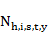) and the energetic demands (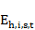; X).
Equation 5.
The number of predators by age in inland waters is determined by: 1) the annual aggregated population abundance estimate (), 2) the proportion of the animals in each age class by sex and year (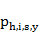), and 3) the fraction of the population present in inland waters on day ()(Table 5).
The age composition of killer whales is known without error, less is known about the age composition of pinniped populations. Winship et al. (2002) provide a coarse estimate of the Steller sea lion age structure; however, very little is know about the age and sex distribution of Steller and California sea lions in inland waters. Only stage-based estimates for harbor seals exist for inland waters (Howard et al. 2010). For details of the estimated age and sex composition of the predators see Supplemental 5.3; we generally assumed them to be at or near that of a stable age distribution (and not changing through time).
Estimating the number Chinook salmon consumed
The number of Chinook salmon of age that are consumed by predator is a function of the daily energetic demands of the predator (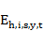), the fraction of predator's energy derived from Chinook salmon (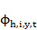), the proportion of different aged Chinook salmon in the diet (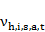), and the age-specific energetic content of the Chinook salmon (),
Equation 6.
The proportion of Chinook salmon in the predator diets (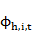) ranges between 0.01 and 0.02 in the pinniped diets, and 0.63 to 0.95 in the killer whale diet (Tables 6 and 7; Adams et al. 201X). The estimates are based mainly on frequency of occurence data from scat samples; however, unpublished work by Thomas et al. (201X) suggests the average diet fraction of harbor seals based on genetics data is 0.069. Consumption results for Thomas's anlaysis are included separately in the results. The predator diet fration () has a daily subscript because killer whale diet fractions change significantly between the summer and winter months.
The energy content of different aged Chinook salmon is based on work by O'Neil et al. (2014),
where, is the average length-at-age for the Puget Sound populations.
There are no temporally explicit estimates of the age of the Chinook salmon in the predator diets, but we assume they change based on the availability of salmon at different times of the year. Our estimate of the age composition of Chinook salmon in the diet () is based on: 1) the size of prey in the predator diets (i.e., 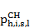; Table xx), 2) the size of Chinook salmon at a given age (i.e., ), and 3) the probability of salmon of a given age being present in Puget Sound,
The distribution of Chinook in predators diets (Equation ) is based on mostly observational diet studies, or back calculating prey sizes from hardstructures (Table 8; Supplemental 5.4)
where, and are the estimated mean and standard deviation of the fish lengths for predator . The length distributions at age for Chinook are easily defined,
where, and are the mean and standard deviations for the length at each age . The overlap of these distributions, combined with the probability that Chinook of a given age are present (), provides an estimate of the Chinook age composition in the predator diets on a given day.
The parameter describes the probability that Chinook of age is present in Puget Sound on day . Fresh (2006) and Duffy et al. (2005) describe juvenile smolts in Puget Sound residing between the months of May to August, with a smaller proportion remaining until September. Similarly, adult salmon returning to spawn migrate back to Puget Sound and are present from the beginning of May to the end of September. Within Puget Sound waters, there are also "blackmouth", immature salmon that do not migrate northward up to Canadian and Alaskan waters. To account for these individuals we assume that 10% of the smolt to two year old adult age classes remain in Puget Sound throughout the year.

Chinook population dynamics and movement
To quantify indirect effects between predators, including the time lag of salmon maturation, we adopt a simple forward projection approach. We begin by taking estimated the annual consumption smolts of across the entire population harbor seal population, . Next we project forward the consumed smolts forward as if they had entered the ocean, and determine how many of them would have returned,
where, is the survival from to , and is the conditional probability of maturing at age . The number of Chinook of a given age returning to inland waters is ??????
Estimates of the ocean survival and age composition can vary across stocks within Puget Sound. Some coarse estimates of ocean mortality are from Argue et al. (1983): the bi-monthly instaneous mortality rates are 0.035, 0.015, and 0.0075 for ocean ages 1, 2, and 3+, respectively. These translate into annual survival estimates of 0.43, 0.69, and 0.83. The conditional probability maturing at age given that the fish has survived and remained in the ocean is 0.02, 0.5, 0.8, 1.0, for ocean ages 1, 2, 3, and 4, respectively, based age composition data from the catch and escapement (NMFS 1998).

Results

Daily consumption rates
Estimates of the average daily Chinook salmon consumption by adult predators ranges from ~0.01 individual fish for female Steller sea lions to ~16 fish per day for male killer whales (Figure 1). The daily consumption estimates for male predators of a given age are consistently higher than females because of their size, except for female harbor seals which have considerably higher reproductive costs than the other species (Supplemental S1, Equation XX, Table 2). The age composition of Chinook in the pinnipeds diets is mostly smolts, while for killer whales, prey is dominated by larger three- and four-ocean Chinook (cite Ford and Ellis 2006).

Annual consumption rates
Aggregated across all seasons, estimated annual consumption of Chinook salmon by pinnipeds has increased tenfold since 1970 (Figure 2), and this change has been driven by exponential increases in abundance within inland waters (see supplemental S5.3). Killer whale consumption has also increased from 1970 since their population has increased from 53 animals to 84 currently. The seasonal differences in the age composition of Chinook salmon in predator diets is driven by life history; Chinook salmon are available as prey as juveniles, and then several years later as adults returning to spawning grounds. In the absence of smaller juvenile smolts during the winter months, pinnipeds likely switch to larger resident fish (‘blackmouth’; effect shown in Fig. 2). Because blackmouth Chinook are larger than smolts, the total number of salmon consumed by pinnipeds in winter months decreases. Southern Resident killer whales are largely absent from inland waters in the winter months (particularly K- and L-pods). During brief visits to inland waters, we predict Chinook in killer whale diets is primarily smaller two-ocean resident blackmouth . These resident Chinook are generally smaller than non-blackmouth Chinook, thus from a killer whales’ perspective, foraging in winter may be less efficient than summer (more individuals need to be consumed to meet the same energy demands).

Comparing numbers to biomass consumed
The time-series of Chinook consumption by predator shows considerable differences depending on whether the unit of currency is in numbers (Figure 3, column 1) or biomass (Figure 3, column 2). Beginning in 1970 the number of Chinook consumed by harbor seals was estimated to be 350,000 smolts, approximately six times greater in number than the 60,000 adult salmon consumed by killer whales that year. By 2015, the number of smolts consumed by harbor seals is estimated to have increased to 3 million, or more than 30 times the 91,000 adults estimated to be consumed by killer whales.
The relative impacts of these top predators are reversed if we consider biomass instead of numbers. In 1970 killer whales consumed an estimated 438 tons of adult Chinook which is roughly ~30 times the 14 tons of smolts estimated to be consumed by harbor seals. By 2015 the ratio between biomass consumption decreases to roughly six-to-one, with killer whales consuming an estimated 622 tons and harbor seal consuming 120 tons.
Steller and California sea lions appear to have a minimal impact on the Chinook populations, both in numbers and biomass. By comparison, in 2015 Steller and California sea lions consumed just 1,375 and 6,418 individual Chinook, respectively, or roughly <1 and 1.4 tons, respectively. These estimates are several orders of magnitude less than either habor seals or killer whales.
The seasonal overlap between predators and prey is also reflected in Figure 3. During the two months of the spring season (May and June) in 2015 harbor seals are estimated to have consumed 1,300,000 smolts, compared to 1,600,000 during the three months of summer (i.e., July - September). The decreased consumption rate between spring and summer is due to our model assumption that smolts migrate out of inland waters during the summer months and are less abundant (see Supplemental S6.4 Figure 17). The killer whale consumption increases from 148 tons during spring to 406 tons during summer. Since adult salmon are assumed to be present for the entire spring and summer seasons, the increased consumption rate is due to the bulk of the killer whale population arriving slightly after the start of the adult Chinook migration (Supplemental S6.3).

Genetic versus frequency of occurrence diet fractions
The largest source of uncertainty in our model is the fraction of the predator's energy derived from Chinook salmon. We currently assume the frequency of ocurrence (%FO) of prey in the scat is equivalent to the ratio of energy derived from the different prey sources. Recent work by Thomas et al. (2015) suggests that scat analysis underestimates the fraction of Chinook in the harbor seal diet and using genetic analysis they found that Chinook comprise and average 6.9% of the diet rather than 1.5%. Based on Thomas's estimates we predict the 2015 smolt consumption by harbor seals would increase from 3,000,000 to 13,300,000 individuals and from 120 to 549 tons. This estimate of biomass consumption is comparable to the 622 tons consumed by killer whales (Figure 4).

Harbor seal effects on future returns
To determine the impact of the harbor seal predation on future adult returns, we projected the number of smolts consumed forward in time assuming that the ocean survival and maturation schedule were constant over time (Table XX). Based on Adams's estimated diet fraction (Table XX), harbor seal predation could lead to a reduction of 50,000 two-ocean, 20,000 three-ocean, and 4,400 four-ocean Chinook in 2015. Those estimates rise to 335,000, 130,000, and 20,000, respectively, if we use Thomas's diet fraction. Although the age composition of projected losses of adult Chinook from harbor seal differs killer whales, their potential impacts Adams's diet fraction assumption is comparable to killer whales (23,000 two-ocean, 34,000 three-ocean, and 25,000 four-ocean adults), and five times greater under Thomas's diet fraction assumption.

Discussion
We demonstrate the relative impacts of four protected marine mammal species on Chinook salmon in Puget Sound waters. Our results show that though harbor seals consume far less Chinook salmon biomass than is consumed by killer whales, they consume many more Chinook salmon in terms of numbers of fish. (Figure 3 and 4. Because Chinook in harbor seal diets are assumed to be almost entirely juveniles ( smolts), we further demonstrate that their predicted impacts on future adult salmon returns is comparable to the annual consumption by killer whales (Figure 5). In comparison, the numbers or biomass of Chinook consumed by Steller and California sea lions in inland waters (Puget Sound) were estimated to be neglible relative to either harbor seals and killer whales. As such, we focus much of our discussion on the impacts of harbors seals on Chinook and killer whales.
A considerable amount of work has examined the bottom up forces affecting Chinook survival (e.g., climate change (Scheuerell and Williams 2005), habitat (Kareiva et al. 2000), nutrients (Scheuerell et al. 2005)), but top down forcing is also suspected to play an important role in early marine survival within Puget Sound. Recently, Duffy and Beauchamp (2011) and Beamish et al. (2011) concluded that much of the marine mortality of Chinook occurs during the early life stage as the result of local conditions in the river estuaries, but attributing this to specific predators can be difficult. Based on our bionenergetics model which accounts for size selectivity of the predators, we found that harbor seal are a likely cause of this early marine mortality, and their consumption is large enough to cause substantialreductions in marine survival.
Our model assumes there is temporal and spatial overlap of harbor seals with outmigrating Chinook smolts; however, they do not feed exclusively in river mouths or estuaries (Orr et al. 2014, Luxa and Acevedo-Gutierrez 2013, Wright et al.2007) and composition of Chinook salmon in the diet can be highly variable (Adams et al. 201X). The predicted daily consumption of Chinook salmon in our bioenergetics models ranges from two to ten smolts per day depending on the diet fraction, and ultimately the plausibility of these estimates depends in part on harbor seal feeding behavior. Harbor seals have been shown to alter their feeding behavior in response to seasonal pulses of other species like herring (Thomas et al. 2011), where frequency of occurence of herring increases to about 40% during the spawning season. Following the pulse of herring spawn in in mid-April, harbor seals in inland waters may switch to large subsidies of hatchery releases smolts (~40 million annually) into Puget Sound between May and July. Given the density of smolts in the estuaries, their approximate size to herring, and observational studies of seal feeding behavior (Scordino et al. 2010), daily consumption rates of two to ten seems reasonable.
In addition to the mechanistic relationship between smolt mortality and harbor seals bioenergetics, the decline in marine survival (i.e., 2.0% to <0.3% from 1970 to 2010; Beamish et al. 2011) coincides directly with the increase in harbor seal abundance. While the several factors like increasing temperatures in inland waters (Beamish et al. 2012), competition (Ruggerone and Goetz 2004), and changes in productivity (Mantua et al. 1997) have also been correlated with the declines, the scale and consistent longer term trend of harbor seal abundance should not be overlooked as a reason for declining marine survival. Based on smolt release data (cite WDFW), and assuming that Puget Sound hatchery smolts comprised 100% of the smolt in the diet of resident Puget Sound harbor seals (an overestimate, given that Chinook smolts originating from British Columbia are also present in inland waters), the annual consumption rate of hatchery smolts has increased from 1% in 1970 to 5% in 2015 based on Adams's diet fraction, and from 3% to 35% based on Thomas's diet fraction (Figure 6).

The impacts of increasing harbor seal abundance (and subsequent impacts on populations of fish prey) is not confined to just Chinook salmon. Many other potential harbor seal prey are species of concern or listed under the US Endangered Species Act (herring, rockfishes, steelhead) and may be affected by the increasing energetic demands of a growing seal population. These changing demands may also impact other top predators. Adult Chinook are an important part of the Puget Sound commercial and recreational fishery, and they are also the preferred prey of endangered Southern Resident killer whales (Ford and Ellis 2006). Since the 1980s commercial catches [where is this – inland waters or all WA?] have declined from 250,000 to 100,000, and recreational catches have declined from 150,000 to 50,000 (WDFW 2010). While there are no estimates of annual changes in preyconsumption by killer whales, there is strong evidence to suggest that declining birth rates of southern resident killer whales are strongly linked to decreased Chinook salmon abundance (Ward et al. 2009). Because harbor seal consumption of juvenile Chinook has the potential to reduce future adult Chinook abundance by 100,000-500,000 individuals annually (Figure 5), harbor seals also have the potential to lower the productivity or carrying capacity of Southern Resident killer whales.
One of the key assumptions in our bioenergetics model is that the frequency of occurrence of Chinook salmon in the predator diets is directly related to the energy derived from Chinook. Studies have shown that occurrence indices can perform poorly relative to biomass reconstruction models (Tollit et al. 2015; Joy et al. 2006). Tollit et al. (2015) compared occurrence, biomass, and energy reconstruction techinques for Steller sea lions and found that energy fraction from salmon in the diet is two to three times the frequency of occurrence of salmon. This suggests that our FO estimate 1.5% might also underpredict the energy fraction for harbor seals. To account for this bias we include the diet fraction estimate of 6.9% based on genetics work by Thomas et al. (2015).
An additional limitation in our study is the lack of juvenile Chinook growth throughout the season. Since the mature adults grow very little as they migrate through Puget Sound toward their spawning streams, we can assume their size is constant. However, hatchery smolts persist in the nearshore environment until mid-summer (Duffy and Beauchamp 2011, Brennan et al. 2004) and in pelagic waters until late fall. During that time they can double their length (Duffy and Beauchamp 2011). The implication is that increased growth increases energy content, thus the fewer juveniles would need to be consumed to achieve the same level of energy in the diet. However, the variability in the release date (see Supplemental S6.5) and the uncertainty in offshore migration of older smolts, makes it difficult to estimate the average size of the mixture of smolts in the nearshore habitat. Thus, based on an average release size, our estimates of Chinook predation probably represents an upper limit for juvenile Chinook consumption.

Future research
This analysis represents a bionenergetics model within a portion of the range of Chinook salmon from Puget Sound. Puget Sound harbor seals might provide a mechanism for the steep drop in the survival of local Chinook stocks, but there are several other distinct predator populations that might also be responsible. Juvenile Chinook salmon from Puget Sound generally migrate north in the Northeast Pacific to Alaska, where they may encounter a wide range of other sources of mortality, including predators. The harbor seal population in southern British Columbia, for example, is thought to be much larger than that of Puget Sound (cite DFO harbor seal stock assessment). Further, there are other populations of salmon-eating killer whale populations that inhabit in the inland waters of southern British Columbia and southeast Alaska. These northern populations of killer whales are also increasing in abundance; for example, the northern resident population has doubled to 261 individuals since 1974 (Allen and Angliss 2013) and could be an increasing source of mortality for Chinook originating from more southern rivers. The California seal lion range does not extend north of Puget Sound, thus they are unlikely to be an additional source of mortality, but the southeast Alaska Steller sea lions population has increased to ~50,000 individuals since 1979 and could provide a significant source predation based on the diet fractions of Tollit et al. (2015). Future research would be to extend this analysis to include additional spatial components for the predators in the British Columbia and southeast Alaska inland waters. Additionally, a salmon migration model would need to be developed to determine the temporal-spatial overlap of Puget Sound Chinook with predators in the northern spatial components.

Conclusion
This study concludes that based on bioenergetics modeling, the relative impacts of different marine mammal predators on Chinook salmon has changed since the passage of the Marine Mammal Protection Act (1972). More recently, some of these changes indicate that predation in general (and specifically harbor seals) may be having an adverse impact on Chinook salmon runs within Puget Sound. While the effects of sea lions are believed to be neglible relative to impacts of seals or killer whales, the large increase in harbor seal predation on smolts has the potential to have impacts that are larger than either the commercial and recreational fisheries, or predation by endangered Southern Resident killer whales. Our model only examines predators within Puget Sound inland watrs and assumes their consumption is derived from only Puget Sound Chinook stocks. In reality the Chinook salmon in inland waters are a mixture of US and Canadian stocks, and the marine mammals predators on the outer coast (from California to Alaska) may also be impacting these US Chinook stocks. We believe this research is a valuable step toward decoupling the mechanisms that lead toward a non-stationary process of marine survival in endangered Chinook salmon, and provide a framework for developing a larger coast-wide model of predation.

Citations
Argue, A. W., Hilborn, R., & Peterman, R. M. MJ Staley, and CJ Walters. 1983. Strait of Georgia chinook and coho fishery. Can. Bull. Fish. Aquat. Sci, 211, 1-91.
Battin, J., Wiley, M. W., Ruckelshaus, M. H., Palmer, R. N., Korb, E., Bartz, K. K., & Imaki, H. (2007). Projected impacts of climate change on salmon habitat restoration. Proceedings of the national academy of sciences, 104(16), 6720-6725.
Beamish, R. J., Sweeting, R. M., Neville, C. M., Lange, K. L., Beacham, T. D., & Preikshot, D. (2012). Wild chinook salmon survive better than hatchery salmon in a period of poor production. Environmental Biology of Fishes, 94(1), 135-148.
Bowen, Don W., Ellis, S. L., Iverson, S. J., & Boness, D. J. (2004). Maternal and newborn life-history traits during periods of contrasting population trends: implications for explaining the decline of harbour seals (Phoca vitulina), on Sable Island. Journal of Zoology, 261(02), 155-163.
Butler, J. R., Middlemas, S. J., Graham, I. M., Thompson, P. M., & Armstrong, J. D. (2006). Modelling the impacts of removing seal predation from Atlantic salmon, Salmo salar, rivers in Scotland: a tool for targeting conflict resolution. Fisheries Management and Ecology, 13(5), 285-291.
Clemons, E., Conrad, R., Simmons, C. D., Sharma, R., Grover, A., & Yuen, H. (2006). FISHERY REGULATION ASSESSMENT MODEL (FRAM).
Deguchi, T., Goto, Y., & Sakurai, Y. (2004). Importance of walleye pollock (Theragra chalcogramma) to wintering ribbon seals (Phoca fasciata) in Nemuro Strait, Hokkaido Japan. mammal study, 29(1), 55-63.
Dorner, B., Peterman, R. M., & Haeseker, S. L. (2008). Historical trends in productivity of 120 Pacific pink, chum, and sockeye salmon stocks reconstructed by using a Kalman filter. Canadian Journal of Fisheries and Aquatic Sciences, 65(9), 1842-1866.
Duffy, E. J., Beauchamp, D. A., & Buckley, R. M. (2005). Early marine life history of juvenile Pacific salmon in two regions of Puget Sound. Estuarine, Coastal and Shelf Science, 64(1), 94-107.
Ford, J. K., Ellis, G. M., Olesiuk, P. F., & Balcomb, K. C. (2010). Linking killer whale survival and prey abundance: food limitation in the oceans' apex predator?. Biology letters, 6(1), 139-142.
Fresh, K. L. (2006). Juvenile Pacific Salmon in Puget Sound (No. N00A-TR-2006-06). NATIONAL OCEANIC AND ATMOSPHERIC ADMINISTRATION SEATTLE WA PACIFIC MARINE ENVIRONMENTAL LABS.
Hare, S. R., Mantua, N. J., & Francis, R. C. (1999). Inverse production regimes: Alaska and west coast Pacific salmon. Fisheries, 24(1), 6-14.
Mantua, N. J., Hare, S. R., Zhang, Y., Wallace, J. M., & Francis, R. C. (1997). A Pacific interdecadal climate oscillation with impacts on salmon production. Bulletin of the american Meteorological Society, 78(6), 1069-1079.
Hollowed, A. B., Bax, N., Beamish, R., Collie, J., Fogarty, M., Livingston, P., ... & Rice, J. C. (2000). Are multispecies models an improvement on single-species models for measuring fishing impacts on marine ecosystems?. ICES Journal of Marine Science: Journal du Conseil, 57(3), 707-719.
Jeffries, S., Huber, H., Calambokidis, J., & Laake, J. (2003). Trends and status of harbor seals in Washington State: 1978-1999. The Journal of wildlife management, 207-218.
Jeffries, S., M.A. Smultea, C.E. Bacon, T.A. Jefferson, B.Mate, L. Irvine, and T. Follett. 2014. Aerial Surveys of Pinniped Haulout Sites in the Pacific Northwest; Marine Mammal Aerial Surveys Conducted in the Pacific Northwest, Inland Puget Sound Waters; and Offshore Large Whale Satellite Tagging in the Northwest Training Range Complex. Draft Report. Submitted to Naval Facilities Engineering Command (NAVFAC) Northwest, Silverdale, WA under Contract No. N62470-10-D-3011, Task Order JPO2 issued to HDR, Inc., San Diego, CA. Prepared by Washington Department of Fish and Wildlife, Lakewood, WA; Smultea Environmental Sciences, Preston, WA; and Oregon State University, Marine Mammal Institute, Newport, OR. June 2014.
Huber, H., Calambokidis, J., & Laake, J. (2003). Trends and status of harbor seals in Washington State: 1978-1999. The Journal of wildlife management, 207-218.
Hanson, M., Baird, R. W., Ford, J. K., Hempelmann-Halos, J., Van Doornik, D. M., Candy, J. R., ... & Ford, M. J. (2010). Species and stock identification of prey consumed by endangered southern resident killer whales in their summer range. Endangered Species Research, 11(1), 69-82.
Hauser, D. D., Logsdon, M. G., Holmes, E. E., VanBlaricom, G. R., & Osborne, R. W. (2007). Summer distribution patterns of southern resident killer whales Orcinus orca: core areas and spatial segregation of social groups. MARINE ECOLOGY-PROGRESS SERIES-, 351, 301.
Herreman, J. K., Blundell, G. M., & Ben-David, M. (2009). Evidence of bottom-up control of diet driven by top-down processes in a declining harbor seal Phoca vitulina richardsi population. Marine Ecology Progress Series, 374, 287-300.
Hilborn, R., Cox, S., Gulland, F., Hankin, D., Hobbs, T., Schindler, D. E., & Trites, A. (2012). The effects of salmon fisheries on Southern Resident killer whales: Final report of the independent science panel. Prepared with the assistance of DR Marmorek and AW Hall, ESSA Technologies Ltd., Vancouver, BC for National Marine Fisheries Service (Seattle. WA) and Fisheries and Oceans Canada (Vancouver. BC). xv.
Hoberecht, L. K., Vos, D. J., & VanBlaricom, G. R. (2006). A remote biopsy system used to sample Steller sea lion (Eumetopias jubatus) blubber. Marine mammal science, 22(3), 683-689.
Hocking, M. D., & Reynolds, J. D. (2011). Impacts of salmon on riparian plant diversity. Science, 331(6024), 1609-1612.
Holmes, E. E., Fritz, L. W., York, A. E., & Sweeney, K. (2007). Age-structured modeling reveals long-term declines in the natality of western Steller sea lions. Ecological Applications, 17(8), 2214-2232.
Howard, S., Lance, M. M., Jeffries, S. J., & Acevedo-Gutiérrez, A. (2013). Fish consumption by harbor seals (Phoca vitulina) in the San Juan Islands, Washington. Fishery Bulletin, 111(1), 27.
Joy, R., Tollit, D. J., Laake, J. L., & Trites, A. W. (2006). Using simulations to evaluate reconstructions of sea lion diet from scat. Sea lions of the world. Edited by AW Trites, SK Atkinson, DP DeMaster, LW Fritz, TS Gelatt, LD Rea, and KM Wynne. Alaska Sea Grant College Program, Anchorage, 205-222.
Kareiva, P., Marvier, M., & McClure, M. (2000). Recovery and management options for spring/summer chinook salmon in the Columbia River Basin. Science, 290(5493), 977-979.
Kleiber, M. (1975). Metabolic turnover rate: a physiological meaning of the metabolic rate per unit body weight. Journal of theoretical biology, 53(1), 199-204.
Kope, R. G., Bryant, G. J., Teel, D., Lierheimer, L. J., Wainwright, T. C., Grant, W. S., ... & Waples, R. S. (1998). Status review of chinook salmon from Washington, Idaho, Oregon, and California.
Magera, A. M., Flemming, J. E. M., Kaschner, K., Christensen, L. B., & Lotze, H. K. (2013). Recovery trends in marine mammal populations.
Marshall, K. N., Stier, A. C., Samhouri, J. F., Kelly, R. P., & Ward, E. J. (2015). Conservation Challenges of Predator Recovery. Conservation Letters.
Mathisen, O. A., Baade, R. T., & Lopp, R. J. (1962). Breeding habits, growth and stomach contents of the Steller sea lion in Alaska. Journal of Mammalogy, 43(4), 469-477.
Mohn, R., & Bowen, W. D. (1996). Grey seal predation on the eastern Scotian Shelf: modelling the impact on Atlantic cod. Canadian Journal of Fisheries and Aquatic Sciences, 53(12), 2722-2738.
Nehlsen, W., Williams, J. E., & Lichatowich, J. A. (1991). Pacific salmon at the crossroads: stocks at risk from California, Oregon, Idaho, and Washington. Fisheries, 16(2), 4-21.
Noren, D. P. (2011). Estimated field metabolic rates and prey requirements of resident killer whales. Marine Mammal Science, 27(1), 60-77.
NMFS (1998). Review of the Status of Chinook Salmon (Oncorhynchus tshawytscha) from Washington, Oregon, California, and Idaho under the U.S.Endangered Species Act. NOAA Technical Memorandum NMFS-NWFSC-35.
Olesiuk, P. F. (1993). ANNUAL PREY CONSUMPTION BY HARBOR SEALS (PHOCA-VITULINA) IN THE STRAIT OF GEORGIA, BRITISH-COLUMBIA. Fishery Bulletin, 91(3), 491-515.
O’Neill, S. M., Ylitalo, G. M., & West, J. E. (2014). Energy content of Pacific salmon as prey of northern and southern resident killer whales. Endangered Species Research, 25, 265-28.
Overholtz, W. J., & Link, J. S. (2007). Consumption impacts by marine mammals, fish, and seabirds on the Gulf of Maine–Georges Bank Atlantic herring (Clupea harengus) complex during the years 1977–2002. ICES Journal of Marine Science: Journal du Conseil, 64(1), 83-96.
Pitcher, K. W., & Calkins, D. G. (1979). Biology of the harbor seal, Phoca vitulina richardsi, in the Gulf of Alaska (pp. 1-72). Outer Continental Shelf Environmental Assessment Program, US Department of Interior, Bureau of Land Management.
Plagányi, É. E., Punt, A. E., Hillary, R., Morello, E. B., Thébaud, O., Hutton, T., ... & Rothlisberg, P. C. (2014). Multispecies fisheries management and conservation: tactical applications using models of intermediate complexity. Fish and Fisheries, 15(1), 1-22.
Punt, A. E., & Butterworth, D. S. (1995). The effects of future consumption by the Cape fur seal on catches and catch rates of the Cape hakes. 4. Modelling the biological interaction between Cape fur seals Arctocephalus pusillus pusillus and the Cape hakes Merluccius capensis and M. paradoxus. South African Journal of Marine Science, 16(1), 255-285.
Region, N. (1997). Impacts of California Sea Lions and Pacific Harbor Seals on Salmonids and on the Coastal Ecosystems of Washington, Oregon, and California.
Rosen, D. A., & Trites, A. W. (2000). Pollock and the decline of Steller sea lions: testing the junk-food hypothesis. Canadian Journal of Zoology, 78(7), 1243-1250.
Ruckelshaus, M. H., Levin, P., Johnson, J. B., & Kareiva, P. M. (2002). The Pacific salmon wars: what science brings to the challenge of recovering species. Annual Review of Ecology and Systematics, 665-706.
Ruggerone, G. T., & Goetz, F. A. (2004). Survival of Puget Sound Chinook salmon (Oncorhynchus tshawytscha) in response to climate-induced competition with pink salmon (Oncorhynchus gorbuscha). Canadian Journal of Fisheries and Aquatic Sciences, 61(9), 1756-1770.
Schaller, H. A., Petrosky, C. E., & Langness, O. P. (1999). Contrasting patterns of productivity and survival rates for stream-type chinook salmon (Oncorhynchus tshawytscha) populations of the Snake and Columbia rivers. Canadian Journal of Fisheries and Aquatic Sciences, 56(6), 1031-1045.
Scheuerell, M. D., & Williams, J. G. (2005). Forecasting climate-induced changes in the survival of Snake River spring/summer Chinook salmon (Oncorhynchus tshawytscha). Fisheries Oceanography, 14(6), 448-457.
Shelton, P. A., Sinclair, A. F., Chouinard, G. A., Mohn, R., & Duplisea, D. E. (2006). Fishing under low productivity conditions is further delaying recovery of Northwest Atlantic cod (Gadus morhua). Canadian Journal of Fisheries and Aquatic Sciences, 63(2), 235-238.
Sigler, M. F., Tollit, D. J., Vollenweider, J. J., Thedinga, J. F., Csepp, D. J., Womble, J. N., ... & Trites, A. W. (2009). Steller sea lion foraging response to seasonal changes in prey availability. Marine Ecology Progress Series, 388, 243-261.
Skern-Mauritzen, M., Ottersen, G., Handegard, N. O., Huse, G., Dingsør, G. E., Stenseth, N. C., & Kjesbu, O. S. (2015). Ecosystem processes are rarely included in tactical fisheries management. Fish and Fisheries.
Smith, L., Gamble, R., Gaichas, S., & Link, J. (2015). Simulations to evaluate management trade-offs among marine mammal consumption needs, commercial fishing fleets and finfish biomass. MARINE ECOLOGY PROGRESS SERIES, 523, 215-232.
Spalding, D. J. (1964). Comparative feeding habits of the fur seal, sea lion, and harbour seal on the British Columbia coast. Fisheries Research Board of Canada.
Temte, J. L., & Wiig, Ø. (1991). Clines revisited: the timing of pupping in the harbour seal (Phoca vitulina). Journal of Zoology, 224(4), 617-632.
Tollit, D. J., Thompson, P. M., & Greenstreet, S. P. (1997). Prey selection by harbour seals, Phoca vitulina, in relation to variations in prey abundance. Canadian Journal of Zoology, 75(9), 1508-1518.
Tollit, D. J., Wong, M. A., & Trites, A. W. (2015). Diet composition of Steller sea lions (Eumetopias jubatus) in Frederick Sound, southeast Alaska: a comparison of quantification methods using scats to describe temporal and spatial variabilities. Canadian Journal of Zoology, 93(5), 361-376.
WDFW, Puget Sound Treaty Tribes (2004). Comprehensive Management Plan for Puget Sound Chinook: Harvest Management Component. Olympia, WA.
Trites, A. W., & Calkins, D. G. (2008). Diets of mature male and female Steller sea lions (Eumetopias jubatus) differ and cannot be used as proxies for each other. Aquatic Mammals, 34(1), 25.
Tyrrell, M. C., Link, J. S., & Moustahfid, H. (2011). The importance of including predation in fish population models: implications for biological reference points. Fisheries Research, 108(1), 1-8.
Weise, M. J., & Harvey, J. T. (2008). Temporal variability in ocean climate and California sea lion diet and biomass consumption: implications for fisheries management. Marine Ecology-Progress Series, 373, 157-172.
Wiles, G. J. (2015). Periodic Status Review for the Steller Sea Lion. Washington Department of Fish and Game. Olympia, Washington.
Williams, R., Krkošek, M., Ashe, E., Branch, T. A., Clark, S., Hammond, P. S., ... & Winship, A. (2011). Competing conservation objectives for predators and prey: estimating killer whale prey requirements for Chinook salmon. PLoS One, 6(11), e26738.
Winship, A. J., Trites, A. W., & Calkins, D. G. (2001). Growth in body size of the Steller sea lion (Eumetopias jubatus). Journal of Mammalogy, 82(2), 500-519.
Winship, A. J., Trites, A. W., & Rosen, D. A. (2002). A bioenergetic model for estimating the food requirements of Steller sea lions Eumetopias jubatus in Alaska, USA. Marine Ecology Progress Series, 229, 291-312.
Winship, A. J., & Trites, A. W. (2003). Prey consumption of Steller sea lions (Eumetopias jubatus) off Alaska: how much prey do they require?. Fishery Bulletin, 101(1), 147-167.
Winship, A. J., Hunter, A. M., Rosen, D. A., & Trites, A. W. (2006). Food consumption by sea lions: existing data and techniques. Sea Lions of the World, Alaska Sea Grant College Program, 177-191.
Woehler, E. J., & Green, K. (1992). Consumption of marine resources by seabirds and seals at Heard Island and the McDonald Islands. Polar Biology, 12(6-7), 659-665.
Wright, B. E., Riemer, S. D., Brown, R. F., Ougzin, A. M., & Bucklin, K. A. (2007). Assessment of harbor seal predation on adult salmonids in a Pacific Northwest estuary. Ecological Applications, 17(2), 338-351.
Zabel, R. W., Scheuerell, M. D., McCLURE, M. M., & Williams, J. G. (2006). The interplay between climate variability and density dependence in the population viability of Chinook salmon. Conservation Biology, 20(1), 190-200.

Table 1. List of subscripts, variables, and papers of the model.

Type | Name | Symbol
Subscript | Predator
 | Predator age
 | Chinook age
 | Predator acitivty type
 | Predator sex
 | Day
 | Year
Variable | Energetic demand
 | Production costs
 | Growth costs
 | Activity costs
 | Chinook energetic content
 | Chinook consumed
 | Gulf of Alaska population
 | Puget Sound population
 | Recruitment from GA to PS
 | Gulf of Alaska / ocean location
 | Predator abundance
 | Predator weight
 | Chinook weight
 | Maturity
Parameter | Predator age proportions
 | Fraction of predator population in inland waters
 | Activity fraction
 | Kleiber constant
 | Kleiber constant
 | Diet fraction
 | Age composition of Chinook in predator diet

Table 2. Description of the daily activities performed by the different species based on the bioenergetic models in the literature.

Species | Activites | Source
Harbor seal | haul-out, surface, diving | Howard et al. 2010
Steller sea lion | land, water | Winship et al. 2002
California sea lion | on-shore, at-sea | Weise and Harvey (2008)
Killer whale | foraging, travelling, resting, socializing | Noren et al. 2011

Table 3. Weight-at-age relationships for the predators.
Species | Source
Harbor seal | Pitcher and Calkins (1979)
Steller sea lion | Winship et al. (2001)
 | Winship et al. (2006)
California sea lion | Winship et al. (2006)
Killer whales | Noren et al. (2011)

Table 4. Variables of the bioenergetics models by species.
Species |  |  |  |  | Source
Harbor seal |  |  |  |  | Howard et al. (2010)
Steller sea lion |  |  |  |  | Winship et al. (2002)
California sea lion |  |  |  |  | Weise and Harvey (2008)
Killer whales |  |  |  |  | Noren et al. (2011)

Table 5. Literature used to describe predator abundance, and sex and age composition on day of year .
Name | Symbol | Species | Literature
Abundance |  | Harbor seal | Jefferies et al. 2003
 |  | Steller sea lion | Wiles 2015
 |  | California sea lion | Region N. 1997
 |  | Killer whales | Hanson et al. 20xx
Age composition |  | Harbor seal | Howard et al. 2013
 |  |  | Olesiuk 1993
 |  | Steller sea lion | Winship et al. 2002
 |  |  | Holmes et al. 2007
 |  | California sea lion
 |  | Killer whales | Hanson et al. 20xx
Fraction present |  | Harbor seal | Jefferies et al. 2003
 |  | Steller sea lion | Jefferies et al. 2014
 |  | California sea lion | Jefferies et al. 2014
 |  | Killer whales | Hauser et al. 2007

Table 6. Diet parameters used to estimate the number of Chinook salmon consumed by marine mammal predators.
Name | Symbol | Species | Literature | CV
Diet/Energy fractions |  | All species | Adams et al. (201X) | 0.3
Chinoon energy content |  |  | O'Neil et al. (2014) | NA

Table 7. Frequency of occurence of Chinook salmon in the predator diets based on a meta-analysis of 279 diet studies in Adams et al. 201X. The harbor seal estimates are with and without unpublished genetics results from Austen Thomas.
Predator | percent Chinook | Source | Caveats
Harbor seal | 0.015, 0.069 | Adams et al. (201X), Thomas (unpubl) | w/o genetics, w/ genetics
Steller sea lion | 0.010 | Adams et al. (201X)
California sea lion | 0.020 | Adams et al. (201X)
Killer whale | 0.635, 0.95 | Adams et al. (201X), Ford (??) | winter, summer

Table 8. Size of the prey in the predator diets.
Species | Chinook | Other fish | Source
Harbor seals | (12) juvenile, (5) sub-adult |  | Lance 2007, Bromaghin et al. 2013
 | (3) 12 - 18in, (1) adult |  | Spalding 1964
 | 38%juv. 62% adult |  | Herreman et al. 2009
 |  | 6 - 25 | Tollit et al. 1997
steller sea lion | 31 12 |  | Sigler et al. 2009
 | 41 4 |  | Hoberecht et al. 2006
 |  | 16 - 90 | Trites and Calkins 2008
California sea lion | same as Steller's |  | NA
Killer whales | 58 - 96 |  | Ford et al. 20XX

Table 9. Chinook salmon population dynamics parameters.
Parameter | Symbol | Source | Age | Estimate
Annual ocean survival |  | Argue et al. 1983 | 0 | 0.10
 |  |  | 1 | 0.43
 |  |  | 2 | 0.70
 |  |  | 3 | 0.84
Conditional probability of maturing |  | NMFS 1998 | 1 | 0.02
 |  |  | 2 | 0.50
 |  |  | 3 | 0.80
 |  |  | 4 | 1.00

Figure 1.
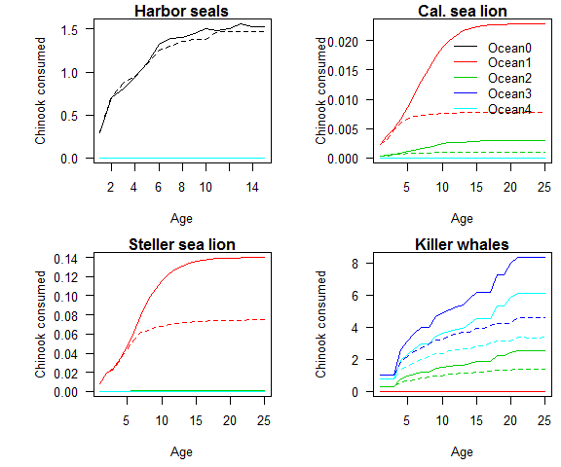

Figure 2.
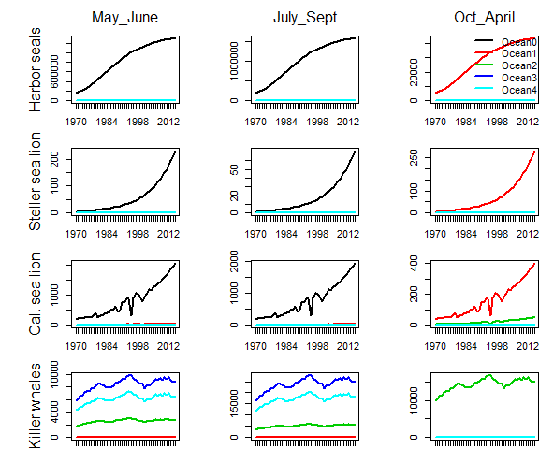

Figure 3.
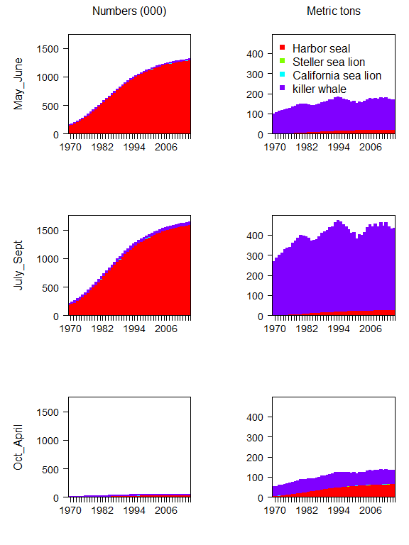

Figure 4.
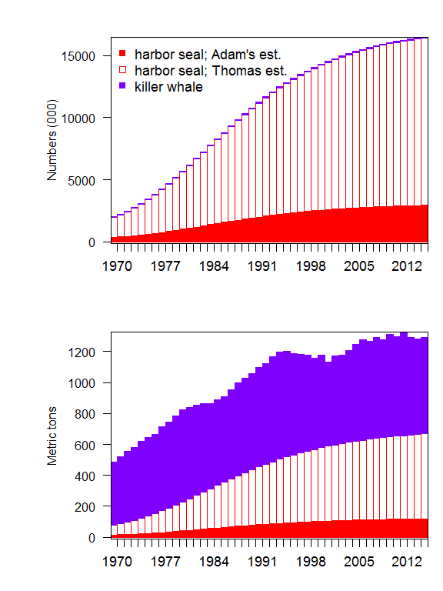

Figure 5.
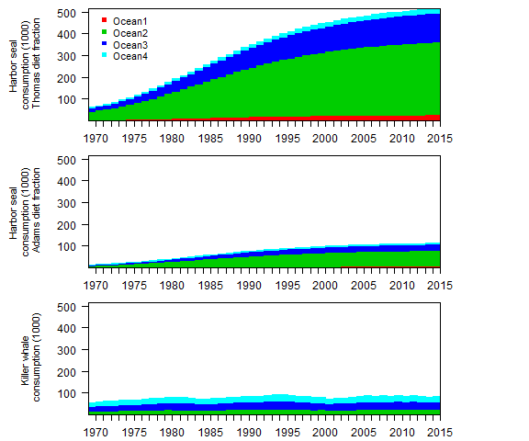

Figure 6.
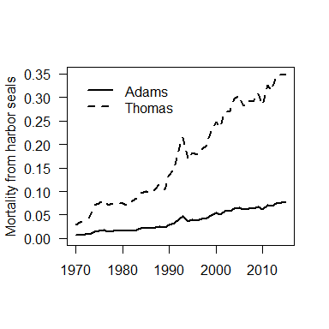

Supplemental material

Predator weigth-at-age
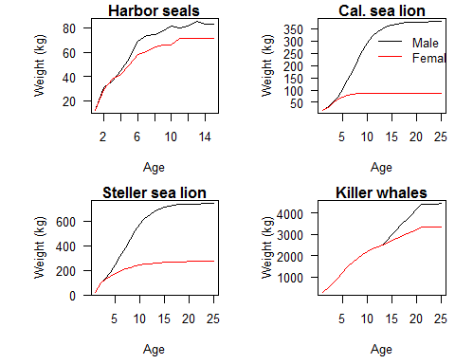

Reproduction and growth costs for harbor seals and Steller sea lions

Production costs
The daily production cost can be disaggregated into the gestation/pupping cost () and lactation cost (). Depending on the time of year the reproductive costs ( and ) will change for predators of different ages and sex. To account for these temporal effects we include an additional set of time-varying estimates,
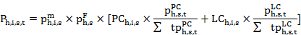
where the variables and are the conditional probability of predator gestating or lacatating on day given that it is both mature () and fecund (). Since males neither lactate nor give birth, setting 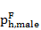 equal to zero negates the reproduction effects.
The lactation and gestation costs listed below are conditional on a female actually producing offspring. For harbor seals the fecundity rate is 0.91 (Howard et al. 2010) and for Steller sea lions the fecundity rate is 0.63 (Winship et al. 2002). There are no gestation or lactation costs calculated for killer whales.
In most instances, the models in the literature (Table 8) describe the annual costs of reproduction. Since and are the daily probability of a reproduction cost, then 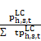 and 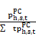 are the daily fraction of the annual reproduction costs. The killer whale literature does not separate the production costs from the activity costs, since they are such a minimal cost compared to the activity costs. The gestation periods of the pinnipeds are based on the following literature,

Variable | Predator | Model | Source
 | Harbor seal | 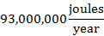 | Howard et al. (2010)
 | Steller sea lion |  | Winship et al. (2002)
 | California sea lion | NA | Weise and Harvey (2008)
 | Killer whales | NA | Noren (2011)
 | Harbor seal | 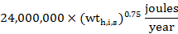 | Howard et al. (2010)
 | Steller sea lion | 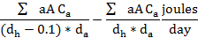 | Winship et al. (2002)
 | California sea lion | NA | Weise and Harvey (2008)
 | Killer whales | NA | Noren (2011)
 | Harbor seal | 0.91 | Howard et al. (2010)
 | Steller sea lion | 0.63 | Winship et al. (2002)
 | California sea lion | NA
 | Killer whales | NA
Summary of production costs by predator.
Parameter | Species | Initial day | Ndays | Source
 | Harbor seal | 9 mos. before pupping | 214 (9 months) | Temte (1994); Temte et al. (1991)
 | Steller sea lion | 9 mos. before pupping | 214 (9 months) | ??
 | Harbor seal | May 25th | 28 - 42 | Bowen et al. 2003; Newby (1973)
 | Steller sea lion | May 24 |  | Mathisen et al. (1962)
Lactation and gestation periods for the each of the predator species.
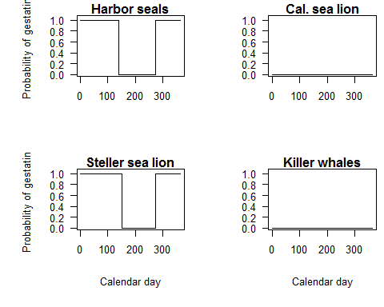
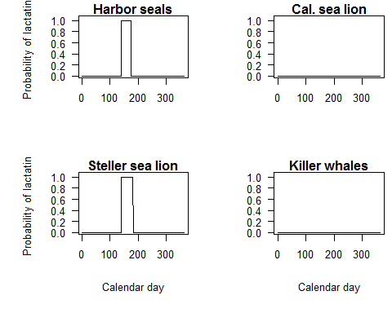
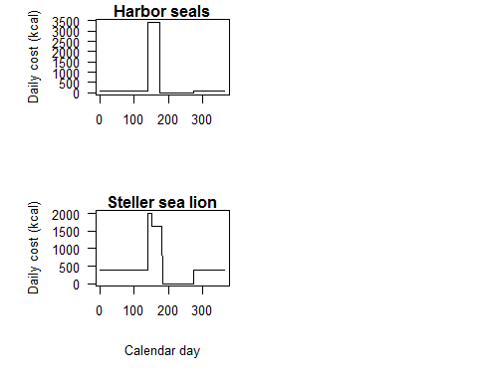

Growth costs
The models for growth costs () are different for each predator. The Steller sea lion model is an annual estimate based the change in weight, while the Harbor seal model is daily estimate for immature individuals. The growth costs for killer whales are integrated into the activity costs.
Variable | Predator | Model | Source
 | Harbor seal |  | Howard et al. (2010)
 | Steller sea lion |  | Winship et al. (2002)
 | California sea lion | NA | Weise and Harvey (2008)
 | Killer whales | NA | Noren (2011)
Summary of growth costs by predator.

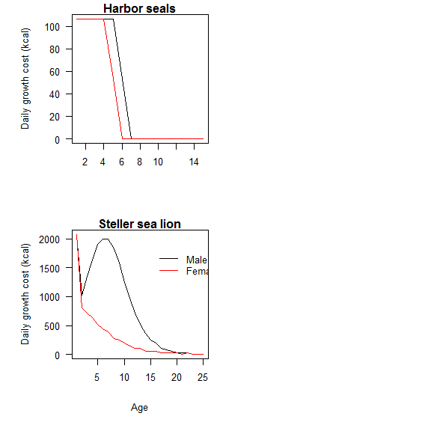

Efficiency
Efficiency measures the energy that is lost through excretion and metabolic heat before it can be converted to maintenance or growth. Our estimate of efficiency () is the percentage energy left after waste () and digestive heat (). Calculating the conversion efficieny for the species is sightly different based on how the parameters were reported in the literature. The efficiency for killer whales is integrated into the activity costs.
Species | Efficiency calculation |  |  | Source
Harbor seal |  | 0.90 | 0.08 | Howard et al. (2010)
Steller sea lion |  | (pup, others) 0.95, 0.85 | 0.88 | Winship et al. (2002)
California sea lion |  | NA | NA | Weise and Harvey (2008)
Killer whale |  | NA | NA | Noren et al. (2011)
Description of the models for energetic efficiency depending on the parameterizations in the literature.
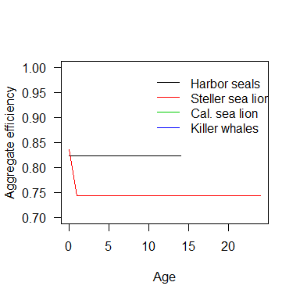

Population structure of the predator populations
To estimate the number of Steller and California sea lions present in Puget Sound inland waters I used the abundance estimate for Washington State from Eric Ward's MARSS model. To estimate the number of Steller and California sea lions in inland waters I applied the ratio between 2015 aerial estimates from Scott Pearson (Pers. Comm. October 23rd) and Eric's 2015 estimate based on his MARSS model. I then applied this ratio to the rest of Eric's time series estimates and multiplied by 1.6, which is the common expansion factor for marine mammal haulout surveys.
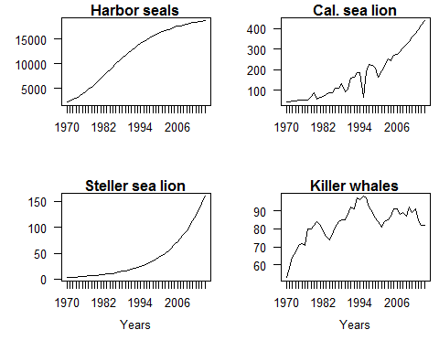
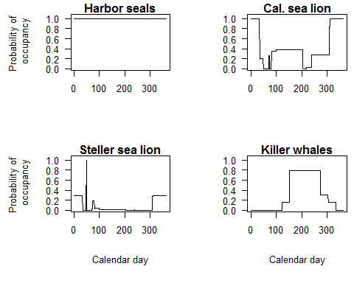
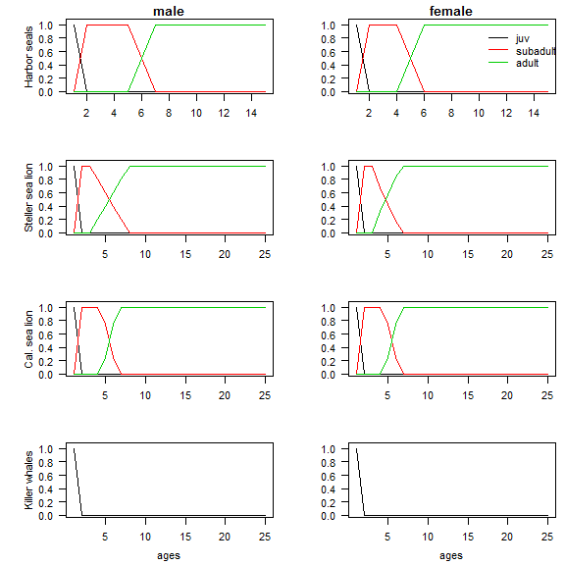
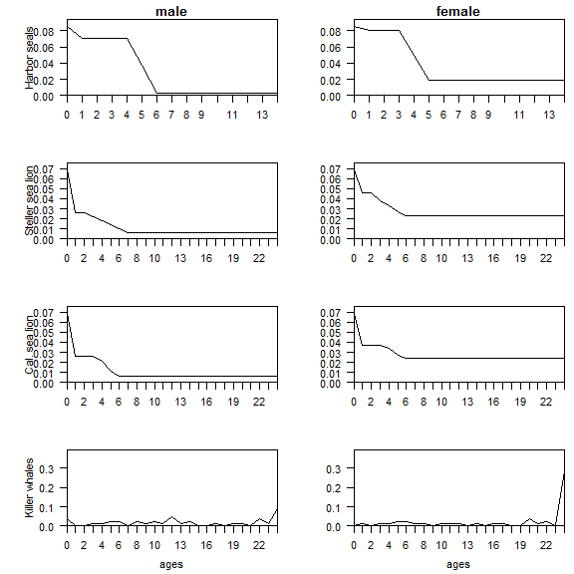

Proportion of different age Chinook in the predator diets
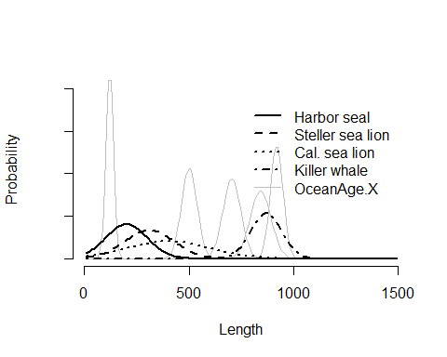
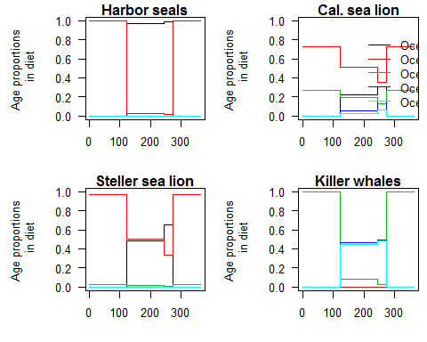

Distribution of hatchery release months
