Differential impacts of freshwater and marine covariates on wild and hatchery Chinook salmon marine survival

Brandon Chasco1, Brian Burke2, Lisa Crozier2, Rich Zabel2

1 Fish Ecology Division, National Marine Fisheries Service, NOAA, Newport, OR 97365

2 Fish Ecology Division, National Marine Fisheries Service, NOAA, Seattle, WA 98125

Short title: Integrated marine and freshwater effects on salmon survival

**Abstract**

Large-scale atmospheric conditions in the Northeast Pacific Ocean affect both the freshwater environment in the Columbia River Basin and marine conditions along the coasts of Oregon, Washington, and British Columbia, resulting in correlated conditions in the two environments. For migrating species, such as salmonids that move through multiple habitats, these correlations can amplify the impact of good or poor physical conditions on growth and survival, as movements among habitats may not alleviate effects of anomalous conditions. Unfortunately, identifying the mechanistic drivers of salmon survival in space and time is hindered by these cross-habitat correlations. To address this issue, we modeled the marine survival of Snake River spring/summer Chinook salmon with multiple indices of the marine environment and an explicit treatment of the effect of arrival timing from freshwater to the ocean, and found that both habitats contribute to marine survival rates. We show how the carryover effect of freshwater conditions on marine survival varies by year and rearing type (hatchery or wild), with a larger effect for wild fish. As environmental conditions change, incorporating effects from both freshwater and marine habitats into salmon survival models will become more important, and has the additional benefit of highlighting how management actions that affect arrival timing may improve marine survival.

**Keywords**: Chinook salmon, hatchery versus wild, marine survival, carryover effects

word count: abstract (214), main (4515), figures (263), tables (179), references (1200)

**Introduction**

Snake River spring/summer Chinook salmon are an iconic species of the Pacific Northwest. Populations once supported large commercial and recreational fisheries, as well as subsistence for indigenous communities. However, overfishing, the effects of hydropower on flows and fish passage, alterations to freshwater habitat, and impacts from production of hatchery fish have all led to steep declines in population sizes since the 1970s. In response to continued declines, wild spring/summer Chinook salmon in the Snake River evolutionary significant unit (ESU) were listed as endangered in 1992 (Federal Register 64(56):14307-14328 2005). Since then, tribal, state, and federal agencies have worked to mitigate these negative effects on salmon in the freshwater environment. However, responses to these efforts have not been as large as expected, as populations have not recovered and evidence suggests that marine survival continues to be the dominant driver of salmon population productivity (Scheuerell and Williams 2005; Kilduff et al. 2014; C. B. Woodson and Litvin 2015; Wells et al. 2016).

Chinook salmon are a semelparous fish with a complex life history, and their survival is the integration of both freshwater and marine processes over very large spatial scales (Quinn 2018). The typical spring/summer Chinook salmon spends one to two years rearing in freshwater and one to three years in the ocean before returning to the original freshwater tributary to spawn. The majority of Chinook salmon in the Snake River ESU spend two years in freshwater and two years in the ocean; however, despite the nearly equal allocation of time between the two environments, variability in mortality rates is much greater in marine waters (Welch et al. 2008; Haeseker et al. 2012). Using data from juvenile Chinook salmon tagged in the freshwater environment and detected as returning adults, evidence suggests that the period when salmon first enter the marine environment is critical to overall marine survival (Beamish et al. 1992; Duffy and Beauchamp 2011; Chasco et al. 2017). Unfortunately, many of the specific mechanisms of mortality during this period are not well known.

Evaluating drivers of survival for migrating animals is difficult because they often spend time in multiple habitat types. The interaction between physical processes at local, regional, and basin scales commonly results in correlated conditions across nearby habitat types. In the Columbia River Basin, inter-annual variability in freshwater conditions tends to be correlated with variability in regional marine conditions (Hodgson et al. 2006; Gosselin et al. 2018), as both habitats are driven by large-scale atmospheric and oceanographic conditions. This correlation has the potential to amplify (or dampen) anomalous conditions in multiple habitats simultaneously, thus complicating our ability to identify causative mechanisms of variability in salmon survival (Litzow et al. 2018).

Moreover, the potential for carryover effects (Gosselin et al. 2018) from one environment to another are difficult to incorporate into analyses. Despite evidence showing that the conditions in the freshwater environment play an important role in determining ocean survival by influencing salmon growth rates, condition, and their spatiotemporal proximity to predator populations (Beamish et al. 1992; Scheuerell et al. 2009; Duffy and Beauchamp 2011; Chasco et al. 2017; Gosselin et al. 2018), many questions about carryover effects from the freshwater environment remain. In this effort, we provide a generalized statistical model which scientists and managers can effectively integrate the complex interacting effects of environmental conditions across multiple habitats. Here, we use a multivariate random effects model to decouple the latent effects of arrival timing from other sources of marine mortality to improve our understanding of the factors affecting the survival of spring/summer Chinook salmon between 2000 and 2015. The analysis is based on a rich dataset consisting of over 285,000 PIT-tagged individuals.

**Methods**

*PIT tag data*

We used Passive Integrated Transponder (PIT) data provided by Columbia Basin Research (CBR, cbr.washington.edu) via PIT Tag Information Systems (PTAGIS, www.ptagis.org) to estimate the survival of Snake River spring/summer Chinook (SRC) salmon. We considered data for all out-migrating SRC salmon detected from 2000 to 2015 at Bonneville Dam -- the furthest downstream dam on the Columbia River. We marked a fish as having survived the marine stage if it was detected at Bonneville Dam (or farther upstream, if not detected at Bonneville Dam) as an adult. The data included *i*) last detection date at Bonneville Dam as juveniles, *ii*) rear type (hatchery or wild), and *iii*) whether the fish was detected in the Columbia River as an adult. We excluded all fish with an unknown rearing type (i.e., hatchery versus wild), geographic regions with fewer than 200 individuals (over the 16 years), those fish released or tagged below the confluence of the Snake and Columbia Rivers, fish that return to spawn without entering the ocean, and fish that were barged downstream as juveniles. We excluded fish that passed Bonneville Dam prior to April 1st or later than June 30th; these fish account for <0.2% of the total observations. This resulted in 285,660 individuals for this analysis (Table 1). All PIT-tag files are available on the CBR website (<http://www.cbr.washington.edu/dart/cs/data/nmfs_sar/>).

*Environmental data*

Because early ocean experiences are thought to have a large influence on salmon ocean survival (Kilduff et al. 2014; C. B. Woodson and Litvin 2015; Wells et al. 2016), we focused environmental correlates on marine conditions spanning the winter prior to when fish out-migrated to the fall after outmigration. We obtained these environmental covariate data from a variety of sources (Table 2). Variables represent large-scale oceanographic patterns as well as regional physical metrics. While not all variables have a direct mechanistic relationship with salmon survival, salmon survival has been shown to correlate with many of them (Burke et al. 2013; Peterson et al. 2014). Furthermore, we binned all environmental data into three-month averages: these seasonal metrics include Dec-Feb (‘win’), Mar-May (‘spr’), Jun-Aug (‘sum’), and Sep-Nov (‘aut’). These seasonal bins are identified as suffixes on the environmental data names. For all variables included in our analyses, we tested each of the four seasons, starting with the winter prior to when salmon enter the ocean.

*Estimation and data processing scripts*

All of the data we used for this analysis are publicly available. We provide a description of the R scripts used to create these environmental data objects from the raw data inputs in the appendix Text.A2. The estimation of the model parameters was done with Template Model Builder (TMB) – a package of C++ libraries that efficiently estimates fixed effects of the model using the AutoDiff libraries and a Laplace approximation to integrate over the random effects.

*Models*

We used a mixed-effect logistic regression model to predict the SAR for fish of each rear type r (i.e., hatchery versus wild) migrating past Bonneville Dam on calendar day j during year t.

Equation 1.

Equation 2.

Where the link function is a linear combination of fixed and random effects. The fixed-effects consist of the mean survival for rear type r, , and the vector of marine coefficients for the rear type r, , times the vector of marine covariates in year t, .The random effects include an effect for calendar day j of rear type r, , an effect for year t of rear type r, , and the interaction between calendar day j and year t for rear type r, . A complete list of the subscripts, parameters and data are available in Table 3.

The smolt-to-adult survival given the observed total cohort of smolts of rear type r that migrated downstream past Bonneville Dam on day j during year t, , and the number of fish from that cohort of rear type r, on day j, and year t that survived, , is binomially distributed

Equation 3.

The random effects by rear type r for calendar day and year are treated as auto-regressive processes with lag 1 (i.e., AR(1)),

Equation 4.

Equation 5.

Where, and are the correlations for the day and year effects, and , respectively, and and are measures of the variances of the random effects for day and year, respectively. The random effect for the interaction between day and year was treated as a two dimensional auto-regressive process,

Equation 6.

#### Where is a vector of random effects across calendar days for rear type r in year t, is the correlation of the vector of day effects between years t and t-1, and is the covariance matrix between days within a year for rear type r. The covariance matrix,, is a compact way of representing the auto-correlation between day effects in the day/year interaction, where the elements between day j and day of the covariance matrix are equal to

Equation 7. ,

and is variability in the day/year interaction for rear type r.

To estimate the fixed and random effects of the model, we use the non-linear optimization libraries in Template Model Builder package (Kristensen et al. 2015) built for R (R Core Development Team 2015). The marginal likelihood of the vector of fixed effects () and the variance parameters () for the random effects () given the data is maximized by integrating across the product of the conditional probability of the data given the fixed and random effects , and the probability of the random effects and the estimated variances (; Thorson & Minto 2014),

Equation 8.

Not all model combinations may be estimable due to the confounding effects among model parameters; in some instances, more than one model parameterization may produce identical fits to the data. In these cases, the Hessian is non-positive definite, and the solution is not unique or estimable. We define a converged model as one with a positive definite hessian and a maximum gradient of 0.001 for the fixed effects. To compare models and select the most parsimonious fit to the data, we used the marginal AIC for the fixed effects (Akaike’s information theoretic; Akaike 1974) using the TMBhelper package.

Testing all of the thousands of parameter combinations for the 31 marine variables, in addition to the different combinations of random effects, is not reasonable. We therefore restricted the potential models to only those with i) zero, one, or two marine covariates and ii) only two-covariate models where the correlation between covariates was less 0.7. Furthermore, initial analyses indicated that estimating random effects for day, year, and the day/year interaction in a single model produced an over-fit to the data. Models with all three random effects did converge in some instances, but the time-series of random effects for either the day or year were so small (<1e-4 in most cases) as to be meaningless. Therefore, we restricted our analysis to no more than two random processes for day, year, and the day/year interaction. This resulted in six different random effects models. Finally, to allow for the most flexibility for a given group of fish, we did not combine the hatchery and wild datasets in a multivariate analysis, but rather ran models for each dataset separately.

*Model validation*

To validate that the fixed-effects and variance parameters for our model (and , respectively) are estimable and unbiased, we conducted simulations in three by three factorial design - three separate trials for three different simulation experiments (see Table.A2 for a list of simulation R scripts). The simulation model drew random day and day/year interaction effects from the probability distributions for the random effects (), and random numbers of fish surviving on each day and year from the measurement probability based on the fixed and random effects ( (see Equation 8). The experiment were conducted for wild fish only. Each trial consisted of 500 randomly drawn data sets, and unless otherwise stated in an experiment, the parameters of the simulation model were equal to mle parameter estimates from the model with the lowest AIC. For each simulated data set, an estimation model in TMB with the same statistical properties as the simulation model was used to estimate the parameters of the model fit to simulated data. The estimated parameters for the kth simulated data for trial h and experiment e were then compared to the true parameters values of the simulation model.

The first experiment examined the effects of sample size by setting the simulated samples equal to 50%, 100%, and 500% of the observed sample sizes . The second experiment examined the effect of correlation for the day by fixing to 0.1, 0.5, or 0.9. Similarly, for the third experiment, we examined the effects of the correlations for the day/year interaction by fixing both and equal to 0.1, 0.5, or 0.9.

Previous mixed-effects models for estimating SAR used the lme4 package in R (Bates et al. 2015) and treated the day effect with a fixed-effect for day, day2, and the day/year interaction (Scheuerell et al. 2009, Gosselin et al. 2017). We were interested to determine if the previous fixed-effects models could lead to differences in the expectation and standard error for the survival. We simulated an additional 500 data sets from the simulation model for wild fish based on the mle parameters from the model with the lowest AIC (Table 4) and then compared parameter estimates from the estimation model using TMB with a fixed-effects model estimated using glm function in R (R Core Team, 2018). For the glm we used binomial model with a log-link function, ,

Equation 9. .

where, for the ith observation of simulation s, is the mean survival, and are the fixed effects for the environmental covariates, and , , and are fixed effects for the day, day2, and day/year interaction, respectively.

**Results**

*Model fit and best model structure*

We found that the models with random effects for day and day/year interactions along with two marine covariates produced the best model fit to the data for wild fish, and models with only day/year interactions and two environmental covariates produced the best model fit for hatchery fish (Table 4). The top models (AIC4) for wild fish all assumed random effects for day and day/year interactions, with differences in model fit arising from the combinations of marine covariate pairs (Table 4). The top models for hatchery fish produced fewer differences in the marine covariates and little evidence for an underlying day effect: the only top model for hatchery fish with a day effect had a AIC equal to 4.

Comparing the best-fit models for each rearing type, our results suggested that the expected survivals and 95% credible interval for wild and hatchery fish were 0.009 (0.002, 0.035) and 0.008 (0.006, 0.010), respectively (Table 5). The marine covariates that improved the fit of the survival model were different for wild and hatchery fish, but the magnitude of the environmental effects was similar for the two rearing types (Table 5, Figure 2). Spring coastal upwelling index (cui.spr) and summer Pacific decadal oscillation (pdo.sum) provided the best fit to the wild fish data, while summer transport (transport.sum - a measure of the northward transport of water based on the Sverdrup index) and the summer North Pacific gyre oscillation index (npgo.spr) provided the best fit to the hatchery fish data. The percent change in marine survival as function of the marine covariates varied between -70% to 150% for wild fish, and 70% and 200% for hatchery fish (Figure 2).

Across all of the top models (), we found differences in the importance of the marine covariates that best explain hatchery and wild survival based on AIC weights (see Figure 3 for calculation). For the top models listed in Table 4, coastal upwelling index (CUI), Washington coastal and arc sea surface temperatures (ersstWAcoast and ersstArc, respectively), and Pacific decadal oscillation (PDO) were important for wild fish (Figure 3), while transport and North Pacific gyre oscillation (NPGO) had the most important for hatchery fish,. Seasonal variations in the marine covariates indices appeared to be more important to hatchery fish compared to wild fish. There were only a couple of seasonal transport and NPGO covariates that offered most of the predictive for hatchery salmon survival, while different seasonal variations in the PDO, sea surface temperature (SST) and CUI were the most predictive for wild salmon survival.

The interaction between day and year were important in the best-fit models for both the wild and hatchery rearing types (Table 4 and Table 5). Differences in the estimated daily survival rates varied between 0.002 and 0.115 for wild fish, and 0.003 and 0.06 for hatchery fish (Figure 4 alternative). Models fits to the observed daily survival rates for each rearing type and year are shown in Figure 4. For day/year effect on the survival of wild fish, there was strong positive correlation between days within a year ( = 0.932), and negative correlation between days across years (= -0.489) (Table 5). However, there was consistently higher survival for the earlier arriving wild fish - hence, the model with the lowest AIC had a day random effect in addition to the day/year random effect (Table 4). The random deviation of the day/year interaction for hatchery fish showed a high degree of correlation between days within a year ( = 0.955) and a weak negative correlation between days across years ( = -0.067). However, hatchery fish showed no underlying daily trend in survival across years (Figure 5), which is why there was no random effect for day in the model with the lowest AIC (Table 4). The standard deviation of the day/year interactions was similar for hatchery fish ( = 0.611) and wild fish ( = 0.58).

To illustrate the effect of arrival timing for wild and hatchery fish we compared the top model for each rearing type that included the random effects for both the day and the day/year interactions. For wild fish, this was the model with the lowest AIC, and for hatchery fish, this was a model with identical marine covariates to the best-fit model but with daily random effects ( = 3.9996; Table 4). The day effect was highest for wild fish passing Bonneville Dam around May 3rd, followed by decreasing survival throughout the remainder of the smolt migration (Figure 6a). By comparison, the model of hatchery fish that included both day and day/year interaction showed no real difference in smolt survival for the day effect (Figure 6a), despite relatively similar mean arrival timing past Bonneville Dam (Figure 6b). The lack of a day effect for hatchery fish is supported by the low estimates for the correlation coefficient and variability in their day effect ( = 0.05 and = 0.134). Conversely, the wild fish had higher correlation and variability ( = 0.986 and = 0.793, respectively) which suggests that the day effect “wanders” more for wild fish.

While none of the top models included a random deviate for year, we predicted the annual survival by aggregating the daily survival estimates weighted by the total number of hatchery and wild fish that arrived each day. The observed annual survival estimates were similar to the model predictions and, with the exception of wild fish in 2003, the observations fell within the 95% credible interval (Figure 7). Both the modeled and observed annual survivals for hatchery and wild fish showed an alternating pattern of increases and decreases, which was evident by the previously described negative correlations in the year dimension for the day/year interaction (Table 5).

*Simulation*

Visual inspection of the simulation results suggestions that the estimation model provided unbiased estimates for parameters simulation model that generated the data (Figure S1). In the sample size analysis (, the parameters of the model are unbiased (i.e., the center of mass of the violins is near zero); however, for some random draws in the sample size analysis lead to some negative biases for the standard deviation for the day effect. These biases are usually associated random draws with few number of surviving fish and little auto-correlation in the day effect. As sample sizes increase, the precision increases (i.e., the violins get vertically compressed) for the correlation coefficients for the day/year interaction and standard deviations for the day and day/year interaction. The precision does not appear increase for the other parameters of the model as sample sizes increase. The magnitude of the correlation for both the day and day/year effects in the simulated data does not appear to bias for the parameter estimates (i.e., average deviation from zero in Figure S1); however, the precision of the estimated correlation for both the day () and day/year interaction ( and ) increases and the precision of the estimated mean survival () decreases as the correlation increases from 0.1 to 0.9. The precision of the coefficients for the marine covariates ( and ) are not affected by the magnitude of the simulated correlations.

When we compared the performance of a generalized linear model with fixed-effects for day, day2, and day/year interaction using the glm function in R (R Core Team 2018) to the random effects model in TMB which treats day and day/year as AR1 processes, we found little difference in the bias and precision of the mean survival () and the marine covariates ( and ) (Figure 4, upper panel). Examining a single realization of the fit of both models, the fixed-effect model in R (Figure S.2, red line) had a similar fits to the simulated daily survival data (points) as the model using the TMB model (blue line). However, the AR1 processes in the TMB model provided more flexibility to capture the daily variability in survival within a year. While there were almost no differences in the bias or precision for the mean survival and environmental covariates, the standard errors for these fixed-effects in the TMB model were between 65%-70% higher than the model in R (Figure 4, lower panel).

**Discussion**

In this study, we used simulation experiments and a case study of Snake River spring/summer Chinook salmon to evaluate how including random processes in models of smolt-to-adult survival can affect the bias and uncertainty in estimated parameters. Previous efforts typically included fixed-effects for day, day2, and day/year interactions to allow for different patterns in survival over days and years (Scheuerell et al. 2009, Gosselin et al. 2018). Our approach of using random instead of fixed effects for the day and year processes increased the flexibility of the model to predict temporal changes in survival (Figure S2). Allowing the random processes to account for more of the variability in the daily survival increased the uncertainty for mean survival and the environmental covariates relative to the fixed-effects generalized linear models (Figure 4). Properly accounting for the uncertainty in the fixed-effects will be critical for evaluating the risk to populations under projected climate conditions.

Our model is generalizable and expanding the two-dimensional “lattice” of AR1 processes from day and year to higher dimensional interactions that include biological predictors such as size and weight, or environmental forces such temperature is very accessible using our TMB model. In addition to improving our understanding of how these forces affect the bias and uncertainty in survival, these forces are associated with “levers” that co-managers of freshwater systems can manipulate quantifying the effects of these drivers will be critical for evaluating future management scenarios.

#### *Hatchery-wild comparisons*

Different rearing types of spring/summer Chinook salmon clearly exhibit differences in SAR within and between years. There are clear and expected differences between fish reared in a hatchery and fish exposed to natural conditions in the wild, including size, condition, risk aversion, arrival timing, parasite load, and numerous other factors. We clearly documented the effect of arrival timing on marine survival of Snake River spring/summer Chinook salmon was not consistent between fish of different rearing types, and we described two primary differences in timing and marine survival. First, the distribution for migrating juvenile salmon differs between the hatchery and wild fish, with hatchery fish exhibiting much more of a peaked, narrow distribution, mostly completed by early June. In contrast, the distribution of wild fish arrival timing starts earlier and has a long tail, with some fish not migrating past Bonneville Dam until mid-July. Second, on average across years, survival peaks for wild fish migrating early and then declines throughout the remainder of the migration, whereas hatchery fish, on average, show no consistent pattern in survival across years based on arrival timing.

There are multiple reasons why wild fish may be more sensitive to arrival timing than hatchery fish, though much of this is speculation. Perhaps the most likely cause is the difference in size between the two groups. If early marine survival is size-dependent, which has been shown for other salmon stocks (Henderson and Cass 1991; Beamish and Mahnken 2001; Duffy and Beauchamp 2011; L. E. Woodson et al. 2013), the larger size of hatchery fish could afford them some level of independence from predators. Additionally, large subsidies of hatchery smolts may increase the density of the predator communities, and these predators may differentially select for wild fish because they are smaller and more available once the pulse of hatchery fish has passed (Beamish et al. 1992).

#### *Arrival Timing*

A key component of this model is the inclusion of arrival timing to the marine environment. Gosselin et al. (2018) showed that management practices in freshwater can have large impacts on marine survival via carryover effects, which can materialize in the form of altered fish size or timing at out-migration. Although size-dependent mortality is important, we focused on the impacts of timing for this effort. Arrival timing has been shown to be an important catalyst for carryover effects (Gosselin et al. 2018) and these data are quite readily available, as each fish detected at Bonneville Dam has its own time stamp. However, there is a large amount of variability in arrival timing, and managers of wild salmon populations have few levers to manipulate the environmental experiences that may influence marine survival. To the extent that the freshwater environment influences salmon behavior, performance, growth, and survival in the marine environment, these influences should be incorporated into modeling efforts aimed at understanding salmon marine ecology. Freshwater conditions affecting arrival timing (e.g., flow and temperature) are likely to be correlated with conditions in the marine environment (Keefer et al. 2008), and phenological variability in the marine ecosystem is driven by atmospheric and oceanographic processes with substantial inter-annual variability (Mantua et al. 1997). For example, wind-driven ocean currents transition from south to north each spring, initiating a strong upwelling of deeper ocean water. The nutrients in this upwelled water can spawn or feed a spring phytoplankton bloom (Du and Peterson 2014). Moreover, the newly transitioned currents can bring species of zooplankton such as copepods that are high in fatty acids (Hooff and Peterson 2006; Keister et al. 2011), further enriching the production at lower trophic levels. Salmon eventually benefit from these dynamics, but the timing and magnitude of local production varies from year to year. Although salmon have evolved to optimize arrival timing on average, the broad distribution of arrival timing is a sort of bet-hedging strategy to ensure some fish arrive at the ocean when conditions are optimal. If future freshwater management practices significantly alter the mean arrival timing or the variability in timing, this could have important, and perhaps unforeseen, effects on marine survival. Similarly, if climate changes in either the freshwater or marine environment result in a mismatch between salmon arrival timing and optimal arrival timing, marine survival will be impacted. These interactions are a clear demonstration of the importance of carryover effects and a direct link between salmon survival and management decisions that may affect arrival timing.

##### *Marine Covariates*

The top models describing Chinook salmon marine survival included three categories of environmental covariates for wild fish (i.e., basin-scale sea surface temperature (‘ersstArc’), a local sea surface temperature (‘ersstWA’), and a regional spring upwelling variable (‘cui’)), and three categories of environmental covariates for hatchery fish (i.e., a measure of alongshore transport (‘transport’), ocean circulation (‘NPGO’), and sea surface temperature (‘errstArc’)). For each rearing type, there are logical links between the metric and multiple oceanographic or ecosystem processes that could influence salmon growth and survival. However, most of these links are indirect and rely on other oceanographic factors. For example, local sea surface temperature can influence growth rates directly (Wells et al. 2007), but a more likely influence on salmon survival involves production at lower trophic levels and temperature-dependent distribution of prey and predator species (Wells et al. 2017).

In this effort, we intentionally restricted our potential ocean covariates to publicly-available (and mostly physical) variables. These variables do not necessarily directly relate to the ecosystem processes that determine salmon survival, but rather represent correlations with these processes. Some biological time series that more directly characterize ecosystem processes such as trophic dynamics are available, but only for recent years (e.g., stoplight chart for ocean survival estimates, <http://www.nwfsc.noaa.gov/oceanconditions>). For other research goals, such as near-term forecasting, these more direct metrics may be more appropriate. Indeed, as more biological data are collected, reliance on correlations should be reduced (Litzow et al. 2020) and the use of mechanistic ecosystem models will become more important (Hollowed et al. 2000; Fulton et al. 2011).

#### *Model Fit*

Comparing the residual deviance ratio, defined as the fit of a particular model relative to a model where each data point has its own parameter, the fixed effects models that included only marine covariates had ratios equal to 0.077 and 0.167 for wild and hatchery fish, respectively. When we removed the marine covariates and included a day/year interaction, the ratios increased to 0.197 and 0.346, respectively. Finally, the ratios increased to 0.208 and 0.350, respectively, for the model that included marine covariates and random effects for day and the day/year interaction (Table 6). The small differences in the ratios between the random effects models with and without marine covariates does not imply that marine conditions do not affect Chinook salmon survival. In fact, as shown by the estimated magnitude of the deviates in Figure 2, the marine covariates were correlated with large differences in marine survival. However, rather than a uniform response of all fish to the marine conditions in a particular year, our model demonstrates that the timing of when the juvenile salmon encounter the marine conditions appears to explain more of the data (Table 6). The mechanism that is driving this differential survival across days and years remains a critical knowledge gap and a focus of future salmon modeling.

Combining impacts from multiple environments has been applied in several past efforts to model Snake River spring/summer Chinook marine survival. The day effect was described by Scheuerell et al. (2009) using a quadratic effect for day in a logistic regression model. The authors showed that earlier fish tend to have higher survival, but this shifted somewhat from year to year. Holsman et al. (2012) also use a logistic regression for this ESU and characterized the impacts of predators, prey, flow, and the temperature difference between the Columbia River and the nearshore ocean; however, they did not include a day effect in their model. Similarly, Haseker et al. (2012) demonstrated the importance of freshwater spill, which is related to flow, in modeling marine survival for this ESU, but included a linear effect of day. Miller et al. (2014) used a logistic regression to show that the size at out-migration was not as important as the size at marine capture (after fish had been in the ocean for weeks to months), suggesting that marine growth is highly influential in setting mortality rates. Finally, Gosselin et al. (2018) used a mixed effects regression to describe carryover effects from the freshwater environment, with particular emphasis on transportation impacts on hatchery and wild fish. The current model design represents a compromise between model complexity, realism, and the clear need to address the interactions between freshwater impacts and the marine ecosystem. Rather than treating the effect timing on survival as a fixed effect described by a linear or quadratic relationship, our model accounts for the heterogeneity in the survival processes by treating the effect of timing as random process.

#### *Caveats*

We included arrival timing, but did not include other attributes such as fish size, which is known to have important impacts on trophic interactions and size-dependent survival (Beamish and Mahnken 2001; Roby et al. 2003; Duffy and Beauchamp 2011; L. E. Woodson et al. 2013). Miller et al. (2014) showed that Snake River spring/summer Chinook marine survival was more related to size after some period of ocean residence than size at out-migration, but did not rule out the possibility that some level of size-dependent mortality did not already occur. Further research to extend this model is necessary to fully understand how other fish attributes such as size in the freshwater environment are likely to affect marine survival. Fortunately, given the flexibility of the multivariate framework, such analyses are possible with the availability of additional data. Additionally, maturation schedules, the fraction of a salmon maturing and returning to spawn at different ages, are also size-dependent – larger and faster growing fish tend to mature earlier. Recent spawner-recruit analysis suggests that climate conditions affect both the maturation schedule and the survival of some stocks of salmon (Scheuerell et al. 2019); however, timing and size were not a part of these models. Future iterations of our model could examine the effects of size and maturation simultaneously, with the goal of understanding how management actions in freshwater environment affect size, maturation, and ultimately, survival.

We view our model as a robust approach for integrating the freshwater and marine effects in a single estimation model. By partitioning the different sources of uncertainty between the observation model (binomial likelihood) and process models (random effects for day, year, and day/year interactions) we provide a more accurate estimate of uncertainty and relative importance of the fixed effects associated with the marine covariates relative to the random deviations in survival associated with differences in arrival timing between years. While our model was restricted to examining the two-dimensional interaction between day and year, this model can quickly be scaled-up to higher-dimensional questions related to the interaction between day, year, size, and maturation.

**References**

Beamish, Richard J., and Conrad Mahnken. 2001. A critical size and period hypothesis to explain natural regulation of salmon abundance and the linkage to climate and climate change. *Progress in Oceanography* 49: 423–437.

Beamish, Richard J., Barbara L. Thomson, and Gordon A. McFarlane. 1992. Spiny dogfish predation on chinook and coho salmon and the potential effects on hatchery-produced salmon. *Transactions of the American Fisheries Society* 121: 444–455.

Burke, Brian J., William T. Peterson, Brian R. Beckman, Cheryl Morgan, Elizabeth A. Daly, and Marisa Litz. 2013. Multivariate Models of Adult Pacific Salmon Returns. *PLOS ONE* 8: e54134. https://doi.org/10.1371/journal.pone.0054134.

Chasco, Brandon, Isaac C. Kaplan, Austen Thomas, Alejandro Acevedo-Gutiérrez, Dawn Noren, Michael J. Ford, M. Bradley Hanson, Jonathan Scordino, Steve Jeffries, and Scott Pearson. 2017. Estimates of Chinook salmon consumption in Washington State inland waters by four marine mammal predators from 1970 to 2015. *Canadian Journal of Fisheries and Aquatic Sciences* 74: 1173–1194.

Du, Xiuning, and William T. Peterson. 2014. Seasonal cycle of phytoplankton community composition in the coastal upwelling system off central Oregon in 2009. *Estuaries and coasts* 37: 299–311.

Duffy, Elisabeth J., and David A. Beauchamp. 2011. Rapid growth in the early marine period improves the marine survival of Chinook salmon (Oncorhynchus tshawytscha) in Puget Sound, Washington. *Canadian Journal of Fisheries and Aquatic Sciences* 68: 232–240.

Federal Register 64(56):14307-14328. 2005.

Fulton, Elizabeth A., Jason S. Link, Isaac C. Kaplan, Marie Savina-Rolland, Penelope Johnson, Cameron Ainsworth, Peter Horne, Rebecca Gorton, Robert J. Gamble, and Anthony DM Smith. 2011. Lessons in modelling and management of marine ecosystems: the Atlantis experience. *Fish and Fisheries* 12: 171–188.

Gosselin, Jennifer L., Richard W. Zabel, James J. Anderson, James R. Faulkner, António M. Baptista, and Benjamin P. Sandford. 2018. Conservation planning for freshwater–marine carryover effects on Chinook salmon survival. *Ecology and evolution* 8: 319–332.

Haeseker, Steven L., Jerry A. McCann, Jack Tuomikoski, and Brandon Chockley. 2012. Assessing freshwater and marine environmental influences on life-stage-specific survival rates of Snake River spring–summer Chinook salmon and steelhead. *Transactions of the American Fisheries Society* 141: 121–138.

Henderson, M. A., and A. J. Cass. 1991. Effect of smolt size on smolt-to-adult survival for Chilko Lake sockeye salmon (Oncorhynchus nerka). *Canadian Journal of Fisheries and Aquatic Sciences* 48: 988–994.

Hodgson, Sayre, Thomas P. Quinn, R. A. Y. Hilborn, Robert C. Francis, and Donald E. Rogers. 2006. Marine and freshwater climatic factors affecting interannual variation in the timing of return migration to fresh water of sockeye salmon (Oncorhynchus nerka). *Fisheries Oceanography* 15: 1–24.

Hollowed, Anne B., Nicholas Bax, Richard Beamish, Jeremy Collie, Michael Fogarty, Patricia Livingston, John Pope, and Jake C. Rice. 2000. Are multispecies models an improvement on single-species models for measuring fishing impacts on marine ecosystems? *ICES Journal of Marine Science: Journal du Conseil* 57: 707–719.

Hooff, Rian C., and William T. Peterson. 2006. Copepod biodiversity as an indicator of changes in ocean and climate conditions of the northern California current ecosystem. *Limnology and Oceanography* 51: 2607–2620.

Keefer, Matthew L., Christopher A. Peery, and Christopher C. Caudill. 2008. Migration timing of Columbia River spring Chinook salmon: effects of temperature, river discharge, and ocean environment. *Transactions of the American Fisheries Society* 137: 1120–1133.

Keister, Julie E., E. Di Lorenzo, C. A. Morgan, Vincent Combes, and W. T. Peterson. 2011. Zooplankton species composition is linked to ocean transport in the Northern California Current. *Global Change Biology* 17: 2498–2511.

Kilduff, D. Patrick, Louis W. Botsford, and Steven LH Teo. 2014. Spatial and temporal covariability in early ocean survival of Chinook salmon (Oncorhynchus tshawytscha) along the west coast of North America. *ICES Journal of Marine Science* 71: 1671–1682.

Kristensen, Kasper, Anders Nielsen, Casper W. Berg, Hans Skaug, and Brad Bell. 2015. TMB: automatic differentiation and Laplace approximation. *arXiv preprint arXiv:1509.00660*.

Mantua, Nathan J., Steven R. Hare, Yuan Zhang, John M. Wallace, and Robert C. Francis. 1997. A Pacific interdecadal climate oscillation with impacts on salmon production. *Bulletin of the american Meteorological Society* 78: 1069–1079.

Miller, Jessica A., David J. Teel, William T. Peterson, and Antonio M. Baptista. 2014. Assessing the relative importance of local and regional processes on the survival of a threatened salmon population. *PloS one* 9: e99814.

Peterson, William T., Jennifer L. Fisher, Jay O. Peterson, Cheryl A. Morgan, Brian J. Burke, and Kurt L. Fresh. 2014. Applied Fisheries Oceanography: Ecosystem Indicators of Ocean Conditions Inform Fisheries Management in the California Current. *Oceanography* 27: 80–89. JSTOR.

Quinn, Thomas P. 2018. *The behavior and ecology of Pacific salmon and trout*. University of Washington Press.

R Core Development Team. 2015. R: A language and environment for statistical computing.

Roby, Daniel D., Donald E. Lyons, David P. Craig, Ken Collis, and G. Henk Visser. 2003. Quantifying the effect of predators on endangered species using a bioenergetics approach: Caspian terns and juvenile salmonids in the Columbia River estuary. *Canadian Journal of Zoology* 81: 250–265.

Scheuerell, Mark D., and John G. Williams. 2005. Forecasting climate-induced changes in the survival of Snake River spring/summer Chinook salmon (Oncorhynchus tshawytscha). *Fisheries Oceanography* 14: 448–457.

Scheuerell, Mark D., Richard W. Zabel, and Benjamin P. Sandford. 2009. Relating juvenile migration timing and survival to adulthood in two species of threatened Pacific salmon (Oncorhynchus spp.). *Journal of Applied Ecology* 46: 983–990.

Welch, David W., Erin L. Rechisky, Michael C. Melnychuk, Aswea D. Porter, Carl J. Walters, Shaun Clements, Benjamin J. Clemens, R. Scott McKinley, and Carl Schreck. 2008. Survival of migrating salmon smolts in large rivers with and without dams. *PLoS biology* 6: e265.

Wells, Brian K., Churchill B. Grimes, and James B. Waldvogel. 2007. Quantifying the effects of wind, upwelling, curl, sea surface temperature and sea level height on growth and maturation of a California Chinook salmon (Oncorhynchus tshawytscha) population. *Fisheries Oceanography* 16: 363–382.

Wells, Brian K., Jarrod A. Santora, Mark J. Henderson, Pete Warzybok, Jaime Jahncke, Russell W. Bradley, David D. Huff, Isaac D. Schroeder, Peter Nelson, and John C. Field. 2017. Environmental conditions and prey-switching by a seabird predator impact juvenile salmon survival. *Journal of Marine Systems* 174: 54–63.

Wells, Brian K., Jarrod A. Santora, Isaac D. Schroeder, Nathan Mantua, William J. Sydeman, David D. Huff, and John C. Field. 2016. Marine ecosystem perspectives on Chinook salmon recruitment: a synthesis of empirical and modeling studies from a California upwelling system. *Marine Ecology Progress Series* 552: 271–284.

Woodson, C. Brock, and Steven Y. Litvin. 2015. Ocean fronts drive marine fishery production and biogeochemical cycling. *Proceedings of the National Academy of Sciences* 112: 1710–1715.

Woodson, Lindsay E., Brian K. Wells, Peter K. Weber, R. Bruce MacFarlane, George E. Whitman, and Rachel C. Johnson. 2013. Size, growth, and origin-dependent mortality of juvenile Chinook salmon Oncorhynchus tshawytscha during early ocean residence. *Marine Ecology Progress Series* 487: 163–175.

**Figure captions**

Figure 1. Map

Figure 2. Environmental effects on survival of wild (upper panel) and hatchery (lower panel) spring/summer Chinook salmon based on the model fit to the observed data as selected by AIC (see Table 4 for summary of best fit models). *fig_envEffect_ggplot.r*

Figure 3. Relative importance of the different marine covariates for predicting the marine survival of hatchery (left column) and wild (right column) Chinook salmon, where the aggregated weight of a covariate *c* is equal to the sum of the AIC weights for all *m* models containing covariate *c*, divided by the total weight across all *m* models, . The “blank” environmental variable is for models with no environmental predictors. *fig_EnvironmentalVariableWt_ggplot.r*

Figure 5. The observed (dots), and maximum likelihood estimates (line) with 95% credible intervals (ribbons) for the marine survival wild (blue) and hatchery (red) origin Spring/Summer Chinook salmon past Bonneville dam from 2000 to 2015. Each point represents the mean survival of all fish detected at Bonneville Dam on a particular day and year. Annual samples sizes of the survivors and total PIT tagged hatchery (H) and wild (W) for are shown in each panel. To maintain the readability of individual panels, mean observed survivals greater than 0.2 are not plotted. *fig_DayxYearSurvival_ggplot.r*

Figure 6. Predicted smolt-to-adult survival by day for hatchery (red) and wild (blue) spring/summer Chinook salmon (upper panel) for best fit models for each rear type that include both day and day/year interactions (see Table 4). Lines represent expected survivals and shaded regions represent 95% credible intervals. Average daily proportion (across all years) of smolts arriving to and migrating past Bonneville Dam (2000 to 2015) (lower panel). *fig_DailySurv_ggplot.r*

Figure 7. Observed (points) and estimated (line) annual survival with 95% credible intervals (polygons) for hatchery (red) and wild (blue) spring/summer Chinook salmon from 2000 through 2015. *Fig_AnnualSurv_ggplot.r*

**Table captions**

Table 1. Sample size of hatchery and wild juvenile Chinook salmon from different watersheds within the Snake River Basin. (R *script unknown*)

Table 2. Description of the environmental variable names, the years of available data, and the website location of the data. Missing transport description. (R *script unknown*)

Table 3. List of data types, subscripts, parameters (i.e., fixed effects), and random effects used to model the smolt to adult survival of spring/summer Chinook salmon originating from the Snake River Basin.

Table 4. Top models for each origin type based on the random effects and number of marine covariates. The gradient is a measure of the likelihood surface for the maximum likelihood estimate, PD Hessian stands for positive definite Hessian, and N.E. stands for not estimated. *table_AIC.r*

Table 5. Estimated fixed effects for the model with lowest marginal AIC values for wild spring/summer Chinook salmon, and the models with the lowest marginal AIC for hatchery fish with and without a random day effect included (N.E. means not estimated). *table_bestFitModel.r*

Table 6. Deviance ratios for different fixed and mixed-effects models for hatchery and wild fish, where is -2 times the log-likelihood of model *m* and is -2 times the log-likelihood of the null model. The deviance ratio explains how close the model is to the best model that fits the data exactly.

**Figures**

Figure 1. Map

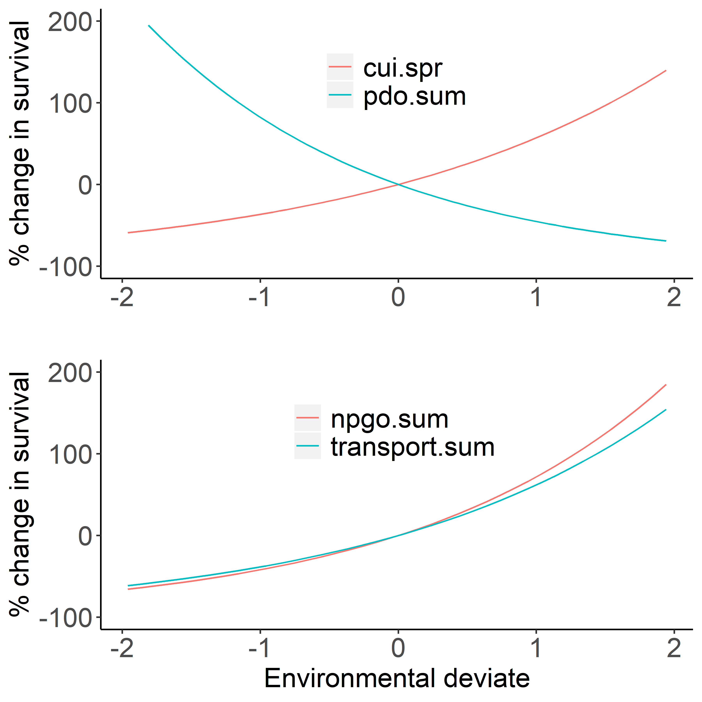

Figure 2. Environmental effects on survival of wild (upper panel) and hatchery (lower panel) spring/summer Chinook salmon based on the model fit to the observed data as selected by AIC (see Table 4 for summary of best fit models). *fig_envEffect_ggplot.r*

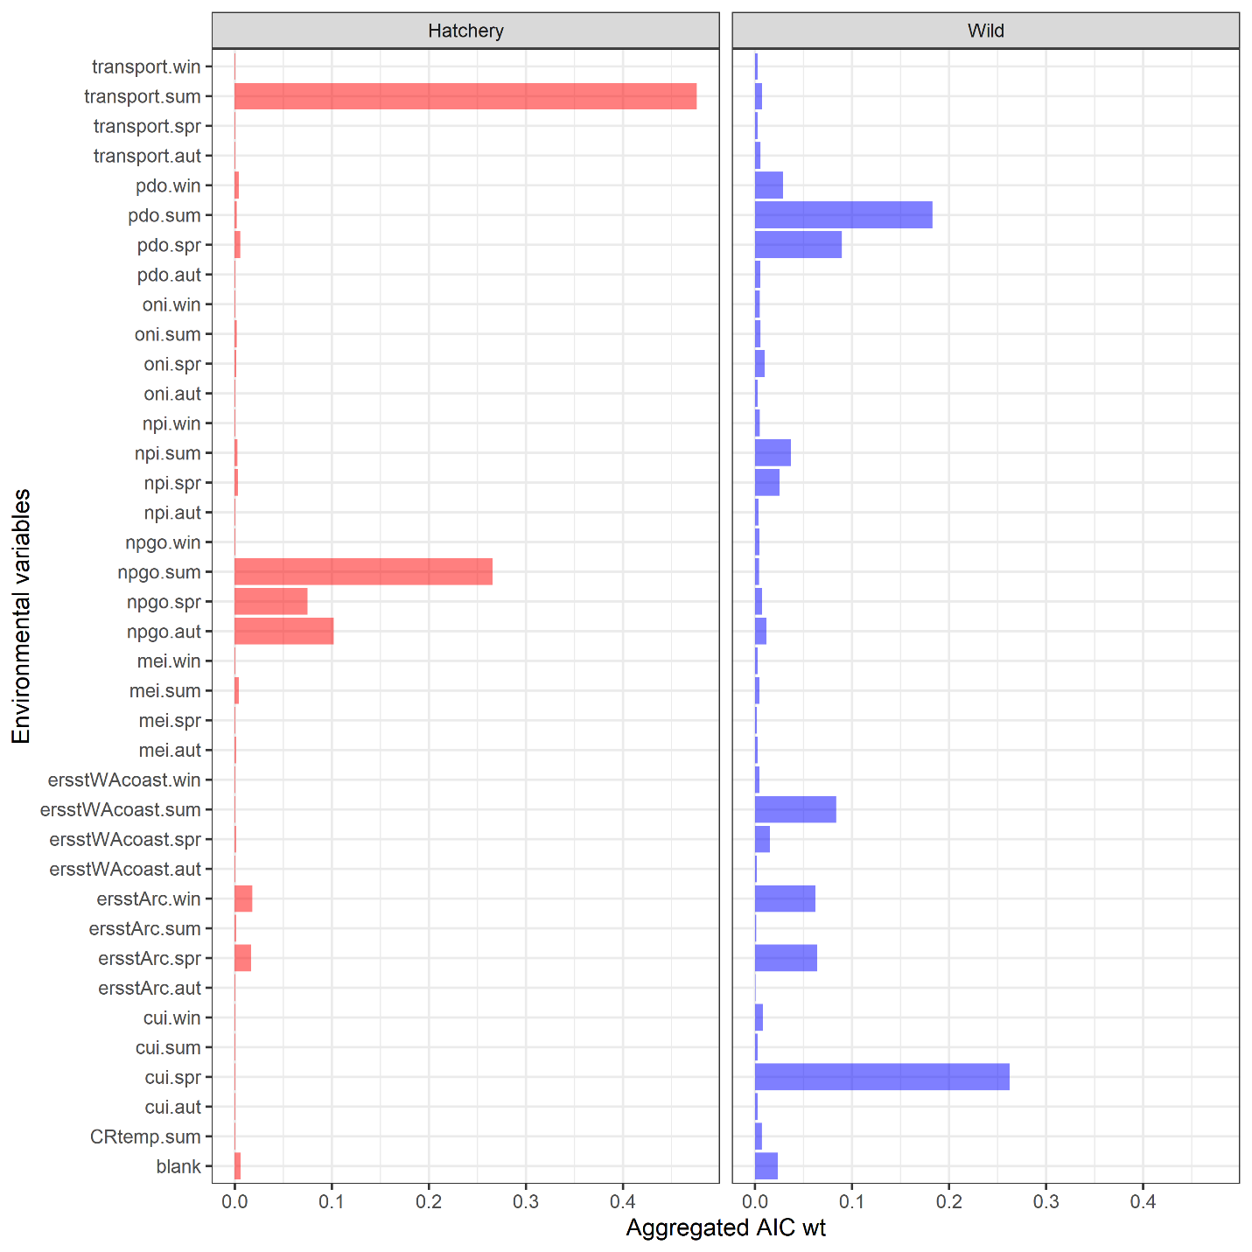

Figure 3. Relative importance of the different marine covariates for predicting the marine survival of hatchery (left column) and wild (right column) Chinook salmon, where the aggregated weight of a covariate *c* is equal to the sum of the AIC weights for all *m* models containing covariate *c*, divided by the total weight across all *m* models, . The “blank” environmental variable is for models with no environmental predictors. *fig_EnvironmentalVariableWt_ggplot.r*

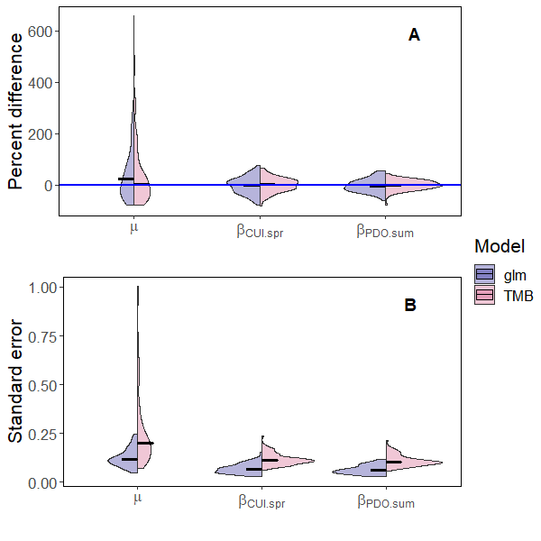

Figure 4. Split violin plot comparing the standard errors for the fixed effects , , and (lower panel) and percent difference (upper panel) between the estimated and true parameter values models with a fixed-effects for day, day2, and day/year interaction (glm; red violins) and the mixed-effect model with AR1 processes for day and day/year interaction (TMB; blue violins) fit to simulated data for wild spring/summer Chinook salmon. Simulated the data were generated from the model with the lowest AIC for wild fish (see Table 4). Horizontal lines represent median values for the violins and the horizontal blue line in panel A represents zero percent difference between the simulation and estimated parameters. *fig_quadraticSimulation_ggplot.r*



Figure 5. The observed (dots), and maximum likelihood estimates (line) with 95% credible intervals (ribbons) for the marine survival wild (blue) and hatchery (red) origin Spring/Summer Chinook salmon past Bonneville dam from 2000 to 2015. Each point represents the mean survival of all fish detected at Bonneville Dam on a particular day and year. Annual samples sizes of the survivors and total PIT tagged hatchery (H) and wild (W) for are shown in each panel. To maintain the readability of individual panels, mean observed survivals greater than 0.2 are not plotted. *fig_DayxYearSurvival_ggplot.r*

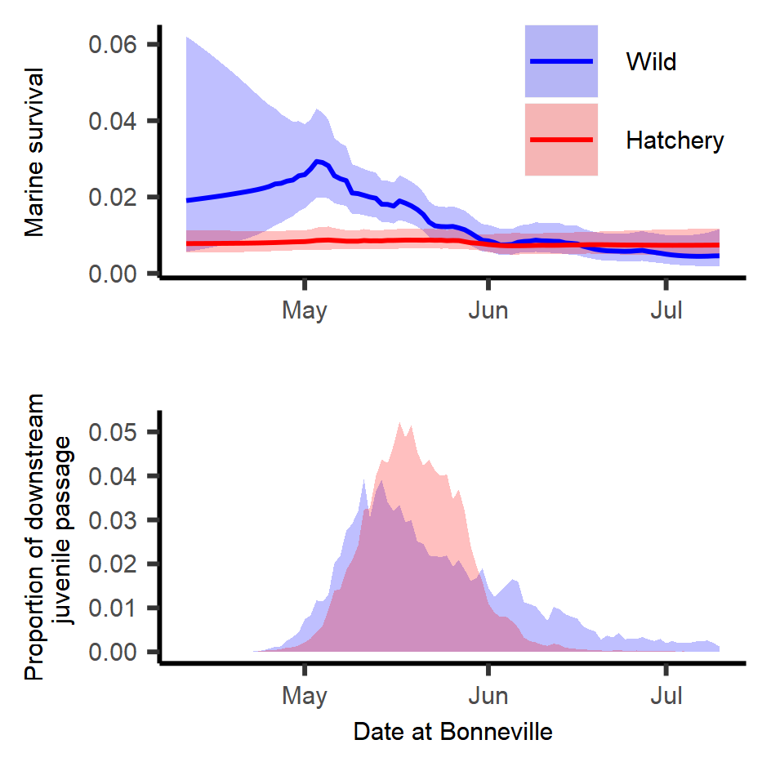

Figure 6. Predicted smolt-to-adult survival by day for hatchery (red) and wild (blue) spring/summer Chinook salmon (upper panel) for best fit models for each rear type that include both day and day/year interactions (see Table 4). Lines represent expected survivals and shaded regions represent 95% credible intervals. Average daily proportion (across all years) of smolts arriving to and migrating past Bonneville Dam (2000 to 2015) (lower panel). *fig_DailySurv_ggplot.r*



Figure 7. Observed (points) and estimated (line) annual survival with 95% credible intervals (polygons) for hatchery (red) and wild (blue) spring/summer Chinook salmon from 2000 through 2015. *Fig_AnnualSurv_ggplot.r*

**Tables**

Table 1. Sample size of hatchery and wild juvenile Chinook salmon from different watersheds within the Snake River Basin. (R *script unknown*)

|  |  |  |
| --- | --- | --- |
| Watershed | Hatchery | Wild |
| Clearwater | 88,895 | 4,512 |
| Grande Rhonde and Wallowa | 16,956 | 5,636 |
| Imnaha, Pahsimeroi, South Fork Salmon | 60,215 | 14,622 |
| Little Salmon | 69,016 | 8 |
| Lower Snake and Tucannon | 11,125 | 988 |
| Middle Fork Salmon | 0 | 3,714 |
| Upper Salmon River (above Yankee Fork) and Lemhi | 5,589 | 4,384 |
| Total | 251,796 | 33,864 |

Table 2. Description of the environmental variable names, the years of available data, and the website location of the data. Missing transport description. (R *script unknown*)

|  |  |  |  |
| --- | --- | --- | --- |
| **Variable** | **Description** | **Years Available** | **URL / Source** |
| **CRflow.spr**  **CRflow.sum** | Seasonal Columbia River flow as measured at The Dalles Dam (USGS site 14105700) | 1978-present | http://waterservices.usgs.gov/rest/DV-Service.html |
| **CRtemp.spr**  **CRtemp.sum** | Seasonal Columbia River temperatures at The Dalles Dam (USGS site 14105700) | 1997-present | http://waterservices.usgs.gov/rest/DV-Service.html |
| **cui.win**  **cui.spr**  **cui.sum**  **cui.aut** | Seasonal coastal upwelling index | 1946-present | http://www.pfeg.noaa.gov/products/PFELData/upwell/monthly/upanoms.mon |
| **mei.win**  **mei.spr**  **mei.sum**  **mei.aut** | Seasonal Multivariate ENSO Index | 1950-present | https://www.esrl.noaa.gov/psd/enso/mei/ |
| **npgo.win**  **npgo.spr**  **npgo.sum**  **npgo.aut** | Seasonal North Pacific Gyre Oscillation | 1950-present | http://www.o3d.org/npgo/npgo.php |
| **npi.win**  **npi.spr**  **npi.sum**  **npi.aut** | Seasonal North Pacific Index (index of Aleutian Low Pressure) | 1899-present | https://climatedataguide.ucar.edu/sites/default/files/npindex_monthly.txt |
| **oni.win**  **oni.spr**  **oni.sum**  **oni.aut** | Seasonal Oceanic Niño Index | 1950-present | http://www.cpc.ncep.noaa.gov/products/analysis_monitoring/ensostuff/ensoyears.shtml |
| **ersstWACoast.win**  **ersstWACoast.spr**  **ersstWACoast.sum**  **ersstWACoast.aut** | Seasonal sea surface temperature for coastal Washington | 1900-present | https://www1.ncdc.noaa.gov/pub/data/cmb/ersst/v5/netcdf/ |
| **ersstArc.win**  **ersstArc.spr**  **ersstArc.sum**  **ersstArc.aut** | Seasonal sea surface temperature from Johnstone and Mantua (2014) | 1900-present | https://www1.ncdc.noaa.gov/pub/data/cmb/ersst/v5/netcdf/ |

Table 3. List of data types, subscripts, parameters (i.e., fixed effects), and random effects used to model the smolt to adult survival of spring/summer Chinook salmon originating from the Snake River Basin.

|  |  |  |
| --- | --- | --- |
| Type | Symbol | Description |
| Data |  | Cohort of juvenile fish of rear type r migrating past Bonneville Dam on day j in year t |
|  |  | Number of fish from the juvenile cohort of rear type r migrating past Bonneville Dam on day j in year t that survived to adulthood |
|  |  | Vector of environmental covariates for year t |
| Index | r | rearing type |
|  | j | calendar day |
|  | t | year |
| Fixed-effects |  | mean survival |
|  |  | vector of marine covariate parameters |
|  |  | correlation coefficient for day effect |
|  |  | correlation coefficient for yearly effect |
|  |  | correlation coefficient for the day effect in the day/year interaction |
|  |  | correlation coefficient for the year effect in the day/year interaction |
|  |  | variance of the day effect for rear type r |
|  |  | variance of the year effect for rear type r |
|  |  | variance of the day year interaction for rear type r |
| Random effects |  | day effect for day j for rear type r |
|  |  | year effect for year y for rear type r |
|  |  | day/year effect for day j, year t, and rear type r |

Table 4. Top models for each origin type based on the random effects and number of marine covariates. The gradient is a measure of the likelihood surface for the maximum likelihood estimate, PD Hessian stands for positive definite Hessian, and N.E. stands for not estimated. *table_AIC.r*

|  |  |  |  |  |  |  |  |  |  |
| --- | --- | --- | --- | --- | --- | --- | --- | --- | --- |
|  |  | | Random effect | | | Covariate | |  |  |
| Rear type | | AIC | Day | Year | Day/Year | 1st | 2nd | Gradient | PD Hessian |
| Hatchery | | 0.0000 | N.E. | N.E. | X | transport.sum | npgo.sum | 0.00035 | TRUE |
|  | | 1.0002 | N.E. | N.E. | X | transport.sum | npgo.aut | 0.00175 | TRUE |
|  | | 1.2726 | N.E. | N.E. | X | transport.sum | npgo.spr | 0.00116 | TRUE |
|  | | 2.9505 | N.E. | N.E. | X | ersstArc.win | transport.sum | 0.00000 | TRUE |
|  | | 3.0477 | N.E. | N.E. | X | ersstArc.spr | transport.sum | 0.00070 | TRUE |
|  | | 3.9997 | N.E. | X | X | transport.sum | npgo.sum | 0.00027 | TRUE |
|  | | 3.9998 | X | N.E. | X | transport.sum | npgo.sum | 0.00043 | TRUE |
|  | |  |  |  |  |  |  |  |  |
| Wild | | 0.0000 | X | N.E. | X | cui.spr | pdo.sum | 0.00019 | TRUE |
|  | | 1.7894 | X | N.E. | X | ersstArc.spr | cui.spr | 0.00000 | TRUE |
|  | | 1.8590 | X | N.E. | X | npi.sum | pdo.spr | 0.00029 | TRUE |
|  | | 2.0080 | X | N.E. | X | ersstArc.win | ersstWAcoast.sum | 0.00007 | TRUE |
|  | | 2.0683 | X | N.E. | X | ersstWAcoast.sum | pdo.win | 0.00007 | TRUE |
|  | | 2.1123 | X | N.E. | X | ersstArc.win | cui.spr | 0.00002 | TRUE |
|  | | 2.4955 | X | N.E. | X | cui.spr | pdo.spr | 0.00009 | TRUE |
|  | | 3.2846 | X | N.E. | X | ersstWAcoast.sum | pdo.spr | 0.00010 | TRUE |
|  | | 3.3064 | X | N.E. | X | ersstWAcoast.sum | oni.spr | 0.00028 | TRUE |
|  | | 3.5296 | X | N.E. | X | ersstArc.win | npi.spr | 0.00018 | TRUE |
|  | | 3.5882 | X | N.E. | X | ersstWAcoast.spr | npi.sum | 0.00030 | TRUE |
|  | | 3.9492 | X | N.E. | X | cui.spr | pdo.win | 0.00001 | TRUE |

Table 5. Estimated fixed effects for the model with lowest marginal AIC values for wild spring/summer Chinook salmon, and the models with the lowest marginal AIC for hatchery fish with and without a random day effect included (N.E. means not estimated). *table_bestFitModel.r*

|  |  |  |  |  |
| --- | --- | --- | --- | --- |
|  |  | Hatchery | | Wild |
| Parameter description | Symbol | without day effect | with day effect |  |
| Mean annual survival |  | 0.008 ( 0.006, 0.01 ) | 0.008 ( 0.006, 0.011 ) | 0.009 ( 0.002, 0.035 ) |
| Correlation of day effect |  | N.E. | 0.05 ( 0.003, 0.517 ) | 0.986 ( -0.992, 0.994 ) |
| Correlation of day in day/year effect |  | 0.955 ( 0.853, 0.972 ) | 0.958 ( 0.835, 0.974 ) | 0.932 ( 0.241, 0.963 ) |
| Correlation of year in day/year effect |  | -0.067 ( -0.355, 0.248 ) | -0.109 ( -0.397, 0.229 ) | -0.489 ( -0.707, 0.058 ) |
| Process error for day effect |  | N.E. | 0.134 ( 0.02, 0.905 ) | 0.793 ( 0.243, 2.588 ) |
| Process error for day/year effect |  | 0.58 ( 0.449, 0.749 ) | 0.576 ( 0.442, 0.75 ) | 0.611 ( 0.451, 0.826 ) |
| Effect of first marine covariate |  | 0.488 ( 0.228, 0.747 )1 | 0.478 ( 0.218, 0.737 )1 | 0.458 ( 0.22, 0.695 )2 |
| Effect of second marine covariate |  | 0.547 ( 0.283, 0.812 )1 | 0.56 ( 0.295, 0.825 )1 | -0.608 ( -0.82, -0.396 )2 |

**1**For hatchery spring/summer Chinook salmon, the first and second marine covariates in the model with the lowest AIC were transport.sum and npgo.sum, respectively.

**2**For wild spring/summer Chinook salmon, the first and second marine covariates in the model with the lowest AIC were cui.spr and pdo.sum, respectively.

Table 6. Deviance ratios for different fixed and mixed-effects models for hatchery and wild fish, where is -2 times the log-likelihood of model *m* and is -2 times the log-likelihood of the null model. The deviance ratio explains how close the model is to the best model that fits the data exactly.

|  |  |  |  |  |  |  |
| --- | --- | --- | --- | --- | --- | --- |
|  | Likelihood | |  | Deviance ratio | | |
| Model | Hatchery | Wild |  | | Hatchery | Wild |
| Null | 1760.4 | 998.3 |  | | 0 | 0 |
| Marine | 1475.2 | 921.6 |  | | 0.162 | 0.077 |
| Day | 1718.6 | 952.1 |  | | 0.024 | 0.047 |
| Day/year | 1151.4 | 802.4 |  | | 0.346 | 0.197 |
| Day + day/year | 1151.4 | 800.4 |  | | 0.346 | 0.198 |
| Marine covariates + day + day/year | 1144.1 | 790.8 |  | | 0.350 | 0.208 |