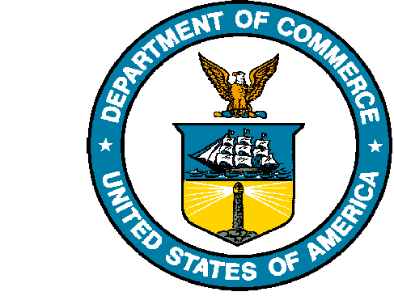**UNITED STATES DEPARTMENT OF COMMERCE**

**National Oceanic and Atmospheric Administration**

NATIONAL MARINE FISHERIES SERVICE

Northwest Fisheries Science Center

Fish Ecology Division

2725 Montlake Boulevard East

Seattle, WA 98112-2097

(206) 860-3270

Brandon Chasco

National Marine Fisheries Service

2203 Marine Science Dr.

Newport, OR 97365

206-460-5793

brandon.chasco@noaa.gov

Editor-in-Chief

PLOS One Biology

May3rd, 2020

Dear Editor:

I am pleased to submit an original research article entitled, *Differential impacts of freshwater and marine covariates on wild and hatchery Chinook salmon marine survival*, by Brandon Chasco and other co-authors for consideration for publication in PLOS One Biology. As a case study, we demonstrate how to estimate the survival of threatened populations of Chinook salmon in the Pacific Northwest, but our generalized method is applicable to other species with individual survival data. While previous research has examined how to integrate the effects of freshwater conditions on marine survival using fixed- and random-effects models, none of these efforts have explored how uncertainty in how the freshwater processes can affect the bias and uncertainty in the survival estimates. Our multivariate statistical approach to integrating freshwater processes yields similar survival estimates to previous research efforts, but with much higher estimates of uncertainty. This increased uncertainty has important implications for conservation and recovery of salmon species as policy makers evaluate the impacts of future management efforts.

We believe that this manuscript is appropriate for publication by PLOS One Biology because it relates to journal’s aim and scope of serving all aspects of biological sciences including ecosystems and ecology. In particular, our manuscript addresses critical areas of conservation and management of a high profile species for which PLOS One has published related articles. As it pertains to salmon conservation, our manuscript addresses the need for integrated models using multiple data sources across both the marine and freshwater ecosystems where salmon live.

This manuscript has not been published and is not under consideration for publication elsewhere. We have no conflicts of interest to disclose, and we have no review conflicts.

Thank you for your consideration!

Sincerely,

Brandon Chasco

Associate Researcher, National Marine Fisheries Service