Differential impacts of freshwater and marine covariates on wild and hatchery Chinook salmon marine survival

Brian Burke1, Brandon Chasco2, Lisa Crozier, Rich Zabel

1 Fish Ecology Division, National Marine Fisheries Service, NOAA, Seattle, WA 98125

2 Fish Ecology Division, National Marine Fisheries Service, NOAA, Newport, OR 97365

Short title: Integrated marine and freshwater effects on salmon survival

**Abstract**

Large-scale atmospheric conditions in the Northeast Pacific Ocean affect both the freshwater environment in the Columbia River Basin and marine conditions along the coasts of Oregon, Washington, and British Columbia, resulting in correlated conditions in the two environments. For migrating species, such as salmonids that move through multiple habitats, these correlations can amplify the impact of good or poor physical conditions on growth and survival, as movements among habitats may not alleviate effects of anomalous conditions. Unfortunately, identifying the mechanistic drivers of salmon survival in space and time is hindered by these cross-habitat correlations. To address this issue, we modeled the marine survival of Snake River spring/summer Chinook salmon with multiple indices of the marine environment and an explicit treatment of the effect of freshwater conditions on migration timing from freshwater to the ocean and found that both habitats contribute to marine survival rates. We show how the carryover effect of freshwater conditions on marine survival varies by year and rearing type (hatchery or wild), with a larger effect for wild fish. As environmental conditions change, incorporating effects from both freshwater and marine habitats into salmon survival models will become more important, and has the additional benefit of highlighting management actions that can be taken to improve marine survival.

**Keywords**: Chinook salmon, hatchery versus wild, marine survival

word count: abstract (211), main (4515), figures (263), tables (179), references (1029)

**Introduction**

Snake River spring/summer Chinook salmon are an iconic species of the Pacific Northwest. Populations once supported large commercial and recreational fisheries, as well as subsistence of indigenous communities. However, overfishing, the effects of hydropower on river temperatures, flows, and fish passage, alterations to freshwater habitat, increased predation, and competition with hatchery fish have all led to steep declines in population sizes since the 1970s. In response to continued declines, wild spring/summer Chinook salmon in the Snake River evolutionary significant unit (ESU) were listed as endangered in 1992 (Federal Register 64(56):14307-14328 2005). Since then, tribal, state, and federal agencies have worked to mitigate these negative effects on salmon in the freshwater environment. However, responses to these efforts have not been as large as expected, as populations have not recovered and evidence suggests that marine survival continues to be the dominant driver of salmon population productivity (Scheuerell and Williams 2005; Kilduff et al. 2014; C. B. Woodson and Litvin 2015; Wells et al. 2016).

Chinook salmon are a semelparous fish with a complex life history, and their survival is the integration of both freshwater and marine processes over very large spatial scales (Quinn 2018). The typical spring/summer Chinook salmon spends one to two years rearing in freshwater and one to three years in the ocean before returning to the original freshwater tributary to spawn. The majority of Chinook salmon in the Snake River ESU spend two years in freshwater and two years in the ocean; however, despite the nearly equal allocation of time between the two environments, variability in mortality rates is much greater in marine waters (Welch et al. 2008; Haeseker et al. 2012). Using data from juvenile Chinook salmon tagged in the freshwater environment and detected as returning adults, evidence suggests that the period when salmon first enter the marine environment is critical to overall marine survival (Beamish et al. 1992; Duffy and Beauchamp 2011; Chasco et al. 2017). Unfortunately, the specific mechanisms of mortality during this period are not well known.

Evaluating drivers of survival for migrating animals is difficult because they often spend time in multiple habitat types. The interaction between physical processes at local, regional, and basin scales commonly results in correlated conditions across nearby habitat types. In the Columbia River Basin, inter-annual variability in freshwater conditions tends to be correlated with variability in regional marine conditions (Hodgson et al. 2006; Gosselin et al. 2018), as both habitats are driven by large-scale atmospheric and oceanographic conditions. This correlation has the potential to amplify (or dampen) anomalous conditions in multiple habitats simultaneously, thus complicating our ability to identify causative mechanisms of variability in salmon survival.

Moreover, the potential for carryover effects (Gosselin et al. 2018) from one environment to another are difficult to incorporate into analyses. For juvenile salmon, the carryover effects of the freshwater environment to marine survival have not been well studied. For example, the conditions in the freshwater environment play an important role in determining ocean survival by influencing salmon growth rates, condition, and their spatiotemporal proximity to predator populations (Beamish et al. 1992; Scheuerell et al. 2009; Duffy and Beauchamp 2011; Chasco et al. 2017; Gosselin et al. 2018).

Managers of wild salmon populations have few levers to manipulate the environmental experiences that may influence marine survival. To the extent that the freshwater environment influences salmon behavior, performance, growth, and survival in the marine environment, these influences should be incorporated into modeling efforts aimed at understanding salmon marine ecology. Given observed correlations between marine and freshwater environments, it is important that models accurately characterize the effects of marine and freshwater, but also appropriately characterize the uncertainty in the underlying processes. In this effort, we provide a general tool with which scientists and managers can effectively integrate the complex interacting effects of environmental conditions across multiple habitats. Here, we use a multivariate random effects model to improve our understanding of spring/summer Chinook salmon survival data from 2000 to 2015. By decoupling the latent effects of migration timing from marine survival, our integrated model may allow managers to adjust future hydrosystem conditions to optimize the timing of salmon arrival to the marine environment.

**Methods**

*PIT tag data*

We used Passive Integrated Transponder (PIT) data provided by the Columbia Basin Research (CBR) via PIT Tag Information Systems (PTAGIS) to estimate the survival of Snake River Chinook (SRC) salmon. We considered data for all out-migrating SRC salmon detected from 2000 to 2015 at Bonneville Dam, the furthest downstream dam on the Columbia River. We marked a fish as having survived the marine stage if it was detected at Bonneville Dam (or farther upstream, if not detected at Bonneville Dam) as an adult. The data included *i*) last detection date at Bonneville Dam as juveniles, *ii*) rear type (hatchery or wild), and *iii*) whether the fish was detected in the Columbia River as an adult. We excluded all fish with an unknown rearing type (i.e., hatchery versus wild), geographic regions with fewer than 200 individuals (over the 16 years), those fish released or tagged below the confluence of the Snake and Columbia Rivers, fish that return to spawn without entering the ocean, and fish that were barged downstream as juveniles. We excluded fish that passed Bonneville Dam prior to April 1st or later than June 30th; these fish account for <0.2% of the total observations. This resulted in 1,284,293 individuals for this analysis (). All PIT-tag files are available on the CBR website (<http://www.cbr.washington.edu/dart/cs/data/nmfs_sar/>).

*Environmental data*

We obtained environmental covariate data from a variety of sources (). Variables represent large-scale oceanographic patterns as well as regional physical metrics. While not all variables have a direct mechanistic relationship with salmon survival, salmon survival has been shown to correlate with many of them (Burke et al. 2013; Peterson et al. 2014). Furthermore, we binned all environmental data into three-month averages: these seasonal metrics include Dec-Feb (‘win’), Mar-May (‘spr’), Jun-Aug (‘sum’), and Sep-Nov (‘aut’). For all variables included in our analyses, we tested each of the four seasons, starting with the winter prior to when salmon enter the ocean.

*Estimation and data processing scripts*

All of the data we used for this analysis are publicly available. A full list of the environmental covariates are listed in . We provide a description of the R scripts used to create these environmental data objects from the raw data inputs in the appendix Text.A1. The estimation of the model parameters was done with Template Model Builder (TMB) – a package C++ libraries that efficiently estimates fixed effects of the model using the AutoDiff libraries and a Laplace approximation to integrate over the random effects. A description of the three separate R files that create the data and parameter lists for the TMB estimation object, and a wrapper for combining the necessary objects and completing the estimation are available in appendix Text.A2.

*Models*

We used a mixed-effect logit model to predict the SAR for fish of each rear type r (i.e., hatchery versus wild) migrating past Bonneville Dam on day j during year t.

Equation 1.

Equation 2.

Where the link function is a linear combination of fixed and random effects. The fixed-effects consist of the mean survival for rear type r, , and the vector of marine coefficients for the rear type r, , times the vector of marine covariates in year t, .The random effects include an effect for day j of rear type r, , an effect for year t of rear type r, , and the interaction between calendar day j and year t for rear type r, . A complete list of the subscripts, parameters and data are available in .

The smolt-to-adult survival given the observed total cohort of smolts of rear type r that migrated downstream past Bonneville Dam on day j during year t, , and the number of fish from that cohort of rear type, on day j, and year t that survived, , is binomially distributed

Equation 3.

The random effects by rear type r for calendar day and year are treated as auto-regressive processes,

Equation 4.

Equation 5.

Where, and are the daily and annual correlations between the day and year effects, and , respectively, and and are measures of the variances of the random effects for day and year, respectively. The random effects for the interaction between day and year was treated as a two dimensional auto-regressive process,

Equation 6.

#### Where is a vector of random effects across calendar days for rear type r in year t, is the correlation of the vector of days effects between years t and t-1, and is the covariance matrix between days within a year for rear type r. The covariance matrix,, is a compact way of representing the auto-correlation between day effects in the day/year interaction, where the elements between day j and day of the covariance matrix are equal to

Equation 7. ,

and is variability in the day/year interaction for rear type r.

To estimate the fixed and random effects of the model, we use the non-linear optimization libraries in Template Model Builder package (Kristensen et al. 2015) built for R (R Core Development Team 2015). The TMB code is in the appendix Text.A3. Not all model combinations may be estimable due to the confounding effects among model parameters; in some instances, more than one model parameterization may produce identical fits to the data. In these cases, the Hessian is non-positive definite, and the solution is not unique or estimable. We define a converged model as one with a positive definite hessian and a maximum gradient of 0.001 for the fixed effects. To compare models and select the most parsimonious fit to the data, we used the marginal AIC for the fixed effects (Akaike’s information theoretic; Akaike 1974) using the TMBhelper package.

Testing all of the thousands of parameter combinations for the 31 marine variables, in addition to the different combinations of random effects, is not reasonable. We therefore restricted the potential models to only those with i) zero, one or two marine covariates and ii) only two-covariate models where the correlation between covariates was less 0.7. Furthermore, initial analyses indicated that estimating random effects for day, year, and the day/year interaction in a single model produced an over-fit to the data. Models with all three random effects converged but the time-series of random effects for either the day or year were so small (<1e-4 in most cases) as to be meaningless. Therefore, we restricted our analysis to no more than two random processes for day, year, and the day/year interaction. This resulted in six different random effects models. Finally, to allow for the most flexibility for a given group of fish, we did not combine the hatchery and wild datasets in a multivariate analysis, but rather ran models for each dataset separately.

**Results**

*Model fit and best model structure*

We found that the models with random effects for day and day/year interactions along with two marine covariates produced the best model fit to the data for wild fish, and models with only day/year interactions and two environmental covariates produced the best model fit for hatchery fish (). The top models (AIC<4) for wild fish all assumed random effects for day and day/interactions, with differences in model fit arising from different combinations of marine covariate pairs (). The top models for hatchery fish produced fewer differences in the marine covariates and little evidence for an underlying day effect: the only top model for hatchery fish with a day effect had a AIC equal to 3.9996.

Comparing the best-fit models for each rearing type, our results suggest that the expected survival and 95% credible interval for hatchery and wild fish were 0.008 (0.006, 0.010) and 0.009 (0.002, 0.035), respectively (). The marine covariates that improved the fit of the survival model varied between hatchery and wild fish, but the magnitude of the environmental effects were similar for the two rearing types (, ). Summer transport (transport.sum - a measure of xx) and the summer North Pacific gyre index (npgo.spr) provided the best fit to the hatchery fish data, while spring coast upwelling (cui.spr) and summer Pacific decadal oscillation (pdo.sum) provided the best fit to the wild fish data. We found the percent change in the marine survival as function of 1.96 standardized residuals marine covariates varied between -70% and 200% for hatchery fish, and -70% to 150% for wild fish (). Across all of the top models (), we found differences in the importance of the marine covariates that best explain hatchery and wild survival (). For the top models listed in , transport (‘transport.’) and north pacific gyre (‘npgo.’) had the most predictive power for hatchery fish, while coastal upwelling (‘cui.’), Washington coastal and arc sea surface temperatures (‘ersstWACoast’ and ‘ersstArc’), and Pacific decadal oscillation (‘pdo.’) were important for wild fish (). Seasonal variations in the marine covariates indices appear to be more important to hatchery fish compared to wild fish. There are only a couple of seasonal transport (transport) and north Pacific gyre (npgo) covariates the offer most of the predictive power for hatchery salmon survival, while different seasonal variations in the Pacific decadal oscillation (pdo), sea surface temperature (ersstArc and ersstWAcoast) and coastal upwelling indices (cui) offer predictive power for wild salmon survival relative to the best-fit model.

The interaction between day and year is important in the best-fit models for both the hatchery and wild rearing types ( and ). The random deviation of the day/year interaction for hatchery fish showed a high degree of correlation between days within a year ( = 0.955) and a weak negative correlation between days across years ( = -0.067). However, hatchery fish showed no consistent daily trend in survival across years (Figure 4), which is why there is no day effect in the model with the lowest AIC (Table 4). There is consistently higher survival for the earlier arriving wild fish (Figure 4) - hence, the day effect in the model with the lowest AIC (Table 4). Similarly, the correlation between days with in a year ( = 0.932), and negative correlation between days across years (= -0.489) (). For the wild fish, the standard deviation of the day/year interaction was similar for hatchery fish ( = 0.611) and wild fish ( = 0.58).

To illustrate the effect of migration timing for hatchery and wild fish we compared the top model for each rearing type that included the random effects for both the day and the day/year interactions. For wild fish, this was the model with the lowest AIC, and for hatchery fish, this was a model with identical marine covariates to the best-fit model but with daily random effects ( = 3.9996). The day effect was highest for wild fish passing Bonneville Dam around May 3rd, followed by decreasing survival throughout the remainder of the smolt migration (, upper panel, red polygon). By comparison, the model of hatchery that included both day and day/year interaction showed no real difference in smolt survival for the daily migration timing across years (, upper panel, blue polygon), despite relatively similar mean migration timing past Bonneville Dam (, lower panel). The estimated temporal correlation and variation in the day effect was lower for the hatchery fish relative to wild fish: = 0.05 and = 0.134, versus = 0.986 and = 0.793.

While none of the top models included a random deviate for year. We predicted the annual survival by aggregating the daily survival estimates weighted by the total number of hatchery and wild fish that migrated each day. The observed annual survival estimates were similar to the model predictions and, with the exception of wild fish in 2003, the observations fell within the 95% credible interval of the predicted annual survivals (). Both the modeled and observed annual survivals for hatchery and wild fish showed an alternating pattern of increases and decreases which was likely explained by the estimated negative correlations in the year dimension for the day/year interaction ().

**Discussion**

#### *Hatchery-wild comparisons*

There are clear and expected differences between fish reared in a hatchery and fish exposed to natural conditions in the wild, including size, condition, risk aversion, migration timing, parasite load, and numerous other factors. We clearly documented the effect of migration timing on marine survival of Snake River spring/summer Chinook salmon. Importantly, these effects were not consistent between fish of different rear types. We described two primary differences in timing and marine survival. First, the distribution for migrating juvenile salmon differs between the hatchery and wild fish, with hatchery fish exhibiting much more of a peaked, narrow distribution, mostly completed by early June. In contrast, the distribution of wild fish migration timing starts earlier and has a long tail, with some fish not migrating past Bonneville Dam until mid-July. Second, the relationship between migration timing and marine survival is dramatically different between hatchery and wild fish. On average, wild fish show a peak in survival for fish migrating early in the season and then decline throughout the season, whereas hatchery fish, on average, show little dependence on migration timing at all.

There are multiple reasons why wild fish would be more sensitive to migration timing than hatchery fish, though much of this is speculation. Perhaps the most likely cause is the difference in size between the two groups. If early marine survival is size-dependent, which has been shown for other salmon stocks (Henderson and Cass 1991; Beamish and Mahnken 2001; Duffy and Beauchamp 2011; L. E. Woodson et al. 2013), the larger size of hatchery fish could afford them some protection from predators. Furthermore, the migration timing may lead to sources of apparent competition (Holt 1977) between the hatchery and wild fish. Large subsidies of hatchery smolts may increase the density of the predator communities, and these predators may differentially the select for wild fish because they are smaller and more available once the pulse of hatchery fish has passed (Beamish et al. 1992).

#### *Model Fit*

The residual deviance ratios for the fixed effects that included only marine covariates were equal to 0.16 and 0.08 for hatchery and wild fish, respectively. The ratios increased to 0.35 and 0.21, respectively, for the model that included marine covariates and random effects for day and the day/year interaction – more than doubling the amount variation explained (). When we removed the marine covariates from the day/year interaction models, we found that the day/year interaction explained most of the additional residual deviance. This does not imply that marine conditions do not affect Chinook salmon survival. In fact, as shown by the estimated magnitude of the deviates in , the marine covariates were correlated with large differences in marine survival. However, rather than a uniform response of all fish to the marine conditions in a particular year, our model demonstrates that the timing of when the juvenile salmon encounter the marine conditions appears to be more important and highly variable. The mechanism that is driving this differential survival across days and years remains a critical knowledge gap and a focus of future salmon modeling.

Combining impacts from multiple environments has been applied in several past efforts to model Snake River spring/summer Chinook marine survival. The day of year effect was described by Scheuerell et al. (2009) using a quadratic effect for day in a logistic regression model. The authors showed that earlier fish tend to have higher survival, but this shifted somewhat from year to year. Holsman et al. (2012) also use a logistic regression for this ESU and characterized the impacts of predators, prey, flow, and the temperature difference between the Columbia River and the nearshore ocean; however, they did not include a day of year effect in their model. Similarly, Heaseker et al. (2012) demonstrated the importance of freshwater flow in modeling marine survival for this ESU, but included a linear effect of day of year. Miller et al. (2014) used a logistic regression to show that the size at out-migration was not as important as the size at marine capture (after fish had been in the ocean for weeks to months), suggesting that marine growth is highly influential in setting mortality rates. Finally, Gosselin et al. (2017) used a mixed effects regression to describe carryover effects from the freshwater environment, with particular emphasis on transportation impacts on hatchery and wild fish. The current model design represents a compromise between model complexity, realism, and the clear need to address the interactions between freshwater impacts and the marine ecosystem. Rather than treating day effect as a fixed effect described by a linear or quadratic relationship, our model provides a flexible framework that allows the day effect to evolve randomly within and across years.

#### *Habitat-specific impacts*

A key component of this model is the inclusion of arrival timing to the marine environment. Gosselin et al. (2017) showed that management practices in freshwater can have large impacts on marine survival via carryover effects, which can materialize in the form of altered fish size or timing at out-migration. Although size-dependent mortality is important, we focused on the impacts of timing for this effort. Arrival timing has been shown to be an important catalyst for carryover effects (Gosselin et al. 2017) and these data are quite readily available, as each fish detected at Bonneville Dam has its own time stamp. Moreover, timing is a variable that managers have some control over, particularly for hatchery fish.

##### *Marine Covariates*

The top models describing Chinook salmon marine survival included three categories of environmental covariates for hatchery fish (i.e., a measure of offshore transport (‘transport’), ocean circulation (‘npgo’), and sea surface temperature (‘errstArc’)), and three categories of environmental covariates for wild fish (i.e., basin-scale sea surface temperature (‘ersstArc’), a local sea surface temperature (‘ersstWA’), and a regional upwelling variable (‘cui’)). For each rearing type, there are logical links between the metric and multiple oceanographic or ecosystem processes that could influence salmon growth and survival. However, most of these links are indirect and rely on other oceanographic factors. For example, local sea surface temperature can influence growth rates directly (Wells et al. 2007), but a more likely influence on salmon survival involves production at lower trophic levels and temperature-dependent distribution of prey and predator species (Wells et al. 2017).

In this effort, we intentionally restricted our potential ocean covariates to publicly available (and mostly physical) variables. These variables do not necessarily directly relate to the ecosystem processes that determine salmon survival, but rather represent correlations with these processes. Some biological time series that more directly characterize ecosystem processes such as trophic dynamics are available (citation), but only for recent years. For other research goals, such as near-term forecasting, these more direct metrics may be more appropriate. Indeed, as more biological data are collected, reliance on correlations should be reduced (Litzow et al. 2XXX) and the use of mechanistic ecosystem models will become more important.

#### *Arrival Timing*

While freshwater conditions affecting migration timing (e.g., flow and temperature) are likely to be correlated with conditions in the marine environment (Keefer et al. 2008), phenological variability in the marine ecosystem is driven by atmospheric and oceanographic processes with substantial inter-annual variability (Mantua et al. 1997). For example, wind-driven ocean currents transition from south to north each spring, initiating a strong upwelling of deeper ocean water. The nutrients in this upwelled water can spawn or feed a spring phytoplankton bloom (ref). Moreover, the newly transitioned currents can bring species of zooplankton such as copepods that are high in fatty acids (Hooff and Peterson 2006; Keister et al. 2011), further enriching the production at lower trophic levels. Salmon eventually benefit from these dynamics, but the timing and magnitude of local production varies from year to year. Although salmon have evolved to optimize arrival timing on average, the broad distribution of out-migration timing is a sort of bet-hedging strategy. If future freshwater management practices significantly alter the mean timing or the variability in timing, this could have important, and perhaps unforeseen, effects on marine survival. Similarly, if climate changes in either the freshwater or marine environment result in a mismatch between salmon migration timing and optimal migration timing, marine survival will be impacted. These interactions are a clear demonstration of the importance of carryover effects and a direct link between management decisions and salmon marine survival.

In addition, we are currently modeling the impact of climate change on survival during each segment of the salmonid life cycle and arrival timing to the ocean will be an important aspect of the potential changes to salmon performance.

#### *Caveats*

Our estimates of the freshwater carryover effects are likely underestimated. We included migration timing, but did not include fish size, which is known to have important impacts on trophic interactions, including size-dependent survival (Beamish and Mahnken 2001; Roby et al. 2003; Duffy and Beauchamp 2011; L. E. Woodson et al. 2013). Miller et al. (2014) showed that Snake River spring/summer Chinook marine survival was more related to size after some period of ocean residence than size at out-migration, but did not rule out the possibility that some level of size-dependent mortality did not already occur.

Maturation schedule are also sizes-dependent – larger and faster growing fish tend to mature earlier. Recent spawner-recruit analysis suggests that climate conditions affect both the maturation schedule and the survival of some stocks of salmon (Scheuerell et al. 2019); however, growth and size were not a part of these models. Future iteration of our model could examine the effects of size and maturation simultaneously, with the goal of understanding how management actions in freshwater environment affect size, maturation, and ultimately, survival in an integrated modeling framework.

Despite the limitations of the data, we view our model as robust approach for integrating the freshwater and marine effects in a single estimation model. By partitioning the different sources of uncertainty between the observation model (binomial likelihood) and process models (day, year, and day/year interaction) we provide a more accurate estimate of uncertainty and relative importance of the fixed effects associated with the marine covariates relative to the random deviations in survival associated with differences in migration timing between years. While our model was restricted to examining the two-dimensional interaction between day and year, the future iterations of the model can quickly be scaled-up to higher-dimensional questions related to the interaction between day, year, length, and maturation when the data become available.

**References**

Beamish, Richard J., and Conrad Mahnken. 2001. A critical size and period hypothesis to explain natural regulation of salmon abundance and the linkage to climate and climate change. *Progress in Oceanography* 49: 423–437.

Beamish, Richard J., Barbara L. Thomson, and Gordon A. McFarlane. 1992. Spiny dogfish predation on chinook and coho salmon and the potential effects on hatchery-produced salmon. *Transactions of the American Fisheries Society* 121: 444–455.

Burke, Brian J., William T. Peterson, Brian R. Beckman, Cheryl Morgan, Elizabeth A. Daly, and Marisa Litz. 2013. Multivariate Models of Adult Pacific Salmon Returns. *PLOS ONE* 8: e54134. https://doi.org/10.1371/journal.pone.0054134.

Chasco, Brandon, Isaac C. Kaplan, Austen Thomas, Alejandro Acevedo-Gutiérrez, Dawn Noren, Michael J. Ford, M. Bradley Hanson, Jonathan Scordino, Steve Jeffries, and Scott Pearson. 2017. Estimates of Chinook salmon consumption in Washington State inland waters by four marine mammal predators from 1970 to 2015. *Canadian Journal of Fisheries and Aquatic Sciences* 74: 1173–1194.

Duffy, Elisabeth J., and David A. Beauchamp. 2011. Rapid growth in the early marine period improves the marine survival of Chinook salmon (Oncorhynchus tshawytscha) in Puget Sound, Washington. *Canadian Journal of Fisheries and Aquatic Sciences* 68: 232–240.

Federal Register 64(56):14307-14328. 2005.

Gosselin, Jennifer L., Richard W. Zabel, James J. Anderson, James R. Faulkner, António M. Baptista, and Benjamin P. Sandford. 2018. Conservation planning for freshwater–marine carryover effects on Chinook salmon survival. *Ecology and evolution* 8: 319–332.

Haeseker, Steven L., Jerry A. McCann, Jack Tuomikoski, and Brandon Chockley. 2012. Assessing freshwater and marine environmental influences on life-stage-specific survival rates of Snake River spring–summer Chinook salmon and steelhead. *Transactions of the American Fisheries Society* 141: 121–138.

Henderson, M. A., and A. J. Cass. 1991. Effect of smolt size on smolt-to-adult survival for Chilko Lake sockeye salmon (Oncorhynchus nerka). *Canadian Journal of Fisheries and Aquatic Sciences* 48: 988–994.

Hodgson, Sayre, Thomas P. Quinn, R. A. Y. Hilborn, Robert C. Francis, and Donald E. Rogers. 2006. Marine and freshwater climatic factors affecting interannual variation in the timing of return migration to fresh water of sockeye salmon (Oncorhynchus nerka). *Fisheries Oceanography* 15: 1–24.

Holt, Robert D. 1977. Predation, apparent competition, and the structure of prey communities. *Theoretical population biology* 12: 197–229.

Hooff, Rian C., and William T. Peterson. 2006. Copepod biodiversity as an indicator of changes in ocean and climate conditions of the northern California current ecosystem. *Limnology and Oceanography* 51: 2607–2620.

Keefer, Matthew L., Christopher A. Peery, and Christopher C. Caudill. 2008. Migration timing of Columbia River spring Chinook salmon: effects of temperature, river discharge, and ocean environment. *Transactions of the American Fisheries Society* 137: 1120–1133.

Keister, Julie E., E. Di Lorenzo, C. A. Morgan, Vincent Combes, and W. T. Peterson. 2011. Zooplankton species composition is linked to ocean transport in the Northern California Current. *Global Change Biology* 17: 2498–2511.

Kilduff, D. Patrick, Louis W. Botsford, and Steven LH Teo. 2014. Spatial and temporal covariability in early ocean survival of Chinook salmon (Oncorhynchus tshawytscha) along the west coast of North America. *ICES Journal of Marine Science* 71: 1671–1682.

Kristensen, Kasper, Anders Nielsen, Casper W. Berg, Hans Skaug, and Brad Bell. 2015. TMB: automatic differentiation and Laplace approximation. *arXiv preprint arXiv:1509.00660*.

Mantua, Nathan J., Steven R. Hare, Yuan Zhang, John M. Wallace, and Robert C. Francis. 1997. A Pacific interdecadal climate oscillation with impacts on salmon production. *Bulletin of the american Meteorological Society* 78: 1069–1079.

Miller, Jessica A., David J. Teel, William T. Peterson, and Antonio M. Baptista. 2014. Assessing the relative importance of local and regional processes on the survival of a threatened salmon population. *PloS one* 9: e99814.

Peterson, William T., Jennifer L. Fisher, Jay O. Peterson, Cheryl A. Morgan, Brian J. Burke, and Kurt L. Fresh. 2014. Applied Fisheries Oceanography: Ecosystem Indicators of Ocean Conditions Inform Fisheries Management in the California Current. *Oceanography* 27: 80–89. JSTOR.

Quinn, Thomas P. 2018. *The behavior and ecology of Pacific salmon and trout*. University of Washington Press.

R Core Development Team. 2015. R: A language and environment for statistical computing.

Roby, Daniel D., Donald E. Lyons, David P. Craig, Ken Collis, and G. Henk Visser. 2003. Quantifying the effect of predators on endangered species using a bioenergetics approach: Caspian terns and juvenile salmonids in the Columbia River estuary. *Canadian Journal of Zoology* 81: 250–265.

Scheuerell, Mark D., and John G. Williams. 2005. Forecasting climate-induced changes in the survival of Snake River spring/summer Chinook salmon (Oncorhynchus tshawytscha). *Fisheries Oceanography* 14: 448–457.

Scheuerell, Mark D., Richard W. Zabel, and Benjamin P. Sandford. 2009. Relating juvenile migration timing and survival to adulthood in two species of threatened Pacific salmon (Oncorhynchus spp.). *Journal of Applied Ecology* 46: 983–990.

Welch, David W., Erin L. Rechisky, Michael C. Melnychuk, Aswea D. Porter, Carl J. Walters, Shaun Clements, Benjamin J. Clemens, R. Scott McKinley, and Carl Schreck. 2008. Survival of migrating salmon smolts in large rivers with and without dams. *PLoS biology* 6: e265.

Wells, Brian K., Churchill B. Grimes, and James B. Waldvogel. 2007. Quantifying the effects of wind, upwelling, curl, sea surface temperature and sea level height on growth and maturation of a California Chinook salmon (Oncorhynchus tshawytscha) population. *Fisheries Oceanography* 16: 363–382.

Wells, Brian K., Jarrod A. Santora, Mark J. Henderson, Pete Warzybok, Jaime Jahncke, Russell W. Bradley, David D. Huff, Isaac D. Schroeder, Peter Nelson, and John C. Field. 2017. Environmental conditions and prey-switching by a seabird predator impact juvenile salmon survival. *Journal of Marine Systems* 174: 54–63.

Wells, Brian K., Jarrod A. Santora, Isaac D. Schroeder, Nathan Mantua, William J. Sydeman, David D. Huff, and John C. Field. 2016. Marine ecosystem perspectives on Chinook salmon recruitment: a synthesis of empirical and modeling studies from a California upwelling system. *Marine Ecology Progress Series* 552: 271–284.

Woodson, C. Brock, and Steven Y. Litvin. 2015. Ocean fronts drive marine fishery production and biogeochemical cycling. *Proceedings of the National Academy of Sciences* 112: 1710–1715.

Woodson, Lindsay E., Brian K. Wells, Peter K. Weber, R. Bruce MacFarlane, George E. Whitman, and Rachel C. Johnson. 2013. Size, growth, and origin-dependent mortality of juvenile Chinook salmon Oncorhynchus tshawytscha during early ocean residence. *Marine Ecology Progress Series* 487: 163–175.

**Figure captions**

Figure 1. Map

Figure 2. Environmental effects on survival of wild (upper panel) and hatchery (lower panel) spring/summer Chinook salmon based on the model fit to the observed data as selected by AIC (see Table 4 for summary of best fit models). *fig_envEffect_ggplot.r*

Figure 3. Relative importance of the different marine covariates for predicting the marine survival of hatchery (left column) and wild (right column) Chinook salmon. The “blank” environmental variable is for models with no environmental predictors. *fig_EnvironmentalVariableWt_ggplot.r*

Figure 4. The observed (dots), and maximum likelihood estimates (line) with 95% credible intervals (ribbons) for the marine survival wild (blue) and hatchery (red) origin Spring/Summer Chinook salmon past Bonneville dam from 2000 to 2015. Each point represents the mean survival of all fish detected at Bonneville Dam on a particular day and year. Annual samples sizes of the survivors and total PIT tagged hatchery (H) and wild (W) for are shown in each panel. To maintain the readability of individual panels, mean observed survivals greater than 0.2 are not plotted. *fig_DayxYearSurvival_ggplot.r*

Figure 6. Observed (points) and estimated (line) annual survival with 95% credible intervals (polygons) for hatchery (red) and wild (blue) spring/summer Chinook salmon from 2000 through 2015. *Fig_AnnualSurv_ggplot.r*

Figure 5. Predicted smolt-to-adult survival by day for hatchery (red) and wild (blue) spring/summer Chinook salmon (upper panel) for best fit models for each rear type the include both day and day/year interactions (see Table 4). Lines represent expected survivals and shaded regions represent 95% credible intervals. Observed daily migration rates past Bonneville Dam averaged across all years (2000 to 2015) (lower panel). *fig_DailySurv_ggplot.r*

**Table captions**

Table 1. Sample size of hatchery and wild juvenile Chinook salmon from different watersheds within the Snake River Basin. (R *script unknown*)

Table 2. Description of the environmental variable names, the years of available data, and the website location of the data. (R *script unknown*)

Table 3. List of data types, subscripts, parameters (i.e., fixed effects), and random effects used to model the smolt to adult survival of spring/summer Chinook salmon originating from the Snake River Basin.

Table 4. Top models for each origin type based on the random effects and number of marine covariates. The gradient is a measure of the likelihood surface for the maximum likelihood estimate, PD Hessian stands for positive definite Hessian, and N.E. stands for not estimated. *table_AIC.r*

Table 5. Estimated fixed effects for the model with lowest marginal AIC values for wild spring/summer Chinook salmon, and the models with the lowest marginal AIC for hatchery fish with and without a random day effect included (N.E. means not estimated). *table_bestFitModel.r*

Table 6. Deviance ratios for different fixed and mixed-effects models for hatchery and wild fish, where is -2 times the log-likelihood of model *m* and is -2 times the log-likelihood of the null model. The deviance ratio explains how close the model is to the best model that fits the data exactly.

**Figures**

Figure 1. Map

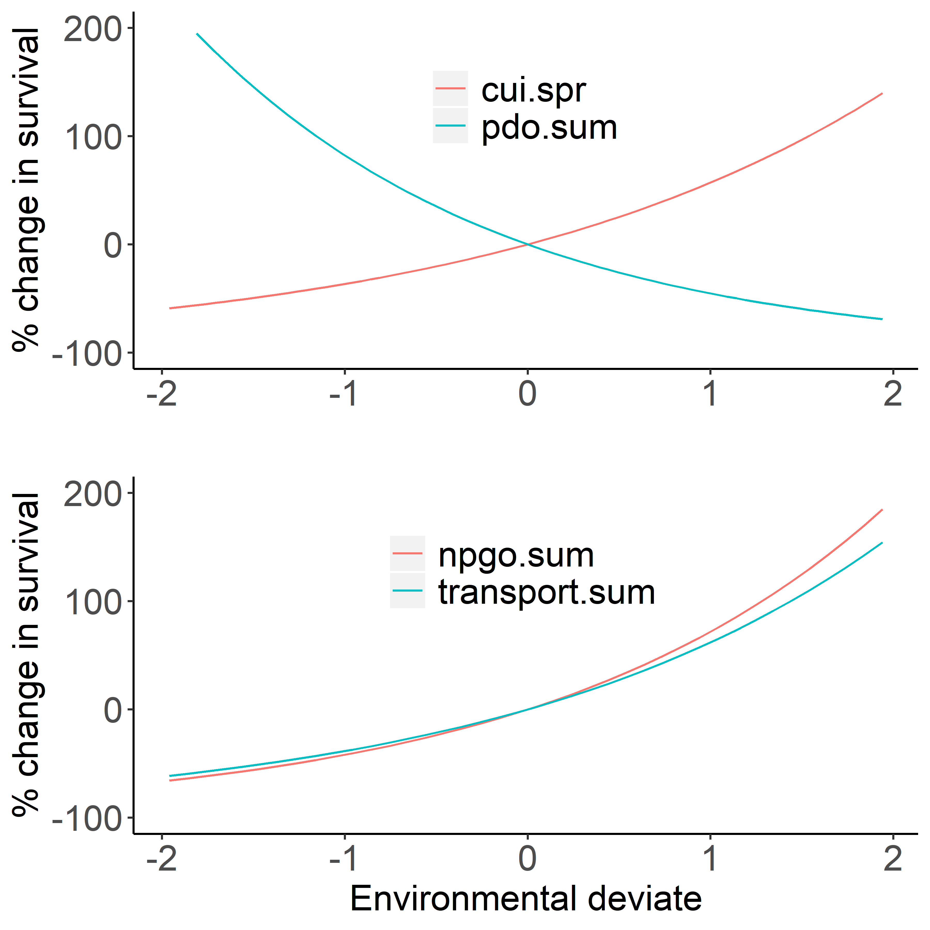

Figure 2. Environmental effects on survival of wild (upper panel) and hatchery (lower panel) spring/summer Chinook salmon based on the model fit to the observed data as selected by AIC (see for summary of best fit models). *fig_envEffect_ggplot.r*

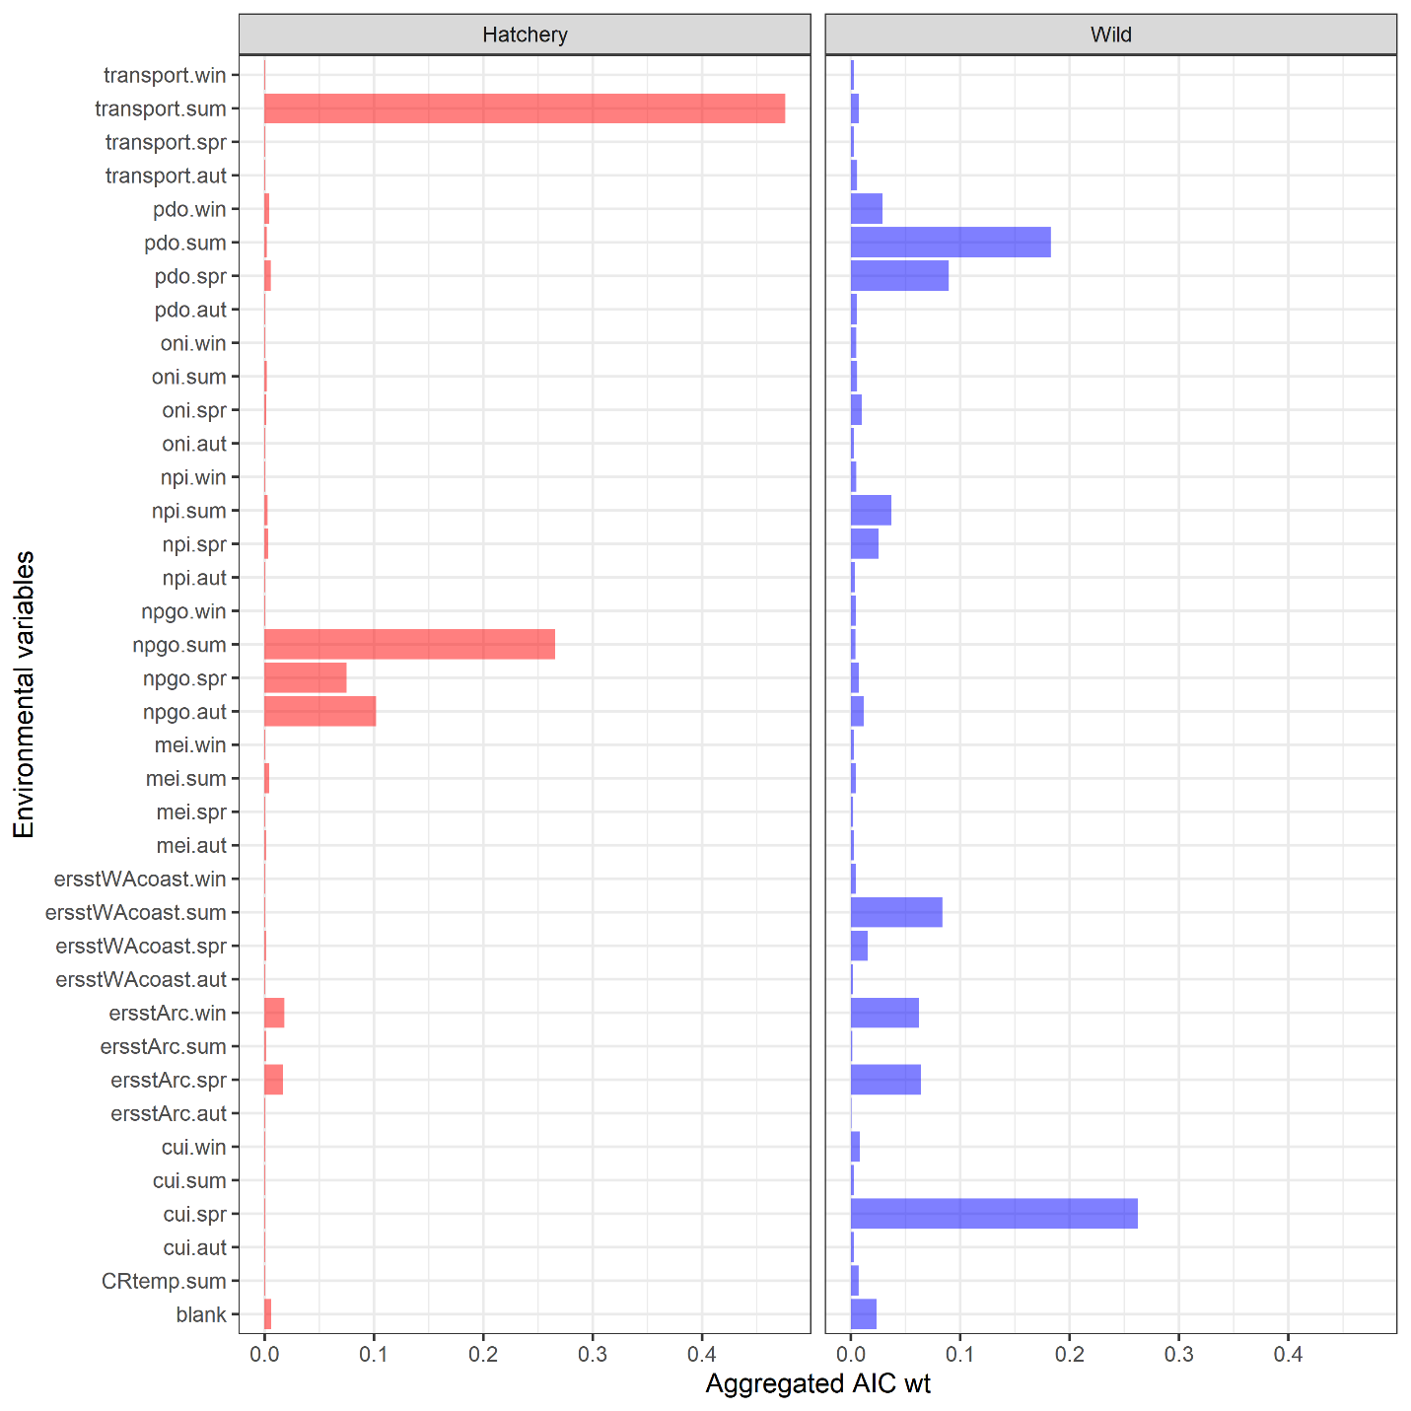

Figure 3. Relative importance of the different marine covariates for predicting the marine survival of hatchery (left column) and wild (right column) Chinook salmon. The “blank” environmental variable is for models with no environmental predictors. *fig_EnvironmentalVariableWt_ggplot.r*



Figure 4. The observed (dots), and maximum likelihood estimates (line) with 95% credible intervals (ribbons) for the marine survival wild (blue) and hatchery (red) origin Spring/Summer Chinook salmon past Bonneville dam from 2000 to 2015. Each point represents the mean survival of all fish detected at Bonneville Dam on a particular day and year. Annual samples sizes of the survivors and total PIT tagged hatchery (H) and wild (W) for are shown in each panel. To maintain the readability of individual panels, mean observed survivals greater than 0.2 are not plotted. *fig_DayxYearSurvival_ggplot.r*

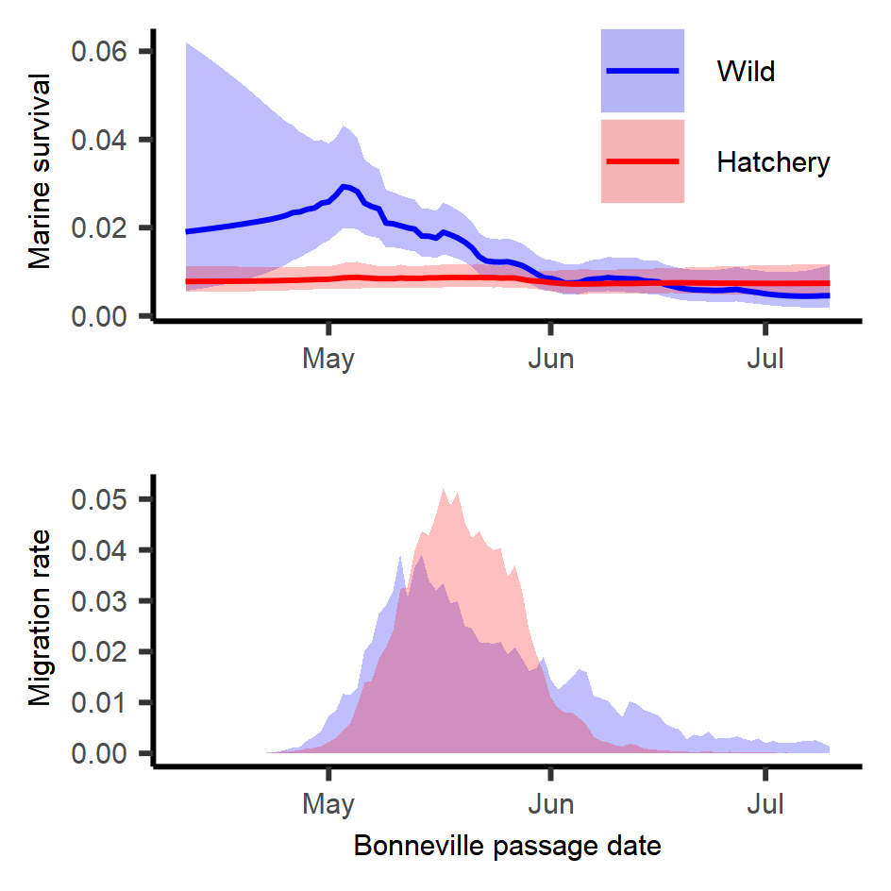

Figure 5. Predicted smolt-to-adult survival by day for hatchery (red) and wild (blue) spring/summer Chinook salmon (upper panel) for best fit models for each rear type the include both day and day/year interactions (see ). Lines represent expected survivals and shaded regions represent 95% credible intervals. Observed daily migration rates past Bonneville Dam averaged across all years (2000 to 2015) (lower panel). *fig_DailySurv_ggplot.r*



Figure 6. Observed (points) and estimated (line) annual survival with 95% credible intervals (polygons) for hatchery (red) and wild (blue) spring/summer Chinook salmon from 2000 through 2015. *Fig_AnnualSurv_ggplot.r*

**Tables**

Table 1. Sample size of hatchery and wild juvenile Chinook salmon from different watersheds within the Snake River Basin. (R *script unknown*)

|  |  |  |
| --- | --- | --- |
| Watershed | Hatchery | Wild |
| Clearwater | 88,895 | 4,512 |
| Grande Rhonde and Wallowa | 16,956 | 5,636 |
| Late (Imnaha, Pahsimeroi, South Fork Salmon) | 60,215 | 14,622 |
| Little Salmon | 69,016 | 8 |
| Lower Snake and Tucannon | 11,125 | 988 |
| Middle Fork Salmon | 0 | 3,714 |
| Upper Salmon and Lemhi | 5,589 | 4,384 |
| Total | 251,796 | 33,864 |

Table 2. Description of the environmental variable names, the years of available data, and the website location of the data. (R *script unknown*)

|  |  |  |  |
| --- | --- | --- | --- |
| **Variable** | **Description** | **Years Available** | **URL / Source** |
| **CRflow.spr**  **CRflow.sum** | Seasonal Columbia River flow as measured at The Dalles Dam (USGS site 14105700) | 1978-present | http://waterservices.usgs.gov/rest/DV-Service.html |
| **CRtemp.spr**  **CRtemp.sum** | Seasonal Columbia River temperatures at The Dalles Dam (USGS site 14105700) | 1997-present | http://waterservices.usgs.gov/rest/DV-Service.html |
| **cui.win**  **cui.spr**  **cui.sum**  **cui.aut** | Seasonal coastal upwelling index | 1946-present | http://www.pfeg.noaa.gov/products/PFELData/upwell/monthly/upanoms.mon |
| **mei.win**  **mei.spr**  **mei.sum**  **mei.aut** | Seasonal Multivariate ENSO Index | 1950-present | https://www.esrl.noaa.gov/psd/enso/mei/ |
| **npgo.win**  **npgo.spr**  **npgo.sum**  **npgo.aut** | Seasonal North Pacific Gyre Oscillation | 1950-present | http://www.o3d.org/npgo/npgo.php |
| **npi.win**  **npi.spr**  **npi.sum**  **npi.aut** | Seasonal North Pacific Index (index of Aleutian Low Pressure) | 1899-present | https://climatedataguide.ucar.edu/sites/default/files/npindex_monthly.txt |
| **oni.win**  **oni.spr**  **oni.sum**  **oni.aut** | Seasonal Oceanic Niño Index | 1950-present | http://www.cpc.ncep.noaa.gov/products/analysis_monitoring/ensostuff/ensoyears.shtml |
| **ersstWACoast.win**  **ersstWACoast.spr**  **ersstWACoast.sum**  **ersstWACoast.aut** | Seasonal sea surface temperature for coastal Washington | 1900-present | https://www1.ncdc.noaa.gov/pub/data/cmb/ersst/v5/netcdf/ |
| **ersstArc.win**  **ersstArc.spr**  **ersstArc.sum**  **ersstArc.aut** | Seasonal sea surface temperature from Johnstone and Mantua (2014) | 1900-present | https://www1.ncdc.noaa.gov/pub/data/cmb/ersst/v5/netcdf/ |

Table 3. List of data types, subscripts, parameters (i.e., fixed effects), and random effects used to model the smolt to adult survival of spring/summer Chinook salmon originating from the Snake River Basin.

|  |  |  |
| --- | --- | --- |
| Type | Symbol | Description |
| Data |  | Cohort of juvenile fish of rear type r migrating past Bonneville Dam on day j in year t |
|  |  | Number of fish from the juvenile cohort of rear type r migrating past Bonneville Dam on day j in year t that survived to adulthood |
|  |  | Vector of environmental covariates for year t |
| Index | r | rearing type |
|  | j | calendar day |
|  | t | year |
| Fixed-effects |  | mean survival |
|  |  | vector of marine covariate parameters |
|  |  | correlation coefficient for day effect |
|  |  | correlation coefficient for yearly effect |
|  |  | correlation coefficient for the day effect in the day/year interaction |
|  |  | correlation coefficient for the year effect in the day/year interaction |
|  |  | variance of the day effect for rear type r |
|  |  | variance of the year effect for rear type r |
|  |  | variance of the day year interaction for rear type r |
| Random effects |  | day effect for day j for rear type r |
|  |  | year effect for year y for rear type r |
|  |  | day/year effect for day j, year t, and rear type r |

Table 4. Top models for each origin type based on the random effects and number of marine covariates. The gradient is a measure of the likelihood surface for the maximum likelihood estimate, PD Hessian stands for positive definite Hessian, and N.E. stands for not estimated. *table_AIC.r*

|  |  |  |  |  |  |  |  |  |  |
| --- | --- | --- | --- | --- | --- | --- | --- | --- | --- |
|  |  | | Random effect | | | Covariate | |  |  |
| Rear type | | AIC | Day | Year | Day/Year | 1st | 2nd | Gradient | PD Hessian |
| Hatchery | | 0.0000 | N.E. | N.E. | X | transport.sum | npgo.sum | 0.00035 | TRUE |
|  | | 1.0002 | N.E. | N.E. | X | transport.sum | npgo.aut | 0.00175 | TRUE |
|  | | 1.2726 | N.E. | N.E. | X | transport.sum | npgo.spr | 0.00116 | TRUE |
|  | | 2.9505 | N.E. | N.E. | X | ersstArc.win | transport.sum | 0.00000 | TRUE |
|  | | 3.0477 | N.E. | N.E. | X | ersstArc.spr | transport.sum | 0.00070 | TRUE |
|  | | 3.9997 | N.E. | X | X | transport.sum | npgo.sum | 0.00027 | TRUE |
|  | | 3.9998 | X | N.E. | X | transport.sum | npgo.sum | 0.00043 | TRUE |
|  | |  |  |  |  |  |  |  |  |
| Wild | | 0.0000 | X | N.E. | X | cui.spr | pdo.sum | 0.00019 | TRUE |
|  | | 1.7894 | X | N.E. | X | ersstArc.spr | cui.spr | 0.00000 | TRUE |
|  | | 1.8590 | X | N.E. | X | npi.sum | pdo.spr | 0.00029 | TRUE |
|  | | 2.0080 | X | N.E. | X | ersstArc.win | ersstWAcoast.sum | 0.00007 | TRUE |
|  | | 2.0683 | X | N.E. | X | ersstWAcoast.sum | pdo.win | 0.00007 | TRUE |
|  | | 2.1123 | X | N.E. | X | ersstArc.win | cui.spr | 0.00002 | TRUE |
|  | | 2.4955 | X | N.E. | X | cui.spr | pdo.spr | 0.00009 | TRUE |
|  | | 3.2846 | X | N.E. | X | ersstWAcoast.sum | pdo.spr | 0.00010 | TRUE |
|  | | 3.3064 | X | N.E. | X | ersstWAcoast.sum | oni.spr | 0.00028 | TRUE |
|  | | 3.5296 | X | N.E. | X | ersstArc.win | npi.spr | 0.00018 | TRUE |
|  | | 3.5882 | X | N.E. | X | ersstWAcoast.spr | npi.sum | 0.00030 | TRUE |
|  | | 3.9492 | X | N.E. | X | cui.spr | pdo.win | 0.00001 | TRUE |

Table 5. Estimated fixed effects for the model with lowest marginal AIC values for wild spring/summer Chinook salmon, and the models with the lowest marginal AIC for hatchery fish with and without a random day effect included (N.E. means not estimated). *table_bestFitModel.r*

|  |  |  |  |  |
| --- | --- | --- | --- | --- |
|  |  | Hatchery | | Wild |
| Parameter description | Symbol | without day effect | with day effect |  |
| Mean annual survival |  | 0.008 ( 0.006, 0.01 ) | 0.008 ( 0.006, 0.011 ) | 0.009 ( 0.002, 0.035 ) |
| Correlation of day effect |  | N.E. | 0.05 ( 0.003, 0.517 ) | 0.986 ( -0.992, 0.994 ) |
| Correlation of day in day/year effect |  | 0.955 ( 0.853, 0.972 ) | 0.958 ( 0.835, 0.974 ) | 0.932 ( 0.241, 0.963 ) |
| Correlation of year in day/year effect |  | -0.067 ( -0.355, 0.248 ) | -0.109 ( -0.397, 0.229 ) | -0.489 ( -0.707, 0.058 ) |
| Process error for day effect |  | N.E. | 0.134 ( 0.02, 0.905 ) | 0.793 ( 0.243, 2.588 ) |
| Process error for day/year effect |  | 0.58 ( 0.449, 0.749 ) | 0.576 ( 0.442, 0.75 ) | 0.611 ( 0.451, 0.826 ) |
| Effect of first marine covariate |  | 0.488 ( 0.228, 0.747 )1 | 0.478 ( 0.218, 0.737 )1 | 0.458 ( 0.22, 0.695 )2 |
| Effect of second marine covariate |  | 0.547 ( 0.283, 0.812 )1 | 0.56 ( 0.295, 0.825 )1 | -0.608 ( -0.82, -0.396 )2 |

**1**For hatchery spring/summer Chinook salmon, the first and second marine covariates in the model with the lowest AIC were transport.sum and npgo.sum, respectively.

**2**For wild spring/summer Chinook salmon, the first and second marine covariates in the model with the lowest AIC were cui.spr and pdo.sum, respectively.

Table 6. Deviance ratios for different fixed and mixed-effects models for hatchery and wild fish, where is -2 times the log-likelihood of model *m* and is -2 times the log-likelihood of the null model. The deviance ratio explains how close the model is to the best model that fits the data exactly.

|  |  |  |  |  |  |  |
| --- | --- | --- | --- | --- | --- | --- |
|  | Likelihood | |  | Deviance ratio | | |
| Model | Hatchery | Wild |  | | Hatchery | Wild |
| Null | 1760.4 | 998.3 |  | | 0 | 0 |
| Marine | 1475.2 | 921.6 |  | | 0.162 | 0.077 |
| Day | 1718.6 | 952.1 |  | | 0.024 | 0.047 |
| Day/year | 1151.4 | 802.4 |  | | 0.346 | 0.197 |
| Day + day/year | 1151.4 | 800.4 |  | | 0.346 | 0.198 |
| Marine covariates + day + day/year | 1144.1 | 790.8 |  | | 0.350 | 0.208 |