CST 336: Internet Programming

Project 2:

Team members: Babak Chehraz, Brock D’Amico, Brandon Martinez, and Andrew Martin

ER Diagram



User Story:

The user can enter some string of characters into the search bar, select a filter (song, artist, or genre) and select ascending or descending, and hit the search button. Upon processing, the page will return a list of songs that match the criteria. (e.g., search => michael, filter =>artist : result = list of songs by artists that have “michael” in the name.)

The user can select an item in the output and there will be a dropdown of extra details about the song such as price.

Mock up:

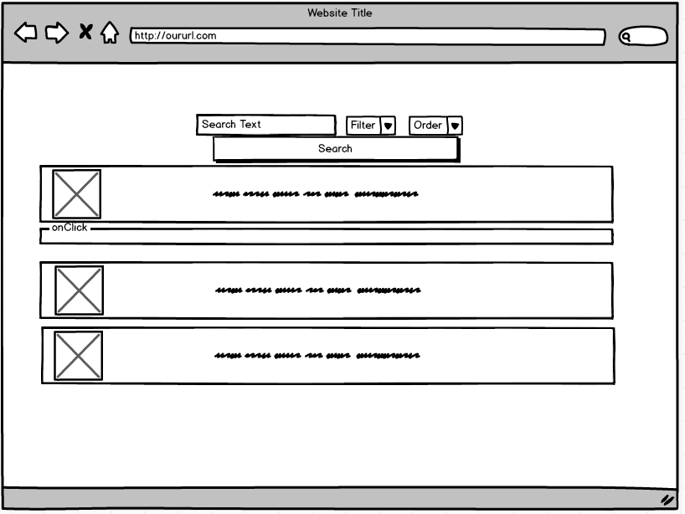

Schema (without inserts):

CREATE TABLE artist (

artistId INTEGER PRIMARY KEY AUTO_INCREMENT,

artistName VARCHAR(64) NOT NULL,

artistBio VARCHAR(512)

);

CREATE TABLE genre (

genreId INTEGER PRIMARY KEY AUTO_INCREMENT,

genre VARCHAR(32) NOT NULL

);

CREATE TABLE song (

songId INTEGER PRIMARY KEY AUTO_INCREMENT,

songName VARCHAR(64) NOT NULL,

artistId INTEGER NOT NULL,

genreId INTEGER NOT NULL,

FOREIGN KEY (artistId) REFERENCES artist(artistId),

FOREIGN KEY (genreId) REFERENCES genre(genreId)

);